
LAB-4399: From VMware to OpenShift Virtualization

A Hands-On Migration Lab



Bryan Buckland

Bryan.Buckland@ibm.com

STSM, IBM Cloud Solution Architecture
Table of Contents
1 Introduction 5
1.1 About this hands-on lab 6
2 Demo ᐧ Provision a New VM – Localnet UDN (UI) 7
3 Timing (for lab creators) 39
4 Did not complete the lab...?? (for Students) 39
5 Major task in the lab 39
5.1 Architecture 40
5.2 Familiarization Walkthrough 42
5.3 Sub task – Use to break up major tasks into smaller sets of steps 42
5.4 Sub task – Use to break up additional major tasks into smaller sets of steps 42
6 Major task example –Creating a virtual assistant 42
6.1 Creating the virtual assistant 43
6.2 Adding search skills to the assistant 43
6.3 Testing the assistant 43
7 Feedback section 43
8 Getting help and troubleshooting 43
8.1 Reach out to the Lab instructor. 43
8.2 Common troubleshooting tips 43
8.3 Getting help 43
9 Lab Reference Materials (for instructor) 43

Notices and disclaimers
© 2026 International Business Machines Corporation. No part of this document may be reproduced or transmitted in any form without written permission from IBM.
U.S. Government Users Restricted Rights — use, duplication or disclosure restricted by GSA ADP Schedule Contract with IBM.
This document is current as of the initial date of publication and may be changed by IBM at any time. Not all offerings are available in every country in which IBM operates.
Information in these presentations (including information relating to products that have not yet been announced by IBM) has been reviewed for accuracy as of the date of initial publication and could include unintentional technical or typographical errors. IBM shall have no responsibility to update this information.
This document is distributed “as is” without any warranty, either express or implied. In no event, shall IBM be liable for any damage arising from the use of this information, including but not limited to, loss of data, business interruption, loss of profit or loss of opportunity. IBM products and services are warranted per the terms and conditions of the agreements under which they are provided. The performance data and client examples cited are presented for illustrative purposes only. Actual performance results may vary depending on specific configurations and operating conditions.
IBM products are manufactured from new parts or new and used parts.
In some cases, a product may not be new and may have been previously installed. Regardless, our warranty terms apply.”
Any statements regarding IBM's future direction, intent or product plans are subject to change or withdrawal without notice.
Performance data contained herein was generally obtained in a controlled, isolated environments. Customer examples are presented as illustrations of how those customers have used IBM products and the results they may have achieved. Actual performance, cost, savings or other results in other operating environments may vary.
References in this document to IBM products, programs, or services does not imply that IBM intends to make such products, programs or services available in all countries in which IBM operates or does business.
Workshops, sessions and associated materials may have been prepared by independent session speakers, and do not necessarily reflect the views of IBM. All materials and discussions are provided for informational purposes only, and are neither intended to, nor shall constitute legal or other guidance or advice to any individual participant or their specific situation.
It is the customer’s responsibility to ensure its own compliance with legal requirements and to obtain advice of competent legal counsel as to the identification and interpretation of any relevant laws and regulatory requirements that may affect the customer’s business and any actions the customer may need to take to comply with such laws. IBM does not provide legal advice or represent or warrant that its services or products will ensure that the customer follows any law.
Notices and disclaimers (Continued)
Questions on the capabilities of non-IBM products should be addressed to the suppliers of those products. IBM does not warrant the quality of any third-party products, or the ability of any such third-party products to interoperate with IBM’s products. IBM expressly disclaims all warranties, expressed or implied, including but not limited to, the implied warranties of merchantability and fitness for a purpose.
The provision of the information contained herein is not intended to, and does not, grant any right or license under any IBM patents, copyrights, trademarks or other intellectual property right.
IBM, the IBM logo, and ibm.com are trademarks of International Business Machines Corporation, registered in many jurisdictions worldwide. Other product and service names might be trademarks of IBM or other companies. A current list of IBM trademarks is available on the Web at “Copyright and trademark information” at: www.ibm.com/legal/copytrade.shtml.

Introduction
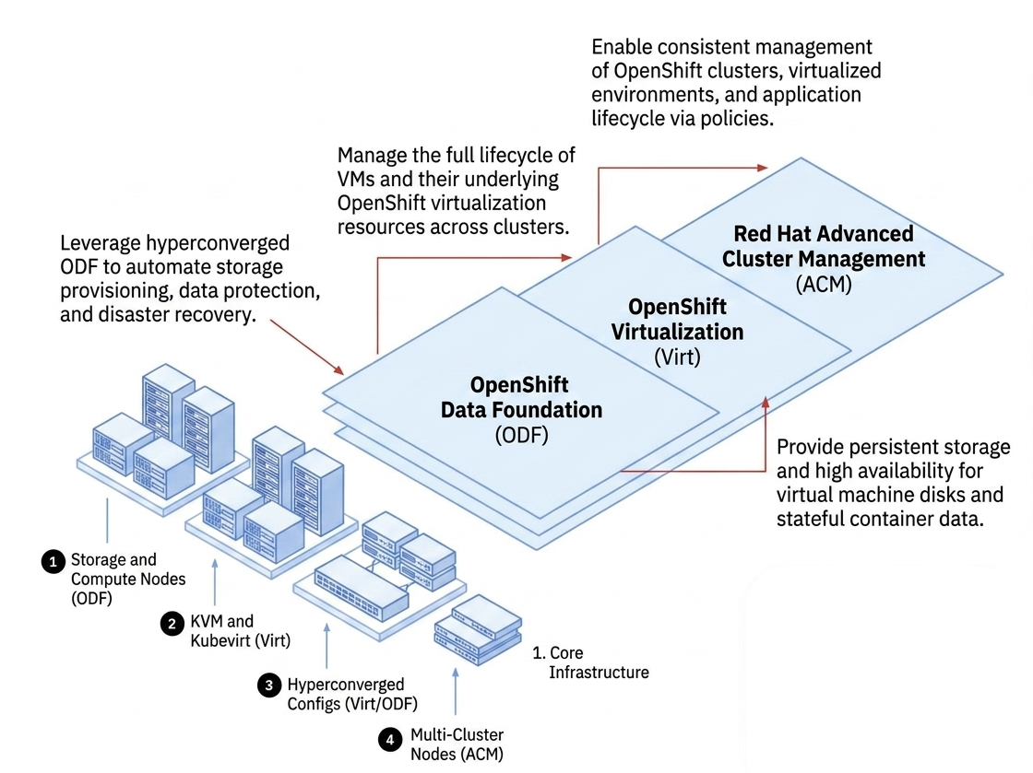

Virtualization modernization is a key step in helping organization increase flexibility, reduce complexity, and prepare for future application modernization initiatives. OpenShift Virtualization enable enterprises to run existing virtual machines alongside containers on a single platform, simplifying operations and accelerating innovation. In this hands-on lab, you will learn how to migrate VMware workloads to OpenShift Virtualization and experience the technologies that help organizations modernize their virtualization environments with confidence.

Demo

Prerequisites:
- A working ROVS cluster with all operators healthy.
- The oc, virtctl, and ibmcloud CLIs installed.
- A VPC subnet with a Public Gateway attached (for outbound internet access).
- At least one allowed VLAN on your bare metal server's PCI network attachment.
- OVS bridge and bridge mapping NNCPs applied and available.

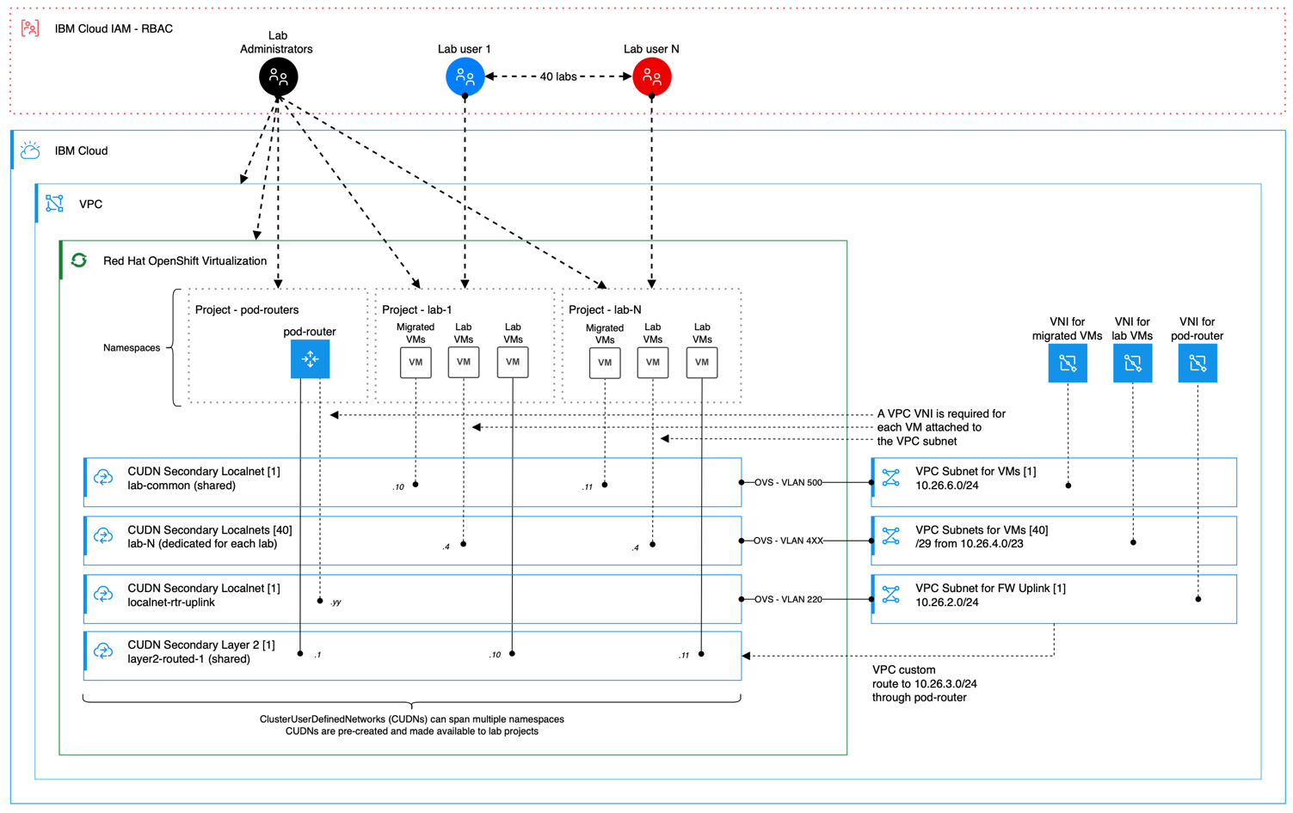

Provision a VM using Layer 2 Primary UDN

A VM whose entire pod network is a Layer 2 primary CUDN. No VNI, no VLAN, no MAC pinning. IP is DHCP-assigned from the CUDN subnet and persistent for the life of the VM.

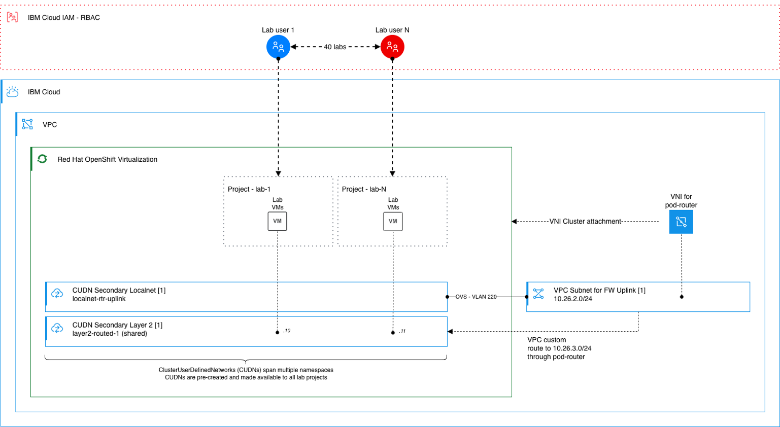

- Access the OpenShift Web Console
  - Open cloud.ibm.com and confirm the account selector (upper right) is set to 2326338 – ITZ-VMWARE.
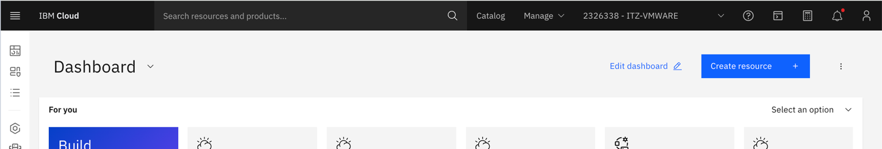

  - Click the hamburger menu (upper left) → Infrastructure → OpenShift virtualization.
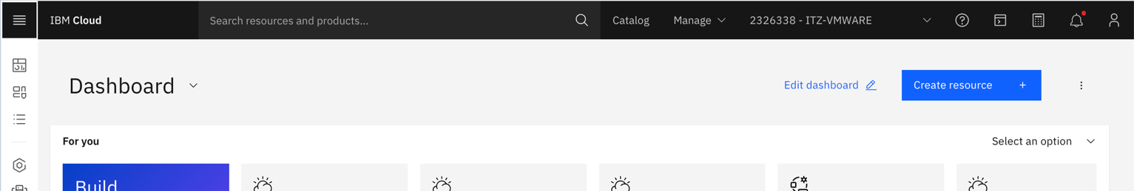
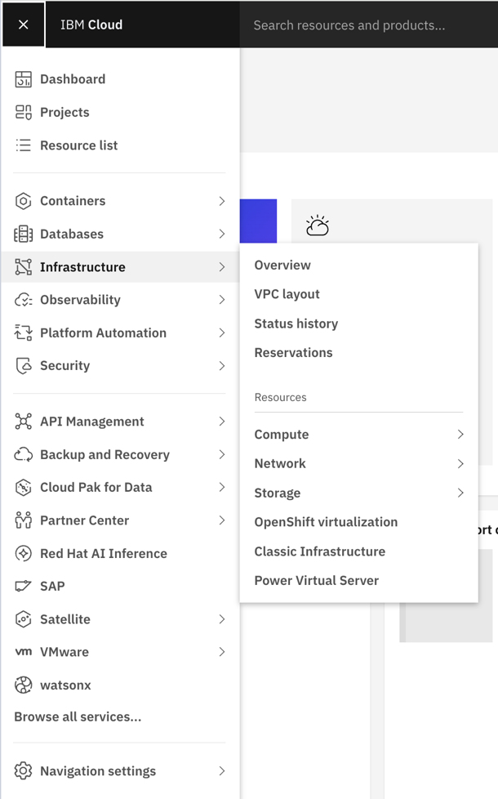
  - Click the cluster name virtualization-4399.

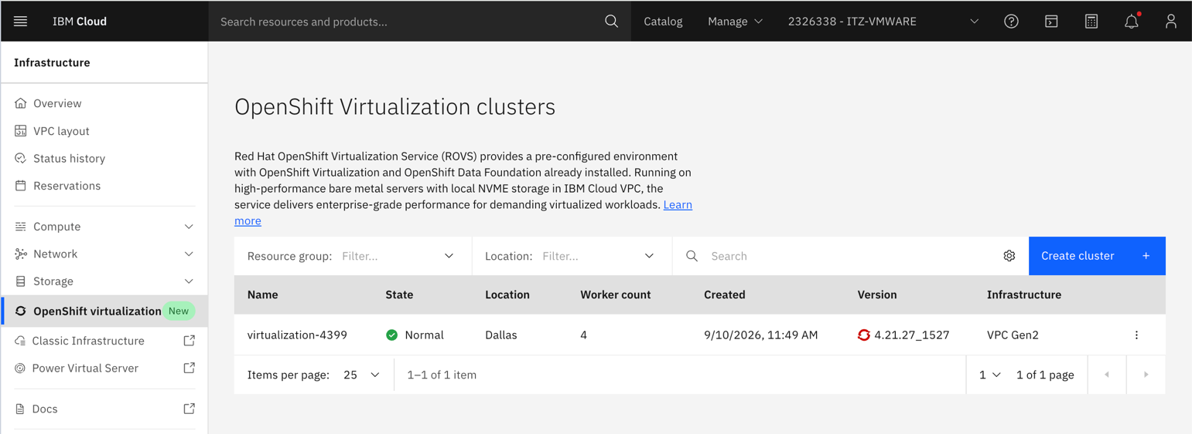

  - Click the blue OpenShift web console button (upper right of the cluster detail page).

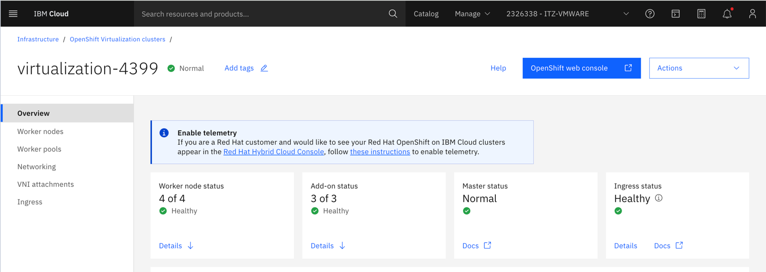

The OpenShift console opens in a new tab, already authenticated.

- Navigate to Virtualization
  - In the drop down, click Virtualization then VirtualMachines. Leave the namespace set to All Namespaces — no need to find your namespace in the dropdown.

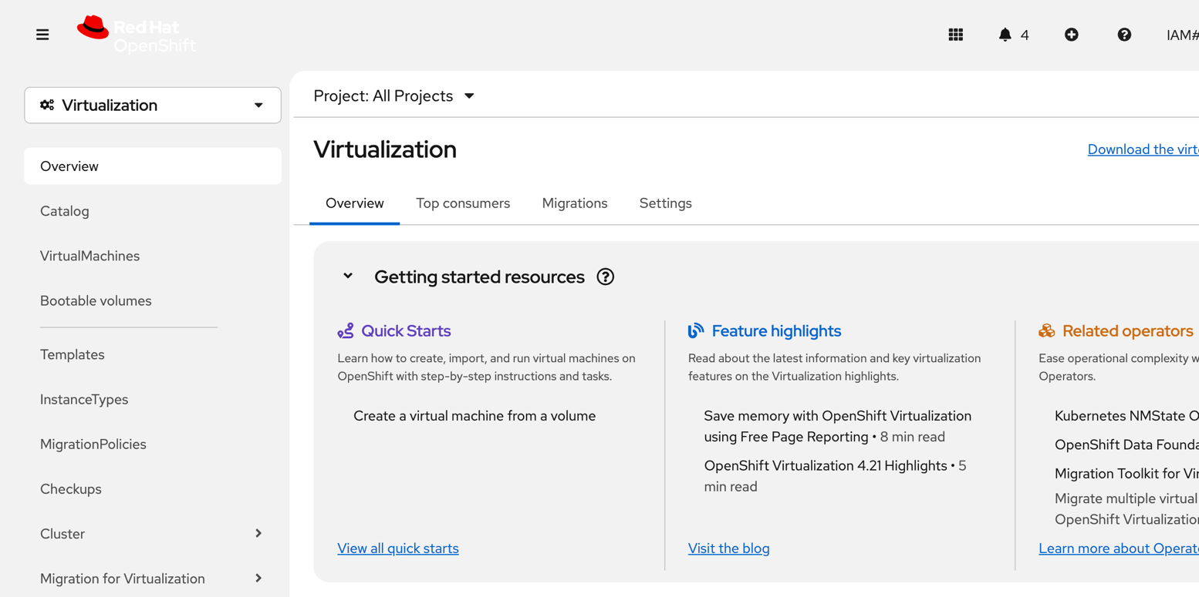

- Create a Virtual Machine from Instance Type
  - Click Create → From Instance Type
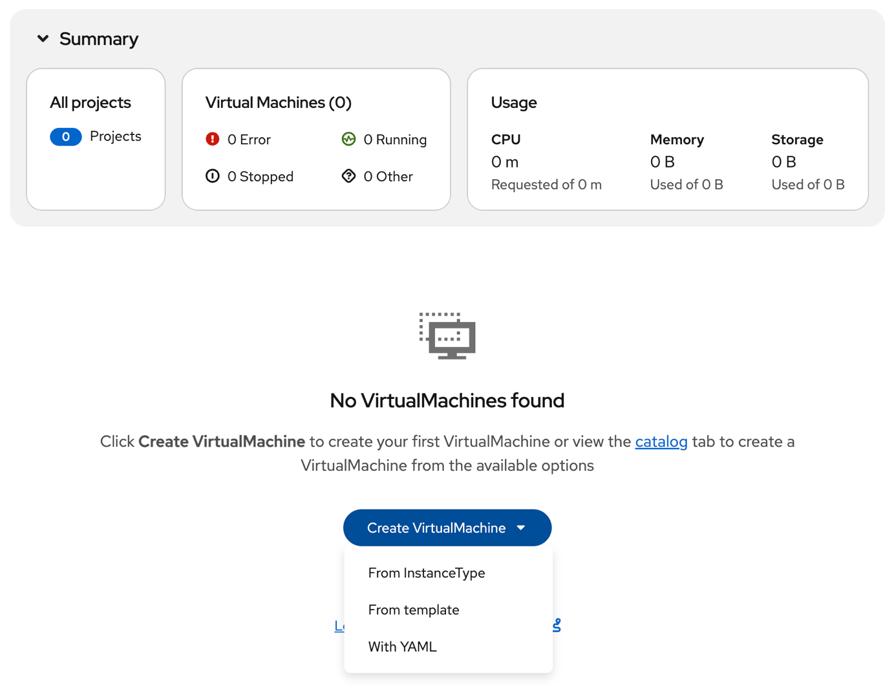

- Create the VM
  - Select centos-stream9.
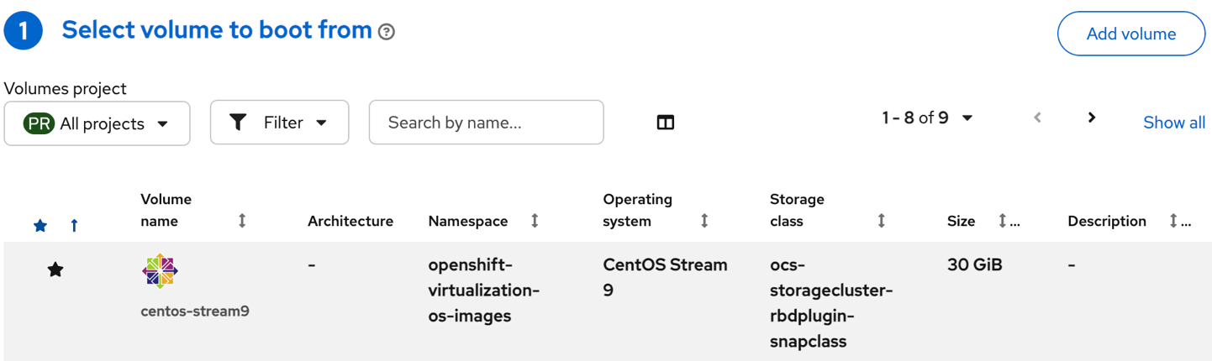
  - Scroll down and select General Purpose. Click the U series drop down and select small: 1CPUs, 2 GiB Memory.
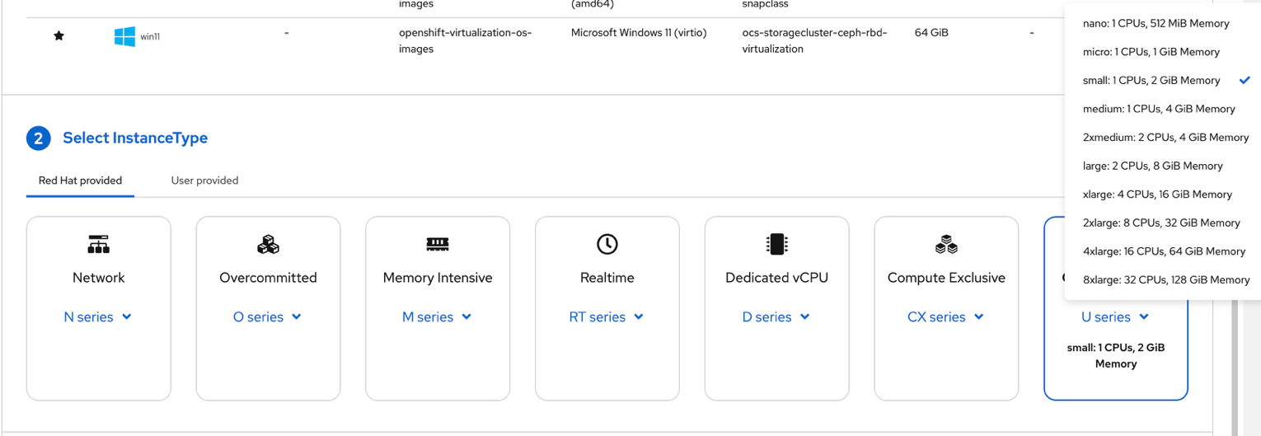

  - Scroll down and change the vm name to <initials>-layer2-vm (ex: js-layer2-vm).
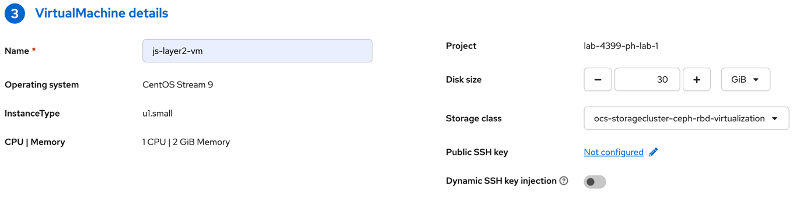

  - DO NOT CLICK CREATE. Click Customize VirtualMachine.
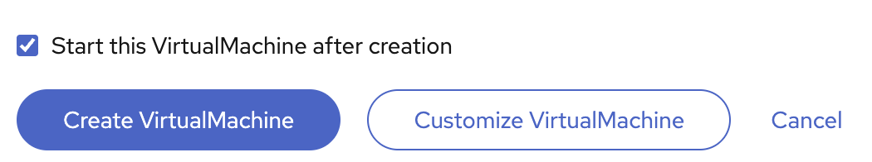

In the Customize screen, click the Configuration tab, then navigate to the Network tab on the left. Click the kebab menu (⋮) on the default interface row and choose Edit.
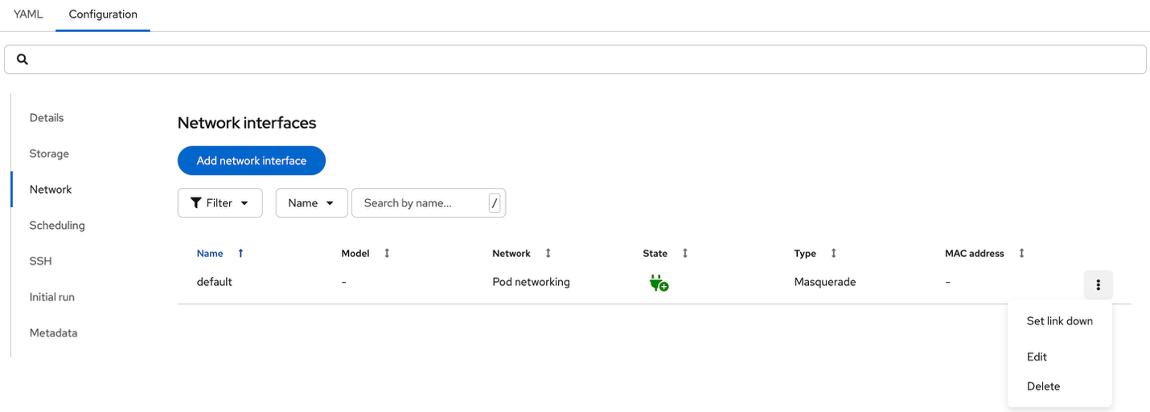
  - In the Network dropdown, select the Layer-2 network binding type. Click Save.
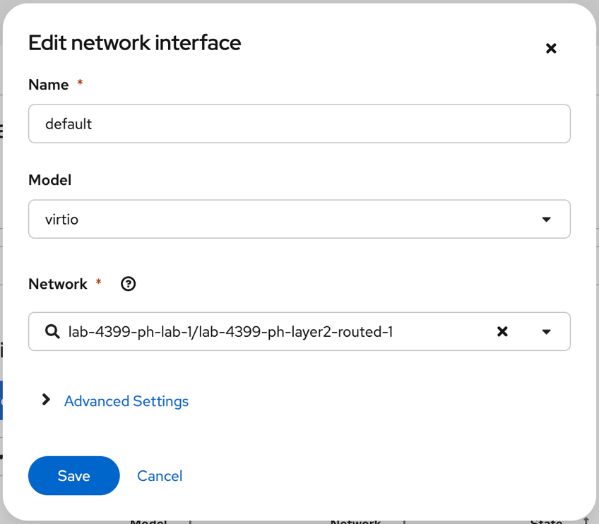

  - Click Create VirtualMachine.
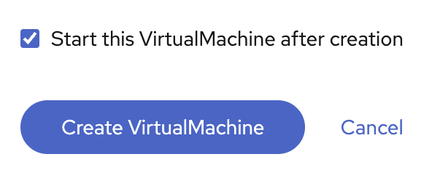
- Watch the VM start
  - Watch the status column update from Provisioning → Starting →Running.
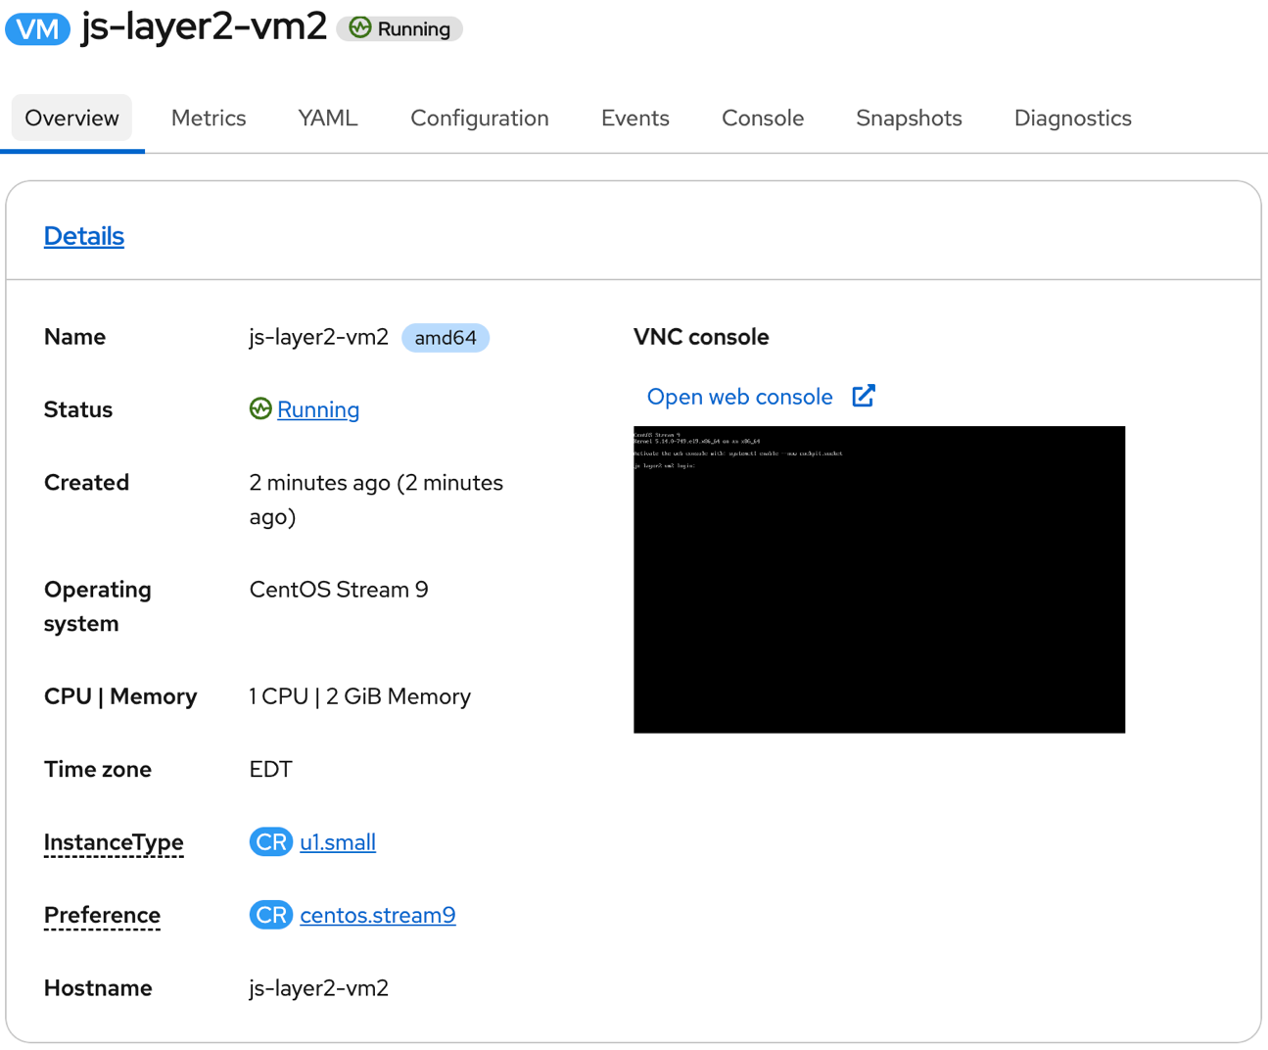

  - View the Network details.
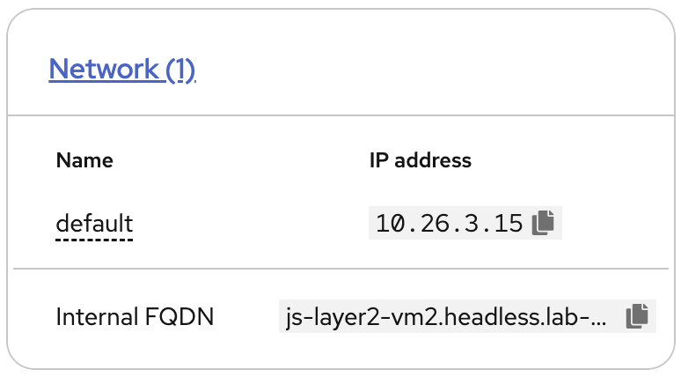
- Open the In-Browser Console
  - In the VM Details section, click Open web console.
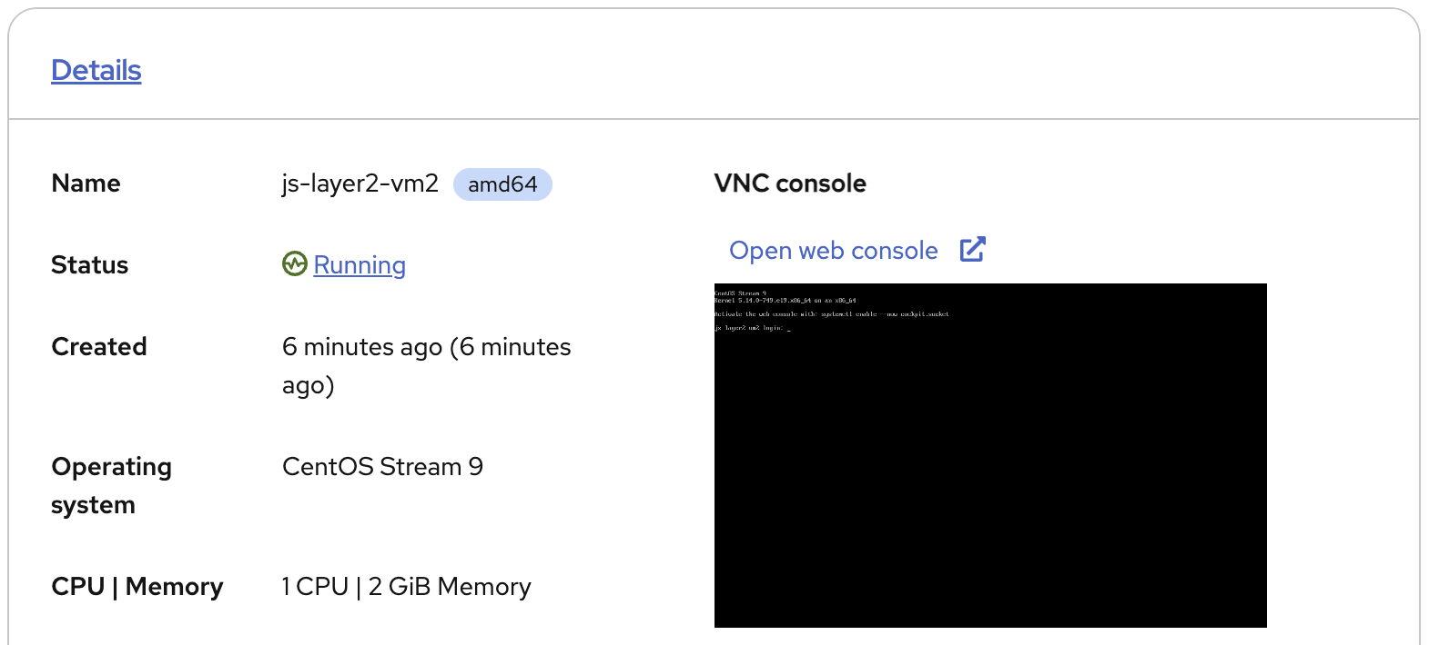

  - Login in with the guest login credentials. Then run: ip addr show
Hint: Use the copy and Paste to console buttons.
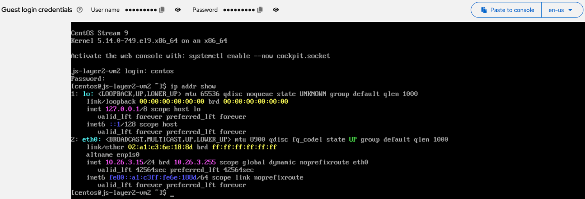

  - Then run: curl http://lab.techzone.ibm.local/
Congratulations, you have completed part 1 of this lab!

Provision a New VM – Localnet UDN

Localnet networking is the most “like for like” network setup when compared to on-premise deployments of Red Hat OpenShift Virtualization Engine. Localnet is the simplest and easiest to understand, but it may not be the most effective way to scale deployments of VMs across ROVS.

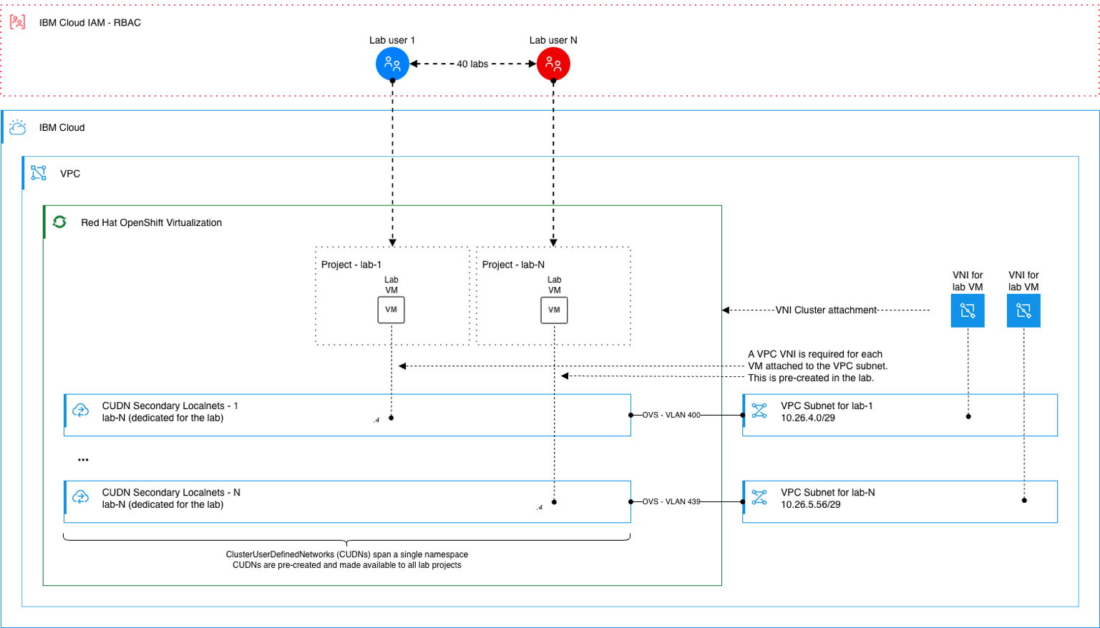

Create the Virtual Network Interface (VNI)
We are going to walk through the process of creating a VNI, but DO NOT CLICK CREATE at the end, as there is already a VNI created and attached for you.
Click the hamburger menu → Infrastructure → Network → Virtual network interfaces.

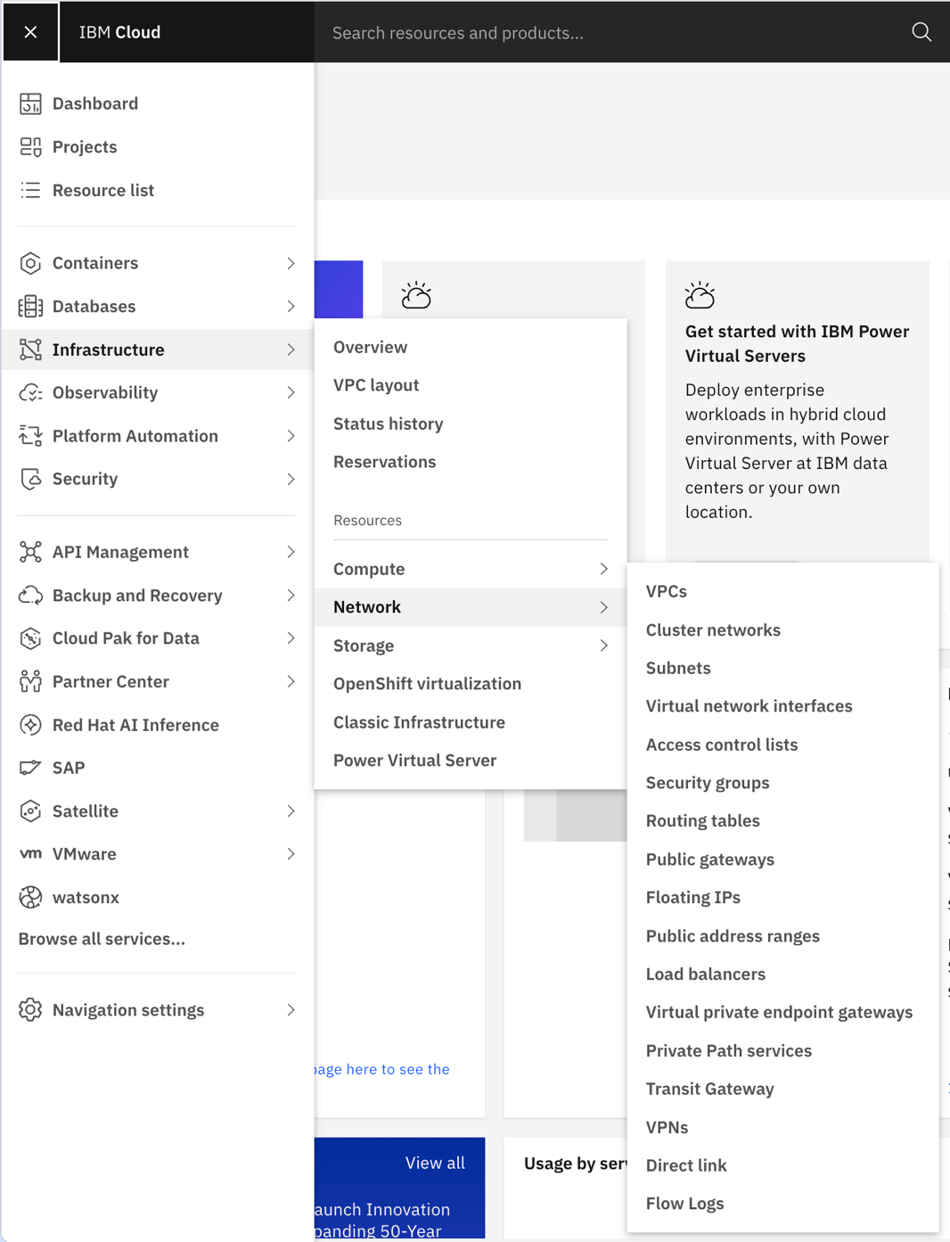

Click Create.
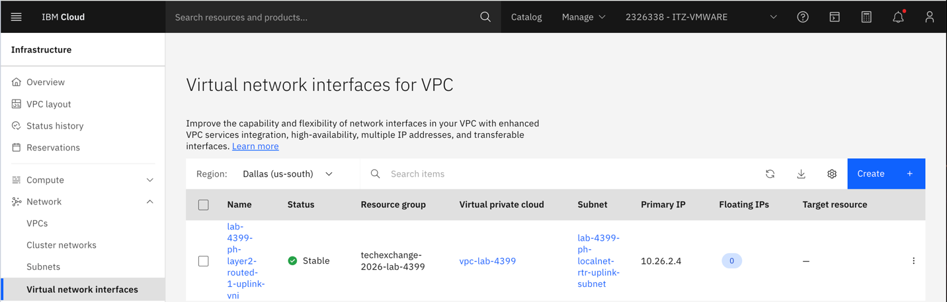

Fill in the form:
- Region: Dallas (us-south) – confirm, do not change
- Name: lab-4399-example
- Resource group: techxchange-2026-lab-4399
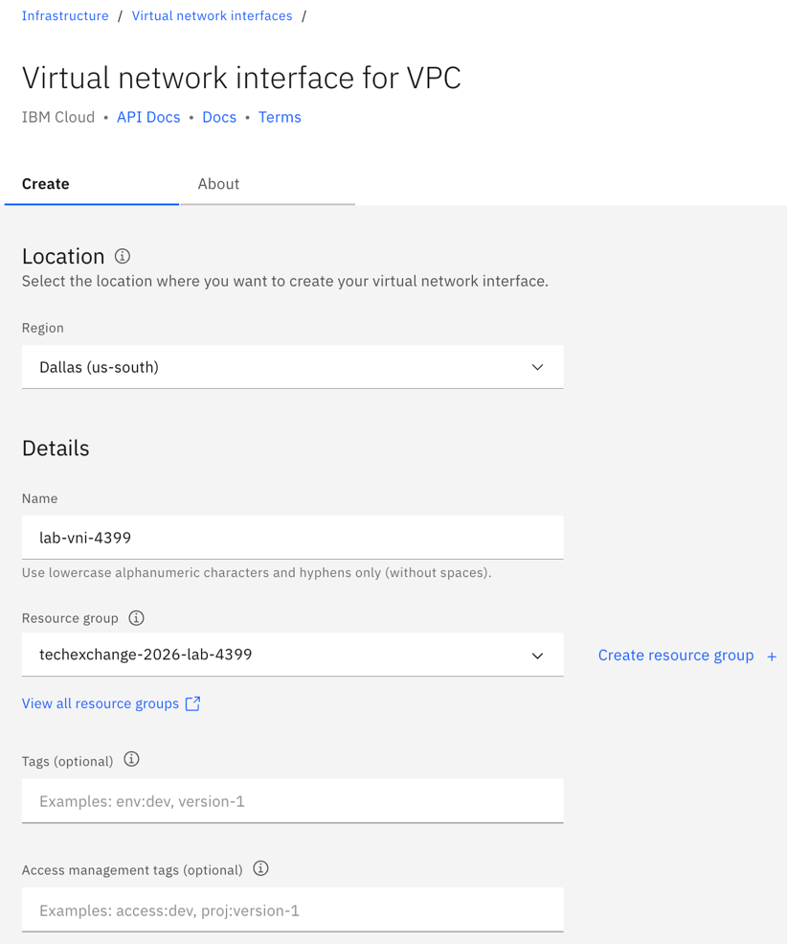
Scroll down to Network configuration. Confirm the VPC is vpc-lab-4399. Then, choose the subnet that corresponds with YOUR lab number. (e.g. Lab 1 would select lab-4399-ph-lab-1-subnet)
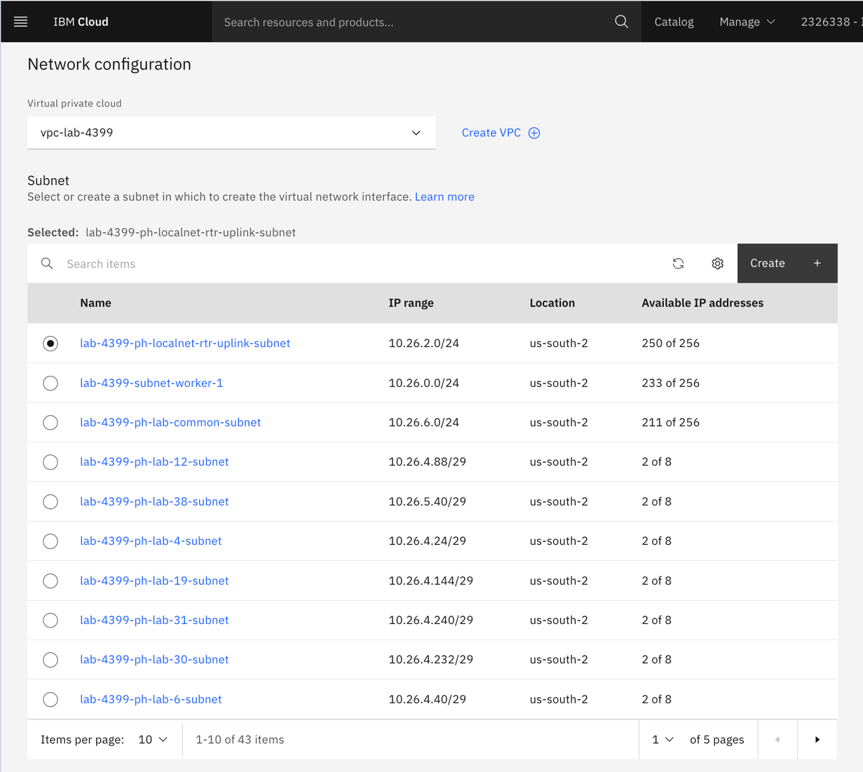

Leave all remaining fields as their defaults. DO NOT CLICK CREATE. Navigate back to the Virtual network interfaces page by clicking the tab at the top of the page.

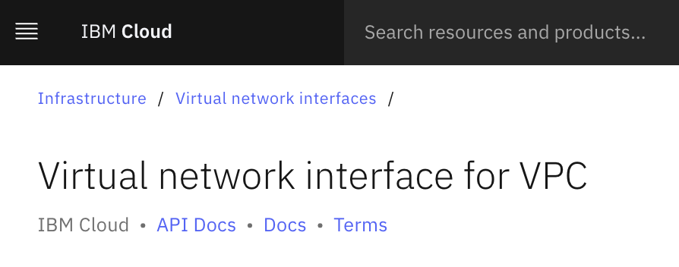
- Investigate the VNI
- Find the VNI that corresponds with YOUR lab number in the list. Click on it.
Hint: It should be in the format of lab-4399-ph-lab-<your lab number>-vm-1

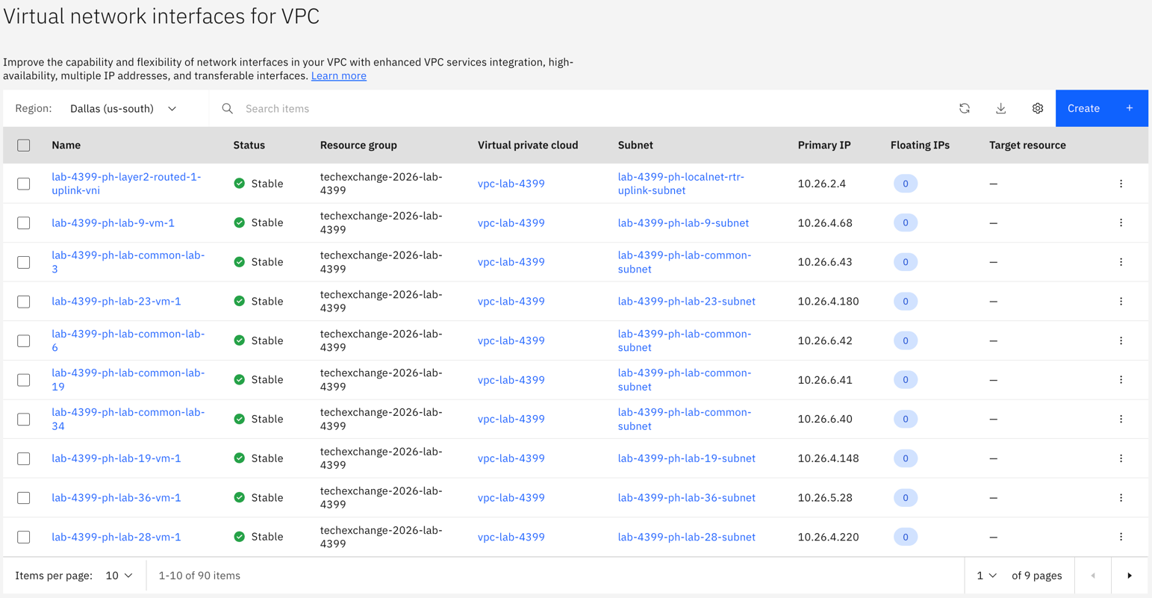

Attach the VNI to the Worker Node

Click the Hamburger menu.

Navigate to Infrastructure → OpenShift virtualization → virtualization-4399.

In the left navigation click VNI attachments.

Scroll until you find an attached VNI with your lab number.

Open it and navigate around.

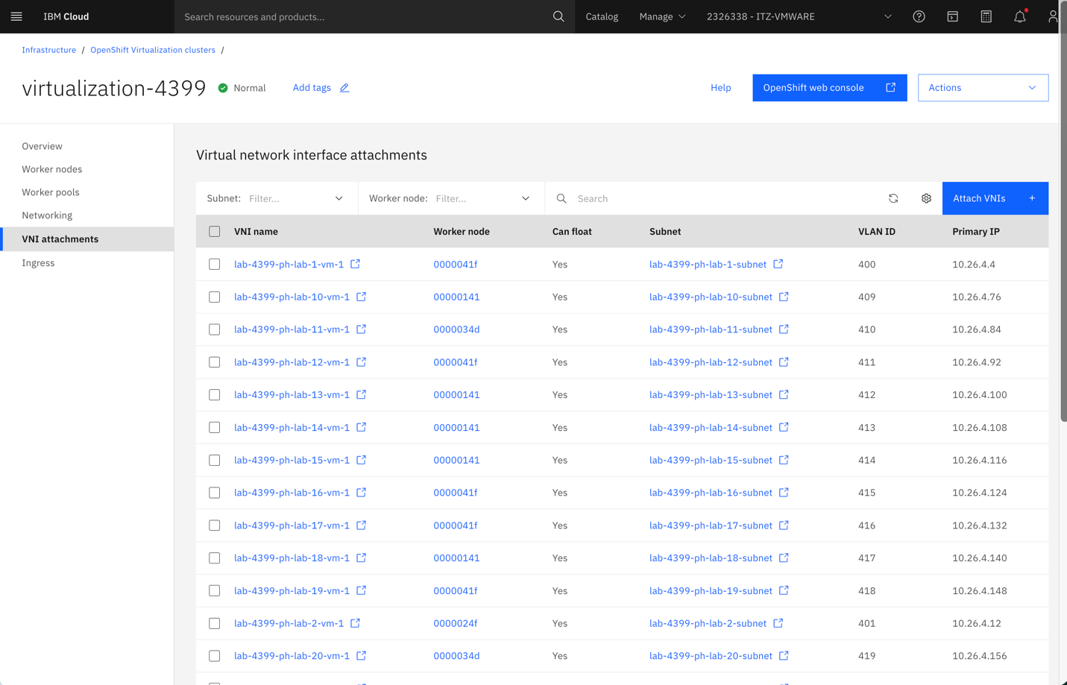

Navigate to VirtualMachines.

Switch to the OpenShift web console tab. (If needed, navigate back to step 0 to see how to do so).

In the left navigation menu, click the dropdown, Virtualization → VirtualMachines. Leave the Project selector set to All Projects.
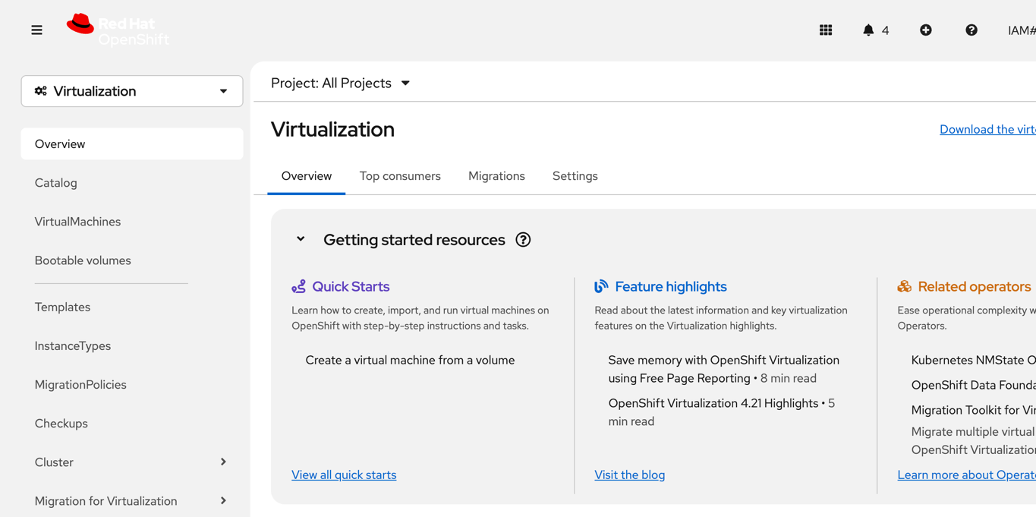

Open the VM Creation Wizard

Click Create VirtualMachines → From InstanceType.
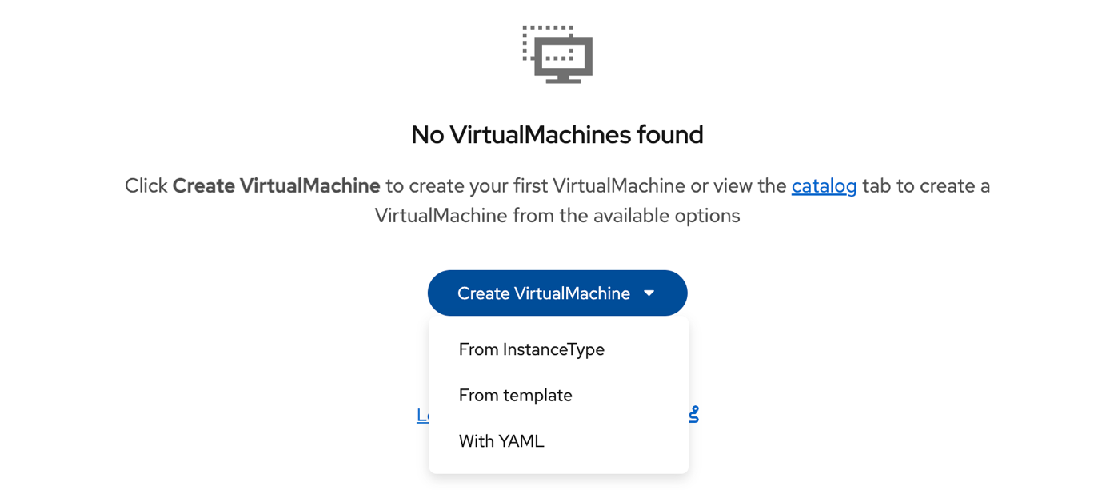

Select the Boot Volume

Under the InstanceTypes tab, select centos-stream9 as the OS.
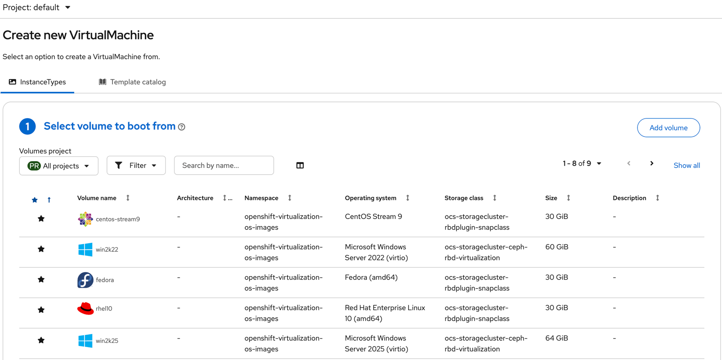

Select the InstanceType

Choose the General Purpose card (U series), then form its dropdown select small: 1 CPUs, 2 GiB Memory.
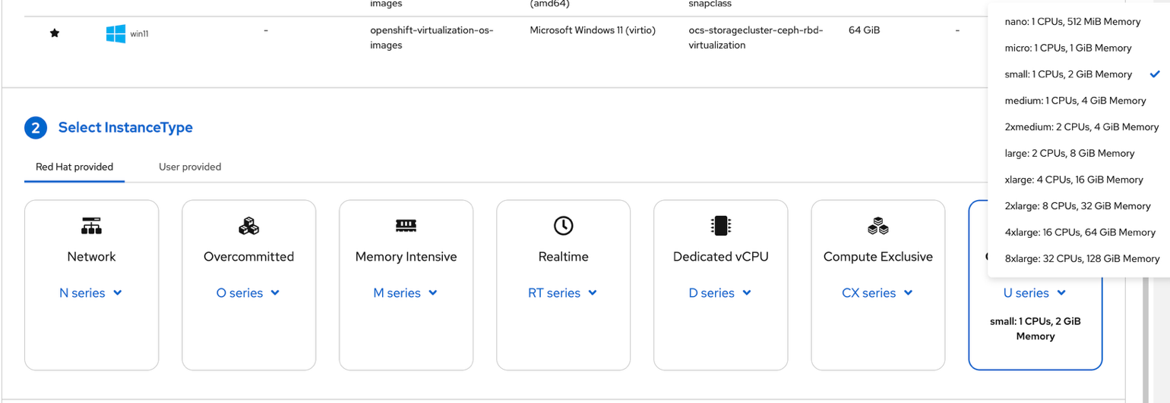

Name the VM

In the VirtualMachine details section, set the Name to <initials>-localnet-vm (e.g. js-localnet-vm).
DO NOT CLICK Create VirtualMachine. Click Customize VirtualMachine – the default wizard puts the VM on the pod network with no fixed MAC. You need to set the Localnet network and MAC address before creation.
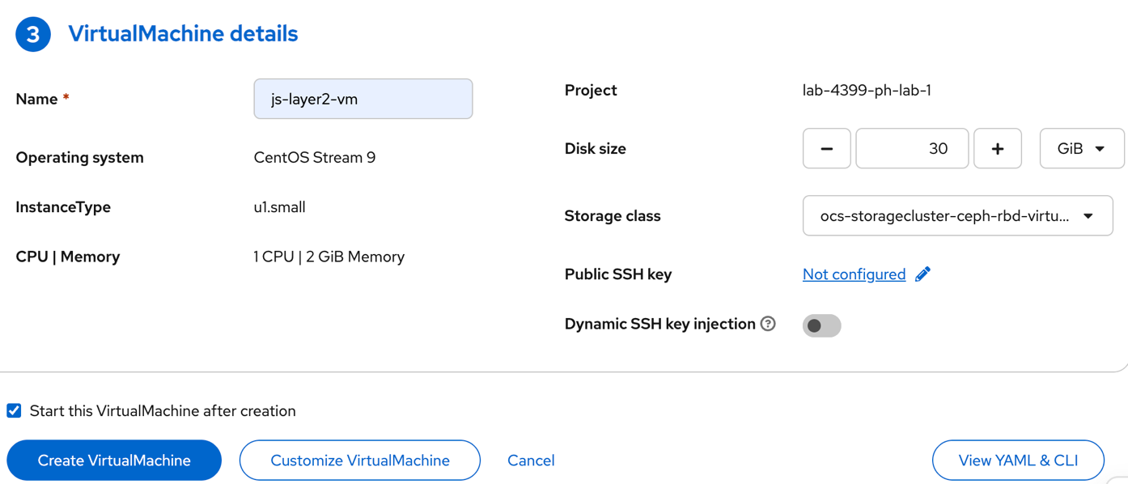

Open Configuration

In the Customize screen, click the Configuration tab, then navigate to the Network tab on the left. Click the kebab menu (⋮) on the default interface row and choose Edit.
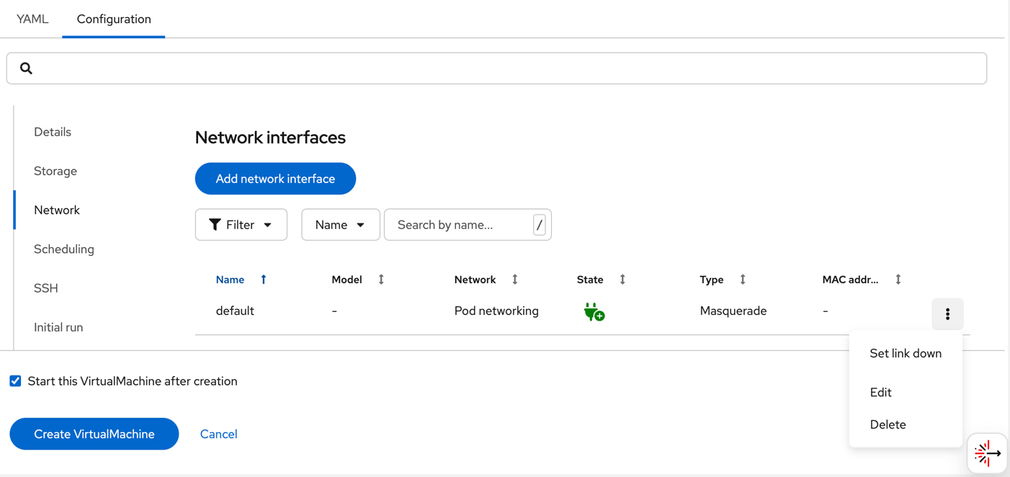

Set Network and MAC Address

In the Edit network interface dialog:
- Network: Choose the one that matches YOUR VM (e.g. lab-4399-ph-lab-1)
- Expand Advanced Settings → set MAC address to the MAC Address you found in your VNI.

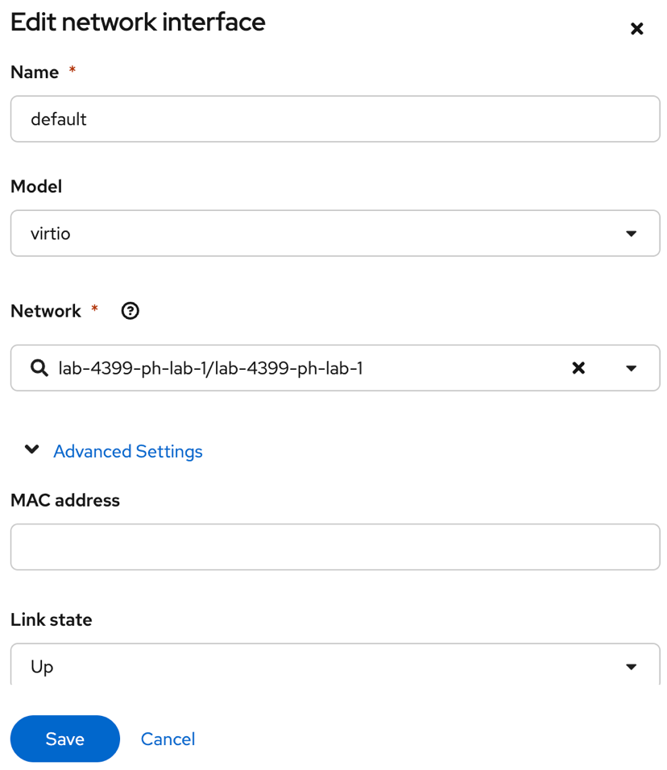

Click Save.

Set the Login Password

In the left-hand list, click Initial run, then click Edit on the Cloud-init section.
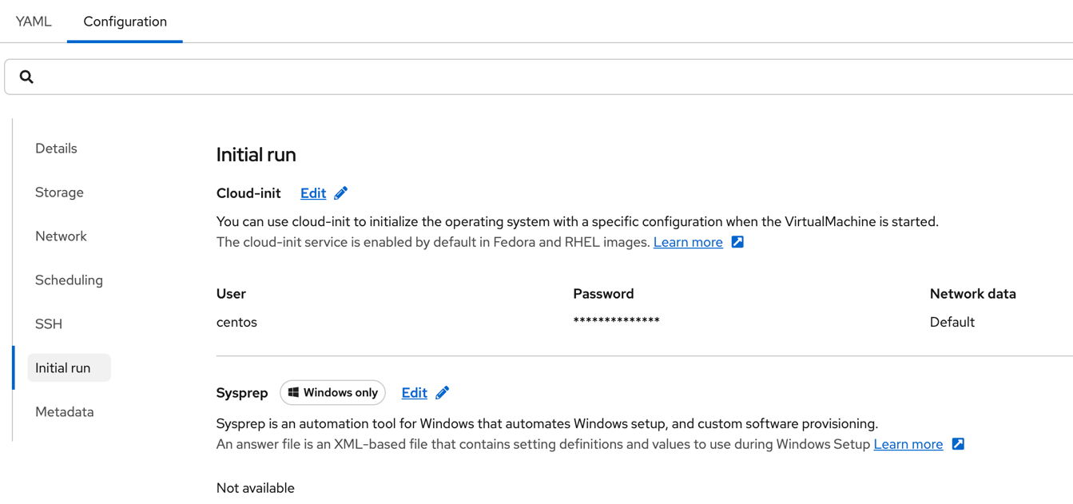

  - Set the password to ChangeMe123! and click Apply.
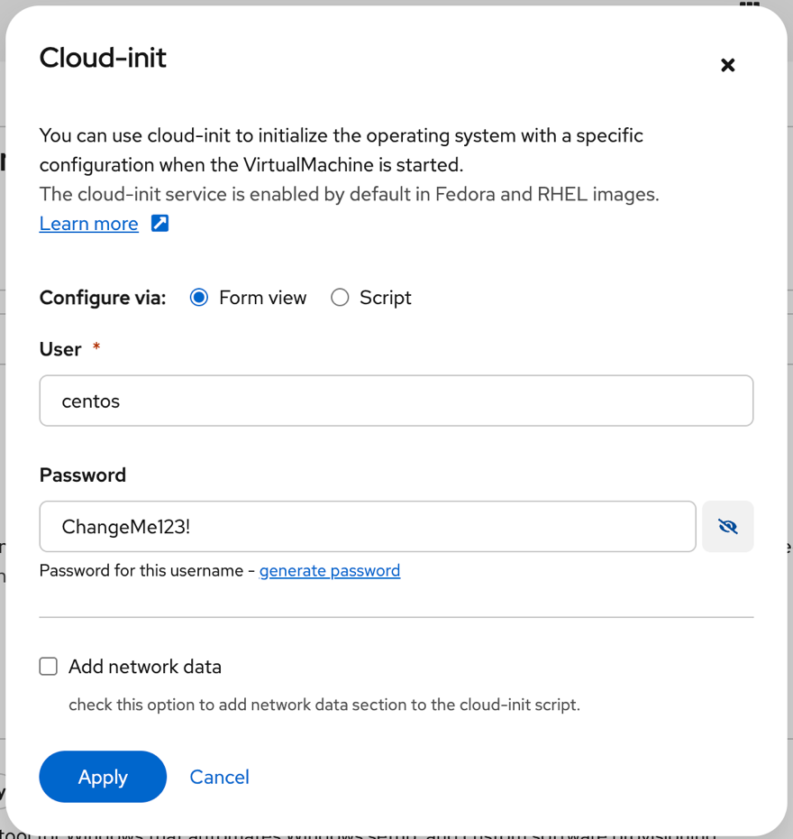

Create the VM

Scroll down and click the blue Create VirtualMachine button at the bottom of the screen.

Watch the VM Boot

Return to the VirtualMachine list. Watch the Status column progress:
Provisioning → Starting → Running

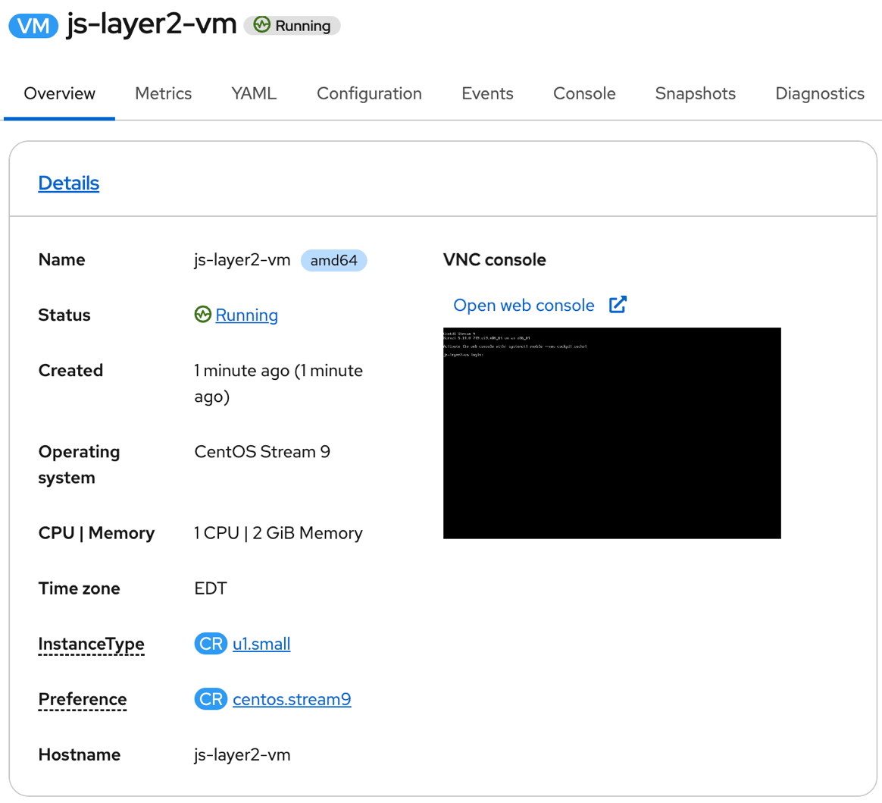

Inspect the VM Overview

Scroll down and look at the Network tile – it shows the static IP assigned to this VM.
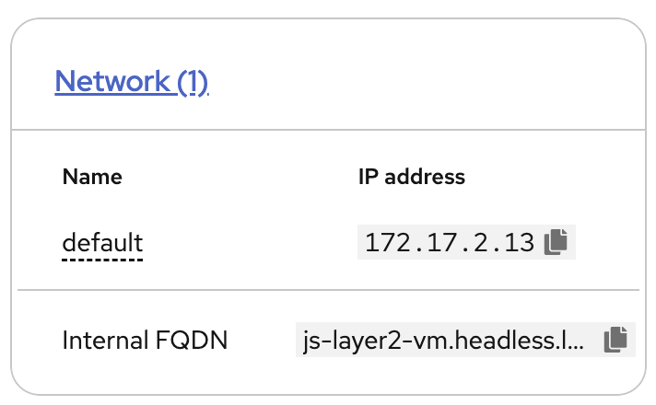

  - Click the Network tile header to jump to Configuration → Network. Point out:
- Network attachment: Pod Networking.
- MAC address matches the VNI reservation – this is what pins the IP permanently.

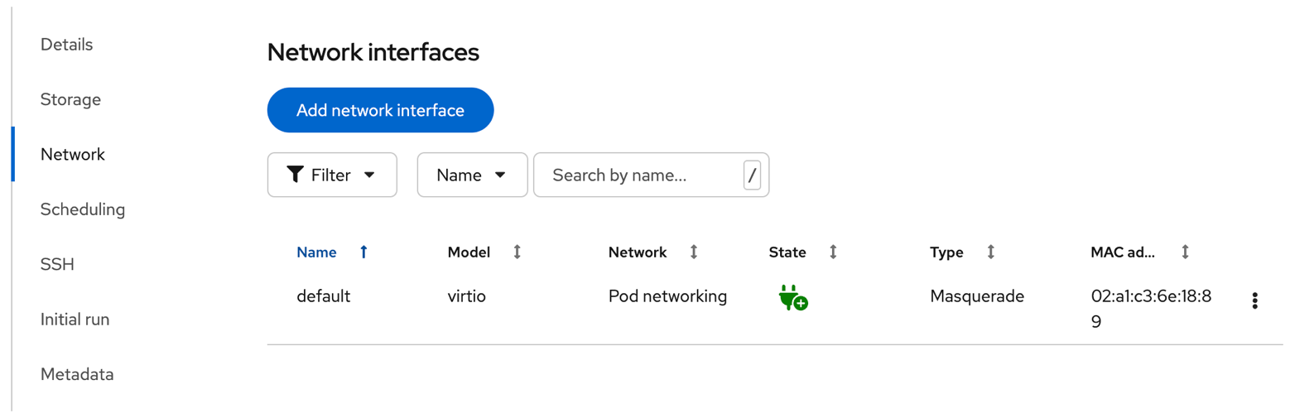

Open the In-Browser Console

Click the Console tab. Log in as Centos with the password as ChangeMe123!

Hint: Use the Copy and Paste to Console buttons to paste logon credentials.

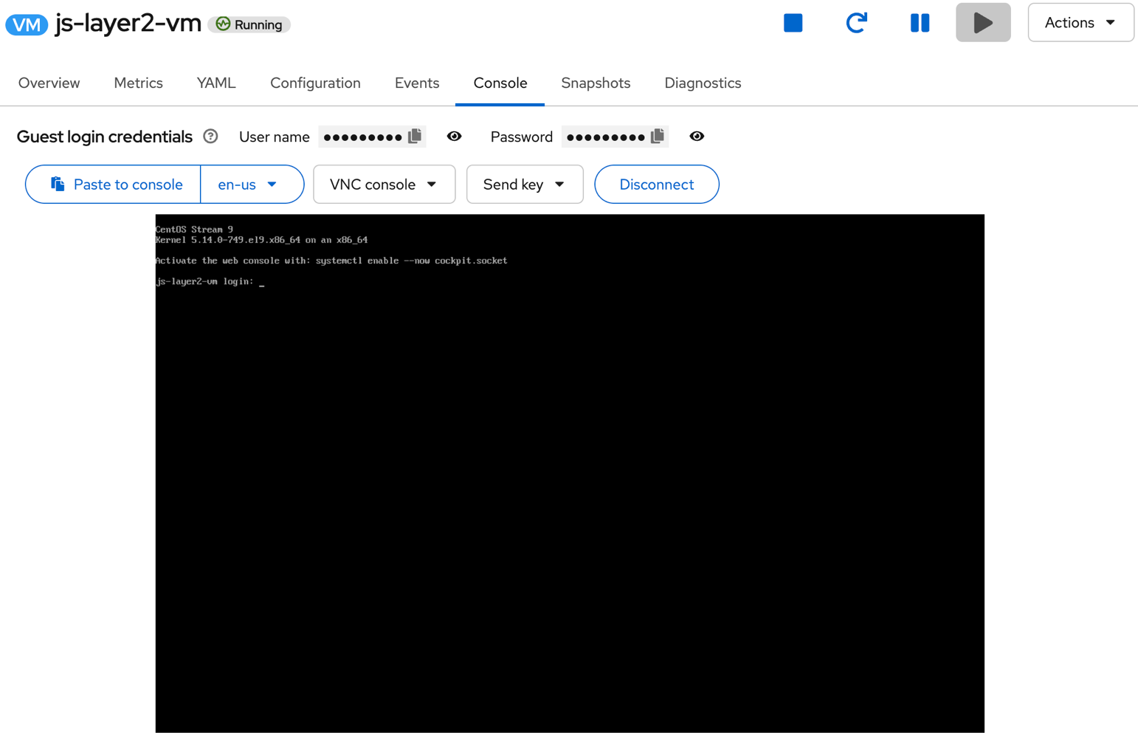

Show the Static IP Inside the VM

In the VM console, run:
ip addr show

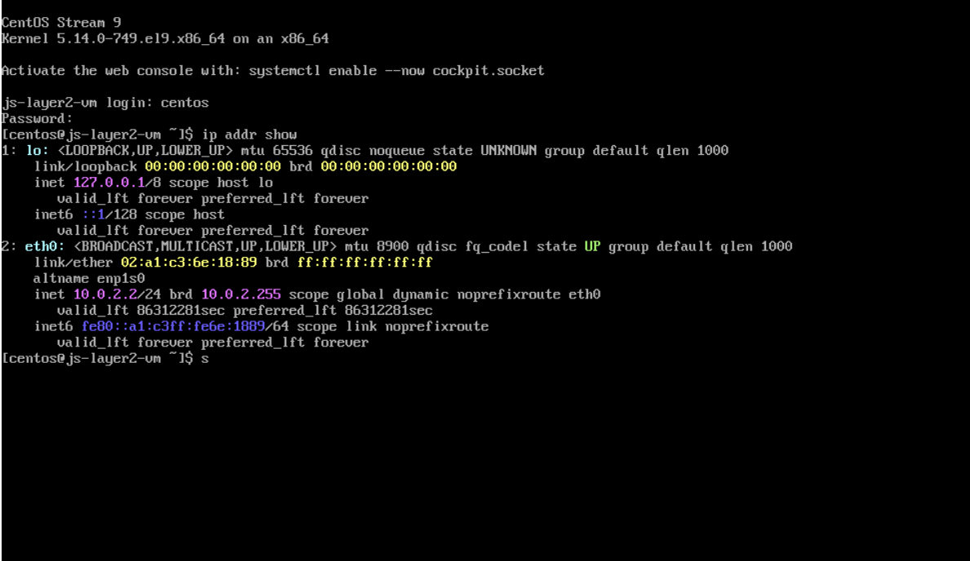

  - Then run:
curl http://lab.techzone.ibm.local/

Congratulations, you have completed part 1 of this lab!

Migration Toolkit for Virtualization – Migrate a VMware VM to ROVS

This end-to-end lab takes you from a clean ROVS cluster to a successfully migrated VMware VM – all in one walkthrough. It ties together the MTV operator (pre-installed on ROVS), VPC networking, and ODF storage into a complete migration scenario. MTV migrates VMs to Red Hat OpenShift Virtualization running on Red Hat OpenShift.

What MTV Does:
- Reads the VM’s disk, CPU, memory, and network configuration from vCenter.
- Converts the VM disk from VMDK format to a KubeVirt-compatible image using virt-v2v.
- Create a VirtualMachine CR in OpenShift with mapped resource.
- Starts the VM and (optionally) powers off the source.

Cold Migration – The source virtual servers are stopped while the data is copied. The default migration.
Warm Migration – Most of the data during the precopy stage is copied. Then, the virtual servers are stopped, and the remaining data is copied during the cutover stage.
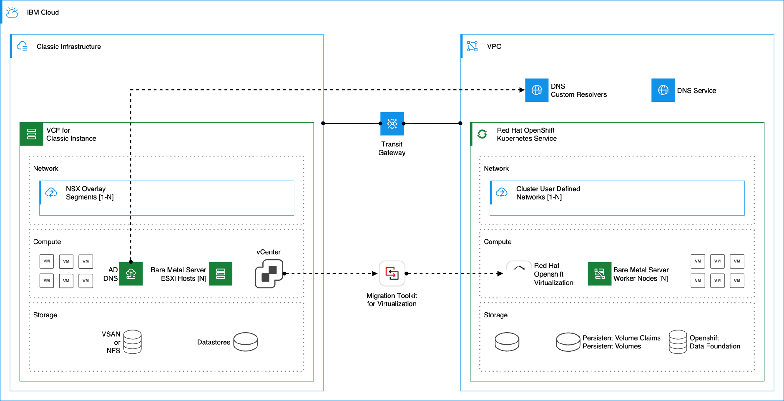

Cold Migration

Create a Network map
  - Open the OpenShift web console. In the left navigation menu, click Migration for Virtualization → Network maps.
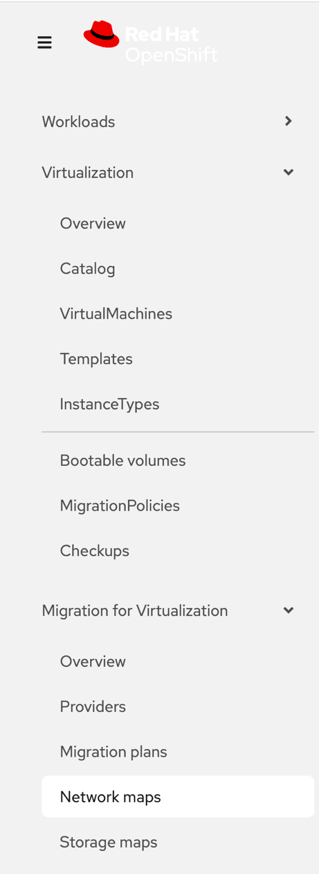

  - Click Create network map → Create with form.

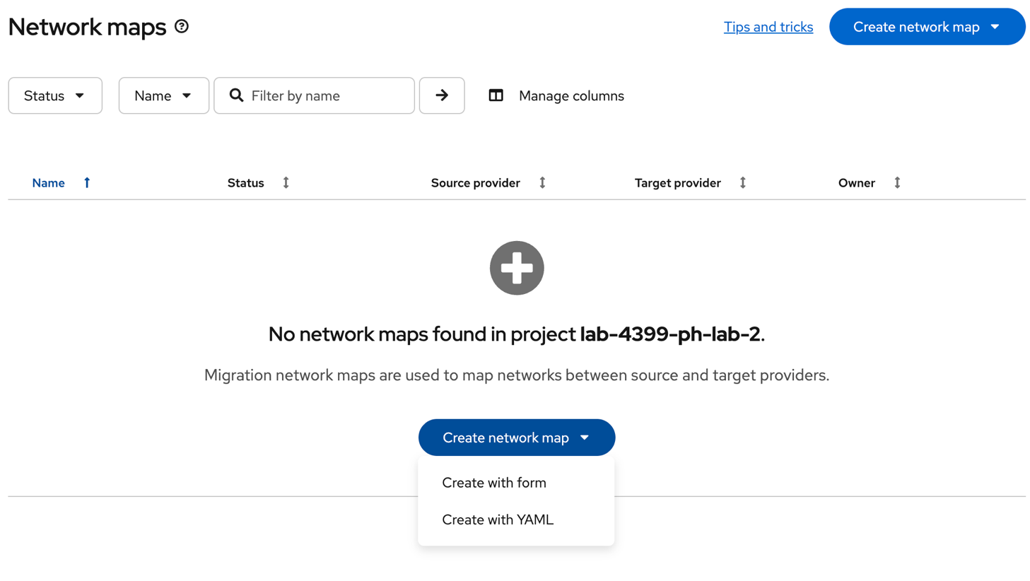
1

  - Fill out the form:
- Network map name: <your lab number>-networkmap (e.g. lab1-networkmap)
- Project: Select YOUR project
- Source provider: ocp-gym-vc
- Target provider: host
- Source network: 6a7c55c9e78638eb8066f39-segment
- Target network: lab-4399-ph-lab-<your lab number>/lab-4399-ph-lab-<your lab number>
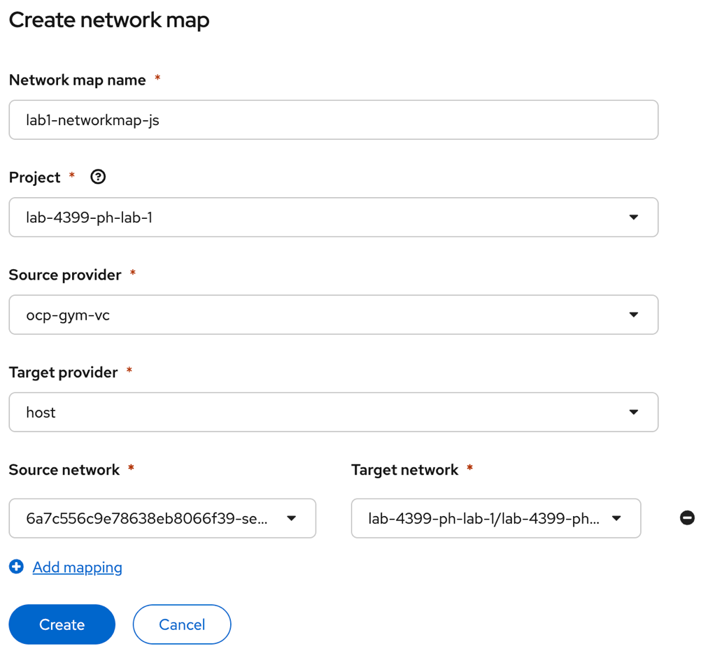

  - Click Create.

- Create a Storage map
  - In the left navigation menu, click Migration for Virtualization → Storage maps.

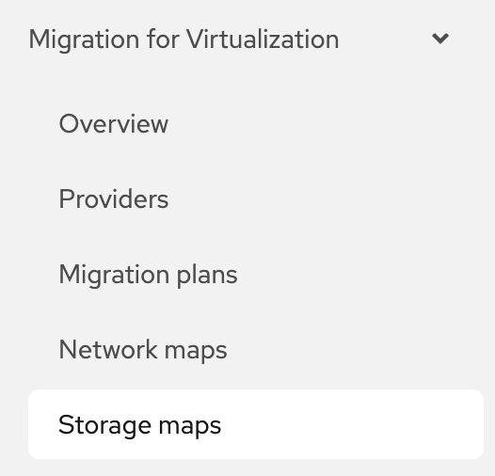

  - Click Create storage map → Create with form.

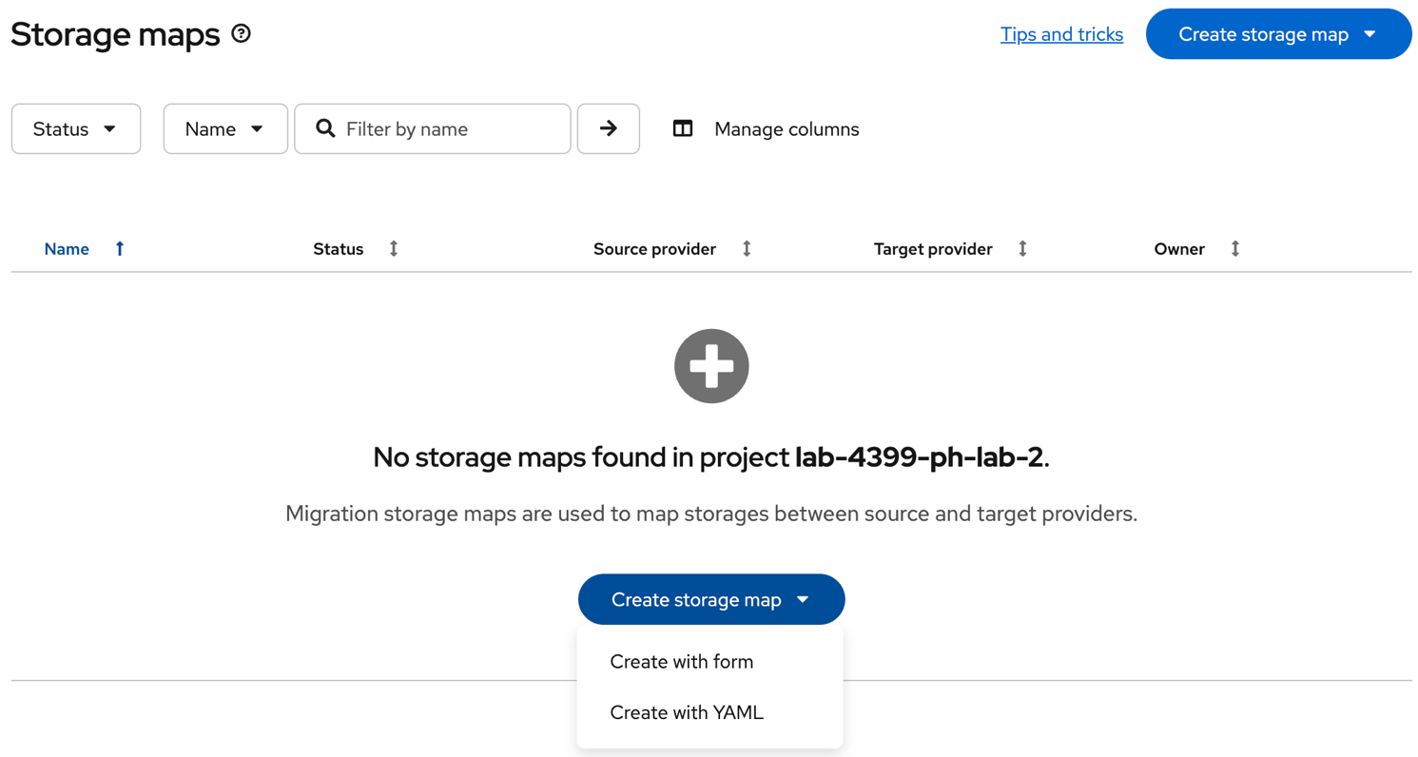

  - Fill out the form:
- Storage map name: <your lab number>-storagemap (e.g. lab1-storagemap)
- Project: Select YOUR project
- Source provider: ocp-gym-vc
- Target provider: host
- Source network: 6a7c55c9e78638eb8066f39-storage
- Target network: ocs-storagecluster-ceph-rpd

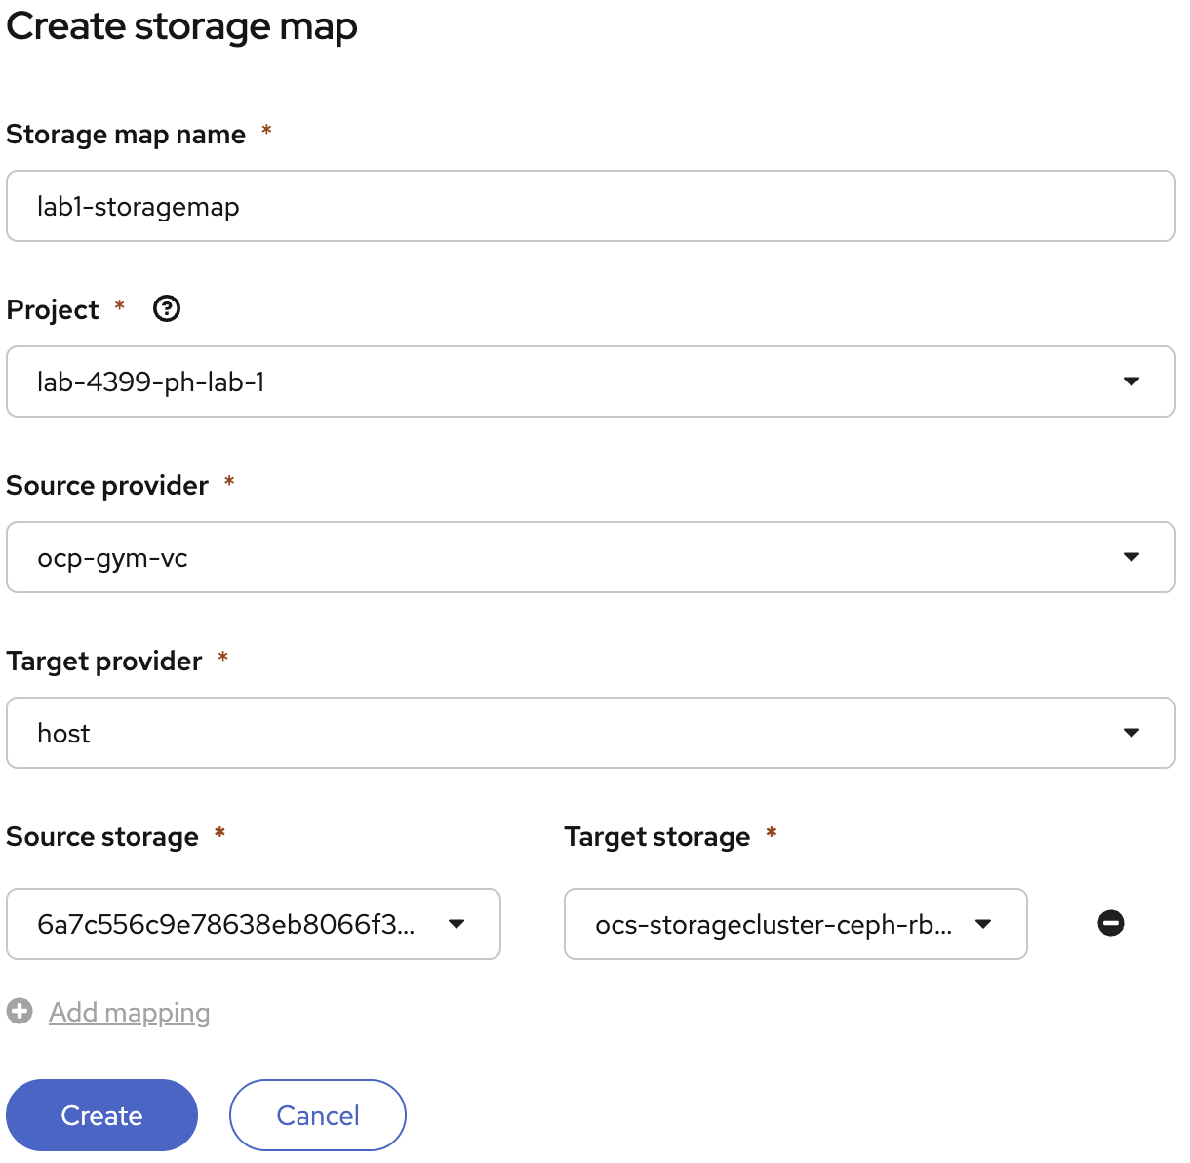

  - Click Create.

Access the MTV UI

In the left navigation menu, click Migration for Virtualization → Migration plans.

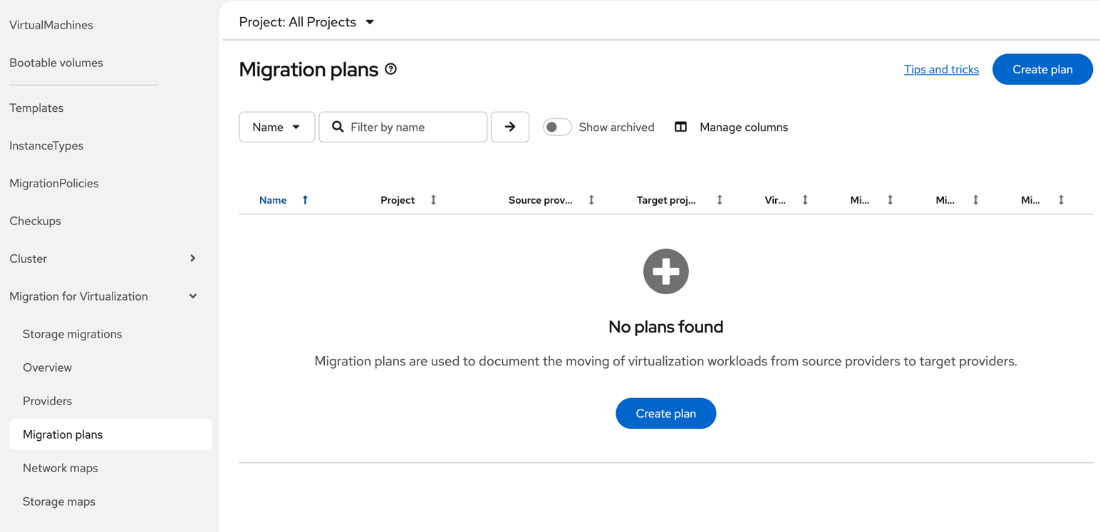

  - Click Create Plan.

- Create a Migration plan
In the General tab, filling in the following:
  - Plan name: cold-migration-lab<your lab number> (e.g. cold-migration-lab1)
  - Plan project: Select YOUR project number (e.g. lab-4399-ph-lab-1)
  - Source provider: vcenter-prod
  - Target provider: host
  - Target namespace: vm-lab<your lab number> (e.g. vm-js)

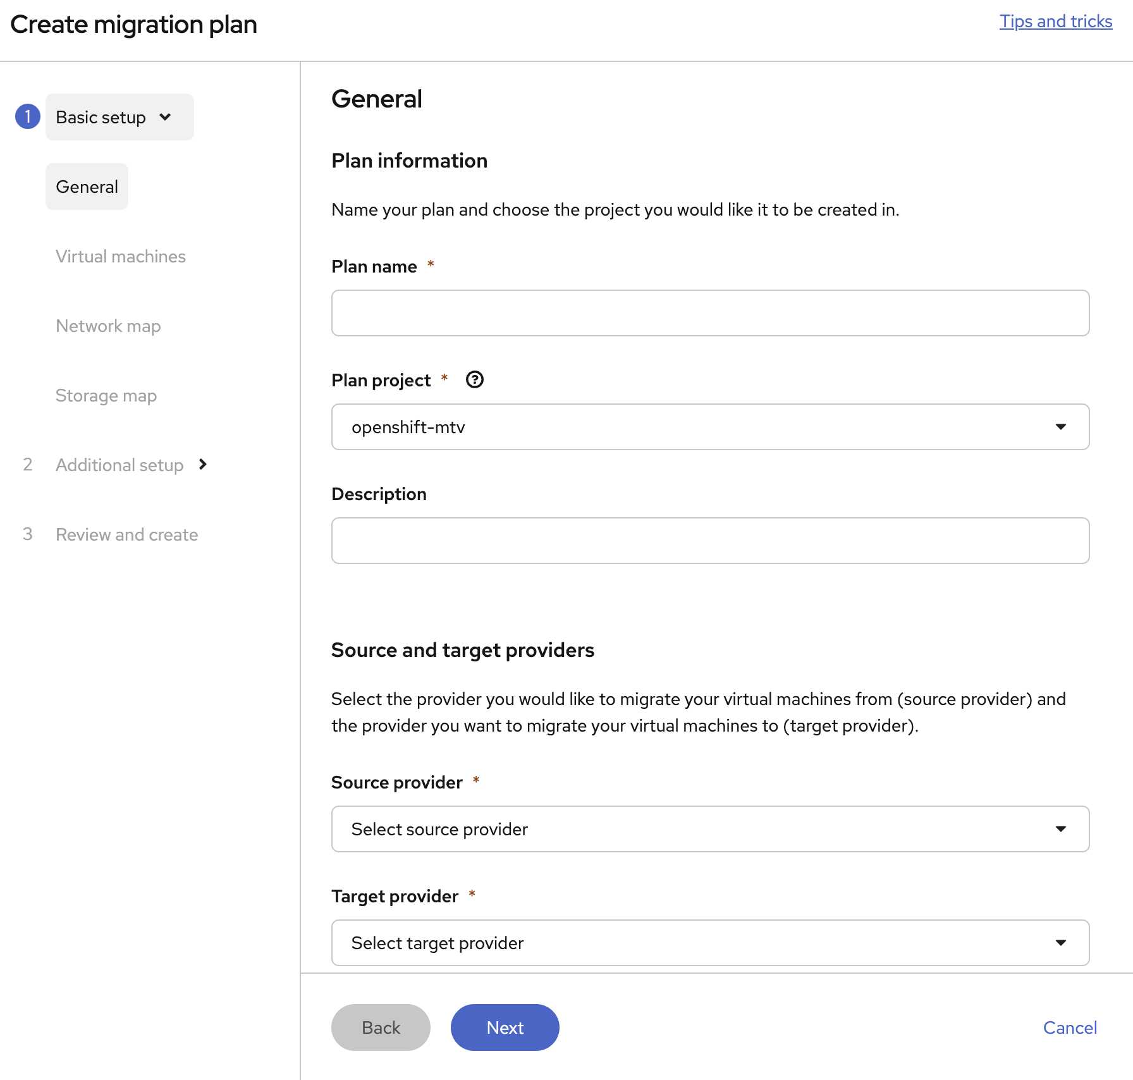
Click Next.
3. Select your project’s VM
- Expand the lab-4399 dropdown.
- Scroll to find YOUR lab number → click the check box next to your lab number.
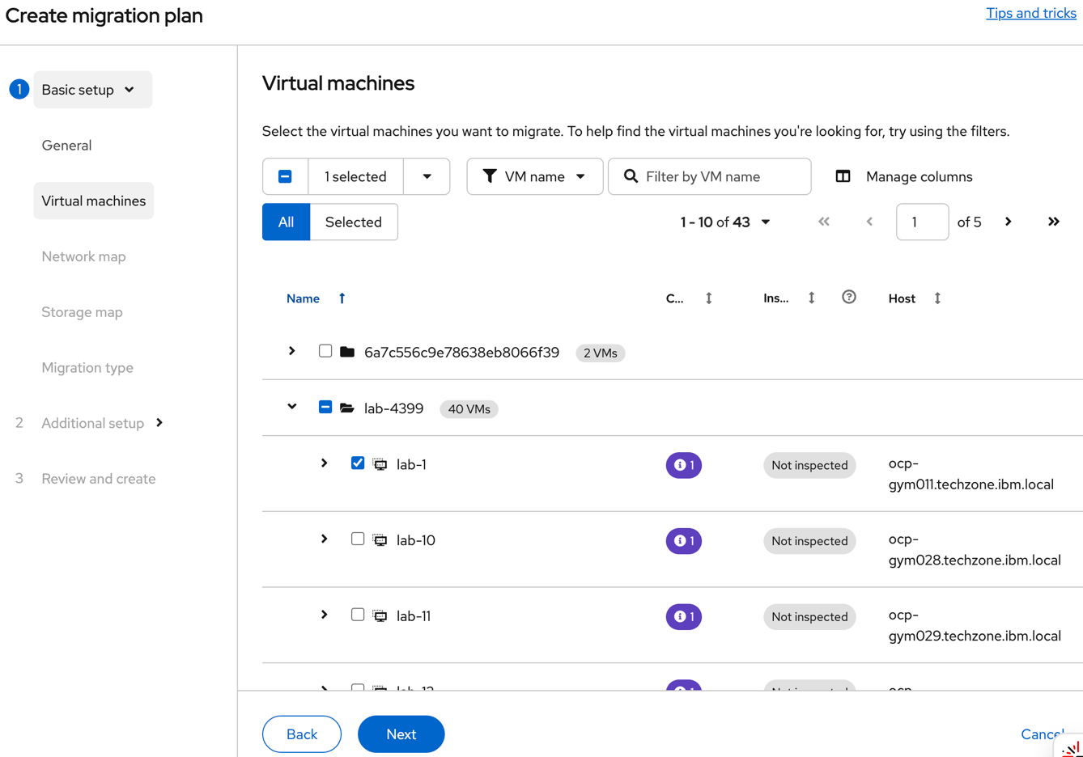

- Click Next.

- Network Map
  - Confirm “Use an existing network map” is selected.
  - From the dropdown, select your networkmap from the dropdown.
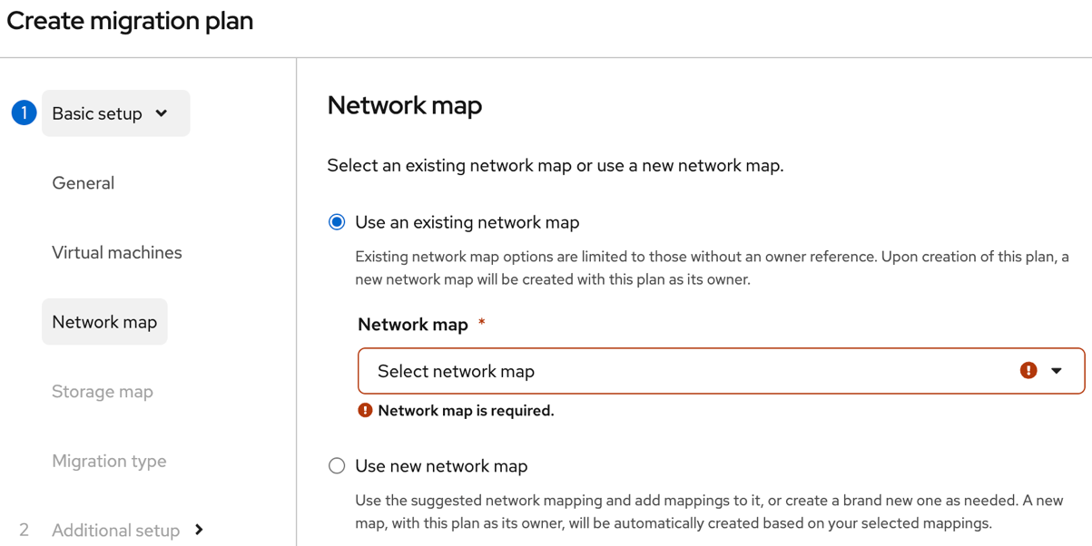
  - Click Next.

- Storage Map
  - Confirm “Use an existing storage map” is selected.
  - From the dropdown, select your storage map
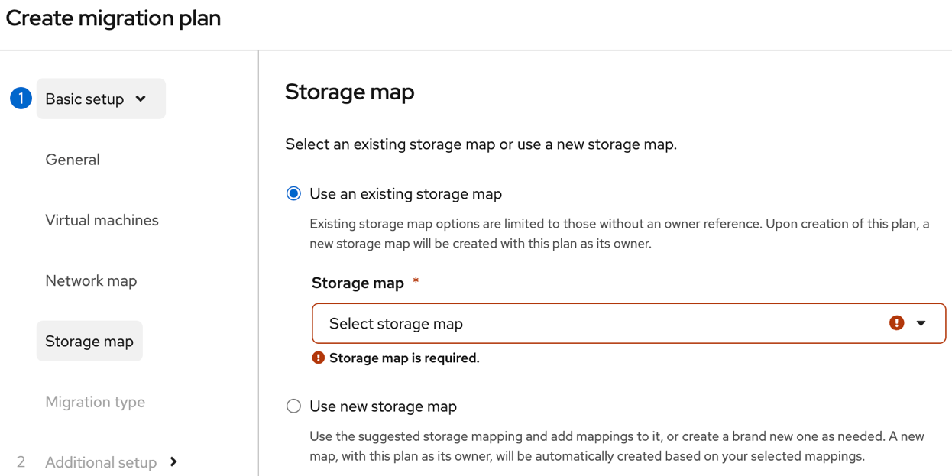
Click Next.
- Select Migration Type
  - Select Cold migration.
  - Click Next.
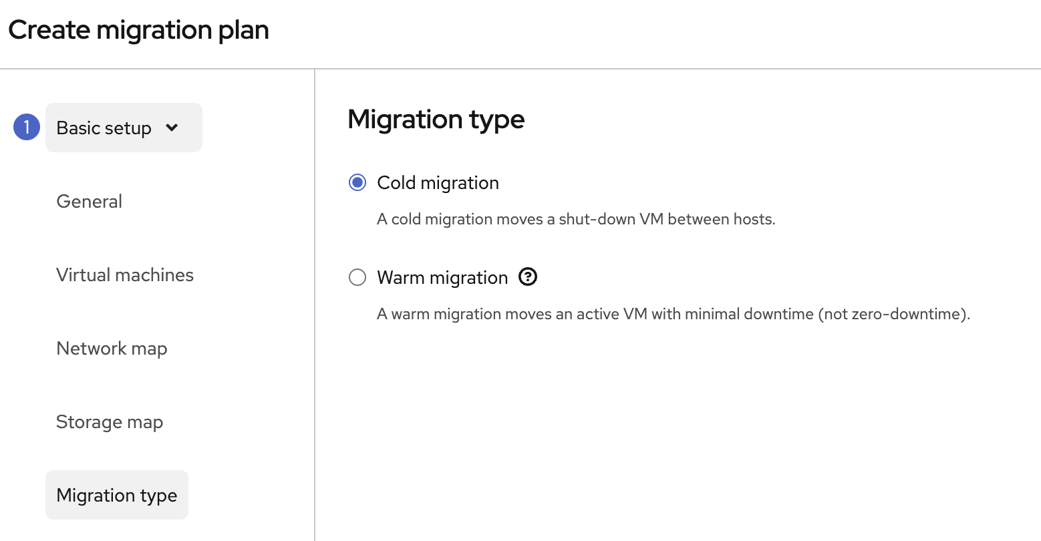

- Create Plan
  - Leave all other settings how they are.
  - Click Skip to Review.
  - Click Create plan.


- Start the Migration
  - Back on Migration plans → click the 3 dots (⋮) on your migration plan.
  - Click Start.


- Monitor the migration progress.
  - Click on the migration plan. Wait for the status to reach Completed.

Warm Migration

Access the MTV UI

Open the OpenShift web console.

In the left navigation menu, click the dropdown and navigate to Migration for Virtualization → Migration plans.

You will see your previous cold migration in the list.

Click Create plan.
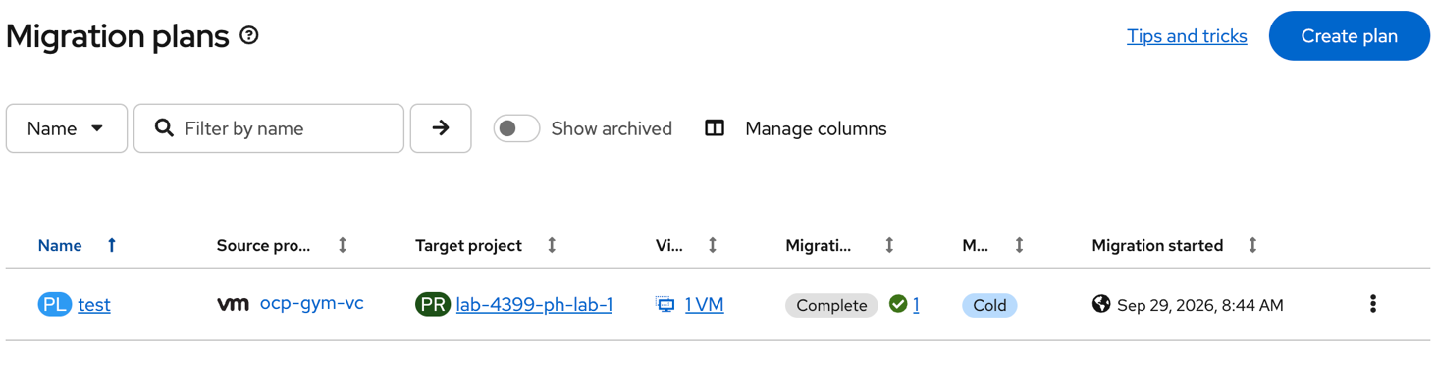

- On the General settings page, fill in the following fields:
  - Plan name: warm-migration-<initials> (e.g. warm-migration-js)
  - Plan project:
  - Source provider: vcenter-prod
  - Target provider: host
  - Target namespace: vm-<initials> (e.g. vm-js)

Click Next.
- Select the Source VM.
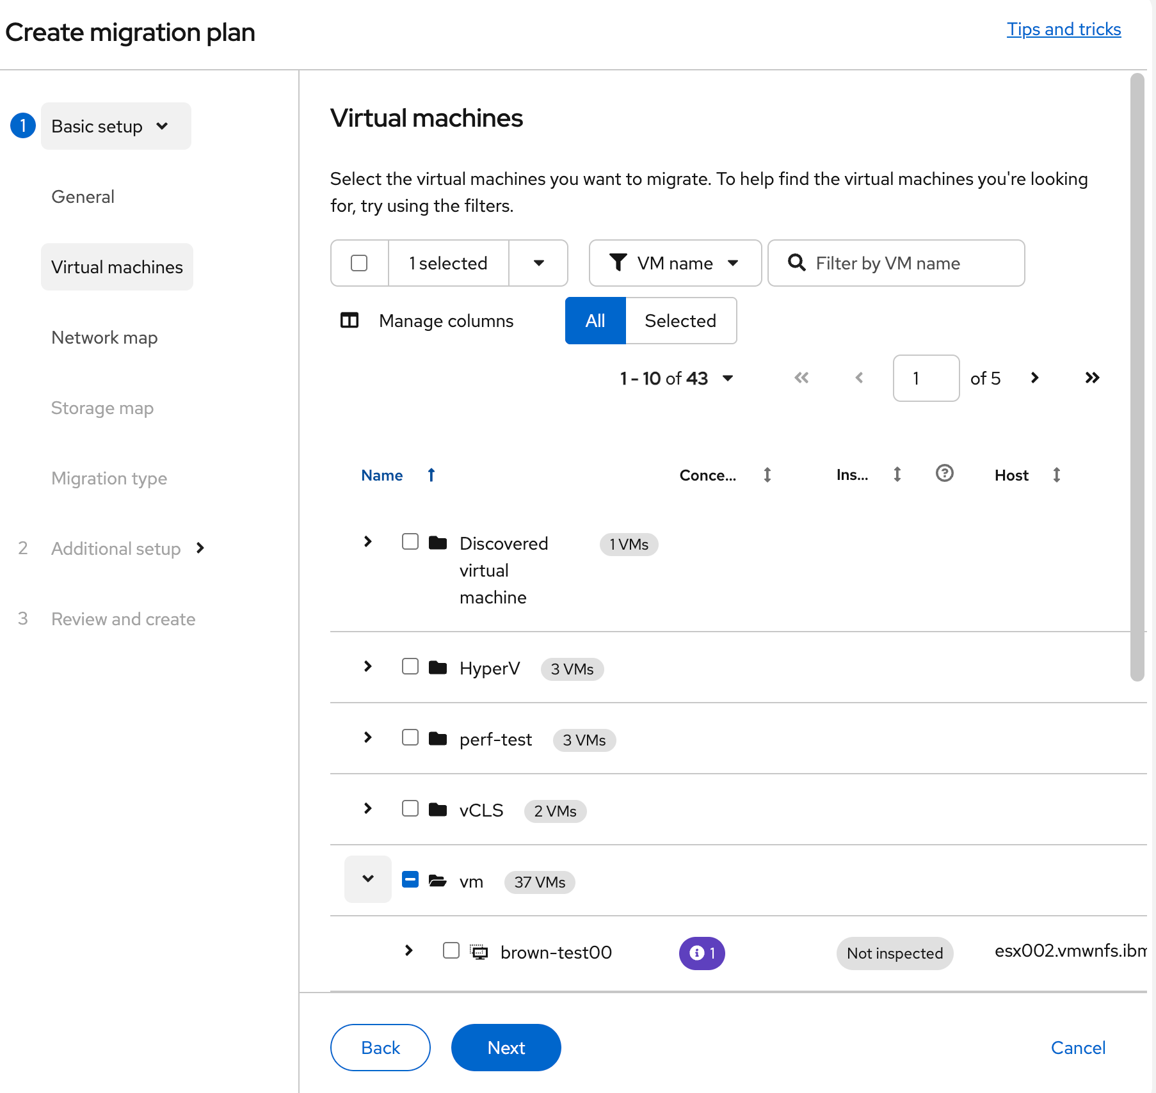

Click Next.

5. Select your Network map.

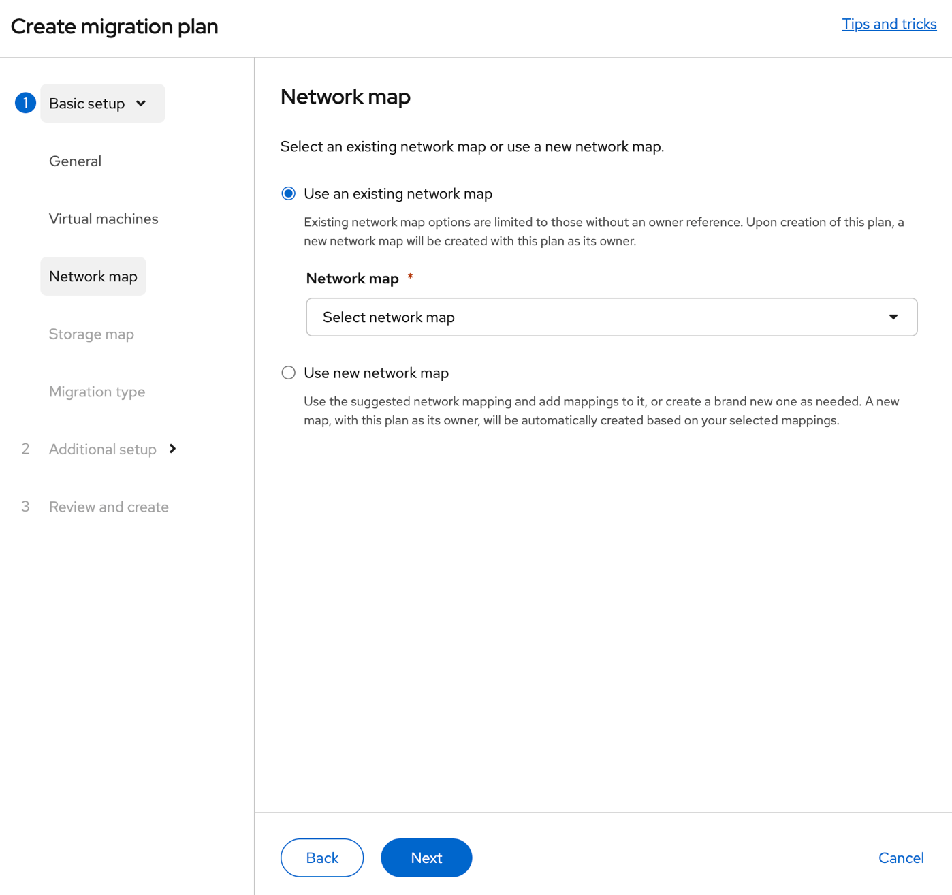

Click Next.

6. Select your Storage map.

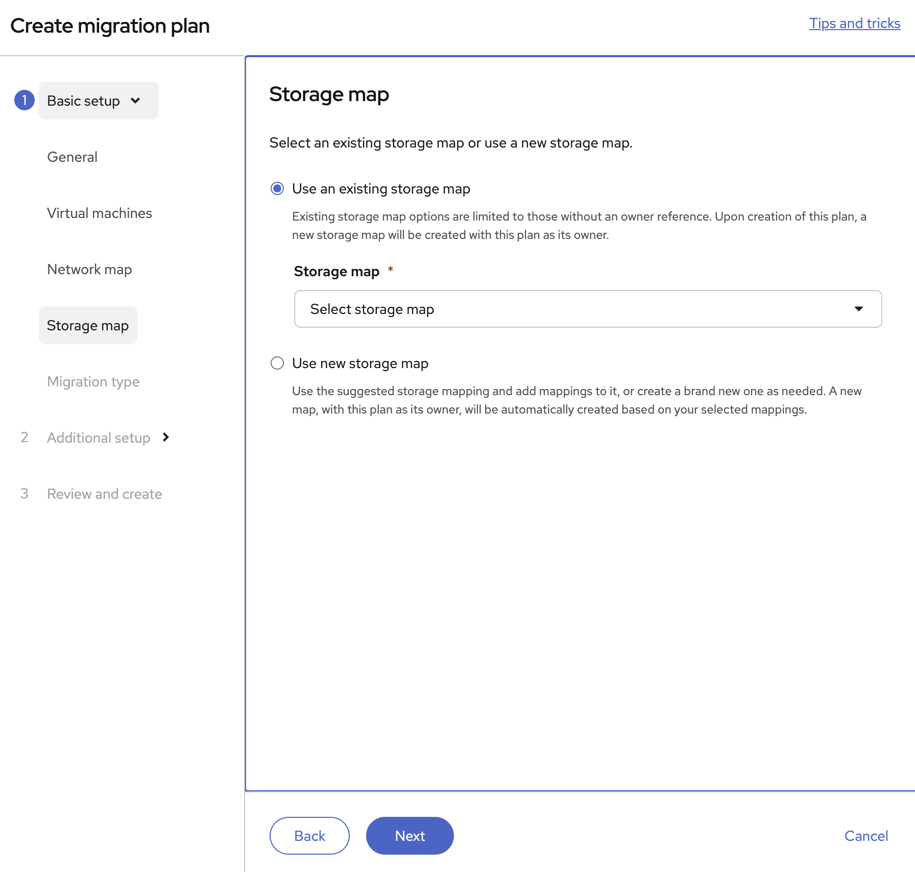

Click Next.

7. Select Warm migration.

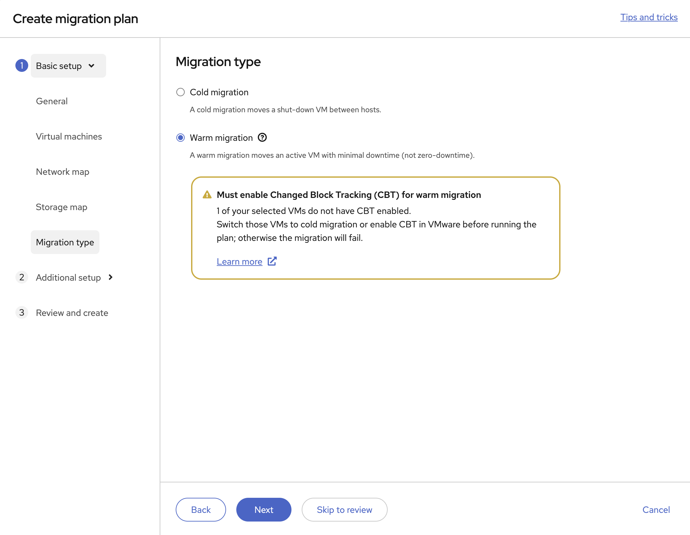

Click Skip to Review.

8. Click Create plan.
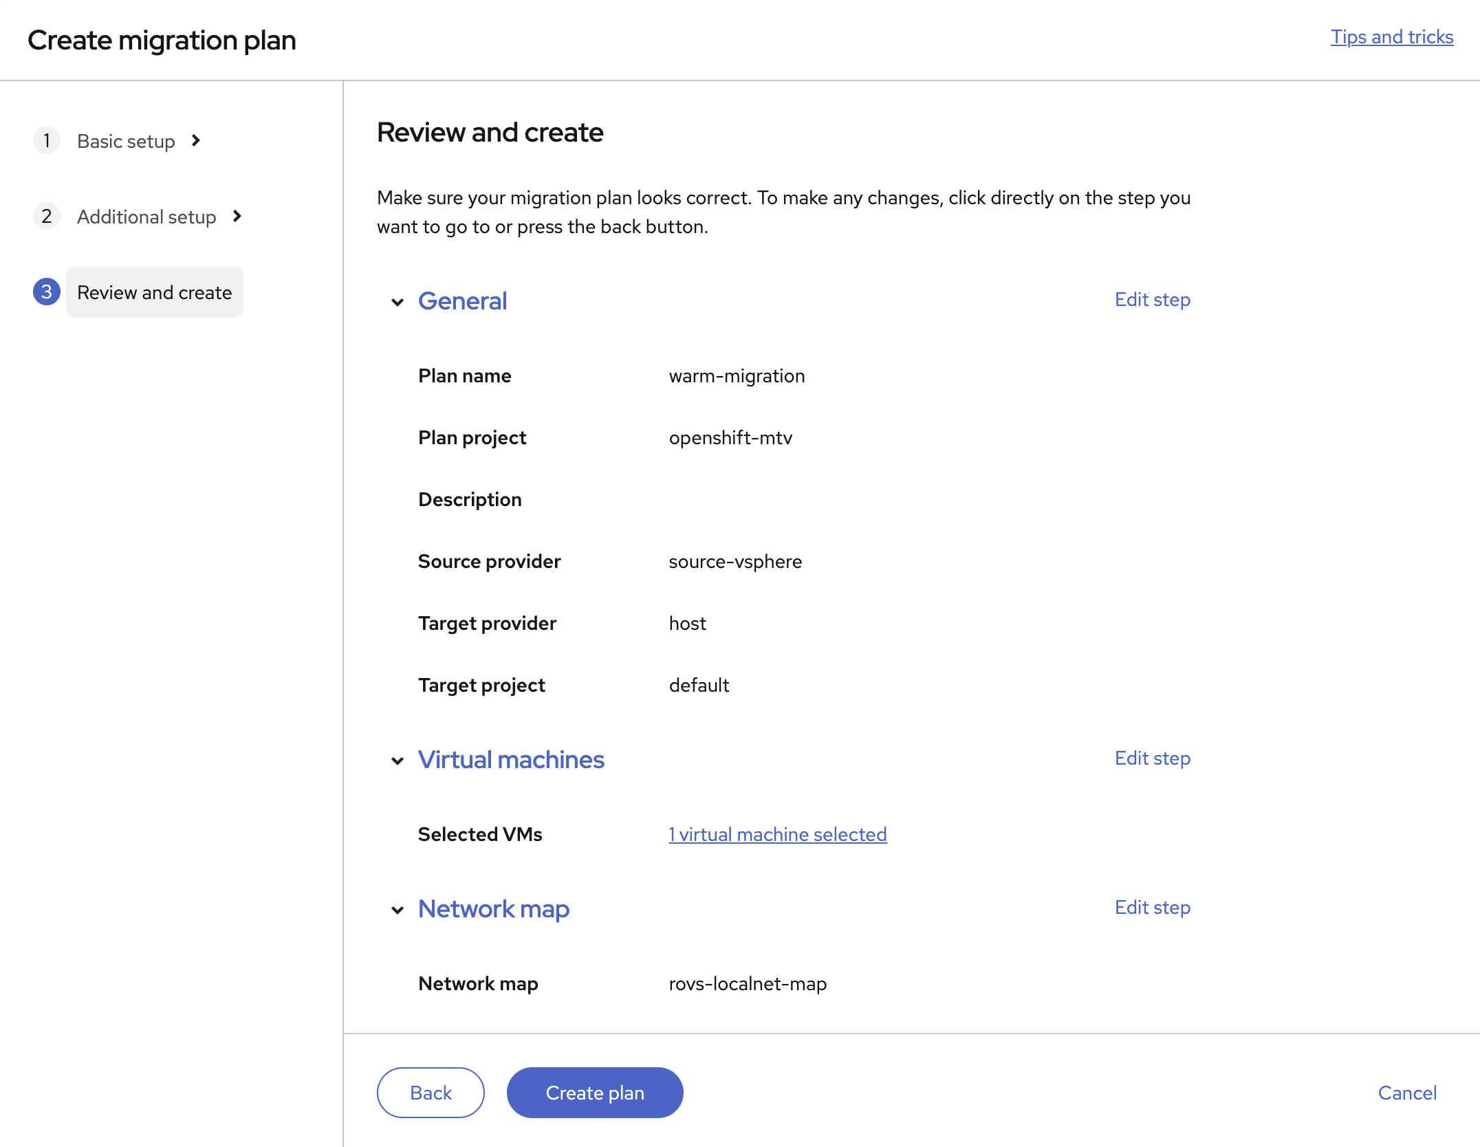

9. Start the Migration.
Back on Migration plans → click the 3 dots (⋮) on your migration plan. Click Start.

10. Monitor the migration progress.
Click on the migration plan. Wait for the status to reach Completed.

