Name: __Adam Herring, Michael Mohn, Bryan Castro

EID: __ah58665, msm5332, bc36587

Semester: Fall 2024
Course: ECE445L

A) Objectives:
- The purpose of this lab was to execute the design and implementation of the custom PCB for a Blutooth headset using both a TM4C123GH6PM and a ESP32. This project integrated two LCDs, two speakers, a 9V battery, 2 buck converters, and the many capacitors for decoupling, resistors with additional connectors for external interfacing. The overall result displayed the song title being played on both LCDs along with varying blue dots on the screen to see voltage changes in the signal being read from the ESP to the TM4C. Additionally, due to issues with the JTAG, we utilized the LaunchPad connectors to program the device. This experience provided valuable insights into the possible complexities of custom PCB design and implementation.

B) Hardware Design Deliverables:
- N/A

C) Software Design Deliverables:
- I have pushed my project to GitHub for grading (Yes/No):

- Deliverable 1: System design diagram of the modules created.
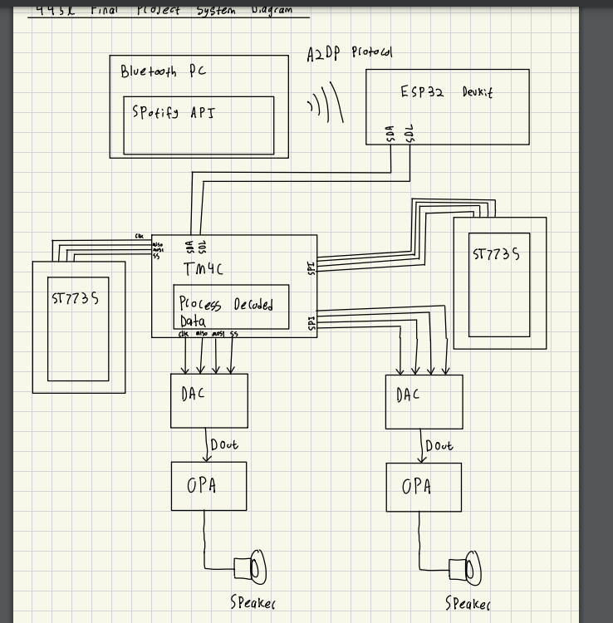

D) General Deliverables:
- Deliverable 2: Software Tests
- Verification of the software modules to include Bluetooth connectivity, audio playback through both speakers, reading the ascii characters correctly for the LCDs and overall system control worked except for the external switches because of the hardware issue present with the having to use the launchpad for flashing the program through a TM4C and this launchpad covered the buttons on the PCB.
- Generalized sound quality as a test for data communication was changed from I2C to UART between the ESP32 and TM4C because of the amount of noise present was overbearing in I2C. Both synchronizations were present but there was too much ambiguity to confirm the sound output via I2C because of the noise.

- Deliverable 3: Hardware Tests
- There were many hardware tests starting from checking if the PCB can flash a program through JTAG. When the PCB was about 90% soldered, aside from the buck converters, we were able to flash the board with no problem. However, after soldering the buck converters, we could not flash any code onto the TM4C of the PCB. After confirming proper voltage values of 3.3V and 1.2V for LDO with the converters soldered and the reset functionality, we deduced the issue of not being able to flash the board to cross talk between the JTAG ports and one of the buck converters that was close to the pins.

- We ensured all 4 test points soldered onto the PCB were functioning properly, with the main focus on ensuring the buck converters change the 9V from the external batter to be changed to 3.3V and 5V. The other two test points were on the out signal of the DACs and before the op-amps needed more testing as we encountered noise in the overall sound output.

- Deliverable 4: Power consumption
Power consumption for KICAD Lab 7 and 10

Current Drawn from IC (Look at worse case scenario)

(1) TM4C123: ~30–40 mA

(2) ST7735R: ~40 mA

(2) MCP34119P: ~120 µA (per amplifier)

(2) TLV5616: ~1 mA per amp

(1) ESP32 - DEVKITC - V4: ~160–240 mA

(1) MPM3610GQV (From 9V to 5V): ~200 µA

(1) MPM3610GQV (From 9V to 3.3V): ~200 µA

(1) LM4041CILPR: ~60–100 µA

Total Load Currents

For 5V: (~120 µA) +(~120 µA) + (~1 mA) + (~1 mA) + (~160–240 mA) = 160 to 240mA

For 3.3V: (~30–40 mA) + (~40 mA) + (~40 mA) + (~200 µA) + (~200 µA) + (~60–100 µA) = 110.46 mA to 120.5 mA,

- Deliverable 5 (10pt EC): Characterization of the system

E) Analysis and Discussion Questions:
- N/A

