

* Home
* Electricity
* Electronics
* Men's Fashion
* Women's Fashion
* Movies
* Car & Bikes
* Baby,Kids & Toys
* Home & Kitchen
* Sports
* Automotive
* Education
* Gifts
* Books
* Stationery







×

Synopsis

Cast & Crew

Sneak Peek

Register Now



In 2013, we were introduced to the terrifying universe of The Conjuring. Helmed by James Wan, inspired by real events and composed of some of the most spine-chilling effects in the history of Hollywood, the entire franchise grew into a classic presentation of horror of the most spine-chilling effects in the history of Hollywood,. This supernatural legacy continues with the next chapter in the saga- The Nun. And it marks the return of the dreadful, demonic entity Valak. First making an appearance in The Conjuring 2 (2016), the demon, in the form of a nun, had left a chilling imprint on our minds coupled with an infinite string of questions. The Nun sheds light on the whole mystery by delving into the past of an accursed abbey. So, if you have been waiting for answers about the birth of this haunting tale and about the origins of Valak, you can get them a day before the movie releases in India. Be a part of Paytm’s special screening of The Nun this September 6 and come face to face with evil before everyone else!

Crew

Cast

Directed By

Steven Spielberg



Mark Rylance



Olivia Cooke

Produced By

Steven Spielberg



Simon Pegg



T.J.Miller

Music By

Steven Spielberg



Tye Sheriden

Step Into The Oasis

   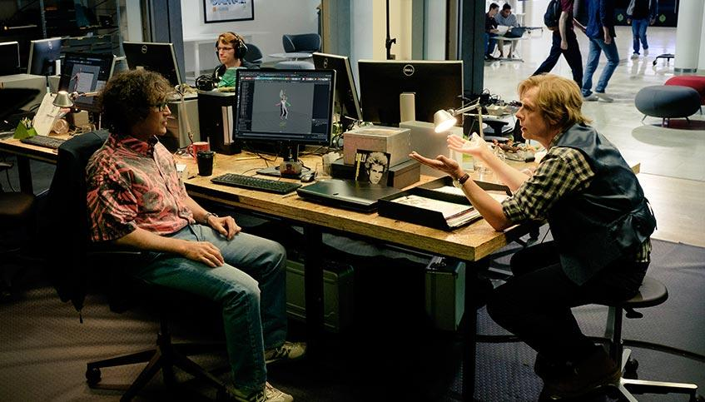 



Get ready for a thrilling sci fi extravaganza with Steven Spielberg's Ready Player One.

Register now with your details below and travel into the OASIS before the rest!

Delhi Dehradun Mumbai

Terms and conditions:

* This 'Ready Player One Exclusive Screening' is to be hosted by Paytm, a unit of One97 Communication Ltd.
* Ready Player One Exclusive Screening is restricted to the authenticated/valid members of Paytm who are residents of India, and attain the age of 18 years and above
* As a benefit under the Special Screening, the Customer will get a change to watch Ready Player One Exclusive Screening on '28th Mar, 2018' in select Cinemas
* List of Participating Cinemas
  + PVR Logix IMAX- Delhi/NCR
  + PVR Logix IMAX- Delhi/NCR
  + PVR Logix IMAX- Delhi/NCR
  + PVR Logix IMAX- Delhi/NCR
* Customer shall be intimated via phone /email as given by Participant for booking Ready Player One Exclusive Screening movie tickets.
* Registration is open on 'XX/XX/XXXX from 10:30 hours to XX/XX/XXXX, 20:00 hours'.
* Benefits/Price under the Spcial Screening cannot be assigned/transferred to others or exchanged for cash or any other benefits.
* Participation in the Campaign is purely voluntary and at the sole discretion of the participant

About Us Partner with us Terms and Conditions Blog Press Customer service Grievence policy Bug bounty

|

Disclaimer

Please do not share your Paytm Wallet password, Credit/Debit card pin, other confidential information with anyone even if he/she claims to be from

Paytm. We advice customers to completely ignore such Communications and report to us at cybercell@paytm.com. read more

 Seller

Become Seller

 Wallet

Wallet Services

Mobile Recharge

ACT Broadband | Airtel Mobile | Reliance Mobile | Jio Mobile | Vodafone Rechage | MTS Mblize| Den Boomband | NPCL Bill Payment

Mobile Recharge

ACT Broadband | Airtel Mobile | Reliance Mobile | Jio Mobile | Vodafone Rechage | MTS Mblize| Den Boomband | NPCL Bill Payment

Mobile Recharge

ACT Broadband | Airtel Mobile | Reliance Mobile | Jio Mobile | Vodafone Rechage | MTS Mblize| Den Boomband | NPCL Bill Payment

Mobile Recharge

ACT Broadband | Airtel Mobile | Reliance Mobile | Jio Mobile | Vodafone Rechage | MTS Mblize| Den Boomband | NPCL Bill Payment

Mobile Recharge

ACT Broadband | Airtel Mobile | Reliance Mobile | Jio Mobile | Vodafone Rechage | MTS Mblize| Den Boomband | NPCL Bill Payment

Mobile Recharge

ACT Broadband | Airtel Mobile | Reliance Mobile | Jio Mobile | Vodafone Rechage | MTS Mblize| Den Boomband | NPCL Bill Payment

Mobile Recharge

ACT Broadband | Airtel Mobile | Reliance Mobile | Jio Mobile | Vodafone Rechage | MTS Mblize| Den Boomband | NPCL Bill Payment

Mobile Recharge

ACT Broadband | Airtel Mobile | Reliance Mobile | Jio Mobile | Vodafone Rechage | MTS Mblize| Den Boomband | NPCL Bill Payment

Mobile Recharge

ACT Broadband | Airtel Mobile | Reliance Mobile | Jio Mobile | Vodafone Rechage | MTS Mblize| Den Boomband | NPCL Bill Payment

Mobile Recharge

ACT Broadband | Airtel Mobile | Reliance Mobile | Jio Mobile | Vodafone Rechage | MTS Mblize| Den Boomband | NPCL Bill Payment