Acknowledgements

First of all, I would like to thank my parents who support me morally, mentally and financially and my siblings for their continuous support in my studies. Without their support, I will not be able or hardly to pursue education in the field of Software Engineering at Asia Pacific University.

Other than that, I would like to express my profound sense of gratitude to my lecturer, Dr. Kalai Anand Ratnam for his priceless and invaluable guidance and advice as well as expertise in the cloud computing field that helps me to improve my cloud computing knowledge as well as dueling with the handful assignment. Without the support/recommendation from my lecturer, I would hardly complete this project on time.

Lastly, I would like to thank my fellow friends for providing valuable feedbacks/comments throughout the project which allows me to improve my idea that would allow me to maintain in the right/better thinking path.
Table of Contents
Acknowledgements 1
1.0 Introduction 3
2.0 Project Plan 4
3.0 Design 6
3.1 Design Considerations 6
3.2 Modelling 6
3.2.1 Use Case 6
3.2.2 Sequence Diagrams 7
3.2.3 Class Diagram 11
3.2.4 Sitemap 12
3.3 Cloud Architecture 13
4.0 Implementation 15
4.1 Application Development 15
4.2 Azure Publishing 17
4.2.1 Web Service 17
4.2.2 Azure Blob Storage 19
4.2.3 Azure SQL Database 19
4.3 Application Scaling 20
4.4 Testing 22
4.4.1 Unit Testing 22
4.4.2 Performance Testing 26
4.4.3 Analysis 28
4.5 Managed Database 29
5.0 Conclusion 31
6.0 References 32

1.0 Introduction
Ukraine International Airlines (UIA) is a flagship carrier and largest airline in Ukraine. It operates domestic and international passenger flights and cargo services to other region countries such as Europe, the Middle East, the United States, and Asia.
The airline is eager to expand into new markets, but problems with its website prevented it from adequately serving customers beyond Ukraine. UIA has long used technology to reduce costs, innovate, and improve customer service. It has gone to a paperless cockpit and uses sophisticated software for analyzing fuel economy. The airline decided that it once again needed to innovate its way out of its web challenges.
Ukraine International Airlines (UIA), is looking at designing and developing an Online Flight Booking System. UIA looked at both Microsoft Azure and Amazon Web Services and chose Azure. Azure was also very compatible with open source software. Thus, the UIA Online Flight Booking System will be developed and deployed on Microsoft Azure cloud platform to help the business to hold their system on the cloud instead of buying physical server. With the popularity and improvement of cloud services, it is common for business to build their system on the cloud especially for startup business.
The booking system provides UIA’s customers the function to create an account and search and book for a flight online. Since the UIA is eager to expand their business into new markets, the high availability and performance of the system are considered as the most crucial non-functional requirements. These requirements are important for user experiences as well in order to hold and retrieve customer for business.
In this project, it has included the details of the development of solution to the problem faced by UIA. These document consists of the modelling of the system architecture as well as the cloud architecture and more. Besides development, it also included some testing scenario to ensure the functionalities of the system are satisfied.

2.0 Project Plan
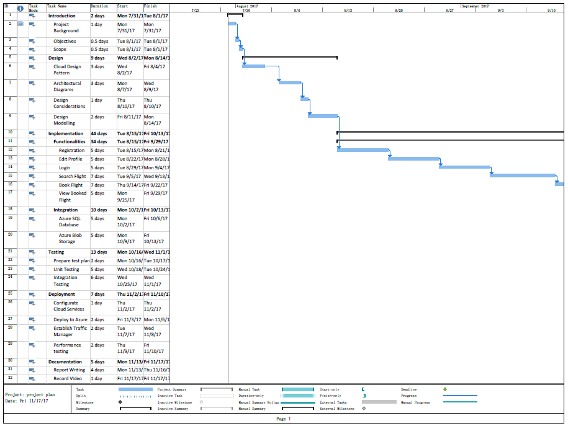
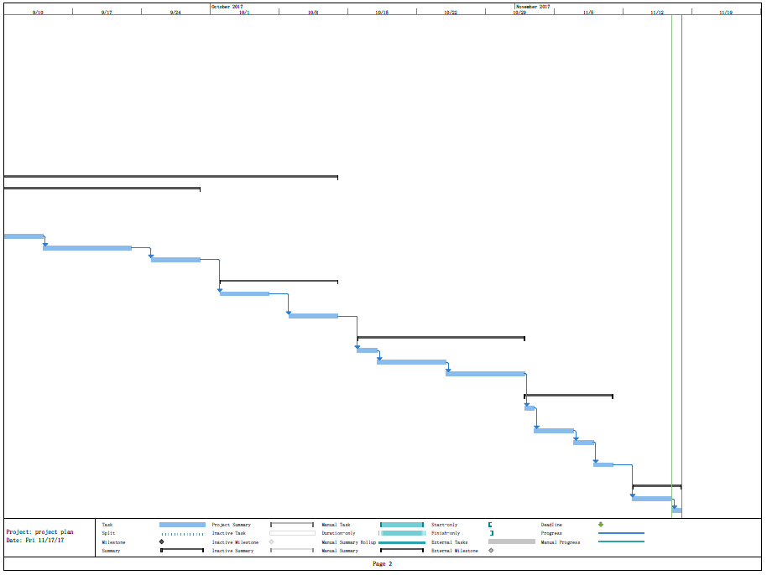

3.0 Design

3.1 Design Considerations
Several assumptions and considerations for this project have listed and detailed before for the design phase begin. As the UIA goal is to expand their business into new markets such as Europe and Asia, the system will be undergo deployment and testing in these two regions. Besides that, the development team has been received RM 150 per month of Azure credit to deploy the completed system into Azure cloud in order to proof of the concept of cloud solution. Other than that, the pricing tier for different services and in different region might charge differently. Hence, it is important for development team to wisely use the small amount of credit and plan for choosing which service tier in order for presenting the cloud architecture.

3.2 Modelling

3.2.1 Use Case
Use case diagram is used to show the functionalities available to each user. New user able to register for an account to use the system while for member can login, edit profile, search and book flight and view booked flight.

3.2.2 Sequence Diagrams
Register Account

Login

Edit Profile
View Booking
Search/Book Flight

3.2.3 Class Diagram

3.2.4 Sitemap
Sitemap above is used to show the view/page flow in the Online Flight Booking System. All users begin at the Home page no matter is member or non-member.

3.3 Cloud Architecture
Figure 1: Implemented Cloud Architecture
The diagram above shows the cloud architecture that used/implemented to the Online Flight Booking System to Azure cloud platform. The booking system has deployed into two regions which are Southeast Asia and West Europe as mentioned early that UIA is looking forward to expanding their business into these two regions. Therefore, deploying system into the targeted regions able to enhance the user experience for user in those two regions by lowering the latency time. Besides that, two blob storages have been implemented to the booking system on both regions to store images such as profile picture. This is to avoid latency of displaying images to end-user when end-user using the system in order to enhance the user-experience. A MSSQL server was provisioned to support the system to store and retrieve data from table and due to the low budgeting concern, only a MSSQL server is implemented. Above diagram shows the real implementation based on restriction on budget while the better ideal of cloud architecture has shown at below.
Figure 2: Ideal Cloud Architecture
Service Type | Region | Description | Estimated Cost (Monthly)
App Service | Southeast Asia | Standard tier (S3), 4 Core, 7GB RAM, 50GB Storage | RM1,324.32
App Service | West Europe | Standard tier (S3), 4 Core, 7GB RAM, 50GB Storage | RM1,324.32
Traffic Manager | Global | 5 million DNS queries for 2 endpoints | RM24.03
SQL Database | Southeast Asia | Standard tier (S6), 400 DTU, 250GB included Storage, 1TB Max Storage | RM1,313.55
SQL Database | West Europe | Standard tier (S6), 400 DTU, 250GB included Storage, 1TB Max Storage | RM1,313.55
Monthly Total |  |  | RM5,299.77
Annual Total |  |  | RM63,597.24
Table 1: Estimated Cost for ideal cloud architecture (Microsoft Azure, n.d.)

4.0 Implementation

4.1 Application Development
The development for the Online Flight Booking System was created by using ASP.net and MSSQL database. Besides that, this system has used MVC framework for structuring the system which consists of model, view and controller and it is also used entity framework on database in order to send and retrieve data from database. The _Layout.cshtml page provides a basic layout by presenting small part of components such as navigation bar and footer for any linked page.
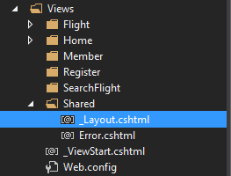
Figure 3: _Layout.cshtml
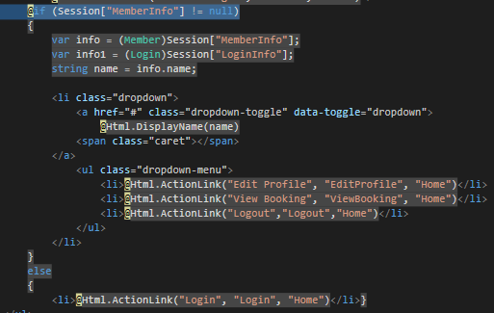
Figure 4: _Layout.cshtml
The above screenshot shows the code of generating different view for non-member and member. If the “Session[“MemberInfo”]” consists of member detail after login to the system, it will shows edit profile button, view booking button and logout button. Where else, for non-member, it will just shows login button instead to ask non-member login to use the system.
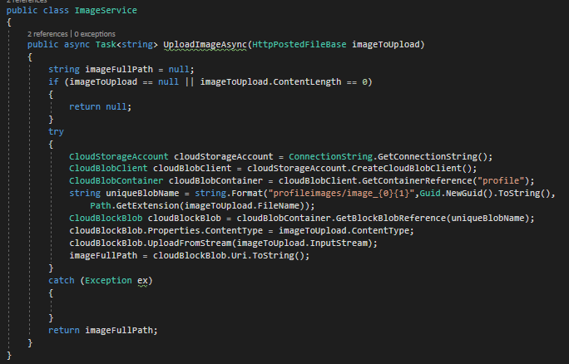
Figure 5: ImageService Controller
The above screenshot shows the code of storing images to Azure Blob Storage. When this method get triggered, it will try to get the connection string to connect to the blob storage. After that, it will looks for the container name in the storage, if the container name does not exist in the storage, it will create a new container and store the uploaded images into the container. After storing the image, it will return the url path which represent the location of image where it is stored at. This return path is important and essential when retrieving image because it leads to the direction where the image stored in order to retrieve the image to the system.

4.2 Azure Publishing
The Online Flight Booking System has integrated with several Azure services such as Azure Blob Storage, Azure SQL Database, Azure Web Service and Traffic Manager. A simple demo video can be found in the CD to enhance the understanding of how system integrate with Azure.

4.2.1 Web Service
The booking system was published manually from Visual Studio 2017. Although, it is manually publishing instead of automate, it is just requires a few click to get the system publish into Azure cloud platform. Developer just needs to right-click on the project and select “publish” and publish to Microsoft Azure App Service. After that, fill up all the necessary information, it will start publishing automatically with just a couple of minutes. The demo of publishing system to Azure App Service can be found in the CD.
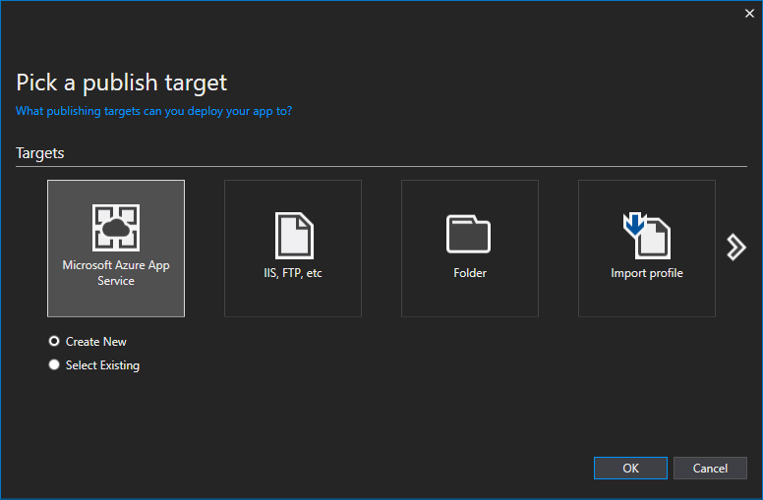
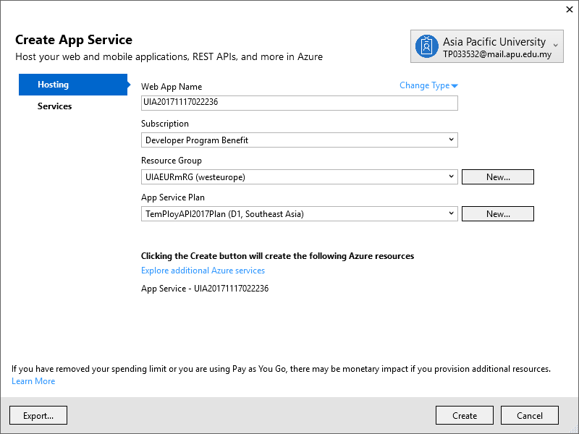
Figure 6: Publish system to Azure Web Service

4.2.2 Azure Blob Storage
The system used Azure Blob Storage to store all the member’s profile pictures. In order to connect to the storage, the storage must be created first by using Azure Storage Explorer or in Azure portal. Upon creation accomplished, developer just needs to copy and paste the storage name and storage key from Azure portal to the booking system in Web.config as shown at below figure. A simple demo of creating a storage in Azure portal has attached in the CD and the management tool to manage the storage on desktop without going through Azure portal has also been introduced.
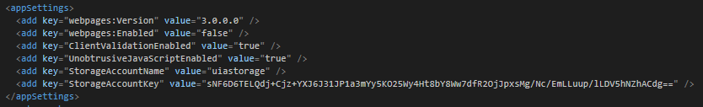
Figure 7: Connect system to Azure Blob Storage

4.2.3 Azure SQL Database
The system has integrated with Azure SQL Database to store all the information such as flight details, member details, booking details and more. SQL database must be established first by using Azure portal in order for the system to connect and utilize it. When SQL database successfully created, developers requires to acquire the database connection string and paste it in the system in Web.config as shown at below figure. A simple demo of creating a SQL database in Azure portal can be found in CD and the management tool to manage the database on desktop without going through Azure portal has also introduced.
Figure 8: Connect system to Azure SQL Database

4.3 Application Scaling
The Online Flight Booking System that has been deployed to both regions; Southeast Asian and West Europe will be using the Standard 1, S1 tier service plan to run the system. The reason of choosing a lower spec of plan is due to the budget restrictions and it is on a planning phase where the system haven’t go live yet for real end-user to utilize the system. When the system is approved by UIA and is ready to release for end-user to use, the service plan will be upgraded to S3 plan which has a better spec than S1. If the usage of the system is huge than what is expected, further upgrade the service plan to premium or increase more instances count might be necessary depends on the budget amount.
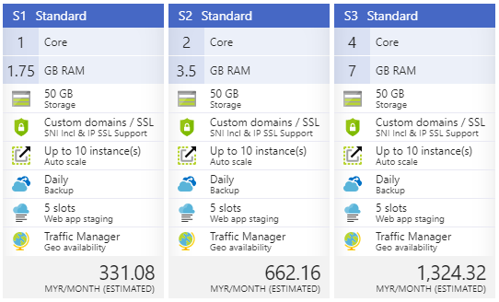
Figure 9: Web service standard plan
Both regions of system must use at least a standard level of plan or higher because there is a different between standard level plan and lower level of plan. First, it would be the supported instance count offer by standard is higher than basic level plan. These would open up more flexibility to scale up and scale out during peak and non-peak hour. The number of instances count can be automatically adjusted based on a few pre-set of metric such as performance, schedule and more (Cavale, Jr, Kemnetz, & mikegauntlett, 2017). Besides that, daily backup service also provided at standard level plan and above which is to ensure there is no data lost. Other than that, only standard level plan and above does offer traffic manager feature which allow to direct end-user to utilize the nearest region of system to reduce the latency time by using another further region of system. For instance, the system will direct user from Asia to the system that deployed at Southeast Asia while user from Europe will get directed to West Europe system.

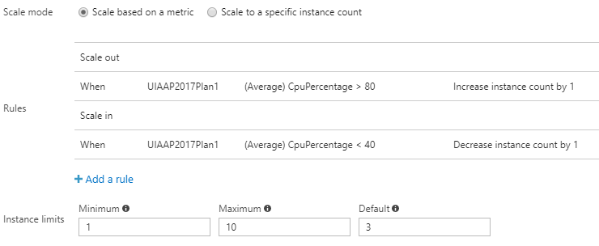Figure 10: Scale out and scale in instance
The above screenshot shows how to make use of the instance from the web service plan when the performance of the system requires to boost up for a moment and cool down when it is necessary. For the booking system, developer has set the default instance to 3 and the number of instance will increase or decrease accordingly based on the condition. The instance will be increase by 1 when the average CPU percentage is greater than 80 while it will decrease by 1 when average CPU percentage is less than 40.

4.4 Testing

4.4.1 Unit Testing
Unit testing is the first level of software testing that focus on the smallest part of unit or component of software. The intention of this testing is to make sure all unit of software is working as expected and is normally performed by software developer. Hence, every function unit from the Online Flight Booking System will be tested in order to ensure that particular block of code is working and behaving exactly as expected. Each unit will be undergo testing independently and it should only pass the test before integrate into other system/component to reduce the possibility of error occurring.
Test Case | Test Steps | Expected Result | Actual Result
Register Account | - At the home page, click on login and select register.  - Fill up all the required details.  - Click on “Register” button when finish fill up all the column. | Display successfully created account message and direct user back to login page. | As expected
Register Account | - At the home page, click on login and select register.  - Click on “Register” button when finish fill up all the column. | Display alert message to ask user to fill up the required field. | As expected

Test Case | Test Steps | Expected Result | Actual Result
Login | - At the home page, click on Login.  - Enter username and password.  - Click on “Login” when finish entering. | Direct user to home page with user’s name appear at the navigation bar when successfully login. | As expected
Login |  | Display incorrect username/password if username and password don’t match with any data in database. | As expected
Login | - At the home page, click on Login.  - Click on “Login” button without entering username and password | Display alert message to ask user to insert value into the field. | As expected

Test Case | Test Steps | Expected Result | Actual Result
Edit Profile | - After successful login, click on Edit Profile.  - Update information.  - Click “Update” button when finish updating. | Display successfully message if passed all the validation and direct user back to home page. | As expected
Edit Profile |  | Display unsuccessfully message if either one of the field didn’t pass the validation accordingly. | As expected
Edit Profile | - After successful login, click on Edit Profile.  - Remove all the information.  - Click “Update” button when finish updating. | Display alert message to ask user to insert information into required fields. | As expected

Test Case | Test Steps | Expected Result | Actual Result
Search Flight | - After successful login, click on Search Flight.  - Select desire destination and insert date and number of passenger.  - Click “Next” button to proceed. | Display targeted flight details. | As expected
Search Flight | - After successful login, click on Search Flight.  - Click “Next” button to proceed. | Display alert message to ask user to insert required information. | As expected
Search Flight | - After successful login, click on Search Flight.  - Select same depart and arrival place and insert date and number of passenger  - Click “Next” button to proceed. | Display alert message to ask user to choose different depart and arrival place. | As expected

Test Case | Test Steps | Expected Result | Actual Result
Book Flight | - After successful searching a flight, select any desire flight.  - Click on “Next” button to proceed.  - Fill up all the passenger details  - Click on “Next” button when finish filled up.  - Click on “Confirm” button to confirm the booking. | Display successfully booked message and direct user back to home page. | As expected
Book Flight | - After successful searching a flight, click on “Next” button. | Display alert message to ask user to select flight(s). | As expected
 | - After successful searching a flight, select any desire flight.  - Click on “Next” button to proceed.  - Click on “Next” button without inserting passenger details | Display alert message to ask user to fill up all the required fields. | As expected

Test Case | Test Steps | Expected Result | Actual Result
View Flight | - After successfully login to the system, click on View Flight to view the booked flight | Display all the booked flight details under the member. | As expected
View Flight |  | Display empty table if user has no booked flight yet. | As expected

4.4.2 Performance Testing
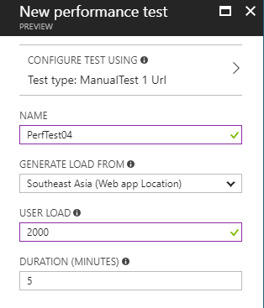
Figure 11: Performance Testing
Performance testing will be conducted at Azure portal site as it is one of the feature that provided by Azure Web Service. The test will be tested on the system under total load of 250 users up to 2000 users for five minutes. The user load will be increased double for every test starting from 250. After a couple of minutes, the result will be generated which consists of average response time, request per second and number of failed request. This testing will be conducted on system with Standard 1, S1 service plan. The average response time will be recorded as well as the number of failed request for every single test. The below figure shows an example of how the performance metrics present the output of testing and the table below shows the satisfice of performance testing for five minutes based on S1 service plan.
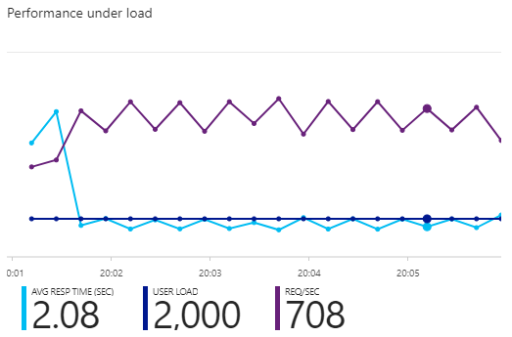
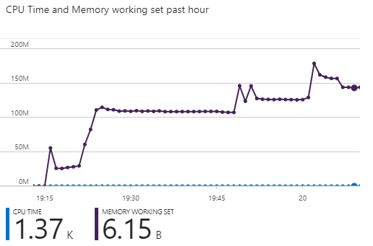
Figure 12: Performance Testing Metrics
Load Users  Service  Plan | 250 | 500 | 1000 | 2000
Standard 1, S1 | 0.04  0 Failed Request  243.7 Req/Sec | 0.11  0 Failed Request  456.13 Req/Sec | 0.5  0 Failed Request  705.04 Req/Sec | 2.08  0 Failed Request  708 Req/Sec
Table 2: Result of performance testing

4.4.3 Analysis
Unit testing is to insure every single unit/component is working as expected/designed by using test plan as a guideline. Test plan is often used by quality assurance to keep track all the functionalities and recorded down the actual output. If the actual output is different with the expected output, changes might need to carry out if necessary. Based on the above test plan in unit testing section, it has recorded down all the test case and testing procedure together with the actual and expected result. By looking on that, reviewer able to know what kind of testing procedure/scenario has missed out and which test case has pass or fail. Test plan helps the quality assurance teams to ease their job by allowing them to review it before they start to perform their job.
As for performance testing, it is conducted in Azure portal with the help of the feature that provided by the Web Service. Performance testing is used to test the performance of the system by simulating certain number of users to use the system at the same time and how much request the system able to process under the stressing situation. If the system no able to handle large a number of user in a short duration, several request will be failed and in result, it will reduce the user experience and eventually users would more likely to use a better performance system. Therefore, analyzing a sample data is important and essential in order to keep the budget as low as possible and provide a great performance system for users. Based on the data above in performance testing section, it shows that a standard service plan had undergo performance testing with total user load of 250, 500, 1000 and 2000 within five minutes. Based on the obtained data, we can notice that the average response time of 1000 to 2000 has increased dramatically. Hence, it can assumes that handling 2000 users for 5 minutes is almost reach the bottleneck of the system performance. Although, assuming 2000 users is the maximum performance, the system still does not consists of any failed request. Thus, we can further assume again, the system able to go live for public use with the current plan until the business has truly and successfully expanded their business in the market.

4.5 Managed Database
With the increasing popularity and usage of cloud platform, several companies trying to migrate the local server to cloud server in order to reduce expenditure on upgrading the hardware and maintenance the server. Hence, this technology has attracted a lot of attention from startup company where costing is crucial for the business. The ideal of platform as a service (PaaS) has become more valuable to the market as it provides the benefits of adding development capabilities without adding additional staff. Platform as a Service components able to support the development team new capabilities without adding staffs who having the required skills (MIcrosoft Azure, n.d.).
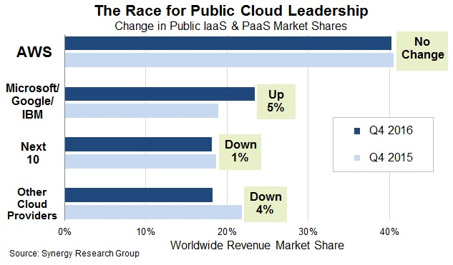
Figure 13: Change in Public IaaS & PaaS Market Shares (Synergy Research Group, 2017)
Based on the above statistic, it shows that international company such as Amazon, Microsoft, Google and IBM are the leading company in the cloud computing where services offered are becoming more accessible with a wide range of features for developer to integrate into system.
The booking system has integrated with a standard level plan of SQL database where it has 20 Database Transaction Unit (DTU) and 250GB of storage. Microsoft guarantees a certain level of resources for that database and providing a predictable level of performance for a single Azure SQL database at a specific performance level within a service tier. This amount of resources is calculated as a number of DTU, and is a blended measure of CPU, memory, data and transaction log I/O (Rabeler & Kerkhove, 2017).
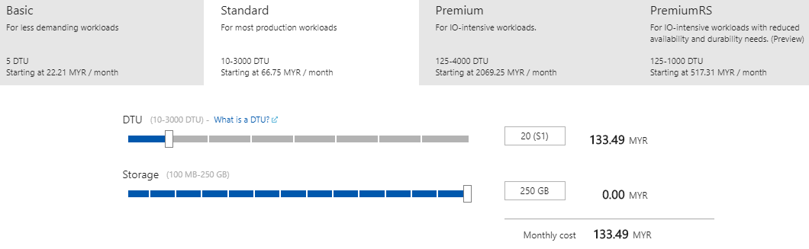
Figure 14: SQL Database service plan
The reason of choosing standard level plan for SQL database instead of basic level plan is because of basic level plan only has a fixed number of 5 DTU and maximum of 2GB storage for the database. By looking at the spec of basic level plan, it is obvious that basic level plan only more suitable for a very small business or maybe just for a simply testing. Thus, Standard 1, S1 plan has been chosen and used due to the budget restriction. After ensuring the overall of the system is running as expected and is ready to go live for public, the service plan will be upgrade to S6 as mentioned at5. the ideal cloud architecture at above section. If the usage of system is unexpected high, increase the DTU able to boost the performance of database and for standard level plan, it allows to increase up to maximum of 3,000 DTU.

5.0 Conclusion
In conclusion, the development of the whole project for Ukraine International Airline is challenging as the development team has to concern regarding to the system architecture as well as the cloud architecture in order to enhance the efficiency of the developed system. In other words, this entire project is not like a normal project where usually only focus on system architecture but also need to take into account about to fit the booking system into cloud platform. By accomplishing this project, it provides new skills and refine our relevant skills which would be benefits to the modern technology industry. Besides that, the concept of cloud platform such as cloud design patterns, cloud resources provisioning and things to be considerate to design a cloud architecture have become much clearer. A clearer understanding of cloud computing through the use of Azure has also been obtained throughout the project as well as the important of cloud platform in future technology. Hence, this project has open up my mind and changed my perspective towards the cloud computing and looking forward to knowing more regard to the cloud computing as well as working on cloud computing in future.

6.0 References
Cavale, A., Jr, R. B., Kemnetz, J., & mikegauntlett. (2017, June 6). Microsoft Azure. Retrieved from Scale instance count manually or automatically: https://docs.microsoft.com/en-us/azure/monitoring-and-diagnostics/insights-how-to-scale#scaling-based-on-a-pre-set-metric
Microsoft Azure. (n.d.). Retrieved from Azure pricing: https://azure.microsoft.com/en-us/pricing/
MIcrosoft Azure. (n.d.). Retrieved from What is PaaS?: https://azure.microsoft.com/en-us/overview/what-is-paas/
Rabeler, C., & Kerkhove, T. (2017, April 17). Microsoft Azure. Retrieved from Database Transaction Units (DTUs) and elastic Database Transaction Units (eDTUs): https://docs.microsoft.com/en-gb/azure/sql-database/sql-database-what-is-a-dtu
Synergy Research Group. (2017, February 2). Retrieved from Microsoft, Google and IBM Public Cloud Surge is at Expense of Smaller Providers: https://www.srgresearch.com/articles/microsoft-google-and-ibm-charge-public-cloud-expense-smaller-providers

