**Diabetes Registry**

**User Manual**

Version 2

March 16, 2017

Table of Contents

1.0 Introduction 3

1.1 Overview 3

1.2 Purpose 3

2.0 System Functions 4

2.1 User Sign In 4

2.2 Password Reset Request 6

2.3 Add New Patients 7

2.4 Update Patients 8

2.5 Data Entry 9

2.6 Patient Treatment Entry 10

2.7 Quality Checklist 11

2.8 Progress Note 12

2.9 Patient History 14

2.10 Call Lists 16

2.11 Clinic Statistics 17

3.0 Important Notes 18

3.1 Signing Out 18

3.2 Security Practices 18

3.3 Troubleshooting 18

# 1.0 Introduction

## 1.1 Overview

The Diabetes Registry is a database-centered electronic system to allow healthcare providers an efficient way to store and track information on patients with metabolic disease. Using this registry, providers are able to add and update patient demographic information in the database, enter patient prescription and medication information, and record laboratory measurements, quality activities, and progress notes. The program also allows for the retrieval of information in the form of longitudinal charts, clinic population statistics, and call list reminders.

## 1.2 Purpose

The purpose of this manual is to guide healthcare providers through the various functionalities that the registry provides. The topics covered include signing into the system, adding patients to the database, updating patient demographic information, entering patient lab measurements, entering quality checklist activities, entering patient treatment information, retrieving patient histories, using the progress note, and retrieving call lists.

# 2.0 System Functions

## 2.1 User Sign In

New users must be added to the system by the administrator. Sign-in credentials will be produced and distributed to the new users by the administrator.

To sign in, navigate to the Diabetes Registry by opening a web browser and pointing the browser to the URL where it is deployed. If it is running on a local machine, the URL will be: <http://localhost:8080/diabetesregistry>.

The sign-in page will be visible.

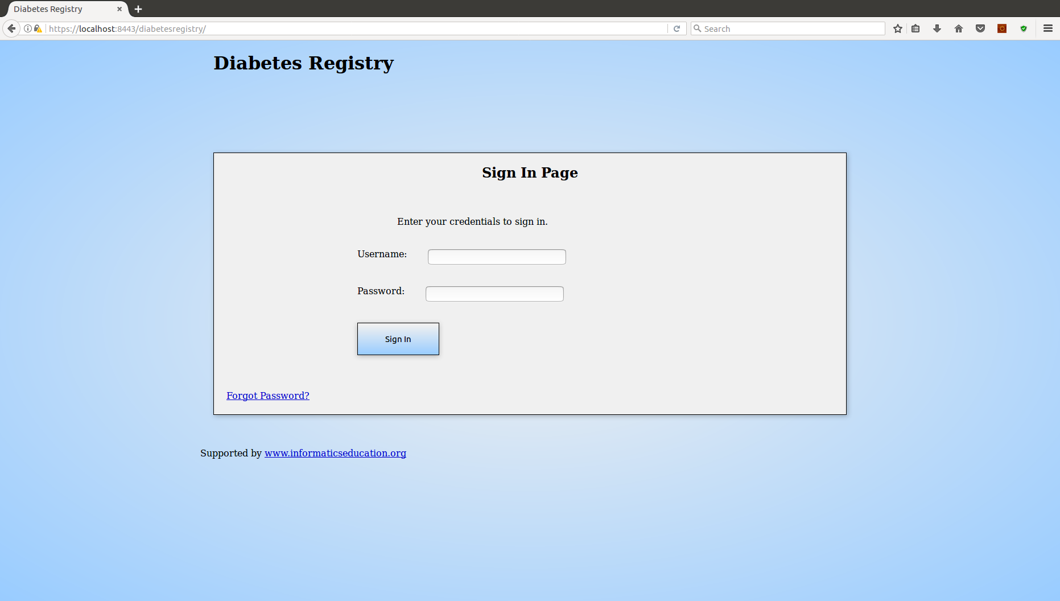

Figure 1 Sign-In Screen

Sign into the system by entering the username and password into the sign-in form, then selecting the “Sign In” button. On successful sign in, the welcome page will appear. Click on the “Proceed to Registry” button to find the home page of the application.

A new user is required to create a new password after signing in with the temporary password given by the administrator. The password must contain at least one lower-case letter, at least one upper-case letter, at least one number, at least one special character, must contain no spaces, and must have between 10 and 20 characters inclusive.

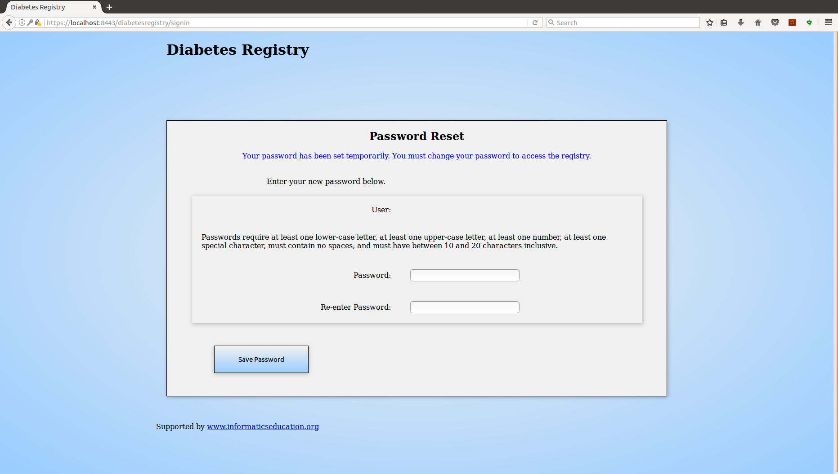

Figure 2 Update Password

When the password is updated successfully, a message indicating success will be visible in the sign-in page.

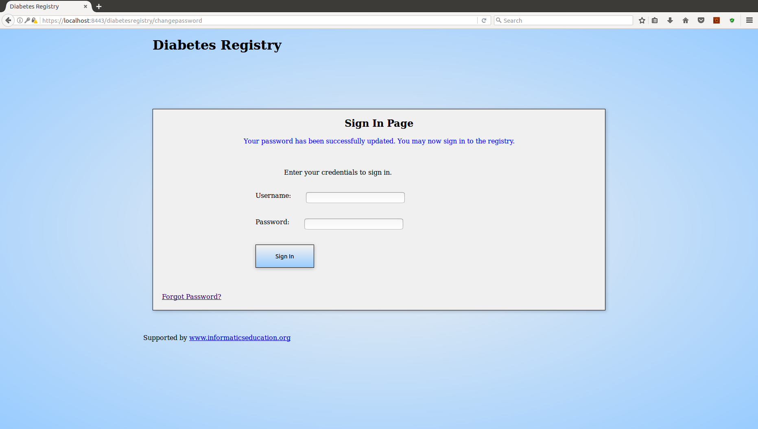

Figure 3 Password Successfully Updated

## 2.2 Password Reset Request

In the case of a forgotten password, click on the “Forgot Password?” link to log a request to the administrator to allow a password reset. When approved, the administrator will produce a temporary password which can be used to sign in and create a new password.

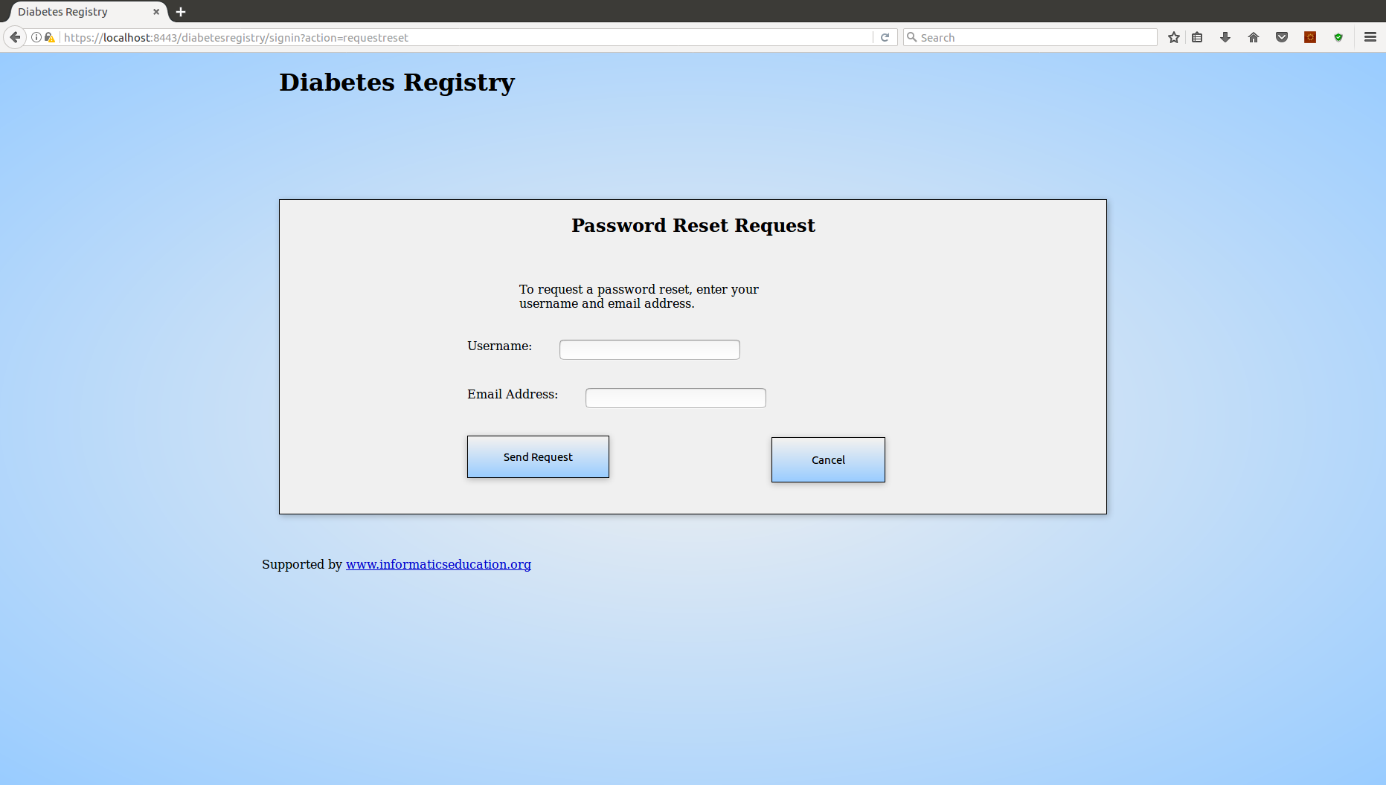

Figure 4 Password Reset Request

## 2.3 Add New Patients

To add a new patient to the database, navigate to the new-patient page by selecting the “New Patient” button in the navigation menu.

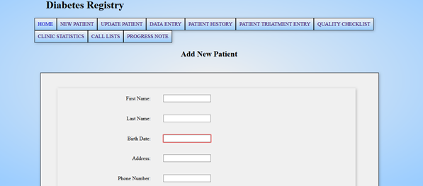

Figure 5 New Patient

First name, last name, birth date, gender, race, and start date are required form fields. When the form is filled with the new patient information, click “Add Patient” below the form to add the patient to the database. When the patient has been added successfully, the message, “Patient was added successfully!” will appear at the top of the page.

## 2.4 Update Patients

If existing information must be changed or new information must be added for an existing patient, navigate to the update-patient page by selecting the “Update Patient” button in the navigation menu. A drop-down selection to select the appropriate patient is visible on the page. When the patient is selected, an update form will appear.

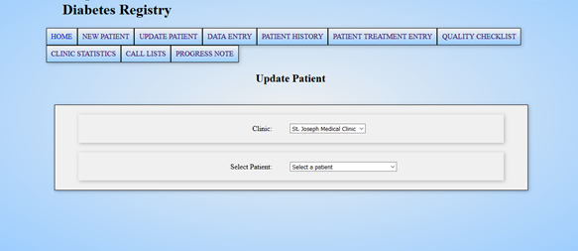

Figure 6 Update Patient

Add or modify the information in the patient’s form and click the “Update Patient” button below the form to update the patient’s demographic information. When complete, a message indicating success will appear if the patient was updated, otherwise, an error message will appear if the operation failed.

## 2.5 Data Entry

The data-entry page is used for saving lab measurements, telephone follow-up status, vaccination dates, and topic-specific notes. To enter data for a patient, navigate to the data-entry page by selecting the “Data Entry” button in the navigation menu. Use the drop-down selection to select the appropriate patient for data entry.

In the data-entry form, there are input fields for laboratory values, telephone follow-up status, vaccination dates, and notes. The date must be entered in the date-of-results field at the top of the form to successfully save the information. When the form is complete, select the “Save Data” button at the top of the form to save the data. A message indicating success will appear at the top of the page when the operation is complete.

If a data submission is incomplete or incorrect, simply enter the missing or corrected values into the form and save the data with the date of results used previously. It is not necessary to refill the entire data-entry form for corrections or missing values.

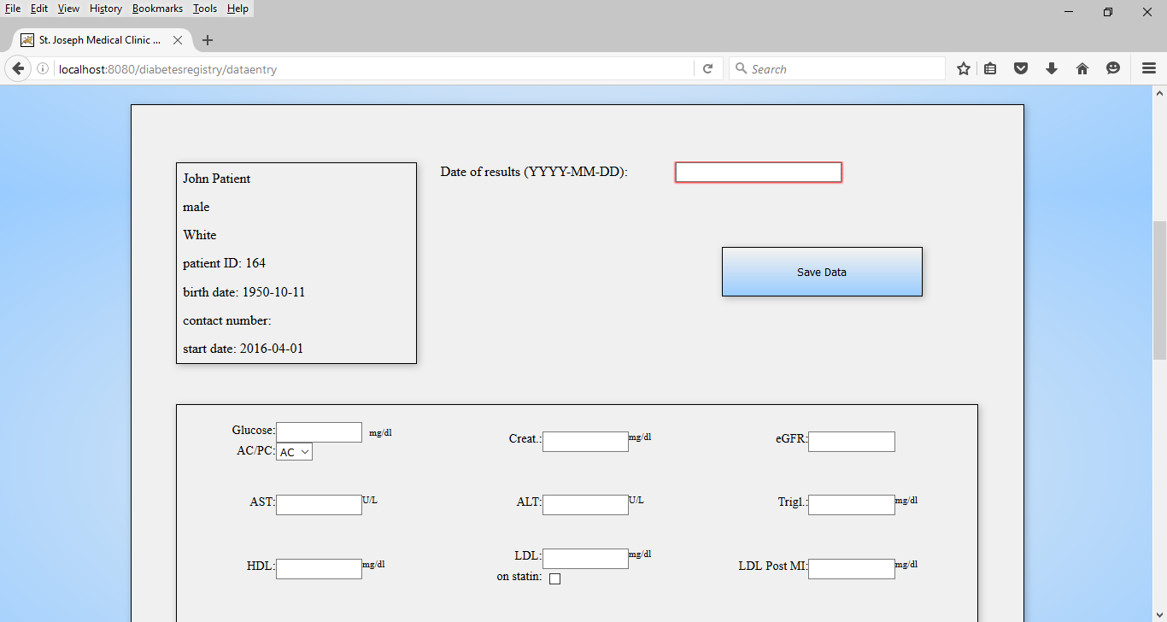

Figure 7 Data Entry Form

## 2.6 Patient Treatment Entry

To save a patient’s prescription class and current medications, navigate to the treatment page by selecting “Patient Treatment Entry” in the navigation menu and select the appropriate patient from the drop-down selection. The treatment form allows a user to select a single prescription class and multiple medications. When the selections are made, enter the date reviewed at the top of the form and select the “Save Treatment” button to save the information to the database. New entries made on the same date for the same patient can add information to the saved treatment, but will not erase previous entries.

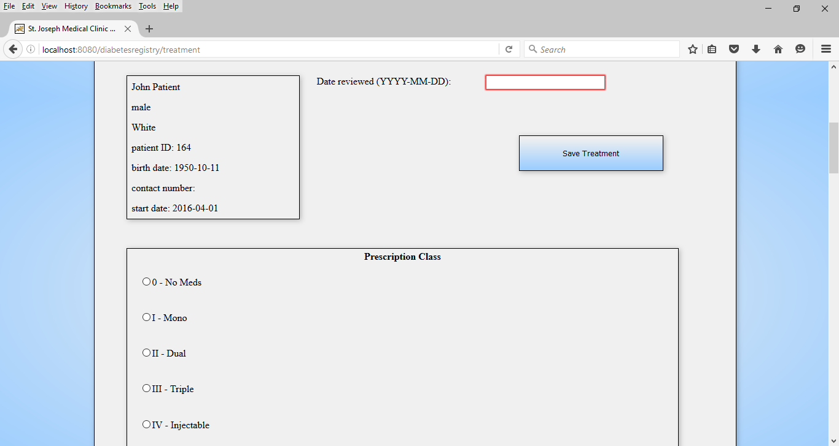

Figure 8 Patient Treatment Entry

## 2.7 Quality Checklist

The quality checklist is utilized to record completed tasks performed in the course of a patient’s care. The checklist items are grouped into time-specific categories such as pre-appointment, during visit, after visit, and once a year. To save quality checklist items that have been performed for a patient, navigate to the quality checklist by selecting “Quality Checklist” in the navigation menu and select the appropriate patient from the drop-down selection. Once items have been selected, enter the date of results at the top of the form and select “Save Checklist” to save the items.

If additional items need to be saved on the same date for the same patient, simply select the additional items and save the information using the date of results used previously. It is not necessary to re-enter items previously saved for the same date and same patient. Like the treatment entry function, items can be added, but not erased.

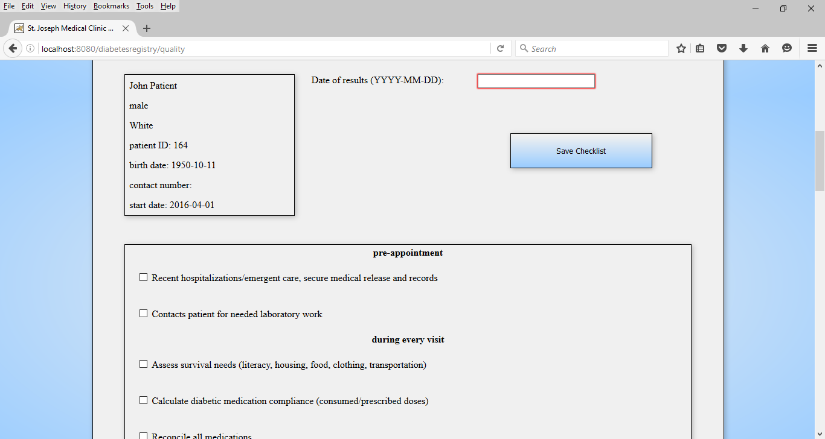

Figure 9 Quality Checklist

## 2.8 Progress Note

The progress note is a form where healthcare providers can describe the patient’s condition, treatment, and goals. Access the progress note by selecting “Progress Note” in the navigation menu. After selecting the appropriate patient from the drop-down selection, the option to create a new note or update an existing note will appear. Create a new note by entering a date in the input field labeled “Date of new note”, and then select the “Start New Note” button. To retrieve a previous note, select a date from the drop-down selection labeled “Select previous note”.

The progress note form contains the following input fields:

* allergies
* medications
* medical insurance status
* shoe size
* weight
* height
* body mass index
* weight reduction goal
* waist circumference
* blood pressure
* pulse
* respirations
* temperature
* foot screening status
* average weekly fasting glucose
* A1C recorded at the clinic
* eye screening result
* foot screening result
* psychological screening result
* date of class attendance
* date of hospitalization
* smoking status
* patient-reported compliance
* physical activity
* nurse/dietitian note
* subjective section
* objective section
* assessment section
* plan section

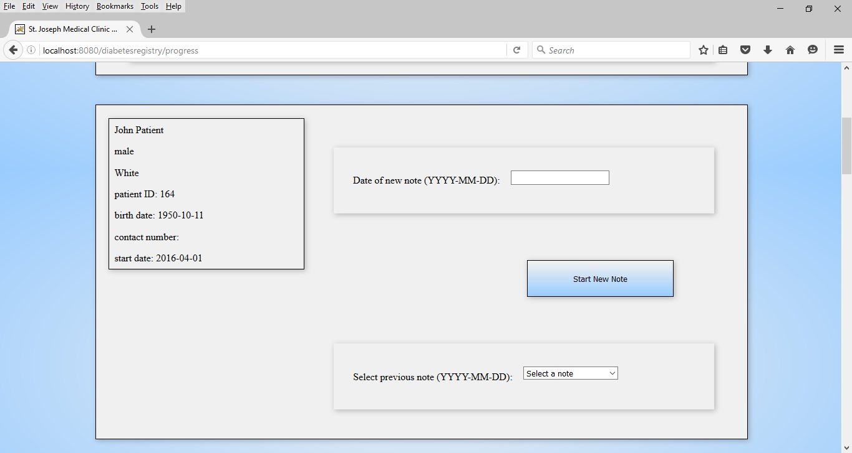

Figure 10 Start New Note

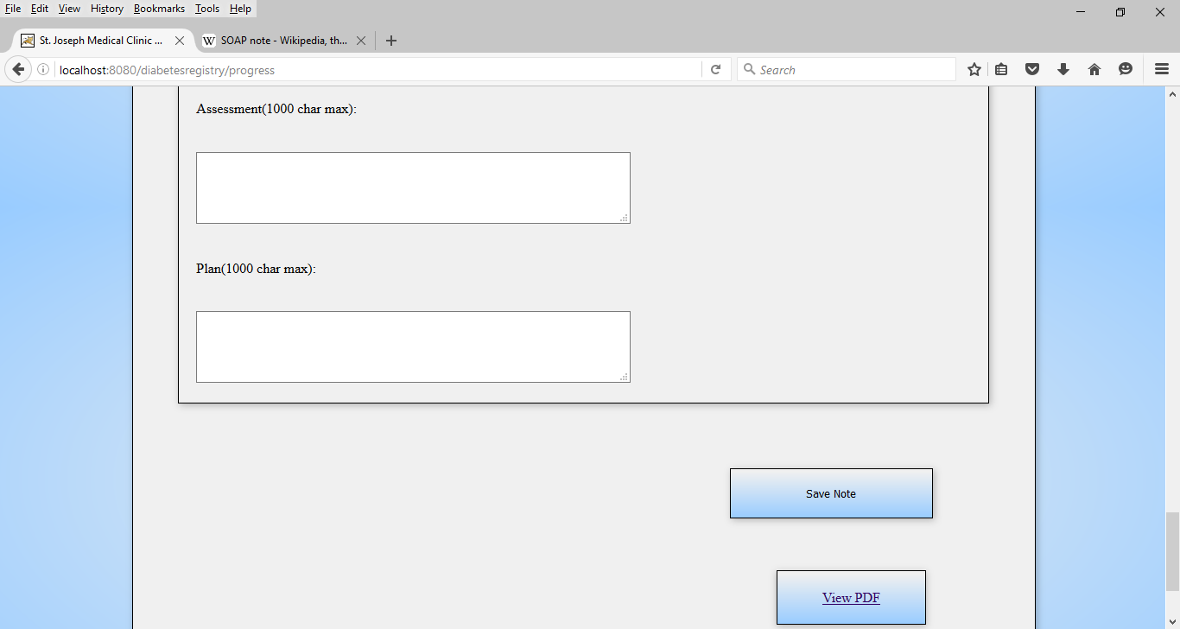

Figure 11 Save/View Progress Note

To save or update the progress note, select the “Save Note” button at the bottom of the form. To view a printable version of the note as a PDF file, select the “View PDF” button. New information in the note must be saved before it is viewable in PDF form.

## 2.9 Patient History

The history page provides functions for viewing previously saved information on individual patients. Find the patient history page by selecting the “Patient History” button in the navigation menu. Select the appropriate patient from the drop-down selection to view the patient dashboard, which shows the most recent data entered for the selected patient.

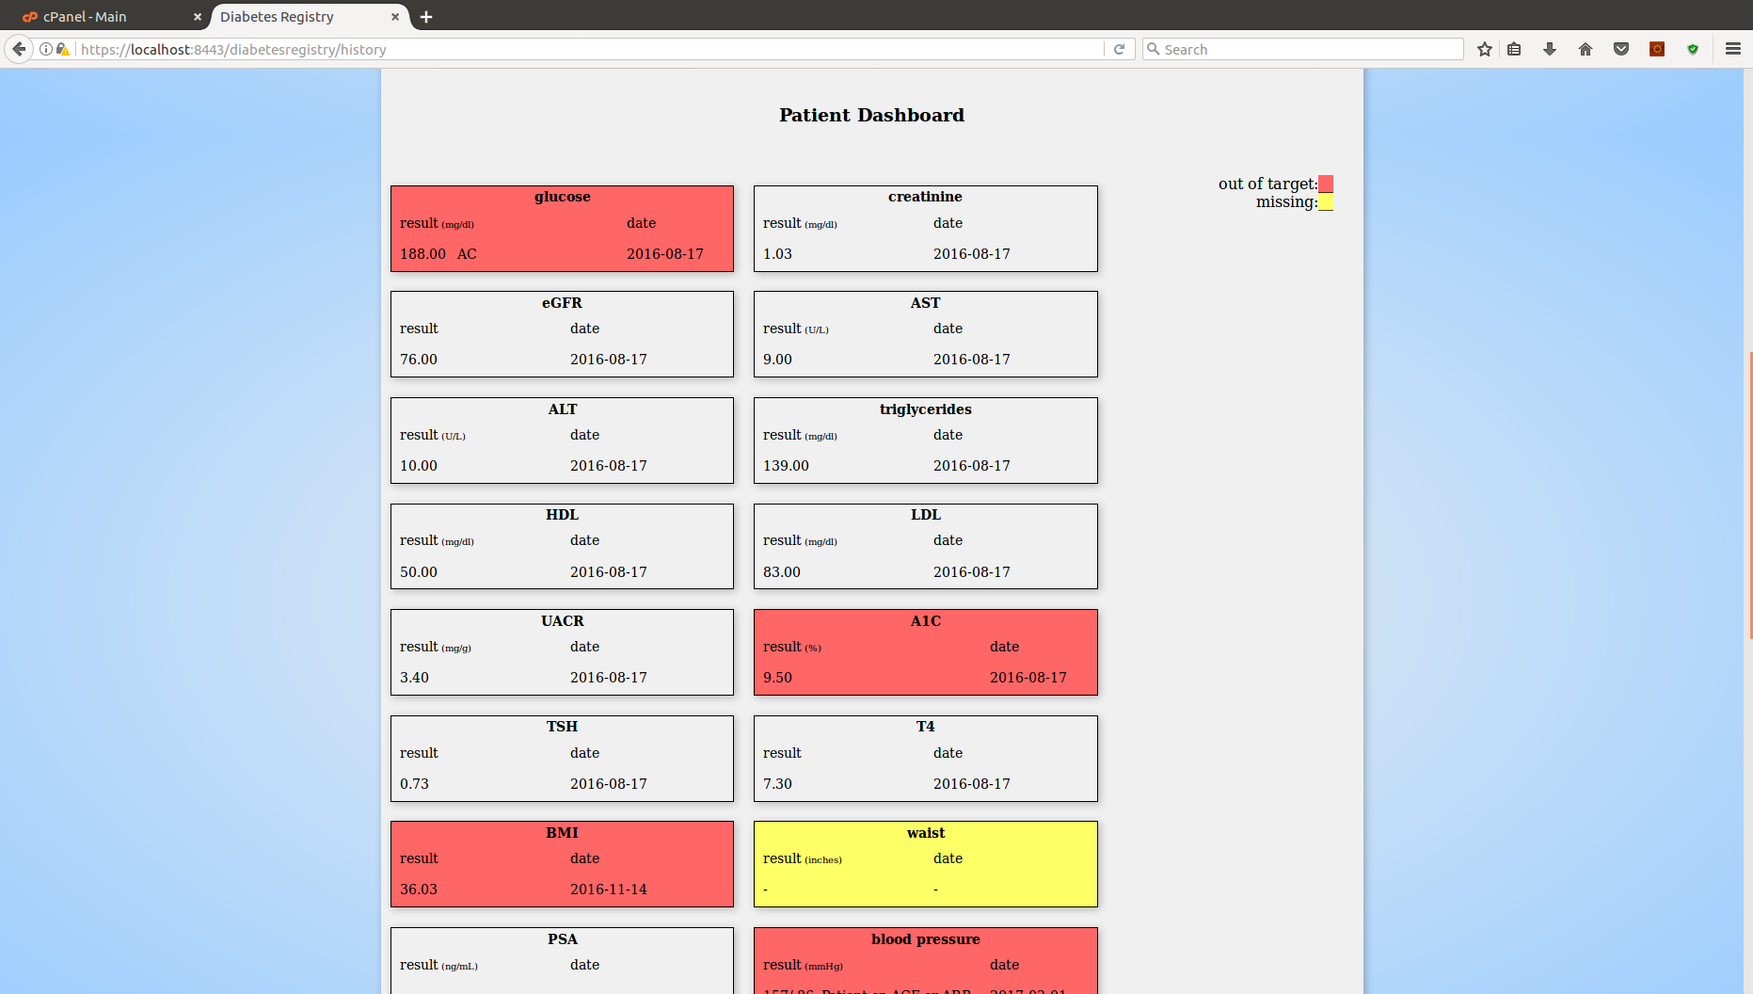

Figure 12 Patient Dashboard

To view the patient’s longitudinal history of a recorded item, select the item from the drop-down selection labeled “History Selection”. Figure 13 shows an example of blood pressure history for a selected patient.

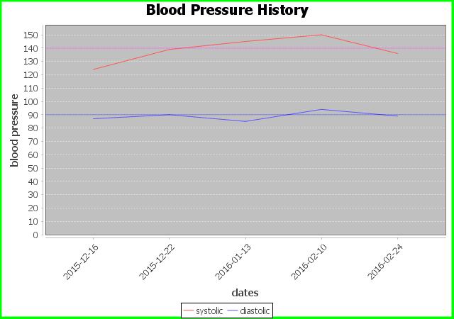

Figure 13 Blood Pressure History

## 2.10 Call Lists

The call-lists page contains options for retrieving a list of patients who may need telephone or email reminders for follow-up care. To view a call list, navigate to the call-lists page by selecting the “Call Lists” button in the navigation menu. Select the desired call list from the drop-down selection labeled “Select a Call List”.

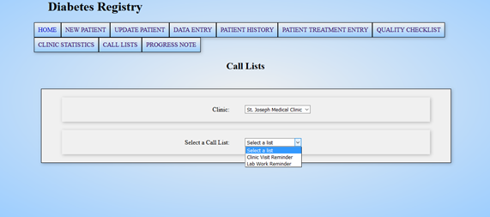

Figure 14 Call List Selection

To send automated email reminders to patients in the call list, check the checkboxes next to the appropriate patients, scroll to the bottom of the list to find the administrator email password input field, and enter the password for the administrator email account. Finally, select the “Send Emails” button to send reminders to the selected patients.

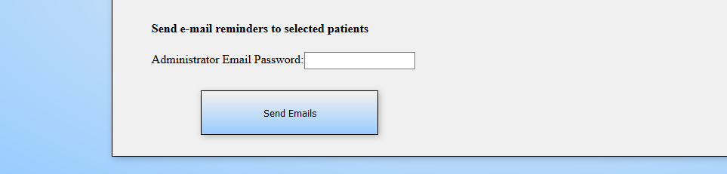

Figure 15 Email Reminders Function

## 

## 2.11 Clinic Statistics

The clinic statistics page provides options to view clinic population statistics for demographics, body mass, glycemic control, and treatment. Find this page by selecting the “Clinic Statistics” button in the navigation menu. Select the desired statistic from the drop-down selection. Figure 17 shows an example of age distribution for a clinic in the demographic statistics view.

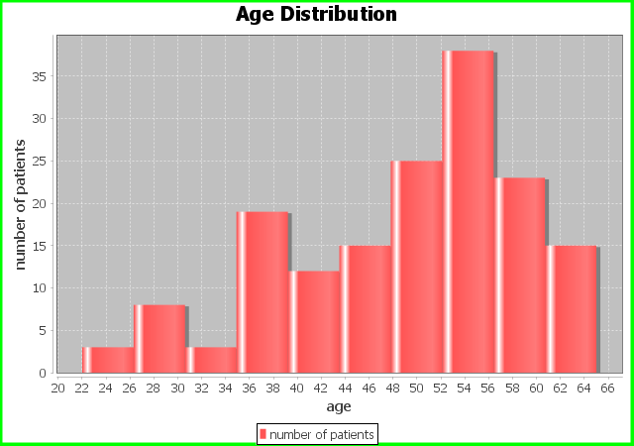

Figure 16 Age Distribution

# 3.0 Important Notes

## 3.1 Signing Out

When tasks in the registry are complete, sign out of the application by clicking on the “Sign Out” link in the upper right corner of the page. Upon sign out, the sign-in page will re-appear.

## 3.2 Security Practices

* Do not leave the diabetes registry application unattended without first signing out.
* Do not communicate or transmit your user name or password to others.
* Do not write down sign-in credentials where others may find them.
* Do not sign in for other healthcare providers. Each user should use his or her credentials to access the registry.

## 3.3 Troubleshooting

3.3.1 Browser Scripting

If drop-down selections do not process selections, ensure that JavaScript is enabled in the web browser. The procedures for adjusting browser settings differ for each web browser.

3.3.2 Error Messages

If a function triggers an error message, read the message to determine the possible solution to the problem. If no resolution is found for an error, refer the issue to the registry administrator.

3.3.3 Unexpected Behavior

If the system displays any unexpected behavior not covered in this manual, mention the issue to the registry administrator.