myGFO
Global Flight Operations
Scheduling Manager
Training Guide — Manager Supplement

What the Scheduling Manager role can and cannot currently do in myGFO, and how to work around the gap until the role is granted its pages.
READ THIS FIRST
This is a supplement. It covers only what is additional to the Scheduling role.
Read the Scheduling training guide before this one — the shared workflows are documented there and are not repeated here.

WHO THIS IS FOR
Scheduling Manager and Lead Scheduler.
Read the Scheduling guide first — in practice you will be doing that work under the Scheduling role.

SCOPE OF THIS GUIDE
This guide covers the day-to-day myGFO screens for this role. Three modules are documented separately and are deliberately not covered here: the Tech Log, Irregularity Reports (FIR), and the Scheduling Command Center. The Safety module is also out of scope — it is not in service yet.
You will still see those items in your sidebar. Ignore them for the purposes of this guide.

Getting started
Screenshots in this guide come from the myGFO prototype running on demo data. Tail numbers, names, dates and counts are illustrative — the screen layout, buttons and workflow are what matter.

Where you land
You land on the Dashboard with an empty sidebar. See the note below before going further.
Front door: Dashboard.
KNOWN GAP IN THIS ROLE
The Scheduling Manager role currently has no pages assigned to it. Signing in as Scheduling Manager gives you the Dashboard and an empty sidebar, and the scheduling pages return Access Denied because they are restricted to the scheduling, admin and lead roles.
Until this is fixed, do your scheduling work signed in under the Scheduling role. This document records the gap and will be replaced with a full supplement once the role is granted its pages.

The current state of this role
Choosing Scheduling Manager in the role picker signs you in successfully — the role exists and is selectable. What it does not have is any assigned pages.
You land on the Dashboard, which every role can see, and the sidebar beneath it is empty. There is no Scheduling group, no Approvals, no Document Center.
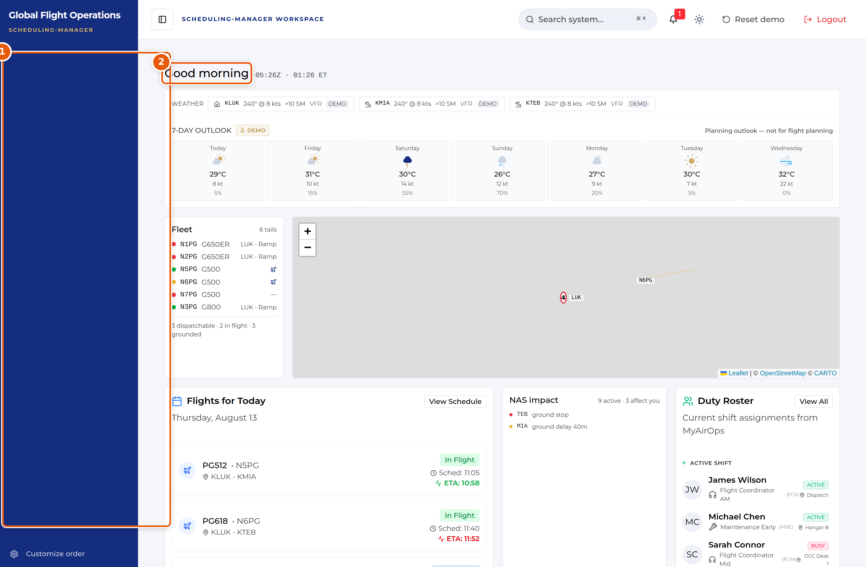
Signed in as Scheduling Manager: the Dashboard loads, the sidebar is empty.
1 | The sidebar, with no navigation items assigned to this role.
2 | The Dashboard renders normally — it is available to every role.

What happens if you navigate directly
Reaching a scheduling page by URL does not work around the gap. The page loads its breadcrumb and then returns Access Denied, naming the roles that do have access — scheduling, admin and lead — and the role you are currently acting as.
This is the permission system behaving correctly. The problem is that Scheduling Manager was never added to those permitted lists.
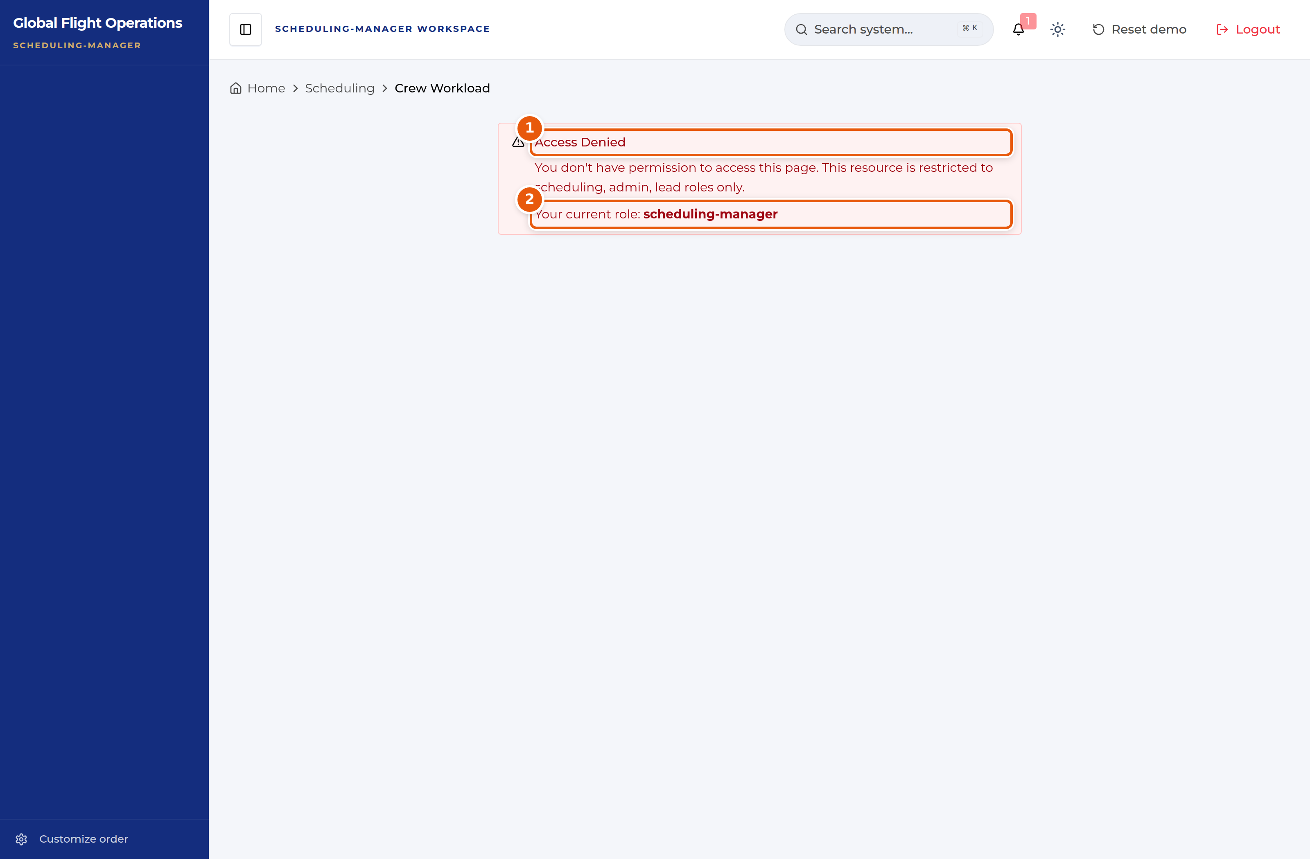
Crew Workload, opened as Scheduling Manager.
1 | Access Denied, naming the roles that do have access.
2 | The role you are currently acting as.

What to do in the meantime
Sign in under the Scheduling role and work from the Scheduling guide. That role has the full set of scheduling pages: Scheduling Dashboard, Trip Coordination, Passenger Forms, Passenger Data Currency, Crew Workload, Pilot Currency, Approvals and the Document Center.
The one thing you lose by doing this is the distinction between manager and scheduler. Any approval you action will be recorded against the Scheduling role rather than against Scheduling Manager. If that distinction matters for a particular decision, hold it until the role is fixed rather than recording it under the wrong authority.

What this role should eventually cover
For planning purposes, the manager-level work this supplement will document once the role is granted its pages:
- Approvals routed to Scheduling Manager, recorded against that authority.
- Crew Workload read across the whole scheduling team rather than one desk.
- Trip Coordination oversight — which trips are behind on their checklists, and who is carrying the load.
- Passenger Forms and Data Currency backlog: whether outreach is actually keeping pace with upcoming trips.

