myGFO
Global Flight Operations
Lead Team
Training Guide

The management view of the operation: the leadership dashboard, deep-dive analytics, live operational metrics, and the critical functions register that records who covers what.
WHO THIS IS FOR
Department leadership and VPs.
A standalone guide — it does not depend on any other role document.

SCOPE OF THIS GUIDE
This guide covers the day-to-day myGFO screens for this role. Three modules are documented separately and are deliberately not covered here: the Tech Log, Irregularity Reports (FIR), and the Scheduling Command Center. The Safety module is also out of scope — it is not in service yet.
You will still see those items in your sidebar. Ignore them for the purposes of this guide.

Getting started
Screenshots in this guide come from the myGFO prototype running on demo data. Tail numbers, names, dates and counts are illustrative — the screen layout, buttons and workflow are what matter.

Where you land
You land on the shared Dashboard. Lead Dashboard, in the Admin group, is your page.
Front door: Dashboard.

Your sidebar at a glance
Your role decides which of these appear. Pages are grouped in the sidebar as shown.
Page | Sidebar group | What it is for
Lead Dashboard | Admin | High-level operations overview with delay alerts and VIP tracking
Manager Insights | Admin | Deep-dive analytics: on-time rate, delay causes, route performance
Live Metrics | Admin | Real-time fleet, crew, maintenance and schedule telemetry
Critical Functions | Admin | Critical function register, rolling action items, suggestion box
Crew Workload | Scheduling | Crew workload and travel
Pilot Currency | Home | Crew currency against Part 91 minimums
Turndown Reports | Maintenance | Maintenance shift report history
Dashboard | Home | Weather, fleet, today’s flights, airspace, duty roster
My Tasks | Home | Action items assigned to you and your own tasks
Approvals | Home | Requests waiting on you, and ones you filed
Document Center | Documents | Controlled publications and your required reads

Signing in
myGFO opens on a demo password screen. Enter the password your administrator gave you and choose Continue.
On the next screen, open Select Your Role, choose your role, and choose Access Dashboard. Your role decides which pages appear in the left sidebar and where you land after sign-in — two people can be looking at the same system and see a different set of pages.
If you hold more than one role, sign in under the one matching the work you are about to do. You can sign out and back in under the other role at any time using Logout at the top right.

Lead Dashboard
The Lead Dashboard is the operational picture at leadership level: active flights, aircraft available, tracked passengers and active alerts, with the day’s schedule beneath.
Delay Alerts is the part that earns the page. Each entry names the station, the cause type (ground delay programme, weather, capacity), the affected flight, and the delay in minutes. That is enough to answer a question from the top of the company without calling anyone.
Tracked Passengers lists the VIPs — board members and C-suite — with their current flight and its state. Where someone has more flights in the period, the card says so.
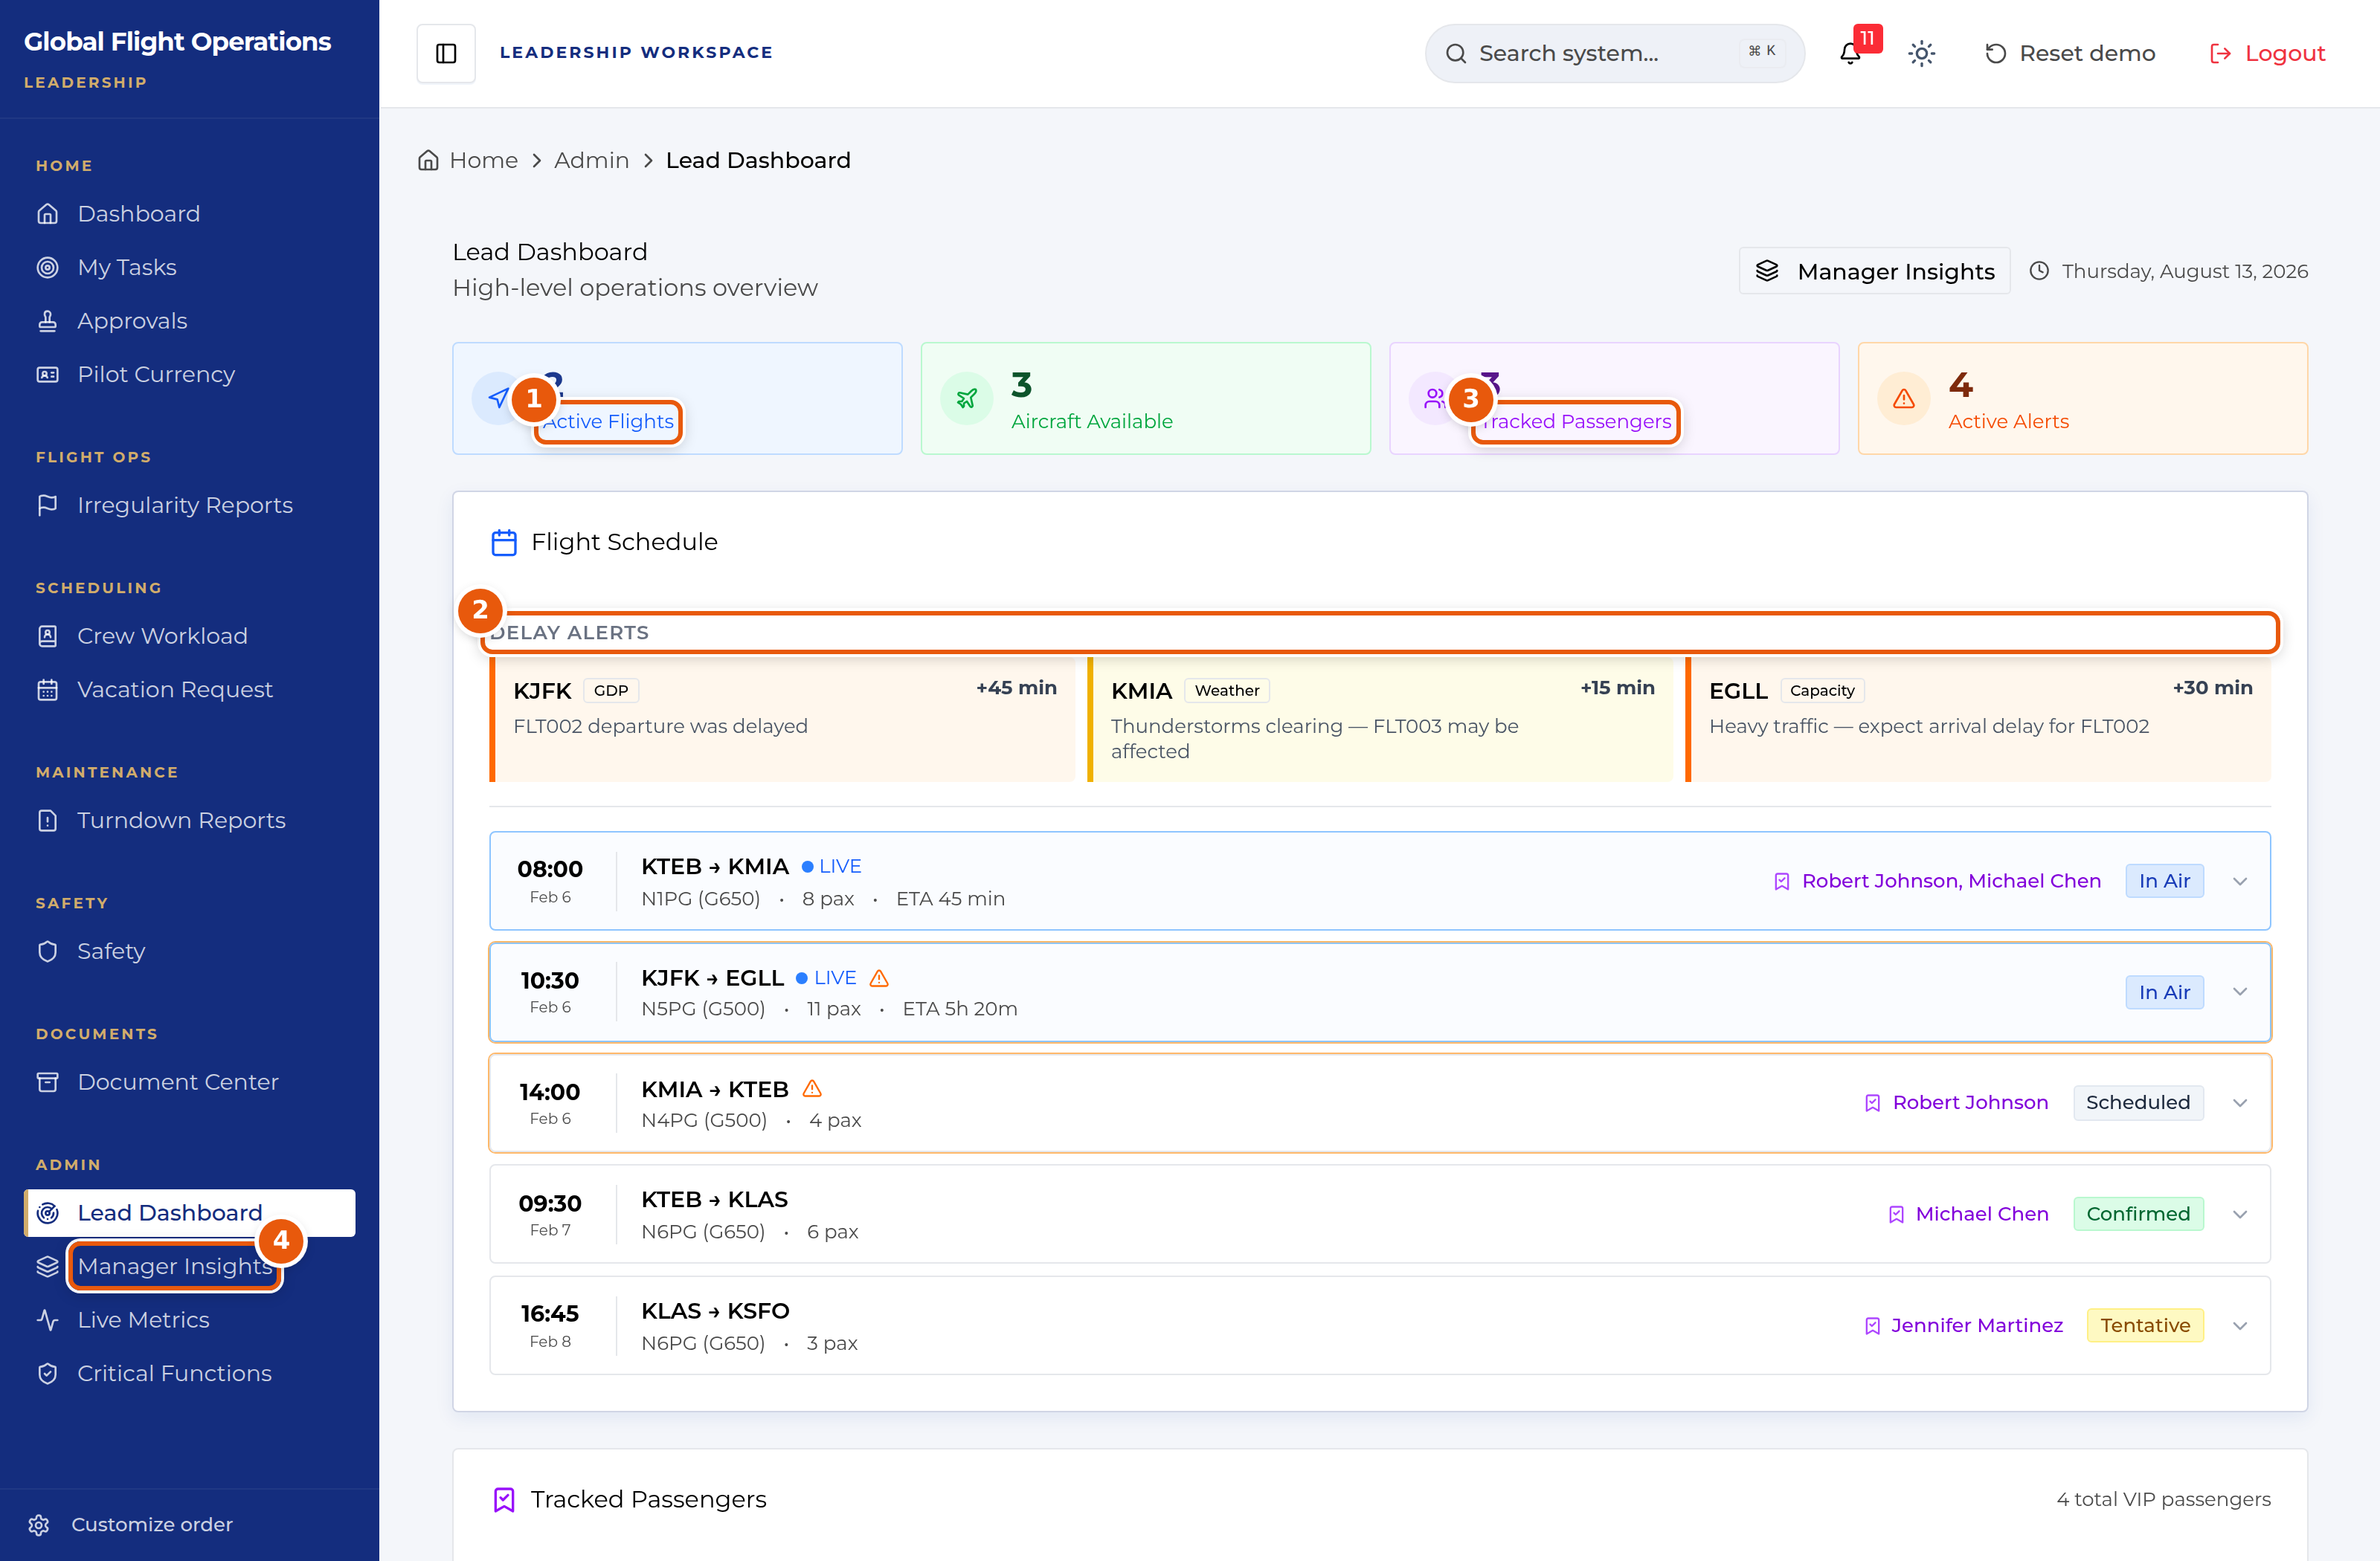
Lead Dashboard.
1 | Headline counters: active flights, aircraft available, tracked passengers, active alerts.
2 | Delay Alerts — station, cause, affected flight and delay in minutes.
3 | Tracked Passengers — VIPs with their current flight and its state.
4 | Manager Insights — the route through to deep-dive analytics.

Aircraft Status, further down, gives the fleet by tail with its state, location, and hours to next inspection. Hours to next inspection is the number to watch: it is the constraint that will decide which tail is available next week.
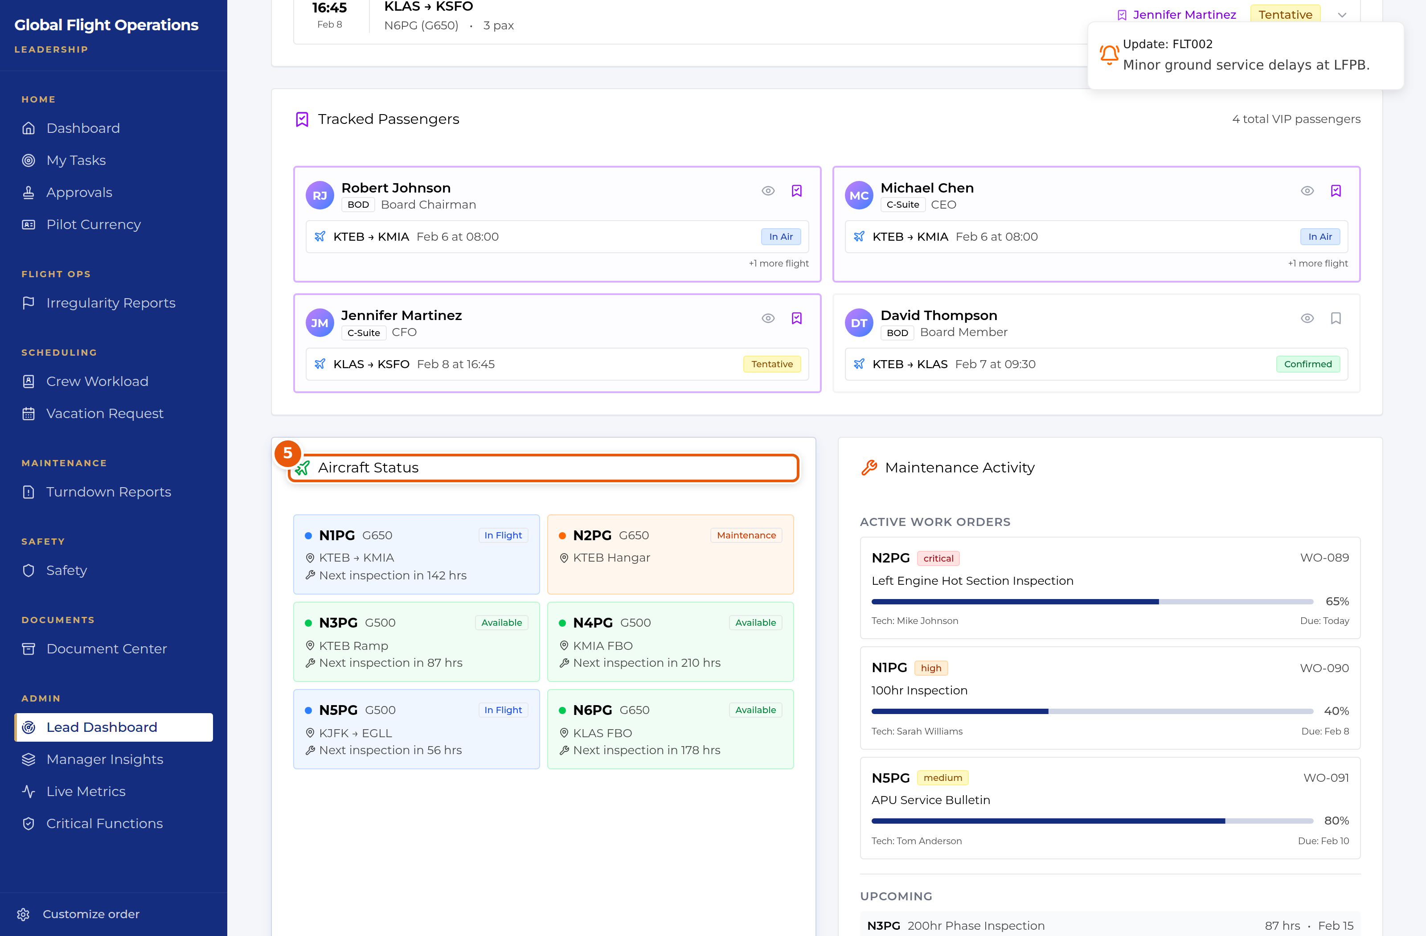
Lead Dashboard — fleet status with hours to next inspection.
5 | Aircraft Status — state, location, and hours to next inspection per tail.

Manager Insights
Manager Insights is the analytical page, on three tabs: Operations Analytics, Crew Management and Fleet Deep-Dive.
The headline metrics carry period-on-period movement — total flights, on-time rate, cancellations and average delay, each with its change. Flight Completion Trend plots completed against delayed and cancelled by month.
Delay Root Causes is the most useful panel on the page, splitting delays by cause with counts and percentages: weather, maintenance, ATC/NAS, crew and passenger. It separates what the department controls from what it does not, which is the distinction that makes an on-time figure actionable.
Top Routes by Frequency gives per-route flights, average block time, on-time percentage and average fuel.
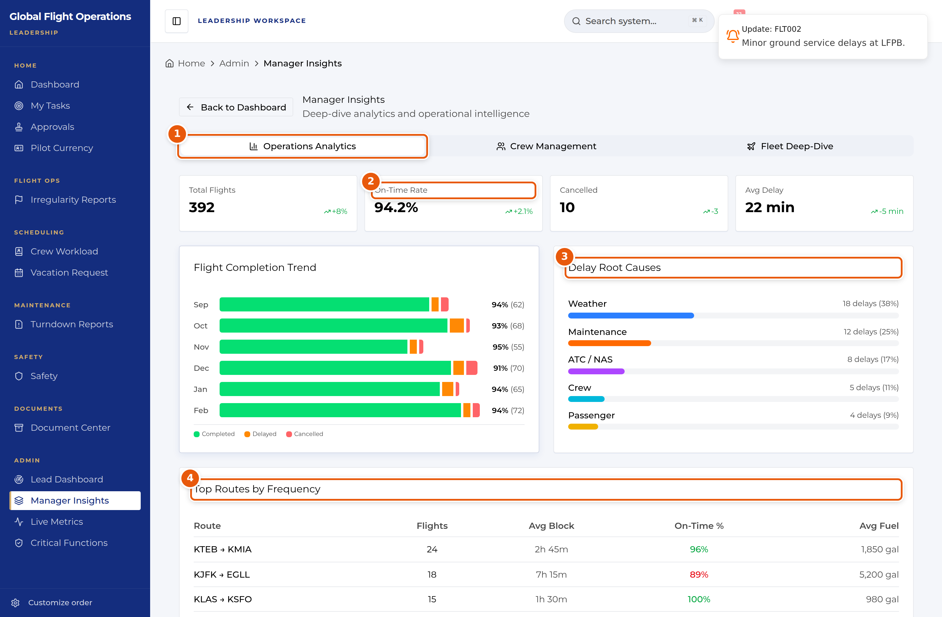
Manager Insights — Operations Analytics.
1 | Tab strip — Operations Analytics, Crew Management, Fleet Deep-Dive.
2 | Headline metrics with period-on-period movement.
3 | Delay Root Causes — separates what the department controls from what it does not.
4 | Top Routes by Frequency, with block time, on-time rate and fuel.

Live Metrics
Live Metrics is the real-time telemetry board, with tabs for Overview, Fleet, Crew, Maintenance and Schedule, and a Zulu clock running in the header.
The Overview carries fleet utilisation, weekly flight hours, active fleet, on-time performance and seat availability, each with its movement. Risk Profile (FRAT) aggregates submitted flight risk assessments into an average score and a low/medium split — it is the one panel that reads the department’s risk posture as a trend rather than one flight at a time.
Below that sit turnaround time, maintenance completion rate, crew readiness and cost per flight hour.
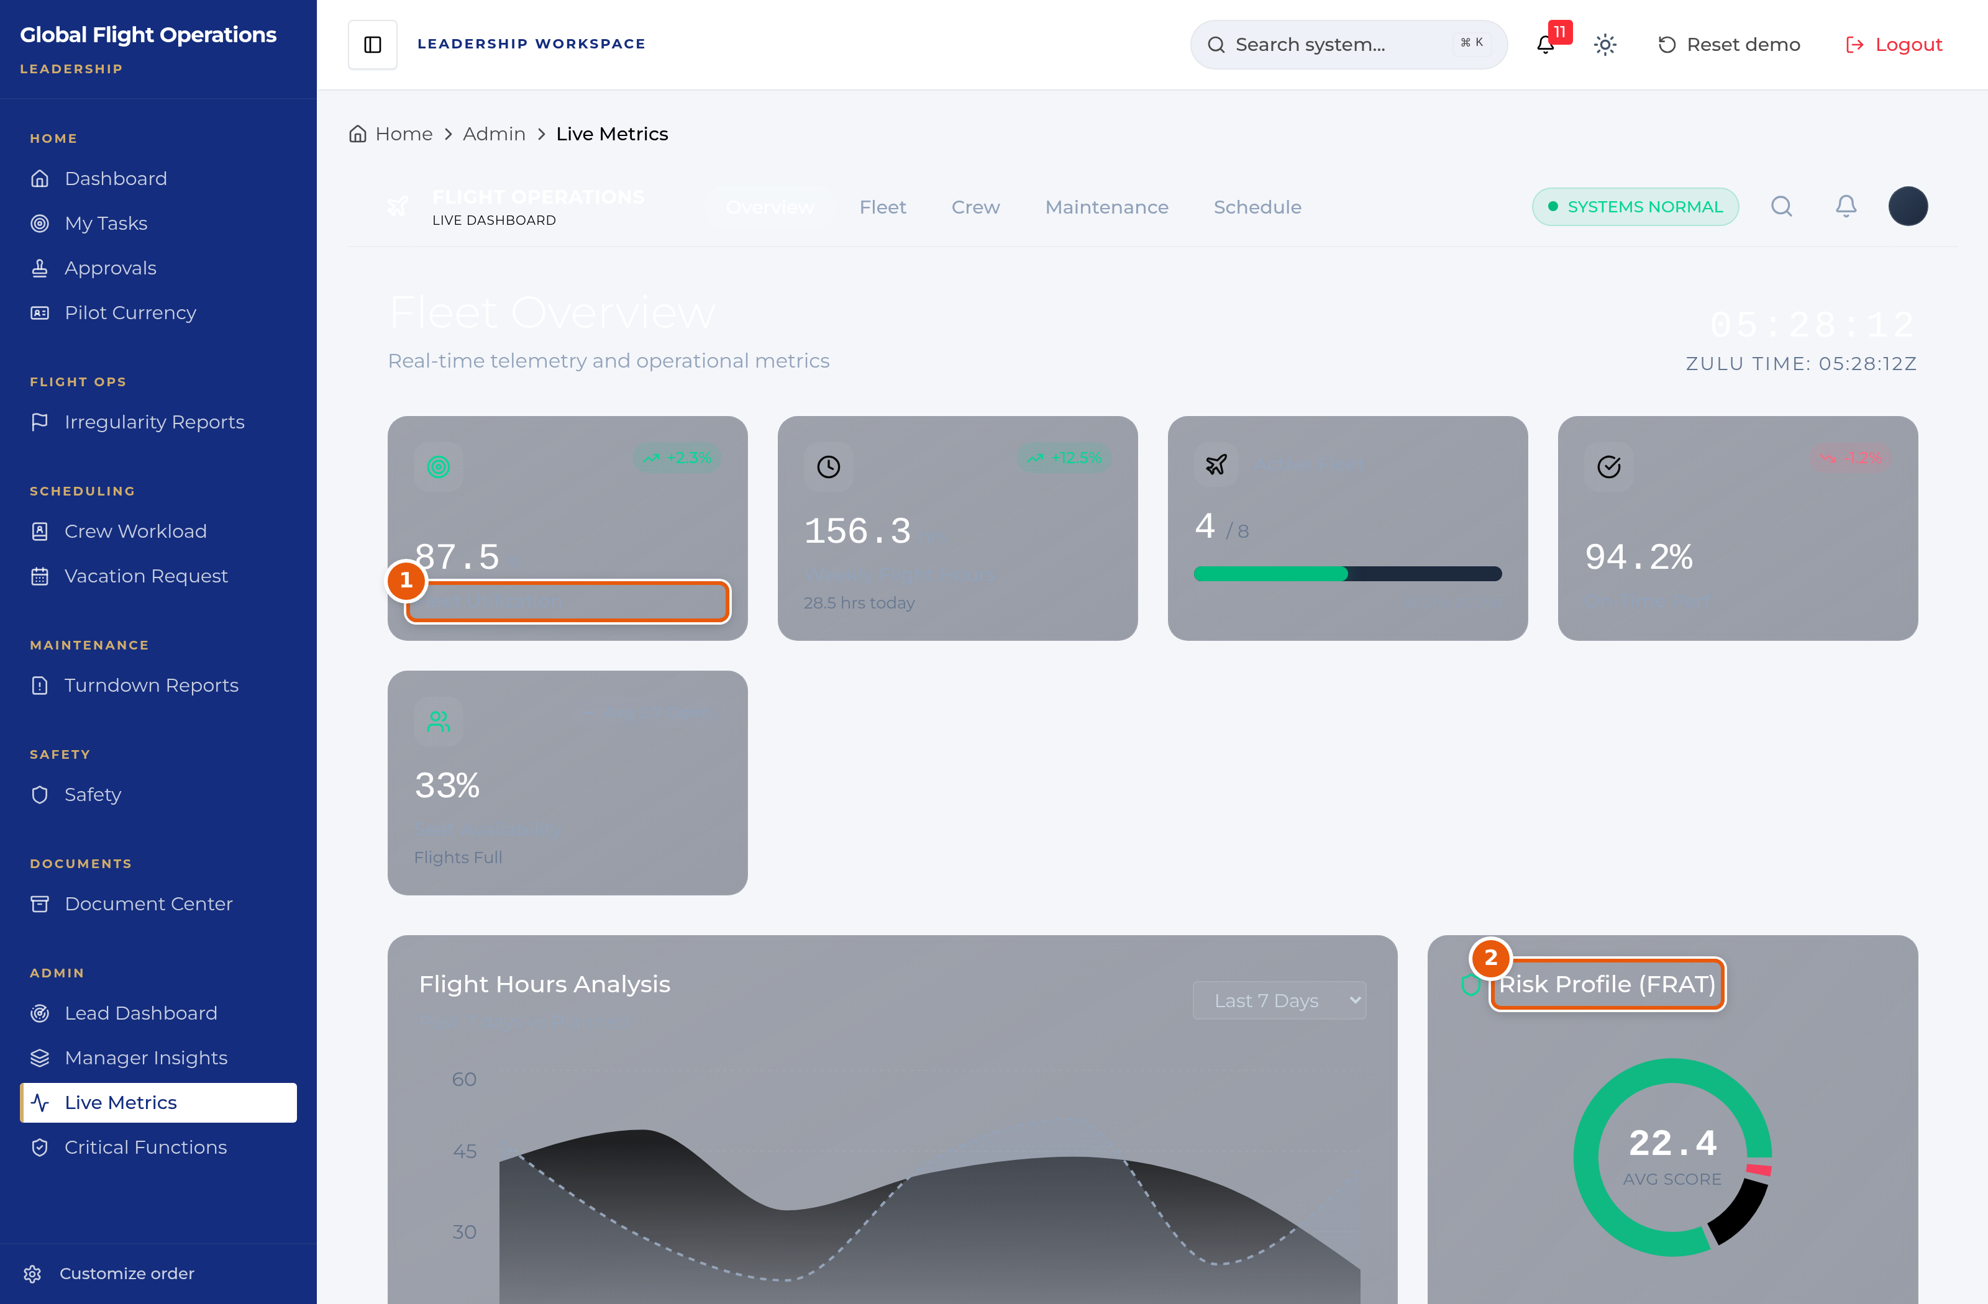
Live Metrics — Overview.
1 | Fleet utilisation and the headline telemetry, each with movement.
2 | Risk Profile (FRAT) — aggregated risk posture across submitted assessments.

Further down, Aircraft Utilization Report compares hours by tail, and Top Routes ranks the most frequent paths with flights and hours.
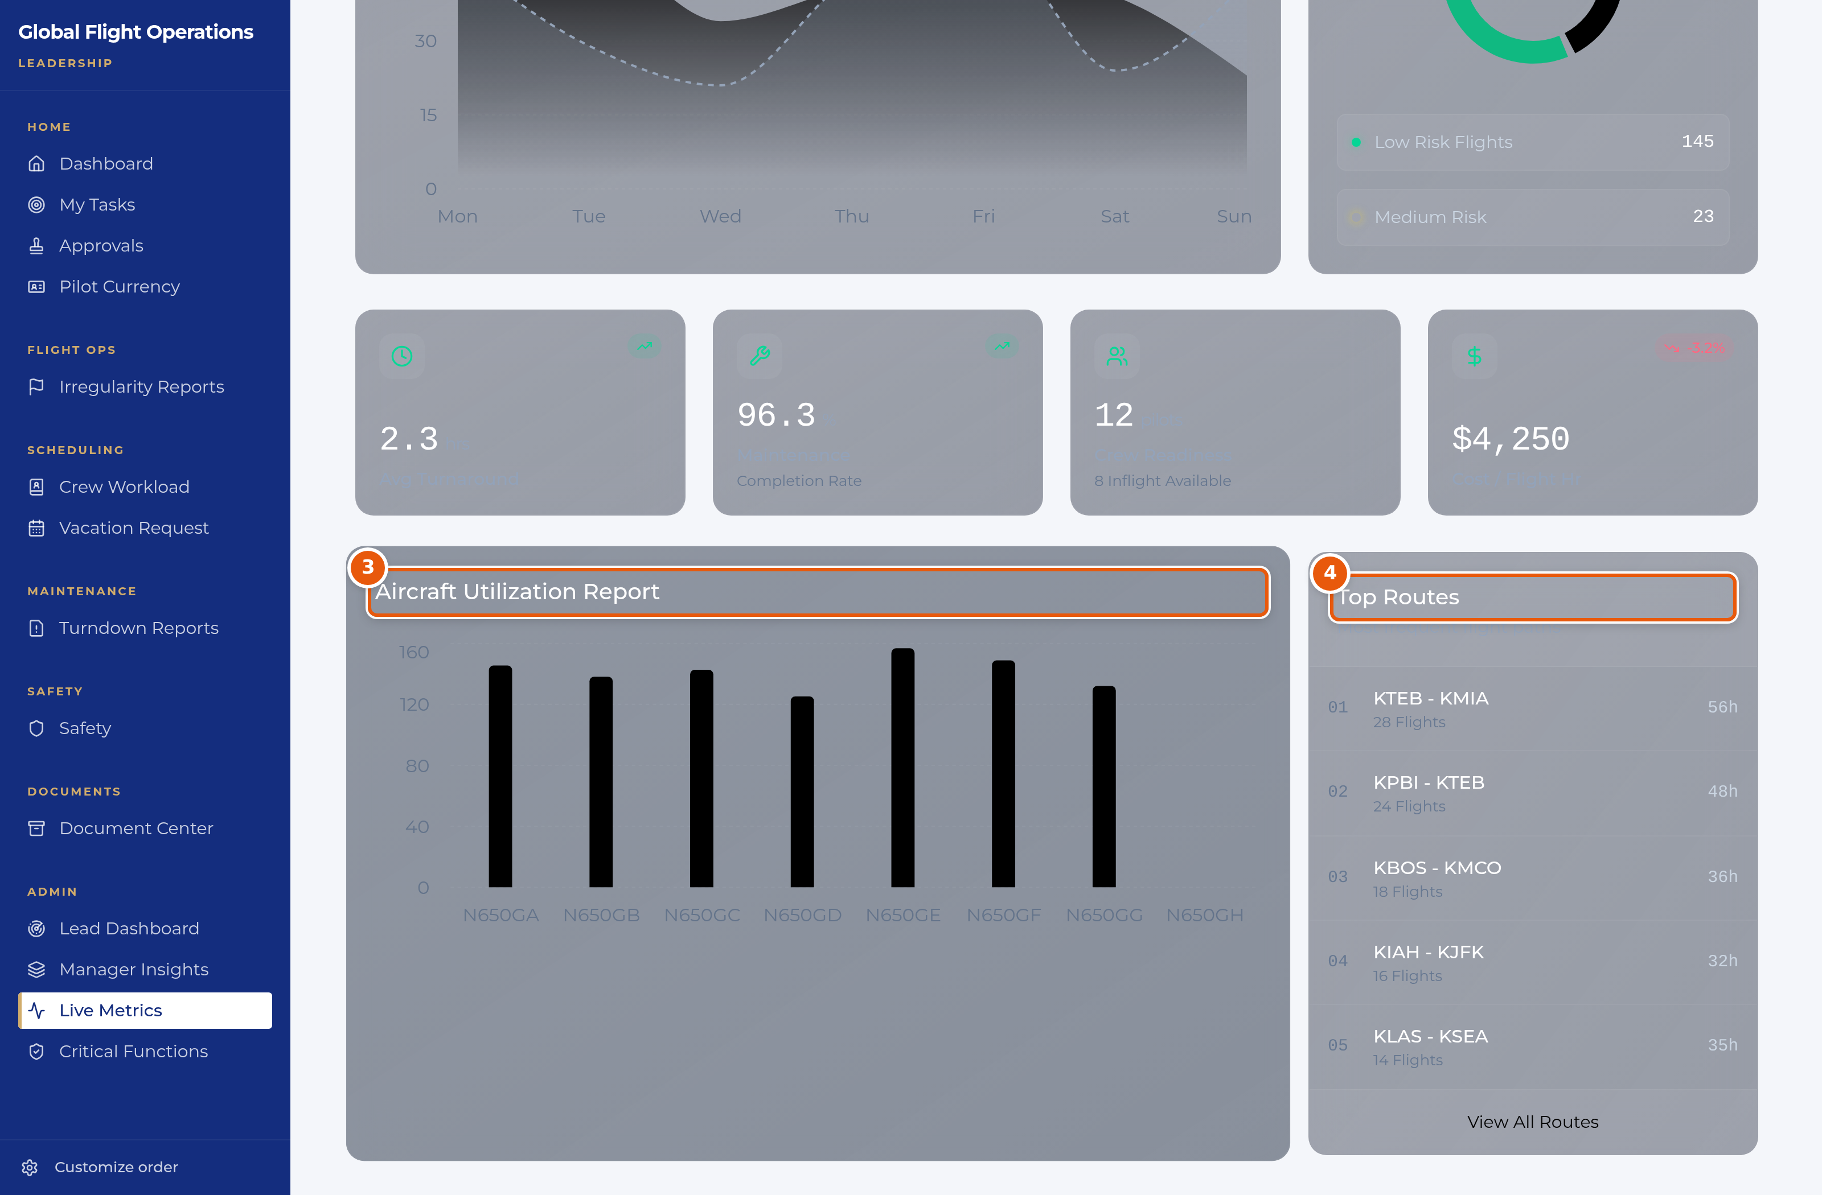
Live Metrics — utilisation by tail and top routes.
3 | Aircraft Utilization Report — hours by tail.
4 | Top Routes, with flights and hours.

Critical Functions
Critical Functions is the register of what the department cannot afford to have uncovered, and it is the page on this list with the longest shelf life. It has three tabs: Critical Functions, Rolling Action Items and Suggestion Box.
Each function records a priority and state, the primary role that owns it, the people currently assigned, the backup roles, tagged personnel, a due date, a review date, a reminder setting, and the procedures the function covers.
Backup Roles is the field that makes the register worth keeping. A function with a named primary and no viable backup is a single point of failure, and this is the page where that becomes visible before it becomes a problem. Review dates and reminders exist so the register is revisited rather than written once.
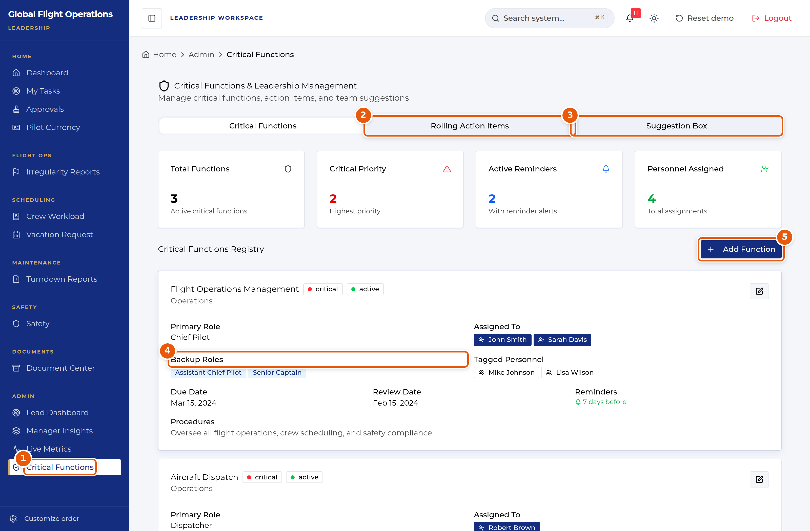
Critical Functions & Leadership Management.
1 | Critical Functions — the register itself.
2 | Rolling Action Items.
3 | Suggestion Box.
4 | Backup Roles — a function with no viable backup is a single point of failure.
5 | Add Function.

Crew workload and currency
Crew Workload is open to the Lead Team role, and it is worth knowing that the Chief Pilot cannot open it — if a Chief Pilot needs workload data, it comes from Scheduling or from you.
Pilot Currency gives crew currency against Part 91 minimums, tracked per aircraft type. At your level the counters at the top are the reading: how many crew are current, due soon and expired. An expired count is a dispatch constraint, not just a training one.
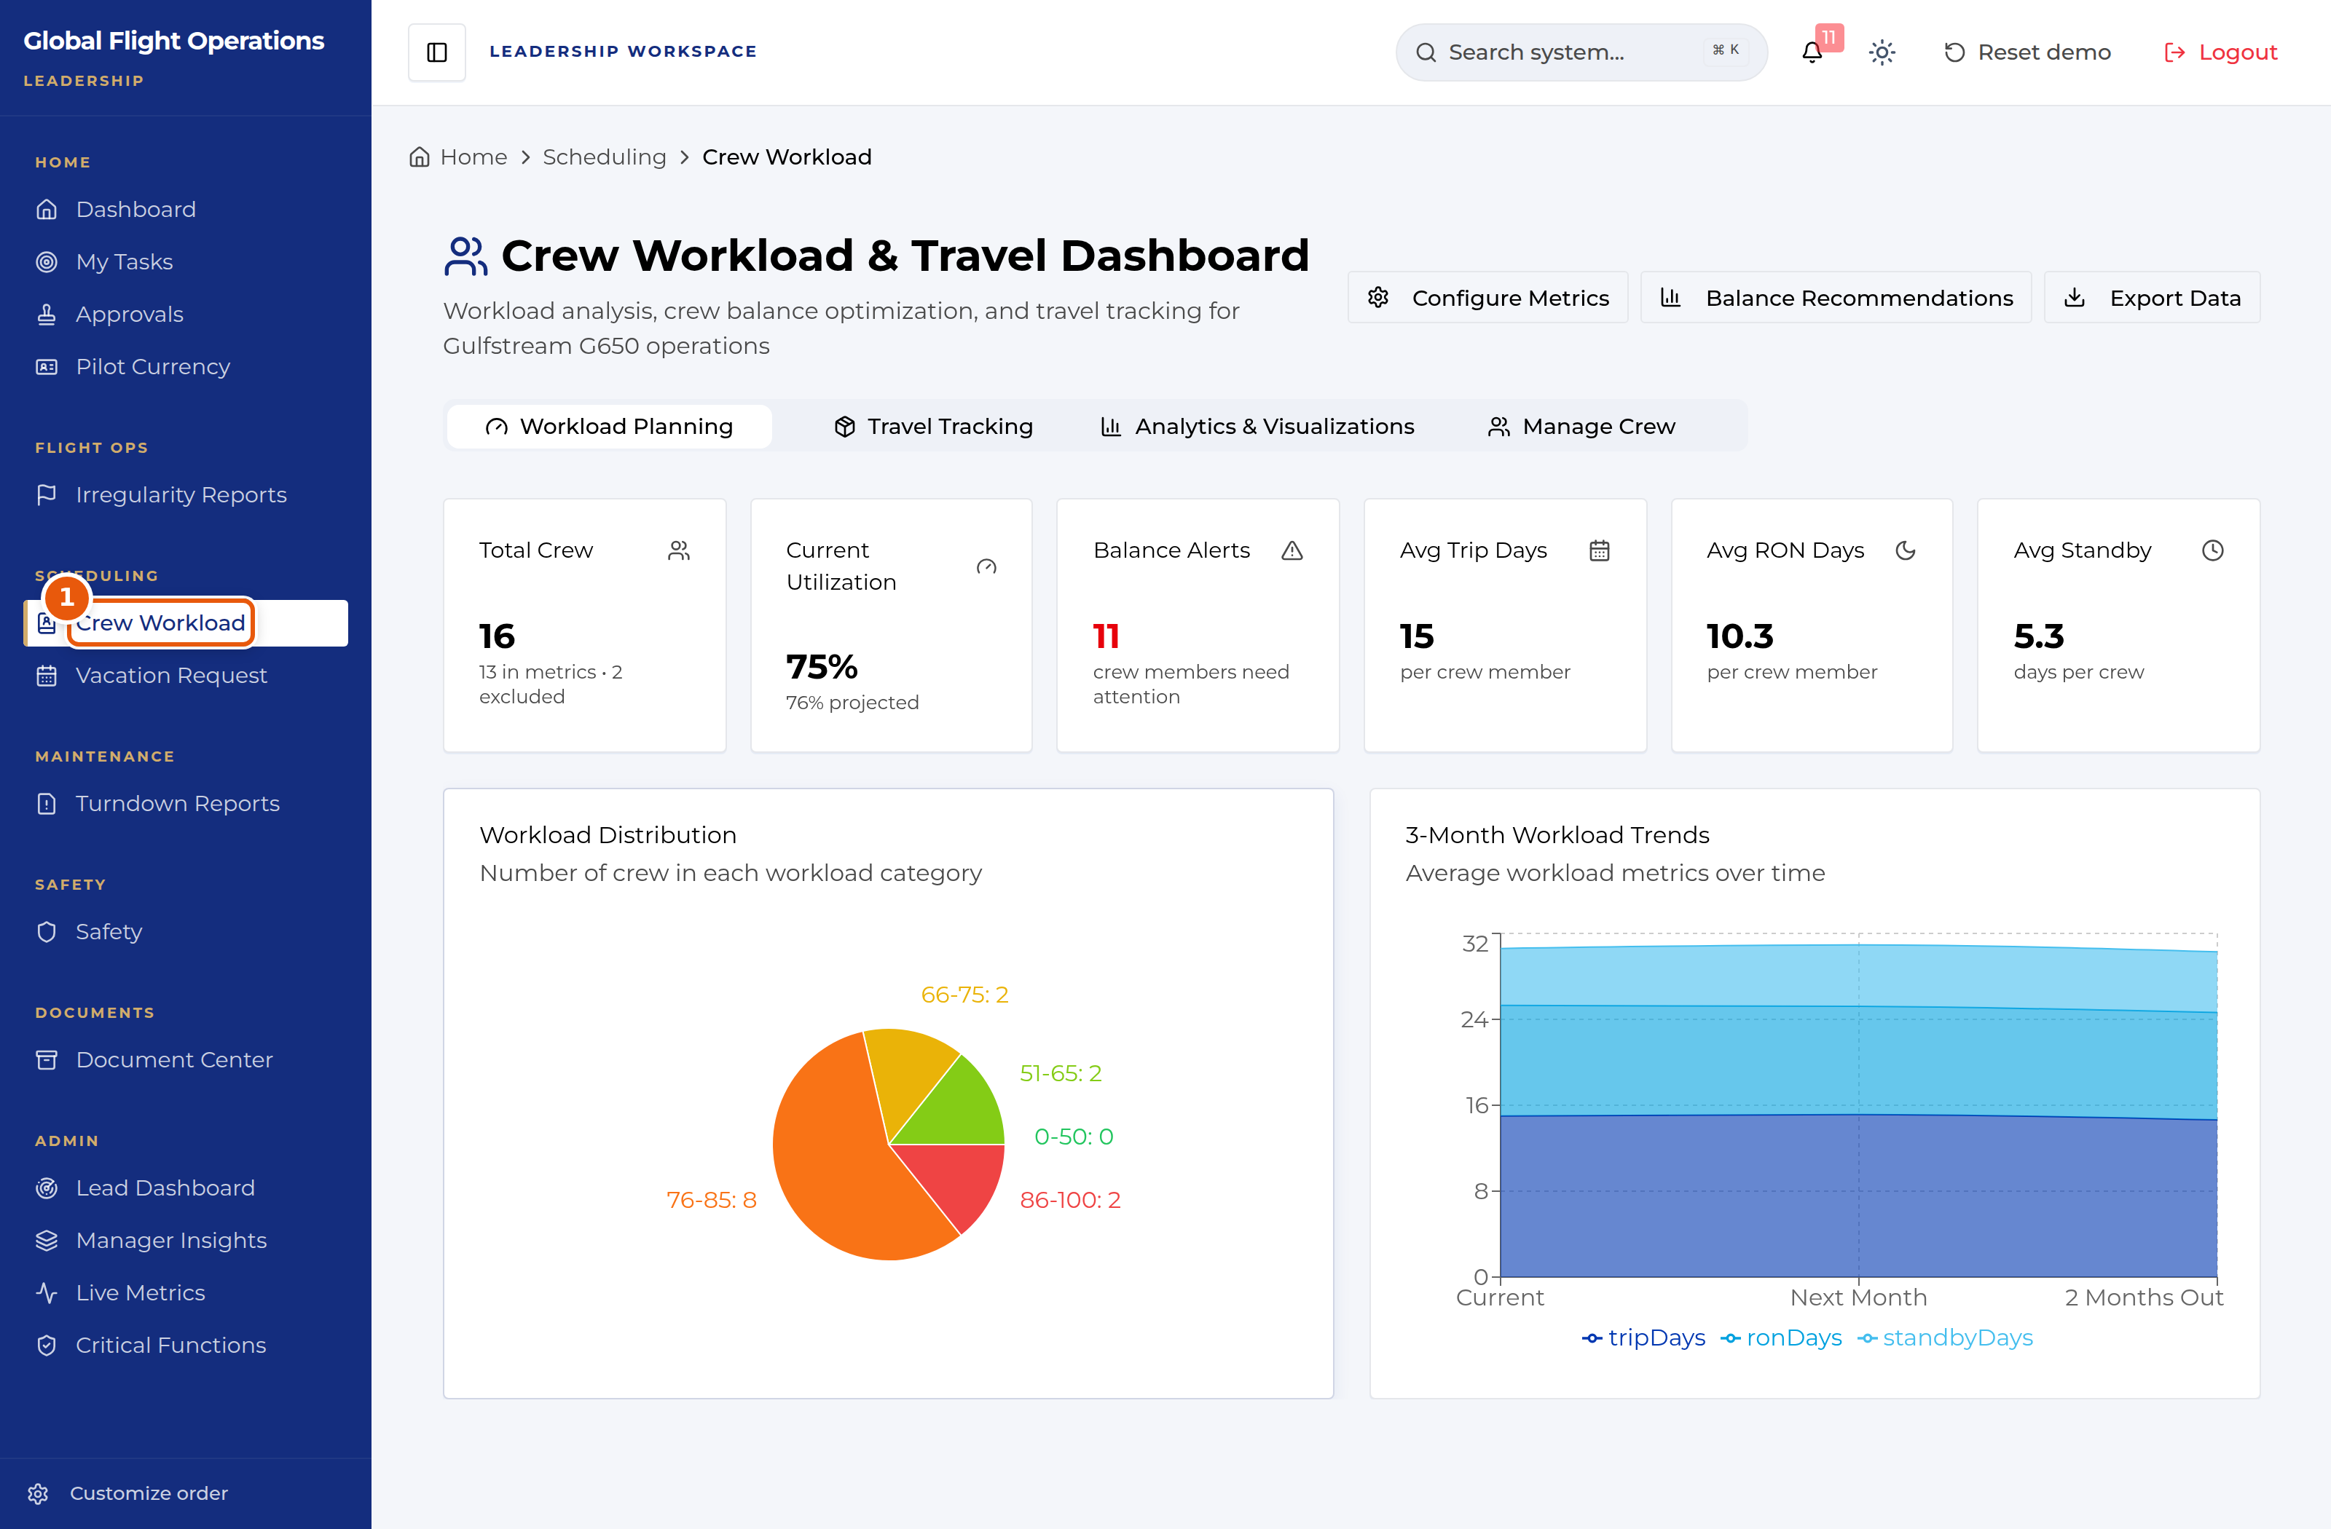
Crew Workload, open under the Lead Team role.
1 | Crew Workload — available to scheduling, admin and lead roles.

The Dashboard
The Dashboard is the shared home page. Every role sees the same building blocks: current weather and a seven-day planning outlook, the fleet with its serviceability, the day’s flights, national airspace impacts, and who is on shift.
Treat it as a situational-awareness page, not a working page. Nothing on it is signed or filed; it tells you what is going on so you know where to go next.
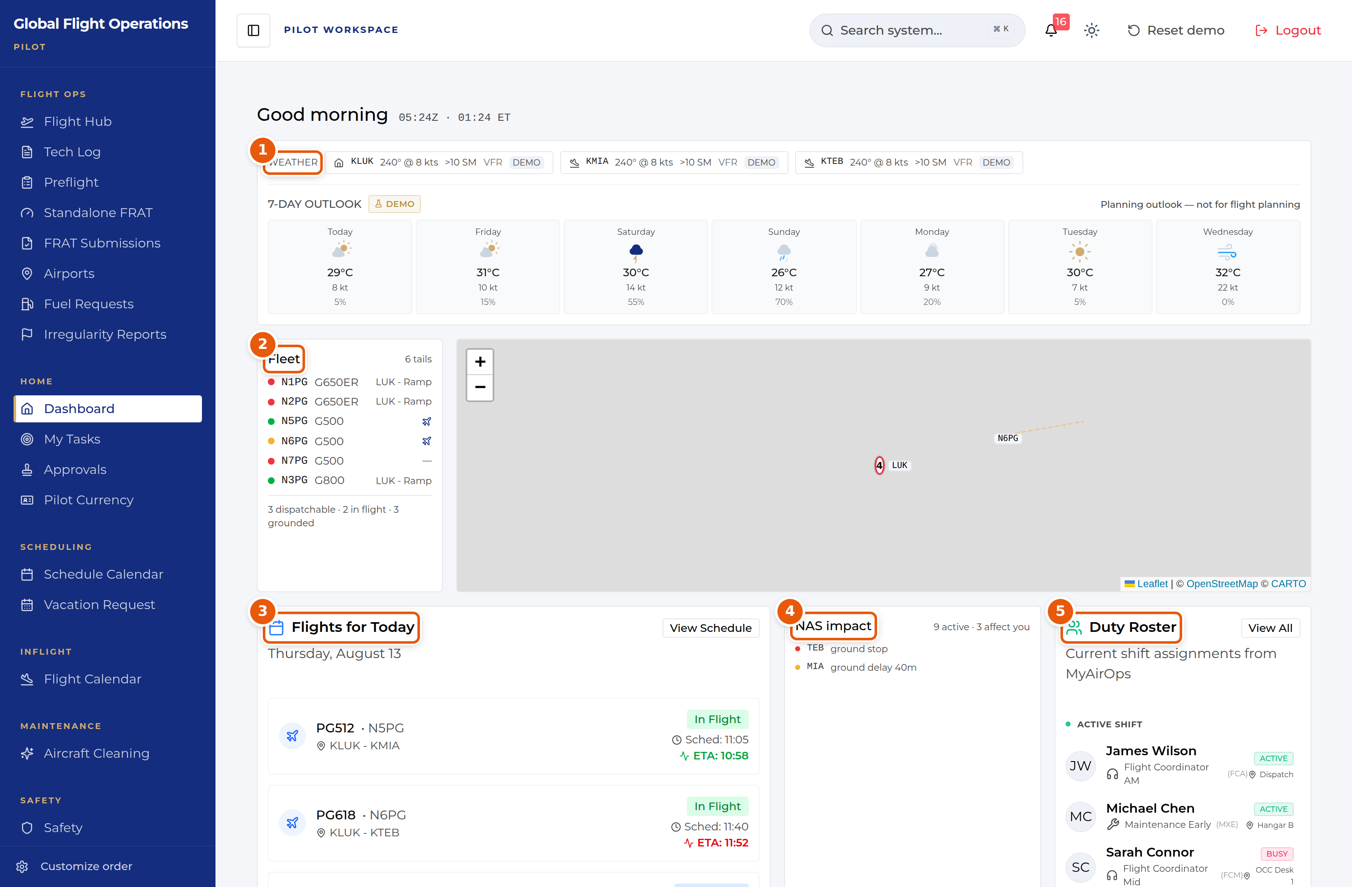
The Dashboard, shown for a Pilot. The panels are the same for every role.
1 | Weather for the home base and the stations in play, plus a seven-day outlook. The outlook is explicitly marked as a planning aid — it is not for flight planning.
2 | The fleet, one line per tail, with a coloured serviceability dot and current location. The summary line underneath counts what is dispatchable, in flight and grounded.
3 | Flights for today with scheduled time and live ETA. Where the ETA has moved away from schedule it is highlighted.
4 | NAS impact — FAA ground stops, ground delays and flow programmes, with a count of how many affect your operation.
5 | Duty Roster — who is on shift now, their function and where they are sitting.

Document Center
The Document Center holds controlled publications and tracks who has read them. It is the same page for every role; what differs is which documents are assigned to you.
My required reads is your personal queue and is the tab to work from. Each row shows the revision, the effective date, a plain-language "What changed" summary, and the acknowledgement the document demands — Read & sign, Read & initial, or Received copy. Rows that have passed their due date are marked Overdue.
Open a document, read it, and complete the acknowledgement at the end. Your outstanding count at the top of the page drops as you clear the queue.
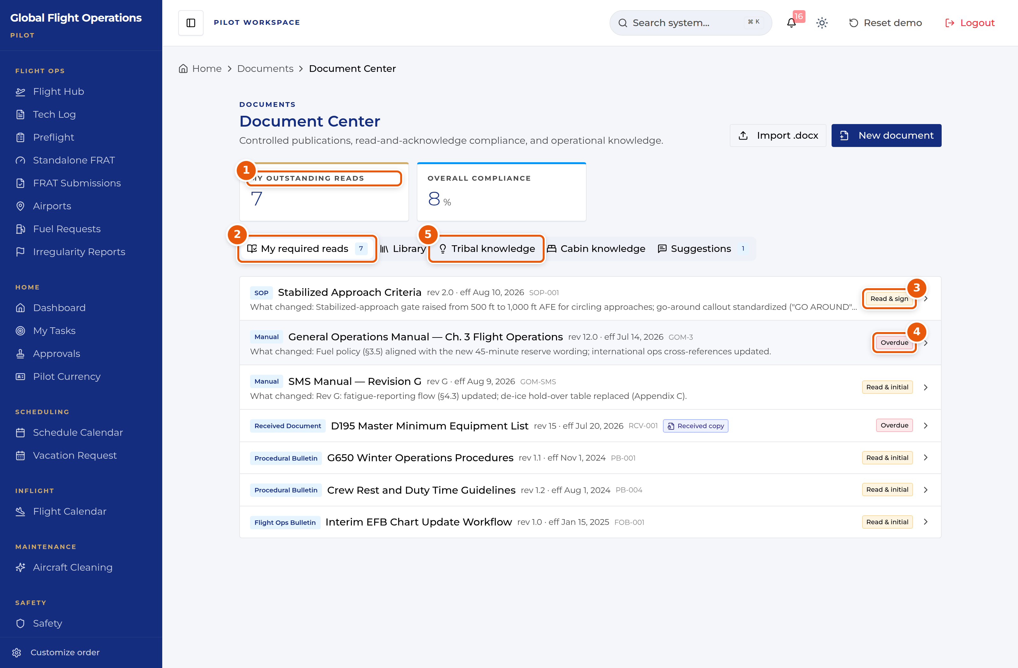
Document Center — the My required reads queue.
1 | My outstanding reads — how many acknowledgements you personally owe.
2 | Tab strip. My required reads is your queue; Library is the full controlled-document set.
3 | The acknowledgement type this document demands. Read & sign is the strongest; Read & initial and Received copy also appear.
4 | Overdue — the acknowledgement deadline has passed. Clear these first.
5 | Tribal knowledge and Cabin knowledge hold non-controlled operational know-how, kept separate from the controlled library on purpose.

Approvals
Approvals is a single inbox with two halves: requests waiting on your decision, and requests you have filed yourself. The page states which role you are acting as, because your approval authority follows your role, not your name.
Multi-step requests show their position in the chain (for example Step 2 of 2) along with what earlier approvers decided and why. Read the earlier decision before you act on yours.
You can Approve, Deny, or Add a comment. Use View request details to see the full submission before deciding.
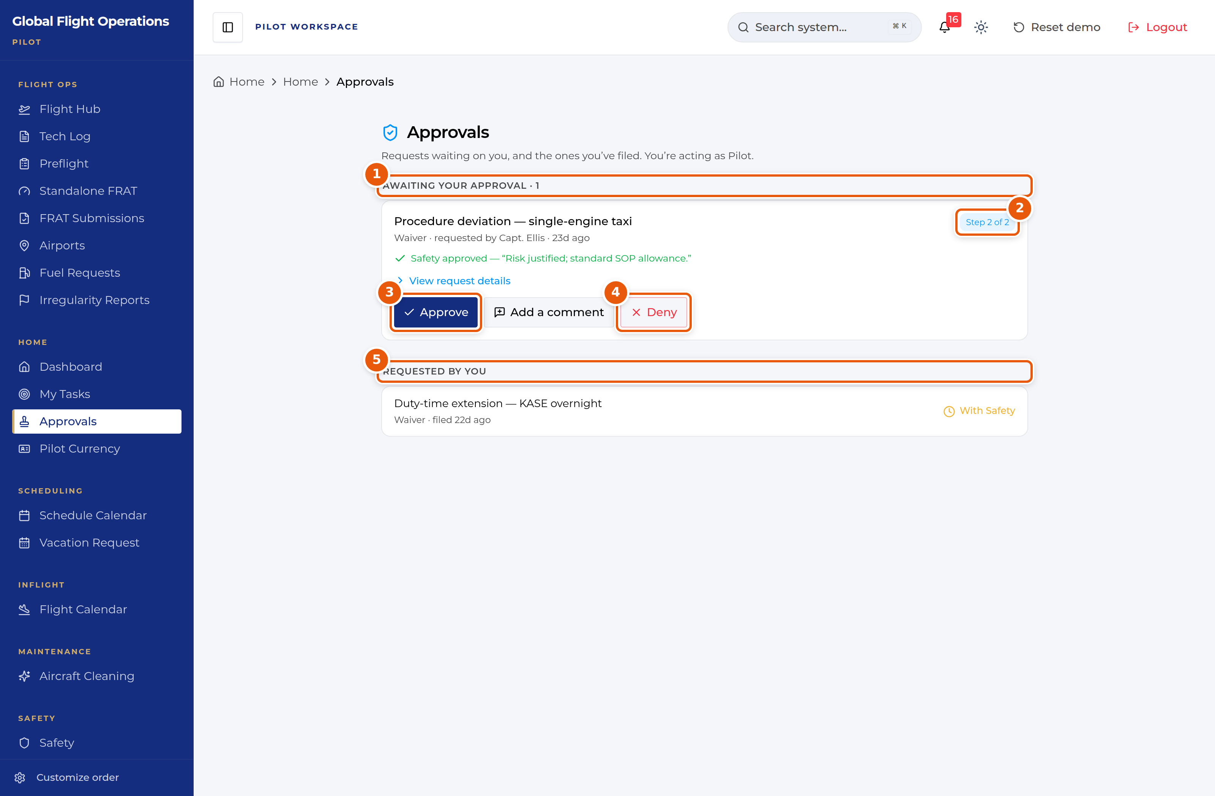
Approvals, shown while acting as Lead Team.
1 | Awaiting your approval, with a count. This is the half you owe action on.
2 | Where this request sits in its approval chain.
3 | Approve — records your decision against your role.
4 | Deny — also records against your role. Add a comment first if the reason is not obvious.
5 | Requested by you — what you have filed, and where each request currently sits.

Vacation and time off
Vacation Request handles vacation, payback stop days (PBST), off days and medical leave through one form.
The page has four tabs: Submit Request, My Requests, Master Calendar and PBST Balance. Check PBST Balance before you file — awarded stop days carry an expiry date, and the balance panel shows how many days are left on each.
On Submit Request choose the request type, set the start and end dates, and add a reason. If you want to spend awarded PBST days against the request, tick them under Apply Available PBST Days before submitting.
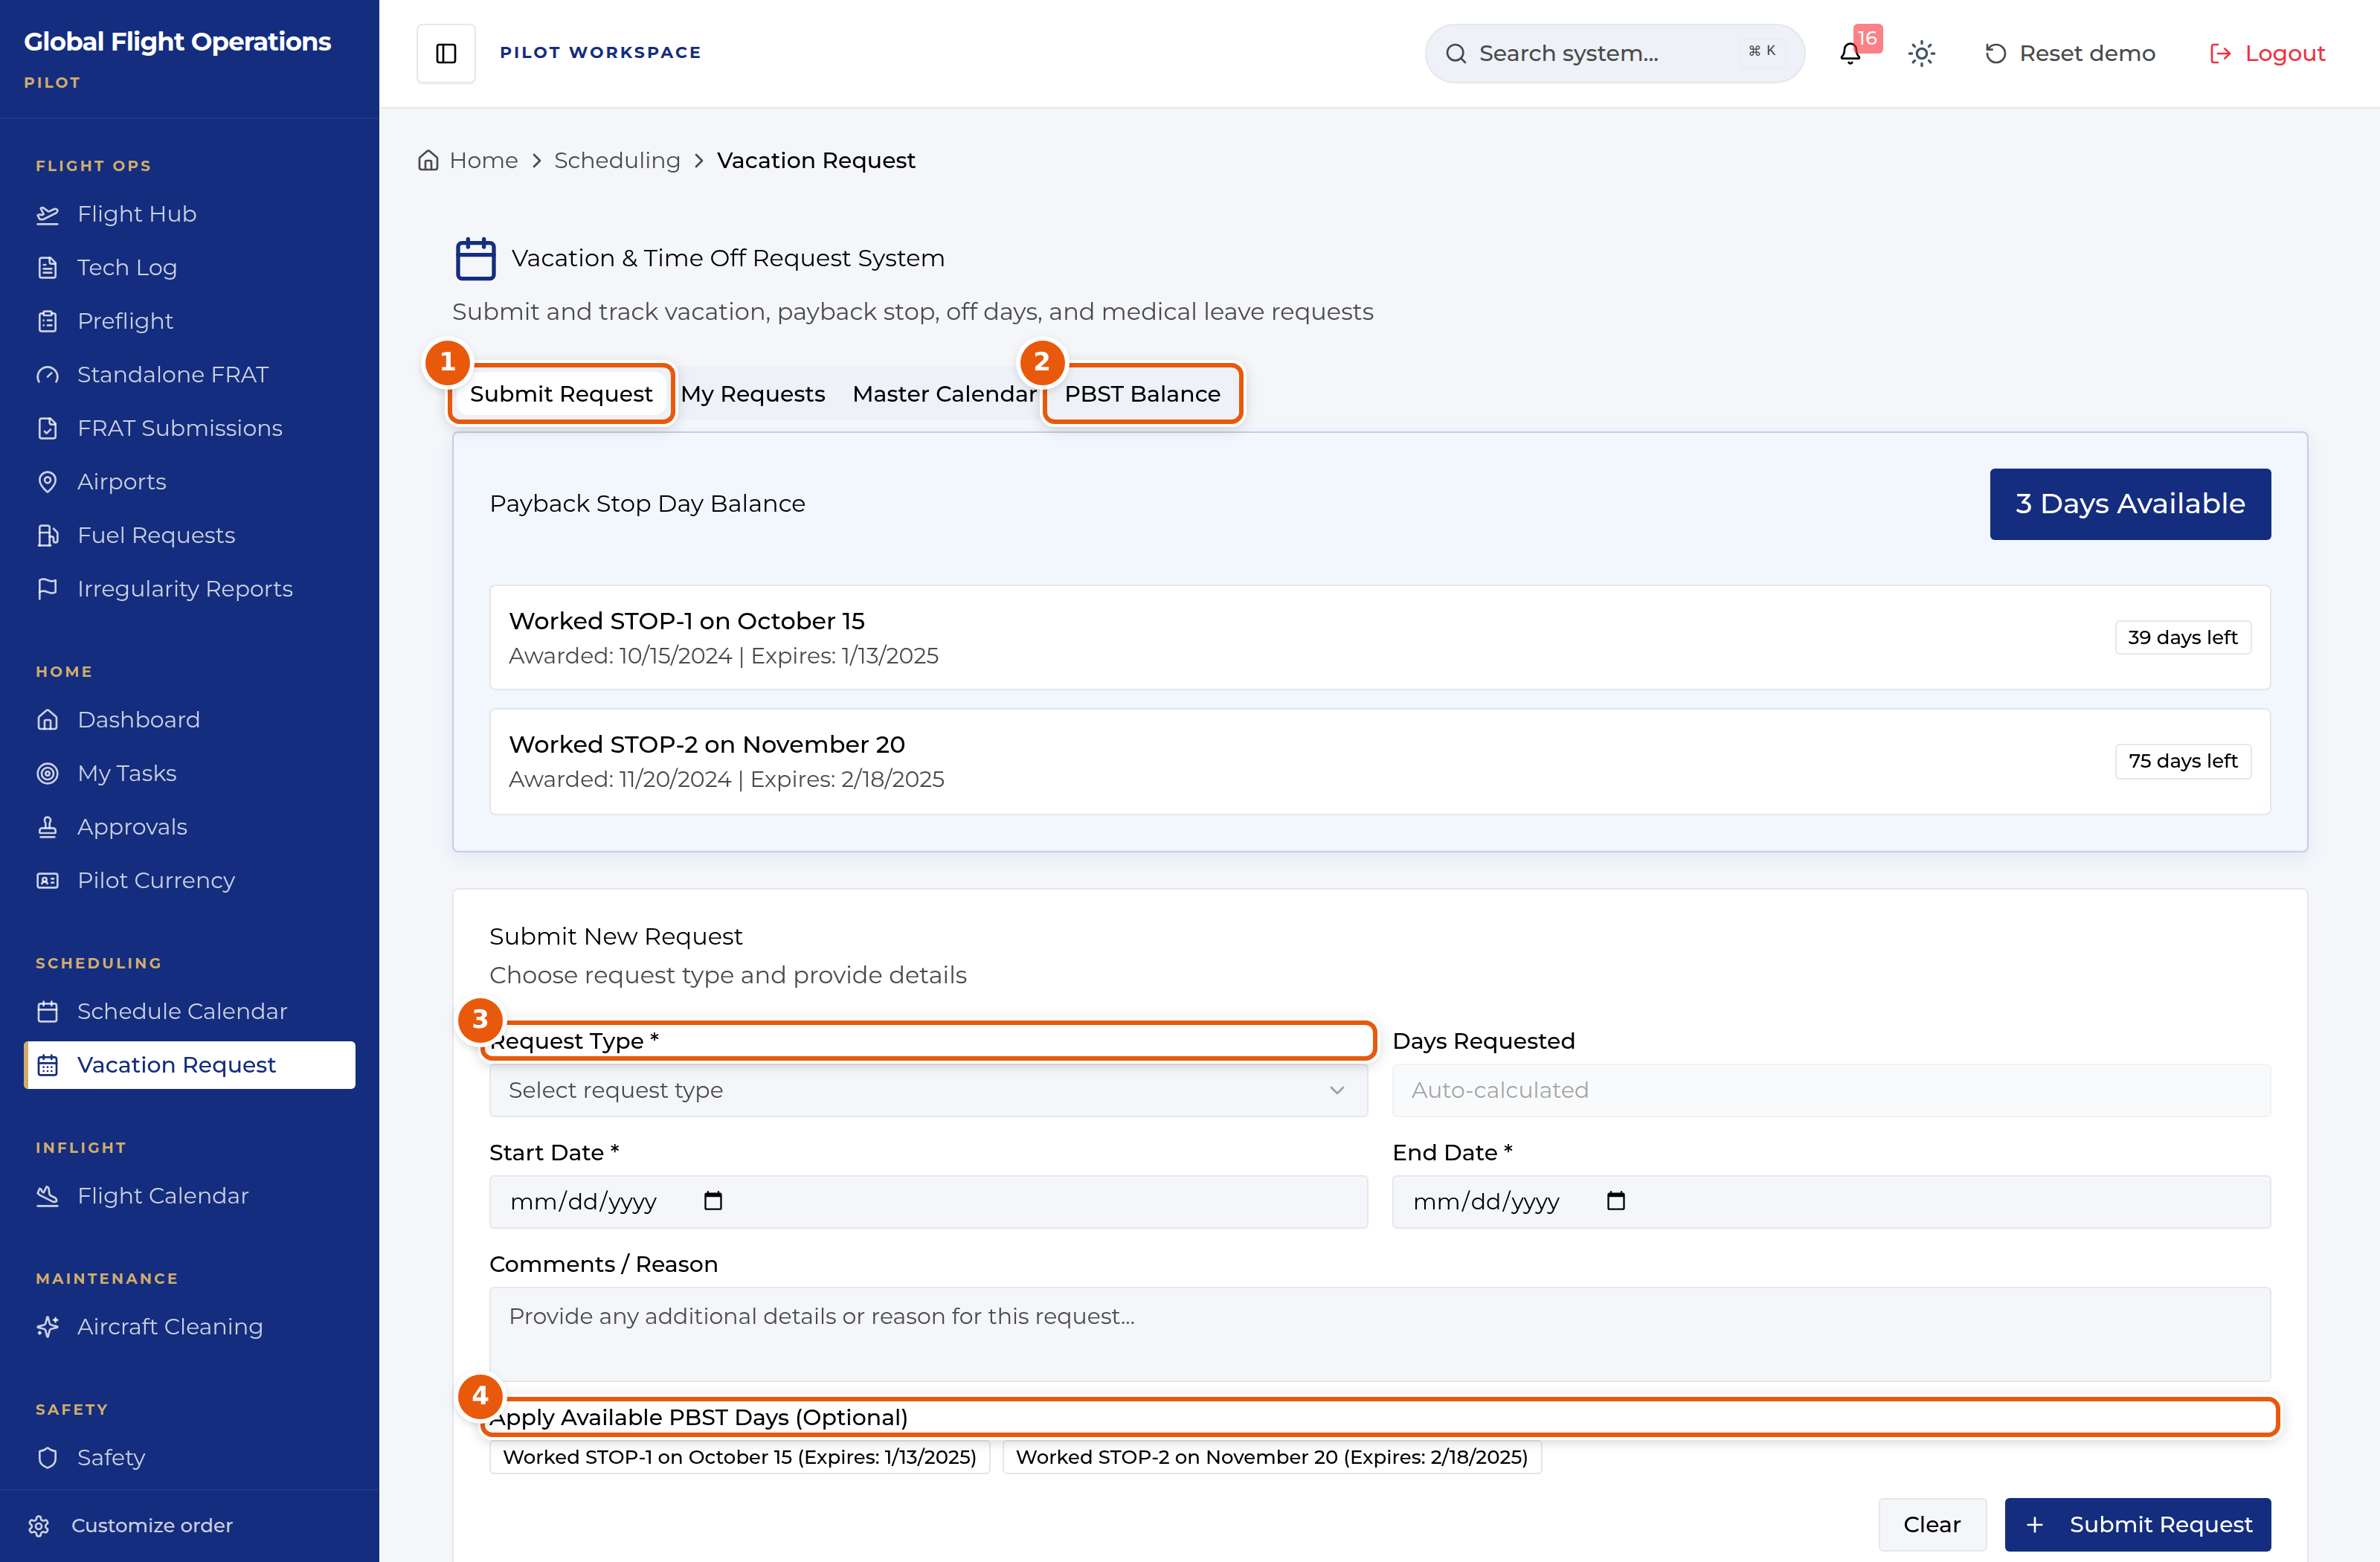
Vacation and time-off request form.
1 | Tab strip — Submit Request, My Requests, Master Calendar, PBST Balance.
2 | PBST Balance shows each awarded stop day, when it was awarded and when it expires.
3 | Request Type drives the rest of the form. Set it first.
4 | Optionally apply awarded PBST days to this request. Expiry dates are shown so you can spend the oldest first.

