myGFO
Global Flight Operations
Maintenance
Training Guide

Day-to-day maintenance work in myGFO outside the Tech Log: parts and procurement, the daily shift turndown, ground risk assessment, fuel farm, vehicles, airport services and work analytics.
WHO THIS IS FOR
Maintenance technicians and maintenance coordinators.
Also the base document for the Chief Inspector and the Director of Maintenance — read this first, then the relevant supplement.

SCOPE OF THIS GUIDE
This guide covers the day-to-day myGFO screens for this role. Three modules are documented separately and are deliberately not covered here: the Tech Log, Irregularity Reports (FIR), and the Scheduling Command Center. The Safety module is also out of scope — it is not in service yet.
You will still see those items in your sidebar. Ignore them for the purposes of this guide.

Getting started
Screenshots in this guide come from the myGFO prototype running on demo data. Tail numbers, names, dates and counts are illustrative — the screen layout, buttons and workflow are what matter.

Where you land
This guide starts from Parts Inventory in the Maintenance group.
Front door: Maintenance workspace.

Your sidebar at a glance
Your role decides which of these appear. Pages are grouped in the sidebar as shown.
Page | Sidebar group | What it is for
Parts Inventory | Maintenance | Stock, purchase orders, vendors and alerts, synced with myCMP
Work Analytics | Maintenance | Technician hours, work orders and completion metrics
Turndown Reports | Maintenance | History of daily shift reports
Turndown Form | Maintenance | File the daily shift report
Vehicles | Maintenance | Passenger vehicle check-in, assignment and tracking
Airport Services | Maintenance | Star-rated airport services, with evaluation expiry
Fuel Farm Tracker | Maintenance | Fuel farm inventory and fuelling operations
GRAT | Maintenance | Ground risk assessment before a maintenance task
Aircraft Cleaning | Maintenance | Cleaning workflow status by tail
Dashboard | Home | Weather, fleet, today’s flights, airspace, duty roster
My Tasks | Home | Action items assigned to you and your own tasks
Approvals | Home | Requests waiting on you, and ones you filed
Vacation Request | Scheduling | Vacation, PBST, off days, medical leave
Document Center | Documents | Controlled publications and your required reads

Signing in
myGFO opens on a demo password screen. Enter the password your administrator gave you and choose Continue.
On the next screen, open Select Your Role, choose your role, and choose Access Dashboard. Your role decides which pages appear in the left sidebar and where you land after sign-in — two people can be looking at the same system and see a different set of pages.
If you hold more than one role, sign in under the one matching the work you are about to do. You can sign out and back in under the other role at any time using Logout at the top right.

Parts and procurement
Parts Inventory is the stock and procurement page, integrated with myCMP. The connection state and the time of the last sync are printed at the top — check them before trusting a stock figure, and use Sync myCMP to refresh.
Five tabs organise the page: Inventory, Purchase Orders, Vendors, Stock Alerts and Analytics. The counters give parts on file, how many are in stock, total inventory value, how many are low or out of stock, and how many orders are awaiting delivery.
Each part line carries its part number, description, current count against minimum, and location down to the shelf. Parts are badged Low Stock or Out of Stock, and serial-tracked parts are marked as such — those cannot be treated as interchangeable units.
A banner appears when stock alerts need attention. Work them from the Stock Alerts tab.
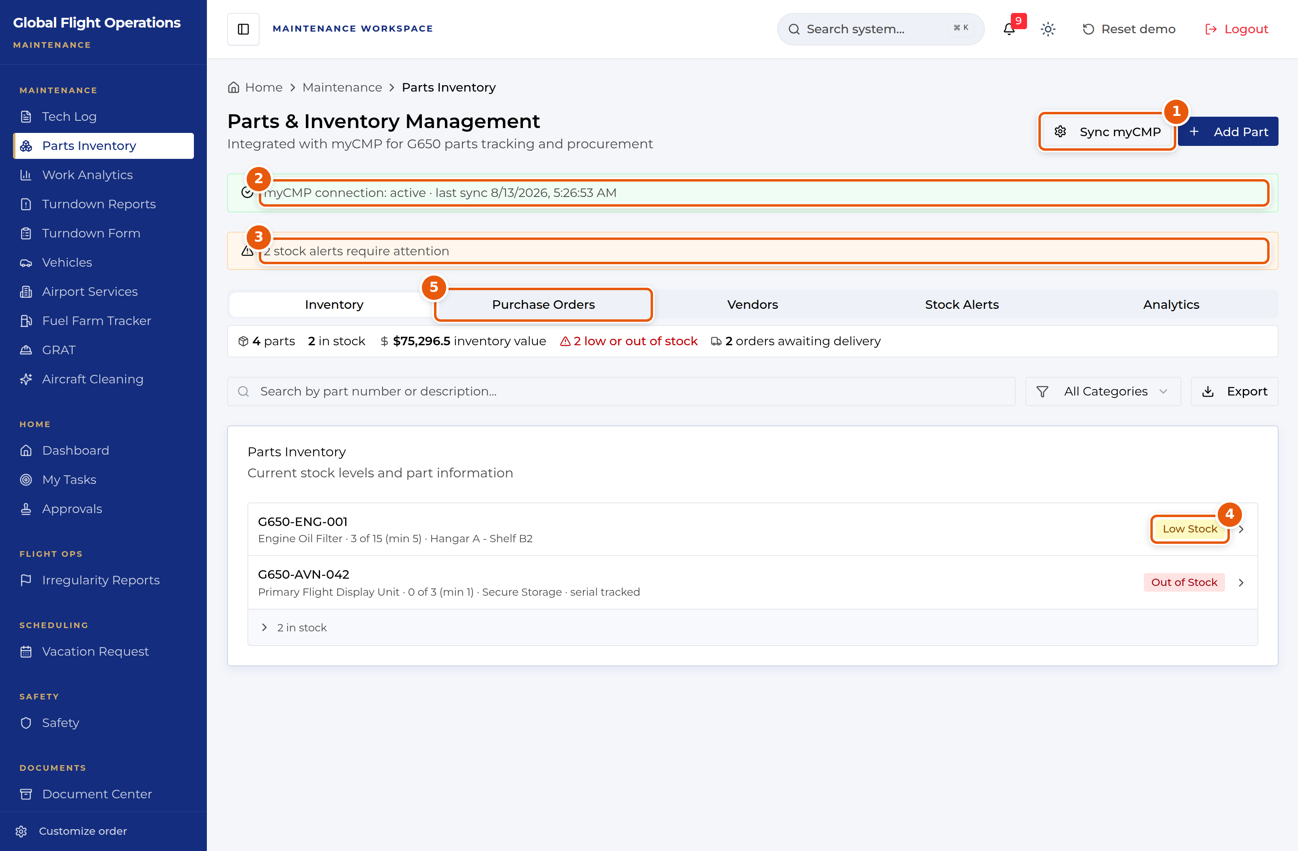
Parts & Inventory Management.
1 | Sync myCMP — refresh from myCMP.
2 | Connection state and last sync time. Check this before trusting a stock figure.
3 | Stock alerts needing attention.
4 | Stock badges — Low Stock and Out of Stock, with count against minimum.
5 | Tab strip — Inventory, Purchase Orders, Vendors, Stock Alerts, Analytics.

The daily turndown
Turndown Form is the daily shift report and the most-used page in this role. It has four parts.
Shift Information records which shift (AM or PM) and who is reporting. Facility Checklist covers the fixed end-of-shift items — commissary dishwasher started, international garbage on arrivals, hangar close up, fuel farm inspection, tool sign-out checked.
Aircraft Status is the substance: one block per tail, each recording status (In Service, Away, Not in Service), any discrepancies, who cleaned it, and fuel on board. Fill a block for every tail, including the ones with nothing to report — a blank block and an aircraft with no issues look identical to the next shift otherwise.
Additional Notes, Additional Tasks, Stockroom, Additional Facility Information and Customs and Border Protection close the form out.
Configure Form, at the top right, edits the checklist items themselves rather than filling them in.
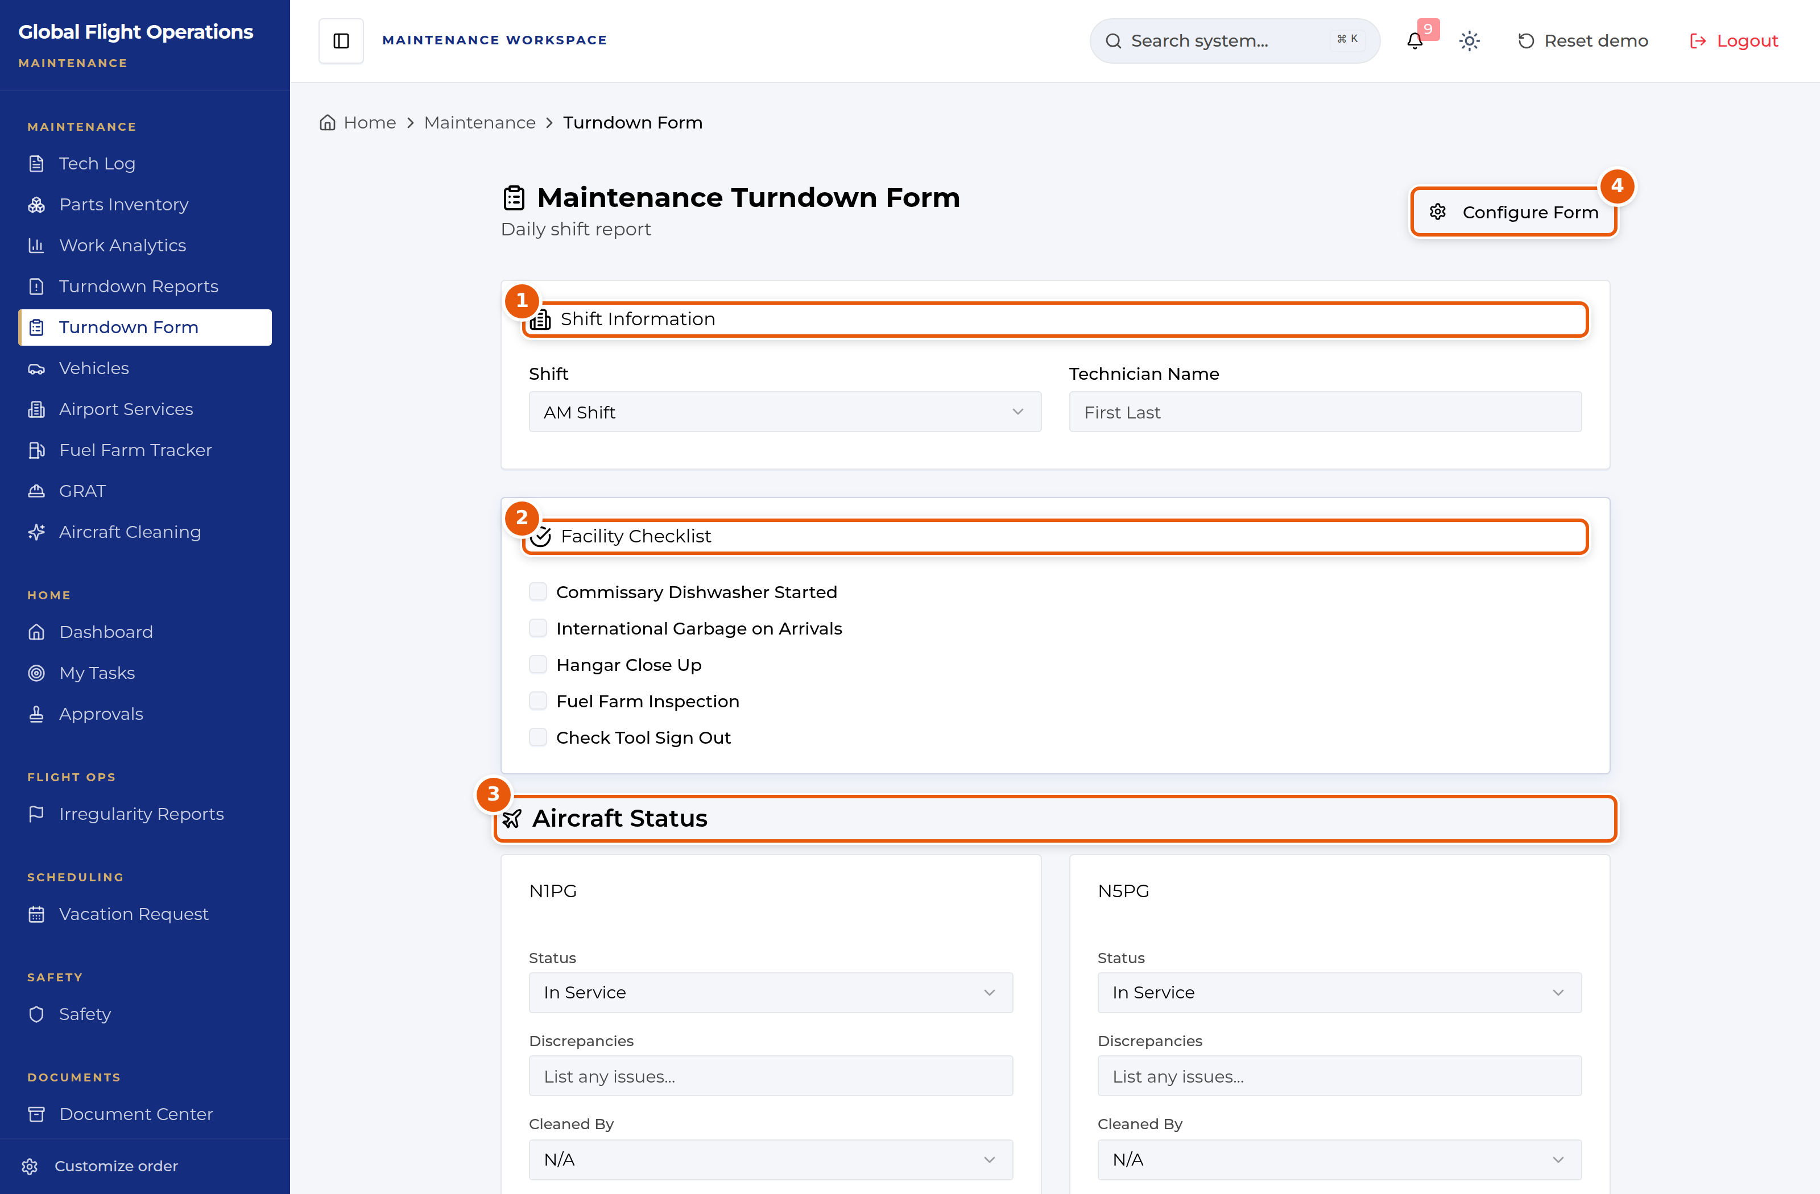
Maintenance Turndown Form — shift information, facility checklist and aircraft status.
1 | Shift Information — which shift, and who is reporting.
2 | Facility Checklist — the fixed end-of-shift items.
3 | Aircraft Status — one block per tail.
4 | Configure Form — edits the checklist itself, not this shift’s answers.

The form closes with free-text sections and the submit button. Everything above has to be complete before you submit — the report is what the next shift reads.
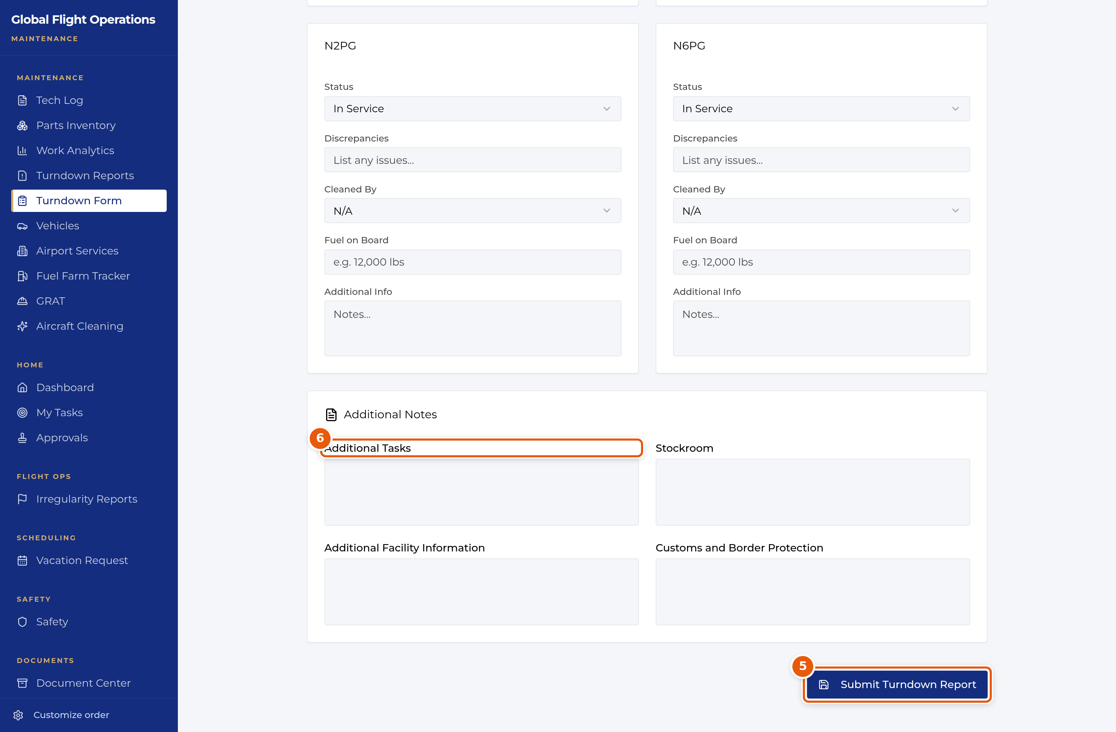
The foot of the turndown form.
5 | Submit Turndown Report.
6 | Free-text sections: additional tasks, stockroom, facility information, customs.

Reading past turndowns
Turndown Reports is the history: past shift reports with their date, shift, technician and fleet status, filterable by date and shift and searchable.
This is the page to open when you come on shift. If it reads "No reports found", no turndown has been filed for the filter you have set — widen the date range before concluding nothing was reported.
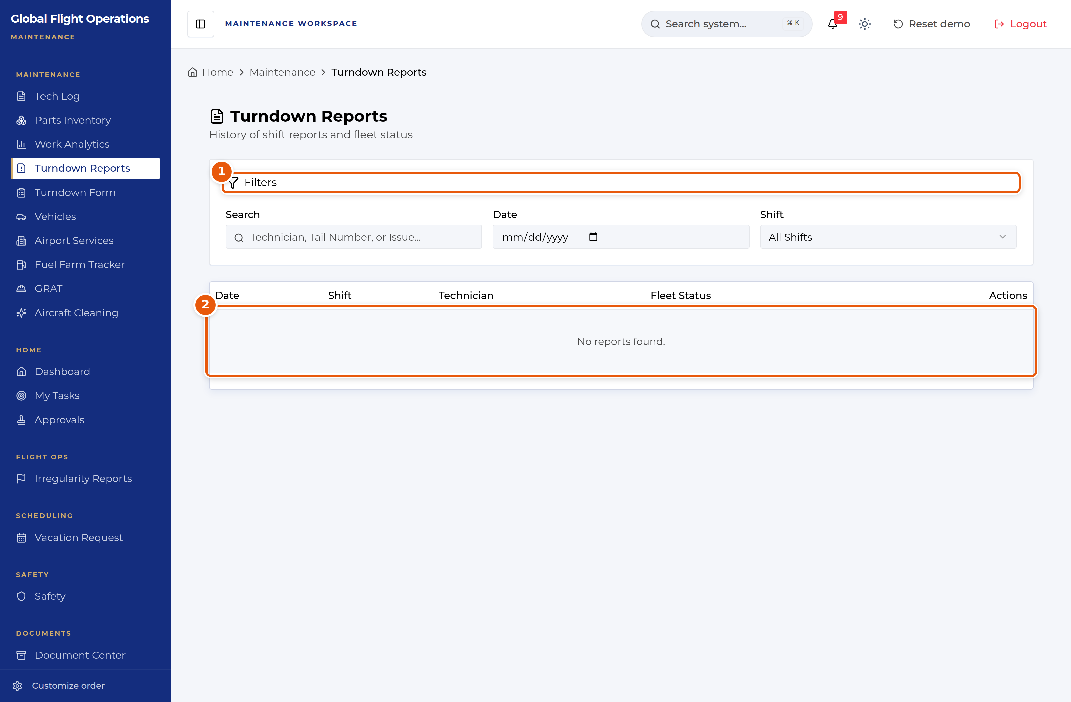
Turndown Reports, with no reports matching the current filter.
1 | Filters — date, shift and search.
2 | An empty result means nothing matched the filter, not necessarily that nothing was filed.

Ground risk assessment
GRAT scores the risk of a maintenance task before you start it, the way a FRAT scores a flight. The running score and band sit at the top and update as you tick factors: 0–10 low, 11–20 medium, 21 and above high.
Factors are grouped into General Outlook (facility and weather), Human Factors, General Conditions Activities (the work itself) and Ramp, Hangar, GSE. Each carries its point value on the row, so you can see what is driving the score.
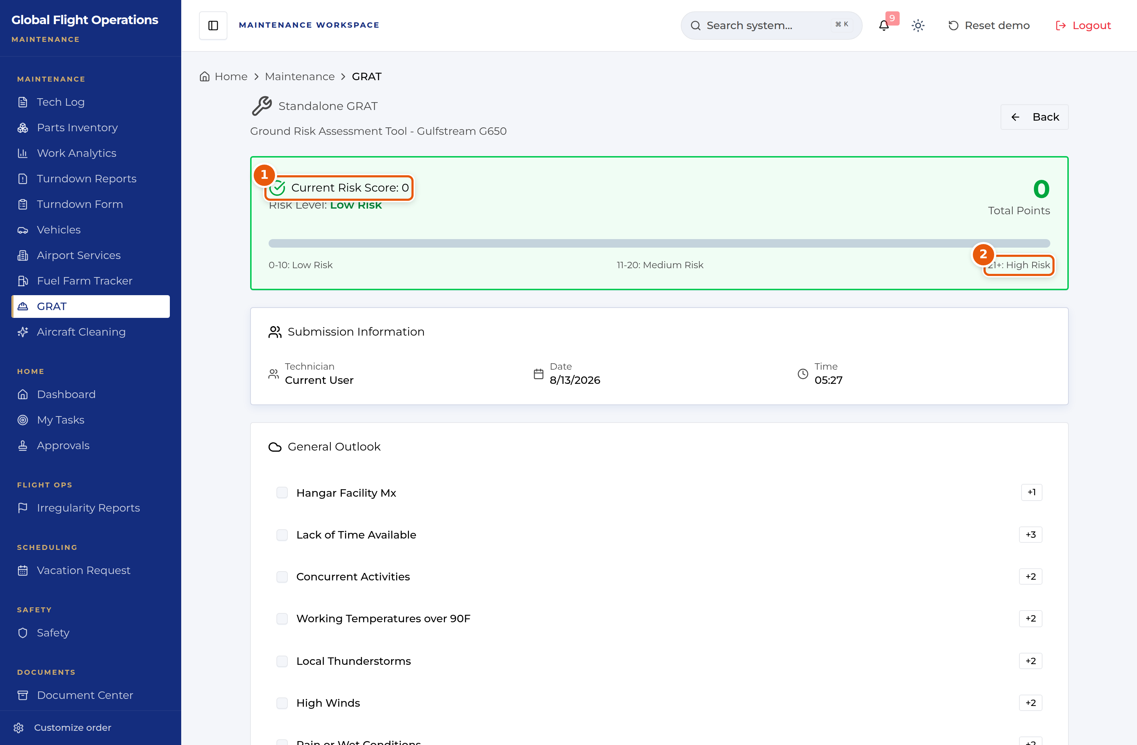
Standalone GRAT — the running score and the first factor group.
1 | Live risk score and level.
2 | The bands, printed on the form.

Human Factors is the group to read most carefully, because the heaviest weightings in the whole form live there and in the activities below it. Working Alone scores +5 on its own; the same work with an emergency notification procedure in use scores 0. Fall Protection scores +2, but Fall Protection (Lone Worker) scores +10 — the single largest factor on the form.
The pattern is deliberate: the form is telling you that working alone is what makes a task dangerous, and that the mitigation is not to work faster but to not be alone, or to have a procedure in place if you are.
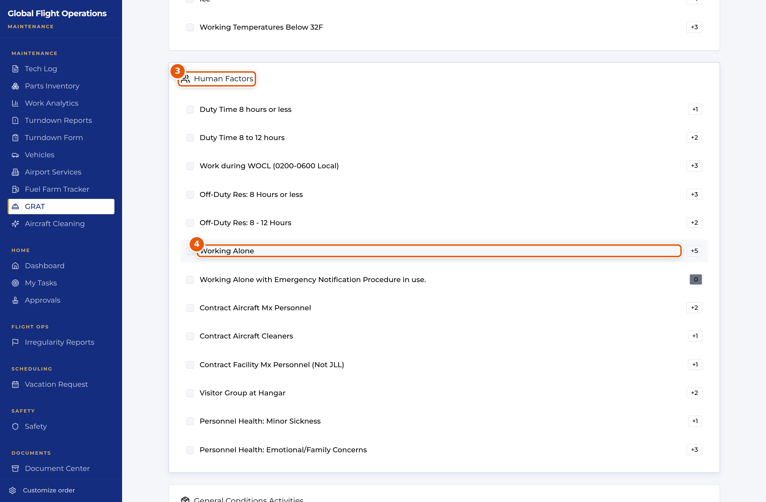
GRAT — Human Factors, where the heaviest weightings sit.
3 | Human Factors — duty time, work during the window of circadian low, rest, and who else is on site.
4 | Working Alone scores +5; with an emergency notification procedure in use it scores 0.

Fuel farm
Fuel Farm Tracker monitors fuel farm inventory and fuelling operations. The header gives the current level in gallons and as a percentage of capacity, what has been dispensed and added today, and when the figures were last updated.
Record Fueling logs fuel dispensed to an aircraft; Add Fuel logs a delivery into the farm. Every entry records start and end gallons, the amount, the technician and the resulting running total, so the tank level is auditable line by line rather than just asserted.
Three tabs split the history: Recent Activity, Aircraft Fueling Log and Fuel Farm Deliveries.
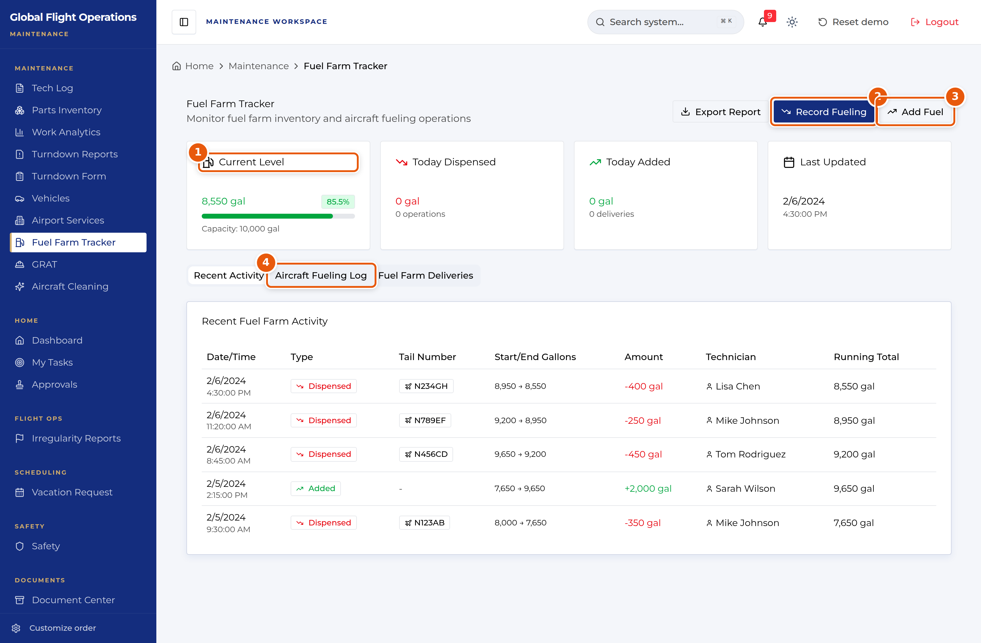
Fuel Farm Tracker.
1 | Current level, as gallons and as a percentage of capacity.
2 | Record Fueling — fuel dispensed to an aircraft.
3 | Add Fuel — a delivery into the farm.
4 | The logs, with start/end gallons and a running total on every entry.

Airport services
Airport Services holds star-rated service information for the airports the fleet uses, and tracks when each evaluation expires.
The banner at the top is the working part: it lists airports that have flights in the next 14 days and whose evaluations are expiring or already overdue. That crossing of expiry against upcoming flights is what makes it actionable — an overdue evaluation for a field nobody is flying to can wait, one with a flight on Friday cannot.
Each upcoming flight lists what it needs at that field — fuel, catering, ground power, customs clearance, light maintenance.
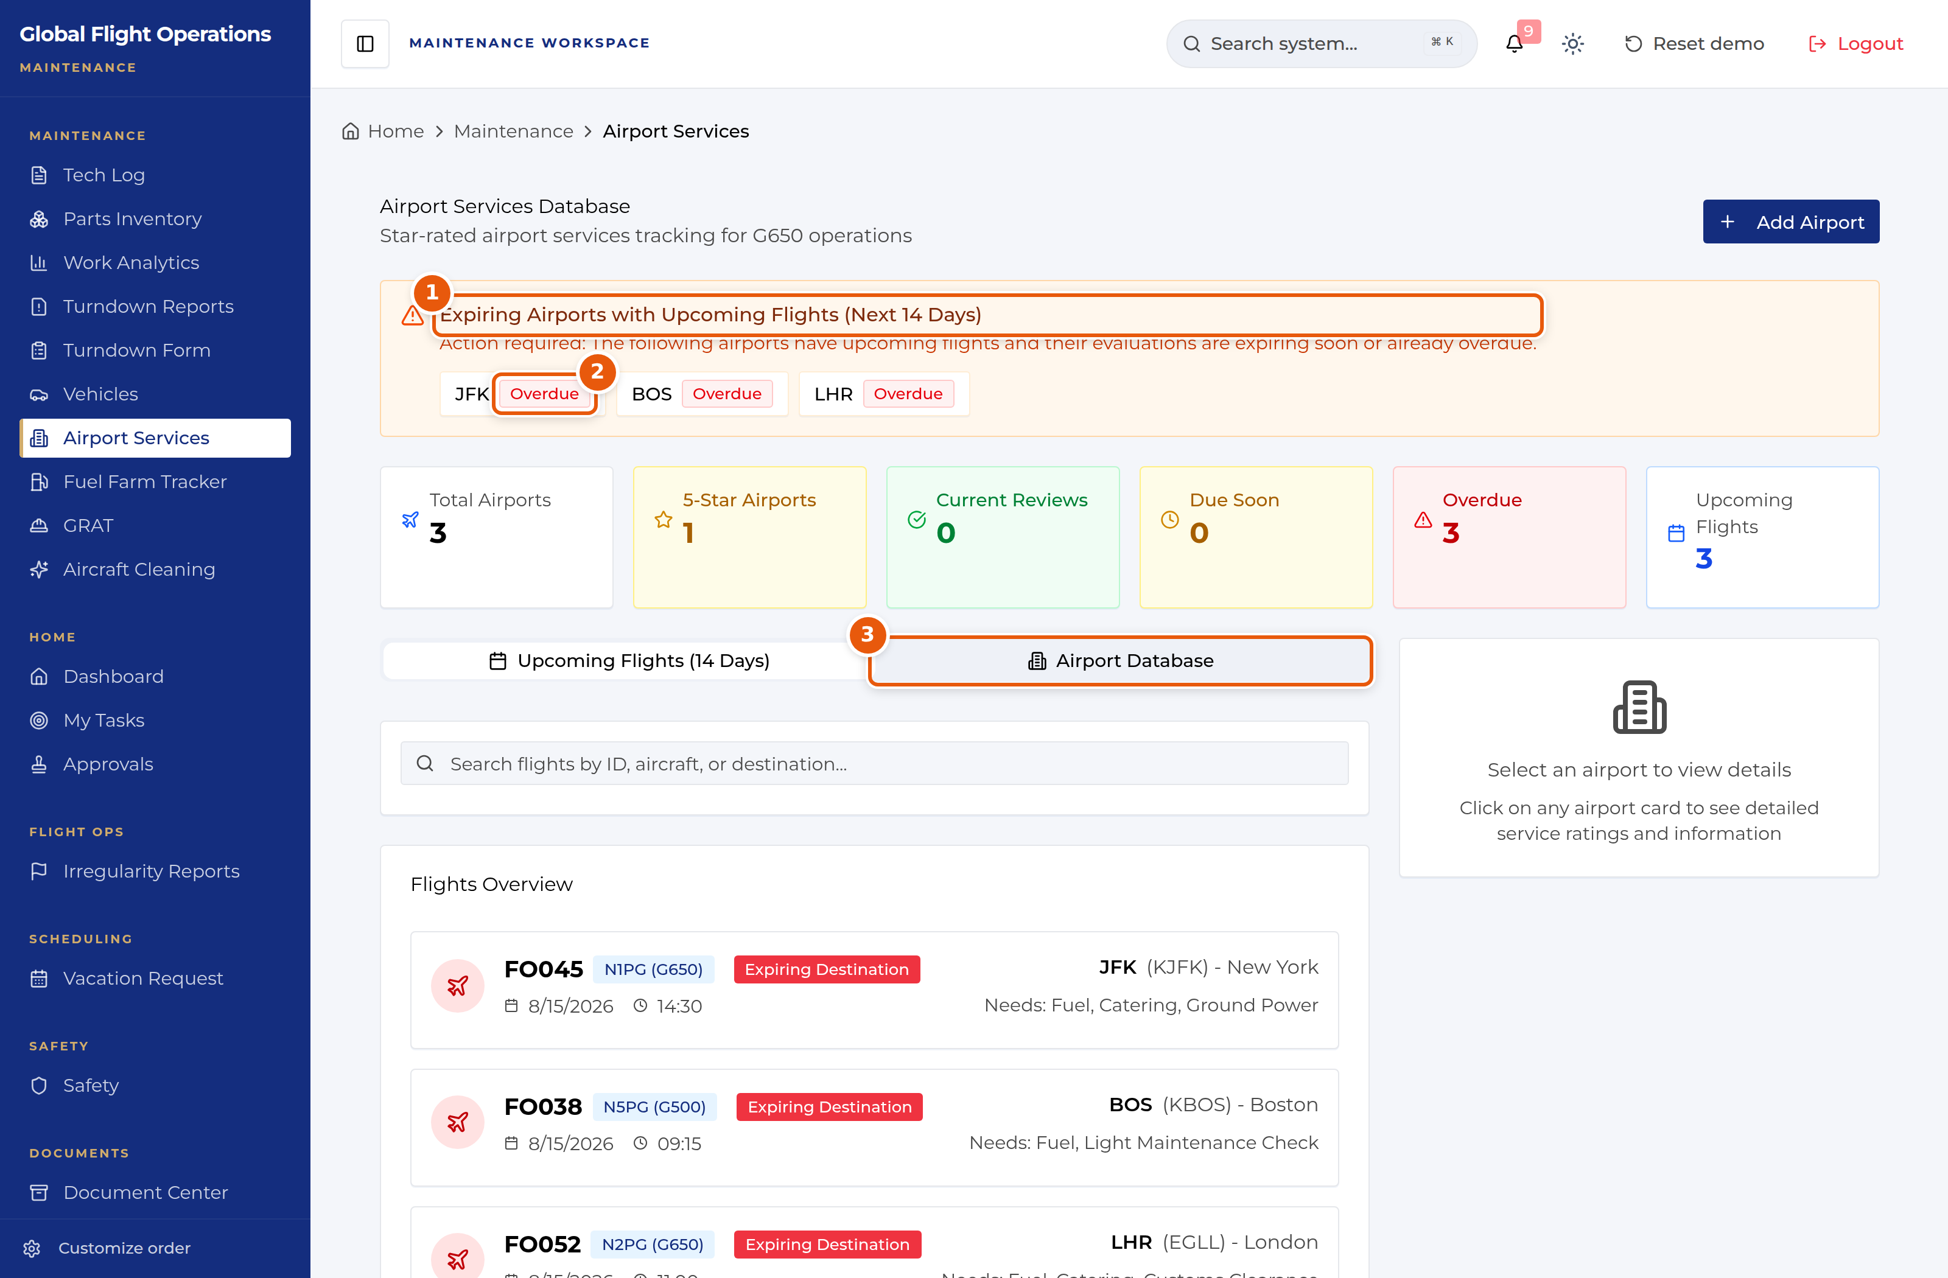
Airport Services Database.
1 | Airports with flights in the next 14 days whose evaluations are expiring or overdue.
2 | Overdue evaluations.
3 | Airport Database — the full set, with service ratings.

Vehicles
Vehicles tracks the passenger cars: check-in and check-out, assignment to a flight and passenger, current location down to the parking slot, and vehicles out for service.
Counters give total cars, available, checked in, assigned and in maintenance. Row actions follow the state — Check Out on a checked-in car, Assign and Check In on an available one, Unassign on an assigned one.
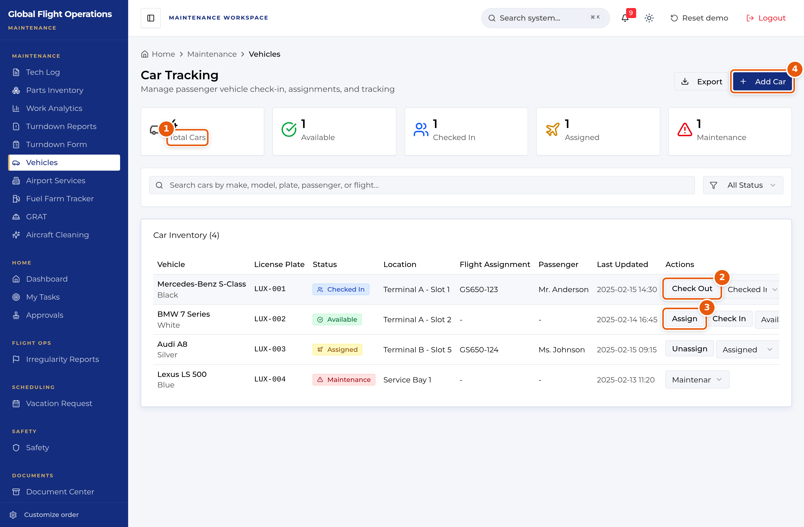
Car Tracking.
1 | Fleet counters by state.
2 | Check Out — release a checked-in vehicle.
3 | Assign — tie a vehicle to a flight and passenger.
4 | Add Car.

Work analytics
Work Analytics tracks technician hours and work orders across a chosen period, filterable by technician.
The counters give total hours, total work orders, and how many are completed and in progress. Work by Category splits the effort into Major, Minor and Ancillary. Performance Metrics gives average completion time, hours per work order and completion rate. Recent Time Entries lists individual entries with technician, work order, duration and notes.
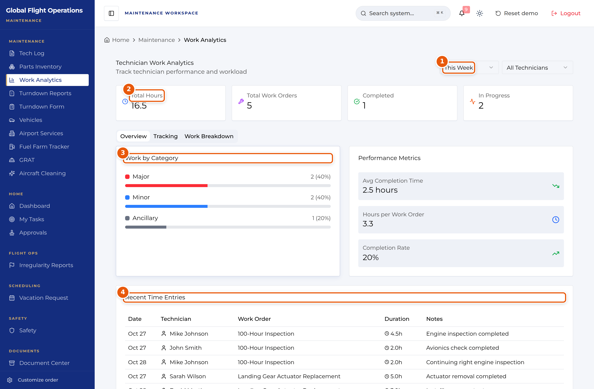
Technician Work Analytics.
1 | Period selector.
2 | Headline counters for the period.
3 | Work by Category — Major, Minor, Ancillary.
4 | Recent Time Entries, with notes.

The Dashboard
The Dashboard is the shared home page. Every role sees the same building blocks: current weather and a seven-day planning outlook, the fleet with its serviceability, the day’s flights, national airspace impacts, and who is on shift.
Treat it as a situational-awareness page, not a working page. Nothing on it is signed or filed; it tells you what is going on so you know where to go next.
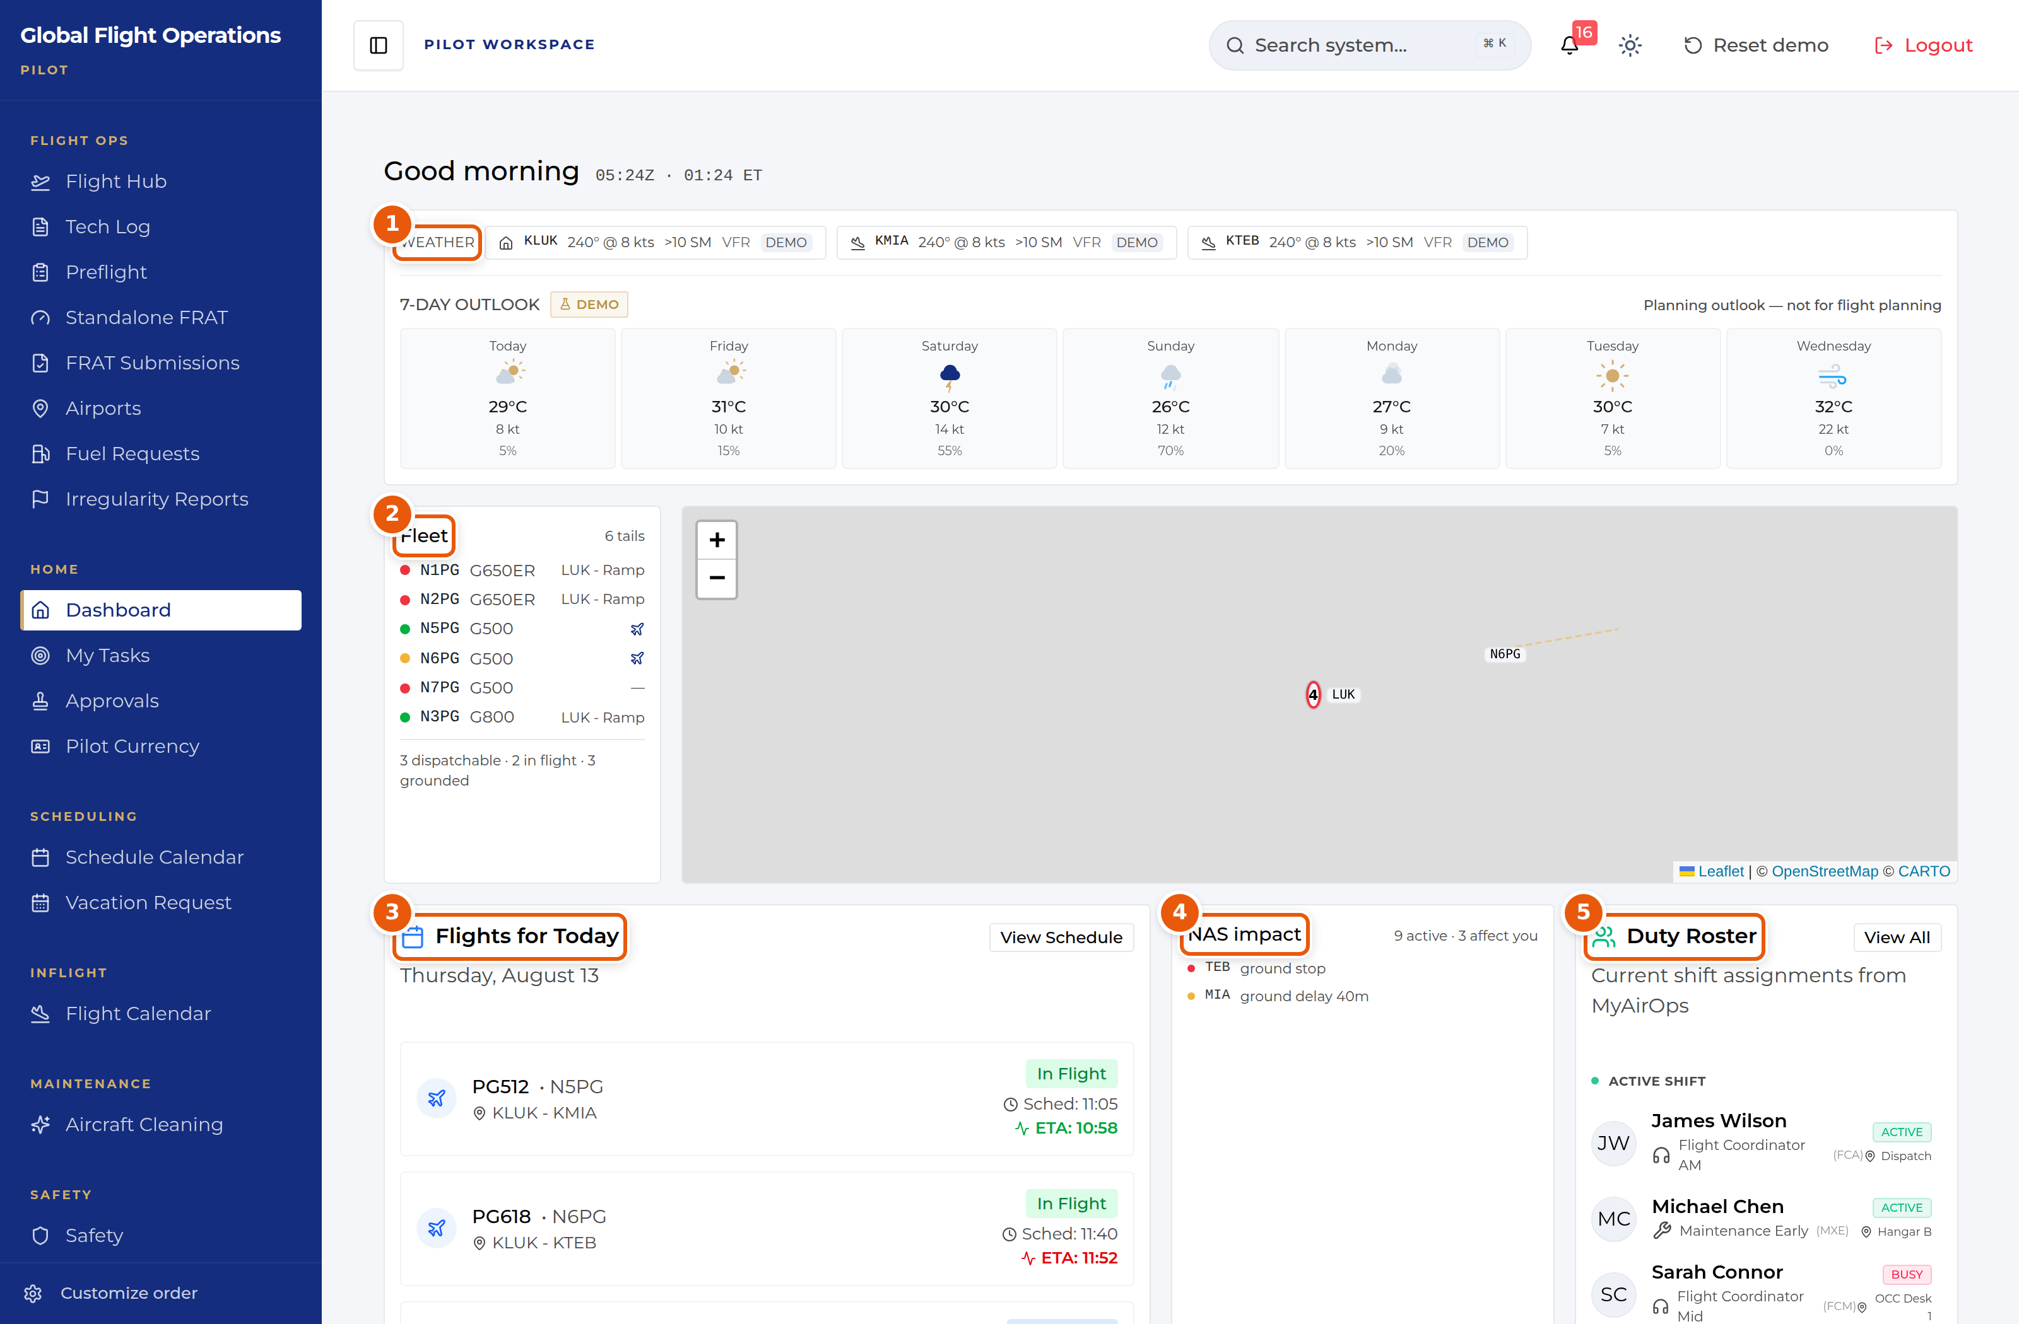
The Dashboard, shown for a Pilot. The panels are the same for every role.
1 | Weather for the home base and the stations in play, plus a seven-day outlook. The outlook is explicitly marked as a planning aid — it is not for flight planning.
2 | The fleet, one line per tail, with a coloured serviceability dot and current location. The summary line underneath counts what is dispatchable, in flight and grounded.
3 | Flights for today with scheduled time and live ETA. Where the ETA has moved away from schedule it is highlighted.
4 | NAS impact — FAA ground stops, ground delays and flow programmes, with a count of how many affect your operation.
5 | Duty Roster — who is on shift now, their function and where they are sitting.

Document Center
The Document Center holds controlled publications and tracks who has read them. It is the same page for every role; what differs is which documents are assigned to you.
My required reads is your personal queue and is the tab to work from. Each row shows the revision, the effective date, a plain-language "What changed" summary, and the acknowledgement the document demands — Read & sign, Read & initial, or Received copy. Rows that have passed their due date are marked Overdue.
Open a document, read it, and complete the acknowledgement at the end. Your outstanding count at the top of the page drops as you clear the queue.
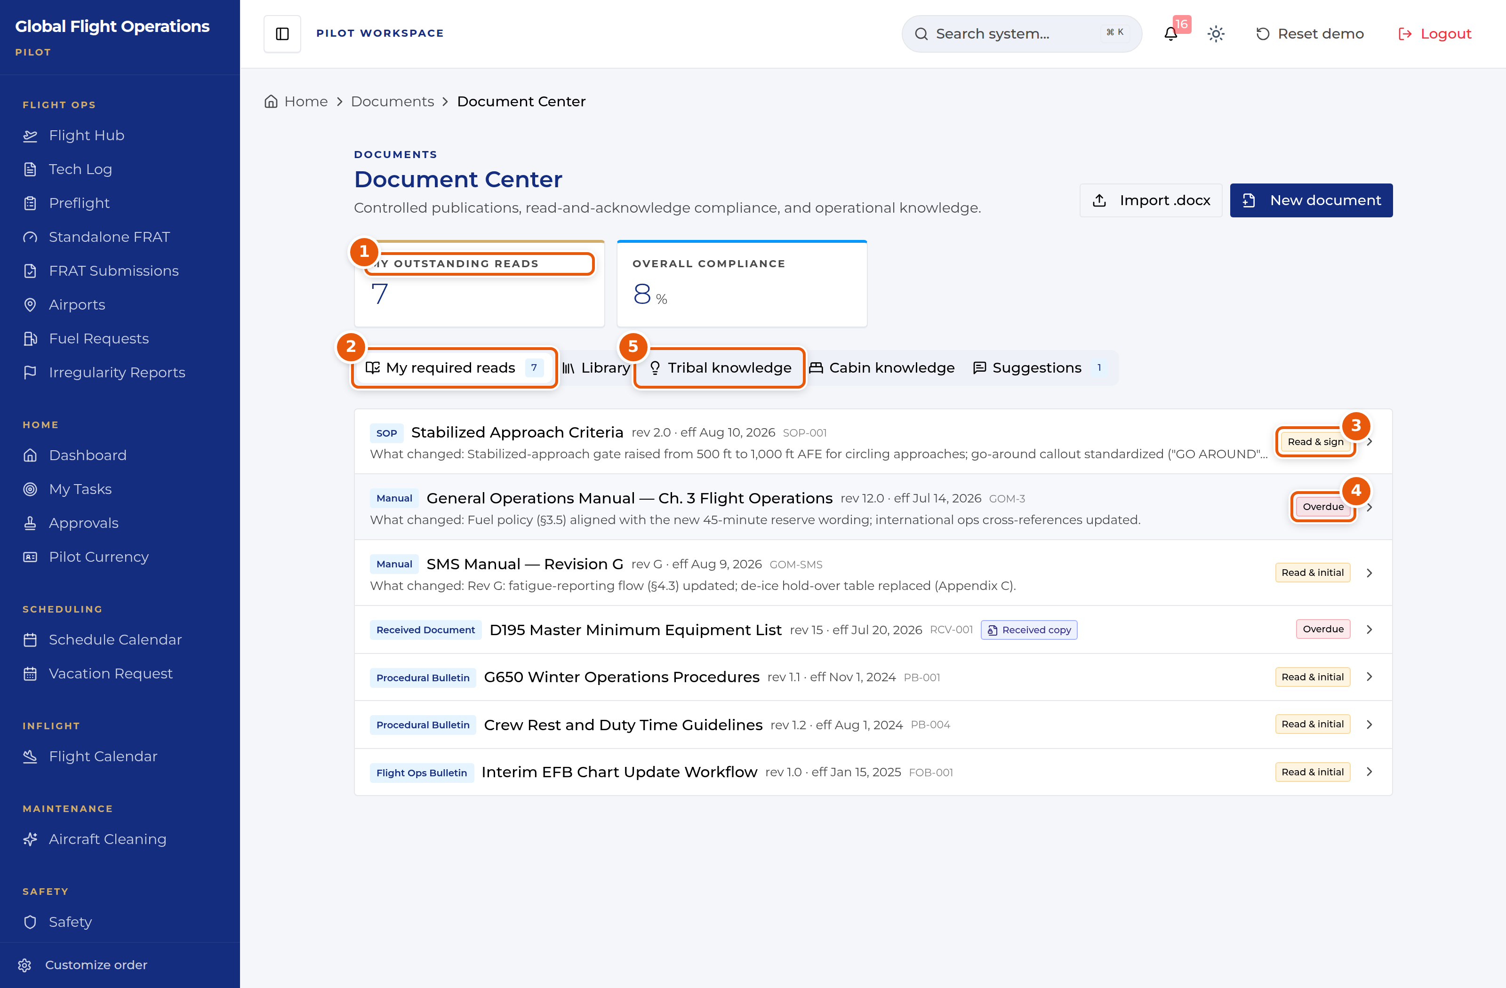
Document Center — the My required reads queue.
1 | My outstanding reads — how many acknowledgements you personally owe.
2 | Tab strip. My required reads is your queue; Library is the full controlled-document set.
3 | The acknowledgement type this document demands. Read & sign is the strongest; Read & initial and Received copy also appear.
4 | Overdue — the acknowledgement deadline has passed. Clear these first.
5 | Tribal knowledge and Cabin knowledge hold non-controlled operational know-how, kept separate from the controlled library on purpose.

Approvals
Approvals is a single inbox with two halves: requests waiting on your decision, and requests you have filed yourself. The page states which role you are acting as, because your approval authority follows your role, not your name.
Multi-step requests show their position in the chain (for example Step 2 of 2) along with what earlier approvers decided and why. Read the earlier decision before you act on yours.
You can Approve, Deny, or Add a comment. Use View request details to see the full submission before deciding.
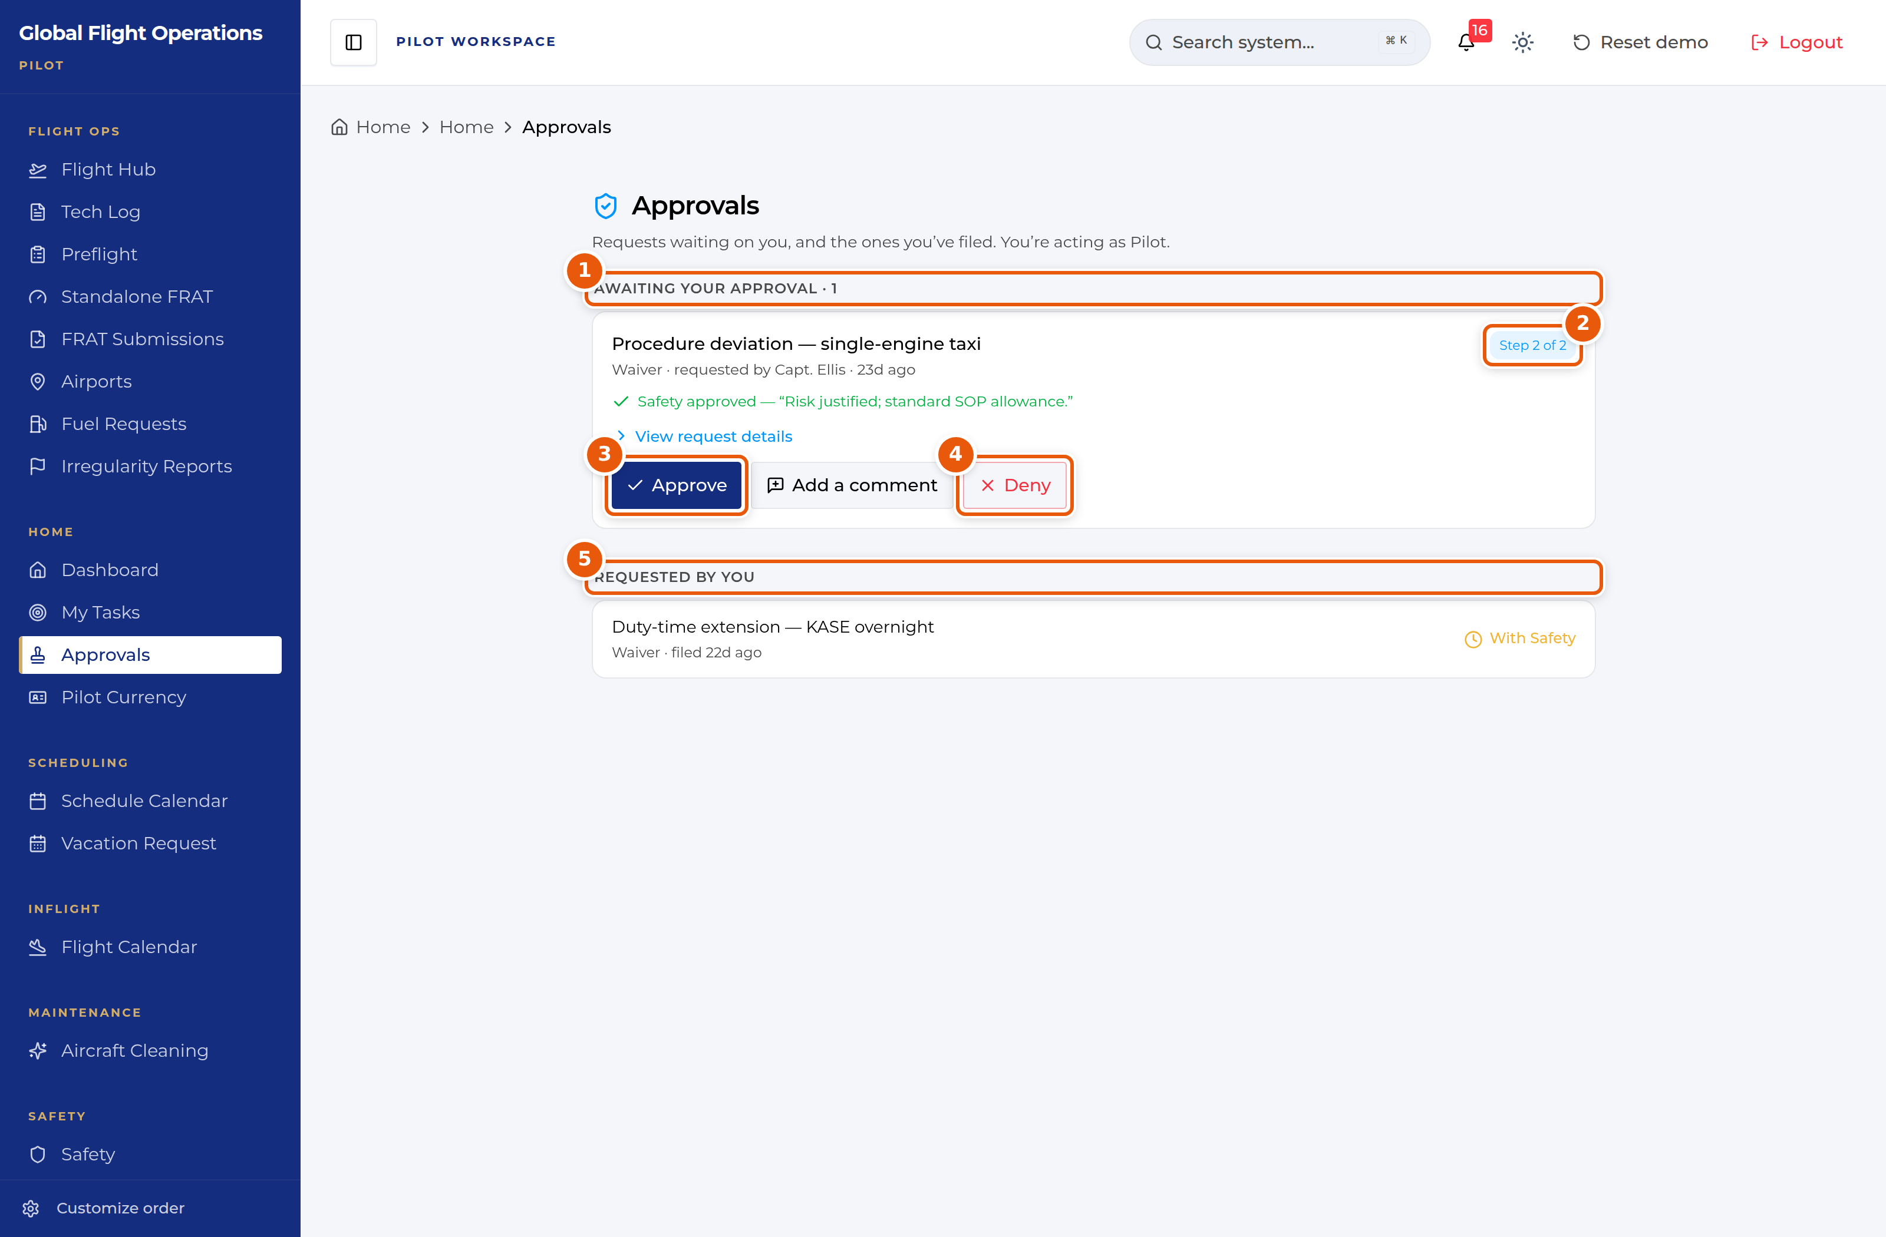
Approvals, shown while acting as Maintenance.
1 | Awaiting your approval, with a count. This is the half you owe action on.
2 | Where this request sits in its approval chain.
3 | Approve — records your decision against your role.
4 | Deny — also records against your role. Add a comment first if the reason is not obvious.
5 | Requested by you — what you have filed, and where each request currently sits.

Vacation and time off
Vacation Request handles vacation, payback stop days (PBST), off days and medical leave through one form.
The page has four tabs: Submit Request, My Requests, Master Calendar and PBST Balance. Check PBST Balance before you file — awarded stop days carry an expiry date, and the balance panel shows how many days are left on each.
On Submit Request choose the request type, set the start and end dates, and add a reason. If you want to spend awarded PBST days against the request, tick them under Apply Available PBST Days before submitting.
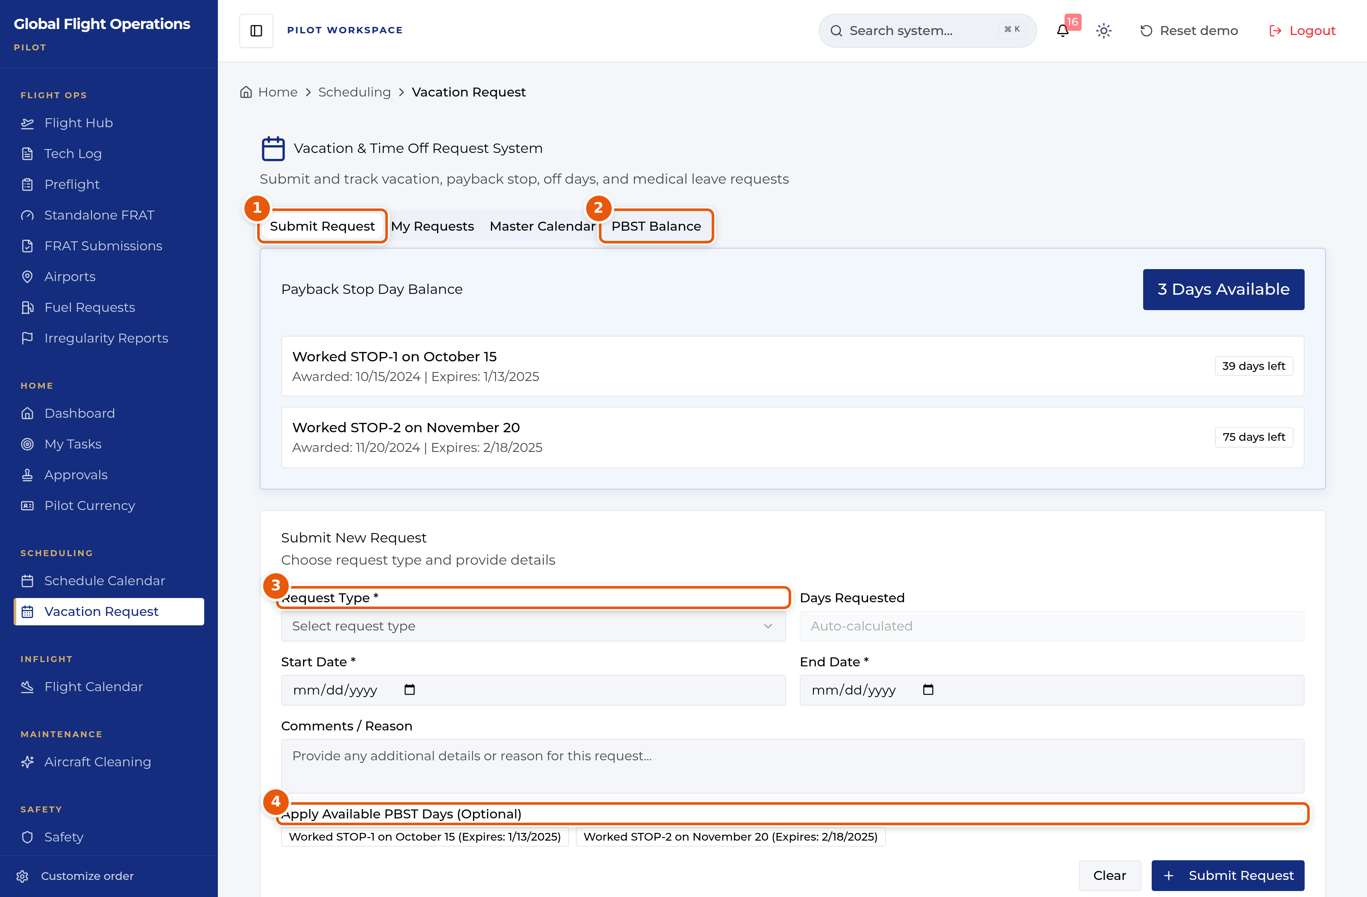
Vacation and time-off request form.
1 | Tab strip — Submit Request, My Requests, Master Calendar, PBST Balance.
2 | PBST Balance shows each awarded stop day, when it was awarded and when it expires.
3 | Request Type drives the rest of the form. Set it first.
4 | Optionally apply awarded PBST days to this request. Expiry dates are shown so you can spend the oldest first.

