myGFO
Global Flight Operations
Pilot
Training Guide

Everything a line pilot does in myGFO: reading your trips, working preflight, filing risk assessments, requesting fuel, keeping your currency visible, and clearing your required reading.
WHO THIS IS FOR
Line pilots flying the G650ER, G500 and G800 fleet.
Also the base document for the Chief Pilot — read this first, then the Chief Pilot supplement.

SCOPE OF THIS GUIDE
This guide covers the day-to-day myGFO screens for this role. Three modules are documented separately and are deliberately not covered here: the Tech Log, Irregularity Reports (FIR), and the Scheduling Command Center. The Safety module is also out of scope — it is not in service yet.
You will still see those items in your sidebar. Ignore them for the purposes of this guide.

Getting started
Screenshots in this guide come from the myGFO prototype running on demo data. Tail numbers, names, dates and counts are illustrative — the screen layout, buttons and workflow are what matter.

Where you land
After sign-in you land on the Flight Hub. It is the page to start every day on.
Front door: Flight Hub (Pilot Workspace).

Your sidebar at a glance
Your role decides which of these appear. Pages are grouped in the sidebar as shown.
Page | Sidebar group | What it is for
Flight Hub | Flight Ops | Your trips, leg by leg, with what each one still needs
Preflight | Flight Ops | Trip-by-trip preflight progress and FRAT completion
Standalone FRAT | Flight Ops | File a flight risk assessment outside a trip
FRAT Submissions | Flight Ops | Your own FRAT history: drafts, pending, approved, rejected
Airports | Flight Ops | Airport directory, company pages and operational flags
Fuel Requests | Flight Ops | Submit and track fuel load requests
Dashboard | Home | Weather, fleet, today’s flights, airspace, duty roster
My Tasks | Home | Action items assigned to you and your own tasks
Approvals | Home | Requests waiting on you, and ones you filed
Pilot Currency | Home | Your currency against 14 CFR Part 91 minimums
Schedule Calendar | Scheduling | Month view of fleet and personal assignments
Vacation Request | Scheduling | Vacation, PBST, off days, medical leave
Flight Calendar | Inflight | Your assignments with passenger manifests
Aircraft Cleaning | Maintenance | Cleaning workflow status by tail
Document Center | Documents | Controlled publications and your required reads

Signing in
myGFO opens on a demo password screen. Enter the password your administrator gave you and choose Continue.
On the next screen, open Select Your Role, choose your role, and choose Access Dashboard. Your role decides which pages appear in the left sidebar and where you land after sign-in — two people can be looking at the same system and see a different set of pages.
If you hold more than one role, sign in under the one matching the work you are about to do. You can sign out and back in under the other role at any time using Logout at the top right.

Flight Hub — your day starts here
Flight Hub answers one question: what do my trips still need from me? Trips are grouped by urgency — In Progress, This Week, Next 2 Weeks — and each card carries a row of readiness chips.
The chips are the point of the page. Each names a prerequisite (FRAT, Fuel, aircraft serviceability, Sched) and shows whether it is satisfied. A chip with a count beside it, such as FRAT · 2, means that many items are still outstanding on that trip. A red Grounded chip means the assigned tail is not currently dispatchable.
Trips needing work carry a NEEDS PREP badge. The filter buttons across the top narrow the list to Domestic, Int’l or DASSP trips, and Needs prep only hides everything already squared away.
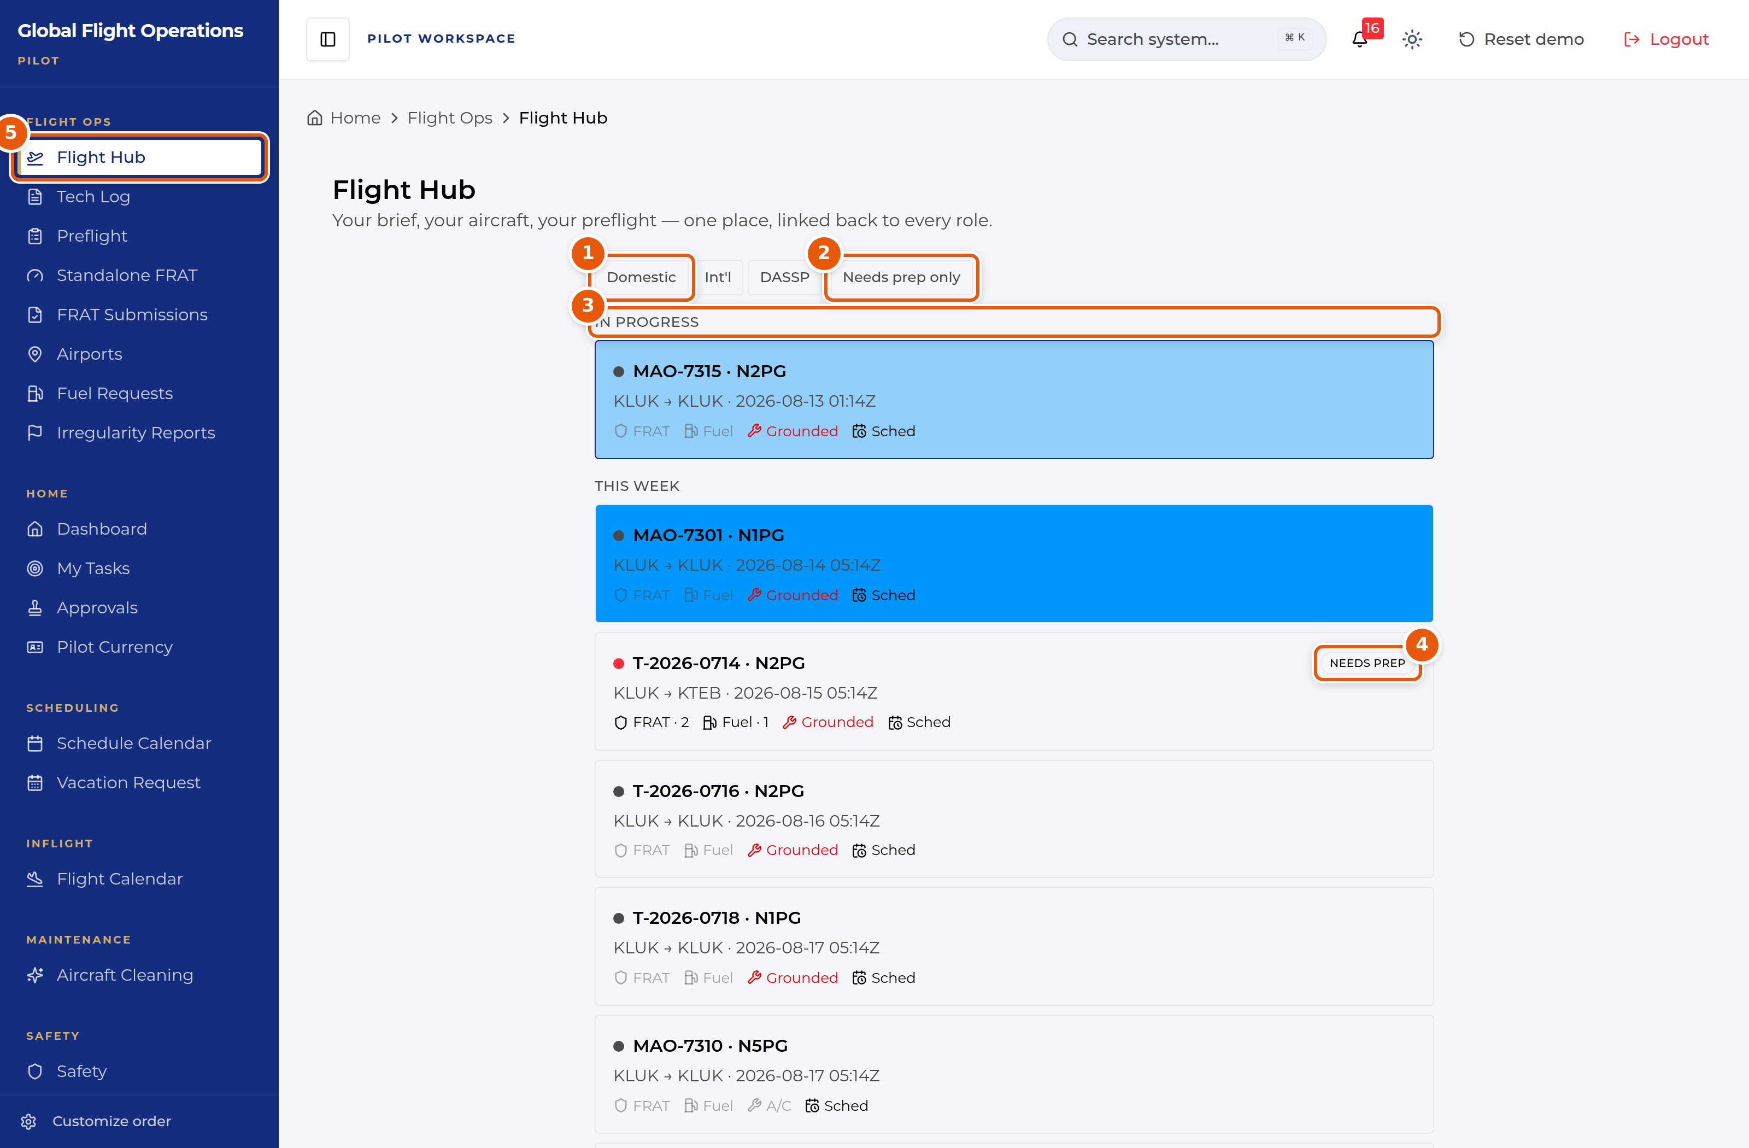
Flight Hub, filtered to show all trips.
1 | Trip-type filters — Domestic, Int’l, DASSP. International and DASSP trips carry extra prerequisites.
2 | Needs prep only — the fastest way to see just the trips still owing you work.
3 | Urgency grouping. In Progress is live now; This Week and Next 2 Weeks follow.
4 | NEEDS PREP — this trip has outstanding prerequisites. The chips underneath say which.
5 | Flight Hub in the sidebar, highlighted as the current page.

Working preflight
Preflight is the working view behind those Flight Hub chips. It lists your active trips with a progress bar reading "Preflight Progress: n/m legs completed", so you can see at a glance how far through a multi-leg trip you are.
The counters across the top summarise your whole workload: Active Trips, Pending FRATs, Completed and Total Legs.
Each trip row carries three actions. Request Fuel opens a fuel load request pre-filled for that trip. Export PDF produces a preflight package. ForeFlight pushes the trip to ForeFlight.
Sync MyAirOps at the top right pulls the current trip and crew assignments from myairops. myGFO reads from myairops and never writes back to it, so a correction made here does not reach myairops — it has to be made there.
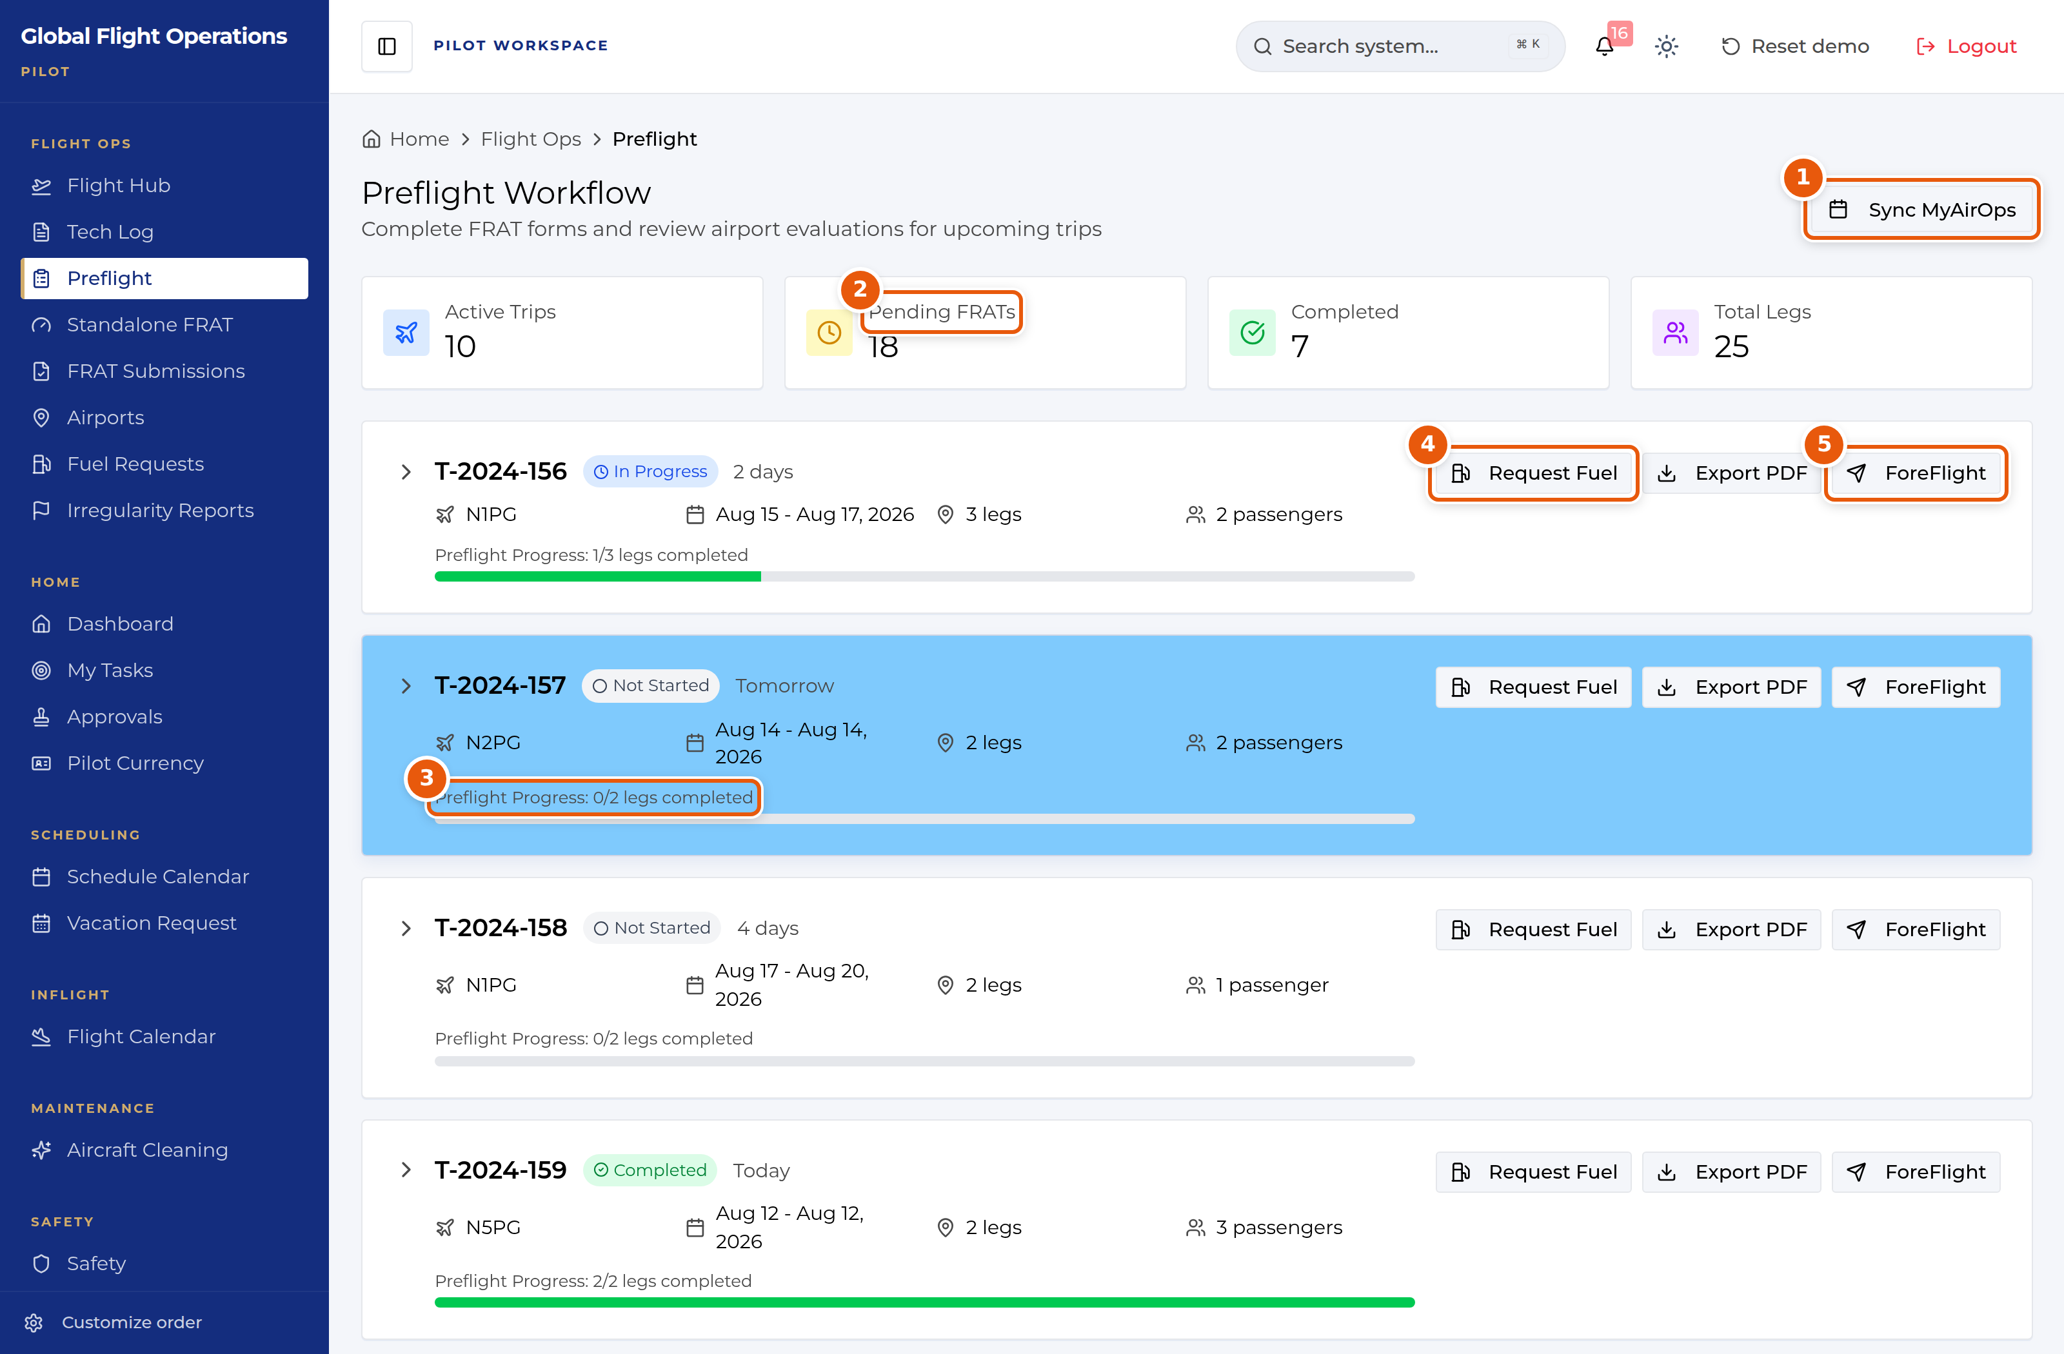
Preflight Workflow, listing active trips and their completion.
1 | Sync MyAirOps — refreshes trips and crew from myairops. Pull only; nothing is written back.
2 | Workload counters across all your trips.
3 | Per-trip progress: how many legs are preflighted out of the total.
4 | Request Fuel — opens a fuel load request already tied to this trip.
5 | ForeFlight — pushes the trip across to ForeFlight.

Filing a FRAT
The Flight Risk Assessment Tool scores a flight’s risk from a set of weighted factors. Most FRATs are filed from inside a trip; Standalone FRAT files one against a flight that is not on a trip yet.
The score band sits at the top of the form and updates live as you answer. The bands are printed on the form: 0–10 low, 11–19 medium, 20 requires mitigation, and 25 is a no-go. Watch the running total as you work rather than waiting until the end.
Flight Information auto-populates from myairops once you pick a flight. Every field stays editable — if the pulled data is wrong, correct it here, and remember the correction does not flow back to myairops.
The remaining groups (Pilot Qualifications, Flight Crew Duty Day, Departure Airport, Destination Airport, Trip Details, Weather, Other) each contribute points.
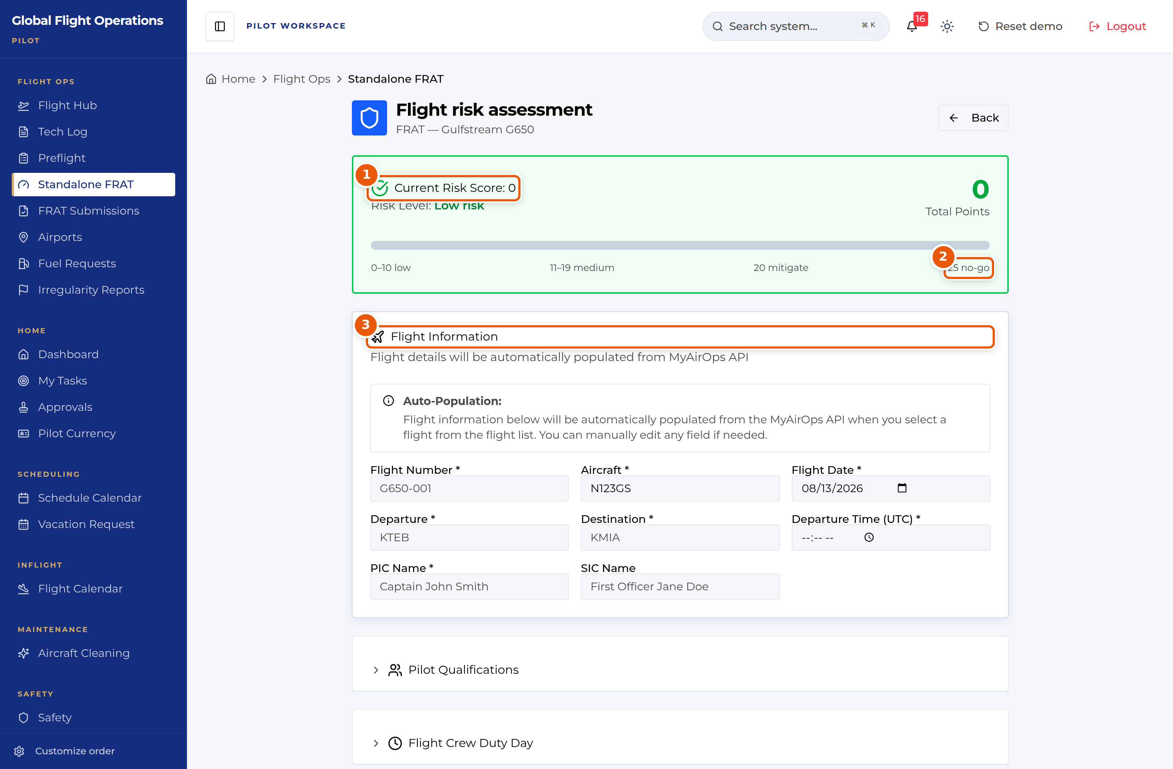
Standalone FRAT — the top of the form, with the live score band.
1 | Live risk score and level. It recalculates as you answer.
2 | The score bands, printed on the form. 20 requires mitigation; 25 is a no-go.
3 | Flight Information — auto-populated from myairops, and editable.

At the foot of the form, Save Draft parks an incomplete assessment in your FRAT Submissions list; Submit FRAT files it for review. Add anything the scoring factors do not capture under Additional Notes before you submit.
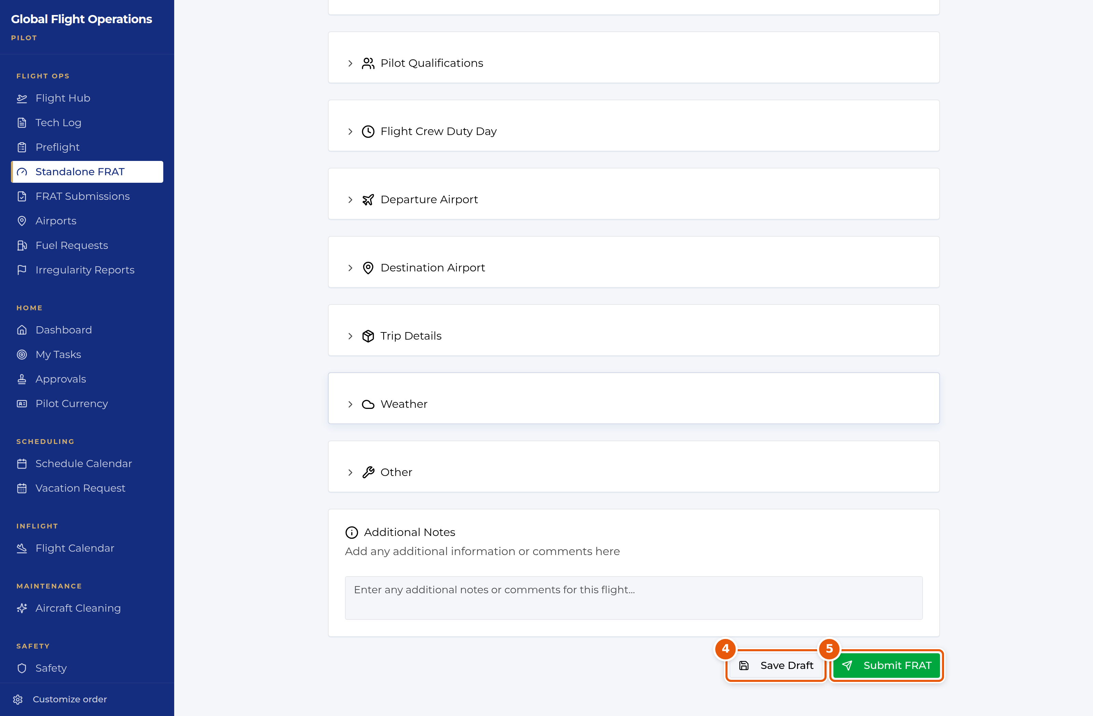
The foot of the FRAT form.
4 | Save Draft — keeps an incomplete FRAT in your submissions list to finish later.
5 | Submit FRAT — files the assessment for review.

Tracking your FRAT submissions
FRAT Submissions is your own history, split by state: Drafts, Pending Review, Approved and Rejected. A rejected FRAT needs revision and resubmission — it does not clear itself.
Filters for status and time period sit above the list, and the list can be shown as a list or as cards.

Requesting fuel
Fuel Requests has two tabs: Upcoming Flights, which is where you raise a request, and My Requests, which tracks the ones you have already filed.
Choose the flight from Select Flight and the form pulls in its details, then specify the fuel requirement. Raising the request from the Preflight page instead pre-selects the flight for you.
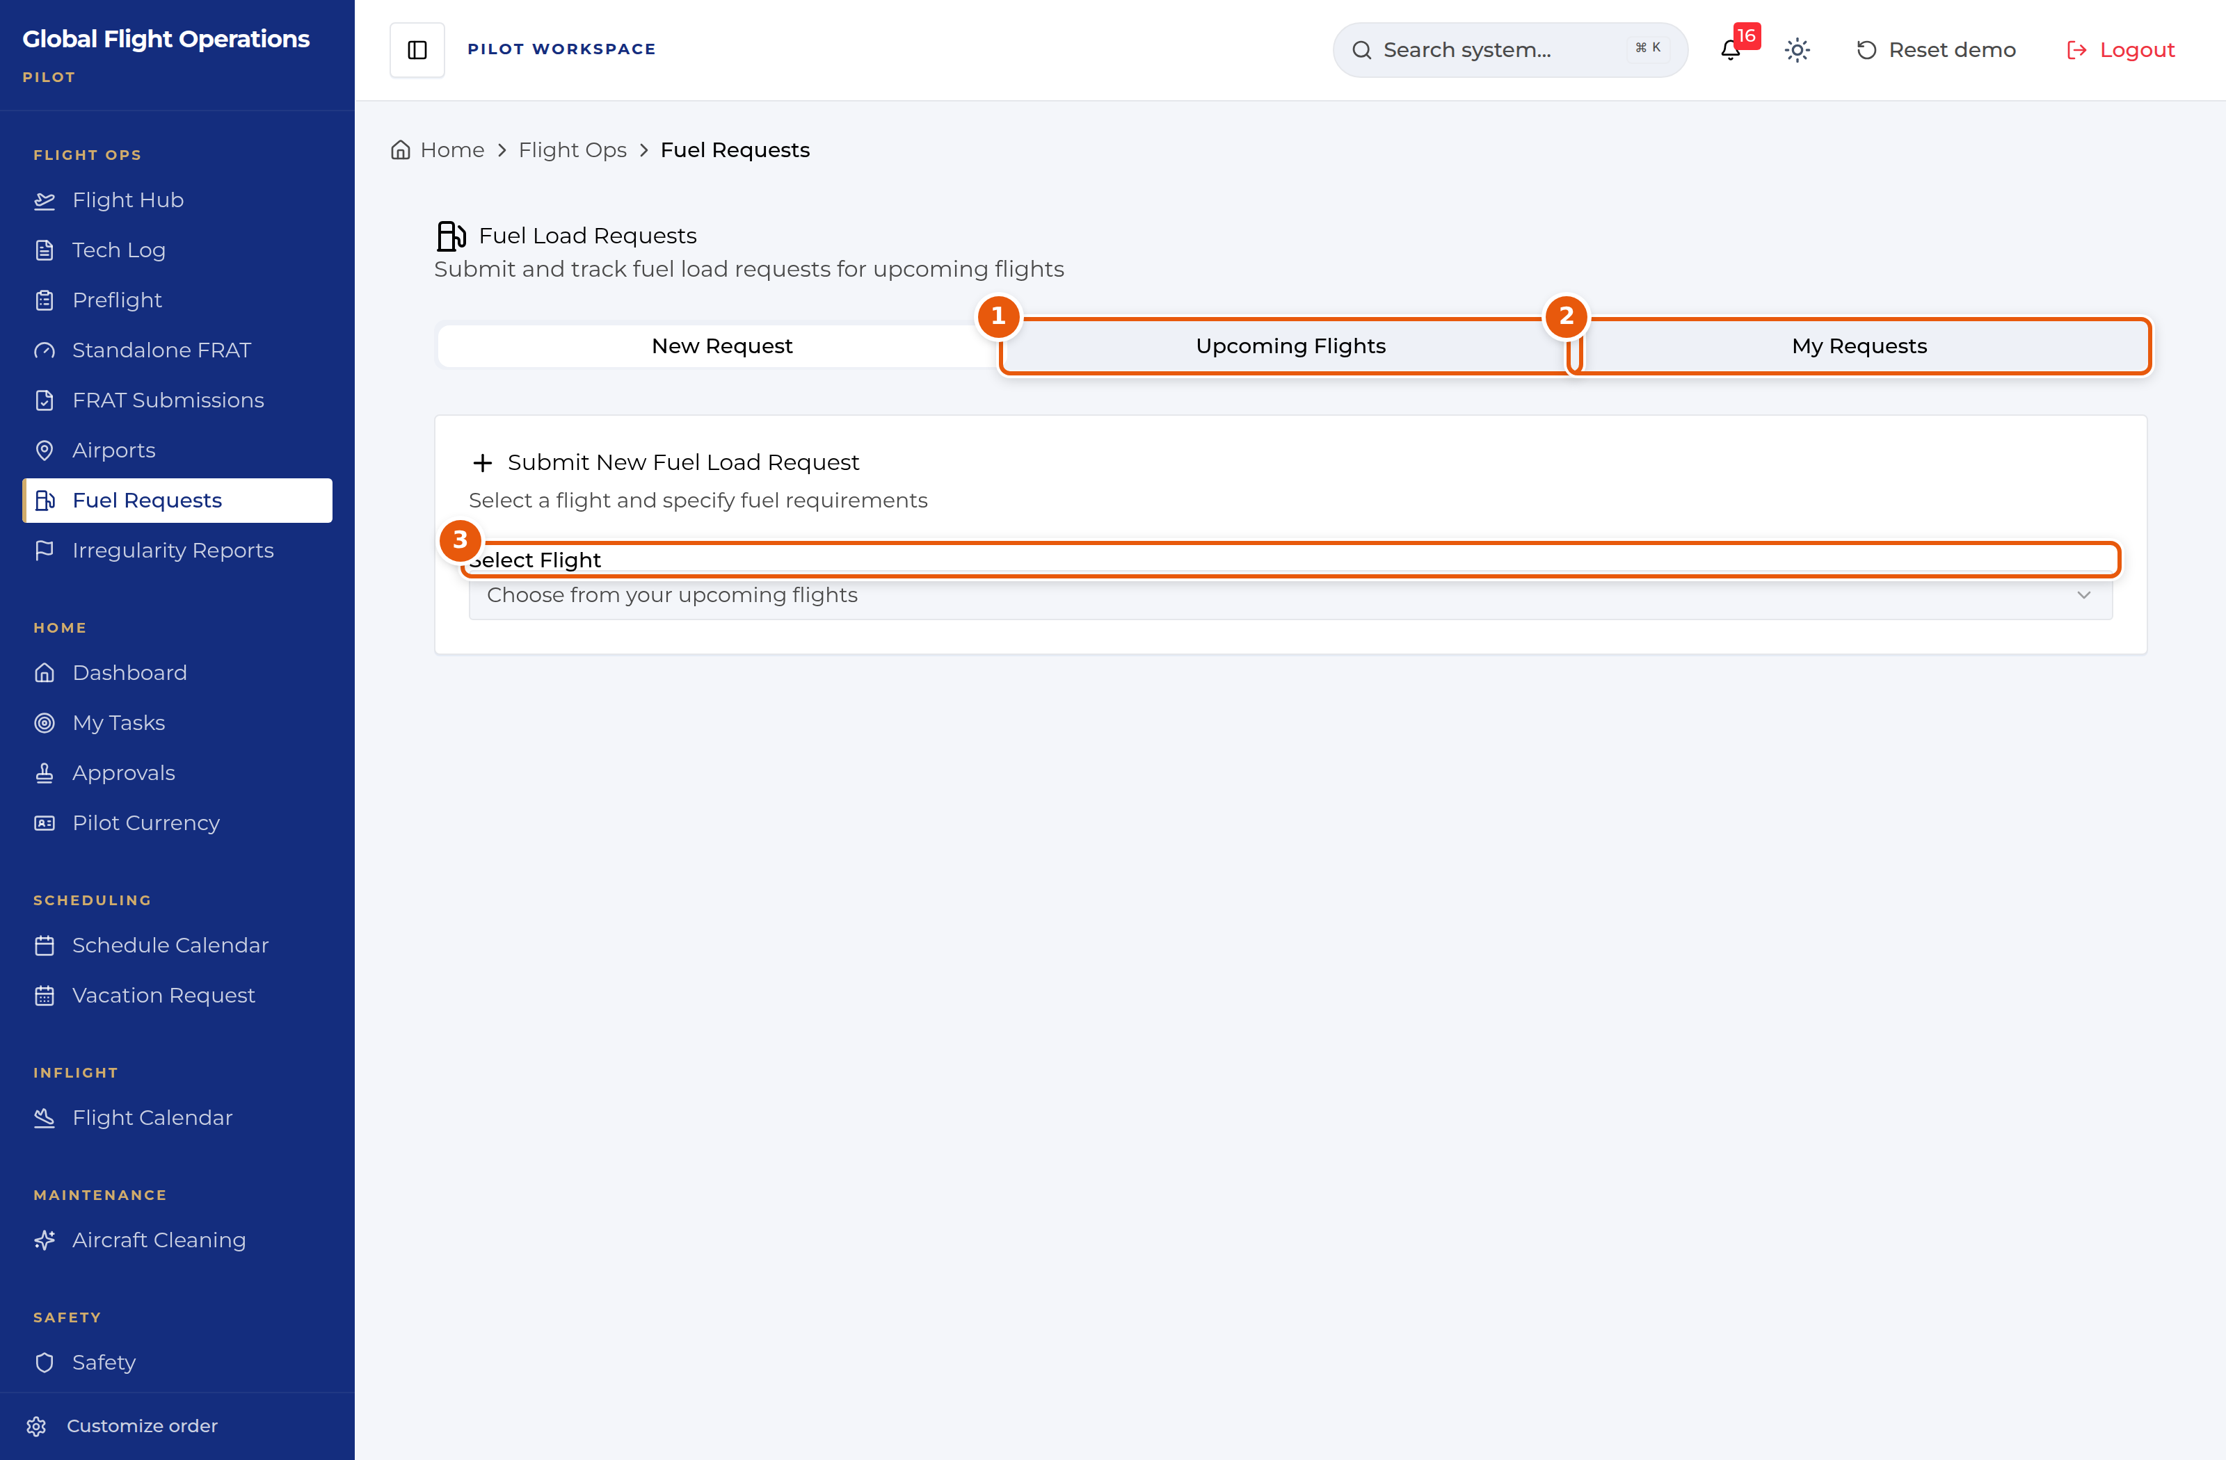
Fuel Load Requests — raising a new request.
1 | Upcoming Flights — the tab to raise a new request from.
2 | My Requests — the ones you have already filed, with their status.
3 | Select Flight — pick the flight and the request is tied to it.

Your currency
The Currency Dashboard tracks crew against 14 CFR Part 91 minimums. It has a tab for Pilots and one for Flight Attendants, and the counters at the top right summarise the population as Current, Due Soon or Expired.
Currency is tracked per aircraft type, so one pilot can be current on one type and expired on another — the row expands to a line per type. Each column shows achieved against required with the look-back window underneath: General 90d, Night 90d/Alt, Inst. Appr. 6mo, Holds 6mo, and the 61.58 proficiency check at 12mo. An ALT badge marks the alternate night-currency provision.
The regulatory reference is printed at the foot of the page so you can check the rule behind each column without leaving it.
Data auto-syncs from myairops; Sync forces a refresh. If a number here looks wrong, the fix belongs in myairops.
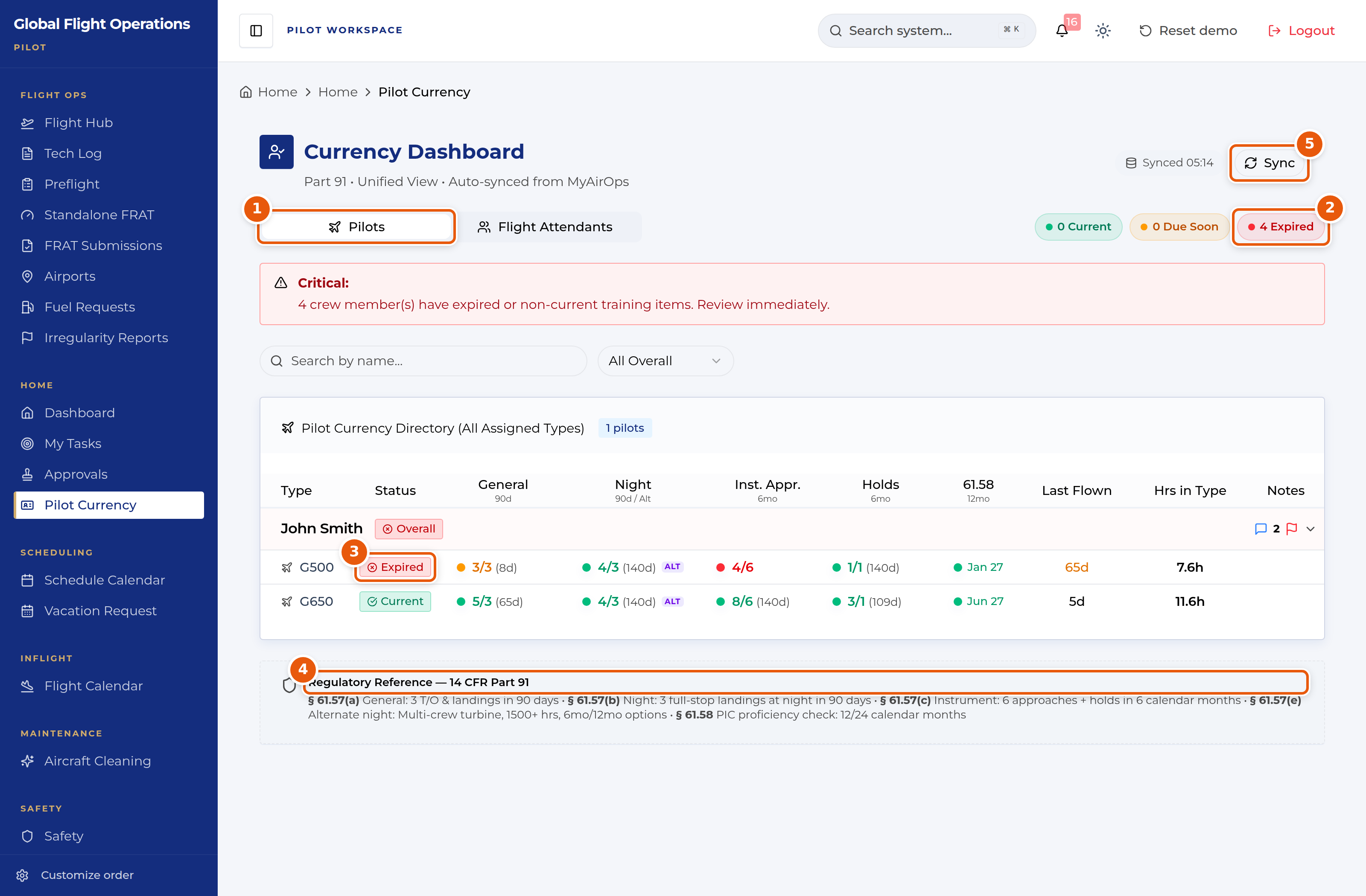
Currency Dashboard, showing per-type currency for one pilot.
1 | Pilots / Flight Attendants tabs.
2 | Population summary — Current, Due Soon, Expired.
3 | Per-type status. Expired on one type does not mean expired on another.
4 | The Part 91 rule behind each column, printed on the page.
5 | Sync — forces a refresh from myairops.

The Dashboard
The Dashboard is the shared home page. Every role sees the same building blocks: current weather and a seven-day planning outlook, the fleet with its serviceability, the day’s flights, national airspace impacts, and who is on shift.
Treat it as a situational-awareness page, not a working page. Nothing on it is signed or filed; it tells you what is going on so you know where to go next.
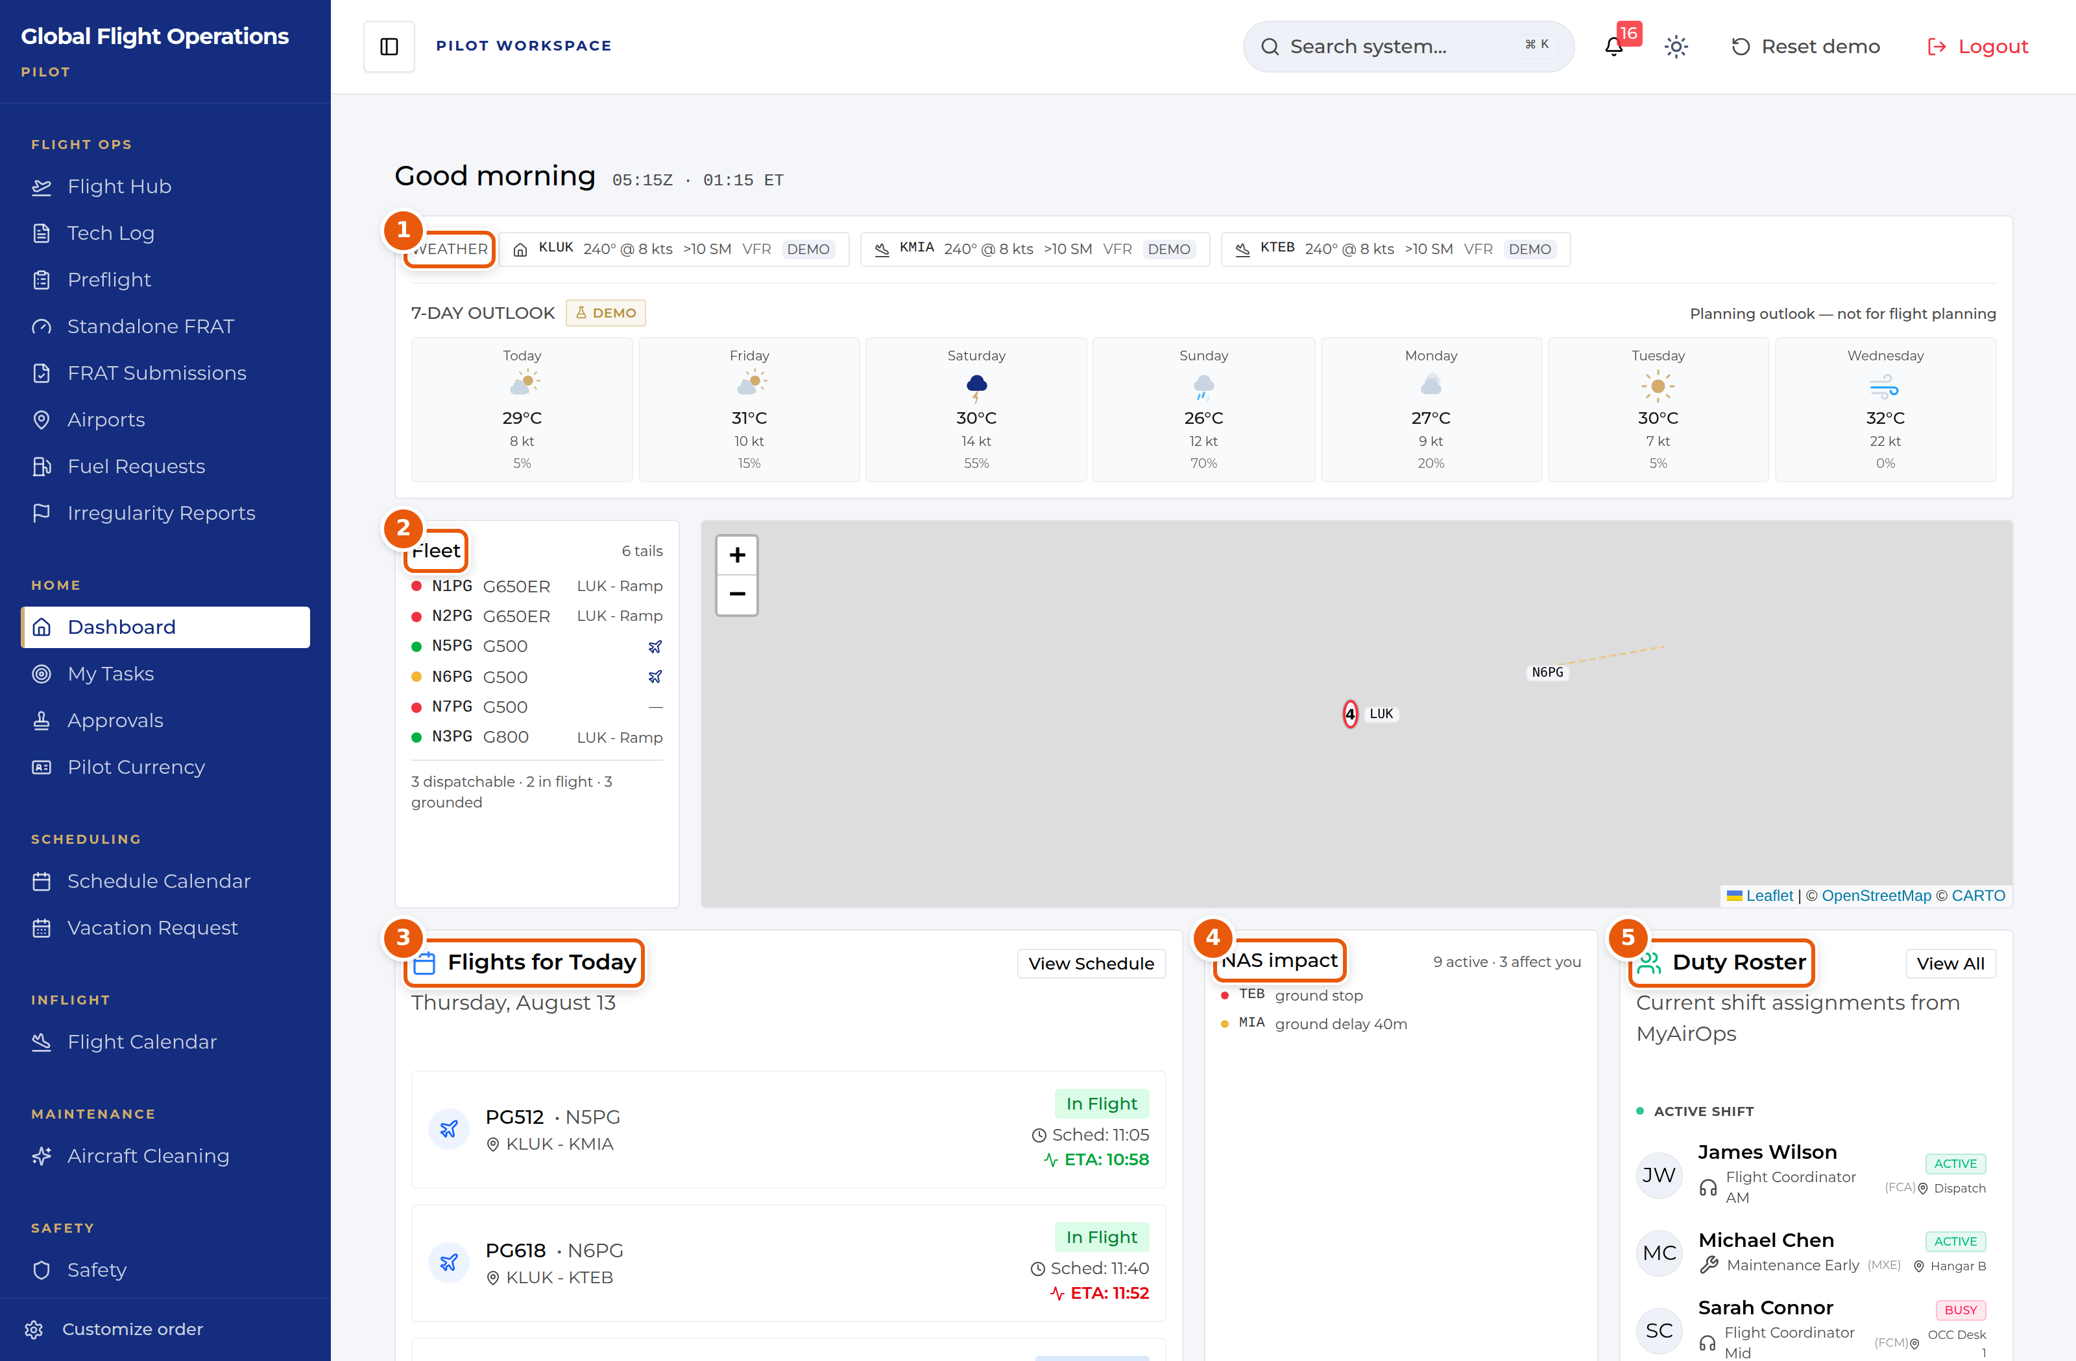
The Dashboard, shown for a Pilot. The panels are the same for every role.
1 | Weather for the home base and the stations in play, plus a seven-day outlook. The outlook is explicitly marked as a planning aid — it is not for flight planning.
2 | The fleet, one line per tail, with a coloured serviceability dot and current location. The summary line underneath counts what is dispatchable, in flight and grounded.
3 | Flights for today with scheduled time and live ETA. Where the ETA has moved away from schedule it is highlighted.
4 | NAS impact — FAA ground stops, ground delays and flow programmes, with a count of how many affect your operation.
5 | Duty Roster — who is on shift now, their function and where they are sitting.

Document Center
The Document Center holds controlled publications and tracks who has read them. It is the same page for every role; what differs is which documents are assigned to you.
My required reads is your personal queue and is the tab to work from. Each row shows the revision, the effective date, a plain-language "What changed" summary, and the acknowledgement the document demands — Read & sign, Read & initial, or Received copy. Rows that have passed their due date are marked Overdue.
Open a document, read it, and complete the acknowledgement at the end. Your outstanding count at the top of the page drops as you clear the queue.
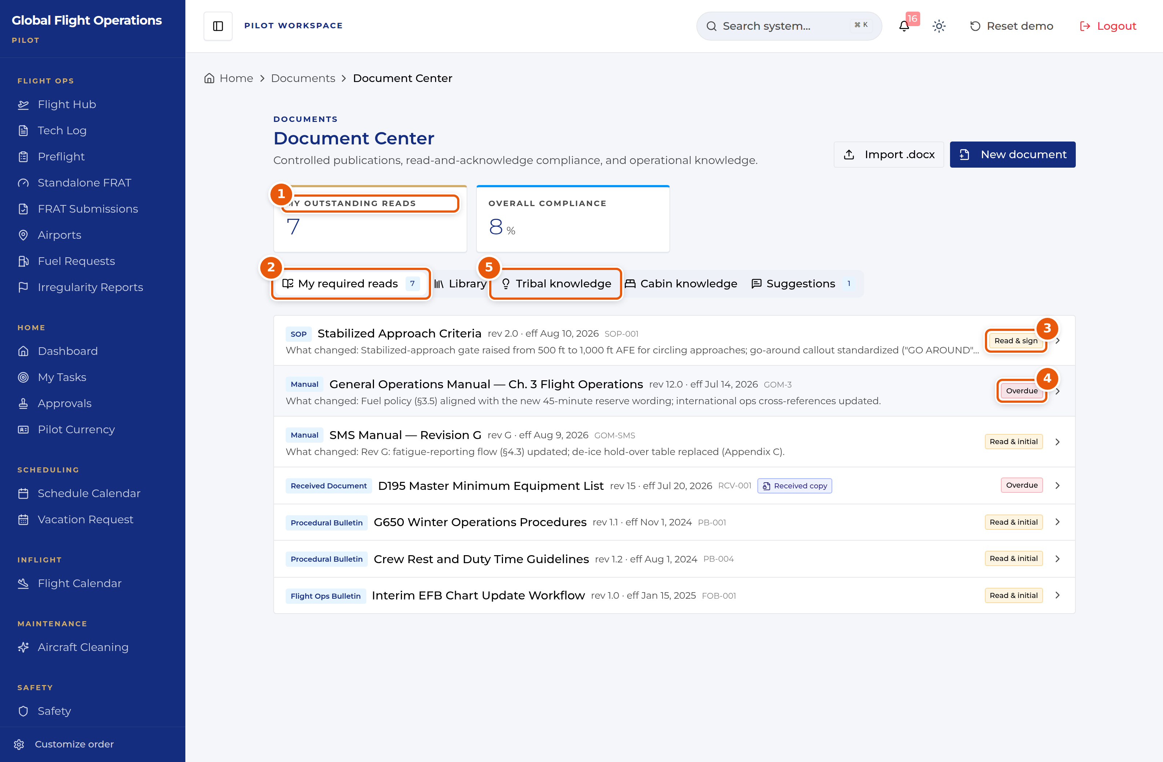
Document Center — the My required reads queue.
1 | My outstanding reads — how many acknowledgements you personally owe.
2 | Tab strip. My required reads is your queue; Library is the full controlled-document set.
3 | The acknowledgement type this document demands. Read & sign is the strongest; Read & initial and Received copy also appear.
4 | Overdue — the acknowledgement deadline has passed. Clear these first.
5 | Tribal knowledge and Cabin knowledge hold non-controlled operational know-how, kept separate from the controlled library on purpose.

Approvals
Approvals is a single inbox with two halves: requests waiting on your decision, and requests you have filed yourself. The page states which role you are acting as, because your approval authority follows your role, not your name.
Multi-step requests show their position in the chain (for example Step 2 of 2) along with what earlier approvers decided and why. Read the earlier decision before you act on yours.
You can Approve, Deny, or Add a comment. Use View request details to see the full submission before deciding.
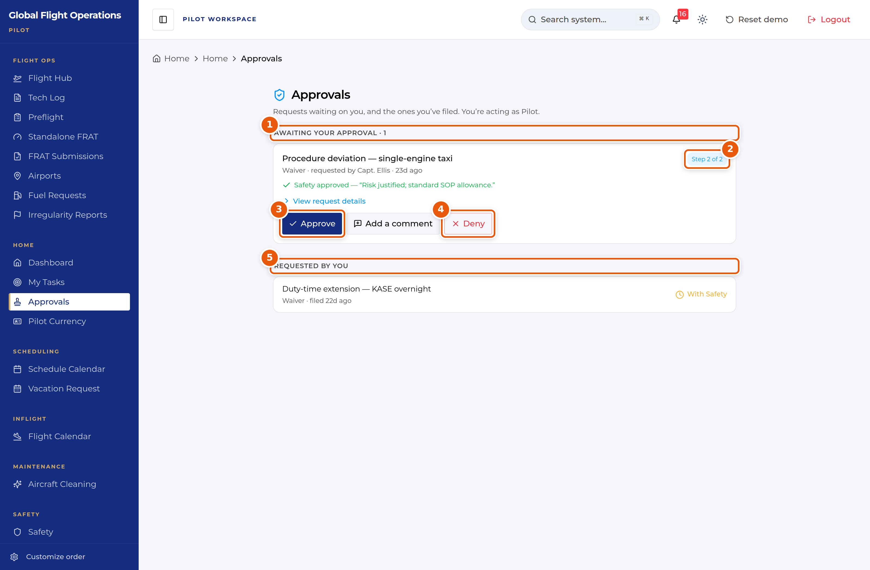
Approvals, shown while acting as Pilot.
1 | Awaiting your approval, with a count. This is the half you owe action on.
2 | Where this request sits in its approval chain.
3 | Approve — records your decision against your role.
4 | Deny — also records against your role. Add a comment first if the reason is not obvious.
5 | Requested by you — what you have filed, and where each request currently sits.

Vacation and time off
Vacation Request handles vacation, payback stop days (PBST), off days and medical leave through one form.
The page has four tabs: Submit Request, My Requests, Master Calendar and PBST Balance. Check PBST Balance before you file — awarded stop days carry an expiry date, and the balance panel shows how many days are left on each.
On Submit Request choose the request type, set the start and end dates, and add a reason. If you want to spend awarded PBST days against the request, tick them under Apply Available PBST Days before submitting.
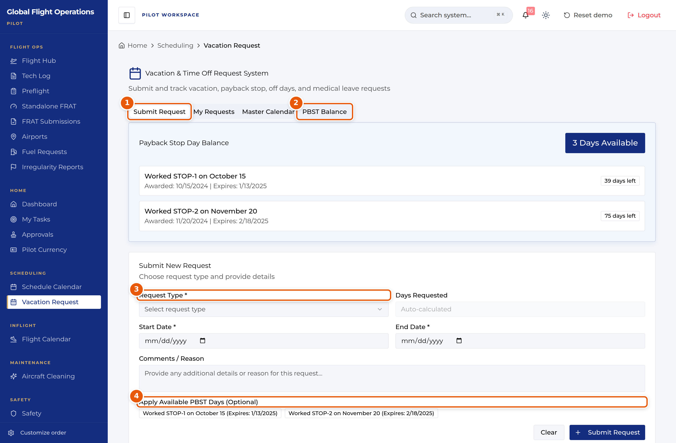
Vacation and time-off request form.
1 | Tab strip — Submit Request, My Requests, Master Calendar, PBST Balance.
2 | PBST Balance shows each awarded stop day, when it was awarded and when it expires.
3 | Request Type drives the rest of the form. Set it first.
4 | Optionally apply awarded PBST days to this request. Expiry dates are shown so you can spend the oldest first.

Other pages in your sidebar
Schedule Calendar gives a month view with Full Fleet and My Schedule toggles, plus monthly totals for flights, hours, maintenance events and training.
Flight Calendar lists your assignments with passenger manifests, flagging critical allergies and passenger birthdays on each leg.
Airports is the airport directory — every US airport with a hard-surfaced runway of 5,000 ft or more, drawn from FAA NASR data, with company pages and operational flags layered on top.
Aircraft Cleaning shows cleaning workflow progress by tail, with required-item counts and who started and completed each workflow.
My Tasks carries action items assigned to you alongside your own tasks, each with section-by-section progress.

