myGFO
Global Flight Operations
Flight Attendant
Training Guide

Cabin work in myGFO: reading your trips and the allergies on each leg, managing passenger records and catering, running aircraft inventory and inspections, and keeping the commissary stocked.
WHO THIS IS FOR
Cabin crew.
Also the base document for the Flight Attendant Manager — read this first, then the manager supplement.

SCOPE OF THIS GUIDE
This guide covers the day-to-day myGFO screens for this role. Three modules are documented separately and are deliberately not covered here: the Tech Log, Irregularity Reports (FIR), and the Scheduling Command Center. The Safety module is also out of scope — it is not in service yet.
You will still see those items in your sidebar. Ignore them for the purposes of this guide.

Getting started
Screenshots in this guide come from the myGFO prototype running on demo data. Tail numbers, names, dates and counts are illustrative — the screen layout, buttons and workflow are what matter.

Where you land
You land on the Dashboard. Upcoming Trips, at the top of the Inflight group, is the page to work from.
Front door: Dashboard.

Your sidebar at a glance
Your role decides which of these appear. Pages are grouped in the sidebar as shown.
Page | Sidebar group | What it is for
Upcoming Trips | Inflight | Your trips leg by leg, with allergies and catering per leg
Passenger Database | Inflight | Passenger records: preferences, allergies, birthdays
Catering Tracker | Inflight | Caterers and hotel partners, with lead times and coverage
Post-Flight Checklist | Inflight | Flight reset procedures, per flight
Aircraft Inventory | Inflight | Pre-flight inventory check by tail
Aircraft Cleaning | Inflight | Cleaning workflow status
Trips | Inventory | Trip-linked inventory: what was requested and stocked
Inspections | Inventory | Monthly baseline audit against system records
Commissary | Inventory | Stock room by shelf, with par levels and expiry
Replenish | Inventory | Restock list generated from inspection shortfalls
Unit Requests | Inventory | Requests for items to be added to a unit
Dashboard | Home | Weather, fleet, today’s flights, airspace, duty roster
My Tasks | Home | Action items assigned to you and your own tasks
Approvals | Home | Requests waiting on you, and ones you filed
Vacation Request | Scheduling | Vacation, PBST, off days, medical leave
Document Center | Documents | Controlled publications and your required reads

Signing in
myGFO opens on a demo password screen. Enter the password your administrator gave you and choose Continue.
On the next screen, open Select Your Role, choose your role, and choose Access Dashboard. Your role decides which pages appear in the left sidebar and where you land after sign-in — two people can be looking at the same system and see a different set of pages.
If you hold more than one role, sign in under the one matching the work you are about to do. You can sign out and back in under the other role at any time using Logout at the top right.

Upcoming Trips — allergies first
Upcoming Trips is your working page. It shows your assigned trips broken down leg by leg: who is on board, every allergen to plan the menu around, and the catering order for each leg.
The summary strip counts trips, legs, passengers, and how many catering orders still need chasing. Below it, a banner counts critical allergens across all the trips shown, and each leg then lists its own.
The allergy panel is the part to read carefully. Allergens are graded — Critical entries name the reaction and the response (for example "critical, Anaphylaxis · EpiPen - seat pocket"), while Moderate entries are graded lower. Underneath, a separate Avoid list holds preferences that are explicitly not medical.
Keep that distinction. The Avoid list is about service quality; the allergy list is about passenger safety, and the two are deliberately not mixed.
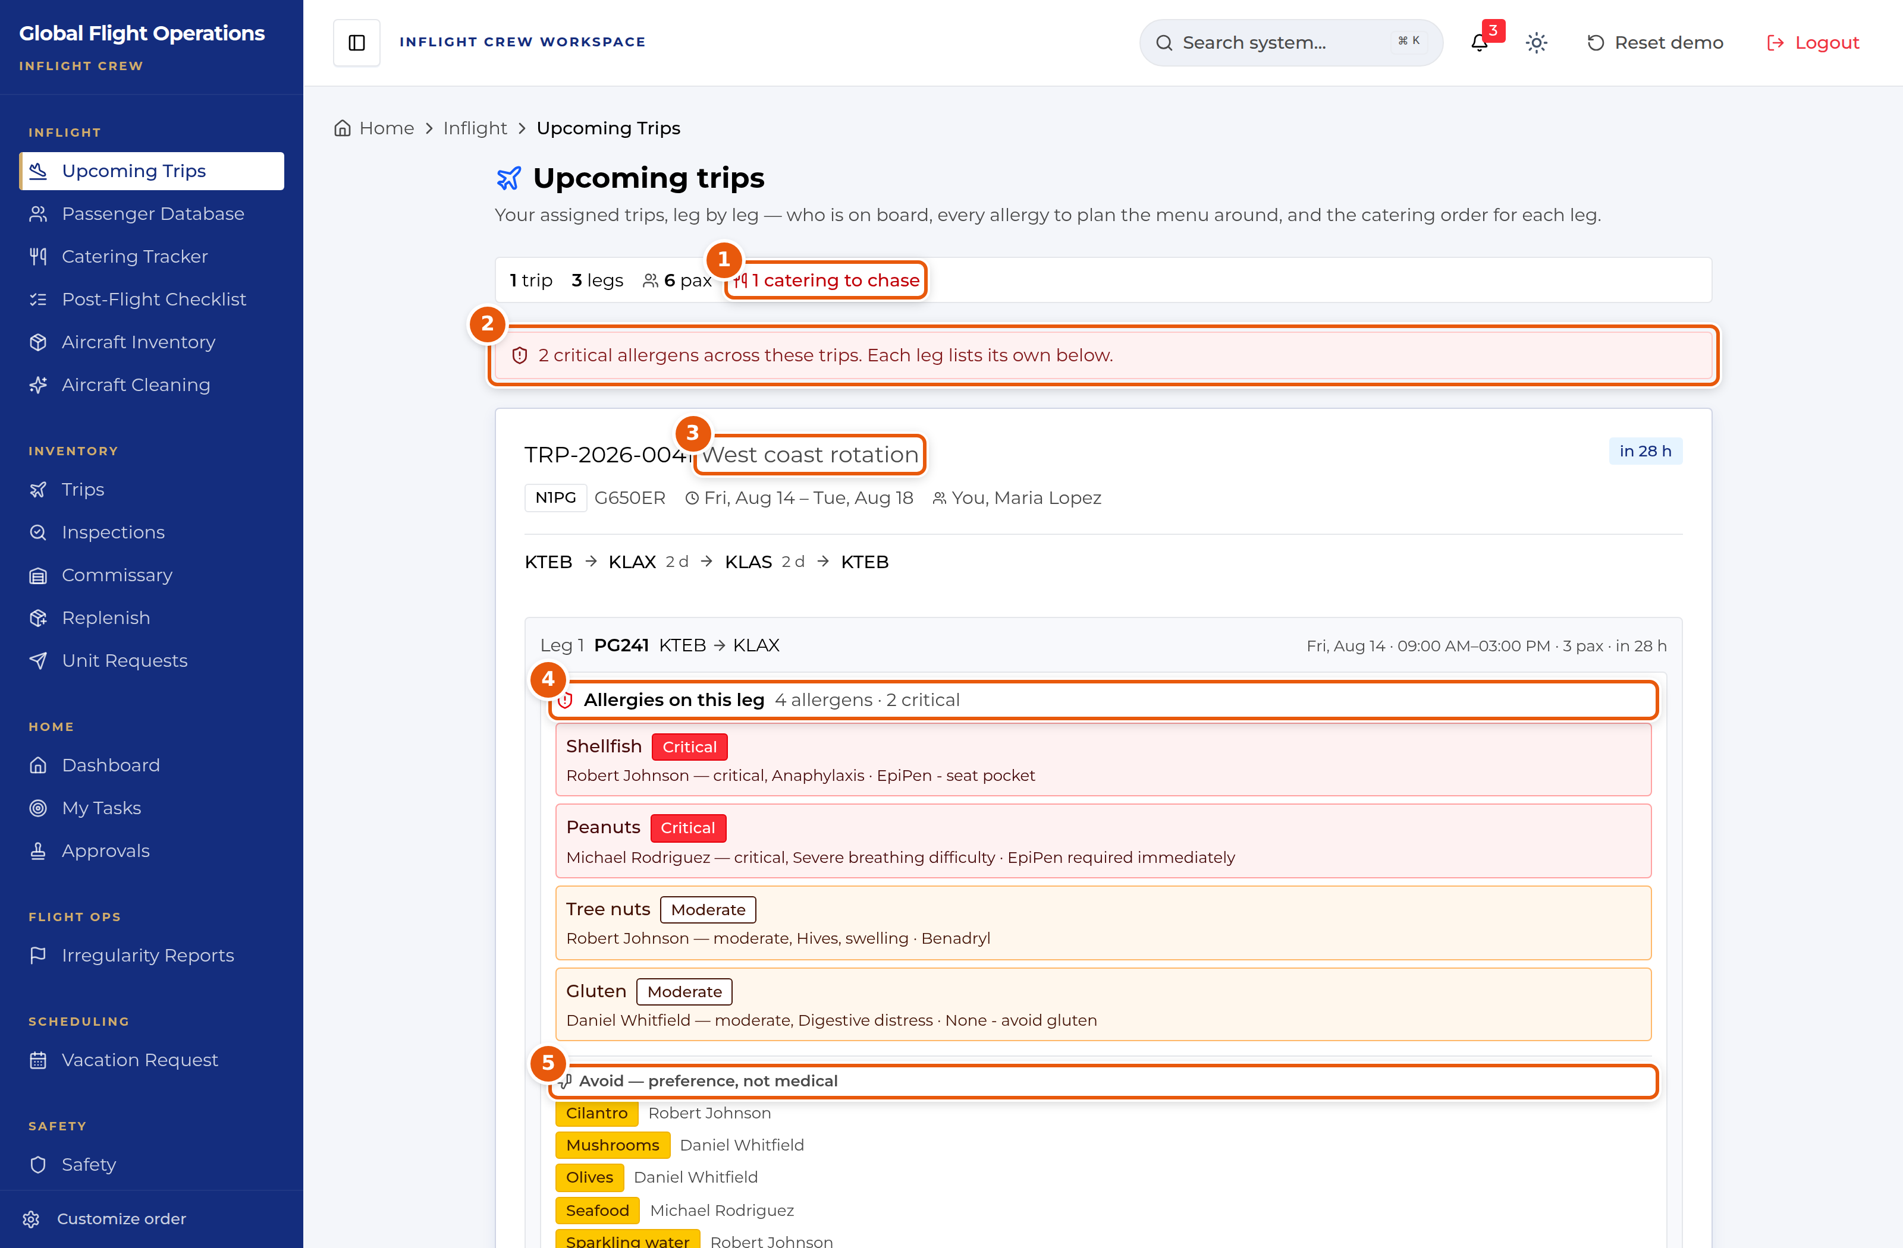
Upcoming trips, showing leg 1 with its allergy panel.
1 | Catering still to chase across the trips shown.
2 | Critical allergens across all these trips. Each leg lists its own below.
3 | A trip, with tail, dates, routing and who is crewing it.
4 | Allergies on this leg, graded Critical or Moderate, each naming the reaction and the response.
5 | Avoid — preference, not medical. Kept separate from the allergy list on purpose.

Passenger records
Passenger Database holds the standing record for each passenger: their role or relationship to the company, food and drink preferences, allergies and birthdays.
The counters at the top tell you how many passengers are on file, how many have allergies recorded, and whose birthday falls this month. A numeric badge on a passenger row indicates recorded allergies.
This is the source the trip allergy panels draw from, so it is worth keeping accurate. Add Passenger creates a new record.
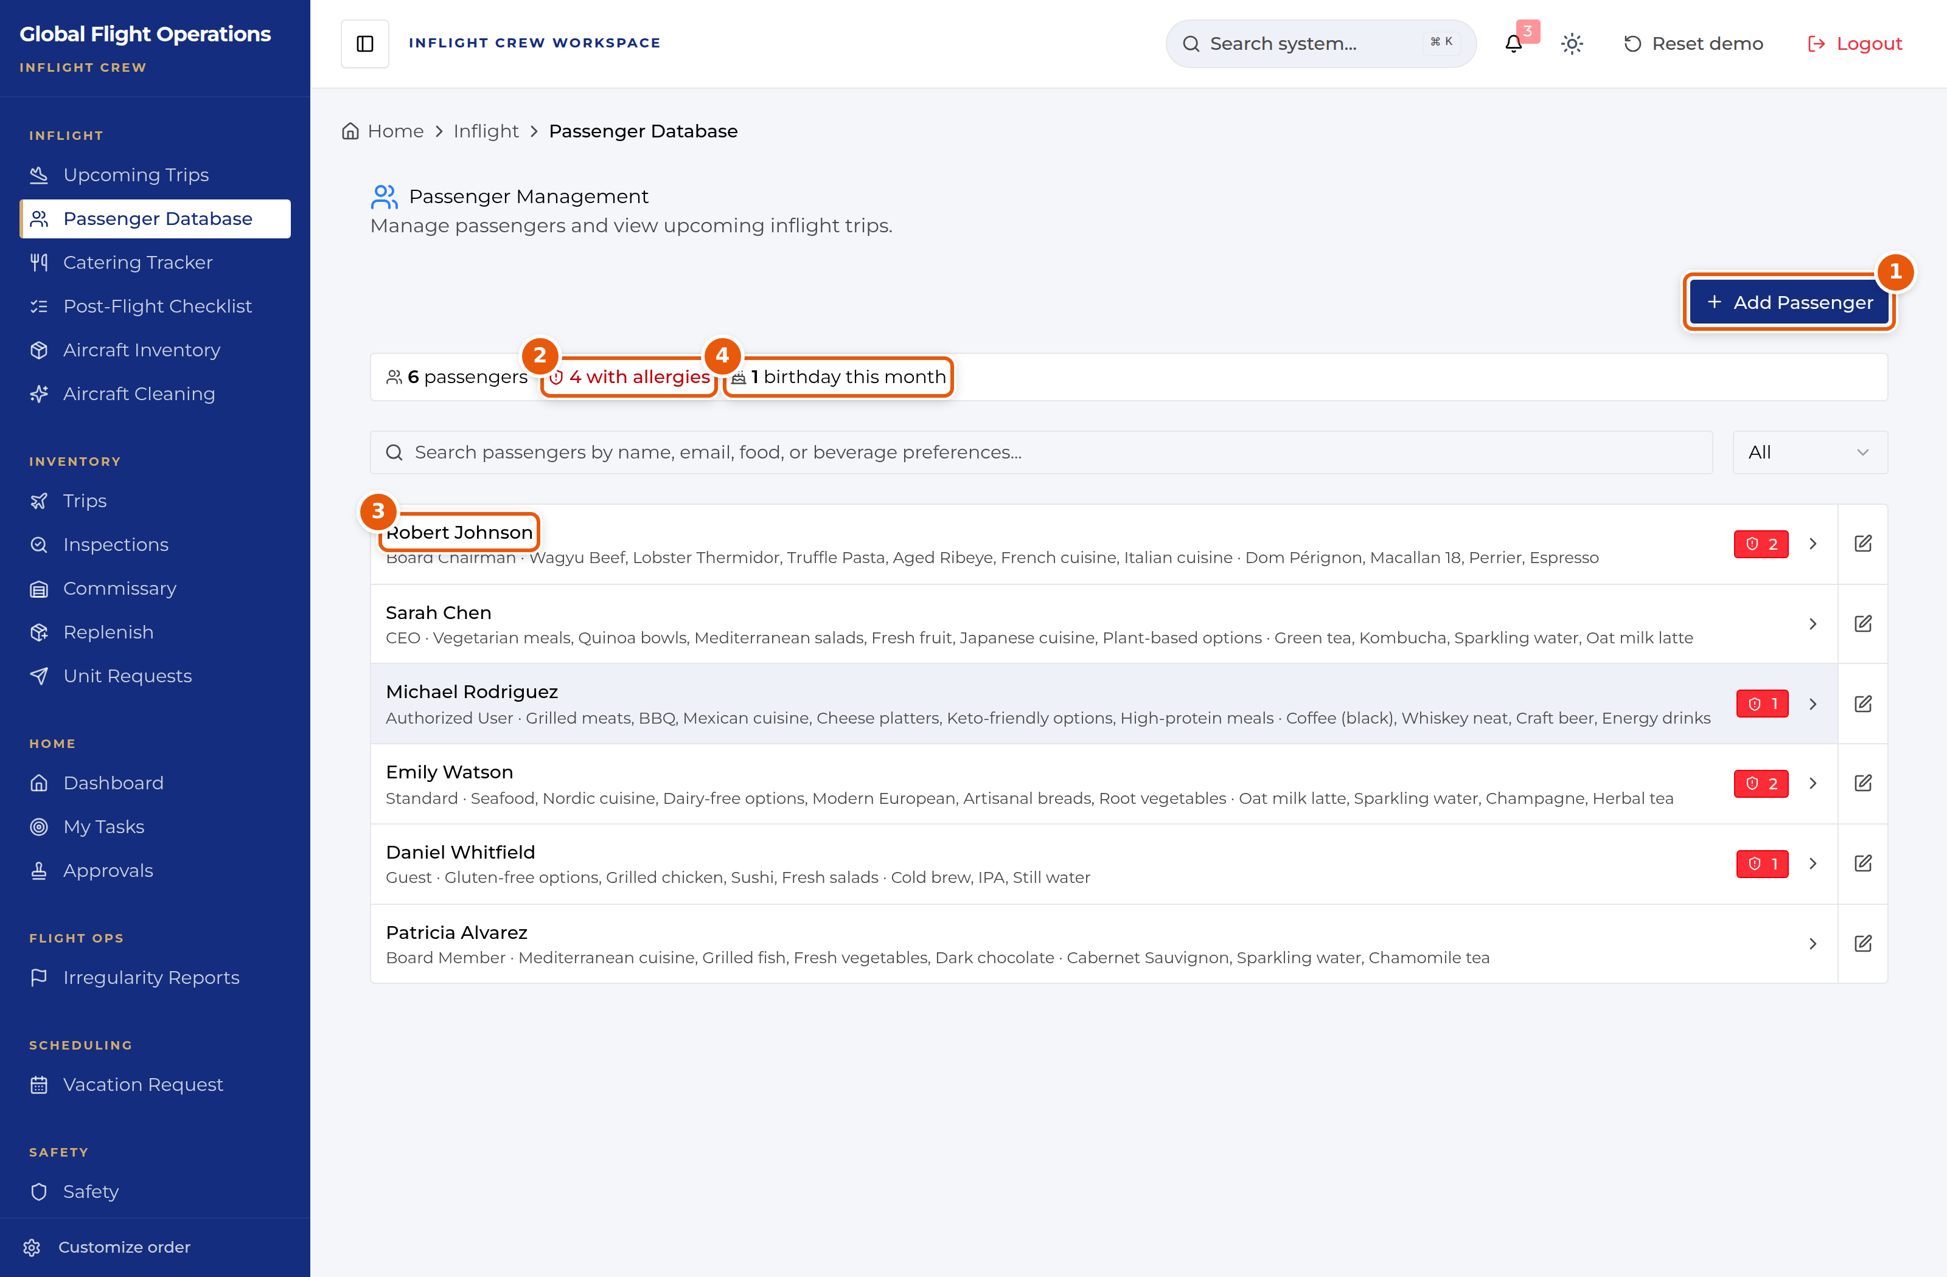
Passenger Management.
1 | Add Passenger — create a new standing record.
2 | How many passengers have allergies recorded.
3 | A passenger record: role, food preferences, drink preferences.
4 | Birthdays falling this month.

Catering and hotels
Catering Tracker holds the caterers and hotel partners the department uses, on two tabs.
Each caterer entry carries the operational facts you need when placing an order: the contact, the lead time, the service radius, operating hours, a rating, and free-text notes on how they actually perform. Lead time is the field to check first — a three-hour caterer and a six-hour caterer are not interchangeable on a short turn.
Caterers covering more than one airport are marked Multi-Airport and list the fields they serve. Show only multi-airport services filters the list down to those.
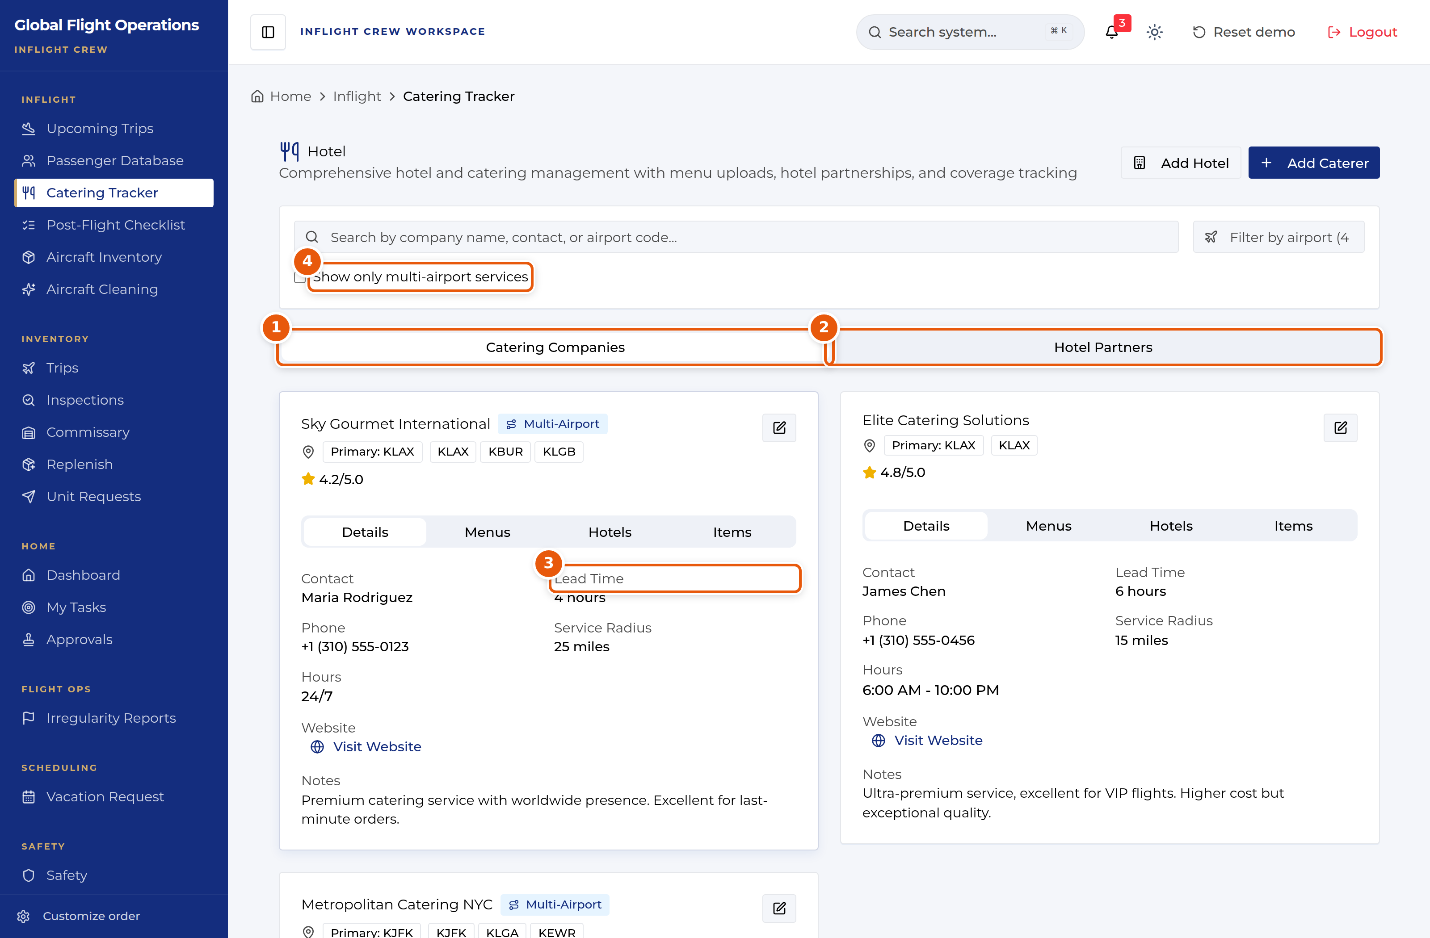
Catering Tracker, on the Catering Companies tab.
1 | Catering Companies tab.
2 | Hotel Partners tab.
3 | Lead Time — check this before committing to an order on a short turn.
4 | Filter to caterers covering more than one airport.

Trip inventory
The Inventory group tracks what is physically on each aircraft. Trips is the trip-linked view: each tail shows its current leg pulled from myairops, how many items were requested, and its last stocking score.
Where a tail has an active leg you get Open leg. Where it does not, Start Trip begins a trip-linked inventory session. If the leg shown is not the one you are working, Not this leg? lets you correct the association.
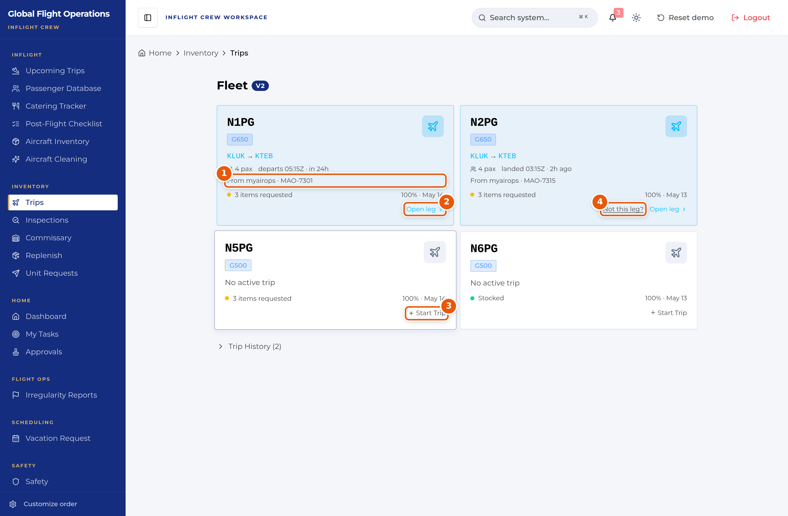
Inventory — Trips, one card per tail.
1 | The leg pulled from myairops, with its reference.
2 | Open leg — work the inventory for the active leg.
3 | Start Trip — begin a session on a tail with no active trip.
4 | Not this leg? — correct the leg association.

Inspections
Inspections is the monthly baseline audit: verifying that what is physically on the aircraft matches what the system says should be there.
Each tail shows when it was last inspected, how many inspections it has had this year, and its score. Inspection History below lists past inspections with who did them, how many items were checked, and the resulting score — a score below 100% carries the shortfall alongside it, for example "93% — 3 missing".
Missing items found during an inspection feed the Replenish list.
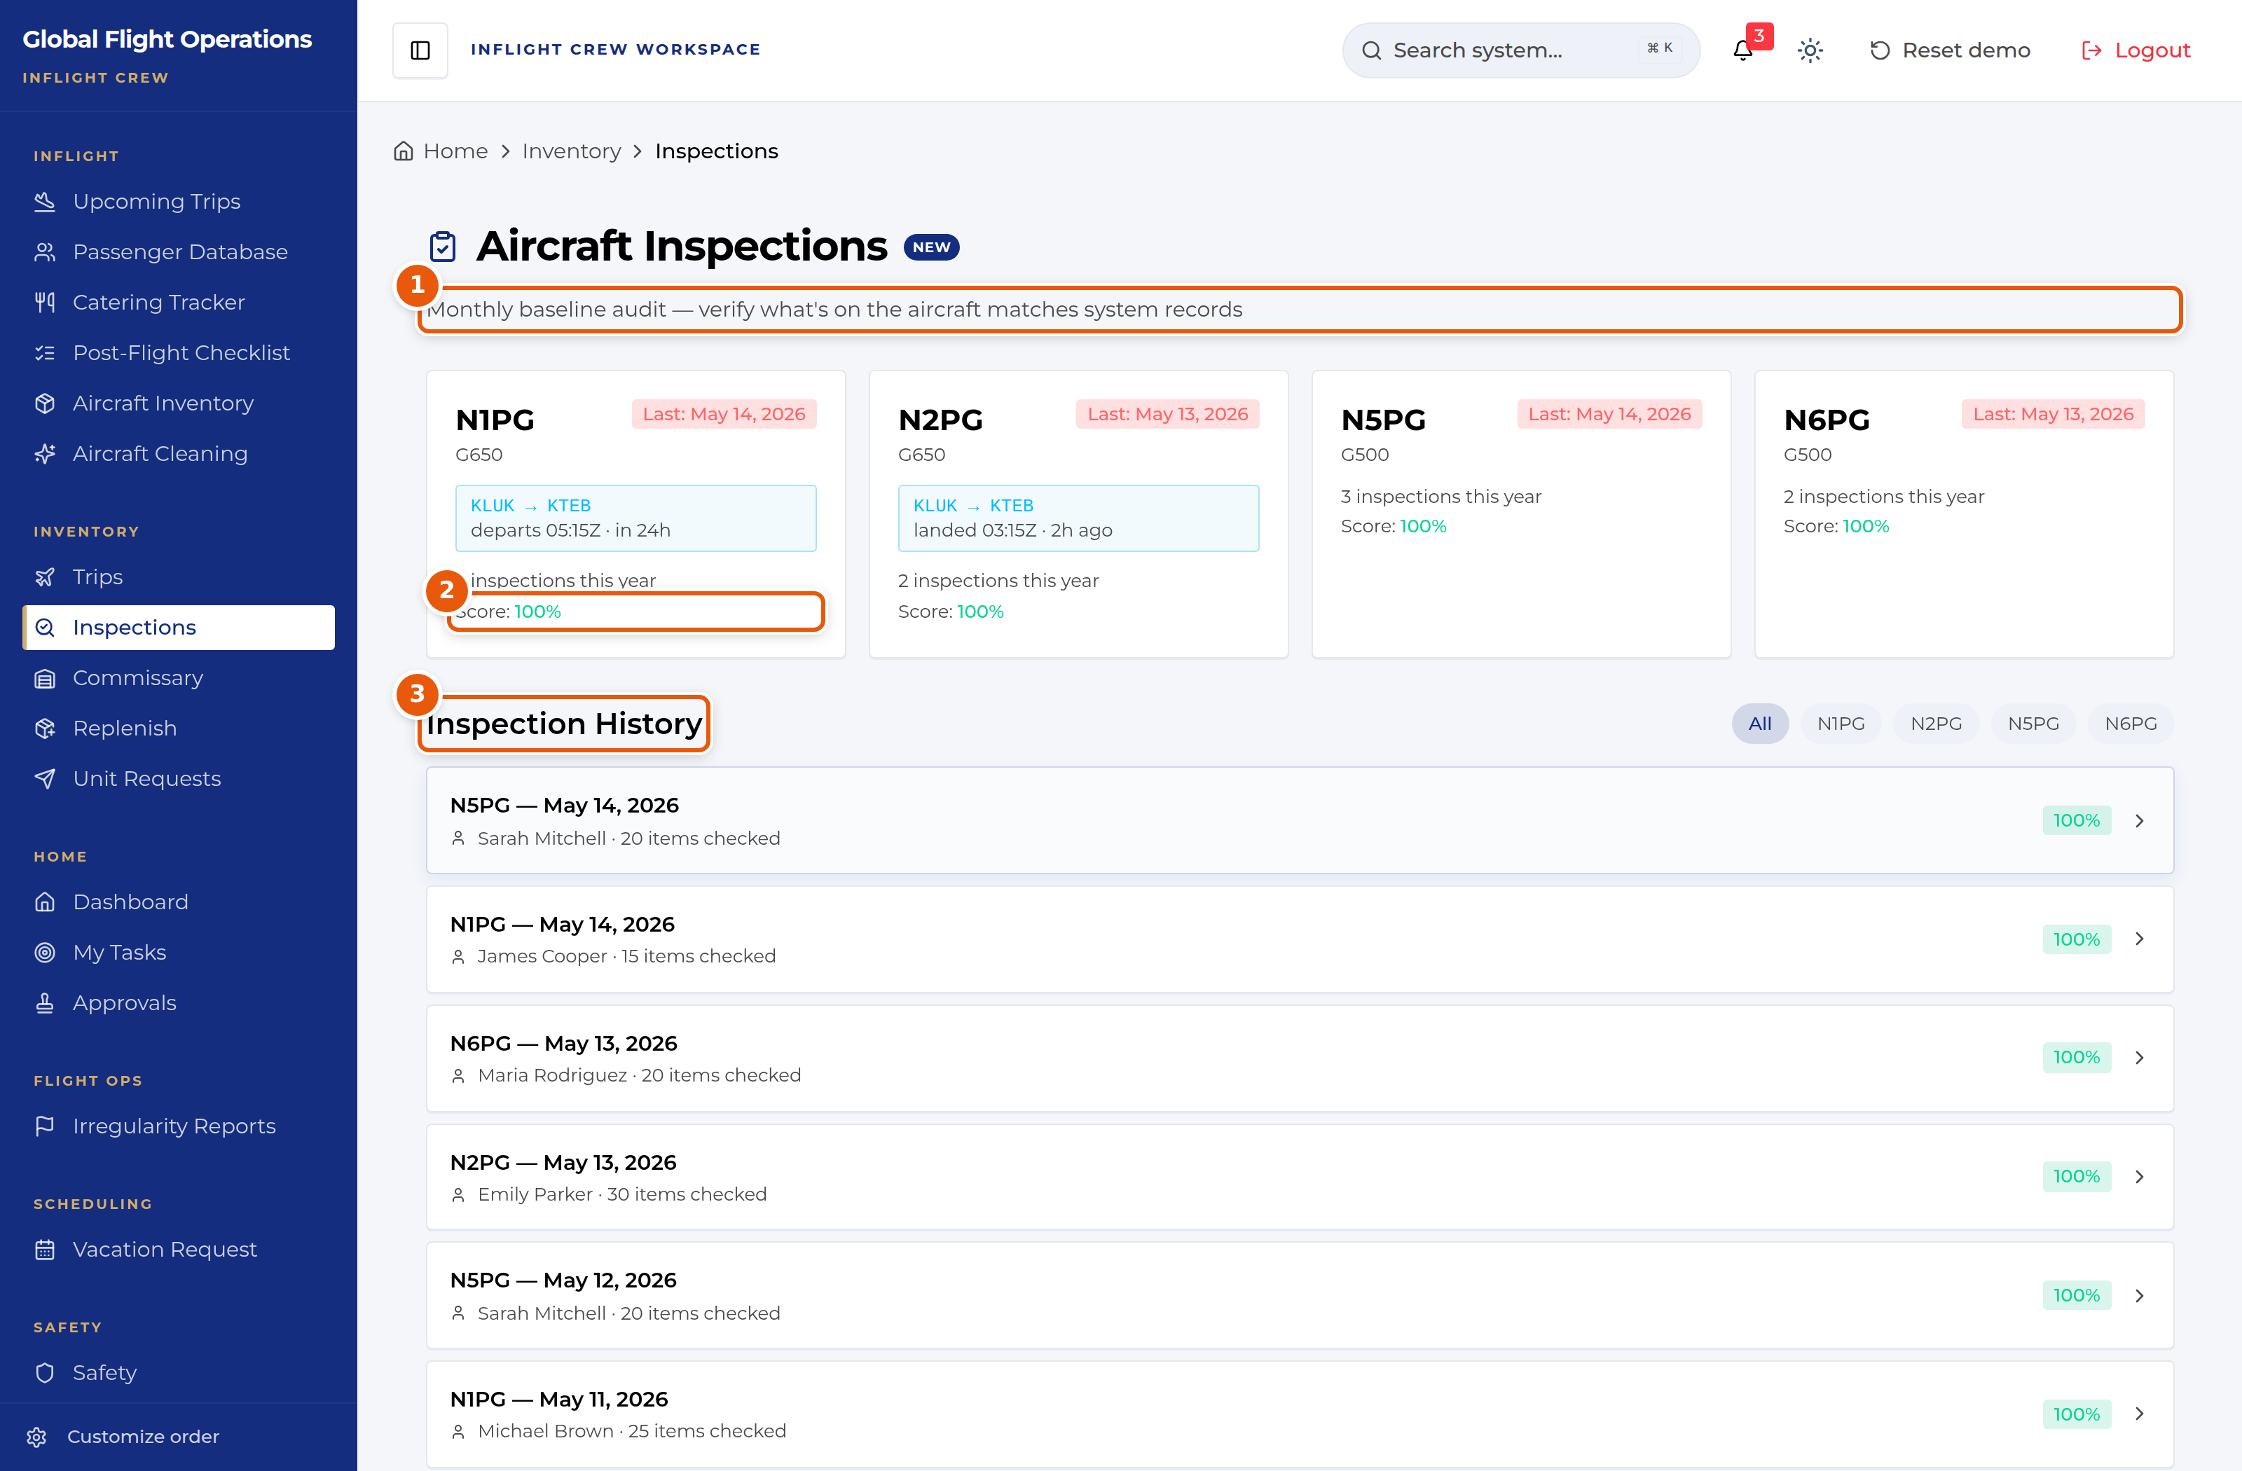
Aircraft Inspections.
1 | What the inspection is for — verifying the aircraft against system records.
2 | Per-tail score and inspection count for the year.
3 | Inspection History — who inspected, how many items, and the score.

Commissary
Commissary is the stock room, organised by physical location — shelves, the medicine cabinet, the wine rack, the linen closet. That grouping is deliberate: it matches the walk you actually do when checking stock.
The header carries the totals: item count and value on hand, then how many items are below par and how many are expiring. Each location repeats those counts for itself, so you can see which shelf needs attention without opening it.
Below par means the count has fallen under the par level set for that item; par levels are maintained in Inventory Settings by the Flight Attendant Manager or Commissary Manager.
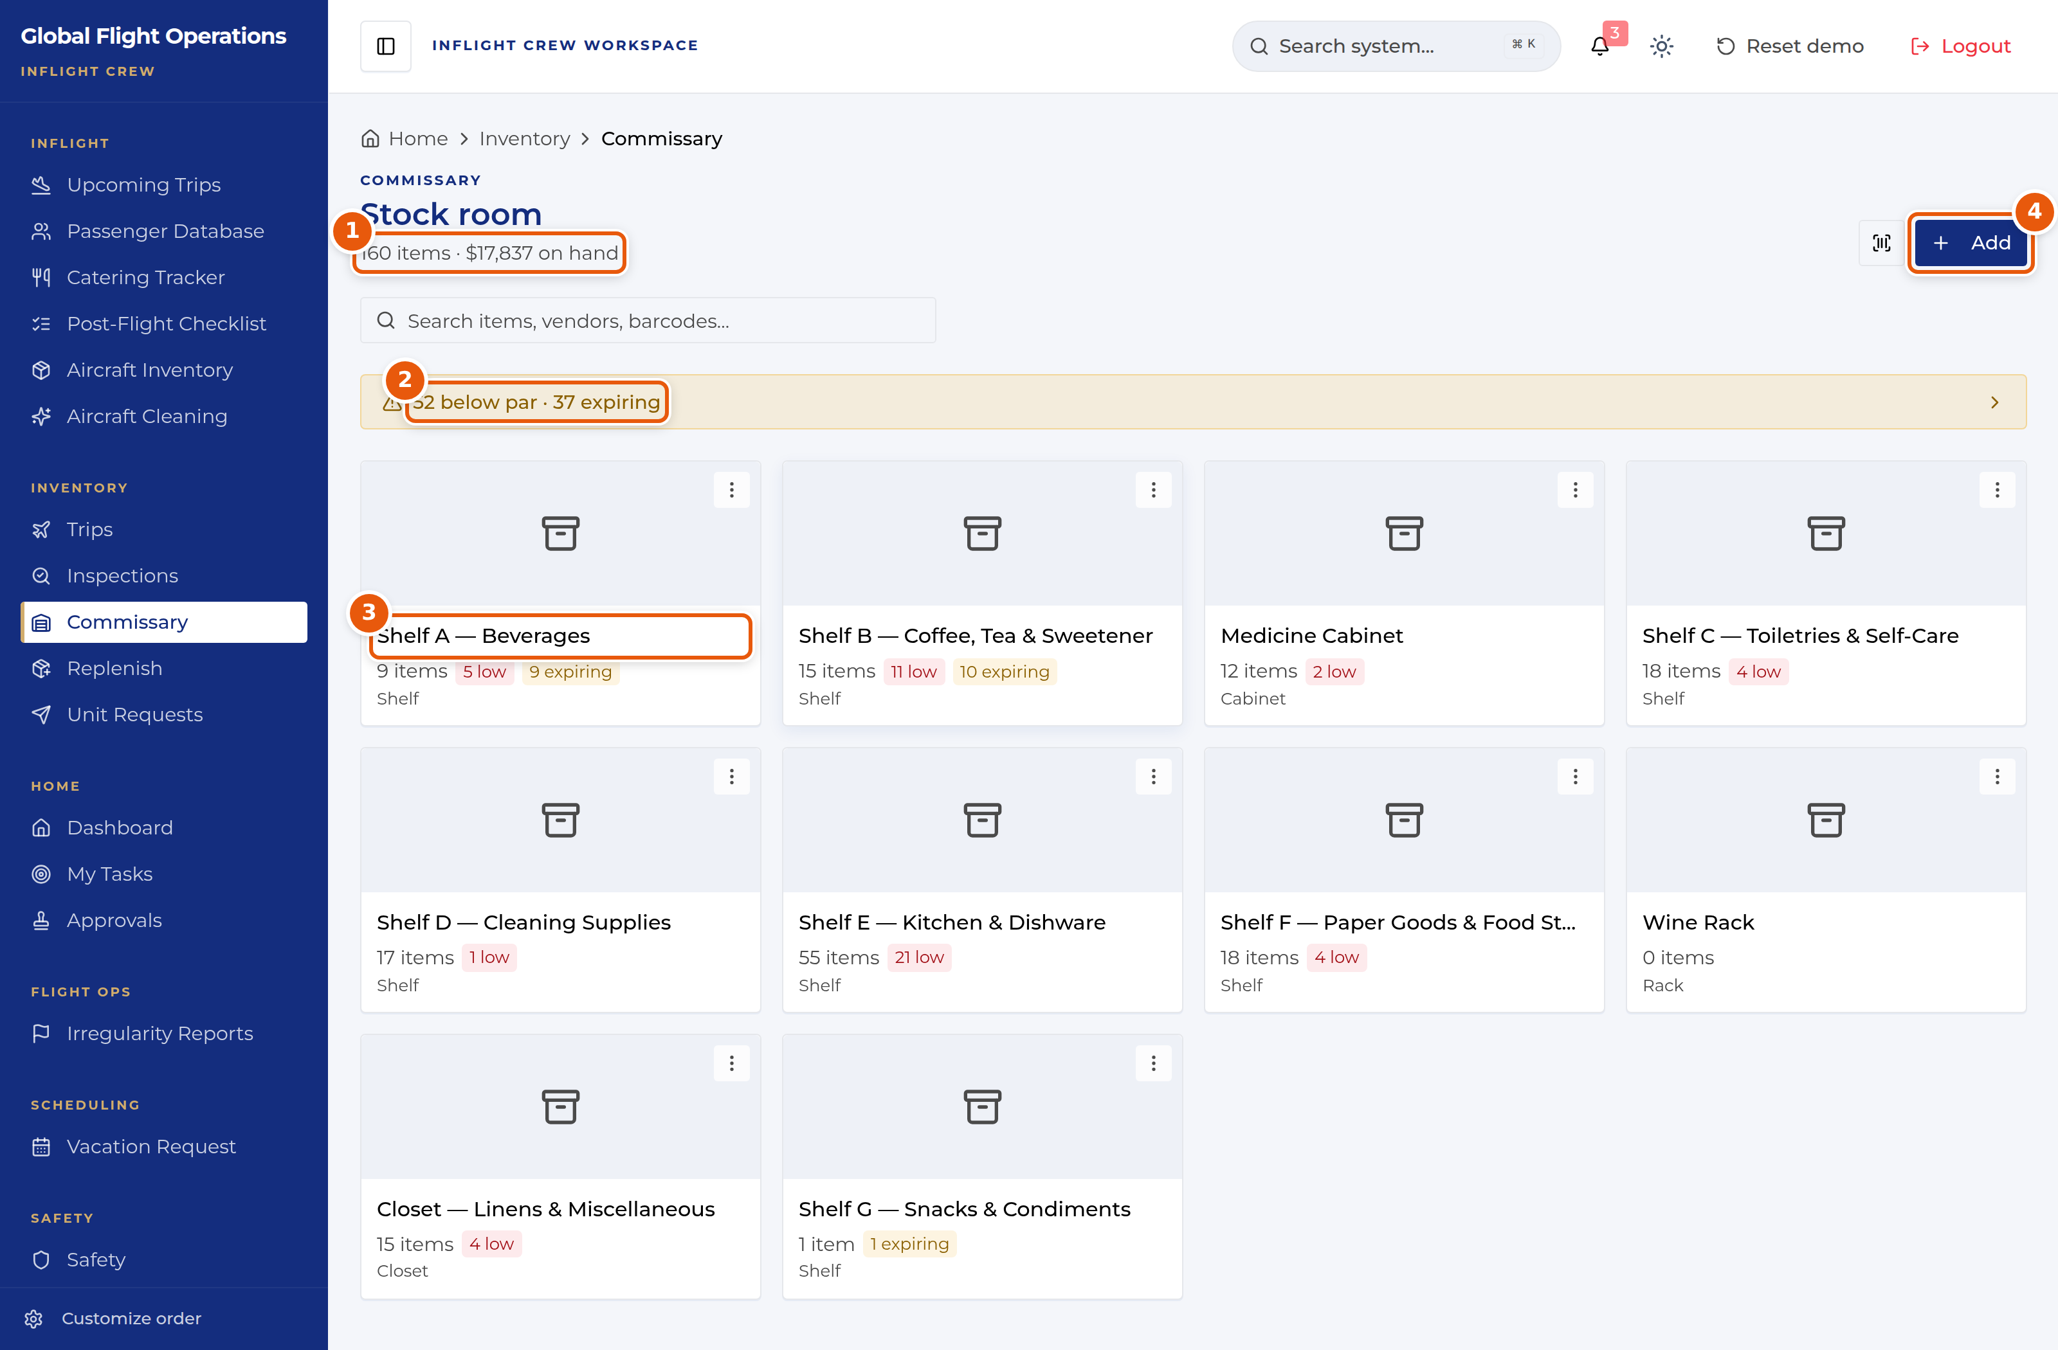
Commissary stock room, grouped by physical location.
1 | Item count and value on hand across the stock room.
2 | How many items are below par, and how many are expiring.
3 | A storage location, with its own low and expiring counts.
4 | Add — record new stock.

Replenish and unit requests
Replenish is the restock list, and it is generated rather than typed: complete an inspection with missing items and the shortfall appears here. If the page says there is nothing to replenish, no inspection has produced a shortfall yet. It also supports barcode scanning.
Unit Requests is for asking that specific items be added to a unit. Each request is tagged Guest or Non-Guest — a guest request traces to a passenger need ("VIP guest requested extra sparkling water and hot towels"), a non-guest request is operational ("restocking cleaning supplies after deep clean"). Requests show who raised them, when, and how many items are involved.
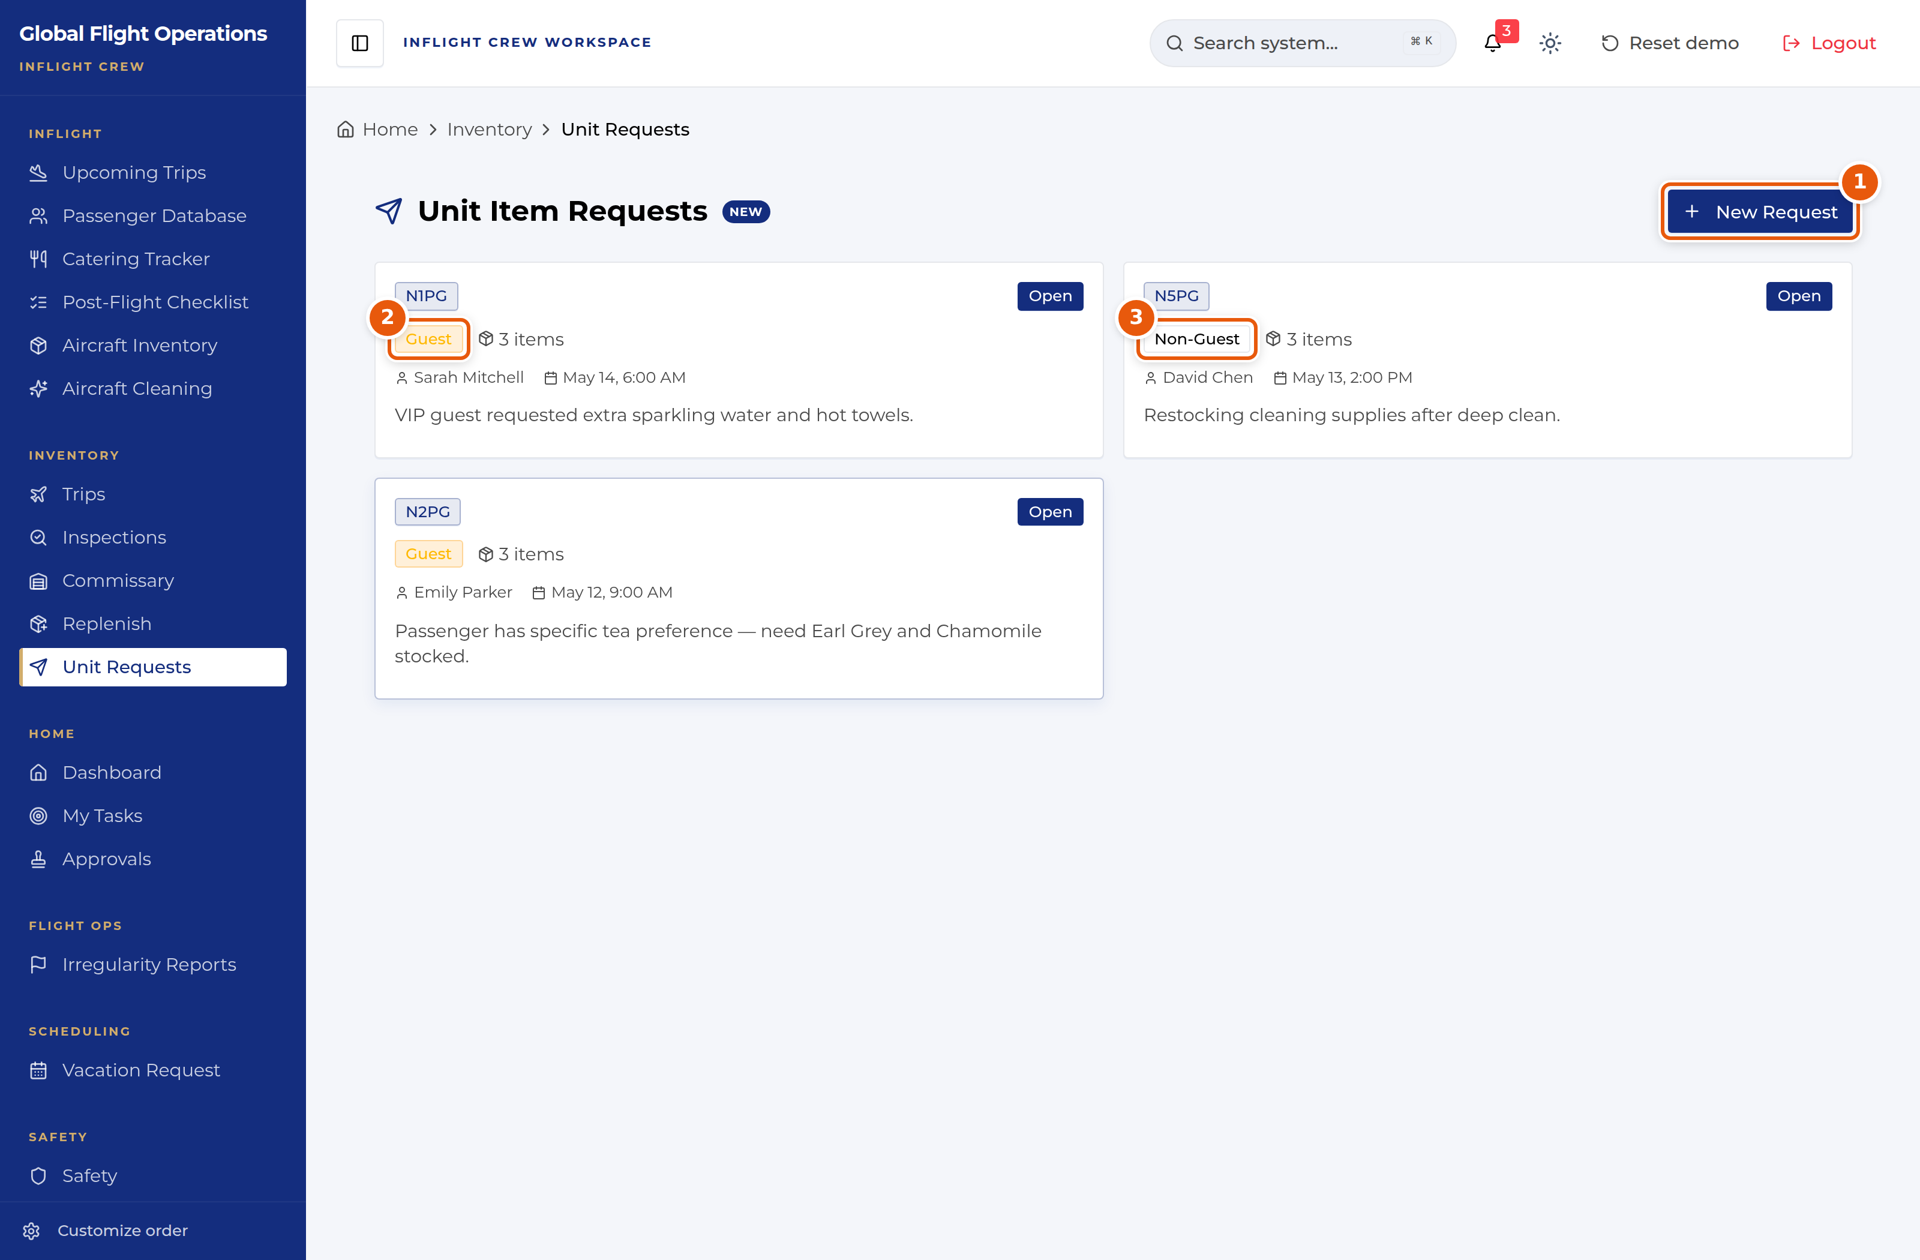
Unit Item Requests.
1 | New Request.
2 | Guest — the request traces to a passenger need.
3 | Non-Guest — an operational restock.

Pre-flight inventory and post-flight reset
Aircraft Inventory, in the Inflight group, is the pre-flight check. Pick the tail you are working and step through its inventory.
Post-Flight Checklist covers the flight reset. Select a flight from Recent Flights and its checklist opens, showing how many items remain and how many are done. The checklist is shared, so more than one crew member can work it.
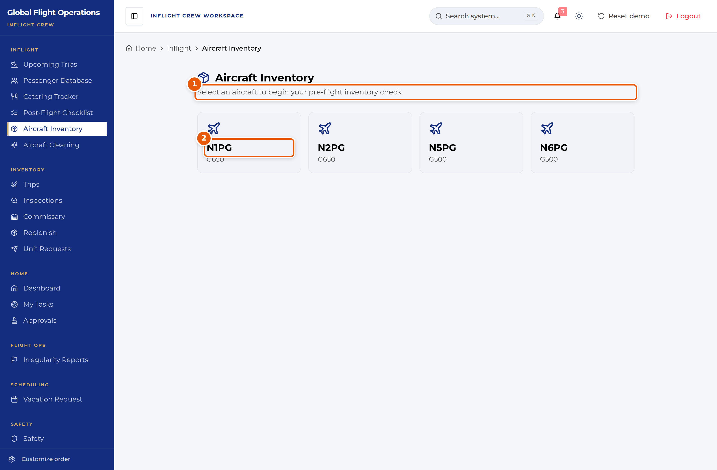
Aircraft Inventory — choose a tail to begin.
1 | Start by selecting the aircraft you are checking.
2 | The fleet, by tail and type.

The Dashboard
The Dashboard is the shared home page. Every role sees the same building blocks: current weather and a seven-day planning outlook, the fleet with its serviceability, the day’s flights, national airspace impacts, and who is on shift.
Treat it as a situational-awareness page, not a working page. Nothing on it is signed or filed; it tells you what is going on so you know where to go next.
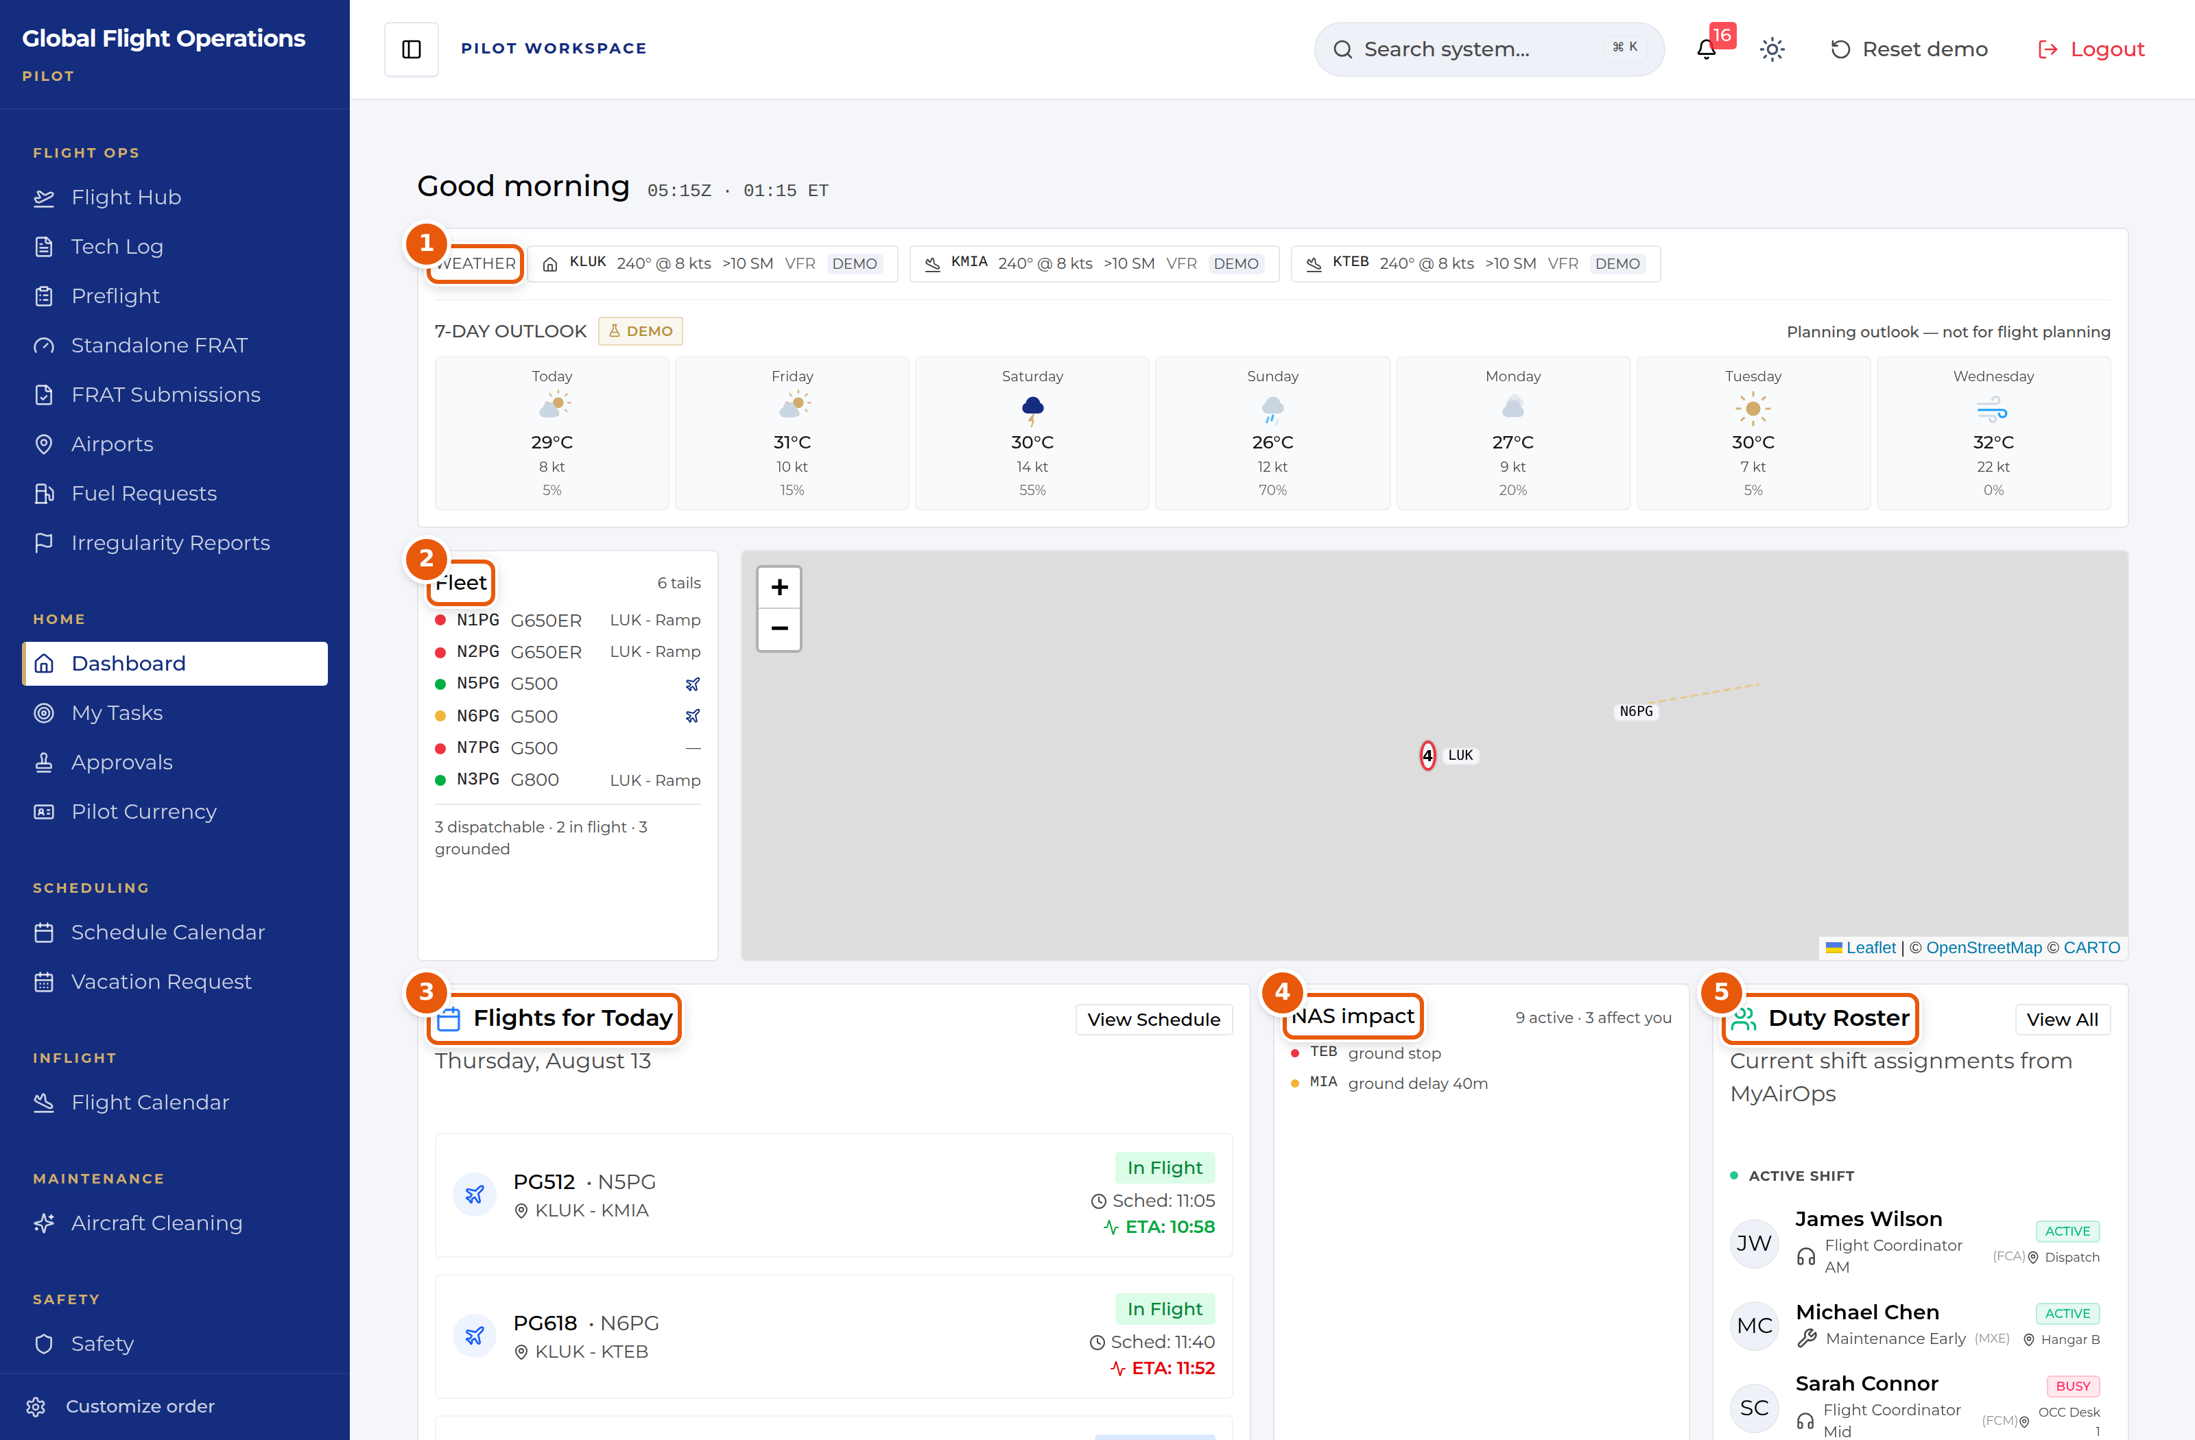
The Dashboard, shown for a Pilot. The panels are the same for every role.
1 | Weather for the home base and the stations in play, plus a seven-day outlook. The outlook is explicitly marked as a planning aid — it is not for flight planning.
2 | The fleet, one line per tail, with a coloured serviceability dot and current location. The summary line underneath counts what is dispatchable, in flight and grounded.
3 | Flights for today with scheduled time and live ETA. Where the ETA has moved away from schedule it is highlighted.
4 | NAS impact — FAA ground stops, ground delays and flow programmes, with a count of how many affect your operation.
5 | Duty Roster — who is on shift now, their function and where they are sitting.

Document Center
The Document Center holds controlled publications and tracks who has read them. It is the same page for every role; what differs is which documents are assigned to you.
My required reads is your personal queue and is the tab to work from. Each row shows the revision, the effective date, a plain-language "What changed" summary, and the acknowledgement the document demands — Read & sign, Read & initial, or Received copy. Rows that have passed their due date are marked Overdue.
Open a document, read it, and complete the acknowledgement at the end. Your outstanding count at the top of the page drops as you clear the queue.
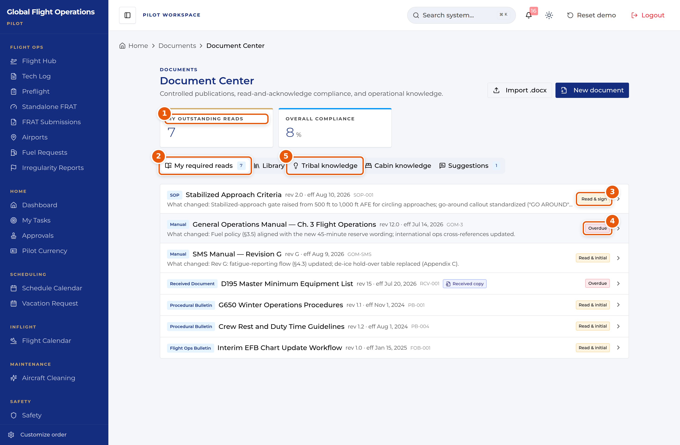
Document Center — the My required reads queue.
1 | My outstanding reads — how many acknowledgements you personally owe.
2 | Tab strip. My required reads is your queue; Library is the full controlled-document set.
3 | The acknowledgement type this document demands. Read & sign is the strongest; Read & initial and Received copy also appear.
4 | Overdue — the acknowledgement deadline has passed. Clear these first.
5 | Tribal knowledge and Cabin knowledge hold non-controlled operational know-how, kept separate from the controlled library on purpose.

Approvals
Approvals is a single inbox with two halves: requests waiting on your decision, and requests you have filed yourself. The page states which role you are acting as, because your approval authority follows your role, not your name.
Multi-step requests show their position in the chain (for example Step 2 of 2) along with what earlier approvers decided and why. Read the earlier decision before you act on yours.
You can Approve, Deny, or Add a comment. Use View request details to see the full submission before deciding.
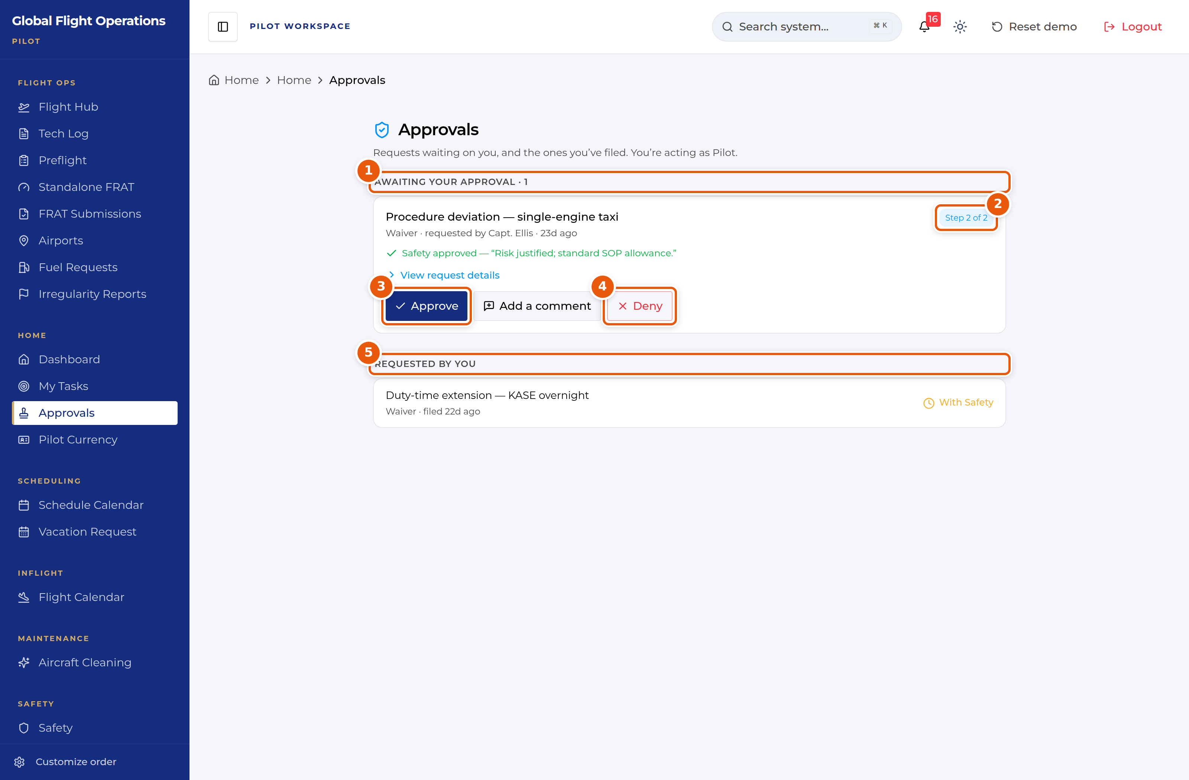
Approvals, shown while acting as Flight Attendant.
1 | Awaiting your approval, with a count. This is the half you owe action on.
2 | Where this request sits in its approval chain.
3 | Approve — records your decision against your role.
4 | Deny — also records against your role. Add a comment first if the reason is not obvious.
5 | Requested by you — what you have filed, and where each request currently sits.

Vacation and time off
Vacation Request handles vacation, payback stop days (PBST), off days and medical leave through one form.
The page has four tabs: Submit Request, My Requests, Master Calendar and PBST Balance. Check PBST Balance before you file — awarded stop days carry an expiry date, and the balance panel shows how many days are left on each.
On Submit Request choose the request type, set the start and end dates, and add a reason. If you want to spend awarded PBST days against the request, tick them under Apply Available PBST Days before submitting.
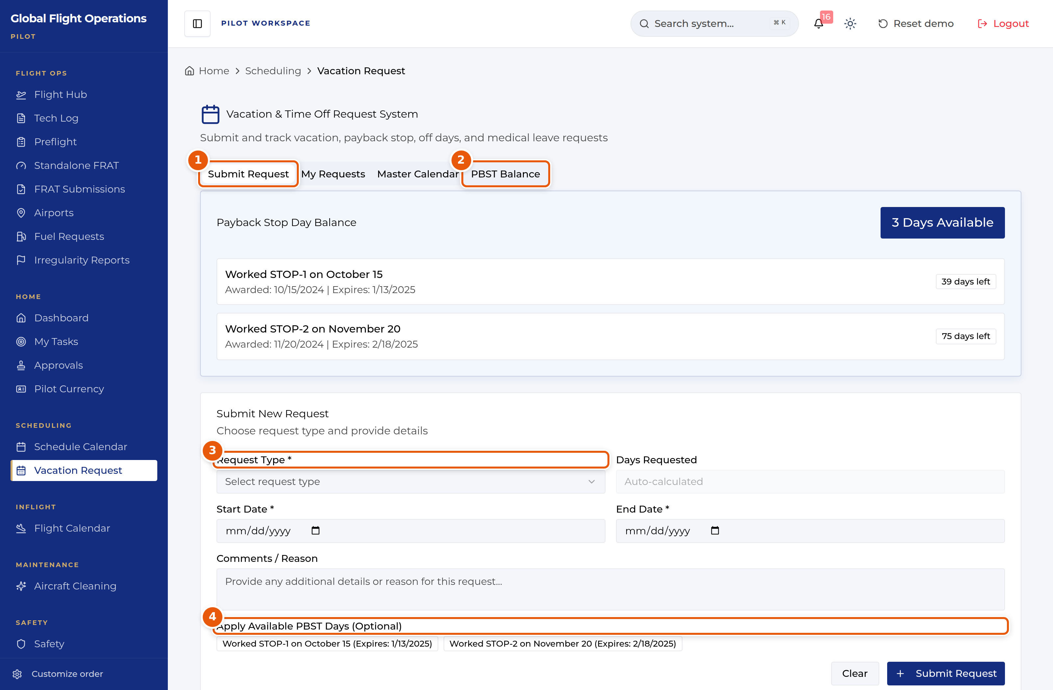
Vacation and time-off request form.
1 | Tab strip — Submit Request, My Requests, Master Calendar, PBST Balance.
2 | PBST Balance shows each awarded stop day, when it was awarded and when it expires.
3 | Request Type drives the rest of the form. Set it first.
4 | Optionally apply awarded PBST days to this request. Expiry dates are shown so you can spend the oldest first.

