myGFO
Global Flight Operations
Flight Attendant Manager
Training Guide — Manager Supplement

The oversight work that sits on top of cabin operations: maintaining the inventory baseline that every aircraft is measured against, reviewing inspection performance, and acting as an approver.
READ THIS FIRST
This is a supplement. It covers only what is additional to the Flight Attendant role.
Read the Flight Attendant training guide before this one — the shared workflows are documented there and are not repeated here.

WHO THIS IS FOR
Flight Attendant Manager, and Commissary Manager where the two are held together.
Read the Flight Attendant guide first for the underlying cabin workflows.

SCOPE OF THIS GUIDE
This guide covers the day-to-day myGFO screens for this role. Three modules are documented separately and are deliberately not covered here: the Tech Log, Irregularity Reports (FIR), and the Scheduling Command Center. The Safety module is also out of scope — it is not in service yet.
You will still see those items in your sidebar. Ignore them for the purposes of this guide.

Getting started
Screenshots in this guide come from the myGFO prototype running on demo data. Tail numbers, names, dates and counts are illustrative — the screen layout, buttons and workflow are what matter.

Where you land
You land on the Dashboard. Your work sits in the Inventory group and on the Approvals page.
Front door: Dashboard.
KNOWN GAP IN THIS ROLE
Your sidebar is narrower than a Flight Attendant’s. The Inflight pages — Upcoming Trips, Passenger Database, Catering Tracker, Post-Flight Checklist — are not currently granted to the Flight Attendant Manager role, so you will not see them while signed in as manager.
If you need those pages, sign in under the Flight Attendant role. This is a role-permission gap that has been raised with the project team, not something you are doing wrong.

Your additional pages
These are the pages this supplement covers. Your sidebar also carries everything documented in the Flight Attendant guide.
Page | Sidebar group | What it is for
Trips | Inventory | Trip-linked inventory across the fleet
Inspections | Inventory | Inspection scores and history across the fleet
Commissary | Inventory | Stock room by shelf, with par levels and expiry
Inventory Settings | Inventory | Fleet, compartments, items and par levels
Approvals | Home | Requests routed to you as Flight Attendant Manager
Document Center | Documents | Controlled publications and your required reads

What is different about your sign-in
Choose Flight Attendant Manager in the role picker. You land on the Dashboard, and your sidebar carries the Inventory group, Approvals and the Document Center.

Inventory Settings — the baseline you own
Inventory Settings is the page that matters most in this role, because it defines the standard everything else is scored against. It has four tabs.
Fleet lists the aircraft inventory is tracked for. Compartments defines the storage locations within each aircraft. Items is the catalogue of everything that can be stocked. Par Levels sets the target quantity for each item.
Par levels are the lever. Every "below par" count a flight attendant sees on the Commissary page, and every shortfall that lands on the Replenish list, is measured against the numbers set here. Raise a par level and you will generate restocking work; set one too low and the aircraft will run short in service. Change them deliberately.
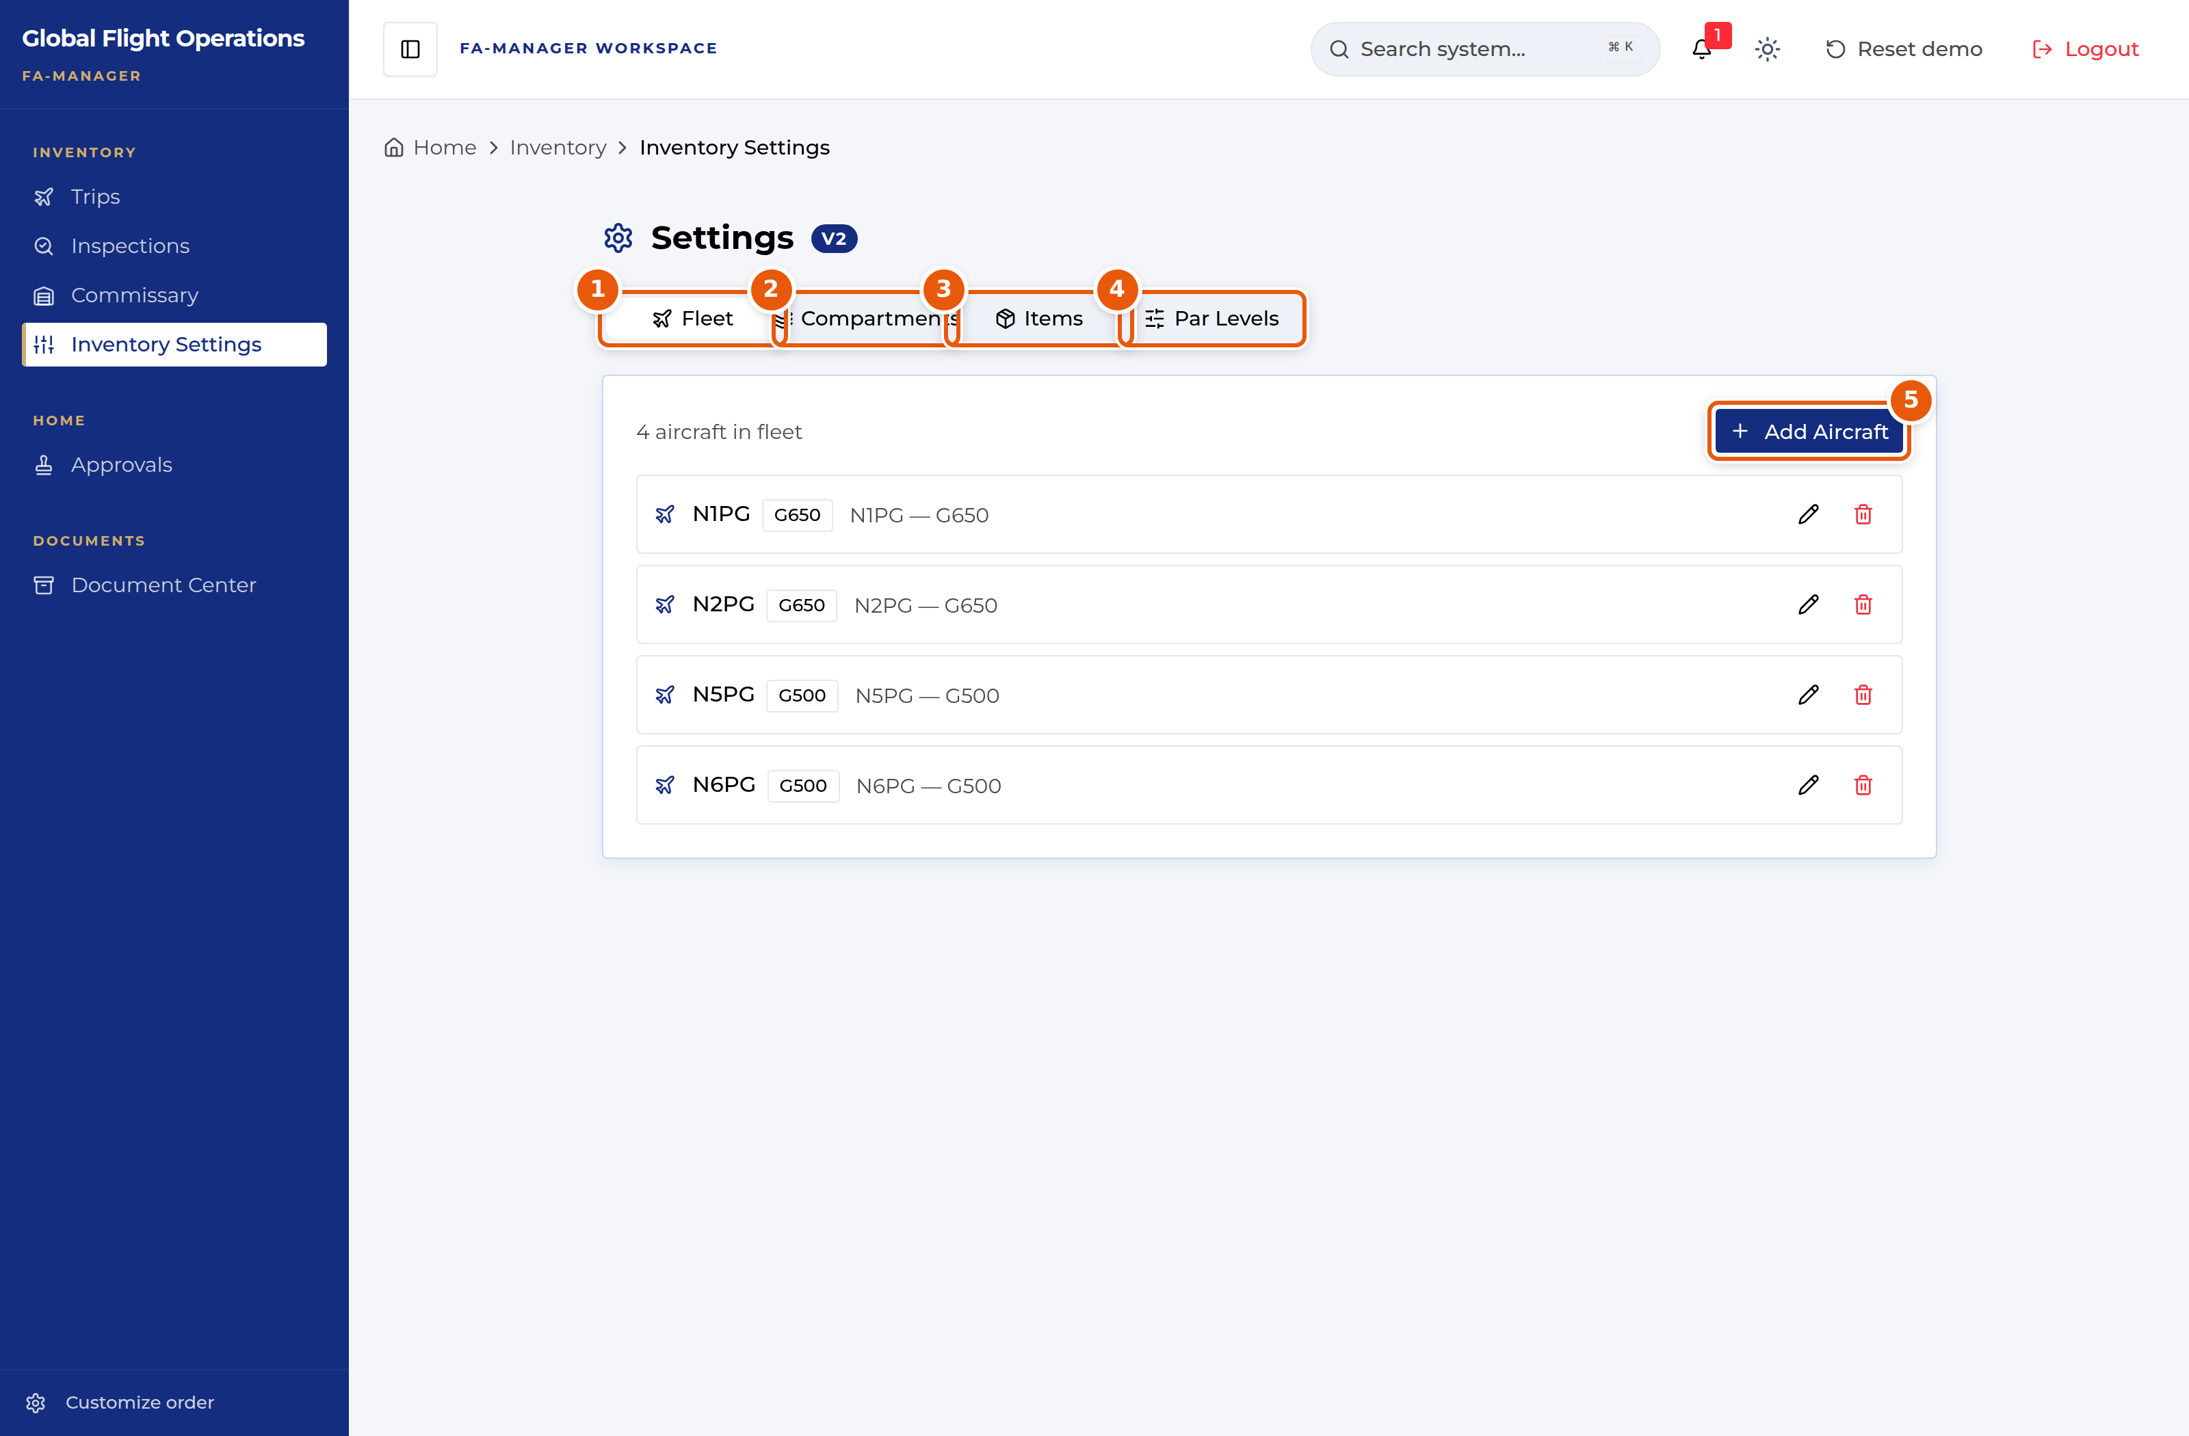
Inventory Settings, on the Fleet tab.
1 | Fleet — the aircraft inventory is tracked for.
2 | Compartments — storage locations within each aircraft.
3 | Items — the catalogue of stockable items.
4 | Par Levels — the target quantities everything else is scored against.
5 | Add Aircraft — bring another tail into inventory tracking.

Reviewing inspection performance
The Inspections page shows the same data a flight attendant sees, but you are reading it differently — across the fleet and over time rather than for the tail in front of you.
Inspection History is where the signal is. Look for tails whose score keeps dropping, items that go missing repeatedly, and gaps where a tail has not been inspected. A recurring shortfall on one item usually means the par level is wrong rather than that stock keeps vanishing — and that is a fix you make in Inventory Settings.
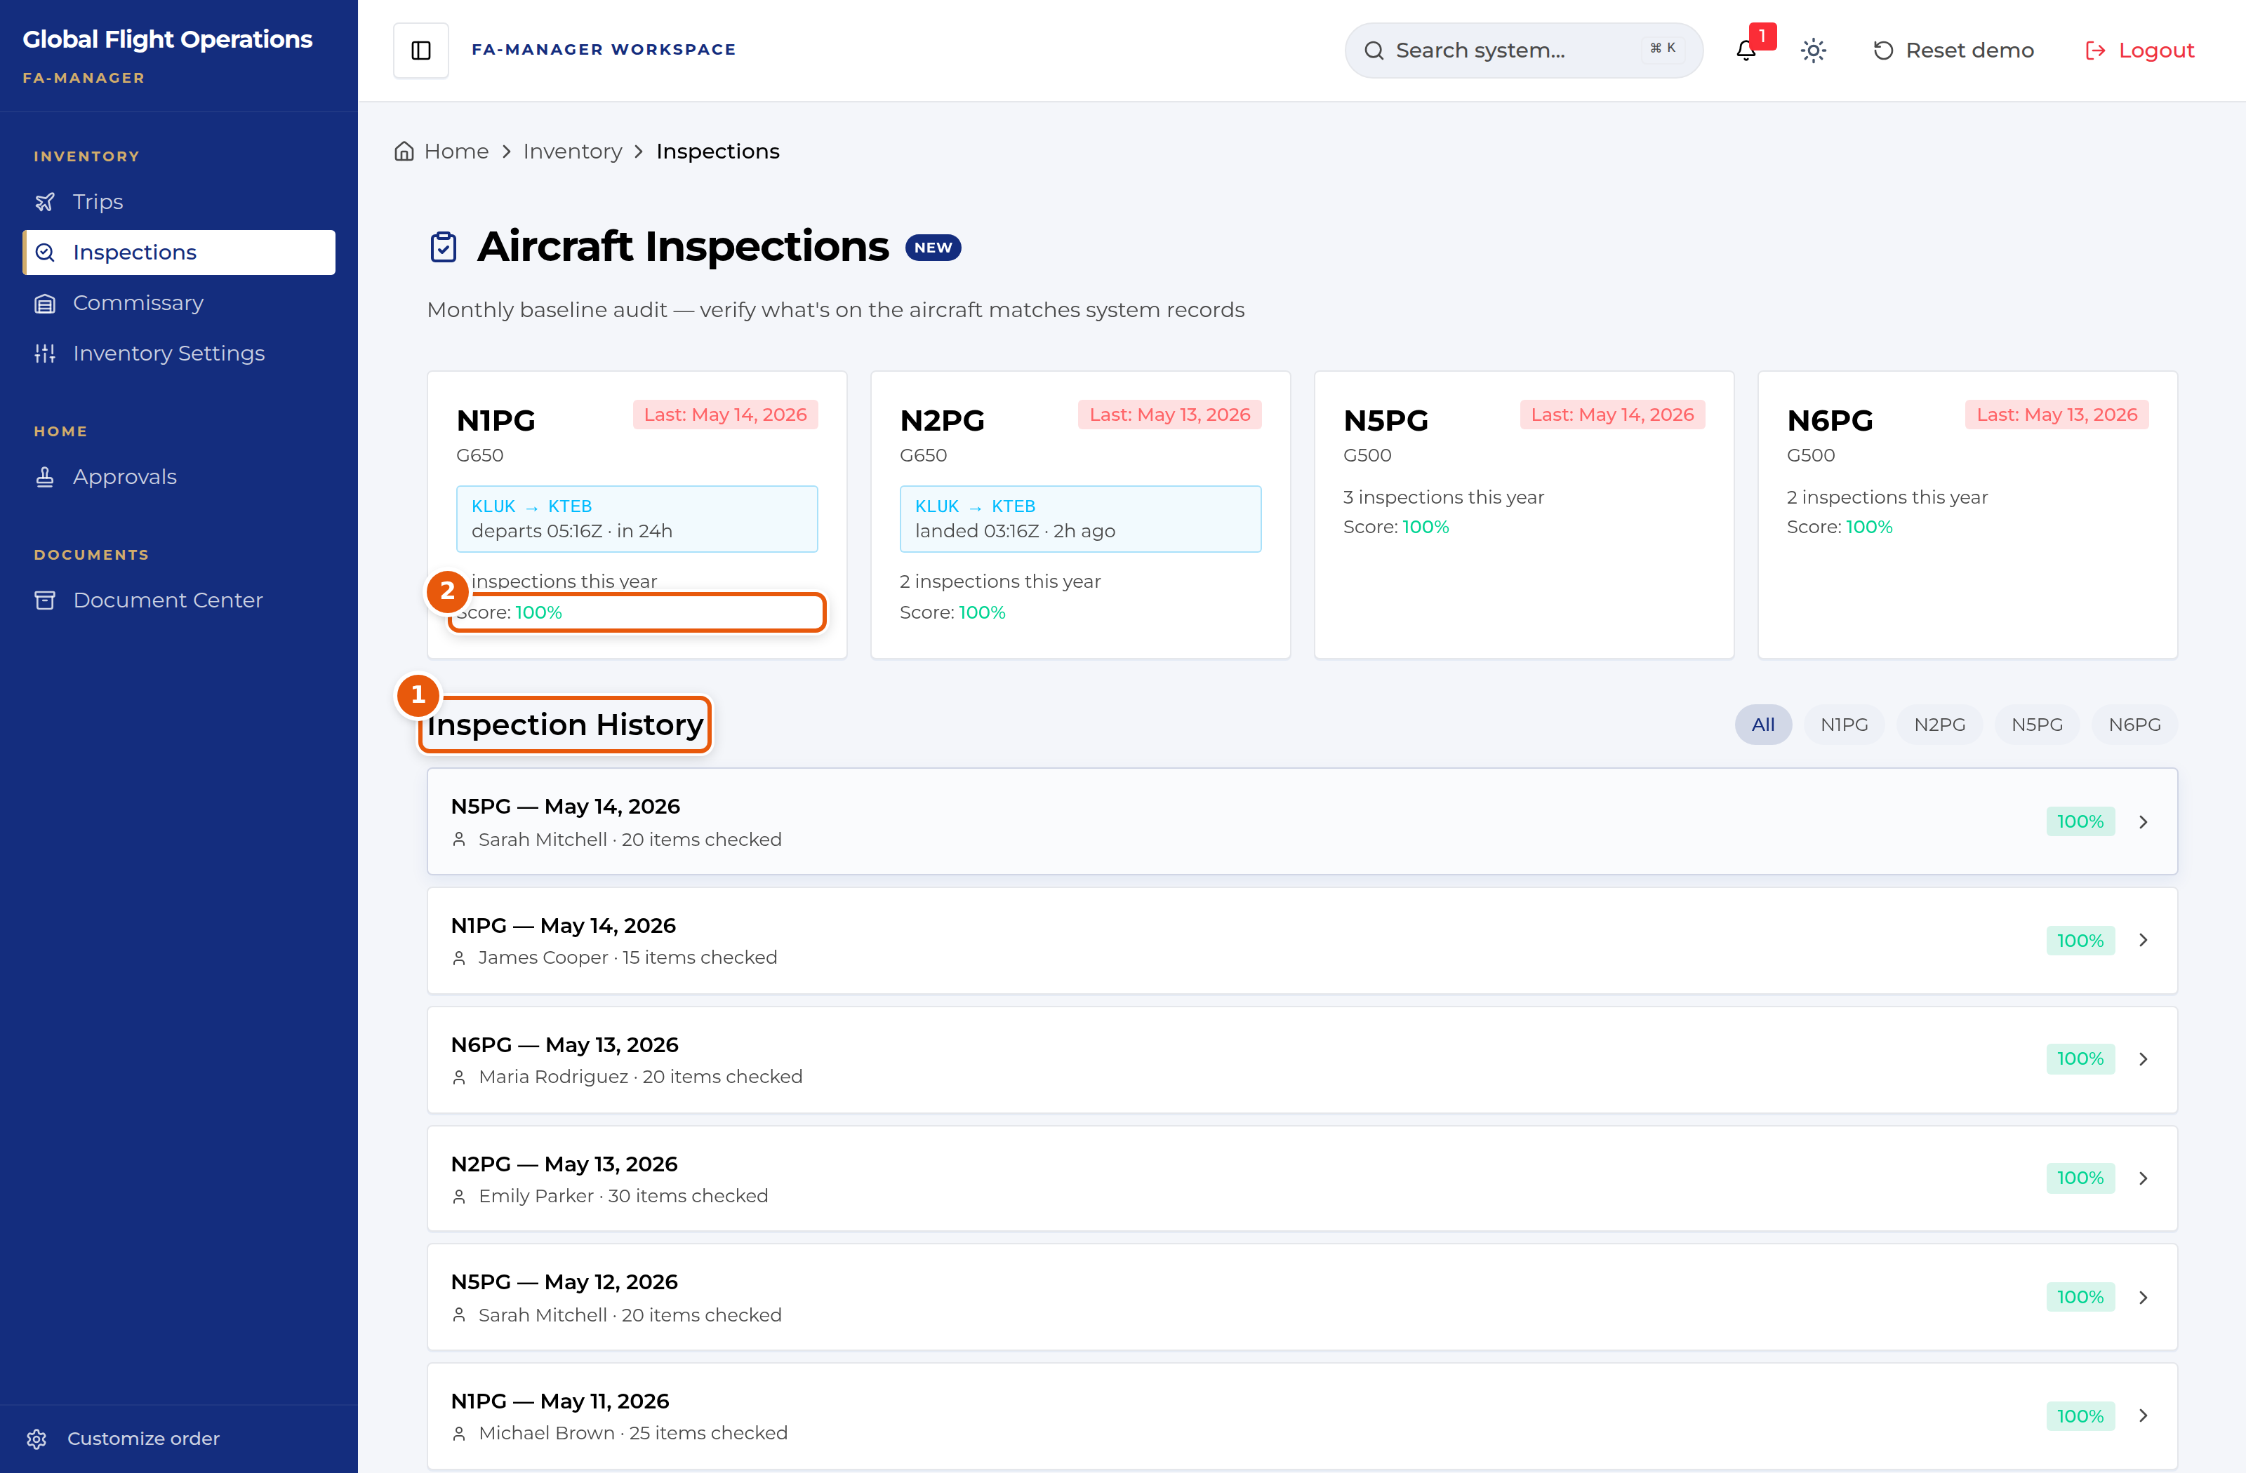
Inspection history across the fleet.
1 | Inspection History — who inspected, how many items, and the score.
2 | Per-tail score. Watch the trend across inspections, not the single number.

Approvals as Flight Attendant Manager
Approvals behaves as described in the Flight Attendant guide. The difference is which requests route to you: your decision is recorded against the Flight Attendant Manager role.
Where cabin knowledge documents require a second approver, the system will not let the author approve their own submission — a submission needs a different approver to clear it.
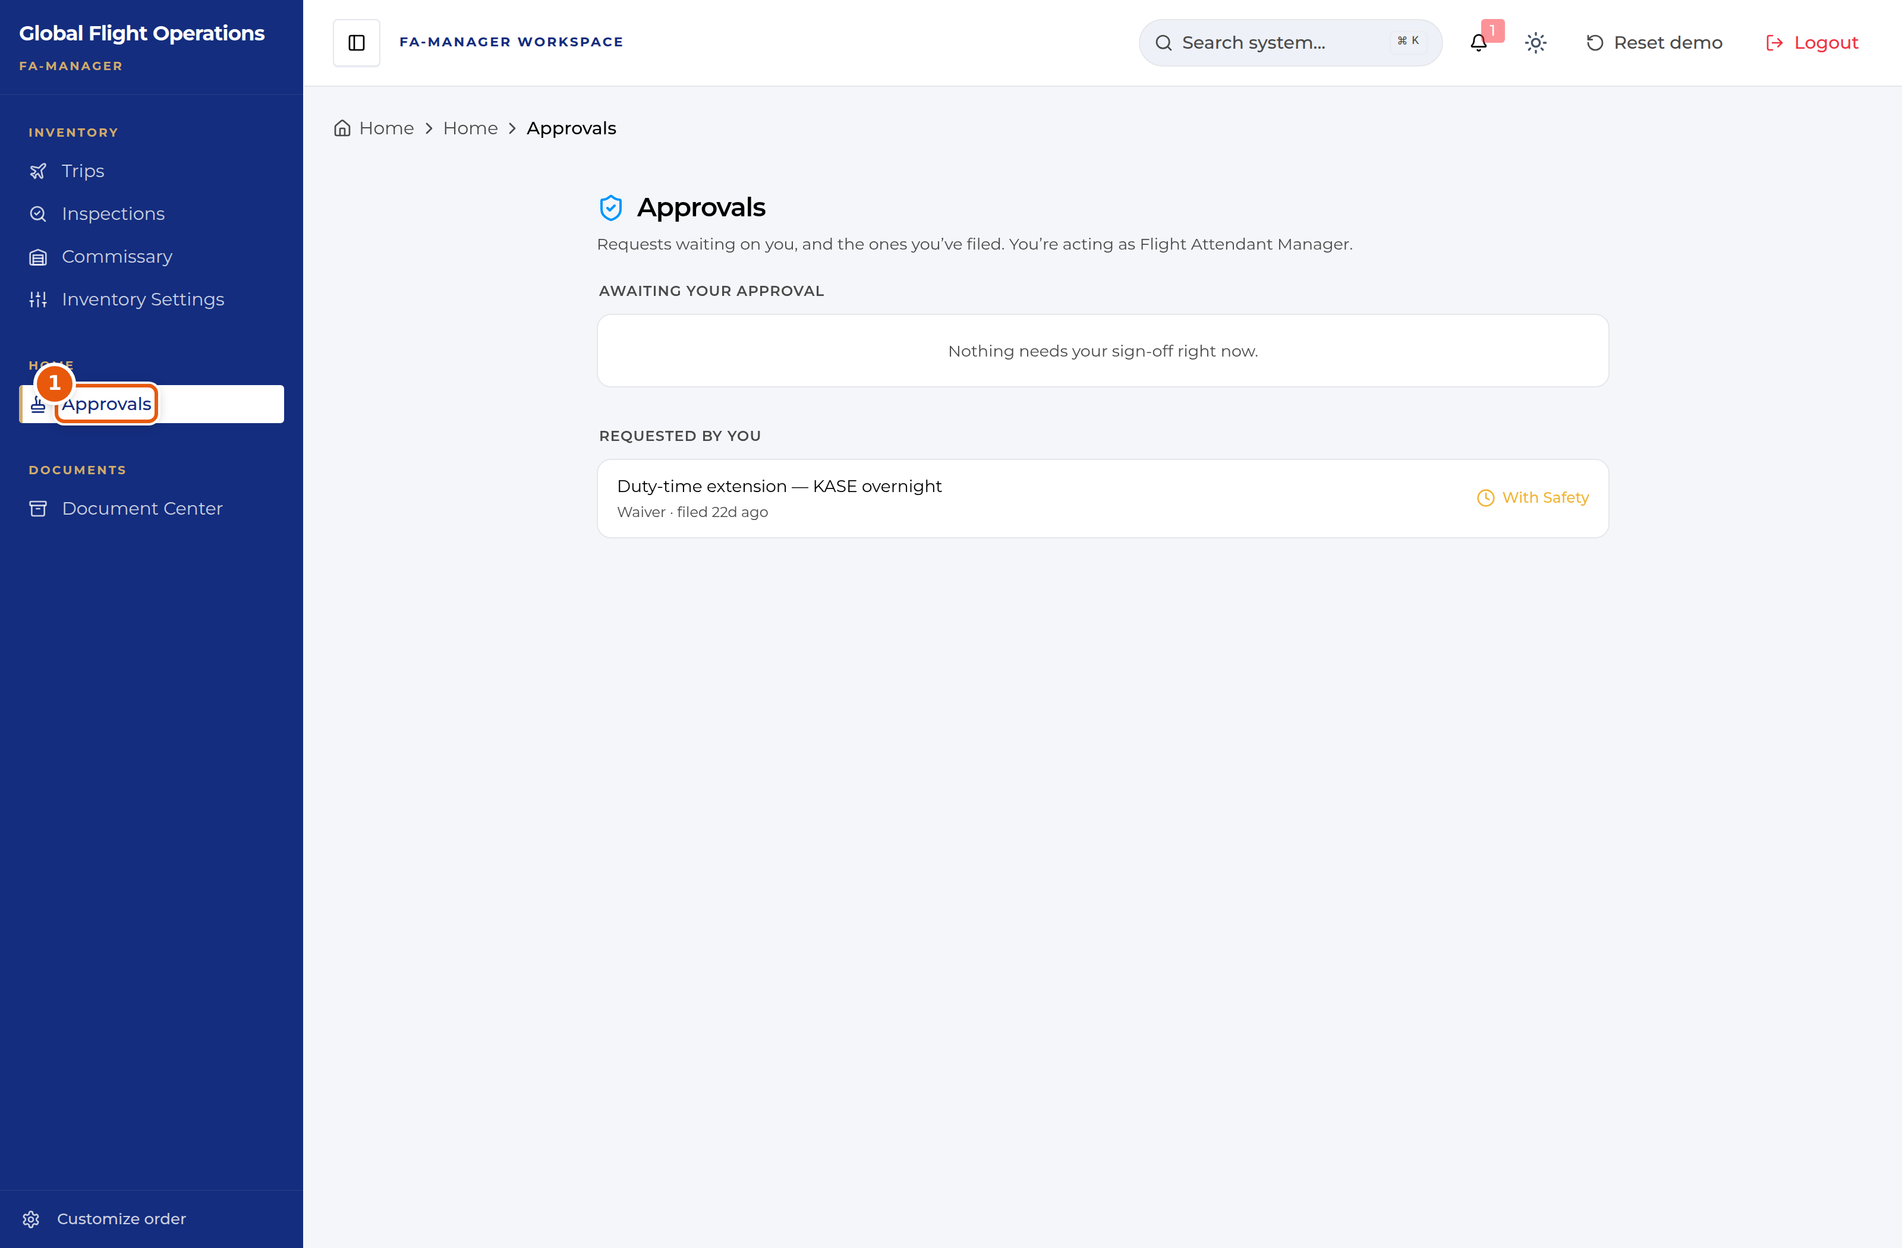
The Approvals inbox, acting as Flight Attendant Manager.
1 | The page states the role you are acting as. Approval authority follows the role.

