myGFO
Global Flight Operations
Scheduling
Training Guide

Day-to-day scheduling work in myGFO: reading fleet serviceability and airspace impact, coordinating trips, and keeping passenger forms and passenger data current enough to fly.
WHO THIS IS FOR
Schedulers and flight coordinators.
Also the base document for the Scheduling Manager — read this first, then the manager supplement.

SCOPE OF THIS GUIDE
This guide covers the day-to-day myGFO screens for this role. Three modules are documented separately and are deliberately not covered here: the Tech Log, Irregularity Reports (FIR), and the Scheduling Command Center. The Safety module is also out of scope — it is not in service yet.
You will still see those items in your sidebar. Ignore them for the purposes of this guide.

Getting started
Screenshots in this guide come from the myGFO prototype running on demo data. Tail numbers, names, dates and counts are illustrative — the screen layout, buttons and workflow are what matter.

Where you land
Scheduling Dashboard, in the Scheduling group, is the page this guide starts from.
Front door: Scheduling workspace.

Your sidebar at a glance
Your role decides which of these appear. Pages are grouped in the sidebar as shown.
Page | Sidebar group | What it is for
Crew Workload | Scheduling | Crew workload and travel
Scheduling Dashboard | Scheduling | Fleet status, airspace, currency alerts, next 24 hours
Trip Coordination | Scheduling | Trips in planning, with checklists and a lead scheduler
Passenger Forms | Scheduling | Passenger form submissions and templates
Passenger Forms · Data Currency | Scheduling | Manifest passengers whose data or documents are stale
Vacation Request | Scheduling | Vacation, PBST, off days, medical leave
Dashboard | Home | Weather, fleet, today’s flights, airspace, duty roster
My Tasks | Home | Action items assigned to you and your own tasks
Approvals | Home | Requests waiting on you, and ones you filed
Pilot Currency | Home | Crew currency — read this before you crew a trip
Document Center | Documents | Controlled publications and your required reads

Signing in
myGFO opens on a demo password screen. Enter the password your administrator gave you and choose Continue.
On the next screen, open Select Your Role, choose your role, and choose Access Dashboard. Your role decides which pages appear in the left sidebar and where you land after sign-in — two people can be looking at the same system and see a different set of pages.
If you hold more than one role, sign in under the one matching the work you are about to do. You can sign out and back in under the other role at any time using Logout at the top right.

Scheduling Dashboard
The Scheduling Dashboard is the situational page for crewing decisions. Fleet Status is the part to read first: every tail with its fuel state and a serviceability verdict — Serviceable, Grounded, or MEL / restricted — and, where relevant, the count of open defects or active deferrals behind that verdict.
MEL / restricted is not the same as Grounded. A tail on an active deferral can fly, but it flies with a restriction, and that restriction may bear on the trip you are about to build.
National Airspace Status carries live FAA ground stops, delays and flow programmes, each with a cause and a start time. Flight Impact Alerts below maps those onto your actual legs so you can see which flights are affected rather than which airports are.
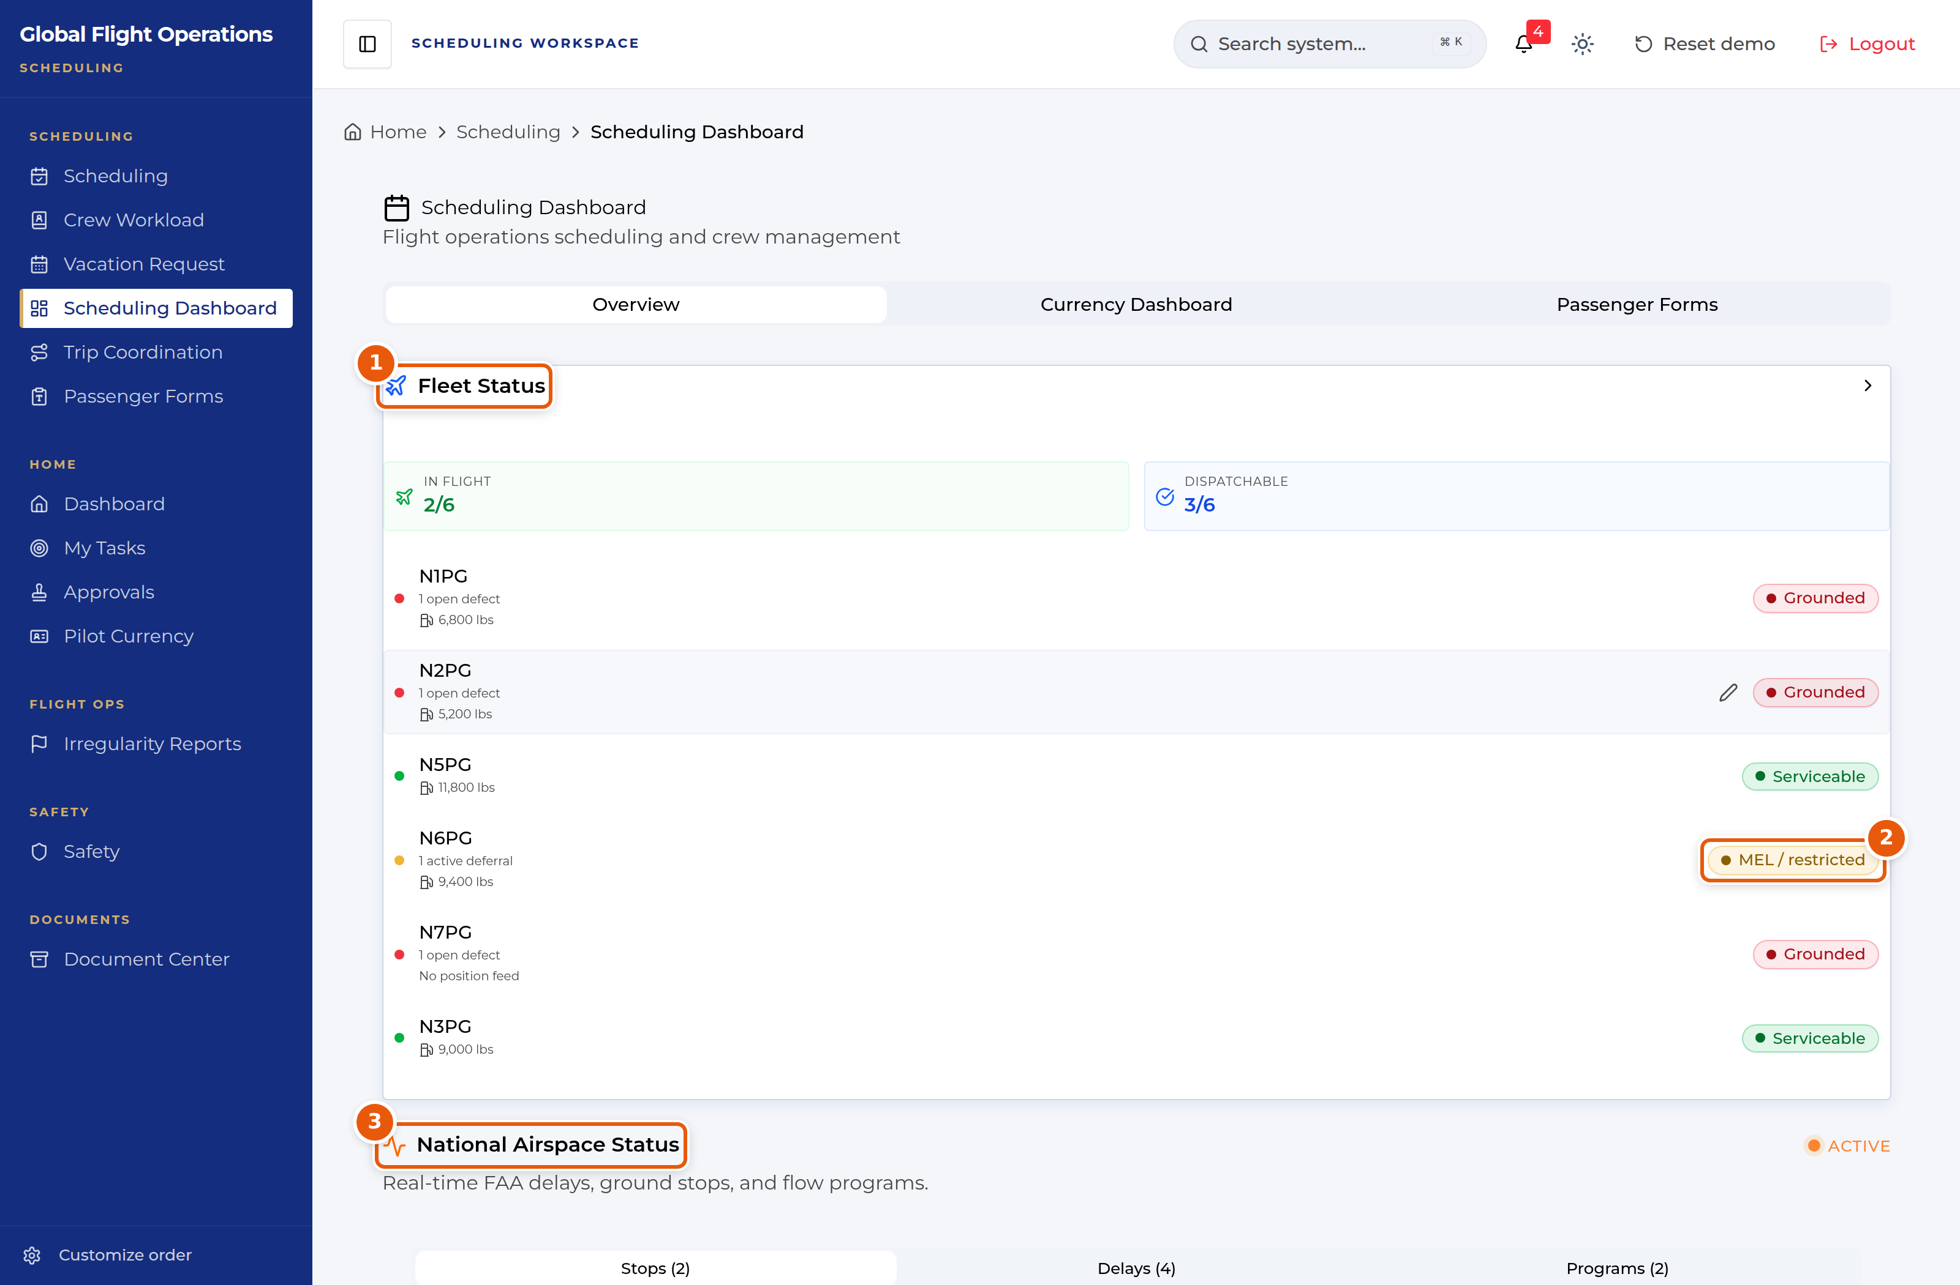
Scheduling Dashboard — fleet status and airspace.
1 | Fleet Status — per-tail serviceability, fuel, and open defects or deferrals.
2 | MEL / restricted — dispatchable, but with a restriction attached.
3 | National Airspace Status — ground stops, delays and flow programmes, with causes.

Further down the page, Currency Alerts names crew whose currency is about to lapse — read it before you assign, not after. Quick Actions gives one-click routes to Send Forms and Check Currency.
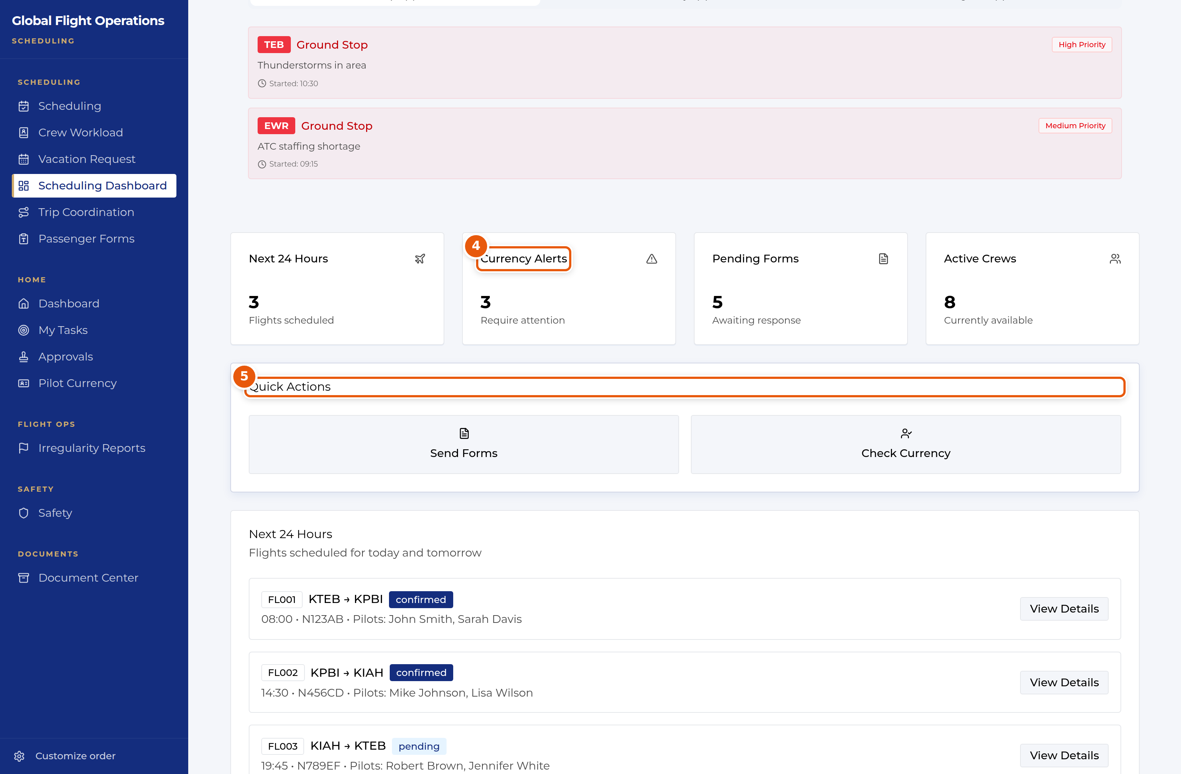
Scheduling Dashboard — currency alerts and quick actions.
4 | Currency Alerts — crew approaching or past a currency limit.
5 | Quick Actions — Send Forms and Check Currency.

Trip Coordination
Trip Coordination tracks trips being built. Each trip carries a priority (standard, vip, urgent), a state (planning, confirmed), the client, and counts of legs, passengers and outstanding tasks.
Two things make this page work as a team tool. Checklist Progress shows how complete the trip’s task list is, so a trip at 0% two days out is visible without opening it. And each trip names a lead scheduler alongside the others working it, so there is never ambiguity about who owns it.
Active Schedulers, down the left, shows who is working which trip right now and when colleagues were last active — useful before you pick up a trip someone else may already be in.
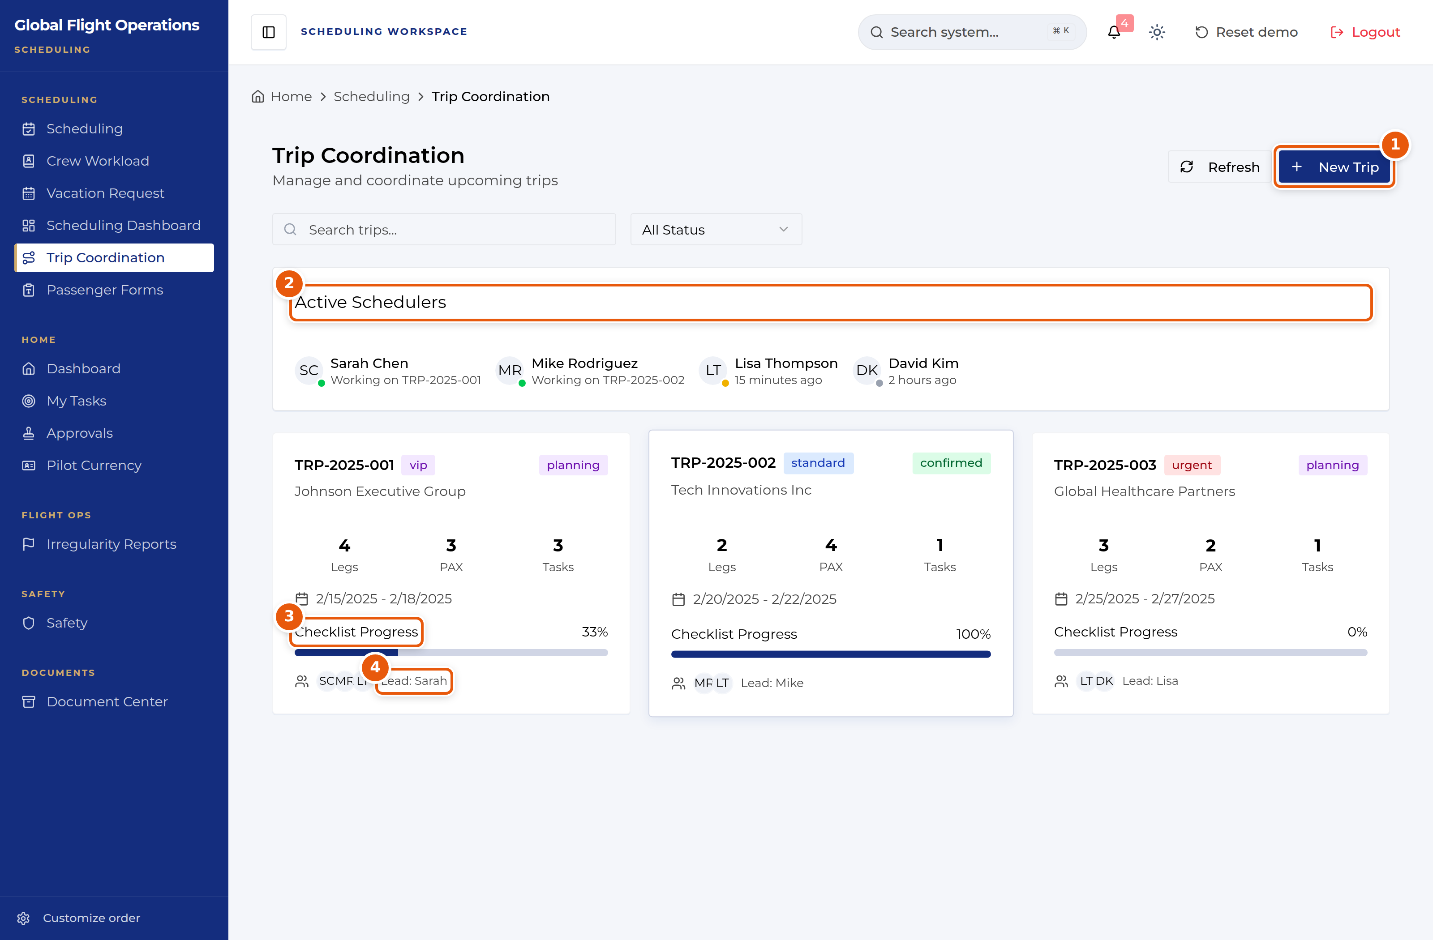
Trip Coordination.
1 | New Trip.
2 | Active Schedulers — who is working what, right now.
3 | Checklist Progress — how complete this trip’s task list is.
4 | The named lead scheduler for the trip.

Passenger Forms
Passenger Forms manages the forms passengers submit and the templates behind them. Counters break the queue into new submissions needing review, documents expiring within 30 days, and data older than two years.
Public Form Link is the workhorse. Copy it and send it to a passenger or an assistant — no login is required to complete the form, which is what makes it usable with people outside the company.
Work the queue with the row actions: Mark Reviewed on a new submission, Mark Entered once the data is in. Manage Templates edits the forms themselves.
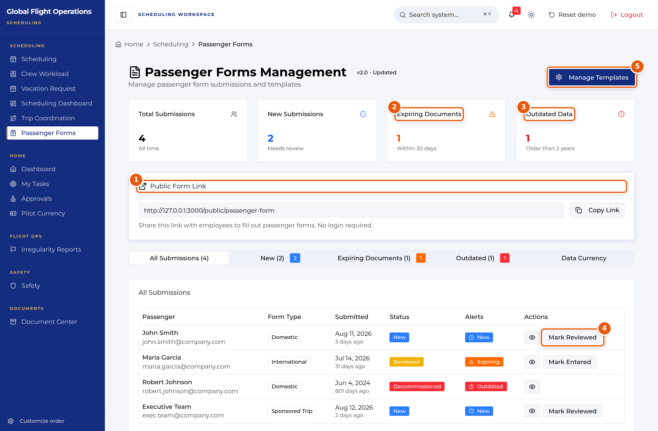
Passenger Forms Management.
1 | Public Form Link — a no-login link you can send outside the company.
2 | Documents expiring within 30 days.
3 | Data older than two years.
4 | Row actions — Mark Reviewed, Mark Entered.
5 | Manage Templates.

Passenger Data Currency
Data Currency crosses upcoming-trip manifests against CRM freshness and answers one question: is every passenger booked on an upcoming trip actually documented well enough to fly? The policy is stated on the page — records updated within two years, travel documents valid through the end of the trip.
Passengers are grouped by trip and flagged three ways. Info stale means the CRM record has not been updated in over two years. Document expiring means the passport expires before the trip ends. No CRM link is the most serious: the passenger is on the manifest with no linked CRM record at all, so identity and documents cannot be verified.
Show needs-action only strips out everyone who is already current. Mark update link sent records that you have chased a passenger.
Read the advisory on the page carefully. Freshness uses the CRM record-modified date as a proxy — it moves on any edit, not only on the passenger confirming their details, so a "current" record is evidence rather than proof. The outreach buttons record your intent locally: the automatic email and any write-back to myairops are deliberately not wired, because myGFO reads from myairops and never writes to it.
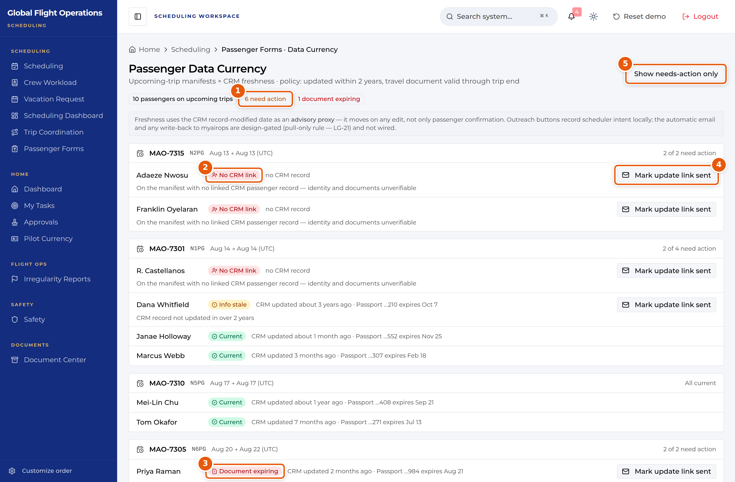
Passenger Data Currency, grouped by trip.
1 | How many passengers on upcoming trips need action.
2 | No CRM link — on the manifest with no linked record. Identity and documents unverifiable.
3 | Document expiring — passport expires before the trip ends.
4 | Mark update link sent — records your outreach. It does not send an email.
5 | Show needs-action only.

Crew Workload and currency
Crew Workload covers crew workload and travel. It is restricted to the scheduling, admin and lead roles — the Chief Pilot cannot open it, so if a Chief Pilot asks for workload data it has to come from you.
Pilot Currency, in the Home group, is the same Currency Dashboard described in the Pilot guide. Read it before you crew a trip: currency is tracked per aircraft type, so a pilot current on one type may be expired on another, and the row expands to a line per type to show exactly that.
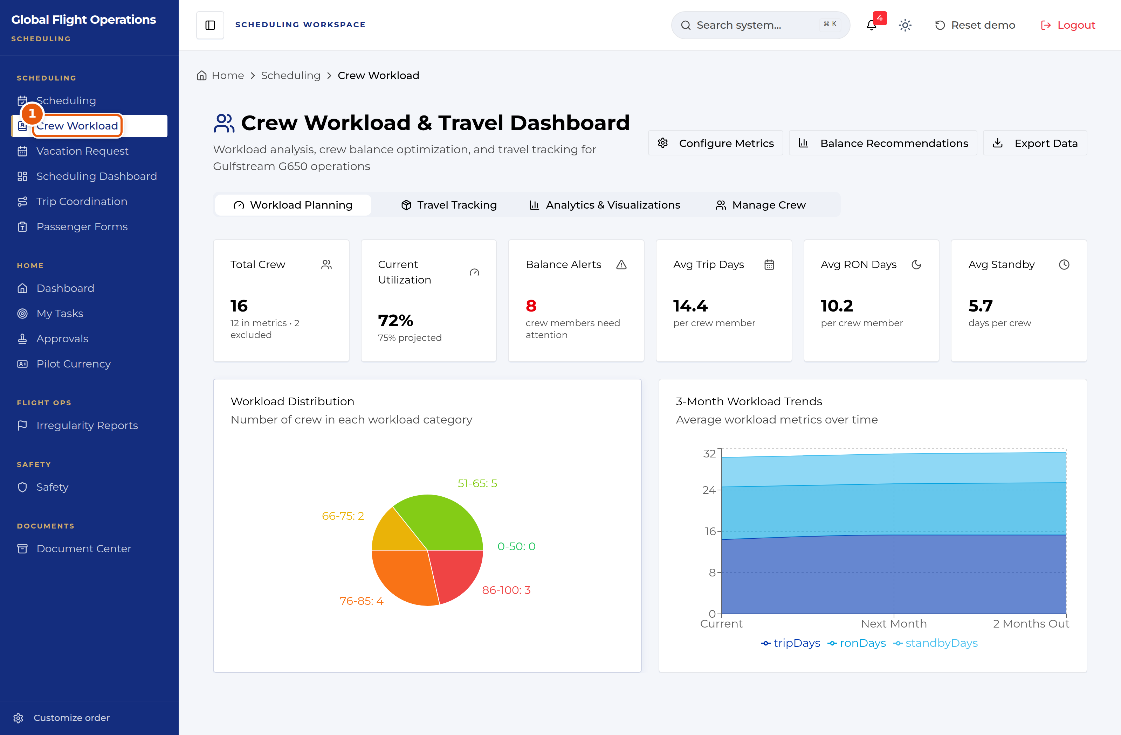
Crew Workload, open under the Scheduling role.
1 | Crew Workload — available to scheduling, admin and lead roles only.

The Dashboard
The Dashboard is the shared home page. Every role sees the same building blocks: current weather and a seven-day planning outlook, the fleet with its serviceability, the day’s flights, national airspace impacts, and who is on shift.
Treat it as a situational-awareness page, not a working page. Nothing on it is signed or filed; it tells you what is going on so you know where to go next.
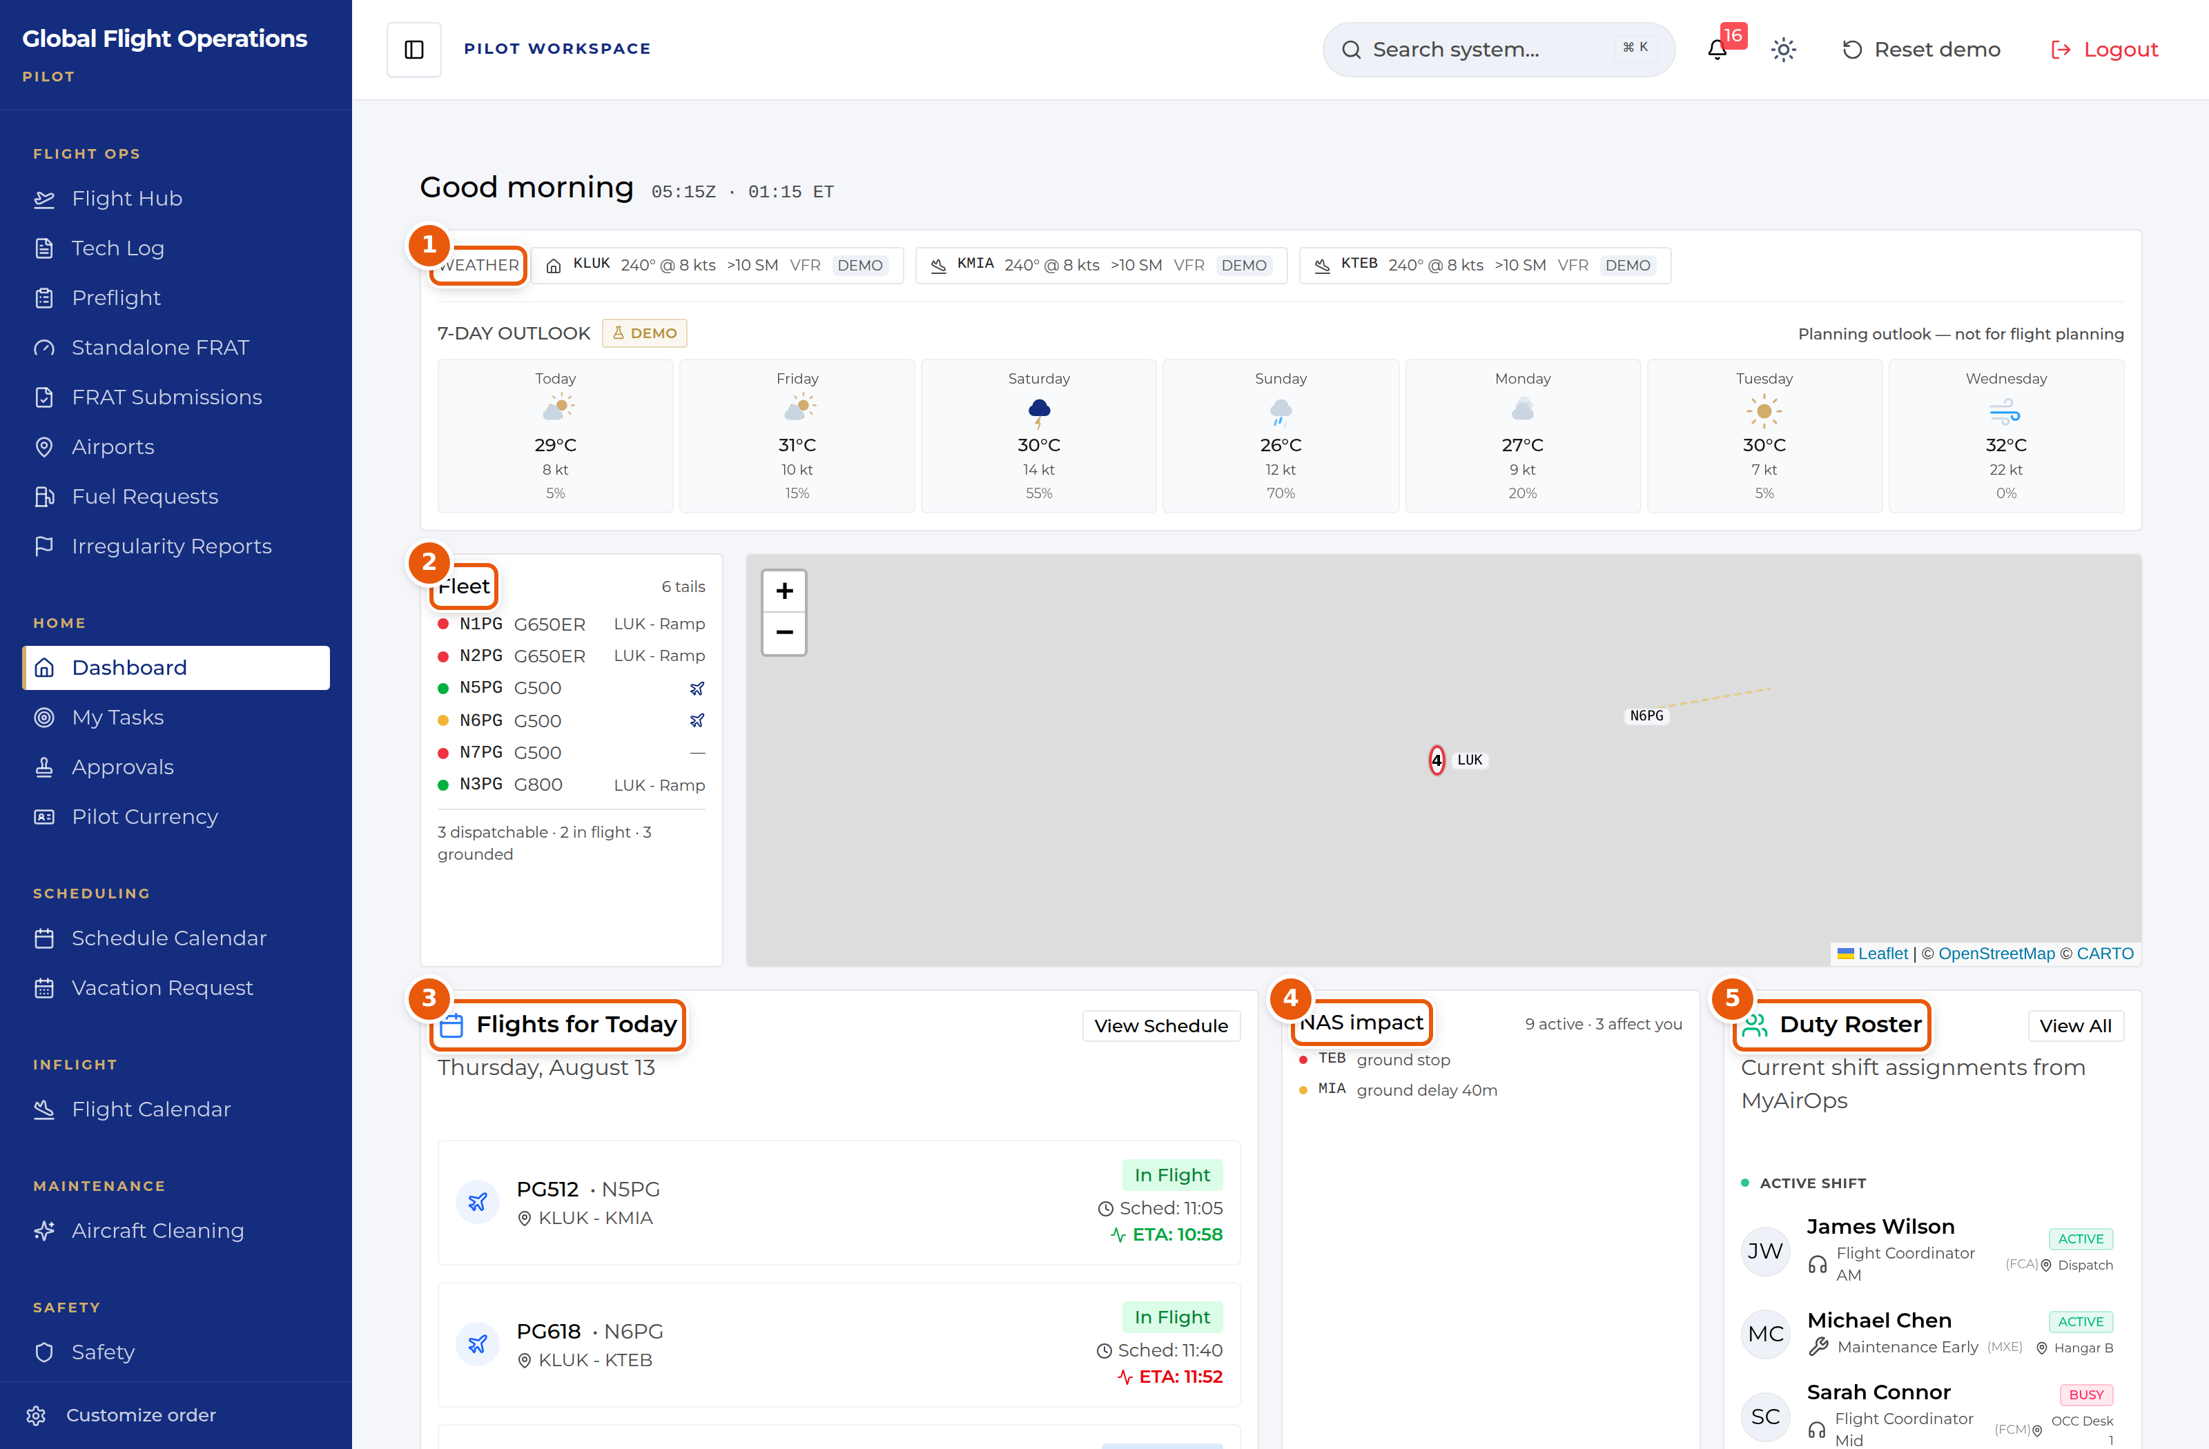
The Dashboard, shown for a Pilot. The panels are the same for every role.
1 | Weather for the home base and the stations in play, plus a seven-day outlook. The outlook is explicitly marked as a planning aid — it is not for flight planning.
2 | The fleet, one line per tail, with a coloured serviceability dot and current location. The summary line underneath counts what is dispatchable, in flight and grounded.
3 | Flights for today with scheduled time and live ETA. Where the ETA has moved away from schedule it is highlighted.
4 | NAS impact — FAA ground stops, ground delays and flow programmes, with a count of how many affect your operation.
5 | Duty Roster — who is on shift now, their function and where they are sitting.

Document Center
The Document Center holds controlled publications and tracks who has read them. It is the same page for every role; what differs is which documents are assigned to you.
My required reads is your personal queue and is the tab to work from. Each row shows the revision, the effective date, a plain-language "What changed" summary, and the acknowledgement the document demands — Read & sign, Read & initial, or Received copy. Rows that have passed their due date are marked Overdue.
Open a document, read it, and complete the acknowledgement at the end. Your outstanding count at the top of the page drops as you clear the queue.
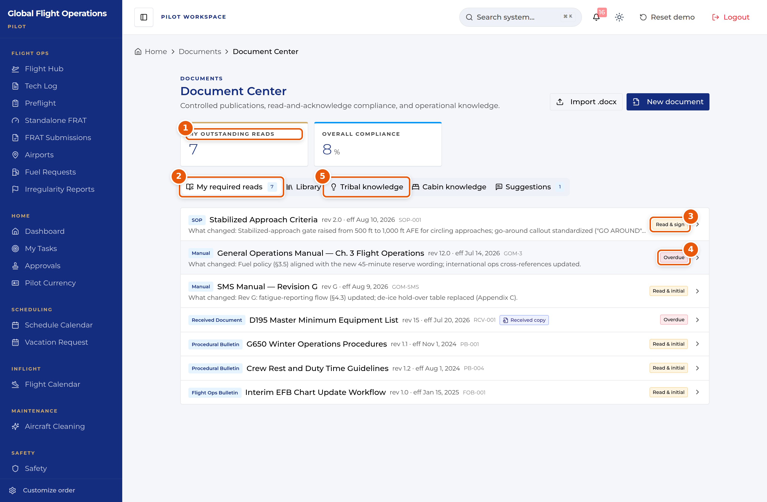
Document Center — the My required reads queue.
1 | My outstanding reads — how many acknowledgements you personally owe.
2 | Tab strip. My required reads is your queue; Library is the full controlled-document set.
3 | The acknowledgement type this document demands. Read & sign is the strongest; Read & initial and Received copy also appear.
4 | Overdue — the acknowledgement deadline has passed. Clear these first.
5 | Tribal knowledge and Cabin knowledge hold non-controlled operational know-how, kept separate from the controlled library on purpose.

Approvals
Approvals is a single inbox with two halves: requests waiting on your decision, and requests you have filed yourself. The page states which role you are acting as, because your approval authority follows your role, not your name.
Multi-step requests show their position in the chain (for example Step 2 of 2) along with what earlier approvers decided and why. Read the earlier decision before you act on yours.
You can Approve, Deny, or Add a comment. Use View request details to see the full submission before deciding.
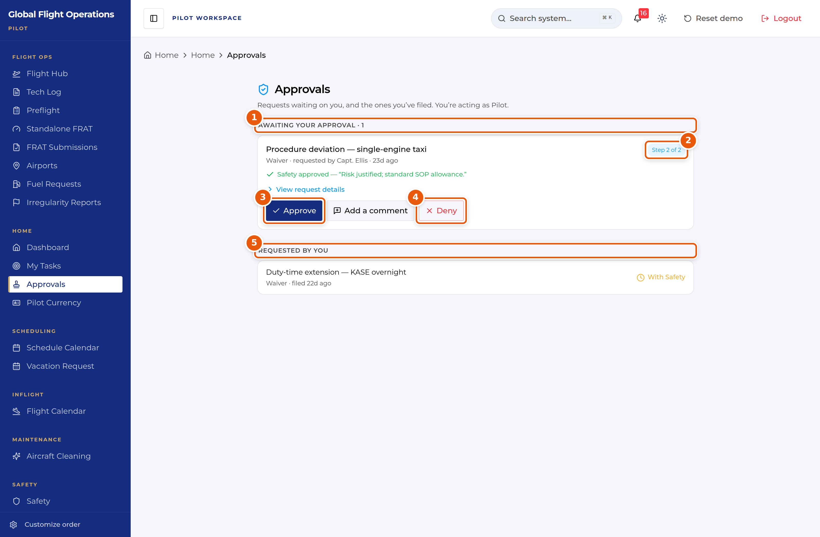
Approvals, shown while acting as Scheduling.
1 | Awaiting your approval, with a count. This is the half you owe action on.
2 | Where this request sits in its approval chain.
3 | Approve — records your decision against your role.
4 | Deny — also records against your role. Add a comment first if the reason is not obvious.
5 | Requested by you — what you have filed, and where each request currently sits.

Vacation and time off
Vacation Request handles vacation, payback stop days (PBST), off days and medical leave through one form.
The page has four tabs: Submit Request, My Requests, Master Calendar and PBST Balance. Check PBST Balance before you file — awarded stop days carry an expiry date, and the balance panel shows how many days are left on each.
On Submit Request choose the request type, set the start and end dates, and add a reason. If you want to spend awarded PBST days against the request, tick them under Apply Available PBST Days before submitting.
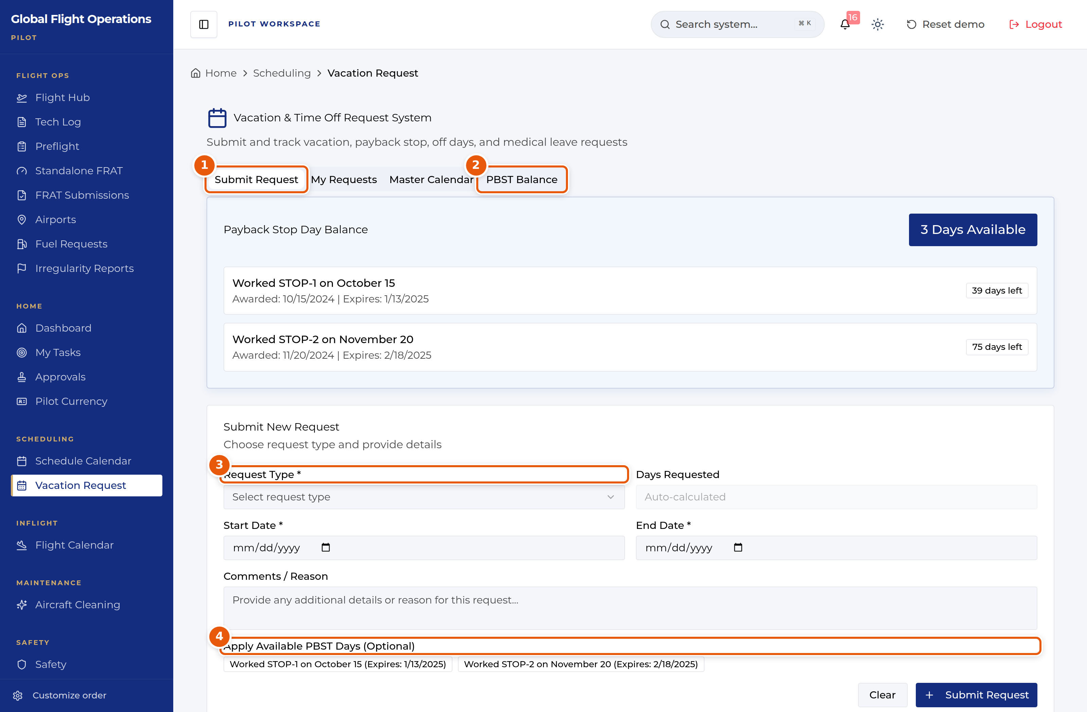
Vacation and time-off request form.
1 | Tab strip — Submit Request, My Requests, Master Calendar, PBST Balance.
2 | PBST Balance shows each awarded stop day, when it was awarded and when it expires.
3 | Request Type drives the rest of the form. Set it first.
4 | Optionally apply awarded PBST days to this request. Expiry dates are shown so you can spend the oldest first.

