myGFO
Global Flight Operations
Chief Inspector
Training Guide — Manager Supplement

The inspection and quality oversight that sits on top of the Maintenance role: acting as an approver, and reading work analytics and turndown history as quality evidence rather than as workload.
READ THIS FIRST
This is a supplement. It covers only what is additional to the Maintenance role.
Read the Maintenance training guide before this one — the shared workflows are documented there and are not repeated here.

WHO THIS IS FOR
Chief Inspector and Shift Lead.
Read the Maintenance guide first. Everything in it applies to you; this covers what is additional.

SCOPE OF THIS GUIDE
This guide covers the day-to-day myGFO screens for this role. Three modules are documented separately and are deliberately not covered here: the Tech Log, Irregularity Reports (FIR), and the Scheduling Command Center. The Safety module is also out of scope — it is not in service yet.
You will still see those items in your sidebar. Ignore them for the purposes of this guide.

Getting started
Screenshots in this guide come from the myGFO prototype running on demo data. Tail numbers, names, dates and counts are illustrative — the screen layout, buttons and workflow are what matter.

Where you land
You land on the Dashboard, with the full Maintenance sidebar beneath it.
Front door: Dashboard.
KNOWN GAP IN THIS ROLE
The Chief Inspector role currently carries the same page set as the Maintenance role, plus Approvals. There is no dedicated inspection or RII surface yet.
The operator-defined list of ATA chapters requiring a Required Inspection Item is an open question on the project, and RII enforcement is not meaningful until that list exists. Until then, RII discipline is procedural rather than enforced by the system.

Your additional pages
These are the pages this supplement covers. Your sidebar also carries everything documented in the Maintenance guide.
Page | Sidebar group | What it is for
Approvals | Home | Requests routed to you as Chief Inspector
Work Analytics | Maintenance | Technician hours and completion, read as quality evidence
Turndown Reports | Maintenance | Shift report history
Parts Inventory | Maintenance | Stock, with attention to serial-tracked parts
Document Center | Documents | Controlled publications and your required reads

What is different about your sign-in
Choose Chief Inspector in the role picker. You land on the Dashboard and your sidebar carries the full Maintenance group — Parts Inventory, Work Analytics, Turndown Reports and Form, Vehicles, Airport Services, Fuel Farm, GRAT and Aircraft Cleaning — plus Approvals and the Document Center.
The pages are the same ones described in the Maintenance guide. What changes is what you are looking for in them.

Approvals as Chief Inspector
Approvals is the surface that is genuinely yours. Requests routed to the Chief Inspector arrive here, and your decision is recorded against that role rather than against your name.
For multi-step requests, the decisions of earlier approvers and their reasoning are shown above the buttons. Read them before deciding — your step exists because someone wanted a second judgement, not a second signature.
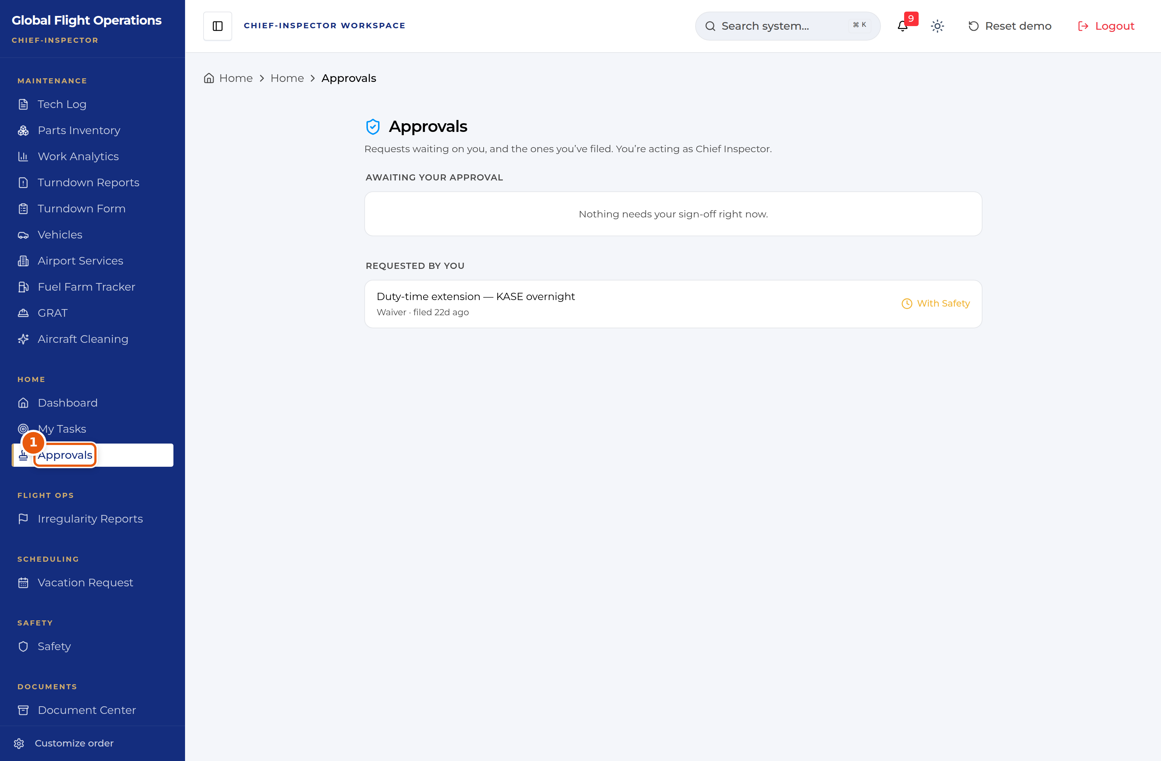
The Approvals inbox, acting as Chief Inspector.
1 | The page states the role you are acting as. Approval authority follows the role, not the person.

Reading work analytics as quality evidence
Work Analytics is presented as a workload page, but for this role it is quality evidence. The same numbers answer a different question.
Filter by technician and read the pattern rather than the total. Completion rate against average completion time is the pairing that matters: work closing fast with a low completion rate suggests items being reopened. Recent Time Entries carries free-text notes, and those notes are often where a recurring defect first becomes visible — the same symptom described three different ways across three shifts.
Work by Category tells you where the effort actually went, which is worth checking against where the department believes it went.
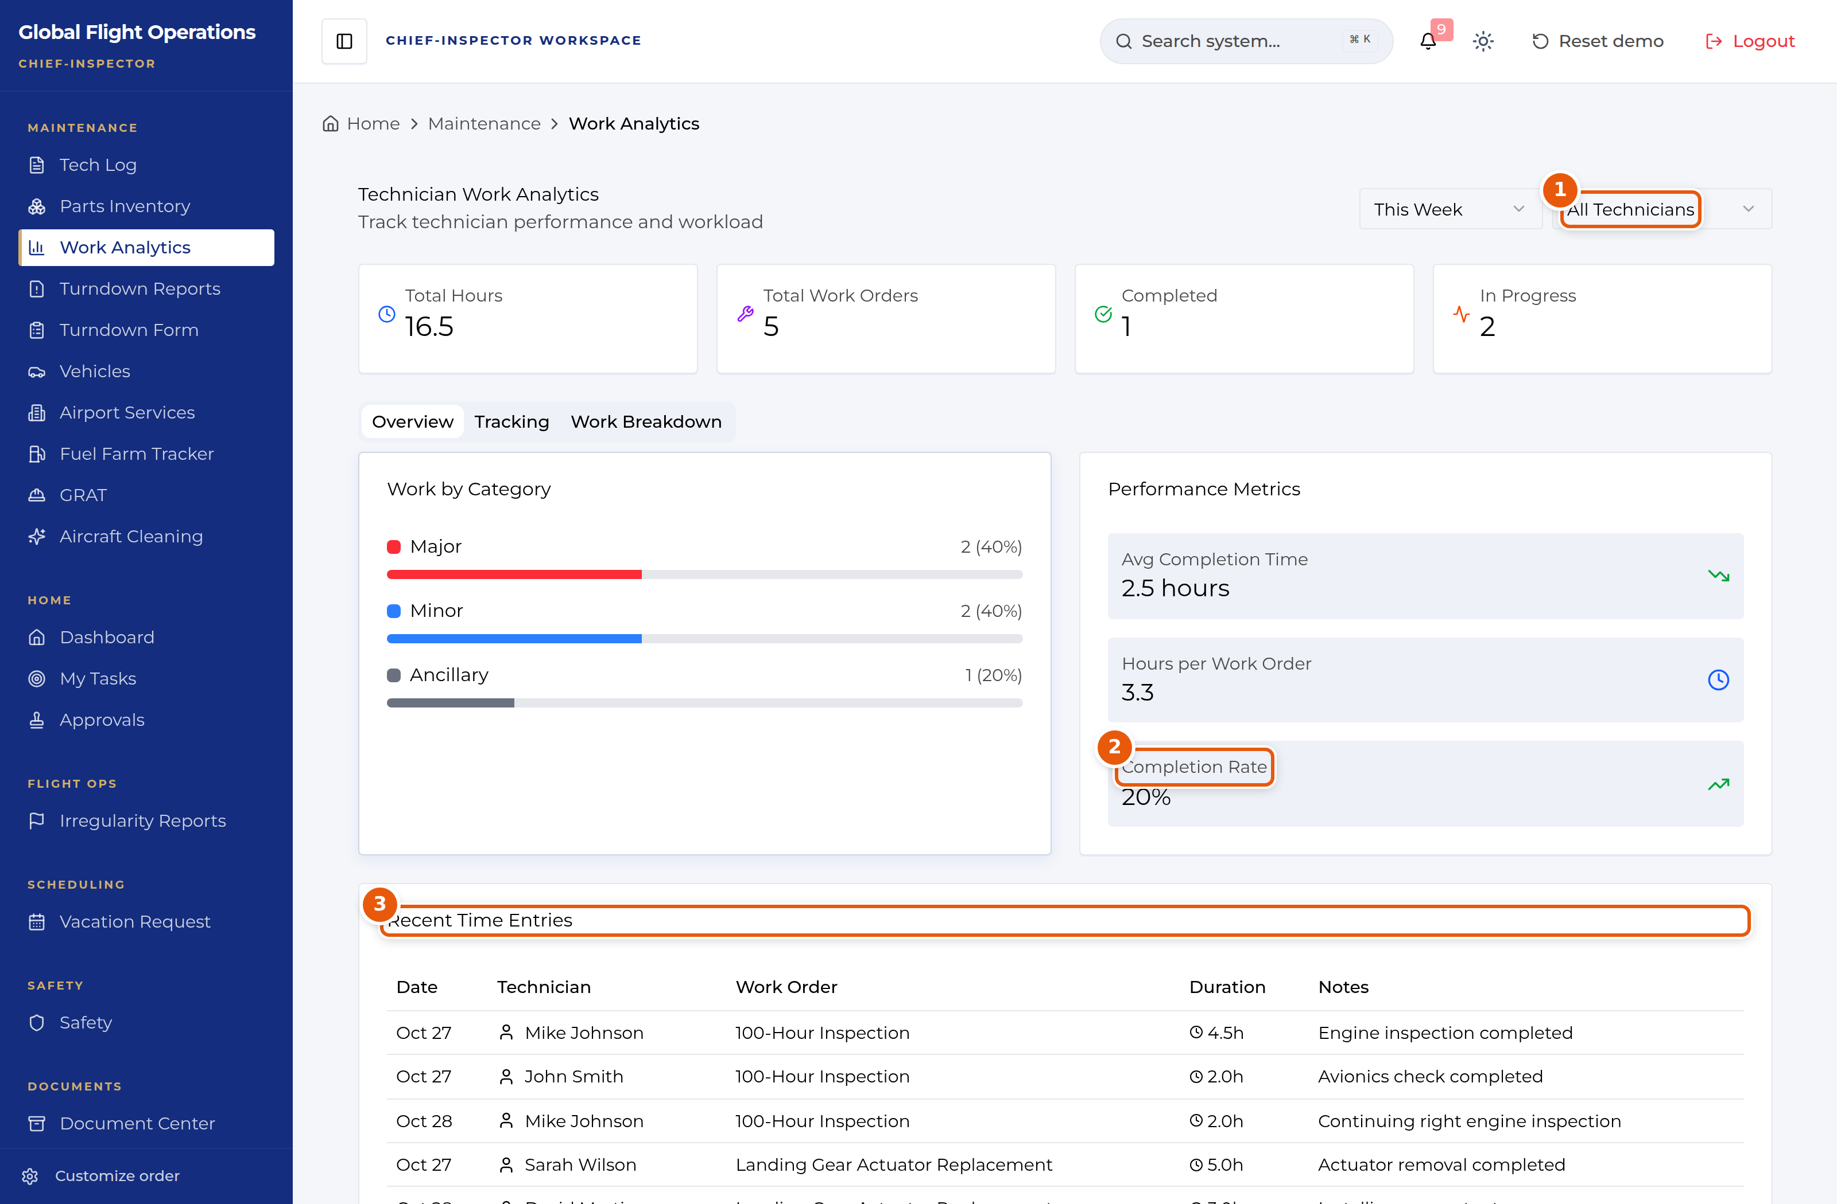
Work Analytics, filtered across all technicians.
1 | Technician filter — read one technician, or the whole shop.
2 | Completion rate. Read it alongside average completion time, not on its own.
3 | Recent Time Entries — the free-text notes are where recurring defects surface.

Turndown history and parts
Turndown Reports is your record of what each shift reported, filterable by date, shift and technician. Read consecutive reports on the same tail: a discrepancy that appears, disappears without a recorded rectification, and then reappears is the pattern worth pulling on.
On Parts Inventory, serial-tracked parts are the ones that concern you. They are badged as serial tracked, and unlike consumables they cannot be treated as interchangeable — the specific unit matters to the airworthiness record.

