myGFO
Global Flight Operations
Director of Maintenance
Training Guide — Manager Supplement

Department-level oversight on top of the Maintenance role: approvals recorded against DOM authority, shop performance, and procurement exposure.
READ THIS FIRST
This is a supplement. It covers only what is additional to the Maintenance role.
Read the Maintenance training guide before this one — the shared workflows are documented there and are not repeated here.

WHO THIS IS FOR
Director of Maintenance.
Read the Maintenance guide first for the underlying pages. This covers how you read them differently.

SCOPE OF THIS GUIDE
This guide covers the day-to-day myGFO screens for this role. Three modules are documented separately and are deliberately not covered here: the Tech Log, Irregularity Reports (FIR), and the Scheduling Command Center. The Safety module is also out of scope — it is not in service yet.
You will still see those items in your sidebar. Ignore them for the purposes of this guide.

Getting started
Screenshots in this guide come from the myGFO prototype running on demo data. Tail numbers, names, dates and counts are illustrative — the screen layout, buttons and workflow are what matter.

Where you land
Your sidebar is the full Maintenance set. This guide covers the pages you will actually live in.
Front door: Maintenance workspace.

Your additional pages
These are the pages this supplement covers. Your sidebar also carries everything documented in the Maintenance guide.
Page | Sidebar group | What it is for
Approvals | Home | Requests routed to you as Director of Maintenance
Work Analytics | Maintenance | Shop capacity, throughput and completion
Parts Inventory | Maintenance | Inventory value, purchase orders and vendors
Turndown Reports | Maintenance | Shift report history across the department
Vehicles | Maintenance | Vehicle fleet state
Airport Services | Maintenance | Evaluation expiry against upcoming flights
Document Center | Documents | Controlled publications and your required reads

What is different about your sign-in
Choose Director of Maintenance in the role picker. Your sidebar is the full Maintenance set, and Approvals carries your department-level authority.
The pages are the ones described in the Maintenance guide. This supplement covers what you are reading them for.

Approvals as Director of Maintenance
Requests routed to the DOM arrive in the Approvals inbox and your decision is recorded against that authority.
Two rules are enforced by the system rather than left to discipline, and they are worth knowing because they will occasionally block you. A release to service cannot be committed by a signer with no A&P certificate number on file. And on work requiring a required inspection, the same person cannot be both the performer and the inspector.
If either blocks a sign-off, the fix is the underlying record — a missing certificate number, or a second person — not a workaround.
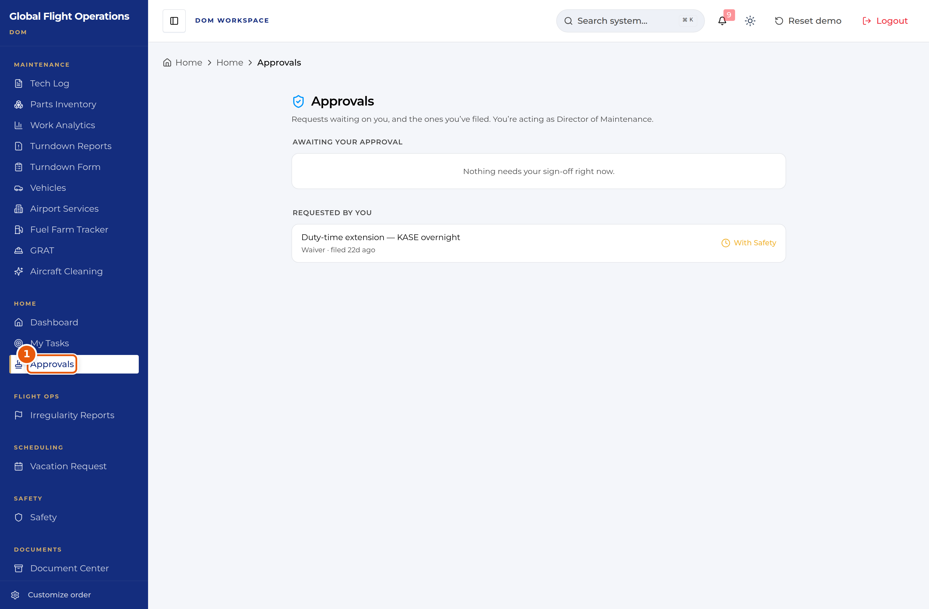
The Approvals inbox, acting as Director of Maintenance.
1 | The page states the role you are acting as. Your decision is recorded against DOM authority.

Shop performance
Work Analytics is your capacity and throughput view. Set the period, then read the shop as a whole before filtering to individuals.
Performance Metrics is the section that answers management questions: average completion time, hours per work order, and completion rate. Work by Category shows the Major / Minor / Ancillary split — if ancillary work is consuming a growing share, that is a resourcing conversation rather than a performance one.
Filtering by technician shows individual load, which is useful for spotting an unbalanced shop. Be careful reading it as productivity: a technician carrying the difficult work will show worse raw numbers than one carrying routine items.
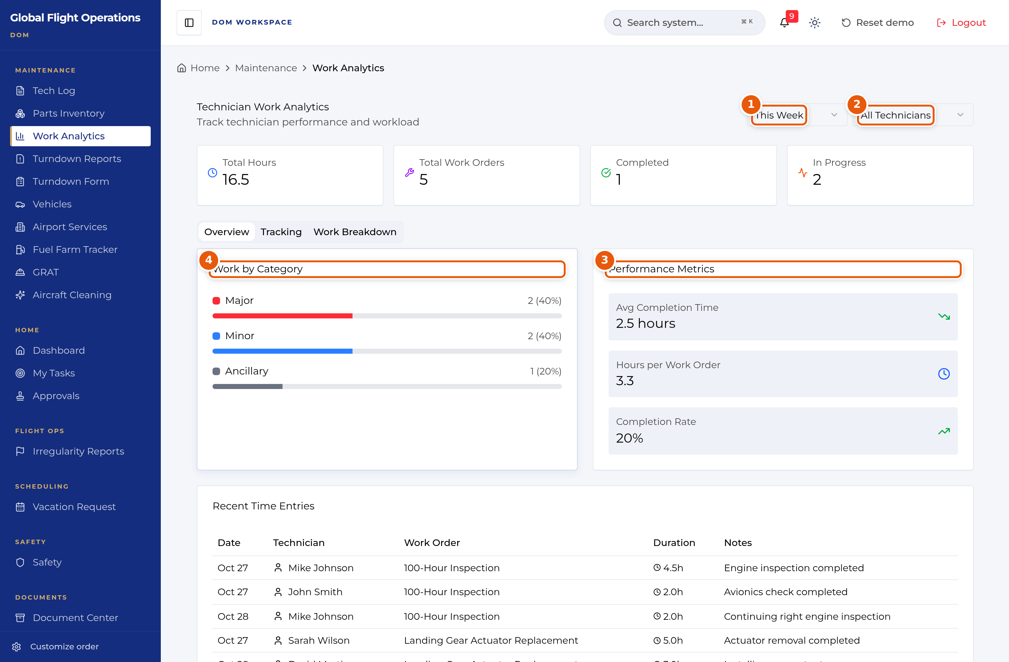
Work Analytics across the department.
1 | Period selector — set this before reading anything else.
2 | Technician filter. Start with All Technicians.
3 | Performance Metrics — completion time, hours per work order, completion rate.
4 | Work by Category — where the effort actually went.

Procurement exposure
On Parts Inventory the counters carry your commercial picture: total inventory value, how many parts are low or out of stock, and how many orders are awaiting delivery.
Purchase Orders and Vendors are the tabs to work from at department level. An out-of-stock part with no purchase order behind it is the exposure worth finding — the Stock Alerts tab surfaces those.
The myCMP connection state and last sync time are printed at the top of the page. A stale sync means the figures below it are stale too; check it before quoting a number.
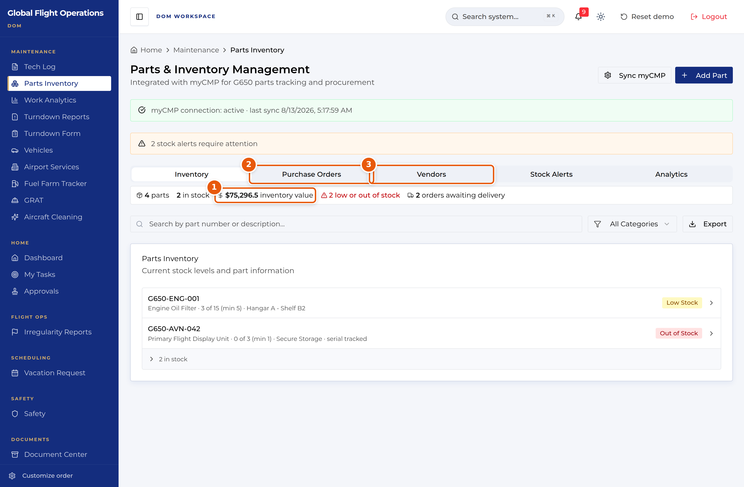
Parts Inventory, read at department level.
1 | Total inventory value.
2 | Purchase Orders — what is on order and when it lands.
3 | Vendors.

Departmental record
Turndown Reports gives you the department’s daily record, filterable by date, shift and technician. Read it for consistency of reporting as much as for content — a shift that files thin reports is a gap in the record, and the next shift inherits it.
Airport Services matters at your level for the same reason it matters to a technician, but with the budget attached: overdue evaluations against upcoming flights are commitments the department has already made without the supporting assessment.

