myGFO
Global Flight Operations
Chief Pilot
Training Guide — Manager Supplement

The oversight work that sits on top of the Pilot role: approving airport company pages, maintaining the rules that flag airports, processing airport evaluation requests, and acting as an approver.
READ THIS FIRST
This is a supplement. It covers only what is additional to the Pilot role.
Read the Pilot training guide before this one — the shared workflows are documented there and are not repeated here.

WHO THIS IS FOR
Chief Pilot and Assistant Chief Pilot.
Read the Pilot guide first. Everything in it applies to you; this document covers only what is additional.

SCOPE OF THIS GUIDE
This guide covers the day-to-day myGFO screens for this role. Three modules are documented separately and are deliberately not covered here: the Tech Log, Irregularity Reports (FIR), and the Scheduling Command Center. The Safety module is also out of scope — it is not in service yet.
You will still see those items in your sidebar. Ignore them for the purposes of this guide.

Getting started
Screenshots in this guide come from the myGFO prototype running on demo data. Tail numbers, names, dates and counts are illustrative — the screen layout, buttons and workflow are what matter.

Where you land
You land on the Flight Hub, exactly as a line pilot does. Your additional work sits behind the Airports tab strip and the Approvals page.
Front door: Flight Hub (Pilot Workspace).

Your additional pages
These are the pages this supplement covers. Your sidebar also carries everything documented in the Pilot guide.
Page | Sidebar group | What it is for
Airports · Needs review | Flight Ops | Company pages that are overdue, never reviewed, or awaiting you
Airports · Proposals | Flight Ops | Proposed page edits awaiting your decision, and approved pages ready to publish
Airports · Rules & flags | Flight Ops | The rules that flag airports from FAA reference data
Airport Evaluation Officer | Admin | Incoming requests for new airport evaluations and corrections
Approvals | Home | Requests routed to you as Chief Pilot

What is different about your sign-in
Sign in by choosing Chief Pilot in the role picker. Your sidebar looks like a pilot’s, because it is — the extra Chief Pilot work is reached through the tab strip on the Airports page rather than through separate sidebar rows.
Open Airports from the Flight Ops group and you get four tabs: Directory, Needs review, Proposals, and Rules & flags. The last three are yours.

The airport worklist
Needs review is the queue of company pages wanting attention, split four ways: awaiting your decision, approved but not yet published, never reviewed, and review overdue.
The page derives everything from the company pages themselves — there is no separate queue to keep in step, so a page cannot be quietly waiting somewhere you are not looking.
Note the line at the foot: review intervals are a flight-department default, between 90 days and a year depending on the field. They are a department standard, not a regulatory deadline.
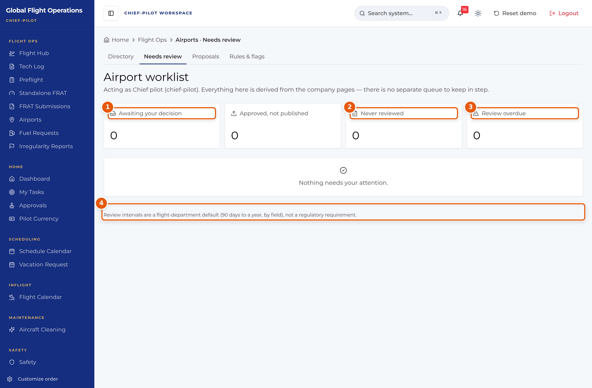
Airport worklist. All four counters are at zero in this demo build.
1 | Awaiting your decision — proposals sitting on you.
2 | Never reviewed — a company page exists but nobody has reviewed it.
3 | Review overdue — past its review interval.
4 | Review intervals are a department default, not a regulatory requirement.

Approving page proposals
Proposals is where crew-submitted edits to airport company pages come to you. It has two lists: awaiting your decision, and approved and ready to publish.
Approval and publication are separate steps on purpose. Approving a page records that you accept the content; publishing pushes it to the crews. A page can sit approved-but-unpublished, and the worklist counts those separately so they do not get lost.
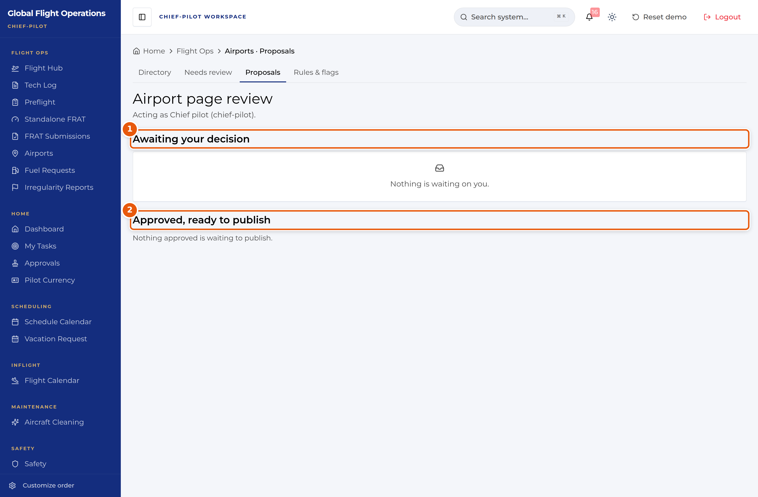
Airport page review, with both lists empty.
1 | Awaiting your decision.
2 | Approved, ready to publish — approved content that crews cannot see yet.

Rules and flags
Rules & flags is the highest-leverage page you own. A flag is a rule evaluated against FAA reference data that marks airports for crews — for example Short runway, High elevation, or No declared distances published.
Each flag carries a severity (caution or info), the surface it shows on, and the advisory text crews will read. Before you save, the page tells you how many of the 2,128 airports in the directory the rule currently matches, so you can see the blast radius of a change before you make it.
Write the advisory text as the instruction you want a crew to act on. "Density altitude will bite. Recheck takeoff and climb performance." is useful; "high airport" is not.
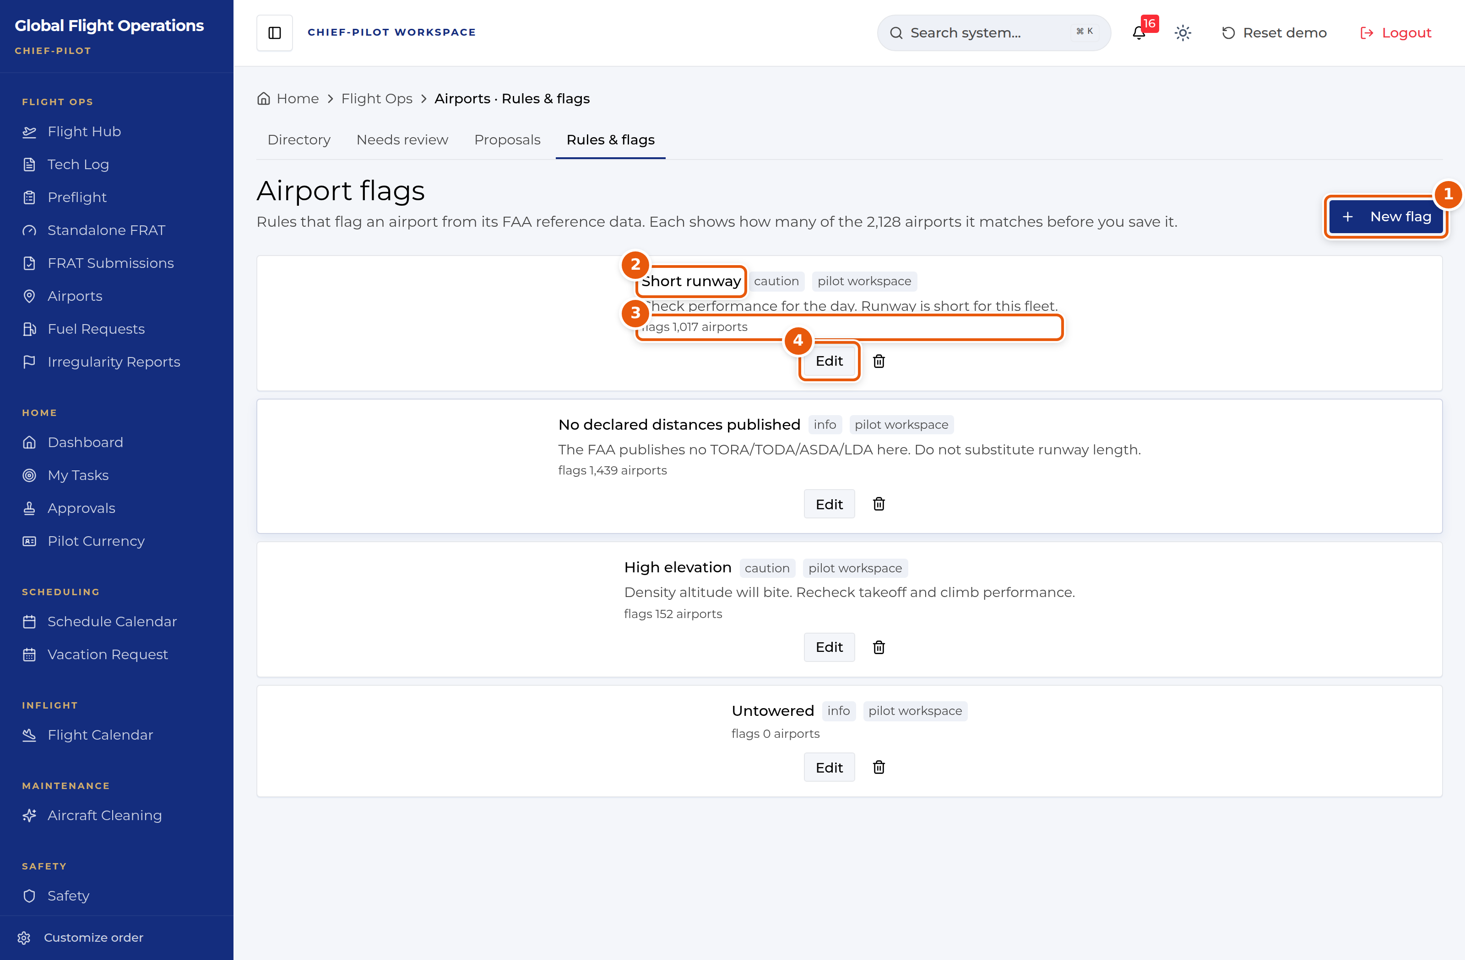
Airport flags, with the match count shown against each rule.
1 | New flag — define a new rule.
2 | The flag name, its severity, and where it surfaces to crews.
3 | How many airports this rule matches right now. Check this before saving a change.
4 | Edit — change the rule or its advisory text.

Airport evaluation requests
Airport Evaluation Officer, in the Admin group, is the intake queue for crew requests: new airports the department has not evaluated, and corrections to existing entries.
Counters at the top break the queue into Pending Review, In Review, New Airports and With FAA Data. That last one matters — a request with FAA data behind it can be evaluated from published reference data, while one without needs full manual research. The queue tells you which is which before you pick up the work.
Each request shows who submitted it and how long it has been waiting.
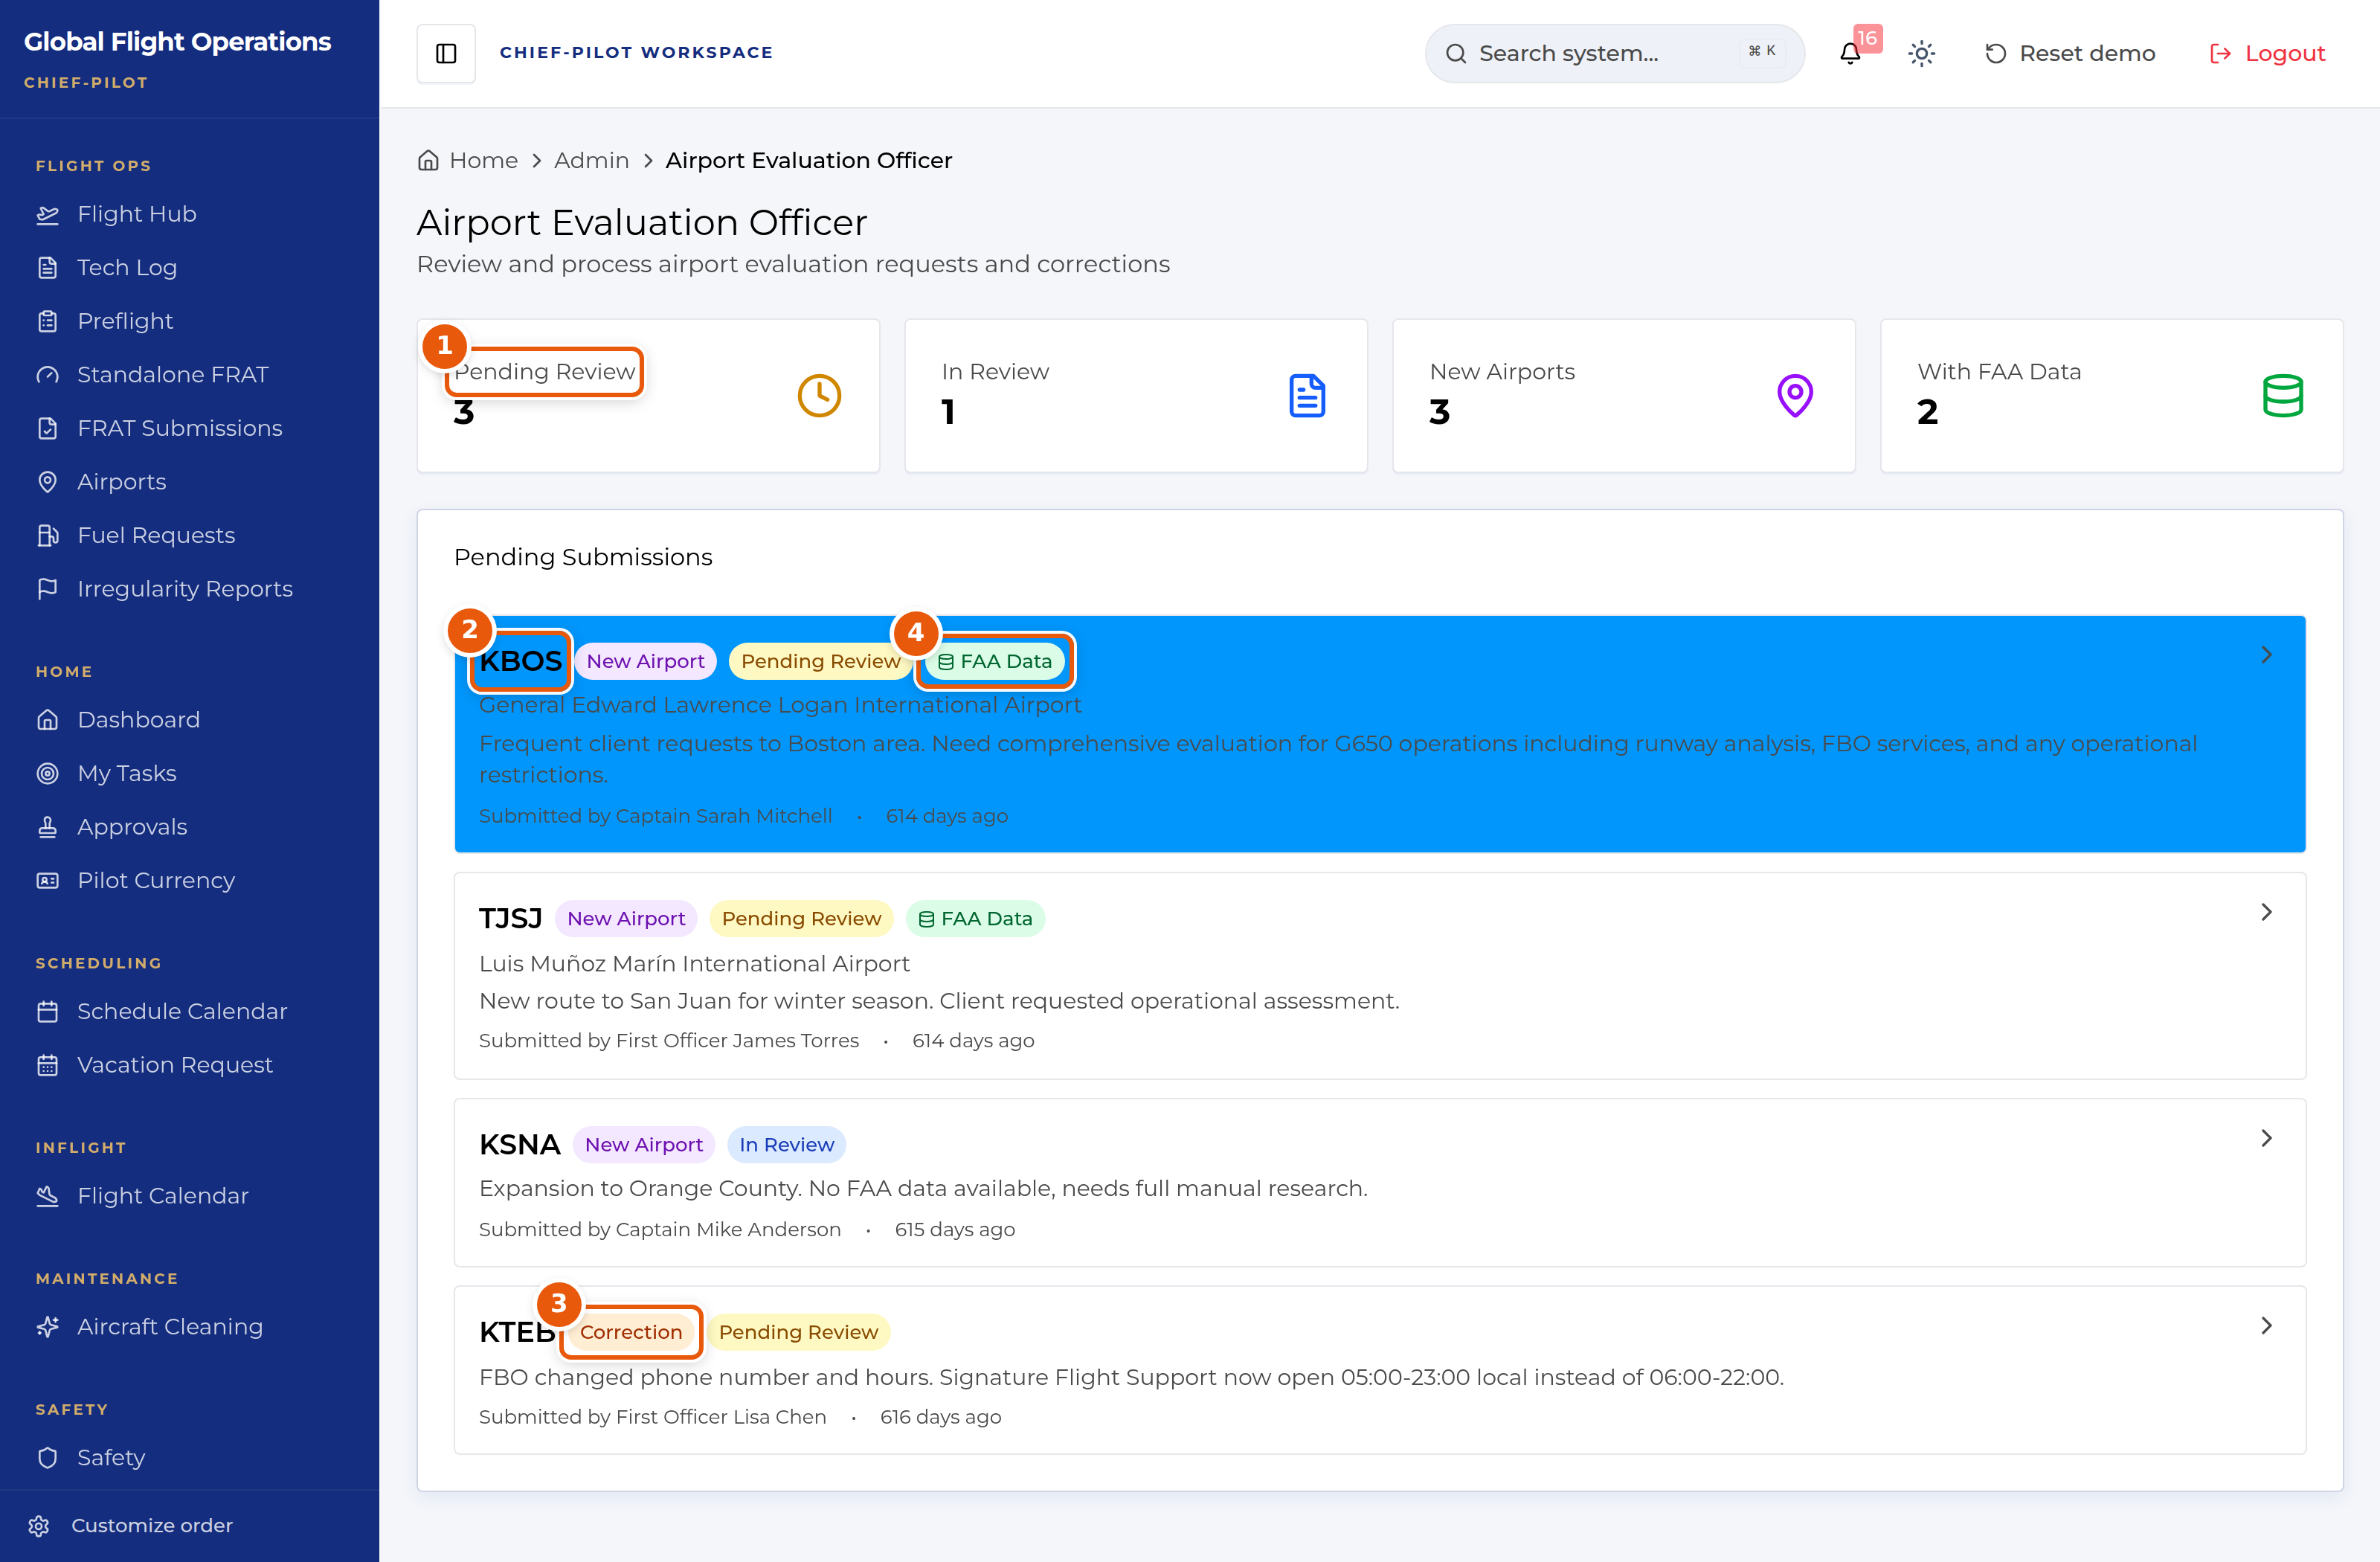
Airport Evaluation Officer intake queue.
1 | Queue state counters.
2 | A new-airport request, with the requester’s justification.
3 | Correction requests sit in the same queue as new airports.
4 | FAA Data — published reference data exists for this field. Requests without it need manual research.

Approvals as Chief Pilot
The Approvals page works exactly as described in the Pilot guide, but the requests routed to you are different — the page records your decision against the Chief Pilot role, not against you personally.
Where a request has already been through another approver, their decision and reasoning are shown above the buttons. Read it before you decide.

A limit worth knowing
Crew Workload, in the Scheduling group, is not open to the Chief Pilot role. Opening it returns Access Denied — the page is restricted to the scheduling, admin and lead roles.
This is worth knowing before you go looking for crew workload data during a rostering conversation: today it has to come from Scheduling or from a Lead Team member.
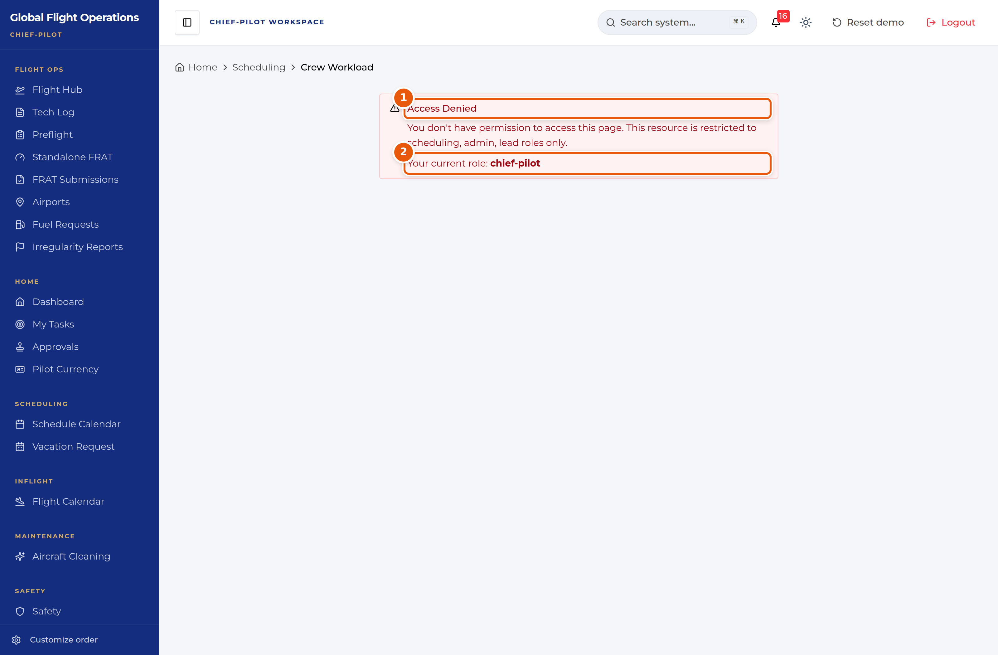
Crew Workload is not available to the Chief Pilot role.
1 | The access-denied message, naming the roles that do have access.
2 | The role you are currently acting as.

