[YOUR COMPANY NAME]

Equipment Substitution Proposal
  - Forklifts and Lowboy Trailer
Prepared exclusively for DZSP21
Prepared for | DZSP21
Prepared by | [Your Company Name]
Proposal date | August 20, 2026
Proposal reference | [Insert reference / solicitation number]
Validity | Subject to final configuration, availability, and written quotation

PROPOSAL INTENT Provide equal-or-greater-capacity substitutions for the requested material-handling and backhoe-transport equipment while preserving the intended power type and operational role wherever practical.

Commercial pricing, delivery schedule, warranty period, and acceptance terms are intentionally left as fillable placeholders pending DZSP21's final configuration and site requirements.

1. Executive proposal
[Your Company Name] respectfully submits the following equipment substitution package to DZSP21. The proposed fleet uses CLARK, Taylor, Combilift, and Trail King equipment to satisfy or exceed the requested nominal capacity classes. The substitution plan consolidates the forklift requirement into three principal platforms, reducing operator familiarization and parts complexity while retaining a dedicated electric unit and a heavy-capacity alternative.
RECOMMENDED AWARD BASIS Accept the listed substitutions subject to confirmation of mast height, lowered height, fork length, tire type, attachments, emissions jurisdiction, UL/EE/DS classification, charging infrastructure, trailer payload, and transported backhoe dimensions.

2. Substitution schedule
Item | Requested equipment | Qty. | Proposed replacement | Qty. | Capacity position
1 | 4K DS forklift | 1 | CLARK S30 DS | 1 | Exceeds 4K class
2 | 4K forklift | 1 | Taylor GT-60 | 1 | Exceeds 4K class
3 | 4K EE forklift | 1 | CLARK GEX30 electric; EE/UL classification to be confirmed | 1 | Exceeds 4K class
4 | 6K forklift | 8 | CLARK S30 DS / Taylor GT-60 | 6 / 2 | Meets nominal 6K class*
5 | 6K DS forklift | 3 | CLARK S30 DS | 3 | Meets nominal 6K class*
6 | 10K forklift | 1 | Option A: Taylor GT-155D; Option B: Combilift C12000ET electric sideloader | 1 | Both exceed 10K class**
7 | Semi-trailer, 2-axle, backhoe | 1 | Trail King 3-axle lowboy (TK102HDG basis or equivalent available unit) | 1 | Higher axle count / heavy-haul configuration

* Capacity must be confirmed at the required 24-inch load center and specified lift height. ** C12000ET capacity and 53-inch platform depth are based on the requirement information supplied; factory model/configuration confirmation is required.

3. Quantity summary
Proposed model | Total quantity | Primary assignment
CLARK S30 DS | 10 | 4K DS and 6K/6K DS requirements
Taylor GT-60 | 3 | 4K and 6K requirements
CLARK GEX30 | 1 | 4K electric requirement
Taylor GT-155D or Combilift C12000ET | 1 | 10K requirement - select one
Trail King 3-axle lowboy | 1 | Backhoe transport

4. CLARK S30 DS - proposed for Items 1, 4, and 5
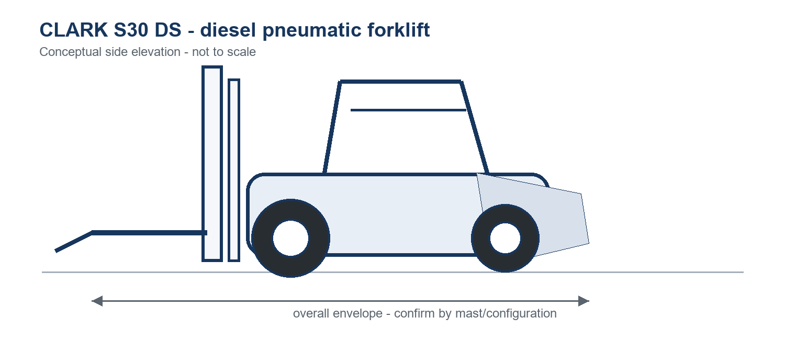
Figure 1. Conceptual CLARK S30 DS side elevation; final mast and fork geometry will vary.
Specification | Proposed basis
Truck type | Counterbalanced pneumatic-tire forklift; diesel configuration
Nominal capacity | Approximately 6,000-6,600 lb class; final rating at 24-in load center to be confirmed
Manufacturer family rating | S20-S35 family: 2,000-3,500 kg at 500 mm load center
Power | Diesel; published family data references 46.0 kW diesel power
Mast / lift height | Two- or three-stage mast selected to DZSP21 clearance and lift requirements
Tires | Pneumatic or superelastic, subject to operating surface
Safety / classification | DS/UL construction and required labels to be confirmed on offered serial-numbered unit

Substitution rationale
- One platform covers the 4K DS and 6K/6K DS roles, simplifying fleet support.
- Nominal capacity exceeds the 4K requirement and is aligned to the 6K class.
- Wet-disc brake and operator-assist features are available within the S-Series family; final options will be listed on the quotation.

5. Taylor GT-60 - proposed for Items 2 and 4
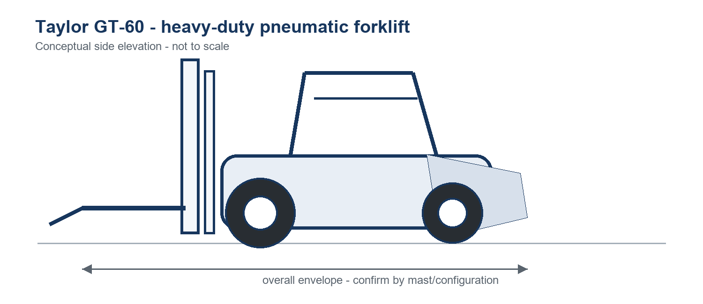
Figure 2. Conceptual Taylor GT-60 side elevation; not to scale.
Specification | Published / proposed basis
Rated capacity | 6,000 lb at 24-in load center
Wheelbase | 66.9 in
Engine | HMC Theta 2.4 L, 65 hp Tier 4 Final LPG standard; Isuzu 2.2 L, 62 hp Tier 4 Final diesel available
Transmission / axle | Single-speed powershift with inching; planetary drive axle with wet-disc brakes
Mast | Two- and three-stage uprights; published family lift heights up to 217 in
Standard GT-60 mast basis | 130-in maximum fork height two-stage mast; approximately 87.9-in lowered height
Standard forks | 1.75 x 5 x 42 in, pin-mounted; alternate length available subject to approval
Operator station | Overhead guard, suspension seat, LCD dash, adjustable steering column

Substitution rationale
- Rated for the 6K requirement at a 24-inch load center.
- Provides substantial reserve over the requested 4K class.
- Heavy-duty construction is suitable for outdoor and mixed-yard duty, subject to tire selection.

6. CLARK GEX30 - proposed for Item 3
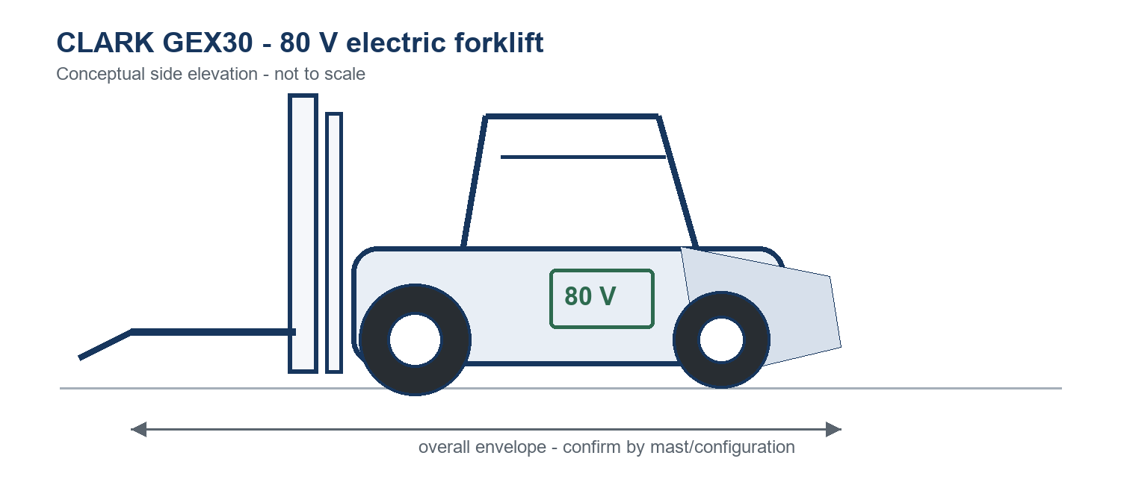
Figure 3. Conceptual CLARK GEX30 electric forklift side elevation; charger not shown.
Specification | Proposed basis
Truck type | Four-wheel counterbalanced electric forklift
Nominal capacity | 3,000 kg / approximately 6,600 lb class; verify rating at required load center and lift height
Electrical system | 80 V traction system
Mast / forks | Configured to DZSP21 lift-height, lowered-height, free-lift, and fork-length requirements
Battery / charger | Battery chemistry, amp-hour capacity, connector, and charger input voltage to be confirmed
EE requirement | EE/UL listing is not assumed from model name; written manufacturer certification and truck data plate must confirm compliance

CRITICAL COMPLIANCE HOLD POINT Do not accept the GEX30 as an EE substitute until the offered serial-numbered truck, battery, and charger package carries the classification required by DZSP21 and the intended hazardous-location policy.

7. 10K forklift alternatives - Item 6

Option A - Taylor GT-155D
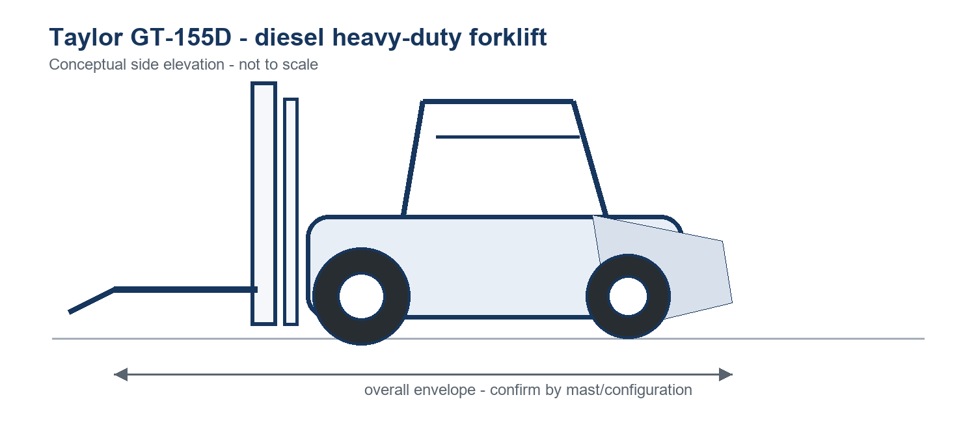
Specification | Published / proposed basis
Rated capacity | 15,500 lb at 24-in load center
Wheelbase | 88.6 in
Power | Diesel configuration proposed; engine/emissions package to be confirmed for destination
Application fit | Conventional front-loading heavy-duty forklift; significant capacity reserve over 10K

Option B - Combilift C12000ET electric sideloader
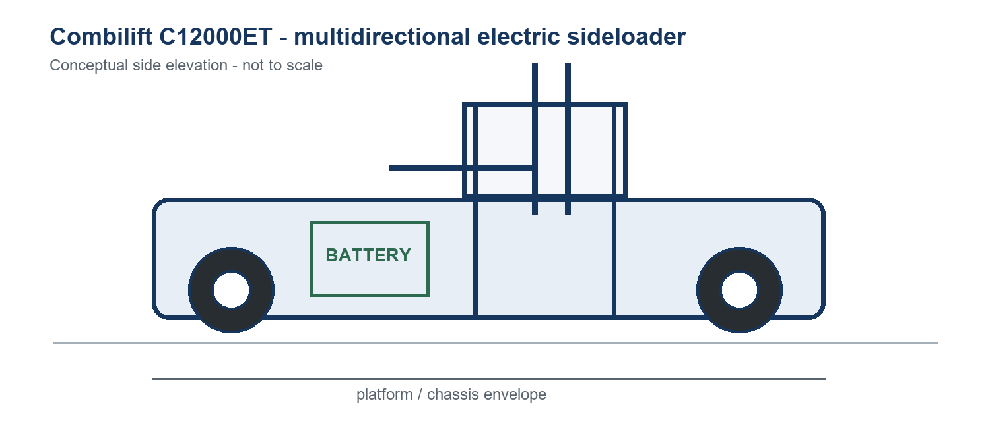
Specification | Requirement / proposed basis
Rated capacity | 12,000 lb at 24-in load center - based on supplied requirement; factory confirmation required
Platform depth | 53 in - based on supplied requirement; confirm exact model drawing
Power / handling | Electric, multidirectional sideloader; suited to long loads and narrow-aisle movement
Battery / charger | To be sized for duty cycle and facility electrical service

SELECTION GUIDANCE Choose the Taylor GT-155D for conventional front-lift work and maximum capacity reserve. Choose the Combilift when long-load handling, side loading, indoor emissions, or aisle maneuverability is the controlling requirement.

8. Trail King 3-axle lowboy - proposed for Item 7
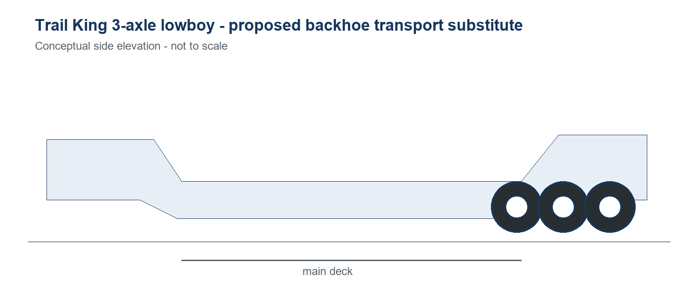
Figure 4. Conceptual Trail King 3-axle detachable-gooseneck lowboy; final offered unit may vary.
Specification | TK102HDG basis / proposed requirement
Trailer type | Hydraulic detachable gooseneck lowboy, semi-trailer
Axles | Three 25,000-lb axles; third axle air lift
Rated capacity | 102,000 lb in 12 ft (manufacturer model basis)
Main deck length | 25 ft 9 in
Axle spacing | 55 in
Loaded fifth-wheel height | 50 in
Decking | 1.75-in apitong raised decking listed for TK102HDG
Final transport check | Backhoe operating weight, axle loads, width, height, wheelbase, ground clearance, tie-down points, tractor compatibility, and local permit limits

Substitution rationale
- The three-axle configuration provides a heavy-haul platform in place of the requested two-axle backhoe trailer.
- Detachable gooseneck supports front loading of construction equipment.
- Final acceptance must be based on the actual backhoe and prime mover, not trailer capacity alone.

9. Configuration, compliance, and acceptance
The proposal defines suitable model families and capacity positions. It is not a final engineered configuration. DZSP21 and the supplier should complete the following schedule before order release.
Acceptance item | DZSP21 requirement / supplier response
Rated load | Confirm capacity at actual load center, lift height, attachment derate, and side-shift/fork-positioner configuration.
Mast envelope | State maximum fork height, free lift, lowered mast height, raised mast height, and overhead-guard height.
Forks / carriage | Confirm fork length, section, spread, carriage class, load backrest, and attachments.
Power / emissions | Confirm diesel/LPG/electric choice, emissions jurisdiction, fuel type, battery duty cycle, and charger input.
Safety classification | Provide written UL/EE/DS certification where required; confirm lighting, alarm, strobe, restraint, fire extinguisher, and data plate.
Environment | Confirm indoor/outdoor use, grades, floor loading, aisle width, weather, corrosion exposure, and tire compound.
Trailer compatibility | Provide backhoe and tractor data; complete axle-load, turning-clearance, deck, tiedown, and regulatory review.
Documentation | Operator manuals, service manuals, parts books, certificates, inspection records, and warranty terms.
Inspection / training | Pre-delivery inspection, site acceptance test, familiarization, and operator/maintenance training.

10. Commercial schedule - to be completed
Commercial item | Offer
Total price | [Insert price and currency]
Delivery | [Insert lead time / delivery location]
Proposal validity | [Insert validity period]
Warranty | [Insert coverage]
Payment terms | [Insert terms]
Freight / duties / taxes | [State inclusion or exclusion]

11. Assumptions and qualifications
- Model names in this proposal are interpreted as equipment families. The final serial-numbered units and option codes govern.
- No attachment derating, aisle study, floor-loading analysis, hazardous-location determination, or trailer route/permit analysis has been performed.
- The term DS is treated as a required safety/construction classification and must be validated by manufacturer documentation and the truck data plate.
- The CLARK GEX30 is proposed as an electric substitute; EE compliance remains an explicit hold point.
- The Combilift C12000ET capacity and 53-inch platform depth are retained from the supplied requirement because the exact factory technical sheet was not identified; written factory confirmation is required before acceptance.
- Availability may require an equivalent model-year configuration with equal or greater capacity, subject to DZSP21 approval.
- All drawings are conceptual, not to scale, and are not approved-for-construction or clearance drawings.

12. Reference sources
Manufacturer | Reference
CLARK | S20-S35 product page and published family technical data: https://clarkmheu.com/en/forklifts-with-diesel-or-lpg-drive/s20-25-30-35
CLARK | GEX electric product-family information: https://clarkmheu.com/en/parts/cabins-rain-caps
Taylor | GT Series brochure: https://taylorforklifts.com/assets/brochures/product/GT-Series.pdf
Taylor | GT-60 / GT-66 brochure: https://taylorforklifts.com/assets/brochures/product/GT-60_GT-66_Brochure.pdf
Trail King | TKHDG hydraulic detachable gooseneck specifications: https://www.trailking.com/products/tkhdg-hydraulic-detachable-gooseneck/
Combilift | C-Series reference family sheet: https://combilift.com/wp-content/uploads/2020/10/C-Series-12000-Technical-UK-2018.pdf

Source data is summarized for proposal development only. Manufacturer literature and specifications can change; the final quotation, certified capacity plate, and approved general-arrangement drawing control.

13. Acceptance / authorization
For DZSP21 | For [Your Company Name]
Name: ______________________________  Title: _______________________________  Date: ________________________________ | Name: ______________________________  Title: _______________________________  Date: ________________________________

