**DATA WRANGLING**

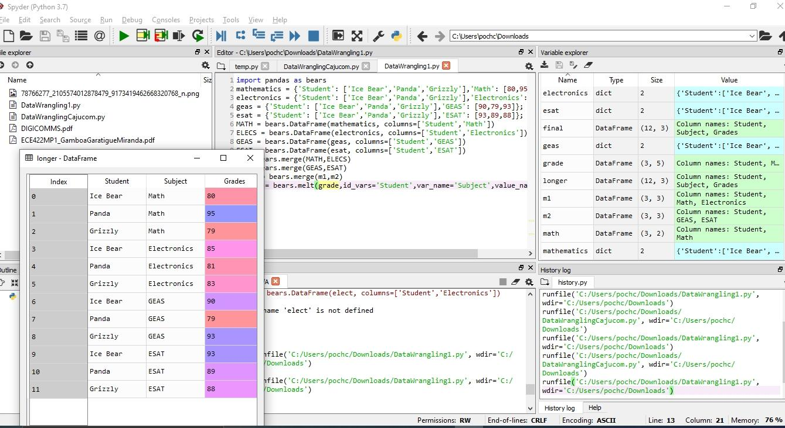**PROBLEM 1**

**PROBLEM 2**

