The existence of Canards in the reduced Hodgken-Huxley nerve model, leading to stable but excitable solutions and periodic solutions.
Abstract:This report deals with periodic solutions to a reduced form of the Hodgken-Huxley equations. With careful selection of the parameters, bifurcations in the applied current give rise to aperiodic solutions, canard like behaviour and periodic behaviour of the voltage across the axon.

Section 1: The Hodgken-Huxley Nerve Model
Classically, it was known that the cell membrane carries a potential across the inner and outer surfaces, hence a basic model for a cell membrane is that of a capacitor and resistor in parallel. The model equation takes the form:
eqn (1)
Whereis the membrane capacitance,is the instantaneous voltage andrepresents the current contribution from the ion movement across the membrane. In landmark patch clamp experiments in the early part of the 20th century, it was determine that many cell membranes are excitable, i.e., exhibit large excursions in potential if the applied current is sufficiently large. Examples include nerve cells and certain muscle cells, e.g., cardiac cells.

From 1948-1952, Hodgkin and Huxley conducted patch clamp experiments on the giant squid axon, a rather large part of nerve tissue suitable for experimentation given the technology of the time. Based on their experiments, they constructed a model for the patch clamp experiment in an attempt to give mathematical explanation for the axon’s excitable nature. A key part of their model assumptions was that the membrane contains channels for Potassium and Sodium ion flow. The underlying model equation
is:
eqn (2)
Here the subscripts K, Na, and L correspond to Potassium, Sodium, and Leakage channels, respectively andis the applied current. The termsandare the conductances (reciprocal of resistances). The variables n, m and h are hypothesized potential dependent gating variables whose dynamics were assumed to follow first order kinetics. The equations take the form :
eqn(3a, 3b, 3c)
Taken together, the above equations represent a four dimensional dynamical system known as the Hodgkin-Huxley model. It does provide a basis for qualitative explanation of the formation of action potentials in the giant squid axon. Moreover, the model structure forms a basis for virtually all models of excitable membrane behaviour.

Ifthe rest stae of the model is leinearly stable but excitable. That is, if a perturbation from the steady state is sufficiently large there is a large excursion of the variables from in their phase space before returning to the steady state. Ifthere is a range of values where regular repetitive firing occurs, that is, limit-cycle characteristics are displayed. Both types of phenomena have been observed experimentally.
However, due to the complexity of solving a four dimensional dynamic system, simpler mathematical models which capture the main properties of the HH model have been suggested, one of the most popular is the FitzHugh-Nagumo Model.

Section 2: The FitzHugh-Nagumo Model
The time scales of n, m and h are not all the same. The timescale for m is much faster than the others so it is reasonable to assume that we may set . Also setting,a constant, the system will still behave as the HH model. Now we are only left with a two dimensional system in V and n:
eqn (4a, 4b, 4c)
Where:

v represents the transmebrane voltage, and w represents the combined effects of n, m and h.
Section 3: Nullclines and Periodic Behaviour
To calculate the phase space of v and w, we first calculate the nullclines of these variables. The nullclines are points where the rate of change is equal to zero, i.e . Algebraicly this occurs if we set in eqn (4b) and in eqn (4c). The trajectory of v and w, starting with initial values , can be estimated by noting the rates of change on either side of the nullclines. The v nullcline is shown by the red line in subsequent diagrams and the w nullcline is shown by the green line.
Where the nullclines intersect, we have stable solutions however some of these solutions may be 'excitable'. By varying the values of and we can achieve 1 stable solution (Fig.1a) which is at the point (0,0).

(Fig.1a) shows that the phase trajectory of v undergoes a large excursion before returning to the stable solution. Canard behaviour is observed, where v is the rapidly changing variable which follows that fast-manifold initially leading to a rapid increase then decrease in its magnitude, finally following the slow manifold back to the satble solution. (Fig.1b) shows how v rapidly increases then decreases along the fast-manifold before returning to zero along the slow manifold, w is the slowly changing variable.
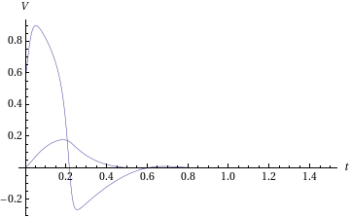
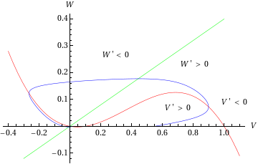
Fig.1a Fig.1b

In (Fig.2a) we again have only 1 stable solution and Canard behaviour of v and w however now the phase trajectory is quite small as the initial values of v and w are quite close to the stable solution.

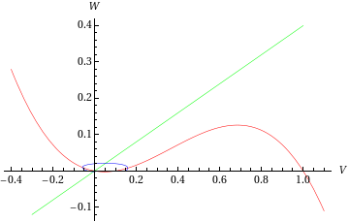
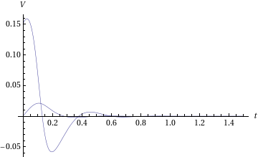

Fig.2a Fig.2b

By again varying the values of and we can now attain 3 stable solutions, and . However, and are stable whilst is stable but 'excitable'. A sufficiently large perturbation from the two stable points will change the phase trajectory of v but any perturbation from the stable-but-excitable point will change the phase trajectory. (Fig.3a) illustrates the situation. An initial value of v is attracted to and so v and w remain at these non-zero solutions.

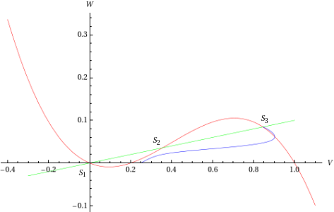

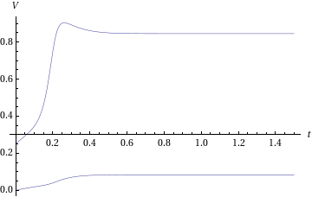

Fig.3a Fig.3b

A sufficiently large perturbation, say an applied current within a short time-scale, will cause switching betweenand. In (Fig.4a and Fig.4b) we see such switching behaviour. A current ofis applied for a short time-interval and the trajectory switches from to

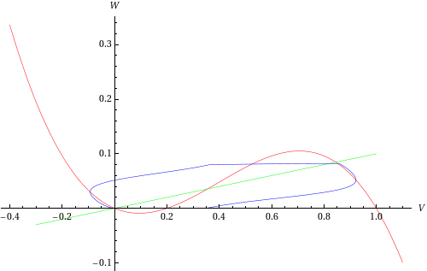
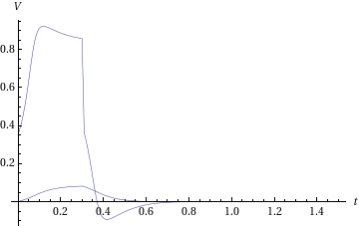

Fig.4a Fig.4b

Now by varying the value of , we cause the v nullcline to shift upwards along the w-axis and can create a situation where limit cycle periodic solutions should emerge. This proves to be so as (Fig.4a) displays.
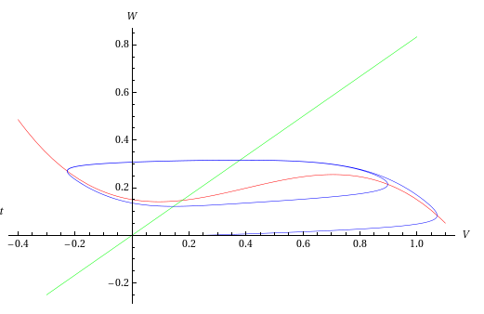
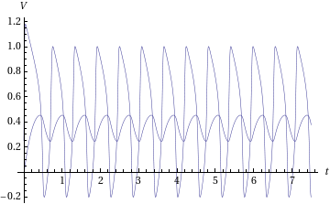

Section 3: Conclusions
This has shown numerically that canards, i.e., periodic orbits for which the trajectory follows both the attracting and repelling part of a slow manifold, can exist for a two-dimensional reduction of the Hodgkin-Huxley equations
described in. Such canards are associated with a dramatic change in properties, such as the amplitude and period, of a control parameter. This also shows that limit cycle periodic solutions are possible when the applied current is varied. Such behaviour is present in nature in periodic neuron firing, or 'spike trains'.

References
- Hodgkin, A. L., Huxley, A. F.: A quantitative description of membrane current and its application to conduction and excitation in nerve. J. Physiol. 117, pp. 500-544 (1952)
- Murray, J.D: Mathematical Biology. Biomathematics Vol. 19 (1989).
- Moehlis, J: Cananrds for a reduction of the Hodgkin-Huxley equations. J.Math.Bio, 52, pp.141-153 (2006)

