Environment Set-up Worksheet
DataOne / Insureligent Training · Interoperability · Before the lab
Do this worksheet before the interoperability lab. It takes about 30 minutes, plus the time to download the IRIS image (several GB).
When you finish, you have:
- IRIS for Health running on your computer, in a Docker container
- the INSURLIGENT namespace, ready for the production that you build in the lab
- two test systems: a hospital system (HIS) that answers HL7, and an insurer that answers REST
- VS Code connected to INSURLIGENT
- a REST client
If a step fails, write down the step number and the error, and tell your instructor before the lab.
1. What you need
Install these first:
Software | Why
Docker Desktop (or any Docker with Compose v2) | Runs IRIS and the two test systems. You do not need to install IRIS.
Git | Downloads the lab environment.
Visual Studio Code | Where you write and compile your classes.
A REST client: the REST Client extension of VS Code (4.1), or Postman | Calls the API that you build.

Login for everything in this course:
Setting | Value
Username | _SYSTEM
Password | SYS
Namespace | INSURLIGENT

2. Get the lab environment
Your instructor gives you access to the repository. Open a terminal. Go to the folder where you keep your projects. Run:
git clone https://github.com/bryanhoonISC/Training2-D1-Lab.git
cd Training2-D1-Lab
You now have a folder called Training2-D1-Lab. Run all the docker compose commands in this worksheet inside this folder.
3. Start the environment
3.1 Start the containers. The first time, this downloads the IRIS image and builds everything. It can take a long time.
docker compose up -d --build
3.2 Watch the set-up. It creates the namespace and loads the classes in src/. At the start of the lab, src/ has only empty package folders.
docker compose logs -f iris
Wait until you see this line:
[insurligent-setup] complete.
Then press Ctrl-C. This stops showing the log. IRIS keeps running.
If the line does not appear, see Appendix D.
4. Set up VS Code
4.1 Install the extensions. In VS Code, open the Extensions view and install these two extensions:
Extension | ID | Why
InterSystems ObjectScript Extension Pack | intersystems-community.objectscript-pack | Edit IRIS classes and compile them on the server.
REST Client (Huachao Mao) | humao.rest-client | Send the test requests of Part F of the lab, from http/PreAuthInfo.http.

When you open the lab folder (4.2), VS Code also recommends these two extensions.
4.2 Open the lab folder. Click File › Open Folder and choose the Training2-D1-Lab folder.
4.3 Connect VS Code to IRIS. The folder already has the file .vscode/settings.json:
{
"intersystems.servers": {
"insurligent": {
"webServer": { "host": "localhost", "port": 52773 },
"username": "_SYSTEM"
}
},
"objectscript.conn": { "server": "insurligent", "ns": "INSURLIGENT", "active": true }
}
When VS Code asks for a password, enter SYS.
4.4 Check the connection. Click the InterSystems icon in the Activity Bar, then the Explorer view. It shows the classes in INSURLIGENT on the server. You should see the Insurligent package with one class, Insurligent.Setup.
4.5 Look at the folders. In the Explorer of VS Code, open src/Insurligent. It has an empty folder for each package that you write in the lab, for example Interop/BO and Interop/MSG/Insurer.
5. Stop and start
Stop the containers when you finish. Give IRIS time to shut down cleanly:
docker compose down -t 60
Start them again. IRIS keeps your work:
docker compose up -d
On the day of the lab, start them before the class starts.
6. Checklist
Tick each line. Bring this to the lab.
Done | Check
☐ | The log shows [insurligent-setup] complete.
☐ | VS Code shows Insurligent.Setup in the InterSystems Explorer view, and the empty folders under src/Insurligent.

The appendixes give more information about the environment. Appendixes B and C are checks that you can do if you want to know more, or if you have a problem.
Appendix A. The systems
docker compose up -d starts three containers. The picture shows them, and the tools on your computer that you use with them.
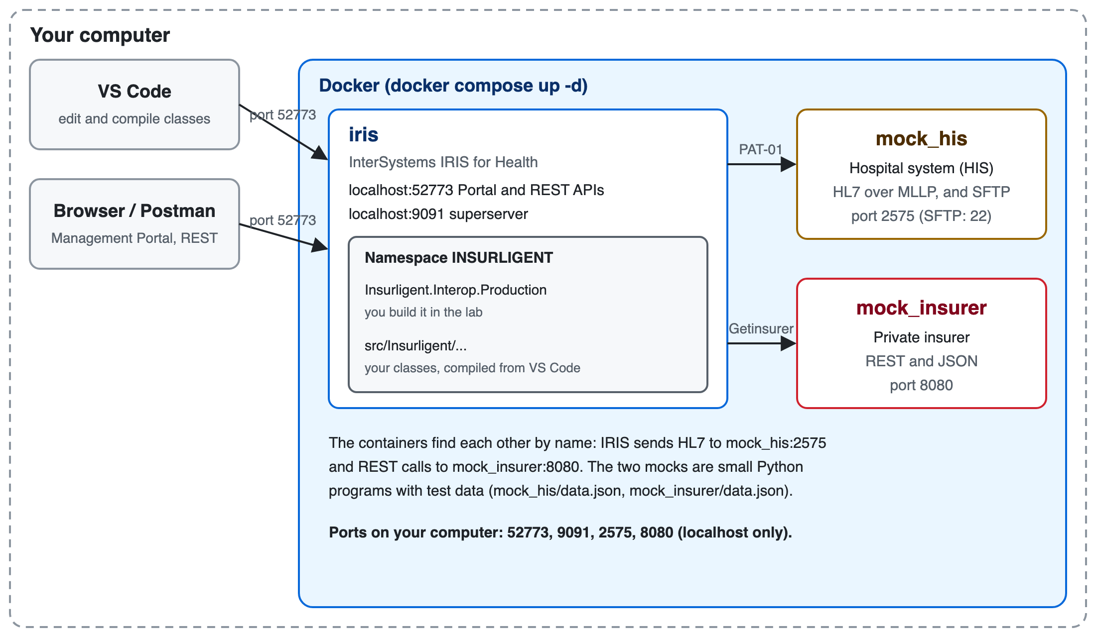
The lab environment: three containers in Docker, and the tools you use.
Container | What it is | Port on your computer
iris | InterSystems IRIS for Health: the Management Portal, the REST APIs and the production | 52773 (web), 9091 (superserver)
mock_his | Test hospital system (HIS). It answers HL7 queries such as PAT-01, over MLLP. It also has an SFTP server with test files for Part G of the lab. | 2575 (SFTP: only inside Docker)
mock_insurer | Test insurer. It answers REST calls such as Getinsurer, with JSON. | 8080

The two test systems are small Python programs, not real systems. They answer with the test data in mock_his/data.json and mock_insurer/data.json.
Inside IRIS, the namespace INSURLIGENT has no production yet. In the lab, you build Insurligent.Interop.Production.
Appendix B. Check IRIS
B.1 Open the Management Portal. In your browser, go to http://localhost:52773/csp/sys/UtilHome.csp. Log in with _SYSTEM / SYS.
B.2 Check the namespace. Go to System Administration › Configuration › System Configuration › Namespaces. INSURLIGENT must be in the list.
B.3 Check interoperability. Go to Interoperability. If IRIS asks for a namespace, choose INSURLIGENT. Then go to List › Productions. The list is empty: you create the production in the lab.
Appendix C. Check the test systems
C.1 Run the self-test of each mock.
docker compose exec mock_his python /app/his.py --selftest
docker compose exec mock_insurer python /app/insurer.py --selftest
The last lines must be:
his selftest: all checks passed
insurer selftest: all checks passed
C.2 Call the insurer directly. In your browser or REST client, send:
GET http://localhost:8080/api/insurer?identity_type=CID&identity_no=3-1258-00558-89-8&company_code=AIA
You should get "response_code": "200" and an insured_person with "insurer_id": "INS123456". No login is necessary for the mock.
Appendix D. If something goes wrong
Problem | What to do
[insurligent-setup] complete. never appears | Read the whole log: docker compose logs iris.
A port is in use (52773, 9091, 2575 or 8080) | Another program or another IRIS environment uses it. Stop that one first (for example docker compose down in its folder).
On Linux: IRIS cannot write to /dur | Run sudo chown -R 51773:51773 data/durable, then docker compose up -d again.
You want to start over completely | docker compose down -t 60, then move the folder data/durable/iris_conf.d out of the project, then docker compose up -d --build.
Anything else | Write down the step and the error, and tell your instructor.

