1. **Filtering**
   1. **Denoising**
      1. 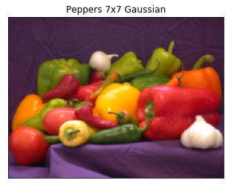
      2. 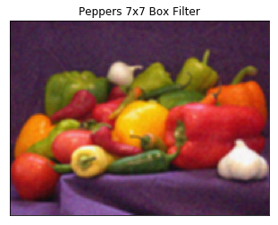
      3. PSNR:
         1. Gaussian Filter: 29.86624480643068
         2. Box Filter: 28.278396476904042

The Gaussian Filter has the higher PSNR out of the two which means it is the superior result due to the higher proportion of signal it has over noise.

* + 1. 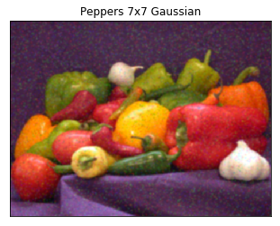
    2. 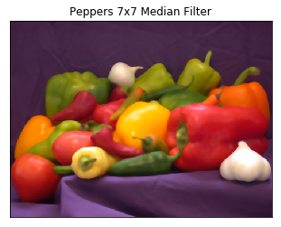
    3. PSNR:
       1. Gaussian Filter: 28.21093117630983
       2. Median Filter: 31.871009920638333

The Median Filter has the higher PSNR out of the two which means it is the superior filter for this image due to the higher proportion of signal it has over noise.

* 1. **Sharpening**
     1. Blurred Images:
        1. 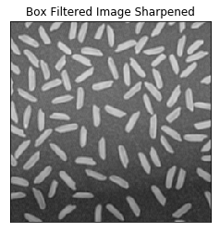
        2. 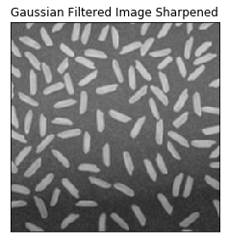
     2. We tend to expect the Gaussian filter to be better when reducing noise. As the box filter is considered the least effective among most low pass filters, however it is the fastest. The quality of the box filter is worst because it just averages out surrounding pixels which does not always stop the high frequencies in the image. Gaussian filter is much better at separating frequencies from one another; however, it is slower. Therefore, we expect the Gaussian filter to produce the better image.   
        The results from the filtering are relatively similar in this scenario with no definite winner to the naked eye.

1. **Edge Detection**
   1. **Sobel Edge Detector**

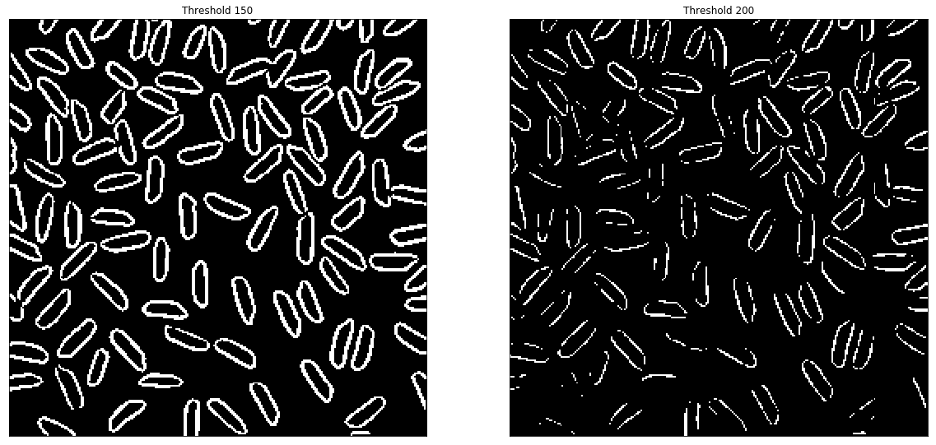

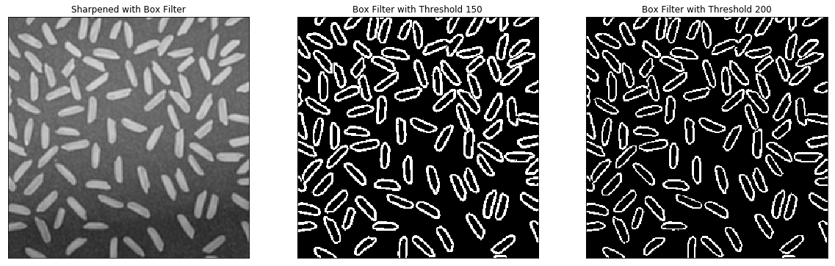

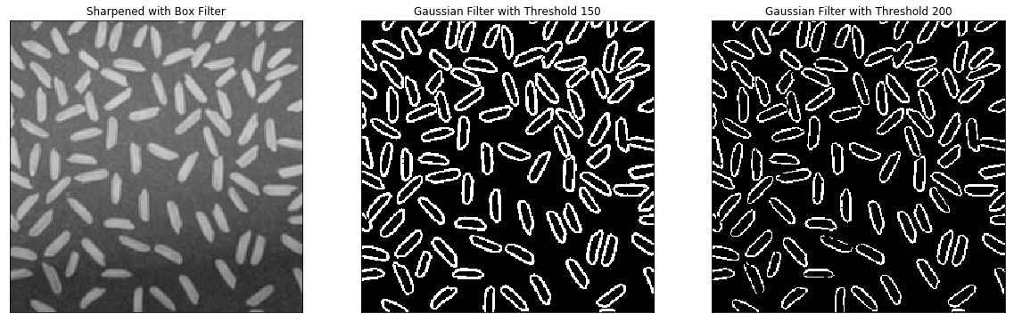

The effect of sharpening an image before applying sobel edge detection makes a major difference especially at higher thresholds. This is due to the fact that when we sharpen an image it is essentially making the edges stronger by creating a bigger gradient along them. This allows the sobel filter to be still valid at higher thresholds.



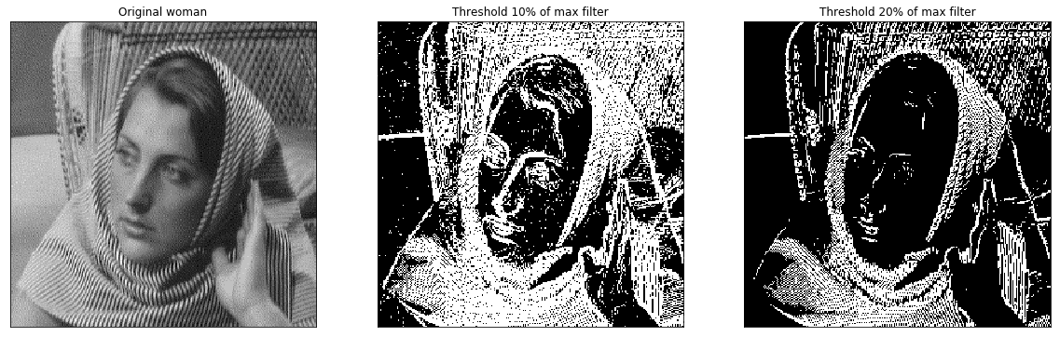

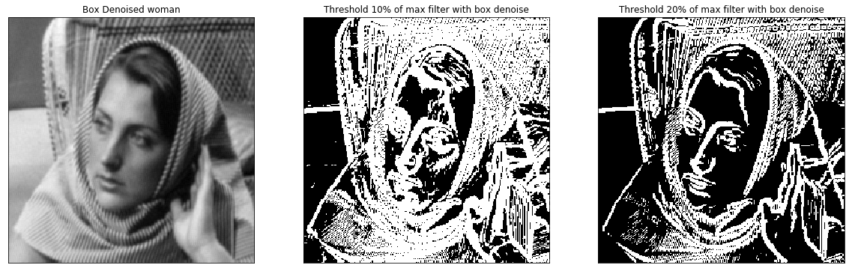

The effect of denoising aids the edge detection because Sobel detection performs a gradient calculation in order to find the edges. When the noise is removed with the box filter, it helps the gradient recognize all edges by avoiding other possible false positives. The best resulting image is when taking the 20% threshold for the box filter.

1. **Laplacian of Gaussian**
   1. 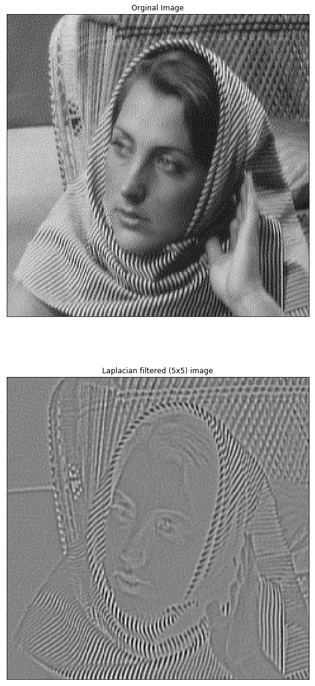
2. **Template Matching**
   1. Waldo is located in the top left of the image and is boxed in black. The four corners of the box are located at the following coordinates: (1258, 73), (1257, 74), (1259, 74), (1258, 75). This is found with a threshold of 0.6

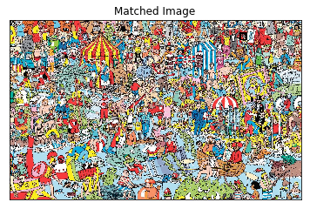

* 1. Similarly to above waldo was located with the exact same threshold and coordinates.

