**Testbench_chebychev_filter.m**

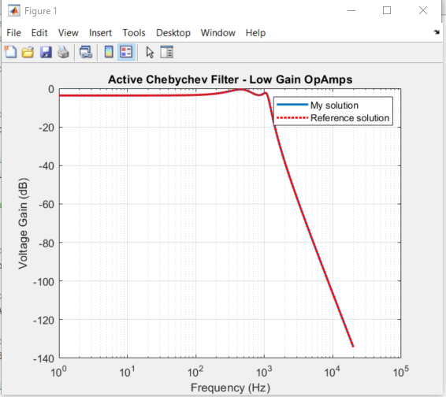 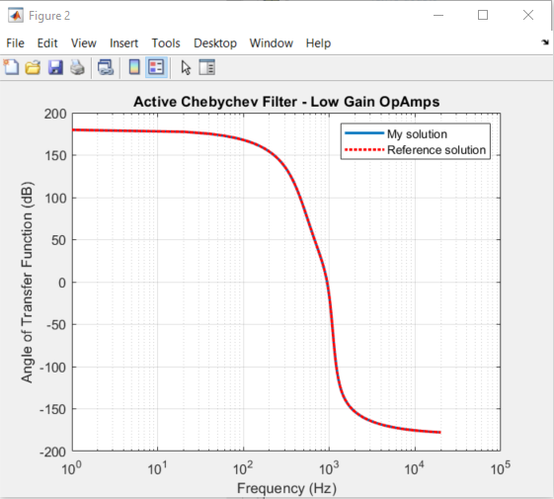

**Testbench_chebychev_filter_largeGain.m**

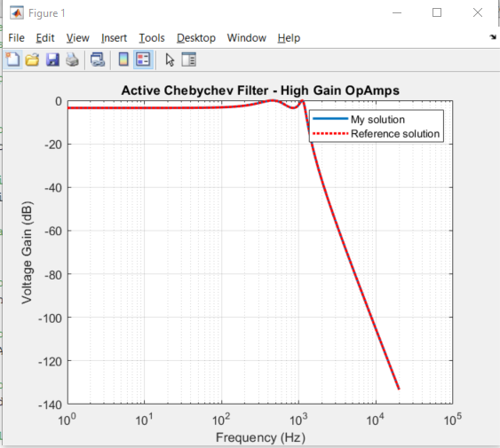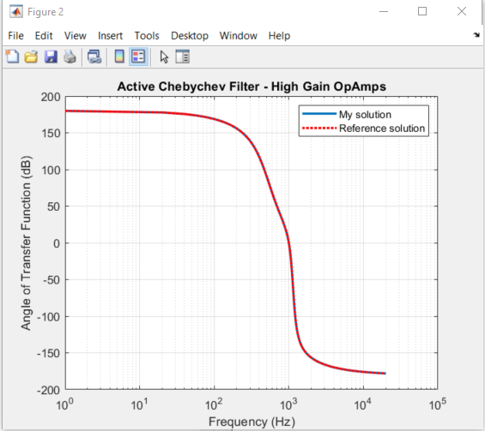

**TestBench_CIR4.m**

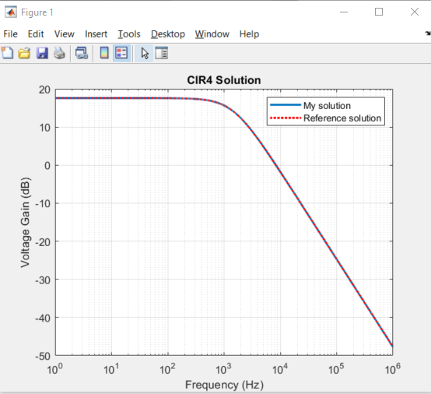 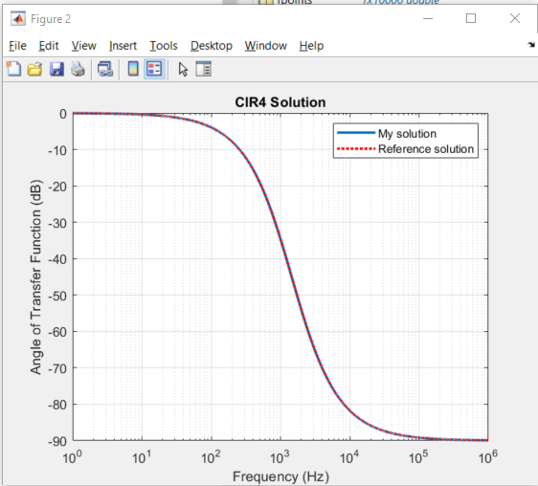

**TestBench_LCfilter1.m**

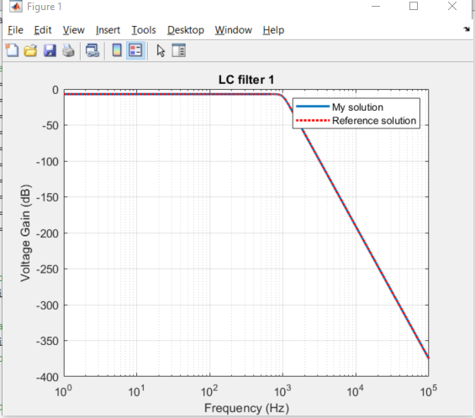 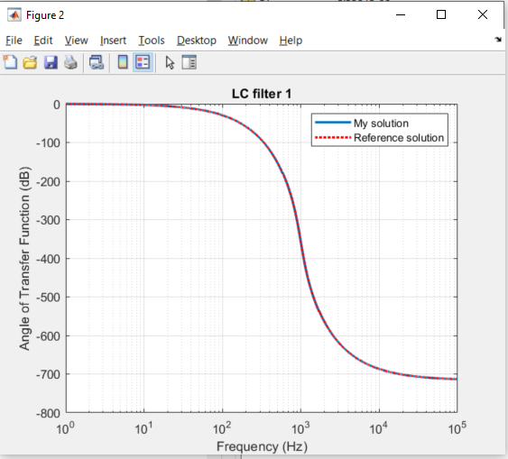

**TestBench_LCfilter2.m**

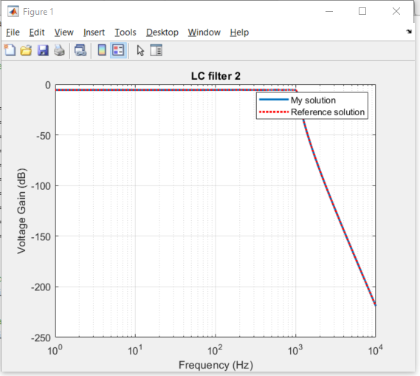 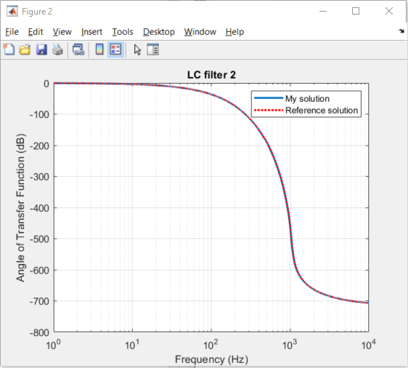

**TestBench_LCfilter3.m**

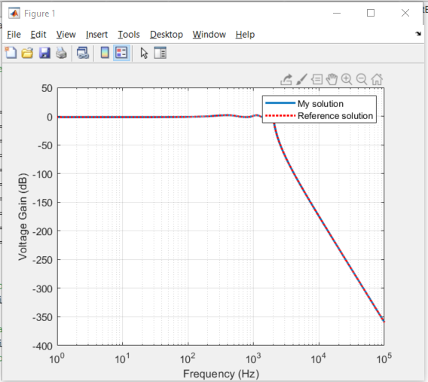 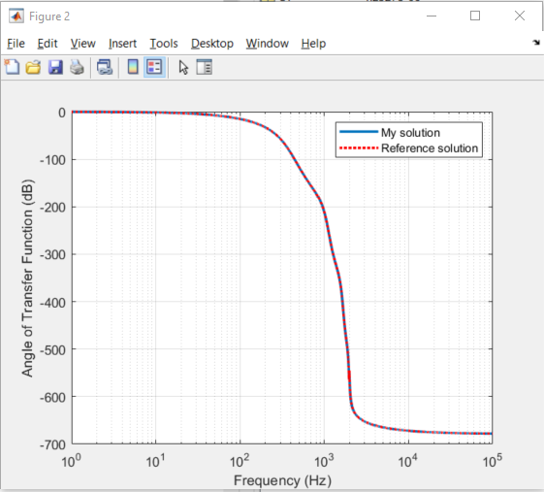

**MATLAB Code**

**ind.m**

function ind(n1,n2,val)

% ind(n1,n2,val)

% Add stamp for inductor to the global circuit representation

% Inductor connected between n1 and n2

% The indjuctance is val in Henry

% global G

% global C

% global b

% Date:

% defind global variables

global G

global b

global C

len = length(G);

sz = len + 1;

b(sz) = 0;

G(sz,sz) = 0;

C(sz,sz) = -val;

if n2 ~= 0

G(n2,sz) = -1;

G(sz,n2) = -1;

end

if n1 ~= 0

G(n1,sz) = 1;

G(sz,n1) = 1;

end

**vccs.m**

function vccs(nd1,nd2,ni1,ni2,val)

% vccs(nd1,nd2,ni1,ni2,val)

% Add stamp for voltage controlled current source

% to the global circuit representation

% ni1 and ni2 are the controlling voltage nodes

% the controlled current source is between nd1 and nd2

% The controlled current (from nd1 to nd2) is val*(Vni1-Vni2)

global G

if nd1 ~= 0

if ni1 ~= 0

G(nd1,ni1) = G(nd1,ni1) + val;

end

if ni2 ~= 0

G(nd1,ni2) = G(nd1,ni2) - val;

end

end

if nd2 ~= 0

if ni1 ~= 0

G(nd2,ni1) = G(nd2,ni1) - val;

end

if ni2 ~= 0

G(nd2,ni2) = G(nd2,ni2) + val;

end

end

**vcvs.m**

function vcvs(nd1,nd2,ni1,ni2,val)

% vcvs(nd1,nd2,ni1,ni2,val)

% Add stamp for a voltage controlled voltage source

% to the global circuit representation

% val is the gain of the vcvs

% ni1 and ni2 are the controlling voltage nodes

% nd1 and nd2 are the controlled voltage nodes

% The relation of the nodal voltages at nd1, nd2, ni1, ni2 is:

% Vnd1 - Vnd2 = val*(Vni1 - Vni2)

global G

global b

global C

d = length(G); %current size of the MNA

sz = d+1; %new row

% increase the size of the matrix

G(sz,sz) = 0;

C(sz,sz) = 0;

b(sz) = 0;

if nd1~=0

G(sz,nd1) = G(sz,nd1) + 1;

G(nd1,sz) = G(nd1,sz) + 1;

end

if nd2~=0

G(sz,nd2) = G(sz,nd2) - 1;

G(nd2,sz) = G(nd2,sz) - 1;

end

if ni1~=0

G(sz,ni1) = G(sz,ni1) - val;

end

if ni2~=0

G(sz,ni2) = G(sz,ni2) + val;

end

**fsolve.m**

function r = fsolve(fpoints ,out)

% fsolve(fpoints ,out)

% Obtain frequency domain response

% global variables G C b

% Inputs: fpoints is a vector containing the fequency points at which

% to compute the response in Hz

% out is the output node

% Outputs: r is a vector containing the value of

% of the response at the points fpoint

% define global variables

global G C b

shape = length(fpoints);

r = zeros(shape,1);

for i = 1:shape

x = inv(G + C*1i*2*pi*fpoints(i))*b;

r(i) = x(out);

end