**ECSE 421 – Assignment 3**

**Question 1:**

|  |  |
| --- | --- |
| **Test**  **w1w2w3w4** | **Faults Detected** |
| **0100** | c/1, d/1, w1/1, w4/1, f/1 |
| **1010** | b/0, d/0, w3/0, w4/1, f/0 |
| **0011** | f/0 |
| **1111** | f/0 |
| **0110** | b/1 c/1, d/1, w1/1, w2/0, w4/1, f/1 |
| **Total Unique Faults** | 11 |

$$\% sav faults=\frac{Total Unique Faults}{Total Possible Faults}$$

There is a total possibility of 16 faults 8 wires with the possibility of 2 faults each. The total number of unique faults based on the given inputs is 11. The percentage of single s-a-v faults detected is 68.75%.

**Question 2:**

* 23 fault sites give 46 s-a-v faults.
* Reduced to 17 checkpoints giving 24 checkpoint faults.

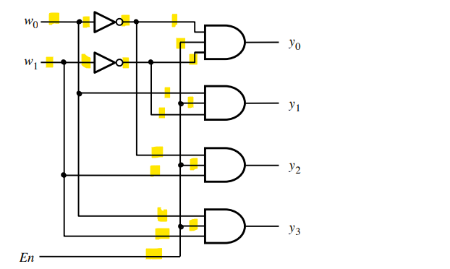

The En signal is dominant signal and needs to be set to 1 to detect all the dominant faults. To test all the other possibilities, the tests will need to include $w_{1}$ and $w_{2}$ possibilities with En set as 1. There are many equivalent tests, when En is unset. Therefore, we can choose one of the possible tests with En set as 0 to catch the En s-a-1.

The set to catch all the errors should contain all these tests:

|  |
| --- |
| **w1w2w3** |
| 000 |
| 001 |
| 011 |
| 101 |
| 111 |

**Question 3:**

A fault is detectable is there exists a test that can detect the fault. Using this diagram, we can test to see if we can detect all the possible faults.

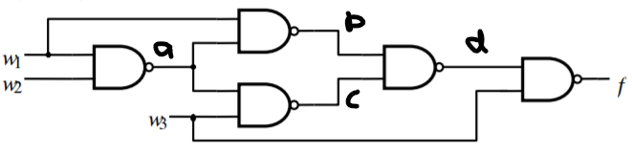

|  |  |  |  |  |  |
| --- | --- | --- | --- | --- | --- |
| **w1w2w3** | **a** | **b** | **C** | **d** | **f** |
| 000 | 1 | 1 | 1 | 0 | 1 |
| 001 | 1 | 1 | 0 | 1 | 0 |
| 010 | 1 | 1 | 1 | 0 | 1 |
| 011 | 1 | 1 | 0 | 1 | 0 |
| 100 | 1 | 0 | 1 | 1 | 1 |
| 101 | 1 | 0 | 0 | 1 | 0 |
| 110 | 0 | 1 | 1 | 0 | 1 |
| 111 | 0 | 1 | 1 | 0 | 1 |

$$f=\overline{w_{3}}+w_{1}w_{2} or \overline{f}=w_{3}\left(\overline{w_{1}}+\overline{w_{2}}\right)$$

Looking at the function we derived clearly it can be implemented with a much simple circuit involving less gates with a smaller cost. Therefore, there is a lot of redundancy in the circuit which means that we would not be able to detect a s-a-1 fault on $w_{1}$.

**Question 4:**

1. The standard (type 2) LFSR implementation for the polynomial.

$$P\left(x\right)=1+x^{2}+x^{5}$$

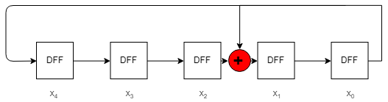

1. Use the formula for an external compaction matrix
$$\left[\begin{matrix}x_{0}(t+1) \\ x_{1}(t+1) \\ x_{2}(t+1) \\ x_{3}(t+1) \\ x_{4}(t+1)\end{matrix}\right]=\left[\begin{matrix}0 & 1 & 0 & 0 & 0 \\ 0 & 0 & 1 & 0 & 0 \\ 0 & 0 & 0 & 1 & 0 \\ 0 & 0 & 0 & 0 & 1 \\ 1 & 0 & 1 & 0 & 0\end{matrix}\right]\left[\begin{matrix}x_{0}(t) \\ x_{1}(t) \\ x_{2}(t) \\ x_{3}(t) \\ x_{4}(t)\end{matrix}\right]$$

2. The following is the next 3 patterns based off the initial states (x0, x1, x2, x3, x4) = 10000. The results were all calculated in Matlab.

A = [0 1 0 0 0; 0 0 1 0 0 ;0 0 0 1 0 ;0 0 0 0 1 ; 1 0 1 0 0]

A =

0 1 0 0 0

0 0 1 0 0

0 0 0 1 0

0 0 0 0 1

1 0 1 0 0

B = [1;0;0;0;0]

|  |  |  |  |  |
| --- | --- | --- | --- | --- |
| **t=** | **0** | **1** | **2** | **3** |
| **X0** | 1 | 0 | 0 | 0 |
| **X1** | 0 | 0 | 0 | 0 |
| **X2** | 0 | 0 | 0 | 1 |
| **X3** | 0 | 0 | 1 | 0 |
| **X4** | 0 | 1 | 0 | 0 |

**Question 5:**

1. The internal (type 2) LFSR implementation for the polynomial.

$$P\left(x\right)=1+x+x^{5}+x^{6}+x^{8}$$

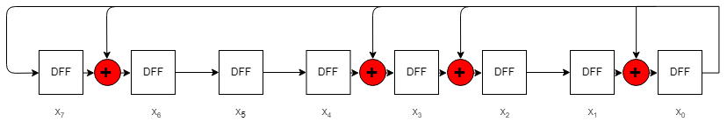

1. Use the given formula to find the compaction matrix.
$$\left[\begin{matrix}x_{0}(t+1) \\ x_{1}(t+1) \\ x_{2}(t+1) \\ x_{3}(t+1) \\ x_{4}(t+1) \\ x_{5}(t+1) \\ x_{6}(t+1) \\ x_{7}(t+1)\end{matrix}\right]=\left[\begin{matrix}0 & 1 & 0 & 0 & 0 & 0 & 0 & 0 \\ 0 & 0 & 1 & 0 & 0 & 0 & 0 & 0 \\ 0 & 0 & 0 & 1 & 0 & 0 & 0 & 0 \\ 0 & 0 & 0 & 0 & 1 & 0 & 0 & 0 \\ 0 & 0 & 0 & 0 & 0 & 1 & 0 & 0 \\ 0 & 0 & 0 & 0 & 0 & 0 & 1 & 0 \\ 0 & 0 & 0 & 0 & 0 & 0 & 0 & 1 \\ 1 & 1 & 0 & 0 & 0 & 1 & 1 & 0\end{matrix}\right]\left[\begin{matrix}x_{0}(t) \\ x_{1}(t) \\ x_{2}(t) \\ x_{3}(t) \\ x_{4}(t) \\ x_{5}(t) \\ x_{6}(t) \\ x_{7}(t)\end{matrix}\right]$$

2. The following is the next 3 patterns based off the initial states (x0, x1, x2, x3, x4, x5, x6, x7) = (0,1,0,0,1,1,1,0). The results were all calculated in Matlab.

A = [ 0 0 0 0 0 0 0 1; 1 0 0 0 0 0 0 1; 0 1 0 0 0 0 0 0; 0 0 1 0 0 0 0 0; 0 0 0 1 0 0 0 0 ; 0 0 0 0 1 0 0 1;0 0 0 0 0 1 0 1 ; 0 0 0 0 0 0 1 0]

A =

0 0 0 0 0 0 0 1

1 0 0 0 0 0 0 1

0 1 0 0 0 0 0 0

0 0 1 0 0 0 0 0

0 0 0 1 0 0 0 0

0 0 0 0 1 0 0 1

0 0 0 0 0 1 0 1

0 0 0 0 0 0 1 0

B = [0;1;0;0;1;1;1;0]

B =

0

1

0

0

1

1

1

0

|  |  |  |  |  |  |  |
| --- | --- | --- | --- | --- | --- | --- |
| **t=** | **0** | **1** | **2** | **3** | **4** | **5** |
| **X0** | 0 | 1 | 0 | 0 | 1 | 1 |
| **X1** | 1 | 0 | 0 | 1 | 1 | 1 |
| **X2** | 0 | 0 | 1 | 1 | 1 | 0 |
| **X3** | 0 | 1 | 1 | 1 | 0 | 1 |
| **X4** | 1 | 1 | 1 | 0 | 1 | 0 |
| **X5** | 1 | 1 | 0 | 1 | 0 | 1 |
| **X6** | 1 | 0 | 1 | 0 | 1 | 0 |
| **X7** | 0 | 1 | 0 | 1 | 0 | 1 |