Name: Bryan J Sanchez

ID: 802-07-8188

Section: 031

Project 2: Operation Sahure UML Design

pyramid package

main package

iomanager package

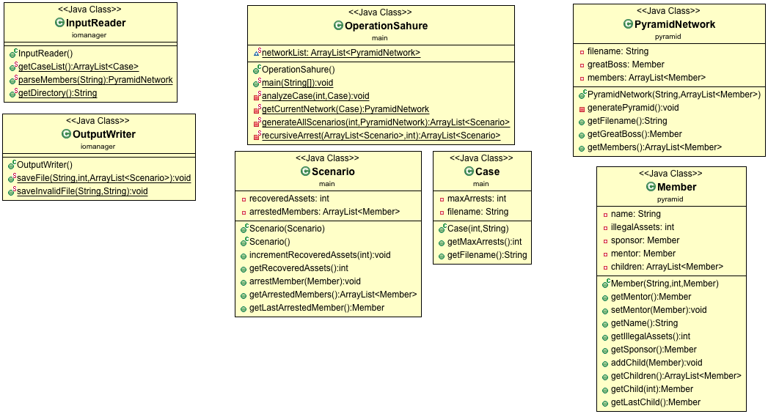

1. **main package**
   1. ***OperationSahure***: Contains main method and is responsible for determining which scenarios return the maximum assets.
   2. ***Case***: A case represents a specific police mission on a certain pyramid scheme in which they will arrest a certain number of its members. It consists of a network log file containing the pyramid structure data and the number of maximum arrests which can be made.
   3. ***Scenario***: Since the police only has the resources to arrest a certain number of members, a scenario represents a specific selection of members that they will arrest. It consists of a list of arrested members and the total assets recovered by the police.
2. **iomanager package**
   1. ***InputReader***: This class is responsible for managing all input files. It should read a file called input.txt which contains a list of cases to be evaluated.
   2. ***OutputWriter***: This class is responsible for writing results to output files.
3. **pyramid package**
   1. ***PyramidNetwork***: Represents the hierarchical structure of the members in a pyramid scheme.
   2. ***Member***: Represents a member of the pyramid scheme.