Introduction to Body Fluids
Graphics are used with permission of:
Pearson Education Inc., publishing as Benjamin Cummings (http://www.aw-bc.com)

Page 1: Introduction to Body Fluids
• The fluids in your body are composed of water and dissolved substances, including electrolytes, which are crucial for body function.

Page 2: Goals
• To list the general functions and importance of water and electrolytes in the body
• To identify the fluid compartments and the relative concentrations of electrolytes within those fluid spaces

Page 3. Movement of Fluids Through the Body
• We ingest water and electrolytes through the gastrointestinal or GI tract.
1. Absorption. These fluids are absorbed into the plasma in the intestine.
2. Circulation. The fluids circulate within the plasma, bathing the cells in the body.
3. Excretion. The kidneys remove excess ions and water from the body through the urine, although water is also lost at other sites, which will be described later.

Page 4. Water in Temperature Regulation
Water performs several important functions in the body.
• Water helps maintain body temperature. When water vaporizes off the skin, it takes large quantities of heat with it. This process cools the body temperature down.
• Because water has a high heat capacity it can absorb and release large quantities of heat before significantly changing temperature. Because our bodies are composed of 50-70% water, that large percentage of water holds heat in the body and helps prevent fluctuation in body temperature.

Page 5. Water in Cushioning and Lubricating
• Water acts as a protective cushion in amniotic fluid and cerebrospinal fluid.
• Water acts as a lubricant in the serous fluids, joints, and gastrointestinal tract.

Page 6. Water as a Reactant
• Water is the reactant for hydrolysis reactions that occur in the body.
• With the help of an enzyme, water molecules are added to the bonds between the glucose units in the starch, hydrolyzing the starch to glucose.
• Note that water can also be formed during some chemical reactions in the body, such as the reactions that produce metabolic water.
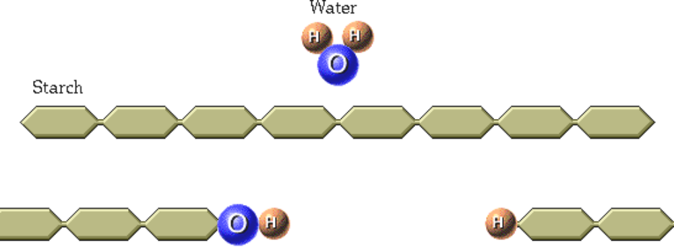

Page 7. Water as a Solvent
• Water acts as a solvent to dissolve molecules and ions in the body.
• For example, if you eat a salty pretzel, the water in your saliva will dissolve the salt.
• Water is a polar molecule. When water dissolves ions the partial negative charge on the oxygen attracts positive ions such as sodium and the partial positive charge on the hydrogen attracts negative ions such as chloride.
• Except for the salts deposited in bone and teeth, most other ions in the body are dissolved because of water's ability to act as a solvent.
• Water within cells is an important solvent. It dissolves many of the proteins and other solutes.
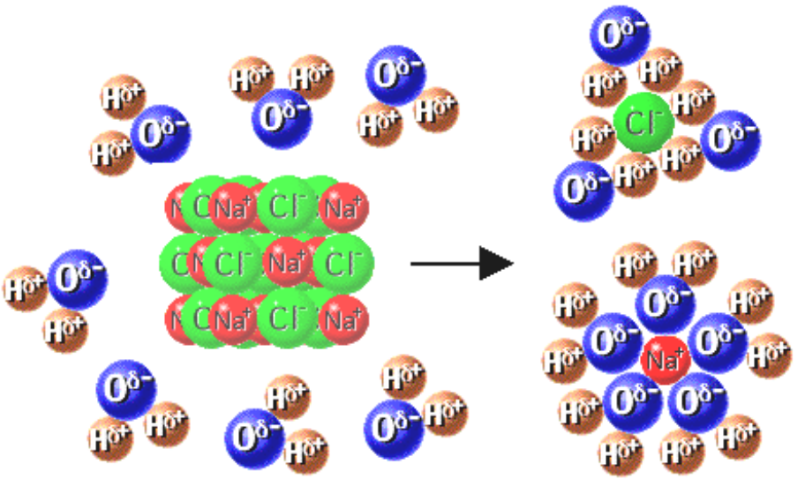

Page 8. Water in Transport
• We are now looking at a blood vessel. Because of water's ability to dissolve ions and molecules within the body fluids, water functions as a medium for the delivery of nutrients and the removal of wastes from the cells through the plasma.

Page 9. Percentage of Water in the Body
• The percentage of water in a person depends on the amount of fat tissue, which is only about 20% water, compared to lean body mass or muscle mass which is about 65% water.
• Newborns have the highest percentage of water in their bodies.
• A healthy young man who is muscular and does not have a lot of fat in his body is about 60% water.
• A healthy young woman naturally has more fat and less muscle than a man and is about 50% water.
• The more fat a person has in his or her body, the less water is present.
• Older people tend to have less lean body mass and therefore contain less water.
• Indicate the percentage of water in the following individuals:

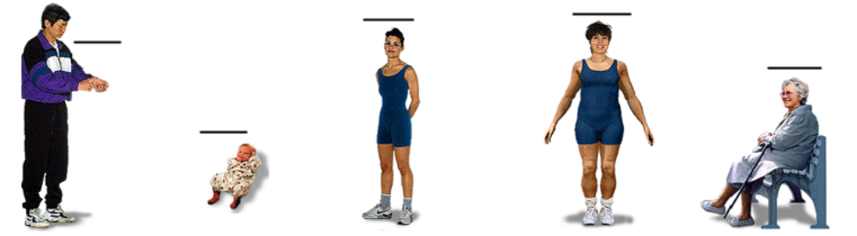

Page 10. Fluid Compartments
• Water, along with its dissolved solutes, occupies two main compartments within the body.
• Intracellular fluid or ICF is the fluid within cells. It is also known as cytosol.
• Extracellular fluid or ECF is the fluid found outside of cells.
• There are two major kinds of extracellular fluid:
1. Interstitial fluid is the fluid surrounding the cells.
2. Plasma is the fluid component of the blood.
• Label the fluid compartments on this diagram:
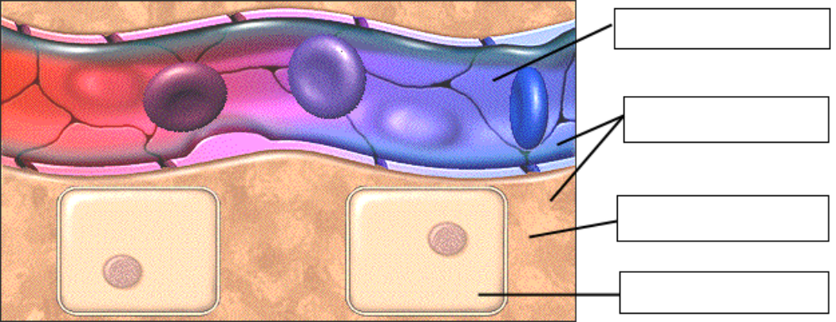
• Let's consider a 70 kg man. 60% of his weight or approximately 40 liters, is fluid.
• Approximately 62% of the body's fluid is intracellular.
• Approximately 30% of the body's fluid is interstitial.
• Approximately 8% of the body's fluid is blood plasma.

Page 11. Composition of Body Fluids
• Label the components on this diagram as follows: nonelectrolytes, electrolytes, solvent, colloid, suspended particle:
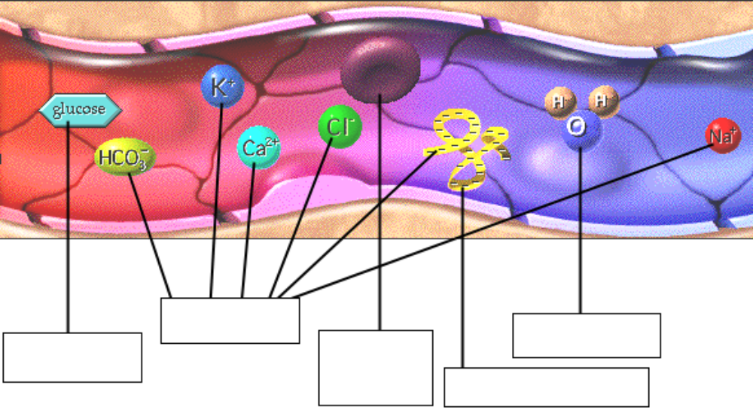

• You are looking at plasma, a typical body fluid.
• The term "body fluid" refers to the water in the body and all of the dissolved substances, which are also known as solutes. Since the water dissolves the solutes, it is the solvent.
• A typical body fluid may contain electrolytes, also known as ions.
• Proteins are considered to be colloids when dispersed in body fluids. Compared to simple ions, proteins are huge molecules. Because they bear a negative charge, we will consider them to be electrolytes.
• Nonelectrolytes are uncharged molecules found in body fluids. Glucose is an example of a nonelectrolyte.
• Blood cells do not dissolve in water. They are suspended particles and are not considered to be a part of the body fluid.

Page 12. Electrolytes
• Electrolytes are charged particles (ions) that are dissolved in body fluids.
Electrolytes (Dissolved Ions)
Major Positive Ions: Cations  Sodium ion, Na+  Potassium ion, K+  Calcium ion, Ca2+  Magnesium ion, Mg2+ | Major Negative Ions: Anions  Chloride ion, Cl-  Bicarbonate ion, HCO3-  Phosphate ions, H2PO4- & HPO42-  Sulfate, SO42-  Organic Acids  Proteins
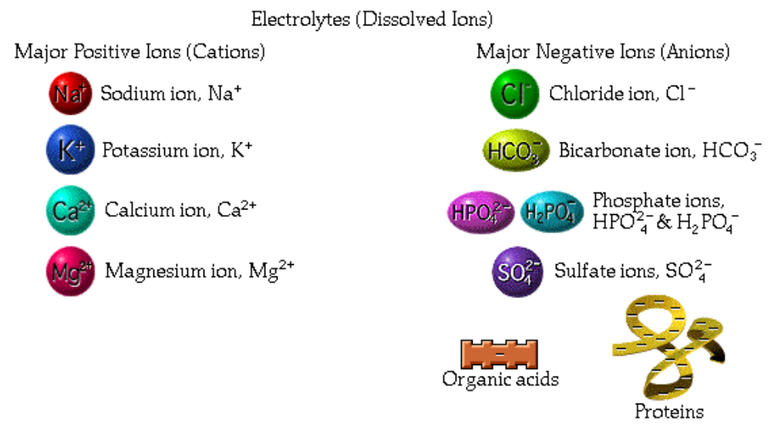

Page 13. Positive Electrolytes in Body Fluids
• Each fluid compartment needs just the right types and levels of electrolytes for proper functioning of neurons, muscle cells, and other cells in the body.
• The electrolyte composition of extracellular fluids and intracellular fluids have significant differences. Filling in the pie graph will help illustrate these differences.
• Sodium is the major positive ion of the extracellular fluid.
• Extracellular fluid also contains other positive ions: potassium, calcium, and magnesium.
• Potassium is the major positive ion of the intracellular fluid.
• Intracellular fluid also contains other positive ions: sodium, and magnesium.

• Fill in this diagram:
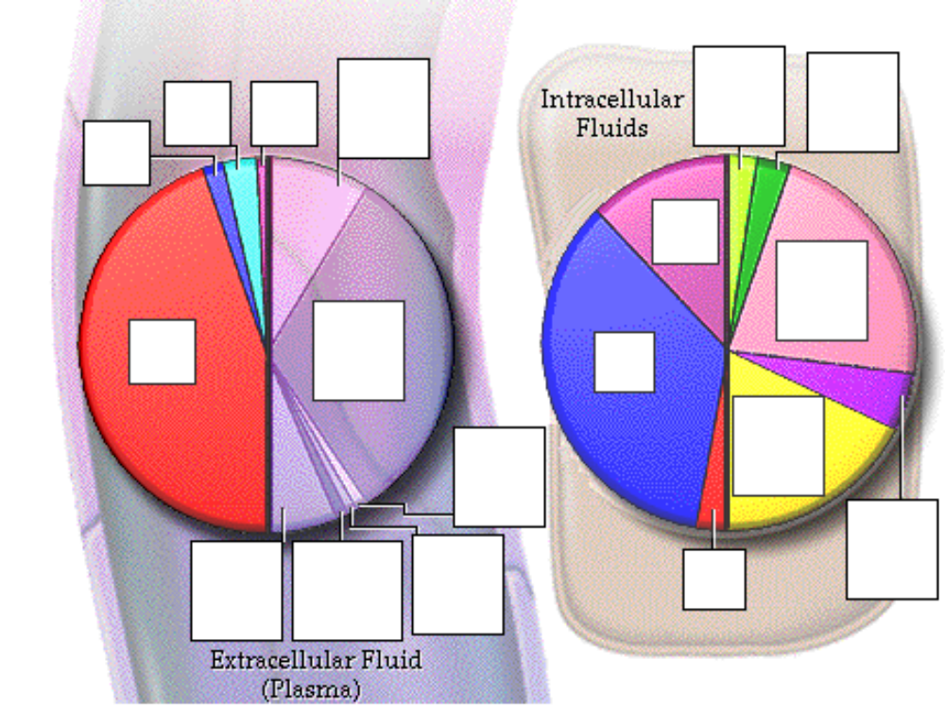

Page 14. Negative Electrolytes in Body Fluids
• Chloride is the major extracellular negative ion.
• Other negative electrolytes found in the extracellular fluid are protein, bicarbonate, and sulfate.
• Drag the two major intracellular negative ions to their proper places on the pie chart.
• Other negative ions found in the intracellular fluid are bicarbonate, chloride, organic acids, and sulfate.
• The composition of interstitial fluid is almost identical to that of blood plasma, except for one negative electrolyte - protein.
• To summarize, the major positive ion of the extracellular fluid is sodium and the major negative ion is chloride. The major positive ion of the intracellular fluid is potassium and the major negative ions are protein and phosphates.

Page 15. Balance of Charge
• Count the number of positive and negative ions (particles) in this sample of intracellular fluid. Are the number of positive ions equal to the number of negative ions?
• There are 6 negative ions and 9 positive ions here, so the number of ions are not equal.
• Now count the number of positive and negative charges in this sample of intracellular fluid. Are the number of positive charges equal to the number of negative charges?
• Yes, the laws of chemistry dictate that within a fluid compartment, the total number of positive charges must be equal to the total number of negative charges.
• Even though there are six negative ions and 9 positive ions here, the charges balance.
• Because the individual ions have different charges, there may not be the same number of positive and negative ions within the compartment, however the charge will always balance.

• Fill in this diagram:
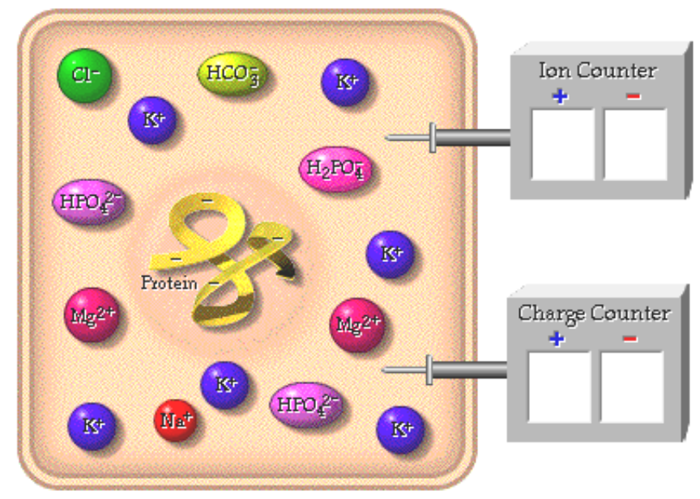

Page 16. Electrolytes as Cofactors
• Now let's look at a few of the many important functions that electrolytes perform in the body.  1. Cofactors.  • Electrolytes serve as cofactors for enzymes.  • A very important reaction in the body occurs when carbon dioxide and water form carbonic acid. We can speed up this reaction with the enzyme carbonic anhydrase.  • Cofactors are nonprotein substances that act, along with enzymes, to speed up reactions in the body. Calcium, magnesium, and other cations such as zinc can serve as cofactors for enzymes.  • Zinc is a cofactor for this enzyme. Click on the zinc to add it to the enzyme.  • This enzymatic reaction shown here cannot occur without a zinc ion present.  • Many other enzymes in the body require positive metal ions as  cofactors in order to function. | 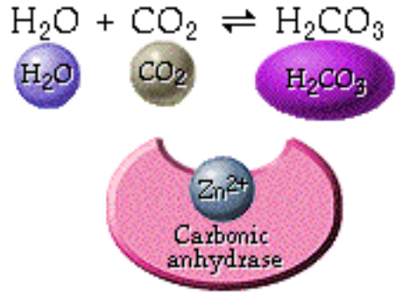

Page 17. Electrolytes in Nerve and Muscle Function
2. Action potentials in neuron and muscle cells.  • Electrolytes in the form of sodium and potassium ions also contribute to membrane potential in all cells and are responsible for action potentials in neuron and muscle cells.  3. Secretion and action of hormones and neurotransmitters.  • Calcium ions are important electrolytes because they are involved in the secretion and action of hormones and neurotransmitters.  4. Muscle contraction.  • Calcium is also involved in muscle contraction, including the heart.  Illustrate these three functions of electrolytes on this diagram: | 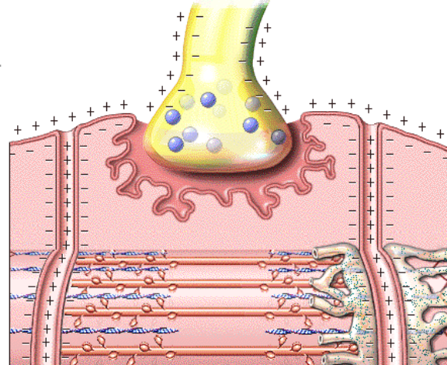

Page 18. Electrolytes in Acid Balance/Transport/Osmosis
5. Acid/base balance.  • Some electrolytes such as bicarbonate, phosphate, and protein help maintain acid/base balance.  • Circle the electrolytes in this diagram that are involved in acid/base balance.  6. Secondary Active Transport.  • By pumping sodium out the cell, the sodium potassium pump expends ATP to keep the concentration of sodium low inside cells.  • During secondary active transport, some transport proteins will allow sodium to diffuse from high to low concentration and drag with it a molecule or another ion such as glucose seen here from an area of lower to higher concentration. Glucose enters the proximal convoluted tubule cells of the kidney tubules and the intestine by secondary active transport. |  | 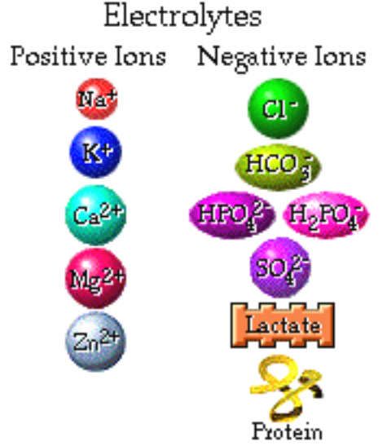
• Illustrate what happens with the sodium/potassium pump and secondary active transport on this diagram: | 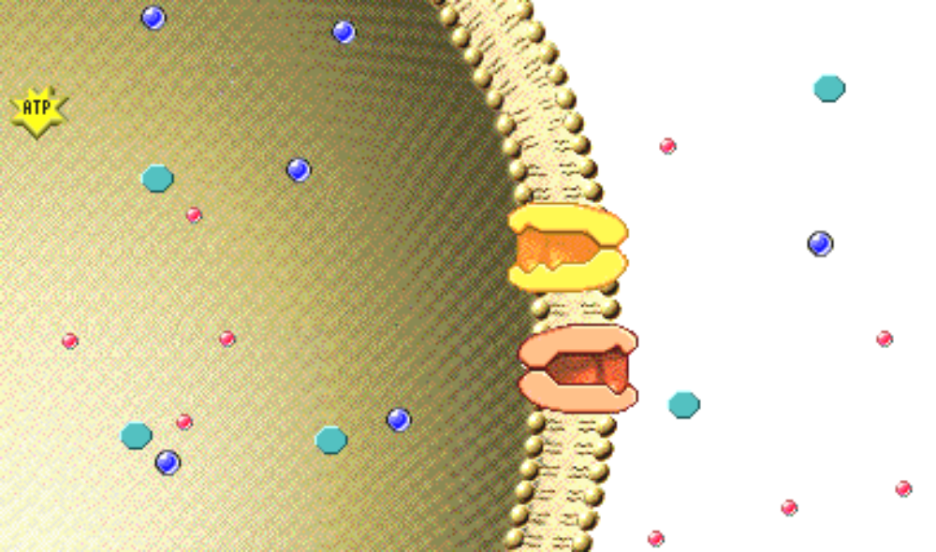

7. Osmosis. Movement of water between body compartments. Finally, electrolytes, including proteins, also play a major role in promoting the movement of water between body compartments or osmosis.

Page 19. Osmosis
• Let's take a closer look at what happens during osmosis. Osmosis is the movement of water across a selectively permeable membrane from the side that has more water, and therefore less solute, to the side that has less water and therefore more solute.
• When there are equal amounts of water particles on either side of the membrane, water moves freely back and forth across the membrane in both directions at the same rate. We say that the two solutions are isotonic, meaning that they have the same total concentration of nonpenetrating solute particles.
• Let's see what happens when more solute particles are added to the left side of the container. Click on the beaker to add more solute to the container.
• Now more solute is present on the left side and that side is hypertonic compared to the right side. Because less solute is present on the right side we say that solution is hypotonic compared to the left side.
• Note that if you increase the concentration of solute you decrease the concentration of water. Water still moves freely across the membrane in both directions. However less water will move from left to right because the higher concentration of water on the right side creates a greater chance for a collision between a water molecule and a channel on the right side. As a result more water will move from the right to the left side of the container.

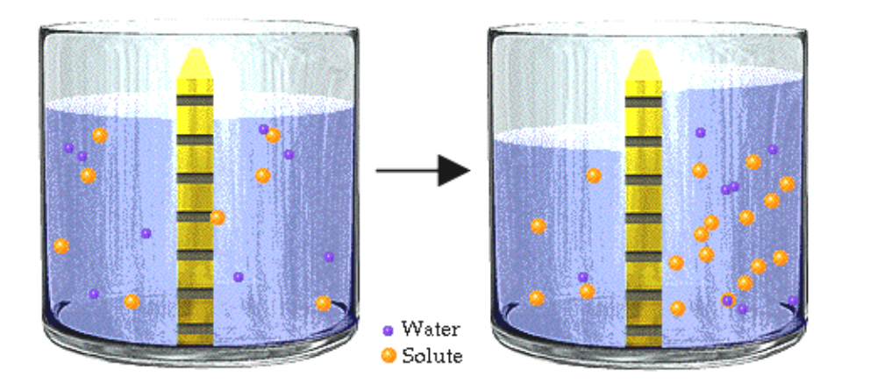

Page 20. Tonicity
• Note that the level of fluid increases in the left side of the container of this experimental situation.
• In a hypotonic solution, water moves into cells and they expand.
• In a hypertonic solution, water moves out of cells and they shrink or crentate.

Page 21. Osmotic Pressure
• We measure the ability of a solution to cause osmosis in terms of osmotic pressure, which is expressed in millimeters of mercury, a unit of pressure.
• Technically the definition of osmotic pressure is the external pressure applied to the top of the fluid to prevent osmosis from occurring. For the purposes of our discussion we need to remember that the greater the number of solute particles dissolved in solution the higher the osmotic pressure.

Page 22. Osmosis and IV Fluids
• Here we see a patient ready to receive an intravenous solution. Normally patients are given an isotonic IV solution. In this patient the hypotonic and hypotonic IVs are contraindicated. Let's see what happens to the blood cells of this patient when each IV is given.
• If we put a red blood cell in an isotonic solution, what will happen to it?
___ It will shrink (crenate).
___ It will expand.
___ The volume will remain constant.
• The volume will remain constant because the solute concentrations are equal on both sides of the membrane.
• If we put a red blood cell in a hypertonic solution, what will happen to it?
___ It will shrink (crenate)
___ It will expand
___ The volume will remain constant
• The cell will shrink or crenate. There is a net flow of water out of the cell and that causes the cell to shrink. This is why hypertonic IV solutions are only used in specific clinical situations.

• If we put a red blood cell in a hypotonic solution, what will happen to it?
___ It will shrink (crenate)
___ It will expand
___ The volume will remain constant
• The cell will expand. If too much water enters the cell eventually it could undergo hemolysis or break open. This is why hypotonic IV solutions are only used in specific clinical situations.

Page 23. Summary
• Fluids are composed of water and all the substances (solutes) dissolved in the water in the body.
• Most fluids within the body exist in three major compartments: the intracellular compartment, the plasma, and the interstitial compartment. The interstitial compartment and the plasma constitute the extracellular compartments.
• Within a solution, positive and negative charges must balance regardless of the number of ions present.
• The concentrations of dissolved ions, or electrolytes in the intracellular compartment are very different than the concentrations of electrolytes that in the extracellular compartment.
• Both water and electrolytes have many important functions in the body.
• Osmosis is the movement of water across a membrane from the side that has more water to the side that has less water.

Notes on Quiz Questions:
Quiz Question #1: Functions of Water
• This question allows you to view clips of animations and then determine the function of water.

Quiz Question #2: Percentage of Fluids
• This question has you predict the approximate percentage of fluid in each of the major fluid spaces.

Quiz Question #3: Definition of Terms
• This question allows you do define cation, anion, colloid, suspended particle, and nonelectrolyte.

Quiz Question #4: Location of Electrolytes
• This question allows you to place the electrolytes in the appropriate compartments.

Quiz Question #5: Components of Plasma
• This question allows you to identify the components of plasma.

Quiz Question #6: Functions of Electrolytes
• This question allows you to view clips of animations and then determine the functions of electrolytes.

Quiz Question #7: Blood Cells
• This question asks you which blood cell is telling the truth.

Study Questions on Introduction to Body Fluids:
1. (Page 3.) What three processes are involved in water balance?

2. (Page 4.) What are two roles of water in temperature regulation?

3. (Page 5.) Give two examples of how water can have a cushioning effect?

4. (Page 5.) Give two examples of how water can have a lubricating effect?

5. (Page 6.) Explain how water can be a reactant in chemical reactions that occur in the body.

6. (Page 6.) Explain how water can be a product in chemical reactions that occur in the body.

7. (Page 7.) Explain why water is a polar molecule.

8. (Page 7.) Ions can be solid or dissolved. Give some examples of solid ions in the body.

9. (Page 7.) Show how water molecules surround sodium and chloride ions.
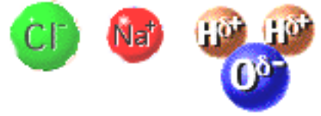

10. (Page 8.) What role does water play in transport.

11. (Page 8.) List the functions of water in the body.

12. (Page 9.) What is the relationship between the amount of fat in the body and the percentage of water in the body?

13. (Page 9.) Who tend to have more water in their bodies? a. men or woman b. a lean woman or a heavier woman c. a baby or an adult

14. (Page 10.) Label the fluid compartments on the diagram on page 10.

15. (Page 10.) Match the size of the fluid compartment to the percentage of fluid in that compartment.
62%  30%  8% | plasma  intracellular  interstitial

16. (Page 11.) Label the diagram on page 11.

17. (Page 12.) List the name and charge of four positive ions found in the body fluids.

18. (Page 12.) List the name and charge of six negative ions found in the body fluids.

19. (Page 13.) What is the most important positive ion of the extracellular fluid?

20. (Page 13.) What is the most important positive ion of the intracellular fluid?

21. (Page 14.) What is the most important negative ion of the extracellular fluid?

22. (Page 14.) What are the most important negative ions of the intracellular fluid?

23. (Page 14.) What negative ion is present in the plasma, but not in the interstitial fluid?

24. (Page 15.) Are the number of positive ions in a body solution equal to the number of negative ions in a body fluid?

25. (Page 15.) Are the number of positive chargers equal to the number of negative charges in a body fluid?

26. (Page 16-18.) List several different functions of electrolytes in the body.

27. (Page 18.) When electrolytes act as cofactors for enzymes. can the enzymes perform it's function without the cofactor?

28. (Page 19.) What is osmosis?

29. (Page 19.) What is the driving force for osmosis?

30. (Page 19.) What is a hypotonic solution? What is a hypertonic solution?

31. (Page 20, 22.) What happens to red blood cells when they are placed in a hypertonic solution?

32. (Page 20, 22.) What happens to red blood cells when they are placed in a hypotonic solution?

33. (Page 21.) What is osmotic pressure?

