Water Homeostasis
Graphics are used with permission of:
Pearson Education Inc., publishing as Benjamin Cummings (http://www.aw-bc.com)

1. Water Homeostasis
• The body maintains a balance of water intake and output by a series of negative feedback loops involving the endocrine system and autonomic nervous system.

2. Goals
• To examine dehydration and hypovolemia
• To examine the role the kidneys play in regulating water homeostasis
• To understand how neural and endocrine mechanisms work to maintain water homeostasis via negative feedback mechanisms
• To examine the role thirst plays in regulating water homeostasis

3. How Water Enters and Leaves the Body
• The average adult body contains about 40 liters of water. This amount, called total body water, remains fairly constant under normal circumstances.

4. Water Tank Analogy
• On this page, the gain and loss of fluid in the human body will be represented by the gain and loss of fluid in the tank below.
• Every day we take in about 2300 milliliters of water in the form of food and beverages.
• Approximately 200 milliliters of body water is generated through cell metabolism for an approximate 2500 milliliters of total intake.
C6H12O6 + 6O2 → 6 H2O + CO2
• At the same time, we lose water, mostly through the kidneys, but also through the lungs, skin, and GI tract.
• We lose approximately 1500 milliliters per day from the kidneys in the form of urine.
• We also lose about 600 milliliters of water per day through the skin and 300 milliliters from the lungs in the form of water vapor in exhaled air. These two forms of water loss are called insensible loss because we are unaware of the process.
• We can lose much more than this insensible loss under conditions of extreme physical exertion. Under such conditions we can lose up to 5000 milliliters per day, through sweating.
• Under normal circumstances we also lose 100 milliliters of water per day though the GI tract.
• As you can see, maintaining water homeostasis is a balancing act. The amount of water taken in must equal the amount of water lost.
• Fill out this chart:
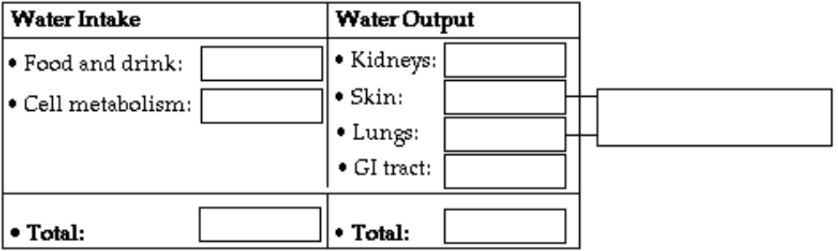

*Now is a good time to go to quiz question 1:
• Click the Quiz button on the left side of the screen.
• Work through all parts of question 1.
• After answering question 1, click on the Back to Topic button on the left side of the screen.
• To get back to where you left off, click on the scrolling page list at the top of the screen.
• Choose "5. Disturbances of Water Homeostasis."

5. Disturbances of Water Homeostasis
Disturbances of water homeostasis:
• Gain or loss of extracellular fluid volume
• Gain or loss of solute
In many instances disturbances of water homeostasis involve imbalances of both volume and solutes. We will discuss four specific examples of water homeostasis:
• Hypervolemia
• Overhydration
• Hypovolemia
• Dehydration
Fill out this chart:
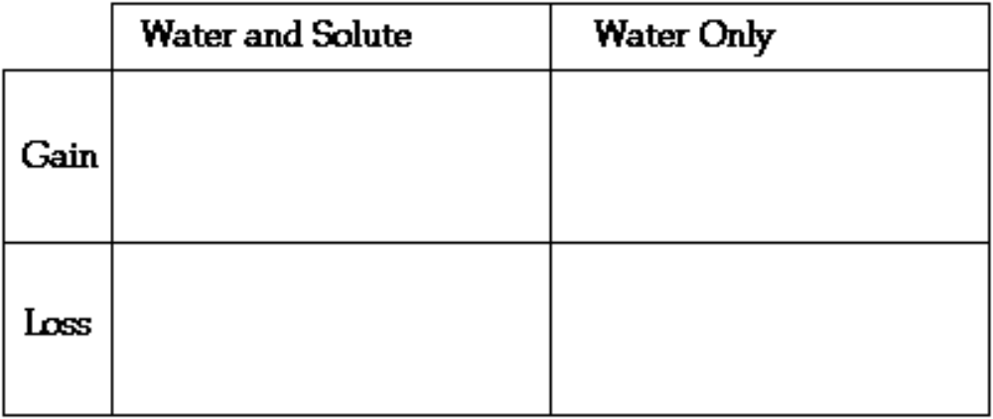

6. Hypervolemia
• Hypervolemia occurs when too much water and solute are taken in at the same time. Although extracellular fluid volume increases, plasma osmolarity may remain normal.  • Show what happens when hypervolemia occurs: | 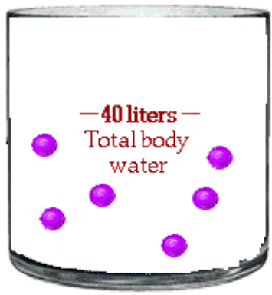

7. Overhydration
• Overhydration occurs when too much water is taken in without solute. Volume increases, but because solute is not present, plasma osmolarity decreases.

• Show what happens when overhydration occurs:

8. Hypovolemia
• Hypovolemia occurs when water and solutes are lost at the same time. This condition primarily involves a loss of plasma volume. Plasma osmolarity usually remains normal even though volume is low.

• Show what happens when hypovolemia occurs:

9. Dehydration
• When water, but not solute, is lost, dehydration occurs.

• Dehydration involves a loss of volume but, because solutes are not lost in the same proportion, plasma osmolarity increases.

• Show what happens when dehydration occurs:

10. Disturbances of Water Homeostasis Exercise
• Here are four examples of conditions that disturb water homeostasis. Drag each one into its correct location in the table.
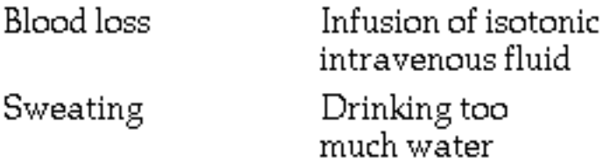

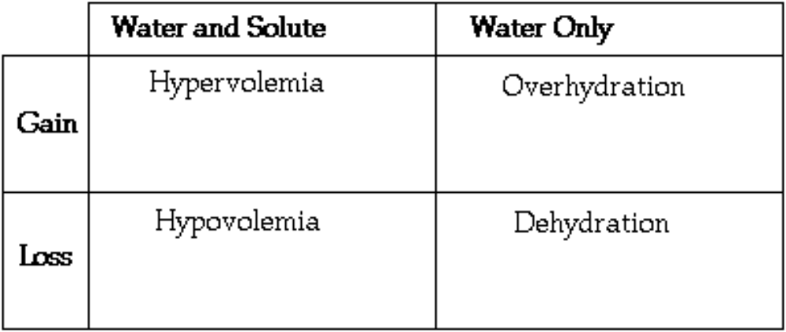

• Blood loss involves a loss of water and solutes resulting in hypovolemia.
• Although sweating causes the loss of some solute through the skin, much more water is lost, and the person becomes dehydrated.
• Too much IV fluids can increase plasma volume dramatically, but with an isotonic solution the plasma osmolarity would remain normal and result in hypervolemia.
• Drinking too much water would dilute the plasma and the osmolarity would decrease resulting in overhydration.

11. The Kidney: Filtration
• The major way that we regulate water loss from the body is through the kidneys. Before we continue let's quickly review how the nephron of the kidney works.
• The kidneys are composed of millions of microscopic structures called nephrons, where urine is formed.
• Blood vessels wrap around the nephron allowing exchanges between the plasma and the filtrate, or forming urine.
• Label this diagram:
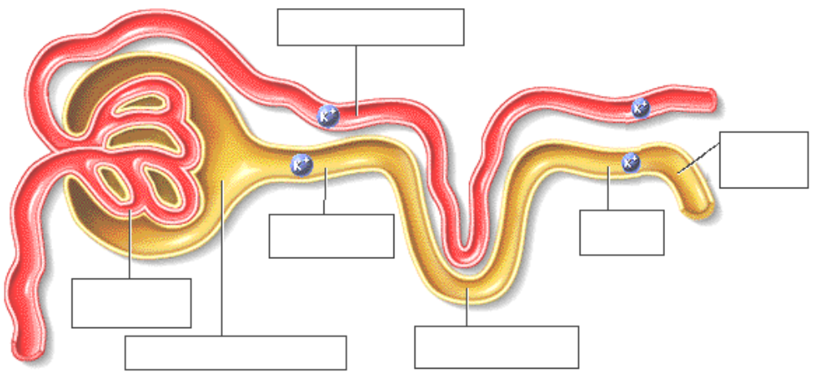

• Let's review the three steps involved in urine formation:
____ Reabsorption
____ Secretion
____ Glomerular filtration.
• What is the first step in urine formation?
• During glomerular filtration, small solutes and water will move from the plasma in the glomerular capillaries into the glomerular capsule, beginning the process of urine formation.

12. The Kidney: Reabsorption
• Drag the potassium ion in the direction it would move if it was reabsorbed into the plasma in the diagram above.
• Reabsorption occurs along the renal tubules and involves the selective uptake of specific substances back into the blood. Water follows via osmosis.

13. The Kidney: Secretion
• Drag the potassium ion in the direction it would move if it was secreted in the diagram above.
• Certain substances are secreted from the blood back into filtrate. Note that there is normally more reabsorption than secretion.
• Urine is formed at the end of the renal tubules.

14. Mechanisms of Fluid Balance
• Our bodies have mechanisms that regulate fluid levels within a narrow range. In this topic we will explore how the body's fluids remain within certain physiological limits, an important aspect of homeostasis.
• Four primary mechanisms regulate fluid homeostasis:
Antidiuretic hormone or ADH
Thirst mechanism
Aldosterone
Sympathetic nervous system
• Three of these mechanisms involve the kidneys.
• Let’s look at a marathon runner to see how fluid balance is maintained. Notice that the runner is sweating. If he continues to lose water and, to a lesser extent, salts, he may become dehydrated.

15. Effect of ADH
• When the runner loses water by sweating, his plasma becomes more concentrated in solutes.
• Osmoreceptors in the hypothalamus detect the increased osmolarity or concentration of solutes in the plasma.
• In response to this increased concentration, antidiuretic hormone is released into the blood at the posterior pituitary.
• The targets for ADH are the collecting duct cells in the kidney.

16. ADH in the Nephron
• These cells become permeable to water only in the presence of ADH.
• ADH promotes the addition of water channels into the cells of collecting duct, allowing water to move from the filtrate to the plasma by way of osmosis.
• ADH therefore increases the reabsorption of water.

17. ADH Exercises
• What effect would ADH have on the concentration of the plasma?
___ Plasma becomes more concentrated.
___ Plasma becomes more dilute.
• Because more water is reabsorbed, the plasma becomes more dilute.
• The greater amount of water in the plasma reduces the plasma concentration of solutes and increases the volume of the plasma, somewhat.
• What effect does antidiuretic hormone have on the volume and osmolarity of urine produced?
___ ADH reduces the volume of urine and increases the osmolarity of the urine.
___ ADH increases the volume and decreases the osmolarity of the urine.
• Because more water is reabsorbed, there is less urine and that urine has an increased osmolarity.
• All of the effects of antidiuretic hormone help to prevent further fluid loss. ADH will probably still be secreted until the runner drinks enough fluid to dilute the plasma. After drinking fluids, the plasma osmolarity decreases to normal, returning the secretion of antidiuretic hormone to baseline levels, completing the negative feedback loop.

*Now is a good time to go to quiz questions 2-3:
• Click the Quiz button on the left side of the screen.
• Work through all parts of questions 2-3.
• After answering question 3, click on the Back to Topic button on the left side of the screen.
• To get back to where you left off, click on the scrolling page list at the top of the screen.
• Choose "18. Thirst Mechanism."

18. Thirst Mechanism
• The thirst mechanism is the primary regulator of water intake and involves hormonal and neural input as well as voluntary behaviors.
• There are three major reasons why dehydration leads to thirst:
1. When saliva production decreases, the mouth and throat become dry. Impulses go from the dry mouth and throat to the thirst center in the hypothalamus, stimulating that area.
2. When you are dehydrated, blood osmotic pressure increases, stimulating osmoreceptors in the hypothalamus and the thirst center in the hypothalamus is now further activated.
3. Decreased blood volume causes a decrease in blood pressure that is signaled by baroreceptors and stimulates the release of renin from the kidney. This causes the production of angiotensin II which stimulates the thirst center in the hypothalamus.
• Stimulation of the thirst center in the hypothalamus gives you the desire to drink.

19. Results of Fluid Ingestion
• This fluid ingestion:
1. Relieves the dryness in the mouth and throat.
2. Fluid ingestion also stimulates stretch receptors in the stomach and intestine to send inhibitory signals to the thirst center.
3. When normal fluid osmolarity and volume is restored, dehydration is relieved, and the thirst center is no longer stimulated.

20. Effect of Aldosterone
• When a person donates large amounts of blood, they lose salts as well as water. When electrolytes and water are lost at the same time, blood volume decreases, threatening hypovolemia.
• When blood volume is lost, what happens to the blood pressure?
__ blood pressure increases
__ blood pressure decreases
• When a person experiences blood loss, blood pressure decreases.
• Because a hypovolemic person experiences a decrease in blood pressure, granular cells in the arterioles of the kidney release renin.

21. Renin to Aldosterone
• As renin travels through the bloodstream, it binds to an inactive plasma protein, angiotensinogen, activating it into angiotensin I.
• As angiotensin I passes through the lung and other capillaries, an enzyme called Angiotensin Converting Enzyme, or ACE, converts angiotensin I to angiotensin II.
• Angiotensin II continues through the blood stream until it reaches the adrenal gland. Here it stimulates the cells of the adrenal cortex to release the hormone aldosterone.
• Angiotensin II also has a vasoconstriction effect that helps to increase the blood pressure.
• On this diagram show how the steps in the formation of aldosterone:
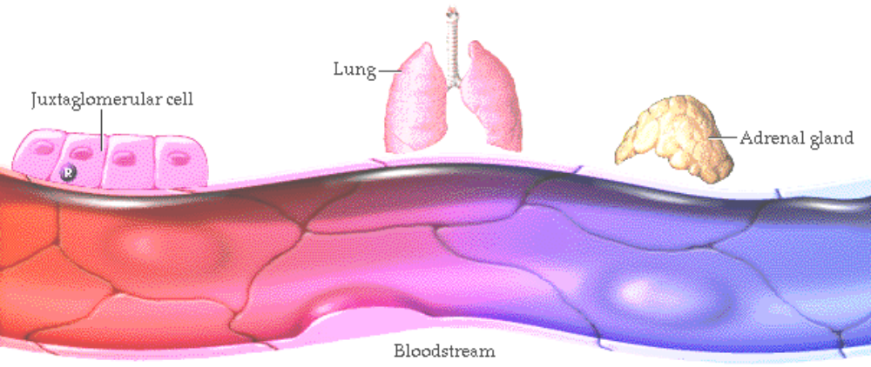• Aldosterone can also be released when potassium concentrations in the blood are high.

22. Aldosterone in the Nephron
• In the absence of aldosterone, the cells in the distal convoluted tubule and collecting ducts allow little sodium and potassium ions to pass because there are few sodium and potassium channels in the cell membrane facing the kidney tubule. There are also few sodium-potassium ATPase pumps on the basal side of these cells.
• Aldosterone exerts its effect by inserting additional channels in the distal convoluted tubule and collecting duct of the kidney. This allows more sodium to move from the filtrate into the blood and potassium to move from the blood into the filtrate.

23. Aldosterone Exercises
• Drag the sodium in the direction it will move if aldosterone is present.
• In the presence of aldosterone, sodium moves from the filtrate to the plasma.
• Drag the potassium in the direction it will move if aldosterone is present.
• In the presence of aldosterone, potassium moves from the plasma to the filtrate.
• If antidiuretic hormone is also present, water will follow the sodium into the plasma by osmosis.
• This movement of water and sodium into the blood causes the blood pressure to increase, completing the negative feedback loop.
• Show the movement of sodium and potassium ions on this diagram:
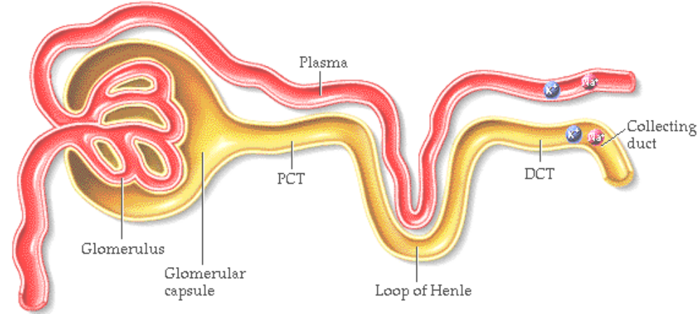

24. Results of Aldosterones Action
• The net result of aldosterones action is the reabsorption of sodium and the secretion of potassium.
• If ADH is also present, water is reabsorbed into the blood at the kidney, preventing further water loss from the body. As a result, blood volume and blood pressure are stabilized until water is consumed.

25. Sympathetic Stimulation
• A decrease in blood volume and therefore blood pressure will further stimulate the sympathetic nervous system.
• When blood pressure is low, baroreceptors in the heart, aortic arch, and carotid arteries send sensory information to the medulla.
• The information sent from the baroreceptors to the medulla will cause an increase in the sympathetic impulses to the kidney.

26. Sympathetic Stimulation in the Nephron
• Release of neurotransmitters from the sympathetic nerves in the kidney stimulates smooth muscle cells in the afferent arteriole to constrict.
• This process causes a decrease in blood flow into the glomerulus and a drop in glomerular filtration rate and results in less urine formation. Less water leaves the body.
• Sympathetic stimulation also causes the release of renin which, by stimulating aldosterone secretion, will increase the reabsorption of sodium.
• As a result, blood volume will stop decreasing and blood pressure may stabilize. However because the blood pressure and blood volume have not yet returned to normal, the baroreceptors will continue to be stimulated to prevent further loss of blood volume.
• In order to bring this person back into to homeostasis, we need to increase the blood volume by drinking fluids. In fact after an individual has given blood, they are encouraged to drink juice to increase their plasma level.

27. Summary
• To maintain homeostasis, water intake must equal water output.
• There are many categories of water and solute imbalances. We use the term overhydration to describe an excess of water only. Hypervolemia involves an excess of both water and solute.
• Dehydration is the loss of water from the body, without significant loss of solute. Hypovolemia is a loss of both water and solute. A person may exhibit more than one type of imbalance at the same time.
• Water balance is maintained within a narrow range by negative feedback loops involving the hormones ADH and aldosterone as well as the thirst mechanism and the sympathetic nervous system.

*Now is a good time to go to quiz questions 4-6:
• Click the Quiz button on the left side of the screen.
• Work through all parts of questions 4-6.

Notes on Quiz Questions:
Quiz Question #1: Water Enters and Leaves
• This question has you predict how water enters and leaves the body.

Quiz Question #2: Dehydration
• This question has you predict the affects of dehydration.

Quiz Question #3: Antidiuretic Hormone
• This question has you list the sequence of events in the secretion and action of ADH.

Quiz Question #4: Thirst
• This question allows you to answer questions about thirst.

Quiz Question #5: Aldosterone
• This question allows you to predict the sequence of events that occur when an individual is experiencing blood loss.

Quiz Question #6: Diabetes Insipidus
• This question allows you to predict what happens when an individual has diabetes insipidus.

Study Questions on Water Homeostasis:
1. (Page 3.) About how many liters of water are there in the average adult? What is this water called?

2. (Page 4.) What are the two ways that water enters the body?

3. (Page 4.) Explain where the water from cell metabolism is derived from?

4. (Page 4.) What are the four ways that water leaves the body?

5. (Page 4.) What is insensible water loss?

6. (Page 4.) Fill out the diagram on page 4.

7. (Page 4.) Why is maintaining water homeostasis a balancing act?

8. (Page 5.) What are two ways we can develop imbalances in water homeostasis?

9. (Pages 6-9.) Explain the problem in each of the situations below:
a. Hypervolemia
b. Overhydration
c. Hypovolemia
d. Dehydration

10. (Page 5-9.) Fill out the chart on page 5.

11. (Page 6-9.) On the diagrams on page 6-9, indicate the level of water and solute in each of these cases:
a. Hypervolemia
b. Overhydration
c. Hypovolemia
d. Dehydration

12. (Page 10.) Classify the following as problems associated with either hypervolemia, overhydration, hypovolemia, or dehydration.
a. Blood loss
b. Infusion of isotonic intravenous fluid
c. Sweating
d. Drinking too much water

13. (Page 11.) Label the diagram on page 11.

14. (Page 11.) Describe the first step in urine formation?

15. (Page 12, 13.) Describe the other two steps in urine formation?

16. (Page 14.) What are the four primary mechanisms regulate fluid homeostasis?

17. (Page 15.) Why would sweating cause the secretion of antidiuretic hormone?

18. (Page 15.) What the target cells for antidiuretic hormone?

19. (Page 16.) What is the affect of antidiuretic hormone on the cells of the late distal convoluted tubule and collecting duct cells in the kidney?

20. (Page 17.) What effect would ADH have on the concentration of the plasma?

21. (Page 17.) What effect does antidiuretic hormone have on the volume and osmolarity of urine produced?

22. (Page 17.) When will the secretion of ADH stop?

23. (Page 18.) Where is the thirst center located?

24. (Page 18.) List the three major reasons why dehydration leads to thirst.

25. (Page 19.) How does fluid ingestion relieve thirst?

26. (Page 20.) When blood volume is lost, what happens to the blood pressure?

27. (Page 20.) When there is a decrease in blood pressure, what happens in the juxtaglomerular cells in the arterioles of the kidney ?

28. (Page 21.) Starting with renin, list the steps in the secretion of aldosterone.

29. (Page 21.) On the diagram on page 21, show how the steps in the formation of aldosterone.

30. (Page 21.) How does angiotensin II help to increase the blood pressure?

31. (Page 21.) What else, besides renin/angiotensin, will cause the release of aldosterone?

32. (Page 22.) What is the effect of aldosterone?

33. (Page 23.) In the presence of aldosterone, show the movement of both sodium and potassium ions on the diagram on page 23.

34. (Page 23.) In the presence of aldosterone, if ADH is also present, which way will water move: from Blood to filtrate or from filtrate to blood?

35. (Page 24.) What is the net result of aldosterone in terms of reabsorption and secretion?

36. (Page 25, 26.) List the steps in the sympathetic secretion of renin.

