Electrolyte Homeostasis
Graphics are used with permission of:
Pearson Education Inc., publishing as Benjamin Cummings (http://www.aw-bc.com)

1. Electrolyte Homeostasis
• The fluid surrounding the cells in the body must maintain a specific concentration of electrolytes for the cells to function properly. Let's look more closely at how electrolyte homeostasis is maintained in the body.

2. Goals
• To recognize that electrolytes must be maintained in a narrow concentration range in order for cells of the body to function properly
• To examine in general how electrolyte composition of the fluid compartments are maintained
• To learn the importance of sodium, potassium, and calcium homeostasis
• To learn the consequences of disturbances of sodium, potassium, and calcium homeostasis
• To examine how fluid movement is regulated in the body

3. Electrolyte Balance
• Electrolytes are a major component of body fluids. They enter the body in the food we eat and the beverages we drink.
• While electrolytes leave the body mainly through the kidneys by way of the urine, they also leave through the skin and feces.
• Severe vomiting and diarrhea can cause a loss of both water and electrolytes from the body, resulting in both water and electrolyte imbalances.
• The concentrations of electrolytes in body fluids must be maintained within specific limits, and even a small deviation outside these limits can have serious or life-threatening consequences.
• In this topic we will concentrate on the three most clinically significant electrolytes sodium ions, potassium ions, and calcium ions.

4. Fluid Movement Across the Cell Membrane
• One of the important functions of electrolytes, particularly sodium, is to control fluid movement between fluid compartments.
• The movement of fluid across the cell membrane differs from the movement of fluid between the interstitial compartment and plasma.
• Label this diagram:
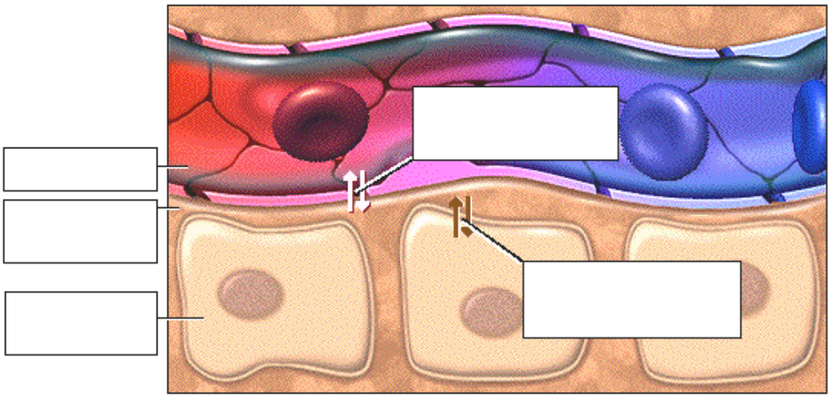

5. Fluid Movement: Sodium/Potassium Ion Pump
• The cell membrane acts as a barrier to separate intracellular and interstitial fluid compartments.
• Electrolytes move across the cell membrane through channels and ion pumps that are selective for specific ions.
• The sodium/potassium ion pump to see the actively transports sodium and potassium.
• Ion pumps in the membrane help move ions against their concentration gradient from an area of lower concentration to an area of higher concentration. These pumps require an input of energy in the form of ATP.
• Label the diagram below and show the direction of movement of sodium and potassium ions through the sodium/potassium pump.
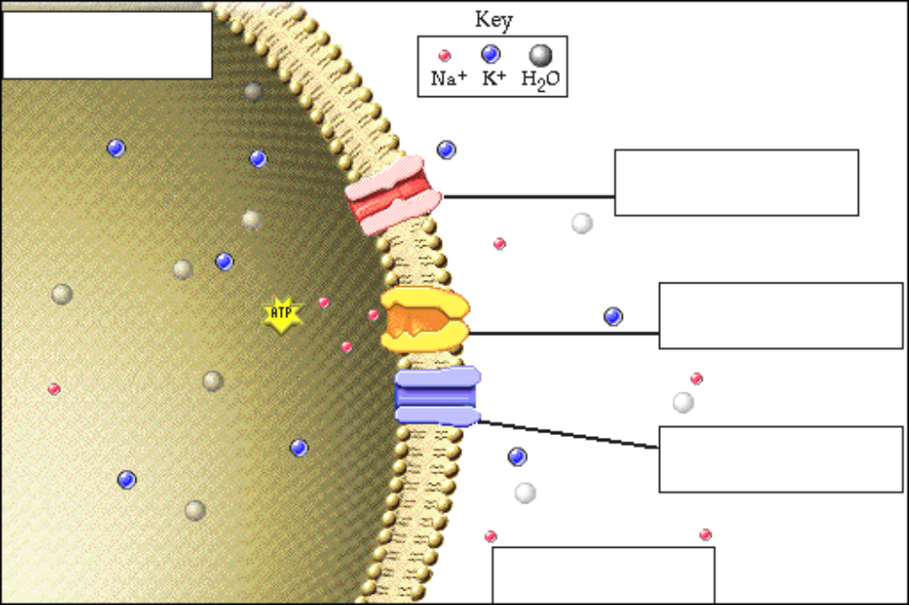

6. Fluid Movement: Sodium Ion Channel
• Channels specific for sodium ions allow these ions to diffuse from areas of higher to areas of lower concentration. Since most cells have few sodium channels, not many sodium ions move across the membrane.
• Show the direction of sodium ion movement through the channel on the diagram above.

7. Fluid Movement: Potassium Ion Channel
• The channels specific for potassium ions allow these ions to move across the membrane from areas of higher to areas of lower concentration.
• Differences in ion concentration between intracellular and interstitial fluids are caused by these selective ion channels and ion pumps in the cell membrane.
• These differences make the membrane potential possible and they facilitate a number of important physiological processes.
• Show the direction of potassium ion movement through the channel on the diagram above.

8. Fluid Movement: Water
• We have seen how ions move across the cell membrane, now let's show water movement across the membrane. The cell membrane is freely permeable to water, which moves from the area of higher water concentration to lower water concentration.
• When there is a higher concentration of solute in the interstitial fluid, which way will water move?
• Water will move from the inside to the outside of the cell.
• Through osmosis, water moves to the side of the membrane with the higher solute concentration or the lower water concentration. You can see how sodium exerts a significant osmotic effect on water and therefore effects its movement.
• Show the direction of water movement on the diagram on the previous page.

9. Fluid Movement Between Interstitial Fluid and Plasma
• We’ve seen how water moves between the intracellular and interstitial fluid compartments.
• Fluid movement between the interstitial compartment and plasma is quite different from the movement between the interstitial compartment and intracellular compartment.
• Click on the endothelial cell to see how fluids move between plasma and interstitial fluid.
• Ions, other small solutes, and water can move freely between the plasma and the interstitial fluid through gaps between endothelial cells.
• In most cases, proteins are too big to leave the blood capillaries.
• Proteins that do escape from the blood capillaries are removed by the lymph capillaries and are moved back into the plasma by way of the lymph.
• Because the protein concentration in the interstitial fluid is low compared to the concentration in the plasma, the protein in the plasma exerts an osmotic effect called the colloid osmotic pressure.

10. Fluid Movement Exercise
• Plasma proteins exert an osmotic effect and water will move from the interstitial fluid into the plasma.
• At the same time, capillary hydrostatic pressure, the blood pressure in the capillaries, forces fluid out of the capillary and into the interstitial space.
• Fluid will move from the blood to the interstitial fluid.
• Label this diagram:
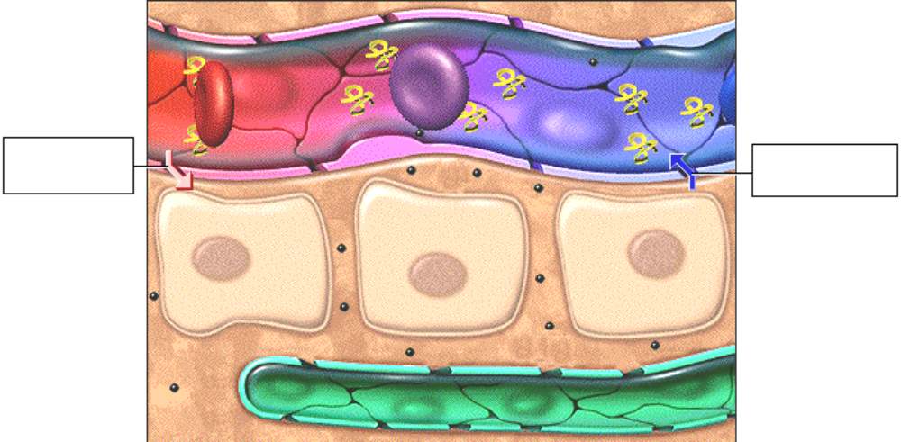

11. Bulk Flow
• The osmotic effect of the protein and the hydrostatic pressure oppose each other. At the arterial end of a capillary bed the hydrostatic pressure is typically stronger than the osmotic effect of the protein, and forces fluid, along with nutrients, into the interstitial fluid space.
• At the venous end of a capillary bed, the osmotic effect of the protein is greater than the hydrostatic pressure, and there is a net movement of fluid containing carbon dioxide and wastes into the plasma.
• This exchange of fluids between the interstitial space and plasma is called bulk flow. The net result of bulk flow is fluid movement out of the capillary at the arterial end and into the capillary at the venous end. This process allows for nutrient/waste exchange.
• Now let’s consider what will happen if the sodium concentration of the plasma increases. What would happen to the concentration of sodium ions in the interstitial fluid?
___ Increase
___ Decrease
• Sodium would move into the interstitial fluid, followed by water.
• What effect would an increase in sodium concentration have on the cells that are bathed by the interstitial fluid?
• The cells will shrink. The high concentration of sodium and other small solutes in the extracellular fluid exerts significant osmotic pressure on cells and contributes to determining the fluid levels in the intracellular compartment.

12. Edema
• Edema is an accumulation of fluid in the interstitial compartment, and can occur either locally, in a specific area of the body, or generally, throughout the body.
• Although edema first appears to be a disturbance of water levels in the body, in many cases it occurs as a result of electrolyte imbalance. A lack of plasma protein commonly causes edema.
• Let’s look at four causes of edema:
Decreased capillary colloid osmotic pressure
Increased capillary hydrostatic pressure
Increased capillary permeability
Lymphatic obstruction

13. Edema: Decreased OP_{c}
• Albumin is a protein made in the liver and secreted into the plasma. Like other proteins, it has an abundance of negative charge.
• Proteins exert an osmotic effect on plasma which, as you remember, is called capillary colloid osmotic pressure. Through this osmotic effect, albumin and other plasma proteins help maintain blood volume by pulling water into the plasma.
• In the presence of liver disease, the synthesis of plasma proteins, including albumin, decreases.
• What will happen to capillary colloid osmotic pressure?
____ Colloid osmotic pressure decreases
____ Colloid osmotic pressure increases
• The colloid osmotic pressure will decrease because there is less protein.
• In which direction will water move?
____ Into the interstitial fluid
____ Into the plasma
• Because protein synthesis is decreased, plasma colloid osmotic pressure decreases. While fluid moves out of the plasma into the interstitial compartment, less fluid moves into the plasma from the interstitial compartment, resulting in fluid accumulation in the interstitial compartment.
• What do you think will happen to the blood pressure?
____ Blood pressure increases
____ Blood pressure decreases
• Generalized edema is significant because blood volume can drop dramatically along with blood pressure. In addition, increased fluid volume in the interstitial compartment impinges on the capillaries, restricting blood flow.

• Explain the defect that occurs when edema occurs due to decreased colloid osmotic pressure.  ________________________________  ________________________________  ________________________________  ________________________________  ________________________________ | 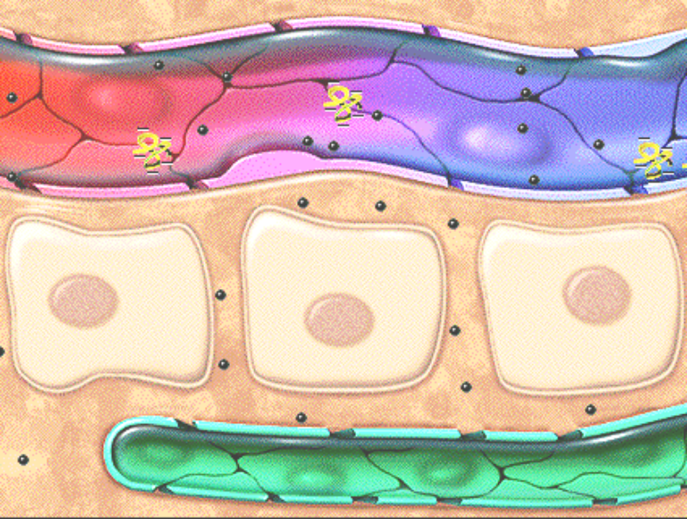

14. Edema: Increased HP_{c}
• Edema can also occur as a result of increased hydrostatic pressure.
• For example, in congestive heart failure, the heart is unable to pump all of the blood returned to it. Blood backs up in the veins, causing an increase in capillary hydrostatic pressure.
• Explain the defect that occurs when edema occurs due to increased hydrostatic pressure.  ________________________________  ________________________________  ________________________________  ________________________________  ________________________________ | 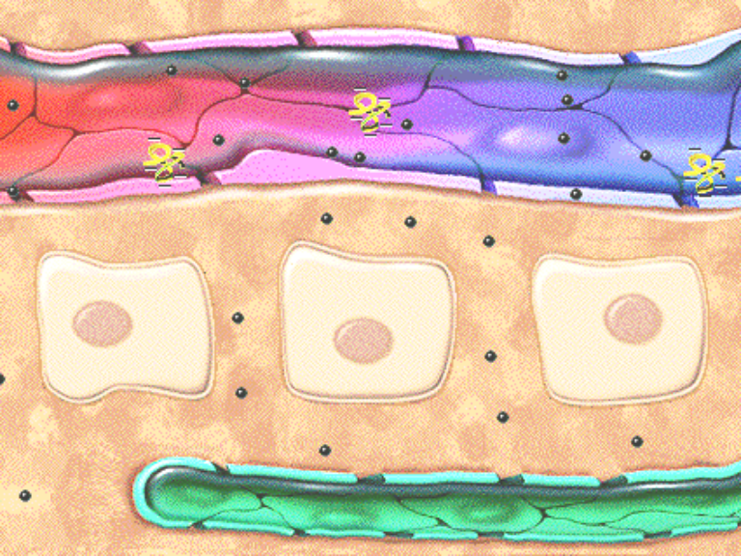

15. Edema: Increased Capillary Permeability
• Local edema can occur as a result of injury or inflammation, such as the swelling that occurs with a sprained ankle.
• In this case, capillaries become more permeable in the area of injury and proteins move more freely into the interstitial compartment.
• What do you think happens to fluid movement now?
____ Fluid moves into plasma
____ Fluid moves into interstitial fluid
• The protein movement creates an osmotic effect that pulls more fluid into the interstitial compartment.
• When the localized inflammation ends, fluid and proteins move through the lymph back to the plasma and the capillary bed returns to 'normal'.

• Explain the defect that occurs when edema occurs due to increased capillary permeability.  ________________________________  ________________________________  ________________________________  ________________________________  ________________________________ | 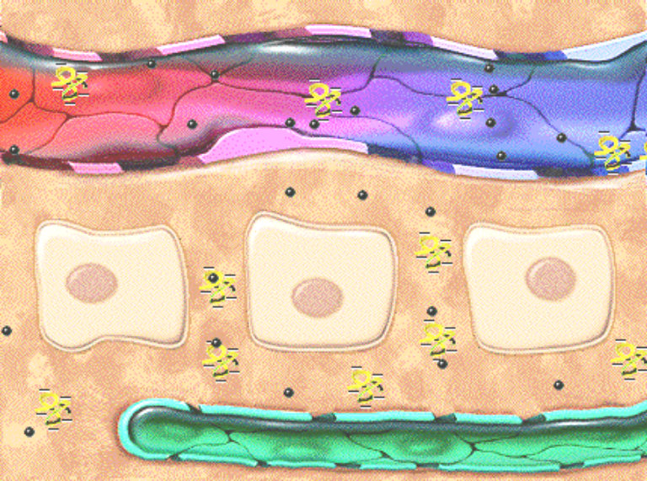

16. Edema: Lymphatic Obstruction
• Obstruction of the lymphatic capillaries, which can occur with surgical removal of lymph nodes, hinders the return of interstitial fluid to the venous capillary.
• The interstitial fluid is trapped in the interstitial compartment. This type of edema is significant because the increased interstitial fluid volume impinges on capillaries and hinders blood flow.
• Explain the defect that occurs when edema occurs due to lymphatic obstruction.  ________________________________  ________________________________  ________________________________  ________________________________  ________________________________ | 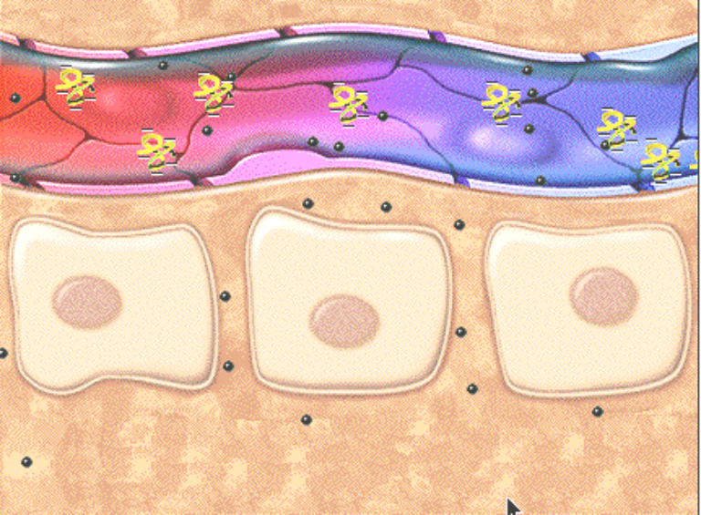

17. Sodium Homeostasis
• The normal concentration range of sodium in the plasma is 136 - 145 milliequivalents per liter, making sodium the ion with the most significant osmotic effect in the extracellular fluid.
• Fill in the blanks below:
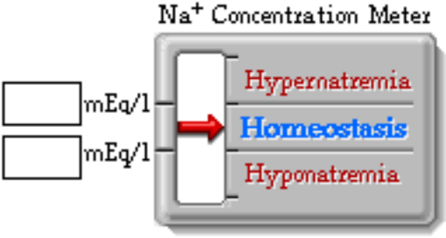

18. Hypernatremia
• Now let’s consider what will happen if the sodium concentration of the blood plasma increases, as in hypernatremia.
• What effect would this increase in sodium concentration have on the cells that are bathed by the interstitial fluid?
___ Cells swell
___ Cells shrink
• The high concentration of sodium in the extracellular fluid exerts osmotic pressure and helps determine the fluid levels in the intracellular space.

19. Hyponatremia
• What effect would this decrease in sodium concentration have on the cells that are bathed by the interstitial fluid?
___ Cells swell
___ Cells shrink
• The water moves into the cell, and the cell expands slightly.

20. Roles of Sodium in the Body
• In addition to playing a pivotal role in nerve impulse conduction and muscle contraction, as the major extracellular positive ion, sodium is the primary regulator of water movement in the body because water follows sodium by osmosis.
• If sodium levels in the plasma change, those changes determine fluid levels in the other compartments.

21. Causes and Symptoms of Hypernatremia
• You have learned that the normal plasma sodium level is 136 to 145 milliequivalents per liter. Hypernatremia occurs when the plasma sodium level is greater than 145 milliequivalents per liter. You have seen what happens to cells when the sodium concentration rises too high.
• Let’s use the marathon runner to see the effect of hypernatremia on the body. The plasma sodium concentration may increase for two reasons:
1. Too much water is lost from the blood without a corresponding loss of sodium.
2. Too much sodium is added to the blood without adding more water.
• Which of these reasons would most likely cause hypernatremia in the marathon runner?
____ Too much sodium added
____ Too much water lost
• Although the runner would lose sodium, he would lose far more water from sweating. Plasma sodium concentration rises resulting in hypernatremia.
• Notice that the runner appears to be confused and disoriented. Symptoms of hypernatremia include non-specific signs of central nervous system dysfunction such as confusion and lethargy, and in severe cases, seizures and death.
• What do you think causes these symptoms?
___ Neurons shrink
___ Neurons swell
• Because the osmolarity of the extracellular fluid is higher than that of the intracellular fluid, water will be drawn out of cells, including neurons, to balance the concentration.
• From your knowledge of water homeostasis, see if you can determine what symptoms the runner will exhibit.
• What will happen to thirst?
___ Thirst increases
___ Thirst decreases
• The high plasma sodium will trigger the thirst mechanism prompting the runner to drink more.
• What will happen to urine output?
___ Increase
___ Decreases
• When plasma osmolarity increases, antidiuretic hormone is released, resulting in reabsorption of water and decreased urine output.
• Remember that water movement is greatly influenced by sodium. Many of the symptoms our runner would experience are also a result of dehydration.

22. Urinary Regulation of Sodium
• One of the functions of the kidney is to fine-tune the concentration of sodium in the plasma.
• Sodium is filtered at the glomerulus. The higher the glomerular filtration rate, the more sodium is filtered out of the plasma.
• Normally 85-90% of that sodium is reabsorbed into the plasma at the proximal convoluted tubule and loop of Henle.

23. Effect of Aldosterone on Sodium
• In the absence of aldosterone, the remaining sodium will remain in the filtrate and end up in the urine.
• In the presence of aldosterone, the remaining sodium will get reabsorbed at the distal convoluted tubule and collecting duct.
• If aldosterone is present, drag the sodium ion to its proper location, urine or plasma.
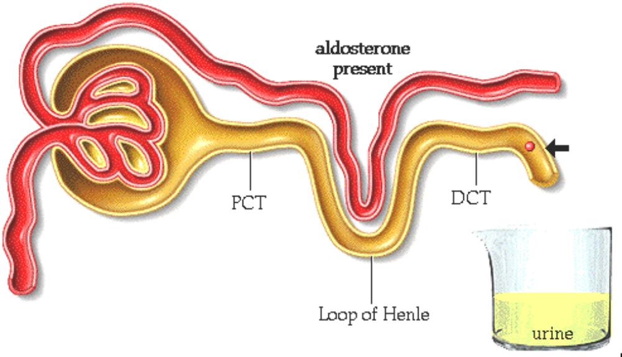
• When aldosterone is present, sodium is reabsorbed into the plasma.
• Note that although sodium can be reabsorbed in the distal convoluted tubule and collecting duct, it is never secreted.
• Would high or low blood pressure cause the secretion of aldosterone?
___ high blood pressure
___ low blood pressure
• When blood pressure is low, renin is secreted, causing the formation of Angiotensin I. Angiotensin I then promotes the formation of Angiotensin II which stimulates the release of aldosterone.

24. Effect of ADH and Aldosterone on Sodium
• Will water follow the sodium reabsorption if ADH is present?
___ yes ___ no
• If ADH is present, water will follow the sodium from the filtrate to the plasma.
• What effect would water reabsorption have on blood pressure?
___ Increases blood pressure ___ Decreases blood pressure
• Blood pressure will increase.
• If aldosterone is not present, drag the sodium ion to its proper location (urine or plasma) on the diagram above.
• More sodium will be found in the urine.

25. Urinary Regulation of Potassium
• Aldosterone also has an effect on potassium. Potassium is filtered at the glomerulus.
• About 90% of potassium is reabsorbed in the PCT and Loop of Henle.
• The kidney handles sodium and potassium differently. While the remaining sodium can be reabsorbed in the late distal convoluted tubule and collecting duct, the remaining potassium is only reabsorbed sometimes. Most often, it is secreted and excreted in the urine.

26. Effect of Aldosterone on Potassium
• If the plasma levels of potassium is high, aldosterone is secreted from the adrenal gland.
• Drag the potassium ion to where it will go in the presence of aldosterone:
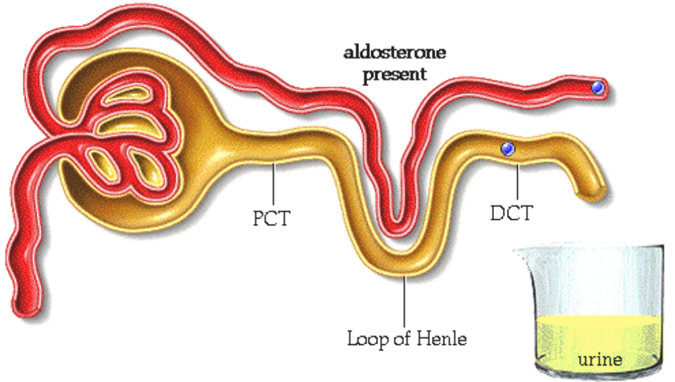
• In the presence of aldosterone, excess extracellular potassium is secreted into the filtrate from the plasma within the distal convoluted tubule and collecting duct and even more potassium ends up in the urine.
• To summarize, aldosterone is secreted from the adrenal gland when angiotensin II is present and/or when potassium levels are high. The effect of aldosterone is to reabsorb sodium into the plasma and secrete potassium into the filtrate within the kidney.

27. Effect of Diuretics
• By promoting urine formation, some diuretics will cause a potassium deficiency.
• The potassium ion that is not reabsorbed in the PCT passes into the urine. Potassium ion deficiency cannot be corrected without ingesting additional potassium ion.
• One reason why a low plasma potassium concentration, or hypokalemia, is clinically significant is because there is no mechanism to compensate for renal losses of potassium.

28. Potassium Homeostasis
• The normal range of sodium in the plasma is 135-145 milliequivalents per liter. Compare this range to the normal range of potassium in the plasma which is 3.5 to 5.1 milliequivalents per liter.
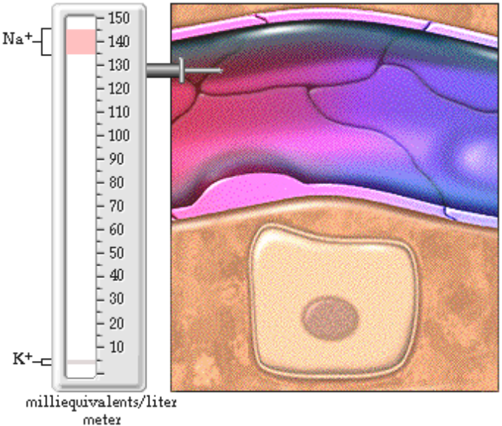

• Because potassium has a much smaller range, the loss of a small amount of potassium can make a significant difference in the body.
• Although most potassium ion is found inside cells, its concentration is measured in the plasma. It ends up in the extracellular fluids in two ways:
1. Like water and sodium, potassium is constantly entering the body in food and leaving the body mostly through the urine.
2. Because the cell membrane is more permeable to potassium than sodium, more potassium leaks out of cells.

29. Roles of Potassium: Osmosis
• Let's look at the roles of potassium in the body.
• As the major intracellular positive ion, potassium is responsible for intracellular fluid volume, through osmosis.
• What would happen if there was a slight increase in potassium ions in the extracellular fluid?
____ Cells would shrink
____ Cells would expand
• Cells will shrink slightly due to osmosis.

30. Roles of Potassium: Membrane Potential
• Because most cells in the body leak potassium but not other ions, potassium will leave the cells though ion channels. Notice that a significant amount of positive charge is leaving the cell.
• What charge will be left inside of the cell?
___ Positive charge
___ Negative charge
• A negative charge is present inside the cell.
• Potassium plays a key role in maintaining resting membrane potential, and therefore a major role in nerve impulse conduction, muscle contraction, and maintenance of normal cardiac rhythm.

31. Roles of Potassium: Acid/Base Balance
• Potassium also plays a role in acid/base balance.
• As hydrogen ions move into and out of the cells in the body, there is a corresponding movement of potassium in the opposite direction by ion transport proteins that link hydrogen ion movement to potassium ion movement. This movement helps maintain electrical balance inside the cells.
• In acidosis, there is an excess of hydrogen ions (which determines the pH) in the extracellular fluids. The hydrogen ions exchange for potassium ions, increasing the extracellular potassium level.  • Indicate the direction that potassium and hydrogen ions go in acidosis:  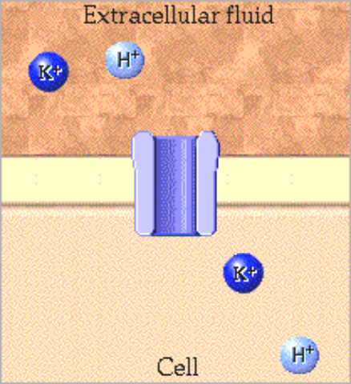 | • In conditions causing alkalosis, there will be a lack of hydrogen ions in the extracellular fluid. Drag the potassium ion in the direction it will go in alkalosis.  • Indicate the direction that potassium and hydrogen ions go in alkalosis:

• Because there is less hydrogen ion in the extracellular fluids in alkalosis, hydrogen ions move into the extracellular compartment in and potassium ions move into the cells. This movement may cause a decrease of potassium ions in the extracellular fluid.
• An increase or decrease of potassium in the extracellular fluid may influence action potentials in excitable membranes.

32. Potassium Exercise
• Hyperkalemia occurs if the plasma potassium level is greater than 5.1 milliequivalents per liter.
• Hypokalemia occurs if the plasma potassium level is less than 3.5 milliequivalents per liter.
• Predict whether or not the following conditions would cause hyperkalemia or hypokalemia.

________________ Excessive intake of potassium, such as overuse of salt substitutes.
Eating too much potassium could lead to hyperkalemia.

________________ Alkalosis
In alkalosis, hydrogen ion comes out of the cells in exchange for potassium ion. The potassium ion in the extracellular fluid decreases, leading to hypokalemia.

________________ Taking diuretics.
Some diuretics can cause too much potassium to leave the body through the urine, resulting in hypokalemia.

________________ Decreased ability of the kidneys to excrete potassium, such as occurs in renal failure.
The failure of the kidneys to excrete potassium may cause hyperkalemia.

________________ A decreased intake of potassium, such as in an unbalanced diet.
Because the body absorbs potassium through food and beverages, a poor diet could cause hypokalemia.

________________ Severe vomiting or diarrhea.
Loss of potassium from the body leads to hypokalemia.

________________ Acidosis.
In acidosis, potassium leaves the cells in exchange for hydrogen ion, resulting in hyperkalemia.
• Because potassium plays a pivotal role in maintaining membrane potential, the effects of both hyperkalemia and hypokalemia are reflected in changes in neuromuscular functioning.
• Mild hyperkalemia may cause:
• intestinal cramping
• diarrhea
• restlessness
• changes in the electrocardiogram
• Severe hyperkalemia may cause:
• muscle weakness progressing to paralysis
• slowed heart conduction
• cardiac arrest
• Hypokalemia causes:
• decreased neuromuscular excitability
• skeletal muscle weakness
• cardiac dysrhythmias
• If hypokalemia continues untreated, the skeletal muscle weakness may progress to respiratory arrest.
• respiratory arrest

33. Calcium Homeostasis
• Calcium homeostasis is crucial to normal body function. Even small changes in calcium ion concentration can be deadly.
• Normally, total calcium level in the plasma varies between 9 and 11 milligrams per 100 milliliters.

• Fill in the normal calcium ion range below:
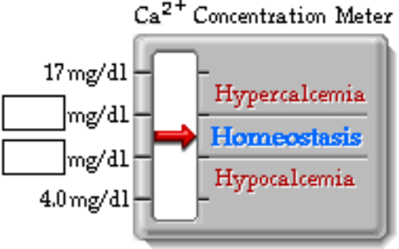

34. Hypercalcemia and Hypocalcemia
• If the level of calcium gets too high, heart dysrhythmias can occur. Other symptoms of hypercalcemia include fatigue, confusion, nausea, coma, cardiac arrest, and calcification of the soft tissues. The heart can stop if the calcium level gets too high.
• If the level of calcium gets too low muscle spasms can occur.
• When the calcium level is very low a person can go into tetanus. If the calcium level goes too low breathing will stop.
• As you can see, it is very important to maintain calcium levels within a specific range.

35. Effects of Calcitonin
• Approximately 99% of the calcium in the body resides in bone as a salt and about 1% is dissolved in the extracellular fluids. Label the diagram below
• When levels of plasma calcium get too high, the thyroid gland may sense the high calcium concentration and may release calcitonin hormone into the blood.
• The target tissue of calcitonin in children and pregnant women is bone.
• Label this diagram:
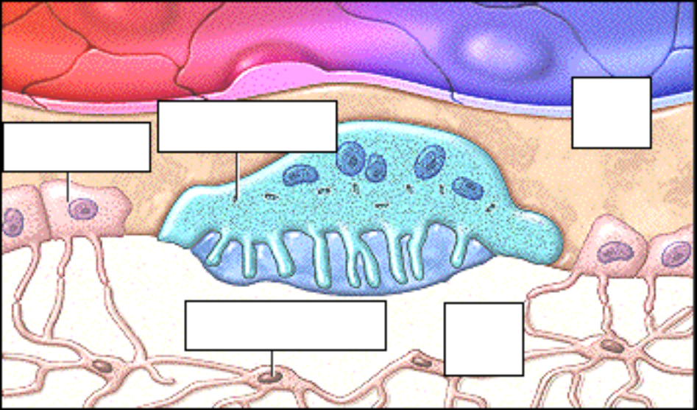
• Calcitonin inhibits the action of osteoclasts, which breakdown bone, and stimulates osteoblasts, which cause bone formation.
• This process accelerates the uptake of calcium and phosphate into bone matrix.
• The osteocytes seen here maintain bone tissue.
• The net effect of calcitonin is a decrease in blood calcium and phosphate concentrations. Calcitonin appears to be a hormone more important in children than adults.

36. Effects of PTH in the Bone
• When levels of plasma calcium get too low, the parathyroid gland senses the low calcium concentration and releases parathyroid hormone.
• One of the target tissues of parathyroid hormone is bone.
• In bone parathyroid hormone increases the number and activity of osteoclasts releasing calcium ion and phosphate into the plasma.
• The other target tissue of parathyroid hormone is the kidney. Click on the parathyroid gland to see what happens there.
• In the kidney, parathyroid hormone increases the uptake of calcium ion and magnesium ion from the filtrate back into the plasma.
• It also inhibits the reabsorption of phosphate by the kidneys and more is excreted in the urine.

37. Effects of Calcitriol
• Parathyroid hormone also promotes the activation of dietary vitamin D into the hormone calcitriol in the kidney. The liver is also involved in the activation of vitamin D.
• Calcitriol will increase the rate of calcium ion, and phosphate absorption from the gastrointestinal tract.
• Click on the arrows that indicate what would happen to calcium ion as a net result of parathyroid hormone secretion:
• Plasma levels of calcium increase to normal.
• When the plasma calcium level returns to normal parathyroid hormone secretion slows, which is the final step in this negative feedback loop.

38. Summary
• To maintain homeostasis, the extracellular fluid must maintain specific concentrations of electrolytes for the cells they bathe to function properly.
• One important function of electrolytes, particularly sodium, is to control fluid movement between the fluid compartments.
• Sodium and potassium balance are maintained by the kidney through the hormone aldosterone.
• Calcium balance is maintained by parathyroid hormone and clacitriol. Calcitonin also plays a role in children and pregnant women.

*Now is a good time to go to quiz questions 1-6:
• Click the Quiz button on the left side of the screen.
• Work through all parts of questions 1-6.

Notes on Quiz Questions:
Quiz Question #1: Fluid Movement Between Compartments
• This question has you predict how substances enter cells and how substances leave the plasma.

Quiz Question #2: Congestive Heart Failure and Hypertension
• This question has you predict what happens with congestive heart failure and hypertension.

Quiz Question #3: Electrolyte Imbalance
• This question has you predict the type of electrolyte imbalance a patient has.

Quiz Question #4: Sodium and Potassium
• This question allows you to answer questions about where sodium and potassium ions go in the presence and absence of aldosterone.

Quiz Question #5: Diuretics
• This question asks you to predict the type of electrolyte imbalance a patient has.

Quiz Question #6: Osteoporosis
• This question asks you to predict the effects of osteoporosis.

Study Questions on Electrolyte Homeostasis:
1. (Page 1.) The fluid surrounding the cells in the body must maintain a _______________________________ for the cells to function properly.

2. (Page 3.) How do electrolytes enter the body?

3. (Page 3.) How do electrolytes leave the body?

4. (Page 4.) Label the diagram on page 4.

5. (Page 5.) Label the diagram on page 5.

6. (Page 5.) How do electrolytes move across the cell membrane?

7. (Page 5-7.) Indicate the direction of ion movement for the:  a. Na+/K+ Ion Pump  b. Na+ Ion Channel  c. K+ Ion Channel | 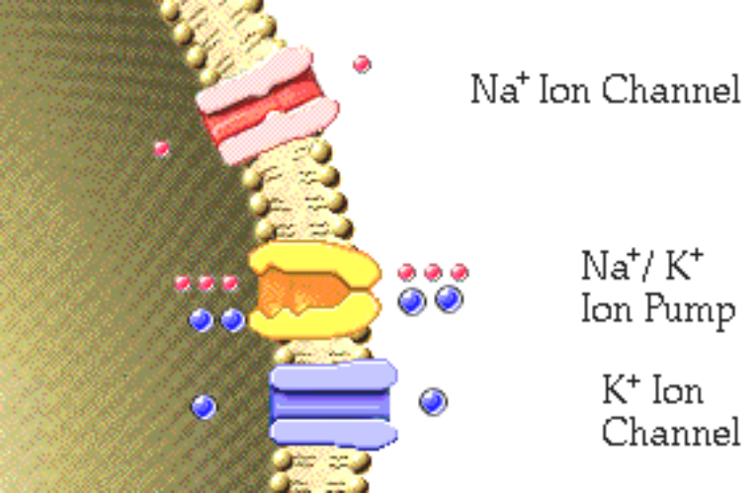

8. (Page 8.) a. When there is a higher concentration of solute in the interstitial fluid, which way will water move? b. When there is a higher concentration of solute inside the cell, which way will water move?

9. (Page 9.) How do ions and other small solutes move freely between the plasma and the interstitial fluid?

10. (Page 9.) Can proteins freely leave the blood capillaries?

11. (Page 9.) What happens to proteins that do escape from the blood capillaries?

12. (Page 9.) What causes the colloid osmotic pressure of the plasma?

13. (Page 10.) a. On the diagram on page 10, which arrow represents the fluid movement that results from the colloid osmotic pressure? b. On the diagram on page 10, which arrow represents the fluid movement that results from the hydrostatic pressure?

14. (Page 11.) What is bulk flow?

15. (Page 11.) Will happen if the sodium concentration of the plasma increases?

16. (Page 12.) What is edema?

17. (Page 12.) List four causes of edema?

18. (Page 13.) Explain how edema can occur due to decreased colloid osmotic pressure.

19. (Page 14.) Explain how edema can occur due to increased hydrostatic pressure.

20. (Page 15.) Explain how edema can occur due to increased capillary permeability.

21. (Page 16.) Explain how edema can occur due to lymphatic obstruction.

22. (Page 17.) Which is the normal concentration range for sodium in the plasma?
a. 9 and 11 milligrams per 100 milliliters
b. 136 - 145 milliequivalents per liter
c. 3.5 to 5.1 milliequivalents per liter

23. (Page 18.) What will happen if the sodium concentration of the blood plasma increases. What effect would this increase in sodium concentration have on the cells that are bathed by the interstitial fluid? Would the cells shrink or swell?

24. (Page 19.) What will happen if the sodium concentration of the blood plasma decreases. What effect would this increase in sodium concentration have on the cells that are bathed by the interstitial fluid? Would the cells shrink or swell?

25. (Page 21.) Which of these reasons would most likely cause hypernatremia in the marathon runner?
a. Too much sodium added b. Too much water lost

26. (Page 21.) Why would a person with hypernatremia be confused and disoriented?

27. (Page 21.) What will happen to thirst in hypernatremia?

28. (Page 22.) What percentage of sodium is reabsorbed into the plasma at the proximal convoluted tubule and loop of Henle?

29. (Page 23.) What will happen to urine output in hypernatremia?

30. (Page 23.) In the absence of aldosterone, will the remaining sodium will remain in the filtrate or end up in the urine?

31. (Page 23.) In the presence of aldosterone, will the remaining sodium will remain in the filtrate or end up in the urine?

32. (Page 23.) Would high or low blood pressure cause the secretion of aldosterone?

33. (Page 24.) What effect would water reabsorption have on blood pressure?

34. (Page 25.) What percentage of potassium is reabsorbed in the PCT and Loop of Henle?

35. (Page 25.) What is the major way difference between how sodium and potassium is handled in the late distal convoluted tubule and collecting duct?

36. (Page 26.) In the absence of aldosterone, will the remaining potassium will remain get secreted or remain in the plasma?

37. (Page 26.) In the presence of aldosterone, will the remaining sodium will remain in the filtrate or end up in the urine.

38. (Page 27.) Why do some types of diuretics cause a potassium deficiency?

39. (Page 28.) Which is the normal concentration range for potassium in the plasma?
a. 9 and 11 milligrams per 100 milliliters
b. 136 - 145 milliequivalents per liter
c. 3.5 to 5.1 milliequivalents per liter
40. (Page 28.) List two ways that potassium enters the extracellular fluids.

41. (Page 29.) What would happen if there was a slight increase in potassium ions in the extracellular fluid? Would cells shrink or expand?

42. (Page 30.) Because most cells in the body leak potassium but not other ions, potassium will leave the cells though ion channels. What charge will be left inside of the cell?

43. (Page 31.) Indicate the direction that potassium and hydrogen ions go in:
a. acidosis
b. alkalosis

44. (Page 32.) Predict whether or not the following conditions would cause hyperkalemia or hypokalemia.
a. Excessive intake of potassium, such as overuse of salt substitutes.
b. Alkalosis
c. Taking diuretics.
d. Decreased ability of the kidneys to excrete potassium, such as occurs in renal failure.
e. A decreased intake of potassium, such as in an unbalanced diet.
f. Severe vomiting or diarrhea.
g. Acidosis.

45. (Page 33.) Which is the normal concentration range for calcium in the plasma?
a. 9 and 11 milligrams per 100 milliliters
b. 136 - 145 milliequivalents per liter
c. 3.5 to 5.1 milliequivalents per liter

46. (Page 34.) What happens if plasma calcium levels get too high?

47. (Page 34.) What happens if plasma calcium levels get too low?

48. (Page 35.) What percentage of calcium in the body resides in bone as a salt and what percentage of calcium is dissolved in the extracellular fluids?

49. (Page 35.)When levels of plasma calcium get too high, the ___________ may sense the high calcium concentration and may release __________ hormone into the blood.

50. (Page 35.) Label the diagram on page 35.

51. (Page 35.) What are the function of osteocytes, osteoclasts, and osteoblasts?

52. (Page 35.) What is the function of calcitonin?

53. (Page 36.)When levels of plasma calcium get too low, the ___________ may sense the low calcium concentration and may release __________ hormone into the blood.

54. (Page 36.) What is the function of parathyroid hormone?

55. (Page 37.) What hormone activates vitamin D to calcitriol in the kidney?

56. (Page 37.) What is the function of calcitriol?

