Acid/Base Homeostasis (Part 4)
Graphics are used with permission of:
Pearson Education Inc., publishing as Benjamin Cummings (http://www.aw-bc.com)

5. The newly formed bicarbonate moves into the plasma.  • Chloride ion moves into the cell at the same time to maintain electrical neutrality.  • What effect does the increase in bicarbonate in the blood have on the pH of the plasma?  __ pH increases  __ pH decreases  • By adding newly generated bicarbonate to the plasma, hydrogen ion is used up and the pH increases.  • Show this process on the diagram to the right: | 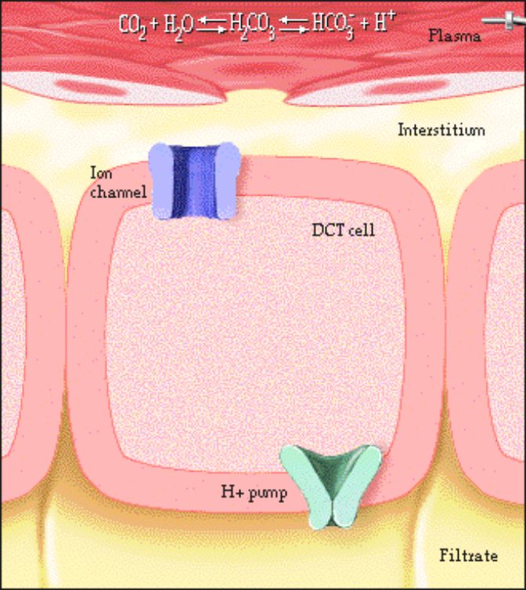
Here are our results:
• Newly generated bicarbonate is added to the plasma, increasing the pH of blood and adding new buffering power to the plasma.
• Hydrogen ion is secreted into the filtrate, attaches to buffers, and is eliminated from the body.

36. Glutamine Metabolism
1. A second and more important process for generating bicarbonate and secreting hydrogen ion occurs within the cells of the proximal convoluted tubule.  • Glutamine is an amino acid that is metabolized in the tubule cells of the kidney. The products of its metabolism are ammonia and bicarbonate.  • The ammonia, which is a base combines with a hydrogen ion inside the cell to form ammonium.  • Label this diagram and show this process on the diagram to the right: | 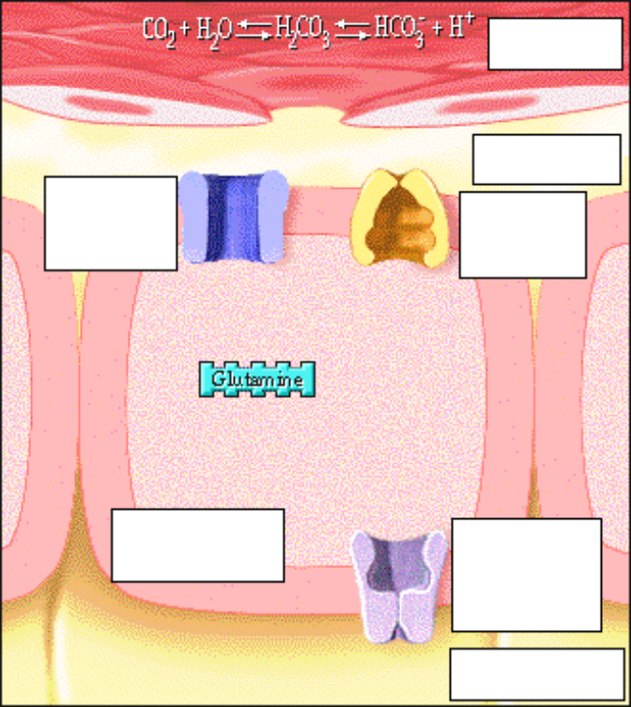

2. The ammonium then travels from the kidney tubule cell to the filtrate in exchange for sodium via an antiport transport protein, or countertransport, which is a type of secondary active transport.  • The sodium ion concentration is kept low inside the cells by the sodium/potassium pump.  • This ammonium is eliminated in the urine. This ion is unable to diffuse back into the cell, therefore trapping the H+ in the filtrate for excretion.  • Show this process on the diagram to the right: | 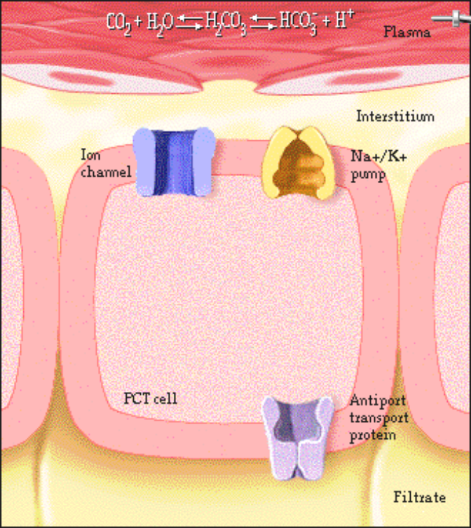

3. The bicarbonate leaves the kidney tubule cell together with sodium and goes into the plasma.

• Show this process on the diagram to the right:

• Result:
1. Newly generated bicarbonate is added to the blood, increasing the pH of plasma and adding new buffering power to the plasma.

2. Hydrogen ion is eliminated from the body in the form of ammonium.

37. Summary: Renal Control of Acidosis
• Summary: Three mechanisms for renal control of acidosis:
1. Conserving (reabsorption) of HCO3-.
2. Generating HCO3- by the kidney tubule cells increases the pH of the plasma and adds new buffering power to the plasma.
3. Secreting buffered H+ into the urine eliminates H+ from the body and increases the pH of the plasma.

• Illustrate the three mechanisms for renal control of acidosis on this diagram:
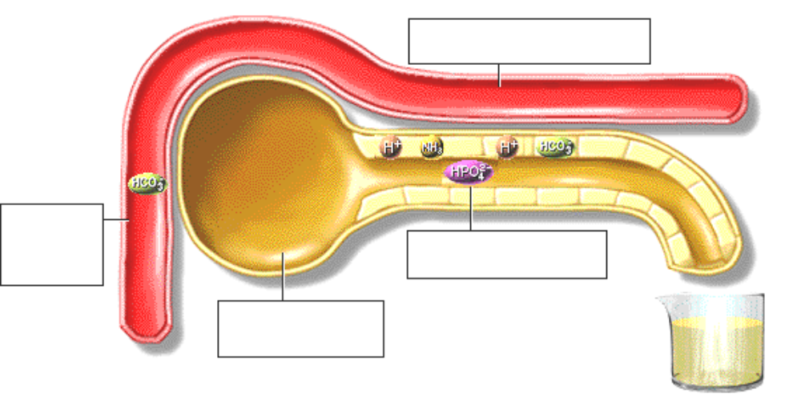

*Now is a good time to go to quiz question 4:
• Click the Quiz button on the left side of the screen.
• Work through all parts of question 4.
• After answering question 4, click on the Back to Topic button on the left side of the screen.
• To get back to where you left off, click on scrolling page list at the top of the screen.
• Choose "38. Mechanisms the Body Uses to Maintain pH."

38. Mechanisms the Body Uses to Maintain pH
Let's review the mechanisms the body uses to maintain pH.
1. Chemical Buffers
• Chemical buffers act within seconds to correct abnormalities in pH within the body fluids.
2. Respiratory Control
• The respiratory control mechanism is slower than the buffers mechanism and may take minutes to begin.
• This mechanism is important in compensating for metabolic acidosis or alkalosis.
• Via the respiratory mechanism, the volatile acid, carbonic acid is eliminated from the body as carbon dioxide.
3. Renal Mechanisms
• Renal mechanisms are the slowest mechanisms may take hours or days to complete.
• Renal mechanisms are important in compensating for respiratory acidosis or alkalosis.
• These mechanisms are important in the elimination of fixed acids from the body.

39. Effect of Plasma Proteins on pH
• The normal arterial plasma pH is between 7.35 and 7.45.
• Remember, most proteins in the plasma have an optimum pH of 7.4.
• Which of these conditions is associated with a pH greater than 7.45?
___ Acidosis
___ Alkalosis
• Alkalosis occurs when the pH of the blood rises above 7.45. There are two major types of alkalosis:
• Metabolic alkalosis
• Respiratory alkalosis
• Acidosis occurs when the pH of the plasma falls below 7.35. There are two major types of acidosis:
• Metabolic acidosis
• Respiratory acidosis

40. Compensation for Acidosis and Alkalosis
The body compensates for acidosis and alkalosis with three major mechanisms:
• Chemical buffers
• Respiratory system
• Urinary System
• Chemical buffers work quickly and immediately, but they have a limited capacity. When the buffer systems become overwhelmed, as in acidosis or alkalosis, the respiratory and urinary systems compensate.
• Note that compensatory mechanisms help return the pH to normal or near normal levels, but do not correct the underlying problem.
• When metabolic acidosis or alkalosis occurs, the respiratory system will compensate by changing the rate of respiration.
• When respiratory acidosis or alkalosis occurs, the problem lies within the respiratory system. Because the respiratory system is not able to correct the condition, the urinary system compensates for the problem.
• On the next four pages we will examine the four major acid/base disturbances and the compensatory mechanisms that help to restore pH to normal levels.

41. Causes of Metabolic Acidosis
• Metabolic acidosis occurs when there is an excess of any body acid, except carbonic acid.
• Metabolic acidosis occurs if there is too much acid production in the body, or if there is loss of base.
• An excess of metabolic acids can occur as a result of many conditions including ketoacidosis from total absence of insulin in the body, or starvation, lack of oxygen in the tissues which causes the production of lactic acid, and some types of kidney disease, which prevent elimination of acid from the body.
• Fill out this chart:
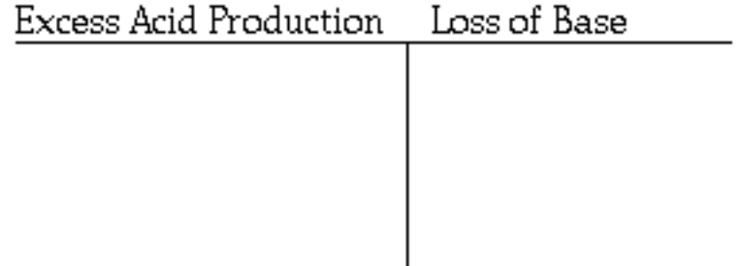
• Excess acid can also appear in the extracellular fluids due to a high potassium ion concentration in the extracellular fluid. As the excess potassium moves into the cells, hydrogen ion comes out.
• Loss of base can occur as a result of excessive diarrhea, which causes the loss of bicarbonate that is plentiful in interstitial fluid.
• Let's look at a specific example of metabolic acidosis, diabetic ketoacidosis.

42. Symptoms of Diabetic Ketoacidosis
• Jennifer Smith, age 14, has been brought to the emergency room. Her parents were unable to awaken her for school this morning.
• Mr. and Mrs. Smith report to the ER physician that Jennifer has been eating a lot but still losing weight for the past month. She has also been thirsty, drinking large amounts of water, and going to the bathroom frequently.
• The physician notices that Jennifer is difficult to awaken, her skin is warm, dry, and flushed, and she is breathing deeply and rapidly.
• You've seen the effect that altered pH has on proteins in the body. The systemic effects of ketoacidosis can be dramatic.
• The individual with ketoacidosis may experience central nervous system depression, heart dysrhythmias, and decreased cardiac contractility as a result of increased intracellular acidity.
• In Jennifer's case she is also experiencing the effects of dehydration from increased blood glucose and increased osmolarity.
• When the blood pH reaches approximately 6.9 brain stem dysfunction occurs, closely followed by death.
• Fortunately Jennifer is in a health care facility where she will be treated.
• After some laboratory tests the physician determines that Jennifer has developed Type I diabetes. As sometimes happens, ketoacidosis is the first indication of the presence of Type I diabetes.
• Let's look more closely at what is happening with Jennifer.

43. Role of Insulin
• In normal cell metabolism, the hormone insulin is released from beta cells in the pancreas when a person eats and allows glucose transport across the cell membrane of some cells.  • When insulin is absent, as in Type I diabetes for example, fat breakdown occurs and production of keto acids by the liver increases until the body's buffer systems become overwhelmed and ketoacidosis ensues.  • Illustrate the role of insulin on the diagram to the right:  • Would you expect Jennifer's blood pH to be high or low?  • Because Jennifer has developed ketoacidosis, her pH will fall. | 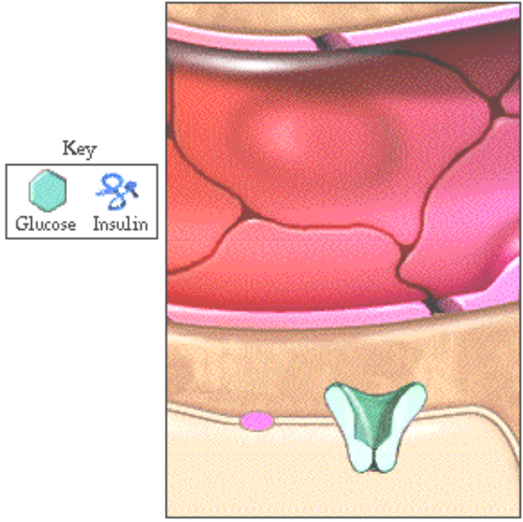

44. Compensation for Metabolic Acidosis
Compensation for Metabolic Acidosis
• Once an individual has metabolic acidosis, the carbonic acid/bicarbonate buffer system will come into action. Which direction will the equilibrium reaction go ?
CO2 + H2O  H2CO3 HCO3- + H+
Carbon dioxide Water Carbonic acid Bicarbonate Hydrogen ion
___ Equilibrium shifts to the right
___ Equilibrium shifts to the left
• Because more H+ is being generated in the body, the excess H+ will combine with HCO3- to form CO2.
• As a result of metabolic acidosis, will the level of HCO3-1 increase or decrease?
___ HCO3- increases
___ HCO3- decreases
• Because there is an excess amount of H+, the H+ will react with HCO3-1 as a result of metabolic acidosis, and the HCO3- will decrease.
• Which body system will respond to compensate for this acid/base imbalance? Click the correct answer.
Urinary system
Respiratory system
• The respiratory system will compensate in an effort to bring the pH back toward normal.
• Predict how the Jennifer will compensate for metabolic acidosis.
Breathe faster
Breathe slower
• Because of the increased CO2, the respiratory centers in the brain and large arteries are stimulated. The patient will begin to breathe faster and deeper. This response is called hyperventilation.
• Hyperventilation allows the body to reduce the overall amount of acid by exhaling H2CO3 in the form of CO2 and H2O.
• Although the respiratory system is the primary compensatory mechanism for metabolic acidosis, the kidneys are not idle.
• The kidneys will respond to the decreased pH by excreting more H+. This response may take several days to occur.

• Respiratory compensation is much faster.
• The body's compensatory mechanisms serve to return the pH to normal or near normal levels, but they do not correct the underlying problem.
• In the case of diabetic ketoacidosis, insulin must be administered to restore normal cell metabolism .

45. Causes of Metabolic Alkalosis
Causes of Metabolic Alkalosis
• Metabolic alkalosis is caused by a relative deficit of any acid in the body, except carbonic acid.
• Metabolic alkalosis can occur from an excess of base in the body. Ingestion of too much bicarbonate, or baking soda, would produce an excess of base.
• Metabolic alkalosis can also occur as a result of too little acid in the body . Vomiting of stomach contents containing hydrochloric acid would deplete the acid in the body.
• Metabolic alkalosis can occur when there is too little potassium in extracellular fluid. Hypokalemia causes potassium to come out of cells in exchange for hydrogen ion.
• List the causes of metabolic alkalosis here:
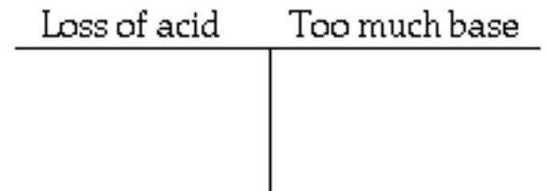

46. Stomach Flu
• Let's look at an example to see how alkalosis occurs.
• Jose Fuentes has caught the stomach flu that's been going around the office, and is vomiting.
• As a result of vomiting, Jose is losing a lot of stomach acid. What would you expect to happen to his blood pH ?
• His pH will rise indicating he is becoming alkalotic from loss of hydrogen ion.
• As alkalosis progresses, Jose will experience the effects of rising pH on interstitial fluid.
• Initially nerve cell membranes become irritable and muscle spasm and convulsions may occur.
• With severe alkalosis, central nervous system depression occurs, and confusion, lethargy, and coma ensue.
• Death occurs when the blood pH reaches about 7.8.
• Fortunately, Jose has a 24 hour flu. Let's see how his body compensates to keep his pH from getting too high.

47. Compensation for Metabolic Alkalosis
Compensation for Metabolic Alkalosis
• Once an individual has metabolic alkalosis, the carbonic acid/bicarbonate buffer system will come into action. Now which direction will the equilibrium reaction go ?
CO2 + H2O  H2CO3 HCO3- + H+
Carbon dioxide Water Carbonic acid Bicarbonate Hydrogen ion
___ Equilibrium shifts to the right
___ Equilibrium shifts to the left
• Because there is less H+ in the body, the reaction will shift to the right and more H+ and HCO3-will form.
• Predict how Jose's body will compensate for metabolic alkalosis.
Hypoventilate
Hyperventilate
• As the equation shifts to the right, CO2 decreases. The respiratory centers in the brain are inhibited and Jose hypoventilates.
• Jose has lost chloride and fluid volume as well as acid. These combined losses prevent the kidneys from excreting excess base.
• As with the other acid/base disturbances, compensatory mechanisms help keep the pH in a range appropriate for body function but they do not correct the underlying problem. Within 24 hours, Jose will be feeling a lot better.

48. Causes of Respiratory Acidosis
Causes of Respiratory Acidosis
• Respiratory acidosis occurs when there is an excess of carbon dioxide, and therefore an increase in carbonic acid in the body.
• Because carbonic acid is excreted by the lungs in the form of carbon dioxide and water, any condition that impairs the elimination of CO2 may result in respiratory acidosis.
• Causes of respiratory acidosis include conditions that impair exchange of gases in the lungs, activity of the diaphragm muscle, or respiratory control in the brain stem.

49. Emphysema
• Patrick O'Shea has smoked cigarettes for 45 years and has emphysema.
• In emphysema, alveolar walls disintegrate over time, producing large air spaces that remain filled with gases during expiration. This condition reduces the surface area in the lung available for exchange of oxygen and carbon dioxide.
• As a result of this destructive process, carbon dioxide becomes trapped in the alveoli and blood levels of carbon dioxide rise.

50. Symptoms of Respiratory Acidosis
Symptoms of Respiratory Acidosis
Headache
Cardiac dysrhythmias
Blurred vision
Dizziness
Disorientation
Lethargy
• The neurologic symptoms of respiratory acidosis are sometimes more severe than those of metabolic acidosis because carbon dioxide crosses the blood-brain barrier more readily than many metabolic acids.
• Because emphysema is a long term process the cumulative effects of respiratory acidosis may not be seen for many years.
• If Patrick were to develop an acute episode of pneumonia, further reducing the lung's ability to exchanges gases, symptoms would become evident more rapidly.
• As a result of respiratory acidosis from emphysema, which direction will this equation go?
• As a result of emphysema, which direction will this equation go?
CO2 + H2O H2CO3 HCO3- + H+
Carbon dioxide Water Carbonic acid Bicarbonate Hydrogen ion
___ Equilibrium shifts to the right
___ Equilibrium shifts to the left
• The build-up of carbon dioxide in the blood causes the equilibrium to shift to the right.
• What happens to acid levels in the blood ?
___ Acid levels rise
___ Acid levels fall
• Acid levels rise.

51. Compensation for Respiratory Acidosis
Compensation for Respiratory Acidosis
• Now predict how the body compensates for respiratory acidosis. Click all that apply.
___ Hypoventilation
___ Hyperventilation
___ Kidneys retain bicarbonate
___ Kidneys excrete bicarbonate
___ Kidneys excrete H+
• The kidneys will reabsorb and generate bicarbonate to maintain acid/base balance. The kidneys will also excrete excess hydrogen ion in the urine.

• Patrick may survive for many years without obvious symptoms of respiratory acidosis, however because he has smoked for so many years, other respiratory conditions such as pneumonia may cause serious problems for him.

52. Causes of Respiratory Alkalosis
Causes of Respiratory Alkalosis
• Respiratory alkalosis is a deficit of carbon dioxide and occurs as a result of hyperventilation.
• When respirations are excessively deep and rapid, carbonic acid is excreted rapidly from the lungs in the form of carbon dioxide and water. The result is a deficit of both carbon dioxide and carbonic acid.
• What causes an individual to hyperventilate to the point of carbonic acid deficit? Low levels of oxygen in the blood, may cause hyperventilation. Stimulation of the brain stem in the case of meningitis may cause hyperventilation. Head injury may also cause hyperventilation.
• For Sally, however, hyperventilation appears to be caused by severe anxiety over a visit to the dentist. Let's see how this works.

53. Symptoms of Respiratory Alkalosis
Symptoms of Respiratory Alkalosis
• Sally is nervous about her visit to the dentist and begins to breathe much more rapidly than usual.
• The symptoms of respiratory alkalosis reflect the irritation to the central and peripheral nervous system that occurs when pH rises too high. The individual may exhibit numbness and tingling in the fingers and around the mouth, dizziness, and confusion.
• As a result of hyperventilation, which direction will this equation go?
CO2 + H2O  H2CO3 HCO3- + H+
Carbon dioxide Water Carbonic acid Bicarbonate Hydrogen ion
___ Equilibrium shifts to the right
___ Equilibrium shifts to the left
• With each exhalation, more carbonic acid is eliminated from the lungs as CO2. The reaction proceeds to the left.
• What will happen to the concentration of H+ in the blood?
___H+ increases
___ H+ decreases
• H+ will decrease because the H+ is combining with HCO3- to form more CO2.

54. Compensation for Respiratory Alkalosis
Compensation for Respiratory Alkalosis
• How will Sally's body compensate for respiratory alkalosis. Click the correct answer.
Retain bicarbonate
Excrete bicarbonate
__ Hyperventilate
__ Hypoventilate
• Because this is an acid/base disturbance of respiratory origin, the kidneys will excrete bicarbonate, the base, to compensate for the loss of acid.
• In reality renal compensation occurs relatively slowly.
• Because the underlying cause of Sally's alkalosis is short lived, renal compensation may not in fact occur.
• Sally will probably return to acid/base homeostasis as soon as her visit to the dentist is over and her respiratory rate returns to normal.

55. Metabolic Acidosis Review
You have just been introduced to the four major acid/base disturbances and their corresponding compensatory mechanisms. Let's review this information.

Continue to Acid/Base Homeostasis – Part V
(Separate Document)

