Acid/Base Homeostasis (Part 5)
Graphics are used with permission of:
Pearson Education Inc., publishing as Benjamin Cummings (http://www.aw-bc.com)

Metabolic Acidosis
• What is the cause of metabolic acidosis? Click all that apply.
___ Excess H+ generated within the body
___ Loss of base from the body
___ Deficit of H+ within the body
___ Gain of base in the body
• Metabolic acidosis can be caused by either a gain of acid or a loss of base from the body.
• Which of the following would be observed in simple, uncompensated metabolic acidosis?
___ CO2 rises
___ CO2 falls
___ HCO3- rises
___ HCO3- falls
• HCO3- levels fall due to loss of HCO3- from the body or increased acid reacting with HCO3-.
• What system will compensate for respiratory acidosis?
___ Respiratory system
___ Renal system
• Because the problem is metabolic in origin, the respiratory system compensates.
• Will this individual hyperventilate or hypoventilate?
___ Hyperventilate
___ Hypoventilate
• The individual hyperventilates to blow off the excess carbon dioxide which is generated.
• As a result of compensation, which direction will this reaction go?
CO2 + H2O  H2CO3 HCO3- + H+
Carbon dioxide Water Carbonic acid Bicarbonate Hydrogen ion
• The increased hydrogen ion stimulates the respiratory centers, increasing ventilation, decreasing carbon dioxide, and shifting the reaction to the left.
• Fill out this chart as you go through the next few pages:
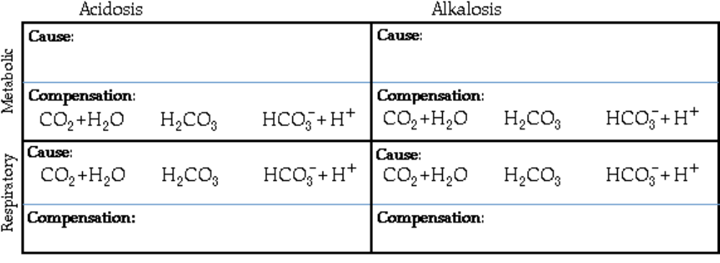
56. Metabolic Alkalosis Review
Metabolic Alkalosis
• What is the cause of metabolic alkalosis? Click all that apply.
___ Excess H+ generated within the body
___ Loss of base from the body
___ Deficit of H+ within the body
___ Gain of base in the body
• Metabolic alkalosis can be caused by either a loss of acid or a gain of base in the body
• Which of the following would be observed in simple, uncompensated metabolic alkalosis?
___ CO2 rises
___ CO2 falls
___ HCO3- rises
___ HCO3- falls
• HCO3- levels rise due to gain of HCO3- or decreased acid reacting with HCO3-.
• What system will compensate for metabolic alkalosis?
___ Respiratory system
___ Renal system
• Because the problem is metabolic in origin, the respiratory system compensates.
• Will this individual hyperventilate or hypoventilate?
___ Hyperventilate
___ Hypoventilate
• The individual hypoventilates to conserve CO2.
• As a result of compensation, which direction will this reaction go?
CO2 + H2O H2CO3 HCO3- + H+
Carbon dioxide Water Carbonic acid Bicarbonate Hydrogen ion
• The decreased H+ causes the equilibrium reaction of this reaction to shift to the right.
• Notice that the equilibrium reaction illustrates how the respiratory system compensates for metabolic acidosis and alkalosis. The respiratory system is not the cause of the condition.

57. Respiratory Acidosis Review
Respiratory Acidosis
• What is the cause of respiratory acidosis?
___ Excess H+ generated in the body
___ Loss of base from the body
___ Deficit of H+ from the body
___ Gain of base from the body
___ Increased H2CO3
___ Decreased H2CO3
• Respiratory acidosis occurs because CO2 is not eliminated from the body.
• As a result of respiratory acidosis, which direction will this reaction go?
CO2 + H2O H2CO3 HCO3- + H+
Carbon dioxide Water Carbonic acid Bicarbonate Hydrogen ion
• Yes, the increased CO2 in the blood will cause the reaction to shift to the right.
• Which of the following would be observed in simple, uncompensated respiratory acidosis?
___ CO2 rises
___ CO2 falls
___ HCO3- rises
___ HCO3- falls
• CO2 rises because the individual is unable to blow off this gas.
• What system will compensate for respiratory acidosis?
___ Respiratory system
___ Renal system
• Over time, the renal system will compensate by generating or reabsorbing HCO3, or excreting H+, but it may take hours or days for complete compensation to occur.

• Fill out this chart with the virtual professor:


58. Respiratory Alkalosis Review
Respiratory Alkalosis
• What is the cause of respiratory alkalosis? Click all that apply.
___ Excess H+ generated in the body
___ Loss of H+ from the body
___ Loss of CO2 from the body
___ Buildup of CO2 in the body
• Respiratory alkalosis occurs when too much carbon dioxide is eliminated from the body because of hyperventilation.
• As a result of respiratory alkalosis, which direction will this reaction go?
CO2 + H2O H2CO3 HCO3- + H+
Carbon dioxide Water Carbonic acid Bicarbonate Hydrogen ion
• The equilibrium reaction shifts to the left as acid is used up.
• As carbon dioxide is blown off, which direction will the reaction go?
• Which of the following would be observed in simple, uncompensated respiratory alkalosis
___ CO2 rises
___ CO2 falls
___ HCO3- rises
___ HCO3- falls
• Yes, CO2 falls due to hyperventilation.
• What system will compensate for respiratory alkalosis?
___ Respiratory system
___ Renal system
• Over time, the renal system will compensate by excreting excess base.

59. Summary
Here's a summary of what we've covered:
• Chemical buffers quickly adjust small changes in pH
• By altering the rate of respiration, the respiratory system can eliminate carbonic acid, a volatile acid, in the form of carbon dioxide.
• By retaining, generating, or eliminating bicarbonate, or secreting hydrogen ion, the urinary system can regulate the pH of body fluids.
• Respiratory acidosis, respiratory alkalosis, metabolic acidosis, and metabolic alkalosis are the four most common disturbances of acid/base balance.
• Compensation for respiratory acidosis and respiratory alkalosis involve renal mechanisms. Compensation for metabolic acidosis and metabolic alkalosis involve respiratory mechanisms.

*Now is a good time to go to quiz questions 5-6:
• Click the Quiz button on the left side of the screen.
• Work through all parts of questions 5-6.

Notes on Quiz Questions:
Quiz Question #1: Weak and Strong Acids and Bases
• This question has you predict if acids or bases are strong or weak.

Quiz Question #2: Buffers
• This question has you predict what happens when acid is added to water vs. adding acid to a buffer.

Quiz Question #3: Respiratory Control
• This question has you predict what happens during hypoventilation and hyperventilation.

Quiz Question #4: Renal Control
• This question asks you to predct what will happen in the kideny during acidosis.

Quiz Question #5: Reabsorption of Bicarbonate
• This question asks you to list the steps in the reabsorption of bicarbonate.

Quiz Question #6: Acid/Base Game
• This question asks you to predict the type of acid/base disturbance.

Quiz Question #7: Name that Acid/Base Disturbance
• This question asks you to predict the type of acid/base disturbance.

Study Questions on Acid/Base Homeostasis:
1. (Page 1.) What three systems work together to ensure that the pH of body fluids remain within a specific narrow limit?

2. (Page 3.) How do we measure the acidity or basicity of a solution?

3. (Page 3.) What does pH measure?
4. (Page 3.) Where do acids and bases in our bodies come from?

5. (Page 4.) Which pH is the most acidic, pH 4 or 8?

6. (Page 4.) The lower the pH, the more ______ the solution is. The higher the pH, the more ______ the solution is.

7. (Page 4.) When H+ increases, acidity ________, and pH _________.

8. (Page 4.) When H+ decreases, acidity ________, and pH _________.

9. (Page 4.) When we increase or decrease the pH by one pH unit, we are changing the concentration of H+ by a factor of ___.

10 (Page 4.) Label the diagram on page 4.

11. (Page 5.) Label the diagram on page 5 with the pH's.

12. (Page 5.) Which of the compartments in the diagram on page 5 is the most acidic?

13. (Page 6.) Label the diagram on page 6 with the pH's.

14. (Page 7.) Define acid.

15. (Page 7.) What is a strong acid?

16. (Page 7.) Write an equation for what happens when the strong acid, HCl dissolves in water.

17. (Page 8.) What's the difference between a strong and a weak acid?

18. (Page 8.) Give the equation for what happens when carbonic acid is dissolved in water.

19. (Page 9.) Do all weak acids have the same acidity?

20. (Page 10.) Define base.

21. (Page 10.) What is another name for a basic solution?

22. (Page 10.) Give an equation that shows what happens when bicarbonate is dissolved in water.

23. (Page 10.) Label the diagram on page 10 with the pH's.

24. (Page 11.) What pH is neutral?

25. (Page 11.) Indicate the pH's on the appropriate beakers on the diagram on p. 11.

26. (Page 12.) Consider the electrolyte chart on p. 12.
a. Which electrolytes can serve as weak bases?
b. Which electrolytes can serve as weak acids?

27. (Page 13.) Why is maintaining the pH of body fluids is very important?

28. (Page 14.) What happens when acid is added to a globular protein?

29. (Page 15.) What happens when base is added to a globular protein?

30. (Page 16.) What are the three mechanisms the body uses to maintain a normal pH range?

31. (Page 16.) What happens when acid is added to an unbuffered solution, such as water?

32. (Page 16.) What are buffers composed of?

33. (Page 16.) What is the purpose of a buffer?

34. (Page 16.) What are the three important buffer systems in the body?

35. (Page 17.) Consider the carbonic acid/bicarbonate buffer system. Which is the weak acid and which is the weak base? H2CO3, HCO3-

36. (Page 17.) When acid is added to the carbonic acid/bicarbonate buffer system, what happens.

37. (Page 17.) When base is added to the carbonic acid/bicarbonate buffer system, what happens.

38. (Page 18.) Consider the dihydrogen phosphate/hydrogen phosphate buffer system. Which is the weak acid and which is the weak base? H2PO4-, HPO4=

39. (Page 18.) When acid is added to the dihydrogen phosphate/hydrogen phosphate buffer system, what happens.

40. (Page 18.) When base is added to the dihydrogen phosphate/hydrogen phosphate buffer system, what happens.
41. (Page 19.) Label the side chains in this protein. | 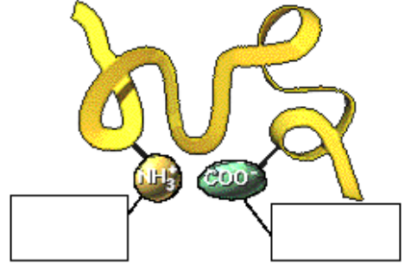

42. (Page 19.) What happens to the COO- group when acid is added? | 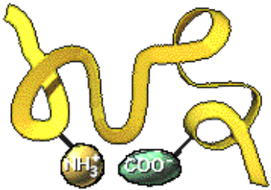
43. (Page 19.) What happens to the NH3+ group when acid is added?

44. (Page 20.) Explain dynamic equilibrium in terms of the carbonic acid/bicarbonate buffer system.

45. (Page 21.) When the body is not in homeostasis and there is too much carbonic acid in the body fluids, which way will the reaction go, to the left or to the right?
H2CO3 H+ + HCO3-
Carbonic acid Hydrogen ion Bicarbonate

46. (Page 22.) When the body is not in homeostasis and there is too much hydrogen ion in the body fluids, which way will the reaction go, to the left or to the right?
H2CO3 H+ + HCO3-
Carbonic acid Hydrogen ion Bicarbonate

47. (Page 23.) When the body is not in homeostasis and there is not enough hydrogen ion in the body fluids, which way will the reaction go, to the left or to the right?
H2CO3 H+ + HCO3-
Carbonic acid Hydrogen ion Bicarbonate

48. (Page 24.)What is the equation for cell metabolism that occurs within the cells of the body?

49. (Page 24.)What happens to the carbon dioxide generated by this equation?

50. (Page 24.) When we breathe more deeply and quickly, what happens to the carbon dioxide leaving the lungs?

51. (Page 24.)When we breathe more slowly or more shallowly, what happens to the carbon dioxide leaving the lungs?

52. (Page 25.) What is the relationship between carbonic acid and carbon dioxide and water?

53. (Page 25.) What enzyme catalyses the reaction between carbonic acid and carbon dioxide and water?

54. (Page 26.) This is the equation for the carbonic acid/bicarbonate buffer.
H2CO3 HCO3- + H+
Carbonic acid Bicarbonate Hydrogen ion
This is the equation for the breakdown of carbonic acid into carbon dioxide and water.
CO2 + H2O H2CO3
Carbon dioxide Water Carbonic acid
Put together these two equations to show the dynamic equilibrium between carbon dioxide and bicarbonate.

55. (Page 27.) If the rate of respiration decreases or if the exchange of gases in the lungs is impaired, what happens to the carbon dioxide in the plasma, will it increase or decrease?

56. (Page 27.) If the rate of respiration decreases or if the exchange of gases in the lungs is impaired, what happens to the direction of this equation, will it shift to the left or to the right?
CO2 + H2O H2CO3 HCO3 + H+
Carbon dioxide Water Carbonic acid Bicarbonate Hydrogen ion

57. (Page 27.) If the rate of respiration decreases, what will happen to the pH of the plasma, will it increase or decrease?

58. (Page 28.) If the respiration rate increases to above normal, what happens to the carbon dioxide in the plasma, will it increase or decrease?

59. (Page 28.) If the rate of respiration increases, what happens to the direction of this equation, will it shift to the left or to the right?
CO2 + H2O H2CO3 HCO3 + H+
Carbon dioxide Water Carbonic acid Bicarbonate Hydrogen ion

60. (Page 28.) If the rate of respiration increases, what will happen to the pH of the plasma, will it increase or decrease?

61. (Page 28.) Why is carbonic acid considered to be a volatile acid?

62. (Page 29.) Label the diagram on page 29.

63. (Page 29.) What are three renal processes?

64. (Page 30.) List some of the important ions and molecules that will affect the pH of the urine.

65. (Page 30.) How do the renal tubules fine-tune the pH of the plasma?

66. (Page 31.) Label the diagram on page 31.

67. (Page 31.) What happens in the kidney when the amount of base increases in the body?

68. (Page 31.) As bicarbonate is eliminated from the body, what happens to the pH of the plasma, will it increase or decrease?

69. (Page 32.) Use the diagram on page 32 to illustrate the three mechanisms the kidney uses to rid the plasma of excess acid?

70. (Page 32.) How does the generation of bicarbonate by kidney tubule cells add new buffering power to the blood?

71. (Page 32.) How fast are renal mechanisms compared to chemical buffers and the respiratory system?

72. (Page 32.) What is a fixed acid and how is the kidney responsible for removing fixed acids?

73. (Page 34.) Label the diagram on page 34.

74. (Page 34.) Using the diagrams on page 34, list the steps in the conserving or reabsorption of bicarbonate.

75. (Page 34.) What is the result of this whole process of the conserving or reabsorption of bicarbonate?

76. (page 35.) Label the diagram on page 35.

77. (Page 35.) Using the diagrams on page 35, list the steps in the generation of bicarbonate.

78. (Page 35.) What is the result of this whole process of the generation of bicarbonate?

79. (page 36.) Label the diagram on page 36.

Continue to Acid/Base Homeostasis – Part VI
(Separate Document)

