Pulmonary Ventilation
Graphics are used with permission of:
Pearson Education Inc., publishing as Benjamin Cummings (http://www.aw-bc.com)

Page 1. Introduction
• Pulmonary ventilation, or breathing, is the exchange of air between the atmosphere and the lungs.
• As air moves into and out of the lungs, it travels from regions of high air pressure to regions of low air pressure

Page 2. Goals
• To relate Boyle's law to ventilation.
• To identify the muscles used during ventilation.
• To understand how volume changes in the thoracic cavity cause pressure changes that lead to air flow.
• To identify factors which influence airway resistance and lung compliance.

Page 3. Boyle's Law: Relationship Between Pressure and Volume
• In order to understand ventilation, we must first look at the relationship between pressure and volume.
• Pressure is caused by gas molecules striking the walls of a container.
• The pressure exerted by the gas molecules is related to the volume of the container.
• This large sphere contains the same number of gas molecules as the original sphere. Notice that in this larger volume, the gas molecules strike the wall less frequently, thus exerting less pressure.
• In this small sphere, the gas molecules strike the wall more frequently, thus exerting more pressure. Notice that the number of gas molecules has not changed.
• These demonstrations illustrate Boyle's Law, which states that the pressure of a gas is inversely proportional to the volume of its container. Thus, if you increase the volume of a container, the pressure will decrease, and if you decrease the volume of a container, the pressure will increase.
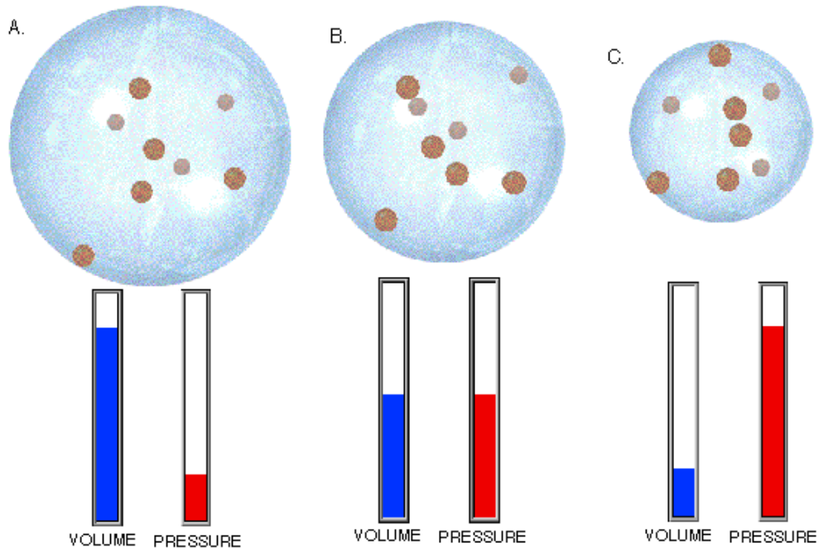

Page 4. Quiet Inspiration: Muscle Contraction
• The volume of the thoracic cavity is changed by muscle contraction and relaxation.
• During quiet inspiration, the diaphragm and the external intercostal muscles contract, slightly enlarging the thoracic cavity.
• As we learned from Boyle's Law, increasing the volume decreases the pressure within the thoracic cavity and the lungs.
• Notice how the diaphragm flattens and moves inferiorly while the external intercostal muscles elevate the rib cage and move the sternum anteriorly. These actions enlarge the thoracic cavity in all dimensions.
• As we learned from Boyle's Law, increasing the volume decreases the pressure within the thoracic cavity and the lungs.

Page 5. Quiet Expiration: Muscle Relaxation
• Quiet expiration is a passive process, in which the diaphragm and the external intercostal muscles relax, and the elastic lungs and thoracic wall recoil inward.
• This decreases the volume and therefore increases the pressure in the thoracic cavity.
• As the diaphragm relaxes, it moves superiorly. As the external intercostal muscles relax, the rib cage and sternum return to their resting positions. These actions decrease the size of the thoracic cavity in all dimensions, and therefore increase the pressure in the thoracic cavity.

Page 6. Muscles of Deep Inspiration and Expiration
• Deep breathing uses forceful contractions of the inspiratory muscles and additional accessory muscles to produce larger changes in the volume of the thoracic cavity during both inspiration and expiration.
• Label the muscles in this diagram. Indicate which muscles are used during each of the following processes: a. quiet inspiration b. quiet expiration c. deep inspiration d. forceful expiration
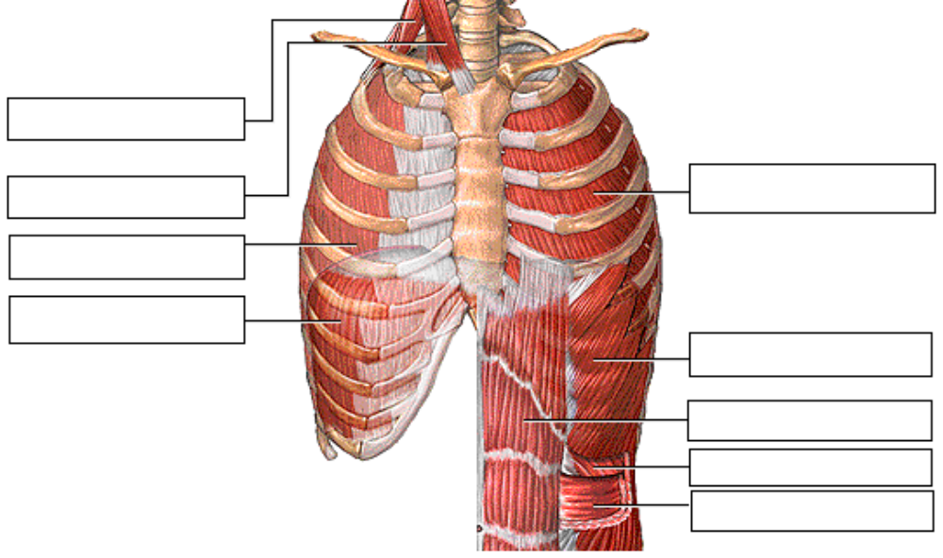
• During deep inspiration, the diaphragm and the external intercostal muscles contract more forcefully than during quiet breathing. Additionally, the sternocleidomastoid and scalenes contract, lifting the rib cage higher. These actions further increase the volume. As we learned from Boyle's Law, this decreases the pressure within the thoracic cavity.

• Deep or forceful expiration is an active process. The internal intercostal muscles depress the rib cage, and the external oblique, internal oblique, transversus abdominis and rectus abdominis muscles compress the abdominal organs, forcing them superiorly against the diaphragm. These actions can dramatically decrease the volume, and further increase the pressure within the thoracic cavity, producing forceful expiration.

** Now is a good time to go to quiz questions 1-3:
• Click the Quiz button on the left side of the screen.
• Work through questions 1-3.
• After answering question 3, click the Back to Topic button on the left side of the screen.
• To get back to where you left off, click on the scrolling page list at the top of the screen and choose "7. Intrapulmonary Pressure Changes".

Page 7. Intrapulmonary Pressure Changes
• Now let's look at the specific pressure changes that occur in the lungs during breathing. For reasons described later, the lungs closely follow the movements of the thoracic wall.
• The pressure within the lungs is called the intrapulmonary, or intra-alveolar, pressure.
• Between breaths, it equals atmospheric pressure, which has a value of 760 millimeters of mercury at sea level. When discussing respiratory pressures, this is generally referred to as zero.
• During inspiration, the volume of the thoracic cavity increases, causing intrapulmonary pressure to fall below atmospheric pressure. This is also known as a negative pressure. Since air moves from areas of high to low air pressure, air flows into the lungs. Notice that at the end of inspiration, when the intrapulmonary pressure again equals atmospheric pressure, airflow stops.
• During expiration, the volume of the thoracic cavity decreases, causing the intrapulmonary pressure to rise above atmospheric pressure. Following its pressure gradient, air flows out of the lungs, until, at the end of expiration, the intrapulmonary pressure again equals atmospheric pressure.  • Draw the pressure changes that occur during inspiration and expiration on this graph: | 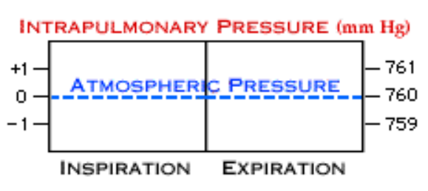

Page 8. Intrapleural Pressure
• Label this diagram:
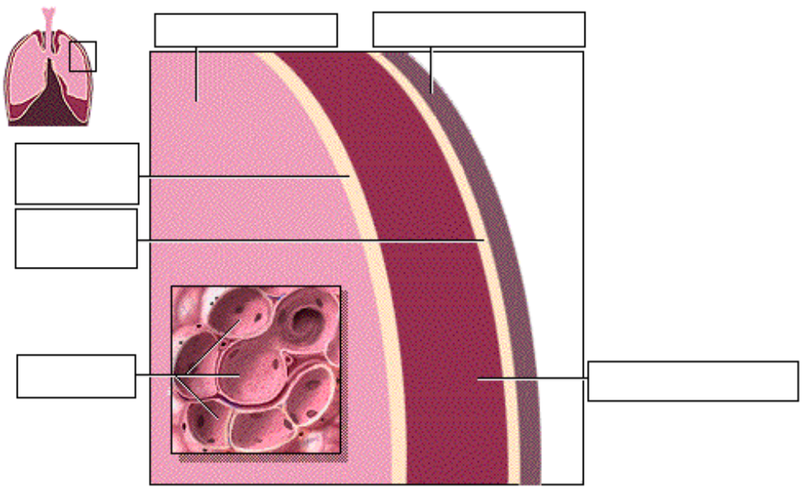

• Intrapleural pressure is the pressure within the pleural cavity. Intrapleural pressure is always negative, which acts like a suction to keep the lungs inflated.
• The negative intrapleural pressure is due to three main factors:
1. The surface tension of the alveolar fluid.
• The surface tension of the alveolar fluid tends to pull each of the alveoli inward and therefore pulls the entire lung inward. Surfactant reduces this force.
2. The elasticity of the lungs.
• The abundant elastic tissue in the lungs tends to recoil and pull the lung inward. As the lung moves away from the thoracic wall, the cavity becomes slightly larger. The negative pressure this creates acts like a suction to keep the lungs inflated.
3. The elasticity of the thoracic wall.
• The elastic thoracic wall tends to pull away from the lung, further enlarging the pleural cavity and creating this negative pressure. The surface tension of pleural fluid resists the actual separation of the lung and thoracic wall.

Page 9. Intrapleural Pressure Changes
• Intrapleural pressure changes during breathing:  • As the thoracic wall moves outward during inspiration, the volume of the pleural cavity increases slightly, decreasing intrapleural pressure.  • As the thoracic wall recoils during expiration, the volume of the pleural cavity decreases, returning the pressure to minus 4, or 756 millimeters of mercury.  • Draw the changes in intrapleural pressure on this graph: | 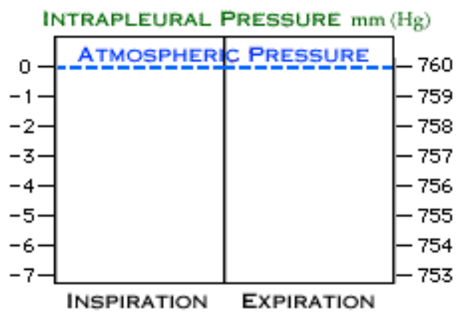

Page 10. Effect of Pneumothorax
• If you cut through the thoracic wall into its pleural cavity, air enters the pleural cavity as it moves from high pressure to low pressure. This is called a pneumothorax.
• Normally, there is a difference between the intrapleural and intrapulmonary pressures, which is called transpulmonary pressure. The transpulmonary pressure creates the suction to keep the lungs inflated. In this case, when there is no pressure difference there is no suction and the lung collapses.
• The lungs are completely separate from one another, each surrounded by its own pleural cavity and pleural membranes. Therefore, changes in the intrapleural pressure of one lung do not affect the other lung.

Page 11. Events During Inspiration
• Label this graph as you work through this page.  • Let's review all the events that occur during inspiration. The upper graph shows the intrapulmonary pressure, that is, the pressure within the lungs. The middle graph shows the intrapleural pressure, the pressure within the pleural cavity. The region between the two graphs is the transpulmonary pressure, the pressure difference between the intrapulmonary and intrapleural pressures. The lower graph shows the volume of air which enters and leaves the lungs during quiet breathing. This is called the tidal volume.  • During inspiration, the diaphragm and external intercostal muscles contract, increasing the volume of the thoracic cavity. This causes the intrapleural pressure to become more negative, which increases the transpulmonary pressure, causing the lungs to expand. The expansion of the lungs lowers the intrapulmonary pressure below atmospheric pressure. Air, following its pressure gradient, now flows into the lungs. | 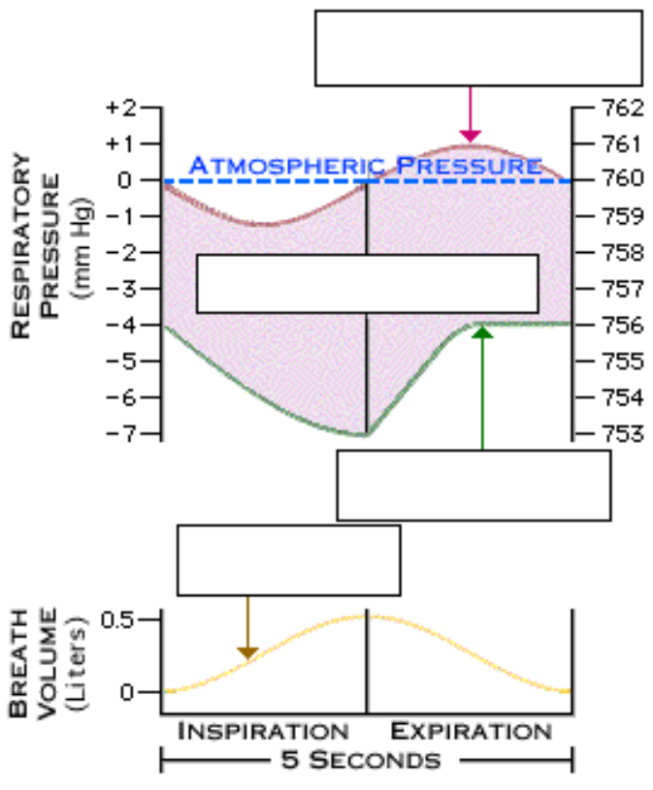

Page 12. Events During Expiration
• During expiration, the diaphragm and external intercostal muscles relax, decreasing the volume of the thoracic cavity. The intrapleural pressure becomes less negative, the transpulmonary pressure decreases, and the lungs passively recoil. This increases the intrapulmonary pressure so that it rises above atmospheric pressure. Air, following its pressure gradient, moves out of the lungs. Watch how the three pressures change together on the graph.

Page 13. Events During Inspiration and Expiration
• Let's correlate the graphs with the movements of the thoracic cavity during inspiration and expiration.
** Now is a good time to go to quiz questions 4-6:
• Click the Quiz button on the left side of the screen.
• Click on the scrolling page list at the top of the screen and choose "4. Sequence of Inspiration and Expiration".
• Work through questions 4-6.
• After answering question 6, click the Back to Topic button on the left side of the screen.
• To get back to where you left off, click on the scrolling page list at the top of the screen and choose "14. Other Factors Effecting Ventilation".

Page 14. Other Factors Affecting Ventilation
• Two other important factors play roles in ventilation:
1. The resistance within the airways.
2. Lung compliance.

Page 15. Resistance Within Airways
• As air flows into the lungs, the gas molecules encounter resistance when they strike the walls of the airway. Therefore the diameter of the airway affects resistance.
• When the bronchiole constricts, the diameter decreases, and the resistance increases. This is because more gas molecules encounter the airway wall. Airflow is inversely related to resistance.
• This relationship is shown by the equation:  • Airflow equals the pressure difference between atmosphere and intrapulmonary pressure, divided by the resistance. | 
• As the resistance increases, the airflow decreases.
• As the resistance decreases, the airflow increases.
• In healthy lungs, the airways typically offer little resistance, so air flows easily into and out of the lungs.

Page 16. Factors Affecting Airway Resistance
• Several factors change airway resistance by affecting the diameter of the airways. They do this by contracting or relaxing the smooth muscle in the airway walls, especially the bronchioles.
• Parasympathetic neurons release the neurotransmitter acetylcholine, which constricts bronchioles. As you can see in the equation, increased airway resistance decreases airflow.
• Histamine, released during allergic reactions, constricts bronchioles. This increases airway resistance and decreases airflow, making it harder to breathe.
• Epinephrine, released by the adrenal medulla during exercise or stress, dilates bronchioles, thereby decreasing airway resistance. This greatly increases airflow, ensuring adequate gas exchange.

Page 17. Lung Compliance: Elastic Fibers
• Another important factor affecting ventilation is the ease with which the lungs expand, also known as lung compliance. It is primarily determined by two factors:
1. The stretchability of the elastic fibers within the lungs.
2. The surface tension within the alveoli.
• Healthy lungs have high compliance because of their abundant elastic connective tissue.
• Low lung compliance occurs in some pathological conditions, such as fibrosis, in which increasing amounts of less flexible connective tissue develop.

Page 18. Lung Compliance: Surface Tension
• The second factor affecting lung compliance is surface tension within the alveoli.
• Some premature infants do not produce surfactant. Is their lung compliance high or low?
• Without surfactant, alveoli have high surface tension, and they tend to collapse. Collapsed alveoli resist expansion, so lung compliance is low. This condition is known as respiratory distress syndrome of the newborn. Natural or synthetic surfactant may be sprayed into the infant's respiratory passageways. Surfactant lowers surface tension and increases lung compliance.

Page 19. Summary
• Muscle activity causes changes in the volume of the thoracic cavity during breathing.
• Changing the thoracic cavity volume causes intrapulmonary and intrapleural pressure changes, which allow air to move from high pressure to low pressure regions.
• Airway resistance is normally low, but nervous stimulation and chemical factors can change the diameter of bronchioles, thereby altering resistance and airflow.
• Lung compliance is normally high due to the lung's abundant elastic tissue and surfactant's ability to lower the surface tension of the alveolar fluid.

** Now is a good time to go to quiz questions 7 and 8:
• Click the Quiz button on the left side of the screen.
• Click on the scrolling page list at the top of the screen and choose "7. Bronchiole Airflow and Resistance".
• Work through quiz questions 7 and 8.

Notes on Quiz Questions:
Quiz Question #1a,b: Pressure and Volume Changes
• This question asks you to watch animations of deep inspiration or expiration and note the pressure and volume changes that occur.

Quiz Question 2: Muscles of Deep Inspiration and Expiration
• This question asks you to label the muscles involved during deep inspiration and expiration.

Quiz Question 3: Blow Out the Candles
• This question asks you to identify the muscles involved when one blows out the candles on birthday cake.

Quiz Question 4: Sequence of Inspiration and Expiration
• This question asks you to list the sequence of events that occur during inspiration and expiration.

Quiz Question 5a,b,c,d,e: Pressure Graph - Airflow In, Airflow Out, No Airflow
• This question asks you to identify the parts of the graph of pressure changes during respiration.
• Make notes on this graph as you do this question:
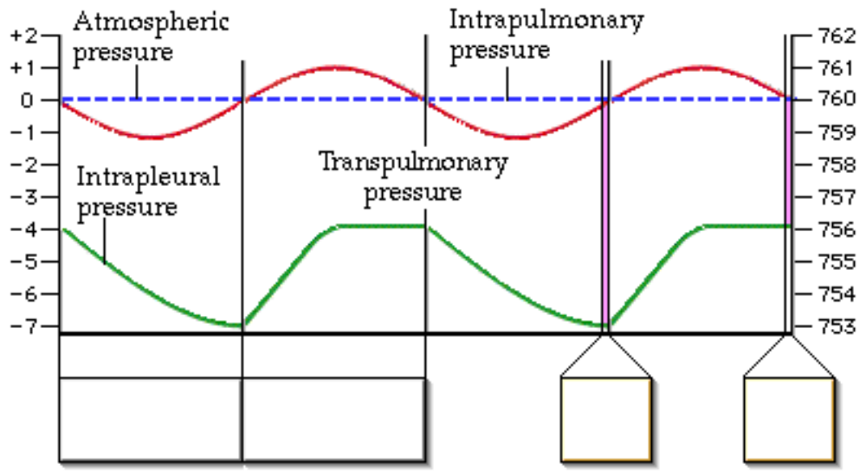

Quiz Question 6: Reinflate the Collapsed Lung
• This question asks you to chose the best way to reinflate a collapsed lung.

Quiz Question 7: Bronchiole Airflow and Resistance
• This question asks you to predict what happens to airflow and resistance when bronchioles dilate.

Quiz Question 8: Asthma and Bronchioles
• This question asks you to chose a treatment for asthma.

Study Questions on Pulmonary Ventilation:
1. (Page 1.) What is another term for pulmonary ventilation?

2. (Page 1.) Define pulmonary ventilation in simple terms.

3. (Page 3.) What causes pressure within a gas sample?

4. (Page 3.) Which of these three samples of gas would have the highest pressure, and which would have the lowest pressure?.
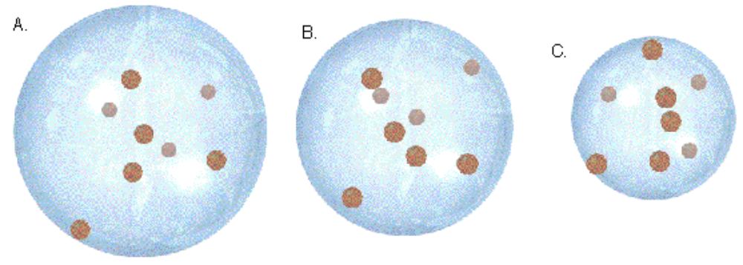

5. (Page 3.) Define Boyle's Law.

6. a. What happens to the pressure of a gas if you increase the size of a container? b. What happens to the pressure of a gas if you decrease the size of a container?

7. (Page 4.) How is the volume of the thoracic cavity changed?

8. (Page 4.) What two muscles contract during quiet inspiration? What is the effect of their contraction?

9. (Page 4.) What happens to pressure when we increase the volume within the thoracic cavity and the lungs?

10. (Page 4.) a. What happens to the diaphragm muscle when it contracts? b. What happens to the external intercostal muscles when they contract?

11. (Page 5.) Explain what happens in quiet expiration.

12. (Page 5.) What effect does quiet expiration have on the volume of the thoracic cavity? How does this effect the pressure within the cavity?

13. (Page 6.) Which of these are active and which are passive processes?
a. quiet inspiration b. quiet expiration c. deep inspiration d. forceful expiration

14. (Page 6.) Label the diagram on p. 6. Indicate which muscles contract in these processes:
a. quiet inspiration b. quiet expiration c. deep inspiration d. forceful expiration

15. (Page 7.) What is the pressure within the lungs called?

16. (Page 7.) What is a typical value for intrapulmonary, or intra-alveolar, pressure during normal breathing at these times. Assume the atmospheric pressure is 760 mm Hg. a. before inspiration b. during inspiration c. after inspiration and before expiration d. during expiration

17. (Page 7.) When discussing respiratory pressures, what do these pressures mean? a. 0 b. -1 c. +1

18. (Page 7.) Draw the pressure changes that occur during inspiration and expiration on this graph:

19. (Page 8.) Label the diagram on p. 8.

20. (Page 8.) What is the value of intrapleural pressure compared to intrapulmonary (alveolar) pressure?

21. (Page 8.) What three factors cause the intrapleural pressure to be less than intrapulmonary (alveolar) pressure?

22. (Page 8.) How do each of the following decrease the pressure inside the pleural cavity: a. the surface tension of the alveolar fluid b. The elasticity of the lungs. c. The elasticity of the thoracic wall.

23. (Page 9.) Draw the changes in intrapleural pressure on this graph:

24. (Page 9.) What happens to the volume of the pleural cavity and the intrapleural pressure during a. inspiration? b. expiration?

25. (Page 10.) Why does a lung collapse if you cut into the pleural cavity?

26. (Page 10.) a. What is the transpulmonary pressure? b. What is the function of the transpulmonary pressure?

27. (Page 10.) If a pneumothorax occurs in one lung, why doesn't it also occur in the other lung?

28. (Page 11.) Label the diagram on page 11.

29. (Page 11.) Match the pressures to their definition:
• Intrapulmonary Pressure  • Transpulmonary Pressure  • Intrapleural Pressure | a. The pressure within the pleural cavity.  b. The pressure within the alveoli.  c. The difference between the pressure within the pleural cavity and the pressure within the alveoli.

30. (Page 11.) What is the tidal volume?

31. (Page 11.) Chose the proper words to explain what happens during inspiration.

The diaphragm and external intercostal muscles __________ (contract, relax).
↓
The volume of the thoracic cavity _________ (increases, decreases).
↓
Intrapleural pressure becomes ________ (more, less) negative.
↓
Lungs ________ (recoil, expand).
↓
Intrapulmonary pressure __________ (increases, decreases).
↓
Air flows _________ (into, out of) the lungs.

32. (Page 12.) Chose the proper words to explain what happens during expiration.

The diaphragm and external intercostal muscles __________ (contract, relax).
↓
The volume of the thoracic cavity _________ (increases, decreases).
↓
Intrapleural pressure becomes ________ (more, less) negative.
↓
Lungs ________ (recoil, expand).
↓
Intrapulmonary pressure __________ (increases, decreases).
↓
Air flows _________ (into, out of) the lungs.

33. (Summary) Which numbers correspond to regions of the graph where:
a. the external intercostal muscles and diaphragm are relaxed.
b. the external intercostal muscles and diaphragm are contracted.
c. air is flowing into the lungs.
d. air is flowing out of the lungs.
e. no air is flowing into or out of the lungs
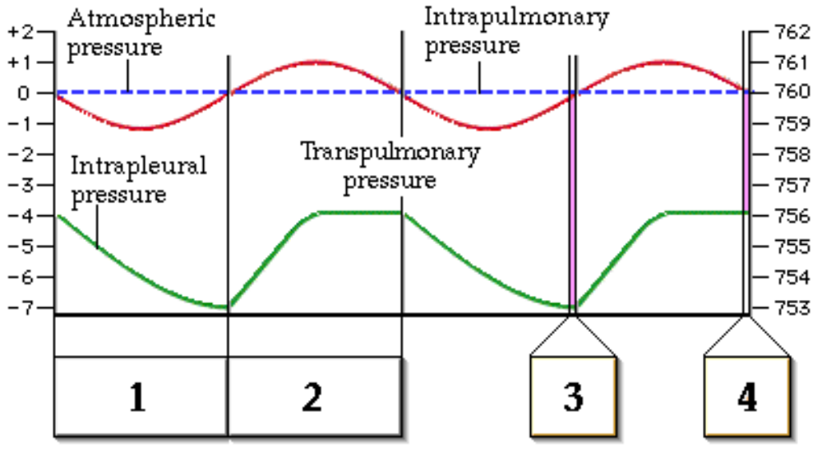

34. (Page 14.) What two factors play roles in ventilation besides muscle contraction?

35. (Page 15.) What is airway resistance due to?

36. (Page 15.) What happens to the airway resistance as the bronchiole constricts?

37. (Page 16.) Does histamine constrict or dilate bronchioles?

38. (Page 16.) Does epinephrine constrict or dilate bronchioles?

39. (Page 17.) What term is used to describe the ease with which the lungs expand?

40. (Page 17.) What two factors is lung compliance dependent upon?

41. (Page 18.) What happens to alveoli when there is not enough surfactant?

