Gas Transport
Graphics are used with permission of:
Pearson Education Inc., publishing as Benjamin Cummings (http://www.aw-bc.com)

Page 1. Introduction
• The blood transports oxygen and carbon dioxide between the lungs and other tissues throughout the body.
• These gases are carried in several different forms:
1. dissolved in the plasma
2. chemically combined with hemoglobin
3. converted into a different molecule

Page 2. Goals
• To explore how oxygen is transported in the blood.
• To explore how carbon dioxide is transported in the blood.
• To understand the effect of variables, such as PO2 and PCO2, on oxygen and carbon dioxide transport.

Page 3. Oxygen Transport
• Transport of oxygen during external respiration:
• With its low solubility, only approximately 1.5% of the oxygen is transported dissolved in plasma.
• The remaining 98.5% diffuses into red blood cells and chemically combines with hemoglobin.
• Label this diagram:
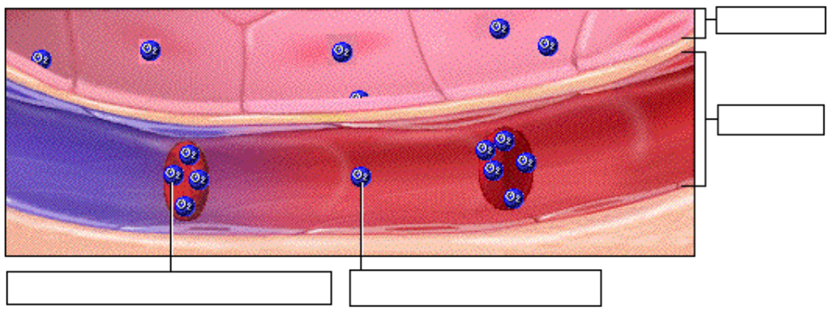

Page 4. Hemoglobin
• Within each red blood cell, there are approximately 250 million hemoglobin molecules.
• Each hemoglobin molecule consists of:
1. A globin portion composed of 4 polypeptide chains.
2. Four iron-containing pigments called heme groups.
• Each hemoglobin molecule can transport up to 4 oxygen molecules because each iron atom can bind one oxygen molecule.
• When 4 oxygen molecules are bound to hemoglobin, it is 100% saturated; when there are fewer, it is partially saturated.
• Oxygen binding occurs in response to the high partial pressure of oxygen in the lungs.
• When hemoglobin binds with oxygen, it is called oxyhemoglobin.
• When one oxygen binds to hemoglobin, the other oxygen molecules bind more readily. This is called cooperative binding. Hemoglobin's affinity for oxygen increases as its saturation increases.
• Label this diagram:
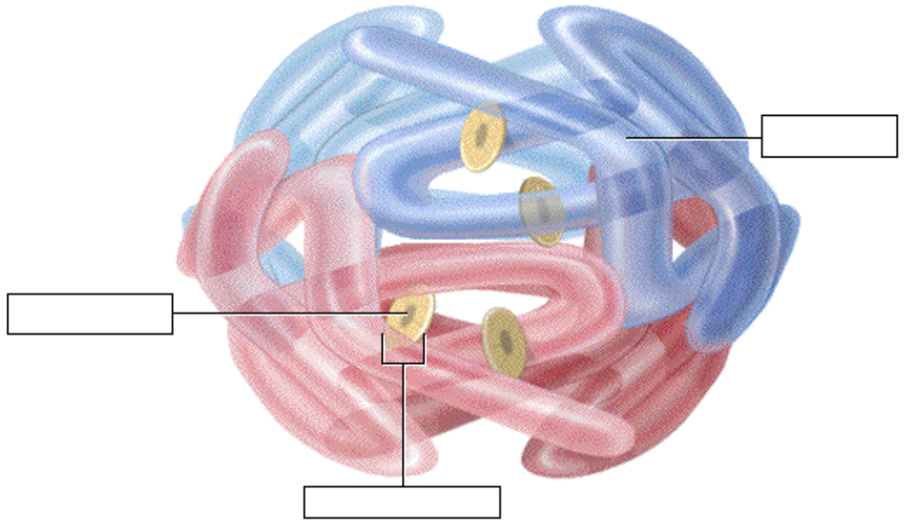

Page 5. Oxyhemoglobin and Deoxyhemoglobin
• The formation of oxyhemoglobin occurs as a reversible reaction, and is written as in this chemical equation:
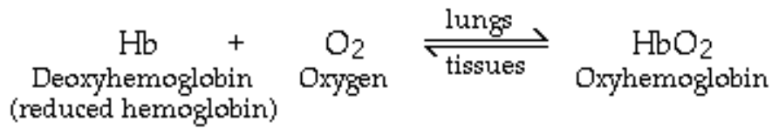
• In reversible reactions, the direction depends on the quantity of products and reactants present.
• In the lungs, where the partial pressure of oxygen is high, the reaction proceeds to the right, forming oxyhemoglobin.
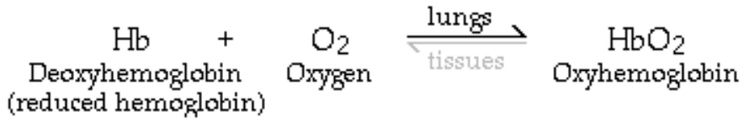
• In organs throughout the body where the partial pressure of oxygen is low, the reaction reverses, proceeding to the left. Oxyhemoglobin releases oxygen, forming deoxyhemoglobin, which is also called reduced hemoglobin.
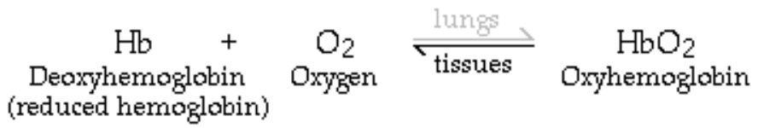
• Notice that the affinity of hemoglobin for oxygen decreases as its saturation decreases.

Page 6. Oxygen-Hemoglobin Dissociation Curve
• The degree of hemoglobin saturation is determined by the partial pressure of oxygen, which varies in different organs throughout the body.
• When these values are graphed, they produce the oxygen-hemoglobin dissociation curve. Notice that the axes on the graph are: partial pressure of oxygen and percent saturation of hemoglobin.
• In the lungs, the partial pressure of oxygen is approximately 100 millimeters of mercury. At this partial pressure, hemoglobin has a high affinity for oxygen, and is 98% saturated.
• In the tissues of other organs, a typical partial pressure of oxygen is 40 millimeters of mercury. Here, hemoglobin has a lower affinity for oxygen and releases some but not all of its oxygen to the tissues. When hemoglobin leaves the tissues it is still 75% saturated.

• Label this graph as you proceed through this page:
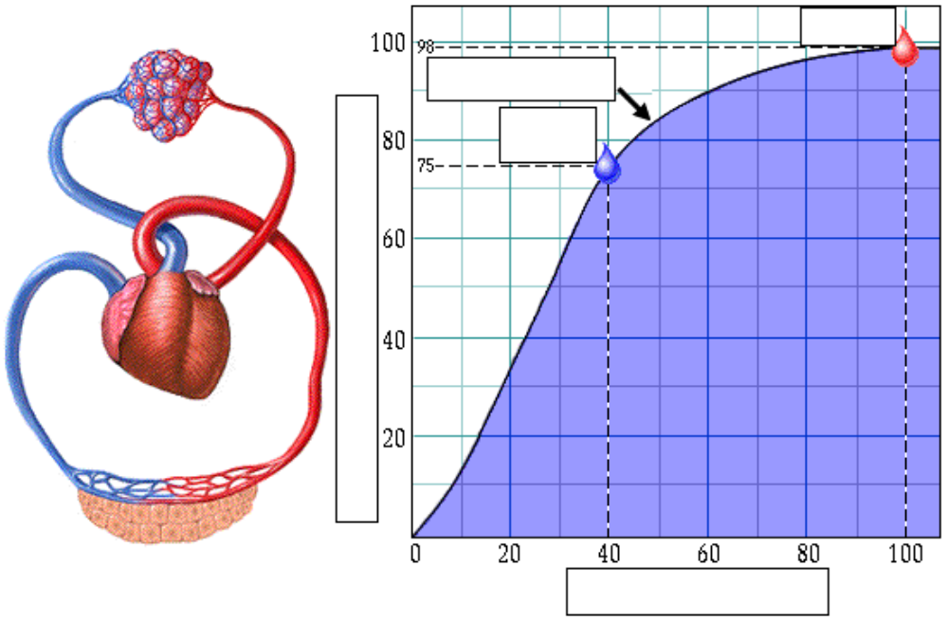
• Notice that the oxygen-hemoglobin dissociation curve is an S-shaped curve, with a nearly flat slope at high PO2's and a steep slope at low PO2's.

Page 7. Hemoglobin Saturation at High PO2's
• A closer look at the flat region of the oxygen-hemoglobin dissociation curve between 80 and 100 millimeters of mercury:
• In the lungs at sea level, a typical PO2 is 100 millimeters of mercury. At this PO2, hemoglobin is 98% saturated.
• In the lungs of a hiker at higher elevations or a person with particular cardiopulmonary diseases, the PO2 may be 80 millimeters of mercury. At this PO2, hemoglobin is 95% saturated.
• Notice that even though the PO2 differs by 20 millimeters of mercury there is almost no difference in hemoglobin saturation. This means that although the PO2 in the lungs may decline below typical sea level values, hemoglobin still has a high affinity for oxygen and remains almost fully saturated.

Page 8. Hemoglobin Saturation at Low PO2's
• A closer look at the steep region of the graph between 20 and 40 millimeters of mercury.
• A PO2 of 40 millimeters of mercury is typical in resting organs.
• At 40 millimeters of mercury, hemoglobin has a lower affinity for oxygen and is 75% saturated.
• In vigorously contracting muscles, would you expect the PO2 is lower than in resting muscle because an actively contracting muscle uses more oxygen, so it has a lower PO2 than a resting muscle, typically 20 millimeters of mercury. At this PO2, hemoglobin is only 35% saturated.
• As the PO2 decreases, hemoglobin releases much more oxygen to the tissues. This allows the body to closely match oxygen unloading by hemoglobin to oxygen utilization by the tissues.

• Fill in the blanks on the graph with the appropriate letters below:
a. Corresponds to the partial pressure of oxygen in the lungs at a high altitude.
b. Corresponds to the partial pressure of oxygen in the tissues at rest.
c. Corresponds to the partial pressure of oxygen in the lungs at a low altitude.
d. Corresponds to the partial pressure of oxygen in active tissues.
e. Corresponds to the percent saturation of hemoglobin in the lungs at a high altitude.
f. Corresponds to the percent saturation of hemoglobin in the tissues at rest.
g. Corresponds to the percent saturation of hemoglobin in the lungs at a low altitude.
h. Corresponds to the percent saturation of hemoglobin in active tissues.
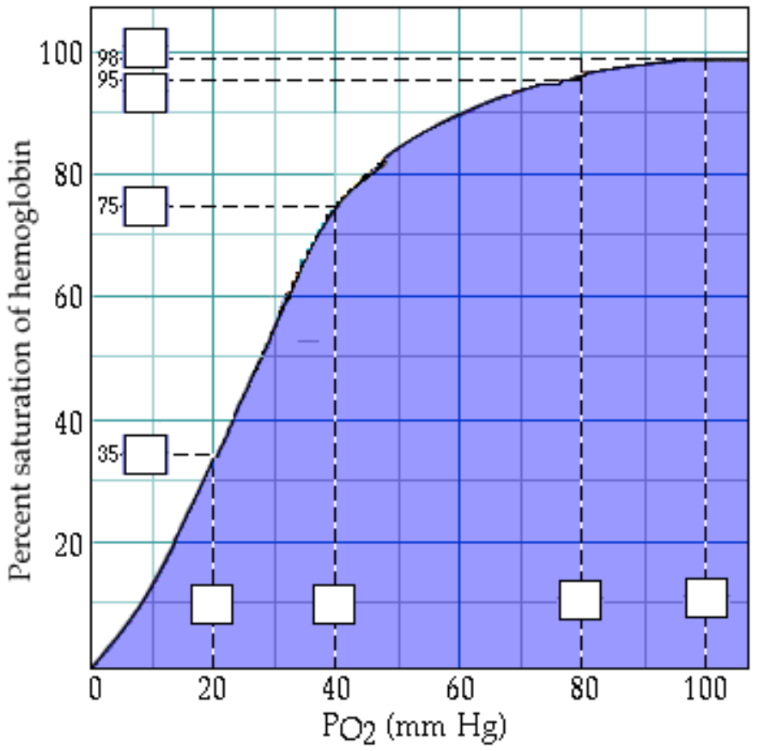

Page 9. Factors Altering Hemoglobin Saturation
• Factors which alter hemoglobin saturation:
1. pH
2. temperature
3. PCO2
4. BPG (2,3-biphosphoglycerate)
• All of these factors, together or individually, play a role during exercise.
• During vigorous exercise, contracting muscles produce more metabolic acids, such as lactic acid, which lower the pH, more heat, and more carbon dioxide. In addition, higher temperature and lower PO2 increase the production of BPG by the red blood cells.
• These conditions decrease hemoglobin's affinity for oxygen, releasing more oxygen to the active muscle cells.
• Let's look at a typical PO2 of active muscle, 20 millimeters of mercury. At a normal blood pH, hemoglobin releases 65% of its oxygen to the muscle cells, and remains 35% saturated. However, as the muscle cells release lactic acid, the pH decreases and hemoglobin releases 75% of its oxygen, leaving it 25% saturated.
• When pH decreases, the curve shifts to the right. This represents increased oxygen unloading compared to normal blood pH. A similar shift to the right occurs in response to increased temperature, PCO2, or BPG.
• Label this graph:
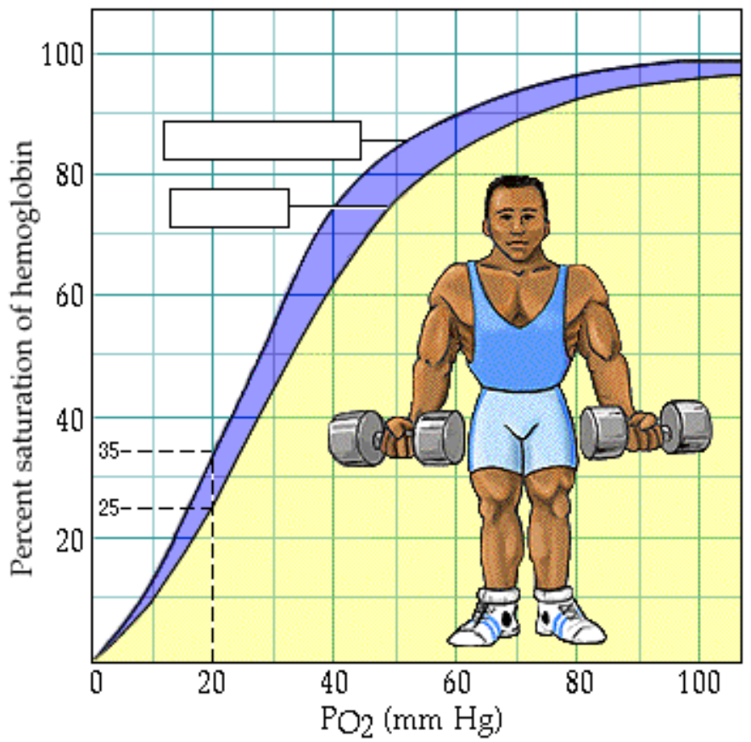
Page 10. Predict the Effect of Decreased Temperature
• Label this graph:
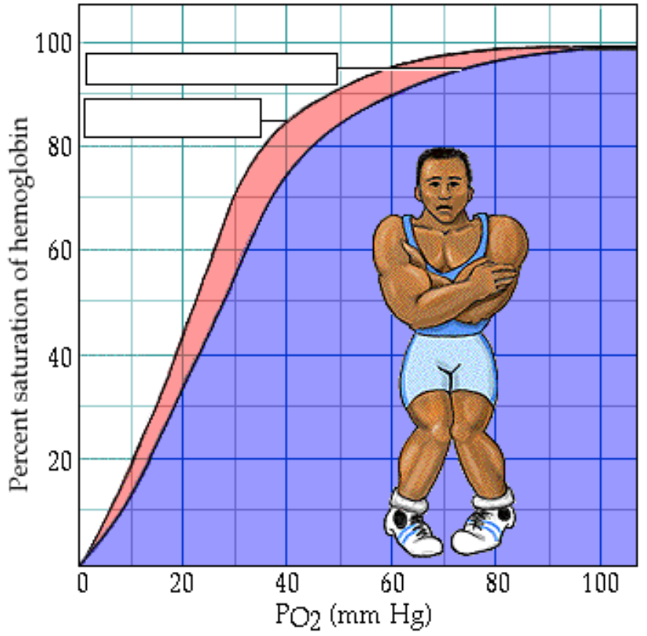

• If body tissues are chilled, their hemoglobin saturation changes.
• At decreased temperatures, hemoglobin's affinity for oxygen is higher, so hemoglobin releases less oxygen to less active tissues. Represented graphically, the curve shifts to the left.
• A similar shift to the left occurs in response to increased pH, decreased PCO2, and decreased BPG.

** Now is a good time to go to quiz questions 1-4:
• Click the Quiz button on the left side of the screen.
• Work through questions 1-4.
• After answering question 4, click the Back to Topic button on the left side of the screen.
• To get back to where you left off, click on the scrolling page list at the top of the screen and choose "11. CO2 Transport".

Page 11. CO2 Transport
• Carbon dioxide transport:
• Carbon dioxide is produced by cells throughout the body.
• It diffuses out of the cells and into the systemic capillaries, where approximately 7% is transported dissolved in plasma.
• The remaining carbon dioxide diffuses into the red blood cells. Within the red blood cells, approximately 23% chemically combines with hemoglobin, and 70% is converted to bicarbonate ions, which are then transported in the plasma.
• Fill in this diagram:
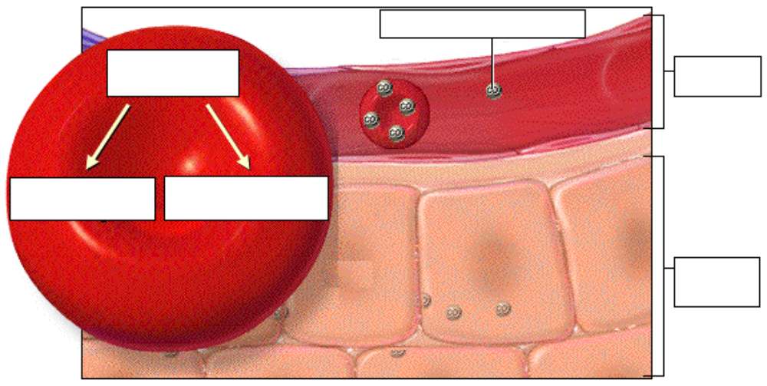

Page 12. CO2 Transport: Carbaminohemoglobin (Tissues)
• Of the total carbon dioxide in the blood, 23% binds to the globin portion of the hemoglobin molecule to form carbaminohemoglobin, as written in this equation:
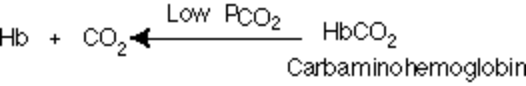
• Carbaminohemoglobin forms in regions of high PCO2, as blood flows through the systemic capillaries in the tissues.

Page 13. CO2 Transport: Carbaminohemoglobin (Lungs)
• The formation of carbaminohemoglobin is reversible.

• In the lungs, which have a lower PCO2, carbon dioxide dissociates from carbaminohemoglobin, diffuses into the alveoli, and is exhaled.

Page 14. CO2 Transport: Bicarbonate Ions (Tissues)
• Of the total carbon dioxide in the blood, 70% is converted into bicarbonate ions within the red blood cells, in a sequence of reversible reactions. The bicarbonate ions then enter the plasma.
• In regions with high PCO2, carbon dioxide enters the red blood cell and combines with water to form carbonic acid. This reaction is catalyzed by the enzyme carbonic anhydrase. The same reaction occurs in the plasma, but without the enzyme it is very slow.
• Carbonic acid dissociates into hydrogen ions and bicarbonate ions. The hydrogen ions produced in this reaction are buffered by binding to hemoglobin. This is written as HHb.
• In order to maintain electrical neutrality, bicarbonate ions diffuse out of the red blood cell and chloride ions diffuse in. This is called the chloride shift.
• Within the plasma, bicarbonate ions act as a buffer and play an important role in blood pH control.
• Label this diagram to show what happens at the tissues:
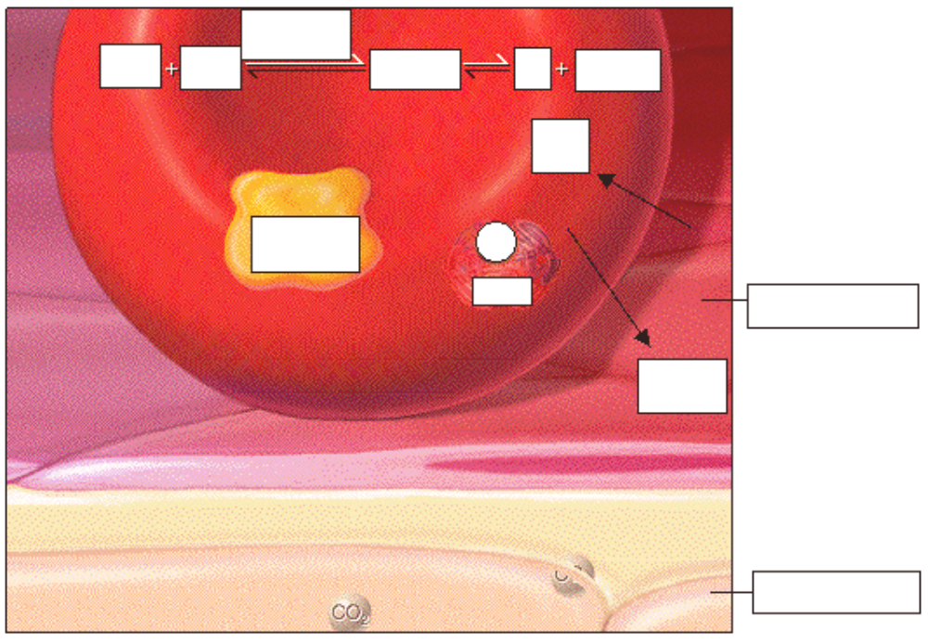

Page 15. CO2 Transport: Bicarbonate Ions (Lungs)
• In the lungs, carbon dioxide diffuses out of the plasma and into the alveoli. This lowers the PCO2 in the blood, causing the chemical reactions to reverse and proceed to the left.
• In the lungs, the bicarbonate ions diffuse back into the red blood cell, and the chloride ions diffuse out of the red blood cell. Recall that this is called the chloride shift.
• The hydrogen ions are released from hemoglobin, and combine with the bicarbonate ion to form carbonic acid.
• Carbonic acid breaks down into carbon dioxide and water. This reverse reaction is also catalyzed by the enzyme carbonic anhydrase.
• Label this diagram:
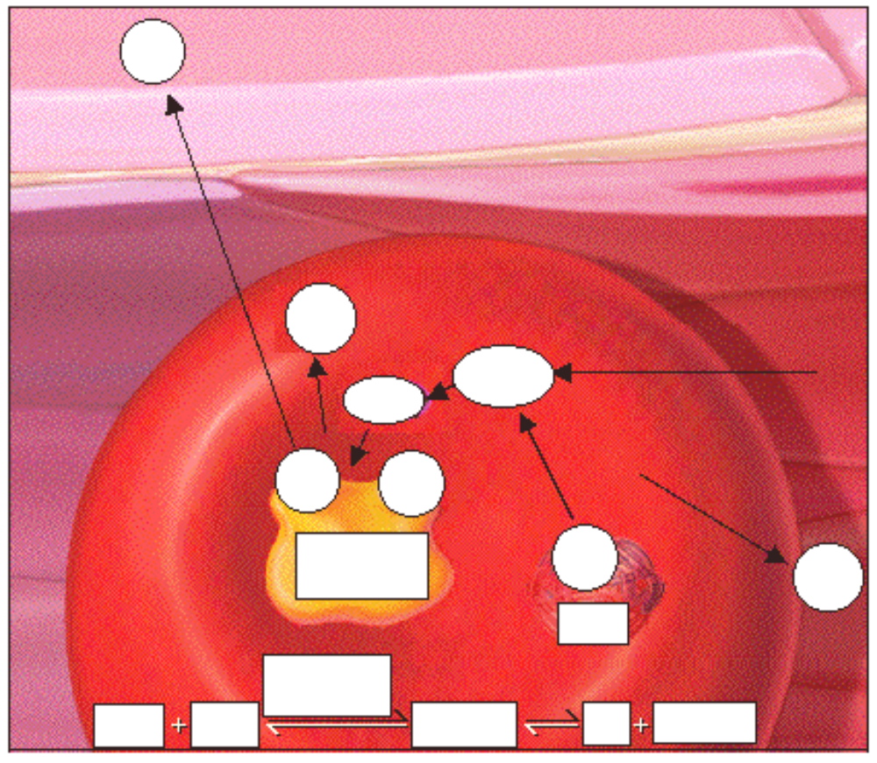

Page 16. Summary: O2 Loading and CO2 Unloading in the Lungs
• Summary of external respiration in the lungs.
• Although we will look at the processes step by step, they actually occur simultaneously.
• Remember, gases always follow their partial pressure gradients.
• As you go through the steps, place the numbers that correspond with the steps in the blanks on this diagram:
• During external respiration, a small amount of oxygen (1) remains dissolved in the plasma. However, the majority of the oxygen (2) continues into the red blood cells, where it combines with deoxyhemoglobin (3) to form oxyhemoglobin (4), releasing a hydrogen ion (5).
• When hemoglobin is saturated with oxygen, its affinity for carbon dioxide decreases. Any carbon dioxide combined with hemoglobin (6) dissociates and diffuses out of the red blood cell (7), through the plasma and into the alveoli. In other words, oxygen loading facilitates carbon dioxide unloading from hemoglobin. This interaction is called the Haldane effect.
• The hydrogen ion released from hemoglobin combines with a bicarbonate ion (8), which diffuses into the red blood cell from the plasma in exchange for a chloride ion (9). Recall that this exchange is the chloride shift. The reaction between hydrogen and bicarbonate ions forms carbonic acid (10).
• Carbonic acid then breaks down into water and carbon dioxide (11), catalyzed by the enzyme carbonic anhydrase. The water produced by this reaction may leave the red blood cell, or remain as part of the cytoplasm. The carbon dioxide diffuses out of the red blood cell (12) into the plasma and then into the alveoli. The small amount of carbon dioxide transported in the plasma diffuses into the alveoli (13).

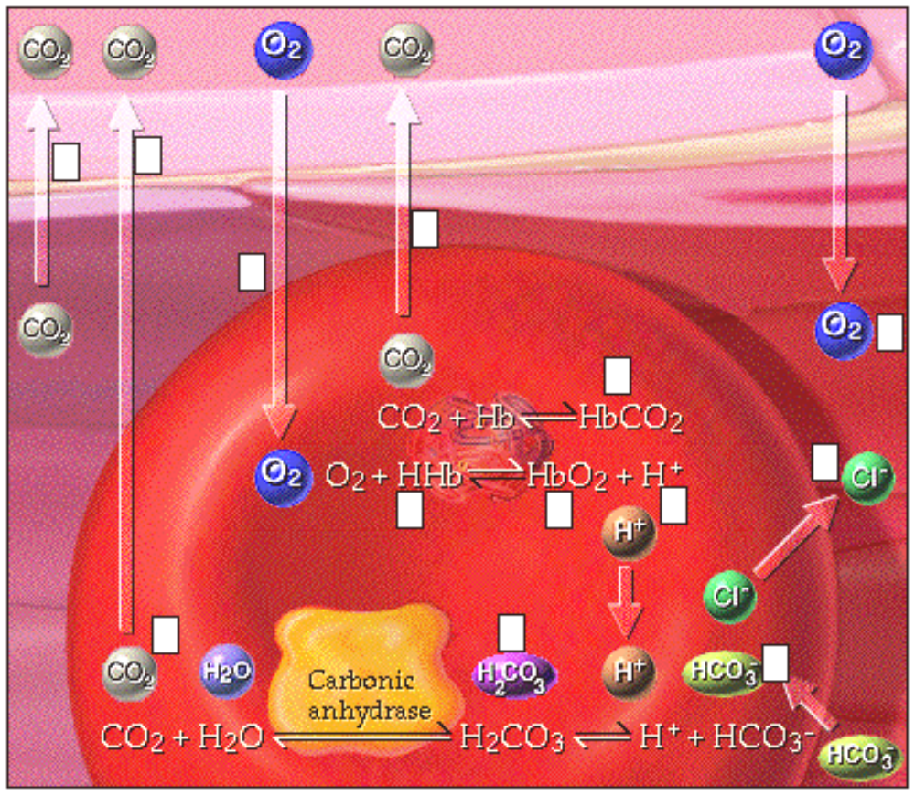

Page 17. Summary: O2 Unloading and CO2 Loading in the Tissues
Summary of internal respiration in the tissues.
• As you go through the steps, place the numbers that correspond with the steps in the blanks on this diagram:
• During internal respiration, a small amount of carbon dioxide (1) remains dissolved in the plasma, but most of the carbon dioxide (2) continues into the red blood cells where much of it combines with water to form carbonic acid (3) or combines with hemoglobin to form carbaminohemoglobin (11). This reaction is catalyzed by carbonic anhydrase. The carbonic acid then dissociates into hydrogen and bicarbonate ions (4).
• During the chloride shift, bicarbonate ions (5) diffuse out of the red blood cell in exchange for chloride ions (6). Bicarbonate ions act as buffers within the plasma, controlling blood pH.
• Within the red blood cell, hydrogen ions (7) are buffered by hemoglobin (8). When hemoglobin binds hydrogen ions, it has a lower affinity for oxygen. As a result, oxygen (9) dissociates from hemoglobin, diffuses out of the red blood cell and into the tissues. The interaction between hemoglobin's affinity for oxygen and its affinity for hydrogen ions is called the Bohr effect. By forming hydrogen ions, carbon dioxide loading facilitates oxygen unloading.
• The small amount of oxygen transported in the dissolved state (10) also diffuses out of the plasma and into the tissue cells.
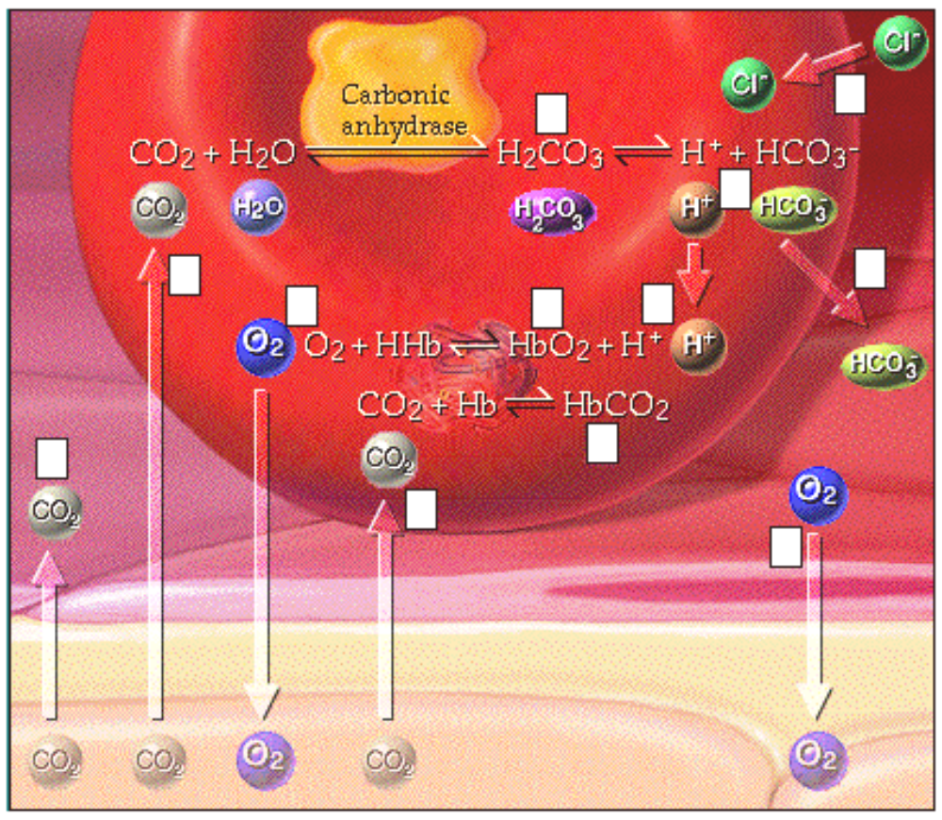

Page 18 Summary
• Oxygen is transported in two ways:
• dissolved in plasma, and
• bound to hemoglobin as oxyhemoglobin
• The oxygen saturation of hemoglobin is affected by:
• PO2
• pH
• temperature
• PCO2, and
• BPG
• Carbon dioxide is transported in three ways:
• dissolved in plasma
• bound to hemoglobin as carbaminohemoglobin, and
• converted to bicarbonate ions
• Oxygen loading facilitates carbon dioxide unloading from hemoglobin. This is known as the Haldane effect.
• When the pH decreases, carbon dioxide loading facilitates oxygen unloading. The interaction between hemoglobin's affinity for oxygen and its affinity for hydrogen ions is called the Bohr effect.

** Now is a good time to go to quiz questions 5-10.
• Click the Quiz button on the left side of the screen.
• Click on the scrolling page list at the top of the screen and choose "5. Bicarbonate Ion Equation".
• Work through quiz questions 5-10.

Notes on Quiz Questions:
Quiz Question #1: Oxygen and Hemoglobin
• This question asks you to watch an animation of oxygen binding to hemoglobin and determine where in the body the process occurs.

Quiz Question #2: Oxygen-Hemoglobin Dissociation Curve
• This question asks you to label the oxygen-hemoglobin dissociation curve.

Quiz Question #3: Shifted Oxygen-Hemoglobin Dissociation Curve
• This question asks you to choose the shift in the oxygen-hemoglobin dissociation curve that occurs when there is a high temperature.

Quiz Question #4a: Fetal Hemoglobin
• This question asks you to choose the curve that has the higher oxygen saturation.

Quiz Question #4b: Fetal Hemoglobin
• This question asks you to choose which graph represents fetal hemoglobin as opposed to maternal hemoglobin.
• Fetal hemoglobin has a higher affinity for oxygen than maternal hemoglobin; therefore as the mother's blood enters the placenta, oxygen is transferred from her blood into the fetus's blood. Thus at the same PO2, the fetal hemoglobin has a higher percent oxygen saturation than the mother's blood.

Quiz Question #5: Bicarbonate Ion Equation
• This question asks you to put together the reaction by which carbon dioxide and water form bicarbonate.

Quiz Question #6: Carbon Dioxide and Hemoglobin
• This question shows you an animation, then asks you to predict if the process occurs in areas of high or low PCO2.

Quiz Question #7: Name That Reaction
• This question asks you to watch an animation, then determine if it is the Haldane effect, Bohr effect, or Chloride shift.

Quiz Question #8: Gas Transport: Lungs
• This question asks you to determine which direction reactions go in the lungs.

Quiz Question #9: Gas Transport: Tissues
• This question asks you to determine which direction reactions go in the tissues.

Quiz Question #10: Lungs or Tissues
• This question asks you to determine if a number of different processes occur in the lungs or the tissues.

Study Questions on Gas Transport:
1. (Page 3.) When oxygen diffuses into the blood during external respiration, what two places within the blood does it end up? What percentage of oxygen ends up in each of these two places?

2. (Page 3.) Why does so little oxygen dissolve in the plasma?

3. (Page 3.) Label the diagram on p. 3.

4. (Page 4.) What are the two components of hemoglobin? What is each part made of?

5. (Page 4.) In each hemoglobin molecule:
a. How many polypeptide chains are there?
b. How many hemes are there?
c. How many irons are there?
d. How many oxygens can bind?

6. (Page 4.) Where, within the hemoglobin, does oxygen bind?

7. (Page 4.) a. When is hemoglobin said to be "saturated"? b. When is hemoglobin said to be "partially saturated"?

8. (Page 4.) What is hemoglobin called when oxygen is attached?

9. (Page 4.) Explain cooperative binding of oxygen to hemoglobin.

10. (Page 4.) Label the diagram of hemoglobin on p. 4.

11. (Page 5.) Give a name to each of these symbols:
a. Hb b. HbO2

12. (Page 5.) Does this reaction occur at the lungs or at the tissues? Hb + O2 HbO2

13. (Page 5.) Does this reaction occur at the lungs or at the tissues? Hb + O2 HbO2

14. (Page 5.) The affinity of hemoglobin for oxygen __________ as its saturation decreases.
a. increases b. decreases

15. (Page 6.) What determines the degree of hemoglobin saturation?

16. (Page 6.) Label the graph on page 6.

17. (Page 6.) a. What is the approximate partial pressure of oxygen in the lungs? b. What is the percent saturation of hemoglobin in the lungs?

18. (Page 6.) a. What is the approximate partial pressure of oxygen in the tissues? b. What is the approximate percent saturation of hemoglobin in the tissues?

19. (Page 6.) What is this graph called?  20. (Page 6.) Use this graph to determine the percent saturation of hemoglobin in the lungs when the PO2 is 100 mm Hg.  21. (Page 6.) Use this graph to determine the percent saturation of hemoglobin in the tissues when the PO2 is 40 mm Hg.  22. (Page 6.) What does this statement mean: "When hemoglobin leaves the tissues it is still 75% saturated"?  23. (Page 6.) What is the slope of the oxygen-hemoglobin dissociation curve at both high and low PO2's?  24. (Page 7.) Use this graph to determine the percent saturation of hemoglobin in the lungs when the PO2 is 80 mm Hg such as at a high elevation. | 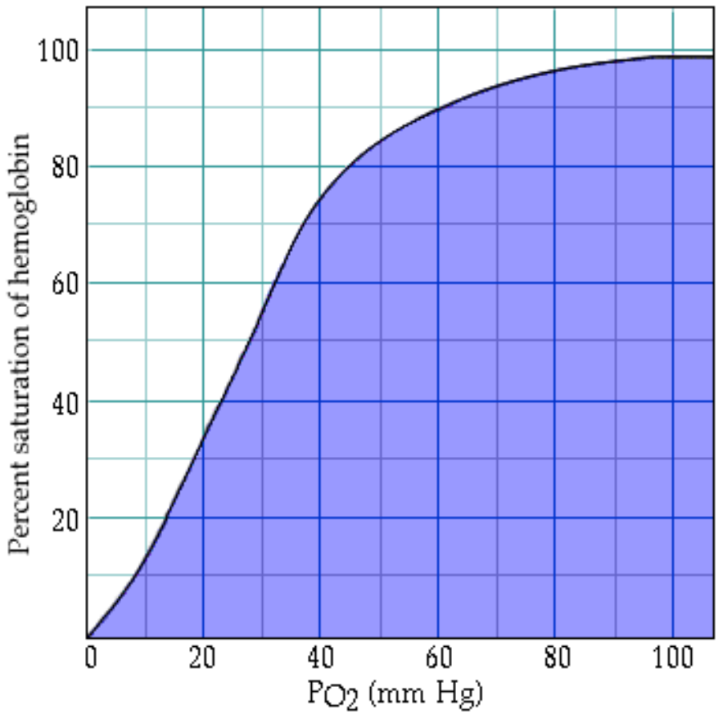

25. (Page 7.) At sea level the PO2 is 100 mm Hg and the hemoglobin is 98% saturated. At a high altitude, the PO2 may be 80 mm Hg but the hemoglobin is 95% saturated. What is the significance of the large difference in PO2, but almost no difference in hemoglobin saturation?

26. (Page 8.) Do the graph-labeling exercise on p. 8.

27. (Page 8.) At rest the PO2 in the tissues is about 40 mm Hg and the hemoglobin is 75% saturated. In vigorously contracting muscles, the PO2 in the tissues may be 20 mm Hg and the hemoglobin is 25% saturated. What is the significance of the large difference in hemoglobin saturation?

28. (Page 9.) List four factors which alter hemoglobin saturation.

29. (Page 9.) Why do pH, temperature, PCO2, and BPG all change during exercise.

30. (Page 9.) What is the effect of the changing pH, temperature, PCO2, and BPG during exercise on hemoglobin's affinity for oxygen.

31. (Page 9,10.) Which of these graphs of percent saturation of hemoglobin vs. partial pressure of oxygen corresponds to these situations:
1. decreased muscle pH 2. decreased muscle temperature
3. increased PCO2 in muscle 4. increased muscle pH
5. increased muscle temperature 6. decreased PCO2 in muscle
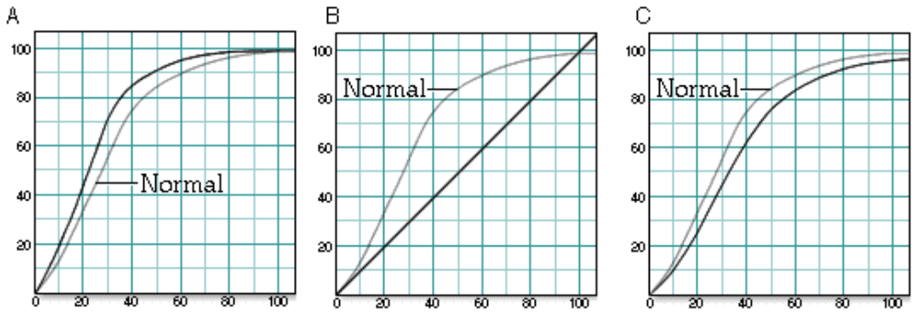

32. (Page 10.) At decreased temperatures, does hemoglobin's affinity for oxygen increase or decrease?

33. (Page 10.) Which of these curves has the higher oxygen saturation?  34. (Page 10.) Which of these curves represents a situation where there is less affinity of oxygen for hemoglobin? | 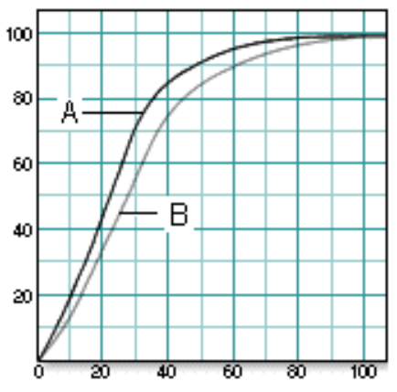
35. (Page 11.) Label the diagram on page 11.

36. (Page 12.) 23% of the total carbon dioxide in the blood binds to the globin portion of the hemoglobin molecule. What is the name and symbol for the molecule formed?

37. (Page 13.) Does carbaminohemoglobin form in areas of high or low PCO2?

38. (Page 13.) Which of these occurs in the lungs? Which occurs in the tissues?
a. Hb + CO2 HbCO2 b. Hb + CO2 HbCO2

39. (Page 14.) Label the diagram on p. 14.

40. (Page 14.) What is the name of the enzyme that catalyzes the reaction of carbon dioxide and water to form carbonic acid?

41. (Page14.) What happens to the hydrogen ions that are generated when carbonic acid dissociates into bicarbonate inside red blood cells?

42. (Page 14.) Explain the chloride shift at the tissues.

43. (Page 14.) Explain the chloride shift at the lungs.

44. (Page 15.) Label the diagram on p. 15.

45. (Page 15.) What happens to the hydrogen ions that are released from hemoglobin at the lungs?

46. (Page 16.) Number the diagram on page 16 to go along with the numbers in the description to illustrate processes that occur at the lungs.

47. (Page 16.) What is the Haldane effect? Where does it occur?

48. (Page 17.) What is the Bohr effect? Where does it occur?

49. (Page 17.) Number the diagram on page 17 to go along with the numbers in the description to illustrate processes that occur at the tissues.

50. (Summary) Do the following processes occur at the lungs or the tissues?
a. CO2 unloading
b. 75% hemoglobin saturation
c. O2 + HHb HbO2 + H+
d. O2 loading
e. H2CO3 H+ + HCO3-
f. CO2 loading
g. H2CO3 H+ + HCO3-
h. 98% hemoglobin saturation
i. CO2 + H2O H2CO3
j. CO2 + Hb HbCO3
k. CO2 + Hb HbCO3
l. CO2 + H2O H2CO3
m. O2 unloading
n. O2 + HHb HbO2 + H+

51. (Summary) Identify the direction that each of the arrows would take in the lungs:
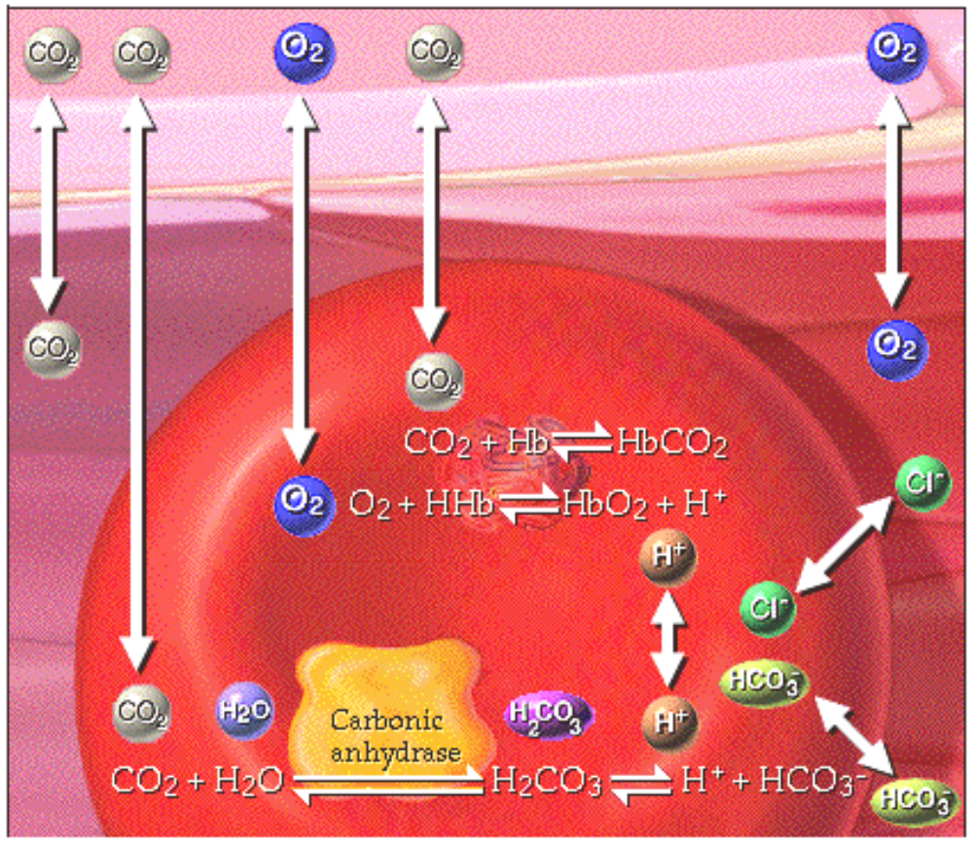

52. (Summary) Identify the direction that each of the arrows would take in the tissues:
