Control of Respiration
Graphics are used with permission of:
Pearson Education Inc., publishing as Benjamin Cummings (http://www.aw-bc.com)

Page 1. Introduction
• The basic rhythm of breathing is controlled by respiratory centers located in the brainstem.
• This rhythm is modified in response to input from sensory receptors and from other regions of the brain.

Page 2. Goals
• To understand how the respiratory centers control breathing to maintain homeostasis.
• To examine how PCO2, pH, PO2, and other factors affect ventilation.
• To understand the relationship between breathing and blood pH.
• To explore the factors which stimulate increased ventilation during exercise.

Page 3. Homeostasis and the Control of Respiration
• Fill out the chart to the right as you proceed through this page.  • The control of respiration is tied to the principle of homeostasis.  • Recall that the body maintains homeostasis through homeostatic control mechanisms, which have three basic components:  1. receptors  2. control centers  3. effectors  • The principal factors which control respiration are chemical factors in the blood.  • Changes in arterial PCO2, PO2 and pH are monitored by sensory receptors called chemoreceptors.  • The chemoreceptors send sensory input to respiratory centers in the brainstem, which determine the appropriate response to the changing variables.  • These centers then send nerve impulses to the effectors, the respiratory muscles, to control the force and frequency of contraction.  • This changes the ventilation, the rate and depth of breathing.  • Ventilation changes restore the arterial blood gases and pH to their normal range. | 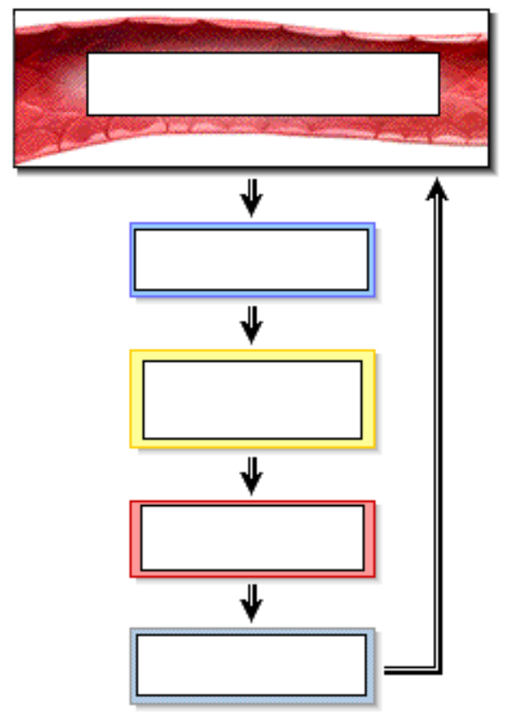

Page 4. Inspiratory Neurons
• Label the diagram to the right.  • The basic rhythm of breathing is controlled by respiratory centers located in the medulla and pons of the brainstem.  • Within the medulla, a group of neurons in the ventral respiratory group sets the basic rhythm by automatically initiating inspiration. | 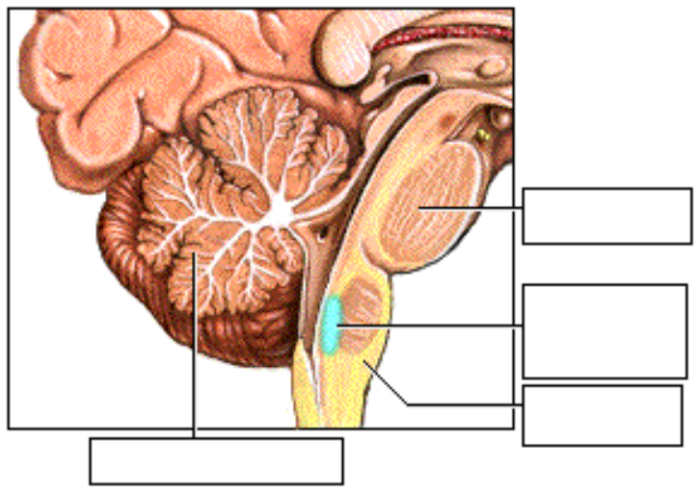
• The inspiratory neurons sends nerve impulses along the phrenic nerve to the diaphragm and along the intercostal nerves to the external intercostal muscles.
• The nerve impulses to the diaphragm and the external intercostal muscles continue for a period of about 2 seconds. This stimulates the inspiratory muscles to contract, initiating inspiration.
• A second group of neurons In the ventral respiratory group now fires, inhibiting the inspiratory neurons for about 3 seconds, which allows the muscles to relax. The elastic recoil of the lungs and chest wall leads to expiration.
• The automatic rhythm generated by these two groups of neurons alternately inhibiting each other produces the normal resting breathing rate, ranging between 12 and 15 breaths per minute.
• Label this diagram:
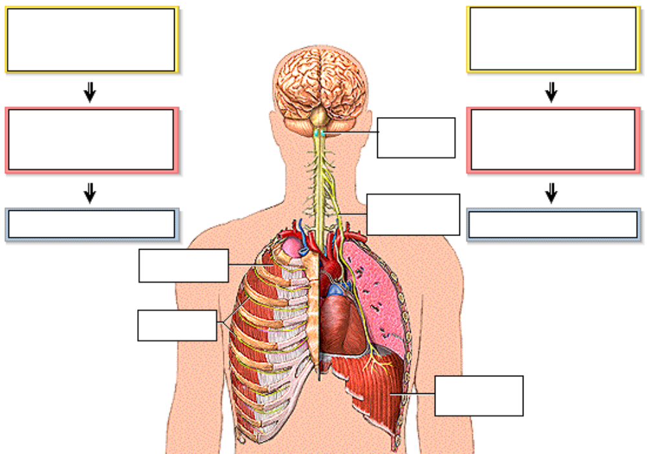

Page 5. Other Respiratory Control Centers
• The dorsal respiratory group, or DRG, acts as an integrating center for peripheral stretch and chemoreceptor inputs, and influences the activity of the neurons in the VRG.
• Both the DRG and the VRG receive inputs from other respiratory centers in the pons, which modify inspiration, and allow for smooth transitions between inspiration and expiration.
• Label the diagram on the next page.

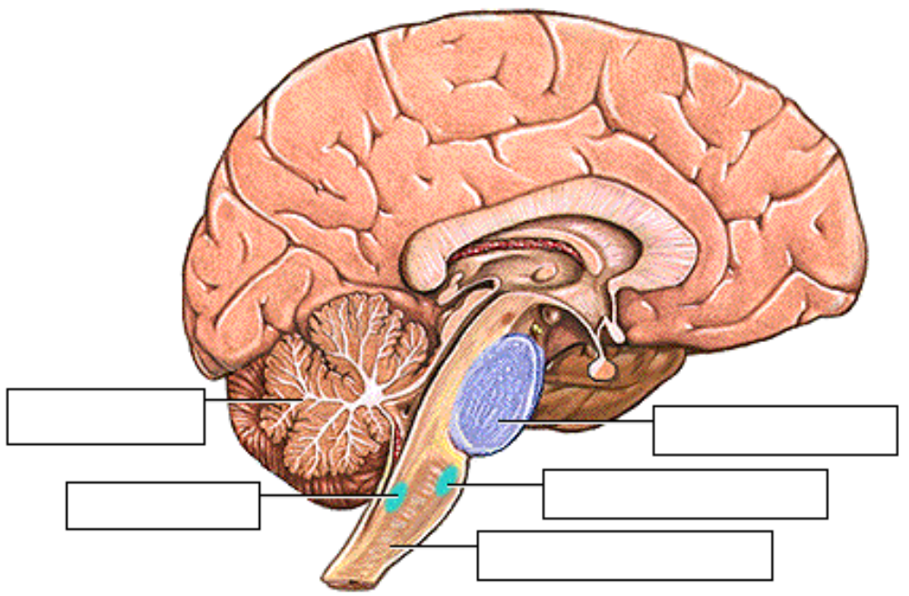
** Now is a good time to go to quiz question 1:
• Click the Quiz button on the left side of the screen.
• After answering question 1, click the Back to Topic button on the left side of the screen.
• To get back to where you left off, click on the scrolling page list at the top of the screen and choose "6. Location of the Chemoreceptors".

Page 6. Location of the Chemoreceptors
• Although the basic rhythm of breathing is established by the respiratory centers, it is modified by input from the central and peripheral chemoreceptors.
• They respond to changes in the PCO2, pH, and PO2 of arterial blood, which are the most important factors that alter ventilation.
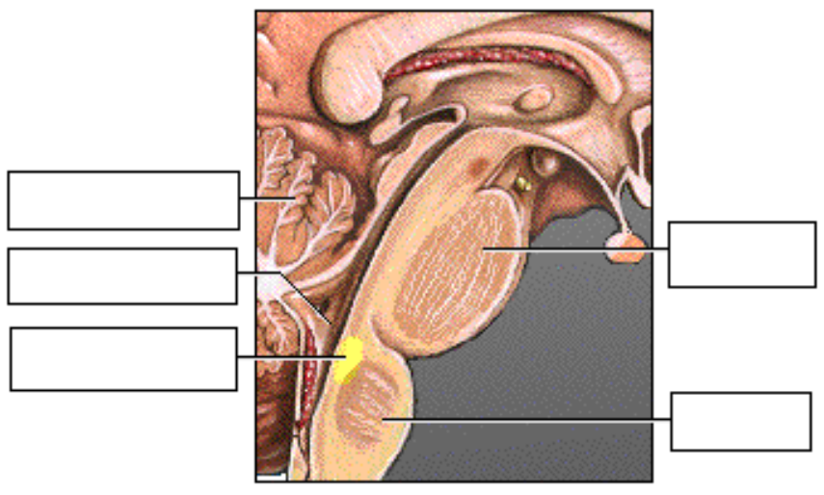
• The central chemoreceptors in the medulla monitor the pH associated with CO2 levels within the brain. The chemoreceptors synapse directly with the respiratory centers.
• The peripheral chemoreceptors are found in two locations:
1. the aortic bodies within the aortic arch
2. the carotid bodies at the bifurcation of the common carotid arteries
• The peripheral chemoreceptors monitor the PCO2, pH and PO2 of arterial blood. This information travels to the respiratory centers via the vagus and glossopharyngeal nerves.

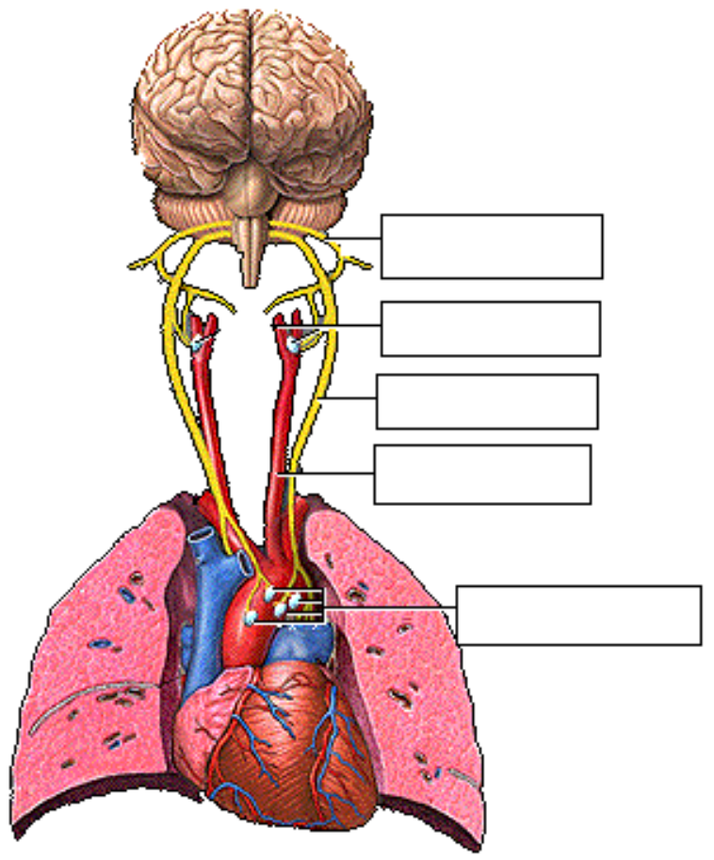

Page 7. Central Chemoreceptors: Effect of PCO2
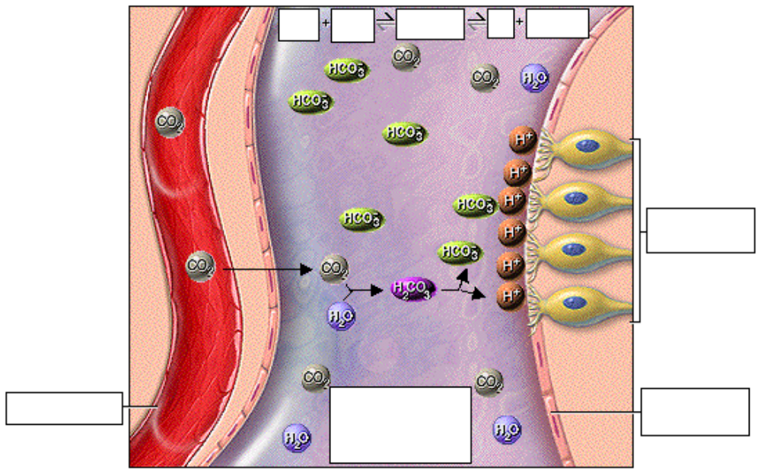
• The most important factor controlling the rate and depth of breathing is the effect of carbon dioxide on the central chemoreceptors.
• Carbon dioxide readily diffuses from the blood into the brain. Here, carbon dioxide combines with water to form carbonic acid, which dissociates into hydrogen ions and bicarbonate ions.
• The hydrogen ions stimulate the central chemoreceptors, which send nerve impulses to the respiratory centers in the medulla.
• As carbon dioxide increases, so does the number of hydrogen ions, which in turn lowers the pH. The central chemoreceptors actually respond to this pH change caused by the blood PCO2.

Page 8. Predict the Effect of Increased PCO2
• Fill in the diagram to the right:  • What will happen to the breathing rate and depth if the arterial PCO2 increases?  • An increase in the PCO2 in the blood leads to an increase in hydrogen ions in the brain, decreasing the pH.  • The central chemoreceptors fire more frequently, sending more nerve impulses to the respiratory centers, which in turn send more nerve impulses to the respiratory muscles.  • This results in an increased breathing rate and depth, allowing more carbon dioxide to be exhaled, returning the blood PCO2 to normal levels. | 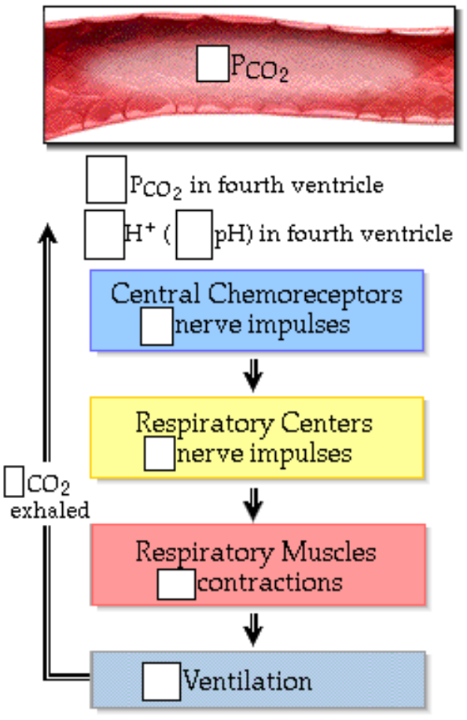

** Now is a good time to go to quiz question 2:
• Click the Quiz button on the left side of the screen.
• Click on the scrolling page list at the top of the screen and choose "2: Central Chemoreceptors".
• After answering question 2, click the Back to Topic button on the left side of the screen.
• To get back to where you left off, click on the scrolling page list at the top of the screen and choose "9. Peripheral Chemoreceptors: Effect of pH Changes".

Page 9. Peripheral Chemoreceptors: Effect of pH Changes
• The peripheral chemoreceptors also respond to pH changes caused by PCO2 changes, however they directly monitor changes in the arterial blood, not the cerebrospinal fluid as the central chemoreceptors do.
• The role of the peripheral chemoreceptors:
• Increased carbon dioxide levels in the arterial blood result in decreased blood pH, which stimulates the peripheral chemoreceptors.
• They respond by sending more nerve impulses to the respiratory centers, which stimulate the respiratory muscles, causing faster and deeper breathing.
• More carbon dioxide is exhaled, which drives the chemical reaction to the left and returns the PCO2 and pH to normal levels.
• Fill in the diagram to the right:  • The peripheral chemoreceptors also respond to acids such as lactic acid, which is produced during strenuous exercise:  • Active muscles produce lactic acid, which enters the blood, releases hydrogen ions, and lowers the pH.  • The decreased pH stimulates the peripheral chemoreceptors to send more nerve impulses to the respiratory centers, which stimulate the respiratory muscles to increase the breathing rate and depth.  • More carbon dioxide is exhaled, lowering the PCO2 in blood, driving the chemical reaction to the left, and lowering hydrogen ion levels. | 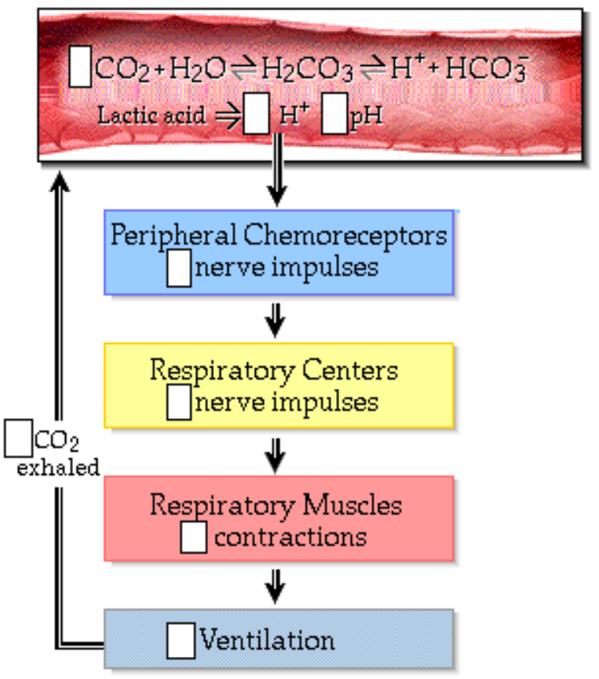

Page 10. Peripheral Chemoreceptors: Effect of PO2
• The peripheral chemoreceptors also monitor arterial PO2, however, the arterial PO2 must drop below 60 millimeters of mercury before the chemoreceptors respond.  • The normal alveolar PO2 of about 100 millimeters of mercury results in 98% hemoglobin saturation in the blood.  • If the PO2 drops to 60 millimeters of mercury, hemoglobin is still 90% saturated.  • Any increased ventilation in this range of PO2's results in only a small increase in the amount of oxygen loaded into the blood.  • However, at very high altitudes, the alveolar PO2 may fall to 40 millimeters of mercury and hemoglobin will be only 75% saturated. At this point, increased ventilation will make a dramatic difference in the amount of oxygen loaded into the blood. | 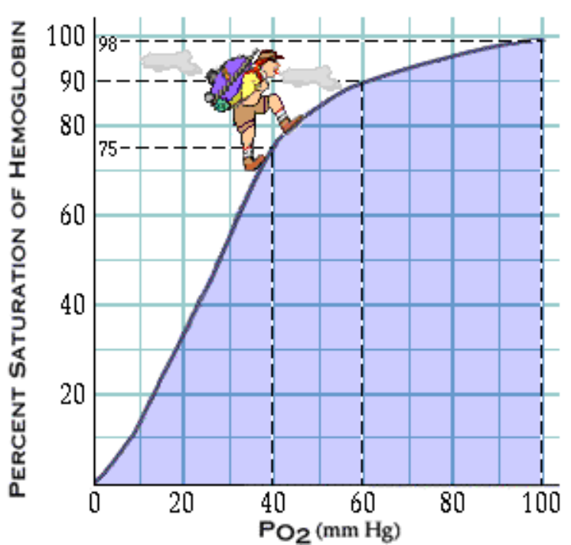

• The low PO2 in the blood stimulates the peripheral chemoreceptors to send nerve impulses to the respiratory centers which stimulate the respiratory muscles, increasing ventilation. More oxygen is inhaled, and the arterial PO2 returns to normal levels.  ** Now is a good time to go to quiz questions 3 and 4:  • Click the Quiz button on the left side of the screen.  • Click on the scrolling page list at the top of the screen and choose "3. Peripheral Chemoreceptors: O2".  • After answering question 4b, click the Back to Topic button on the left side of the screen.  • To get back to where you left off, click on the scrolling page list at the top of the screen and choose "11. Hyperventilation". |  | 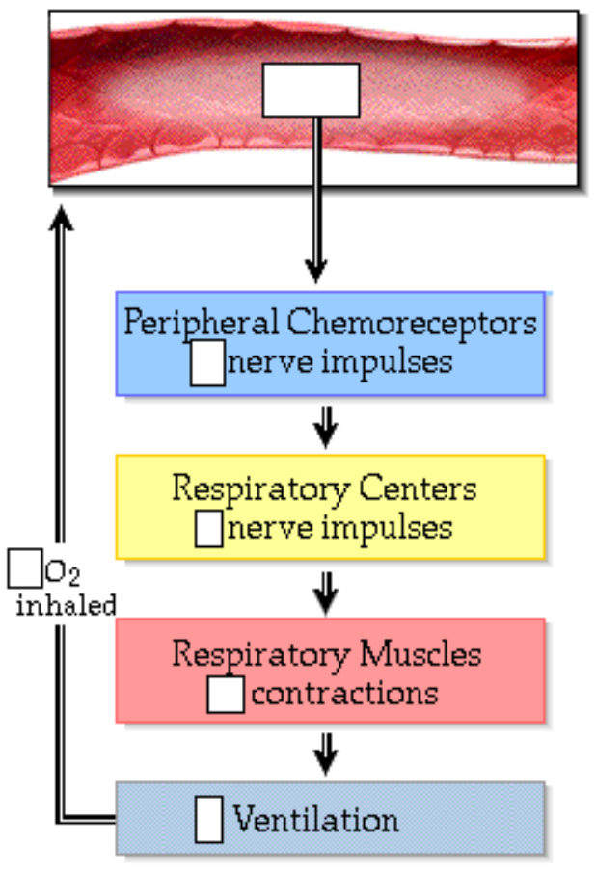
Page 11. Hyperventilation

• What changes will occur if a person hyperventilates, that is, breathes deeper and faster than necessary for normal gas exchange?  • During hyperventilation, carbon dioxide is exhaled, lowering the PCO2.  • This drives the chemical reaction to the left, decreasing the hydrogen ion concentration, and increasing pH:  CO2 + H2O H2CO3 H+ + HCO3-  • Since the PCO2 is low, the central chemoreceptors send fewer impulses to the respiratory centers.  • Since the pH is high, the peripheral chemoreceptors also send fewer impulses to the respiratory centers, which send fewer nerve impulses to the respiratory muscles, thereby further decreasing breathing rate and depth and returning the arterial gases and pH to normal levels. | 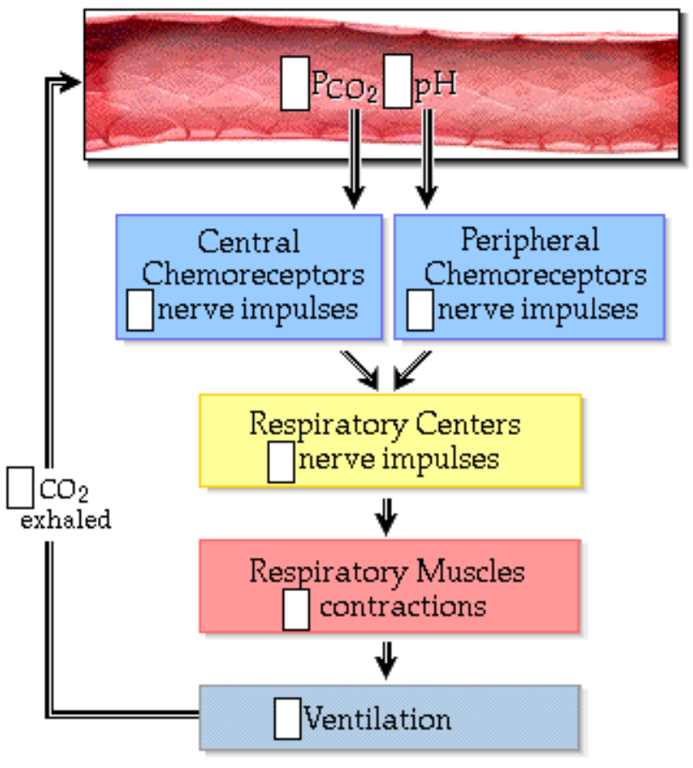
• Hyperventilation does not normally cause an increase in the oxygen levels in the blood, because oxygen is poorly soluble in blood and normally hemoglobin in arterial blood is saturated with oxygen already.

Page 12. Hypoventilation
• Now predict what changes will occur if a person hypoventilates.  • Hypoventilation occurs when the breathing rate and depth is too low to maintain normal blood gas levels.  • During hypoventilation, not enough oxygen is inhaled, so the PO2 decreases. In addition, carbon dioxide builds up in the blood, increasing the PCO2. This drives the chemical reaction to the right, increasing the H+ concentration and decreasing pH.  • The PO2 drops, but not enough to stimulate the peripheral chemoreceptors.  • The high PCO2 stimulates the central chemoreceptors to send more impulses to the respiratory centers.  • A decrease in pH stimulates the peripheral chemoreceptors, which also send more nerve impulses to the respiratory centers, which stimulate the respiratory muscles, increasing the breathing rate and depth.  • This allows oxygen to be inhaled, carbon dioxide to be exhaled, and drives the chemical reaction to the left, returning the arterial gases and pH to normal levels. | 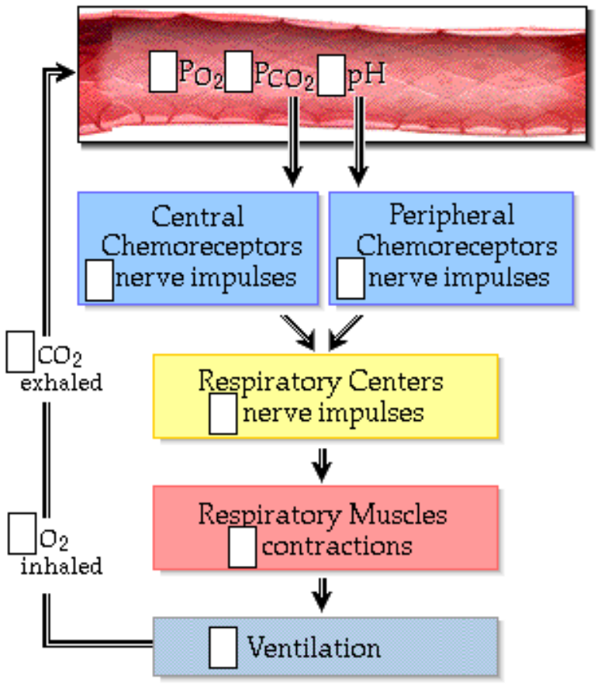

Page 13. Summary: Effects of PO2, pH, and PCO2
• This chart summarizes how the three major chemical factors - PO2, pH, and PCO2 - modify breathing rate and depth.
• When the PO2 drops below 60 millimeters of mercury, the peripheral chemoreceptors send nerve impulses to the respiratory centers. The respiratory centers send nerve impulses to the respiratory muscles, increasing ventilation. More oxygen is inhaled, returning the PO2 to normal levels.
• When cells release acids into the blood, the acids release hydrogen ions, which lower the pH. This stimulates the peripheral chemoreceptors to send more nerve impulses to the respiratory centers. They, in turn, send more nerve impulses to the respiratory muscles, increasing ventilation. More carbon dioxide is exhaled, which returns the pH to normal levels.
• An increase in PCO2 leads to a decreased pH in the blood, which stimulates the peripheral chemoreceptors to send more nerve impulses to the respiratory centers. In addition, the increased PCO2 leads to a decreased pH within the brain. This stimulates the central chemoreceptors to send more nerve impulses to the respiratory centers. The respiratory centers send more nerve impulses to the respiratory muscles, which increase breathing rate and depth. More carbon dioxide is exhaled, returning the PCO2 and pH to normal levels.

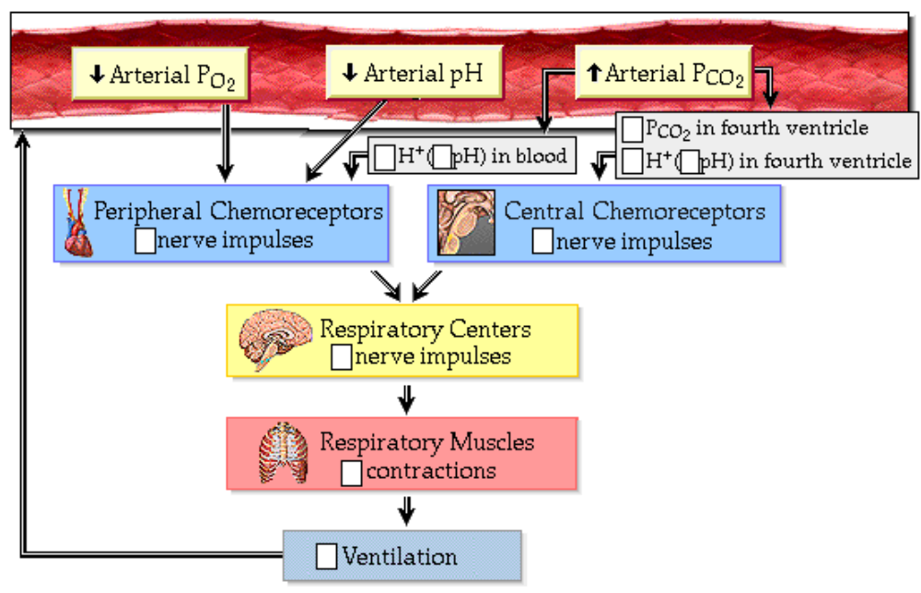
Page 14. Other Factors Which Influence Ventilation
Several other factors influence ventilation. These factors include:
1. Voluntary control.
• By sending signals from the cerebral cortex to the respiratory muscles, we can voluntarily change our breathing rate and depth when holding our breath, speaking, or singing.
• However, chemoreceptor input to the respiratory centers will eventually override conscious control and force you to breathe.
2. Pain and emotions.
• Pain and strong emotions, such as fear and anxiety, act by way of the hypothalamus to stimulate or inhibit the respiratory centers.
• Laughing and crying also significantly alter ventilation.
3. Pulmonary irritants.
• Dust, smoke, noxious fumes, excess mucus and other irritants stimulate receptors in the airways.
• This initiates protective reflexes, such as coughing and sneezing, which forcibly remove the irritants from the airway.
4. Lung hyperinflation.
• Stretch receptors in the visceral pleura and large airways send inhibitory signals to the inspiratory neurons during very deep inspirations, protecting against excessive stretching of the lungs. This is known as the inflation, or Hering-Breuer, reflex.

Page 15. Exercise and Ventilation
• Changes in ventilation during exercise:
• Ventilation increases during strenuous exercise, with the depth increasing more than the rate.
• It appears that changes in PCO2 and PO2 do not play a significant role in stimulating this increased ventilation.
• Although the precise factors which stimulate increased ventilation during exercise are not fully understood, they probably include:
1. Learned responses.
• Ventilation increases within seconds of the beginning of exercise, probably in anticipation of exercise, a learned response.
2. Neural input from the motor cortex.
• The motor areas of the cerebral cortex which stimulate the muscles also stimulate the respiratory centers.
3. Receptors in muscles and joints.
Proprioceptors in moving muscles and joints stimulate the respiratory centers.
4. Increased body temperature.
• An increase in body temperature stimulates the respiratory centers.
5. Circulating epinephrine and norepinephrine.
• Circulating epinephrine and norepinephrine secreted by the adrenal medulla stimulates the respiratory centers.
6. pH changes due to lactic acid
• Lactic acid, produced by exercising muscles, is another stimulus.

Page 16. Summary
• The basic rhythm of breathing is set by the ventral respiratory group, located in the medulla. Other respiratory centers, located in the medulla and pons, also control breathing.
• Chemoreceptors monitor the PCO2, pH, and PO2 of arterial blood and alter the basic rhythm of breathing.
• Carbon dioxide, reflected by changes in pH, is the most important stimulus controlling ventilation.
• pH changes due to metabolic acids also alter ventilation.
• Oxygen stimulates ventilation only when the blood PO2 is very low.
• Other factors, such as voluntary control, pain and emotions, pulmonary irritants, and lung hyperinflation, also play roles in controlling ventilation.
• The control of ventilation during exercise, while complex and not fully understood, involves multiple inputs including chemical and neural factors.

** Now is a good time to go to quiz questions 5 and 6:
• Click the Quiz button on the left side of the screen.
• Click on the scrolling page list at the top of the screen and choose "5.Change in Breathing Rate and Depth".
• Work through quiz questions 5 and 6.

Notes on Quiz Questions:
Quiz Question #1a,b: Respiratory Centers
• This question asks you to identify the parts of the brain which are responsible for setting the basic rhythm of breathing, forceful expiration, and allowing for smooth transitions between inspiration and expiration.

Quiz Question #2a,b: Central Chemoreceptors
• This question asks you to chose the substances that stimulates the central chemoreceptors.

Quiz Question #3: Peripheral Chemoreceptors: CO2
• This question asks you to list the sequence of events that occurs when there is an increase in blood levels of carbon dioxide.

Quiz Question #4a,b: Peripheral Chemoreceptors: O2
• This question asks you to predict when peripheral chemoreceptors will be stimulated due to lack of oxygen and how they respond

Quiz Question #5: Change in Breathing Rate and Depth
• This question asks you to determine the factors that will increase the rate of respiration.

Quiz Question #6a,b: Breath Holding
• This question asks you to predict what happens when you hold your breath.

Study Questions on Control of Respiration:
1. (Page 1.) What controls the basic rhythm of breathing?

2. (Page 3.) What are the three components of a homeostatic control mechanisms?

3. (Page 3.) What are the principal factors which control respiration?

4. (Page 3.) What monitors changes in arterial PCO2, PO2 and pH?

5. (Page 3.) Where do the chemoreceptors send sensory input to?

6. (Page 3.) Where do the respiratory centers send impulses to?

7. (Page 3.) How is homeostasis of PCO2, PO2 and pH maintained?

8. (Page 4.) Label the first diagram on p. 4.

9. (Page 4.) Where, within the brainstem, is the respiratory center that controls the basic rhythm of breathing?

10. (Page 4.) Where, within the brainstem, are the inspiratory neurons?

11. (Page 4.) Label the anatomy on the second diagram on p. 4.

12. (Page 4.) Explain how the inspiratory neurons initiate inspiration.

13. (Page 4.) Explain how the inspiratory neurons initiate expiration.

14. (Page 4.) What is a normal respiratory rate?

15. (Page 5.) Label the diagram on page 5.

16. (Page 5.) What is the function of the dorsal respiratory group?

17. (Page 5.) Where are the respiratory centers that are responsible for smooth transitions between inspiration and expiration?

18. (Page 6.) Label the first diagram on page 6.

19. (Page 6.) Label the second diagram on page 6.

20. (Page 6.) What are the two general categories of chemoreceptors involved in respiration?

21. (Page 6.) Where are the central chemoreceptors located?

22. (Page 6.) Where are the peripheral chemoreceptors located?

23. (Page 6.) What do the central chemoreceptors monitor?

24. (Page 6.) What do the peripheral chemoreceptors monitor?

25. (Page 6.) How does information get from the chemoreceptors to the respiratory centers?

26. (Page 7.) What is the most important factor controlling the rate and depth of breathing?

27. (Page 7.) Does the carbon dioxide stimulate the central chemoreceptors directly?

28. (Page 7.) What is the relationship between hydrogen ions and pH?

29. (Page 7.) Label the diagram on page 7.

30. (Page 8.) In each of these blanks, put "increase(s)" or "decrease(s)": If the arterial PCO2 increases, there is a(an) a. _______ in the PCO2 in the fourth ventricle. This causes a(an) b. ________ in hydrogen ions in the cerebrospinal fluid, which c. ___________ the pH of the cerebrospinal fluid. The hydrogen ions stimulate the central chemoreceptors to d. ________ their rate of firing, which e. __________ the nerve impulses to the respiratory centers. This f. _______ the rate of nerve impulses to the respiratory muscles, resulting in a(an) g. ______ in breathing rate and depth. As a result, there is a(an) h. _________ in carbon dioxide exhalation which i. _________ the blood PCO2 to normal levels.

31. (Page 9.) Do peripheral chemoreceptors directly respond to changes in the arterial blood, venous blood, or brain?

32. (Page 9.) What do the peripheral chemoreceptors directly respond to?
33. (Page 9.) In each of these blanks, put "increase(s)" or "decrease(s)": An increase in carbon dioxide levels in the arterial blood result in a(an) a. _______ in blood pH. There is a(an) b. ________ in the rate of firing of the peripheral chemoreceptors, which c, _______ the rate of respiration. As a result there is a(an) d. ______ in carbon dioxide exhalation, which drives the chemical reaction to the left and e. _________ PCO2 and pH returns to normal levels.

34. (Page 9.) In each of these blanks, put "increase(s)" or "decrease(s)": The peripheral chemoreceptors also respond to acids such as lactic acid, which a. ________ during strenuous exercise. The lactic acid enters the blood and b. __________ the concentration of hydrogen ions which c. _________ the pH which d. _______ the firing rate of the peripheral chemoreceptors. There is a(an) e. ________ in nerve impulses to the respiratory centers, which f. _______ the breathing rate and depth. There is a(an) g. _________ in carbon dioxide is exhalation which h. __________ the PCO2 in blood, driving the chemical reaction to the left, and i. ________ hydrogen ion levels.

35. (Page 10.) When are peripheral chemoreceptors stimulated by oxygen?

36. (Page 10.) In each of these blanks, put "increase(s)" or "decrease(s)": When the PO2 of the arterial blood decreases to below 60 mm Hg, there is a(an) a. _______ in the rate of firing in the peripheral chemoreceptors resulting in a(an) b. _________ in nerve impulses to the respiratory centers. As a result there is a(an) c. _________ in ventilation. As a result, the oxygen level in the blood d. _______ and the arterial PO2 returns to normal levels.

37. (Page 11.) In hyperventilation, which blood gas is affected the most, oxygen or carbon dioxide?

38. (Page 11.) What happens to blood levels of carbon dioxide during hyperventilation?

39. (Page 11.) As a result of hyperventilation, which direction does this reaction go?
a. CO2 + H2O H2CO3 H+ + HCO3- b. CO2 + H2O H2CO3 H+ + HCO3-

40. (Page 11.) In each of these blanks, put "increase(s)" or "decrease(s)": During hyperventilation, carbon dioxide levels in the blood a. ________. This causes a(an) b. ______ in the hydrogen ion concentration. pH c. _________. The rate of firing of the peripheral and central chemoreceptors d. __________. There is a(an) e. ________ in impulses to the respiratory centers and the respiratory rate f. ________.

41. (Page 12.) What happens to blood levels of carbon dioxide during hypoventilation?

42. (Page 12.) As a result of hypoventilation, which direction does this reaction go?
a. CO2 + H2O H2CO3 H+ + HCO3- b. CO2 + H2O H2CO3 H+ + HCO3-

43. (Page 12.) In each of these blanks, put "increase(s)" or "decrease(s)": During hypoventilation, carbon dioxide levels in the blood a. ________. This causes a(an) b. ______ in the hydrogen ion concentration. pH c. _________. The rate of firing of the peripheral and central chemoreceptors d. __________. There is a(an) e. ________ in impulses to the respiratory centers and the respiratory rate f. ________.
44. (Page 14.) Besides pH, PCO2 and PO2what other factors influence ventilation?
45. (Page 14.) What is the Hering-Breuer reflex?
46. (Page 15.) Do changes in PCO2 and PO2 play a significant role in stimulating increased ventilation due to exercise?
47. (Page 15.) What are the factors that stimulate increased ventilation during exercise?

