Glomerular Filtration
Graphics are used with permission of:
Pearson Education Inc., publishing as Benjamin Cummings (http://www.aw-bc.com)

Page 1. Introduction
• Formation of urine by the kidney involves three main processes:
1. filtration
2. reabsorption
3. secretion
• During filtration large quantities of water and solutes pass through the filtration membrane from the blood into the glomerular capsule.

Page 2. Goals
• To preview the three major processes of the kidney.
• To understand the function of the filtration membrane.
• To understand the composition of the glomerular filtrate.
• To understand the forces that determine glomerular filtration rate.
• To examine the regulation of glomerular filtration.

Page 3. Renal Processes
• This simplified diagram of a kidney nephron shows the afferent and efferent arterioles, glomerular capsule, capsular space, glomerulus, the beginning of the renal tubule, and peritubular capillaries.
• Label the diagram and draw arrows to indicate the processes of filtration, reabsorption, and secretion:
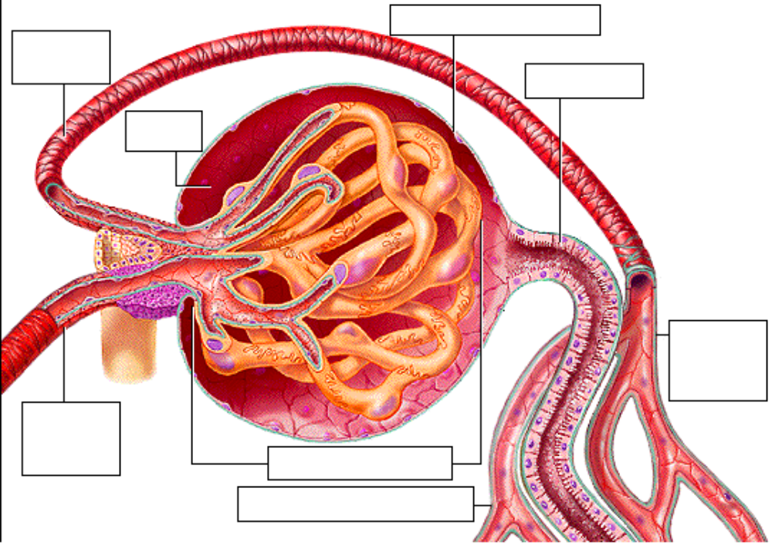
• Filtration. The formation of urine begins with the process of filtration. Fluid and small solutes are forced under pressure to flow from the glomerulus into the capsular space of the glomerular capsule.
• Reabsorption. As this filtrate passes through the tubules, specific substances are reabsorbed back into the blood of the peritubular capillaries.
• Secretion. In addition, some solutes are removed from the blood of the peritubular capillaries and secreted by the tubular cells into the filtrate to “fine tune” the composition of the blood.
• The rest of this topic covers filtration, while the filtrate processing topics in this module will cover reabsorption and secretion.

Page 4. The Filtration Process
• A coffee maker provides an everyday example of filtration. The paper filter acts as the filtration membrane. It holds back the large coffee grounds, while letting water and small solutes like caffeine and flavor molecules pass through.
• A force is required to drive this process. In a coffee maker, it's the force of gravity.

• What is the filtration force in the glomerulus? ________________________________

Page 5. The Filtration Membrane and Glomerular Filtration
• Just as a filter keeps grounds out of your coffee, the glomerular filtration membrane keeps blood cells and proteins out of the urine passageways.
• The filtration membrane is composed of three layers:
1. Fenestrated glomerular endothelium
2. Basement membrane
3. Filtration slits formed by pedicels of the podocytes
• Label this diagram:
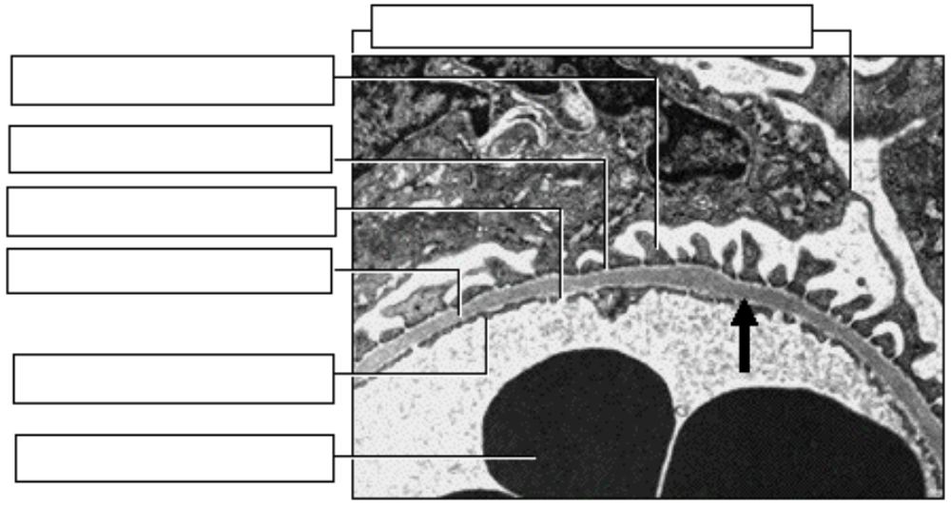
• Passage through the filtration membrane is limited not only on the basis of size but also by charge.
• Glomerular filtration is a process of bulk flow driven by the hydrostatic pressure of the blood.
• Small molecules pass rapidly through the filtration membrane, while large proteins and blood cells are kept out of the capsular space.
• If the filtration membrane is damaged, proteins will leak through and end up in the urine.
• If the filtration membrane is very badly damaged, then blood cells will leak through.
• Consequences of loss of protein in the urine:
• Loss of albumin causes a decrease in osmotic pressure. Fluid will leak into the interstitial spaces and edema results. Eventually there will be a low circulatory volume and possibly shock.
• Loss of blood clotting proteins can cause uncontrolled bleeding.
• Loss of globulins and complement proteins make the individual prone to infection.

Page 6. Glomerular Filtrate
• The fluid and solutes collecting in the capsular space is called glomerular filtrate.
• The concentration of each of these substances in the glomerular filtrate is similar to its concentration in plasma.
• Record the composition of the glomerular filtrate here:
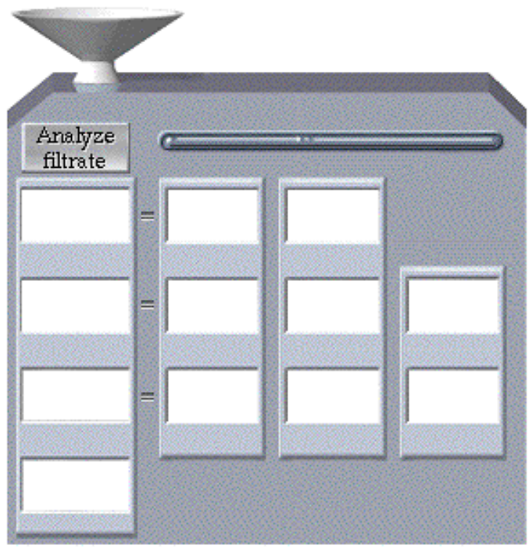

Page 7. Damage to Filtration Membrane
• How might the contents of the filtrate be altered if the filtration membrane is damaged or destroyed? List factors here:

_____________________________________________________

_____________________________________________________
• Presence of protein in the urine is called proteinuria.
• Presence of blood cells in the urine is called hematuria.

** Now is a good time to go to quiz questions 1-2:
• Click the Quiz button on the left side of the screen
• Work through questions 1-2.
• After answering question 2, click the Back to Topic button on the left side of the screen.
• To get back to where you left off, click on the scrolling page list at the top of the screen and choose "8. Forces Affecting Filtration".

Page 8. Forces Affecting Filtration
• There are three forces affecting filtration at the glomerulus:
1. Hydrostatic Pressure within the Glomerular Capillaries
• The blood pressure in the glomerulus averages 60 millimeters of mercury. This unusually high capillary pressure is the result of the short, large diameter afferent arterioles conveying blood at high arterial pressure directly to the glomerular capillaries.
• The smaller diameter of the efferent arterioles leaving the glomerulus also helps maintain the pressure by restricting the outflow of blood.
• However, the glomerular hydrostatic pressure is opposed by two forces that reduce the flow of fluid into the capsular space.
2. Back Pressure from Fluid Within the Capsule
• Fluid already in the capsular space creates a “back pressure” that resists the incoming fluid. This capsular hydrostatic pressure averages 15 millimeters of mercury.
3. Osmotic Pressure within the Glomerular Capillaries
• The second opposing force is the osmotic pressure of the blood in the glomerular capillaries. Remember that the capillaries retain proteins, which become more concentrated in the blood as the filtrate flows out. Because of these proteins, the osmolarity of the blood is higher than the osmolarity of the filtrate. The osmotic pressure of the blood, or its tendency to draw the fluid back in, averages 28 millimeters of mercury.
• The algebraic sum of these three forces produces the net filtration pressure of 17 millimeters of mercury.
Net Filtration Pressure = 60 mm Hg - (15 mm Hg + 28 mm Hg) = 17 mm Hg

Page 9. Forces Affecting Filtration Analogy
• An analogy for this process would be a football player (#60) trying to run for a touchdown. However, his progress to the goal line is slowed by two opposing players (#15 and #28). The runner eventually reaches the goal, but not as easily as he would without the resistance.
• Now let’s see what happens when a smaller player carries the ball. Click the football to start the process. Here the two opposing forces, players #15 and #28, add together to counteract a smaller, weaker player, #43, stopping his forward progress. This situation is analogous to glomerular hydrostatic pressure too low to overcome the countering forces and carry out filtration. This is referred to as “kidney shut-down” or acute renal failure. Serious consequences will occur unless increased pressure and filtration are resumed.

Page 10. Glomerular Filtration Rate (GFR)
• The total amount of filtrate formed by all the renal corpuscles in both kidneys per minute is called the glomerular filtration rate, or GFR. In normal kidneys, the 17 millimeters of mercury of net filtration pressure produces approximately 125 milliliters of filtrate per minute. This translates to about 180 liters in 24 hours--nearly enough to fill a 50-gallon barrel! Fortunately, 99% of this volume will be reabsorbed as the filtrate passes through the tubules.
• The glomerular filtration rate is directly proportional to the net filtration pressure, so a fluctuation in any of the three pressures previously discussed will change the GFR. Prolonged changes in normal GFR will cause either too much or too little water and solutes to be removed from the blood.

** Now is a good time to go to quiz question 3:
• Click the Quiz button on the left side of the screen.
• Click on the scrolling page list at the top of the screen and choose "3. Filtration Pressures".
• After answering question 3, click the Back to Topic button on the left side of the screen.
• To get back to where you left off, click on the scrolling page list at the top of the screen and choose "11. Autoregulation of GFR".

Page 11. Autoregulation of GFR
• Fill out this diagram as you work through this page:
 | Normal | Mild Exercise | Relaxation
Systemic
Pressure
State of Afferent
Arteriole
Glomerular
Hydro-static Pressure
Net Filtration
Rate

• During normal conditions, systemic blood pressure registers approximately 120 millimeters of mercury; the diameter of the afferent arteriole is normal, as is the glomerular hydrostatic pressure. These conditions provide a normal glomerular filtration rate of 125 milliliters per minute.
• When blood pressure fluctuates during normal daily activities, autoregulatory mechanisms of the kidney alter the diameter of the afferent arteriole, in order to maintain a relatively constant glomerular filtration rate.
• During mild exercise, the systemic blood pressure increases to 140 millimeters of mercury. If the afferent arteriole remains at the normal diameter, the 17% increase in glomerular hydrostatic pressure will cause a similar increase in GFR [of 21 milliliters per minute, to 146 milliliters per minute]. If allowed to continue, this increase will quickly cause severe dehydration. To avoid extensive fluid loss, the autoregulation mechanism decreases the diameter of the afferent arteriole, decreasing the glomerular blood flow. The glomerular hydrostatic pressure and GFR return to normal, even though the mild exercise continues and the systemic blood pressure remains elevated.
• Reducing the activity level returns the systemic blood pressure to 120 millimeters of mercury; the afferent arteriole dilates to maintain normal glomerular hydrostatic pressure and GFR.
• During periods of relaxation, the systemic blood pressure may drop to 100 millimeters of mercury or lower. If the diameter of the afferent arteriole remains normal, blood flow into the glomerulus is reduced. This in turn causes a reduction of glomerular hydrostatic pressure and GFR. To avoid poor filtering of the blood, the afferent arteriole dilates further to increase blood flow and glomerular hydrostatic pressure. Autoregulation has normalized the GFR.

Page 12. GFR Regulation Mechanisms: Myogenic Mechanism
• One of the mechanisms that provides autoregulatory control over renal processes is the result of the inherent tendency of vascular smooth muscle cells to contract when stretched. This allows the diameter of afferent arterioles to respond to changes in blood pressure.
• When blood pressure in an arteriole increases, the walls of the vessel automatically constrict, reducing blood flow through the arteriole.
• Low blood pressure reduces this reflexive constriction, so the arteriole dilates and blood flow is increased.
• In renal autoregulation, this is called the myogenic mechanism.
• Stretching the arteriole wall causes a reflexive vasoconstriction. As long as pressure continues, the vessel will stay constricted.
• When pressure against the vessel wall is reduced, the vessel dilates. Changes in blood pressure therefore directly affect the constriction or dilation of the arteriole, and so glomerular blood flow.
• Fill out this diagram as you work through this page:
 | High BP in Afferent Arteriole | Low BP in Afferent Arteriole
Effect on Wall of
Afferent Arteriole

Effect on Blood
Flow to Glomerulus

Page 13. GFR Regulation Mechanisms: Tubuloglomerular Mechanism
• A second regulatory mechanism is the sensitivity of the macula densa cells of the juxtaglomerular apparatus to the concentration of sodium chloride in the filtrate, which is proportional to the rate of filtrate flow in the terminal portion of the ascending loop of Henle.

• High Osmolarity and High Rate of Filtrate Flow in Tubule.
• Label the diagram below to indicate what happens when there is a high filtrate osmolarity:
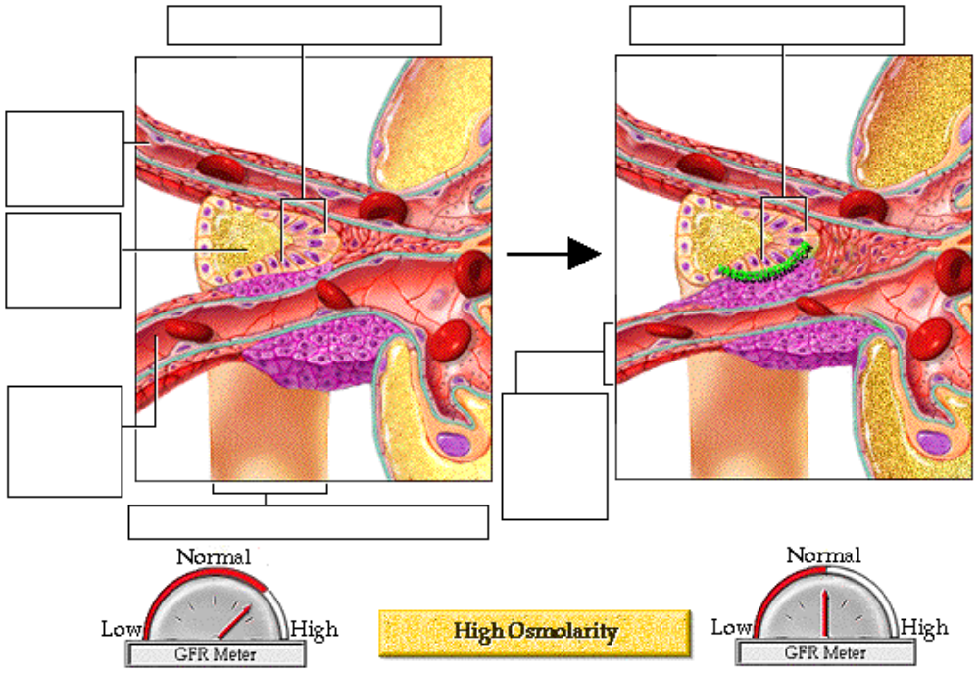
• A higher than normal flow of filtrate, resulting from an increased GFR, causes the concentration of sodium and chloride ions in the filtrate at the end of the ascending limb of the loop of Henle to increase.
• This high sodium chloride concentration stimulates the macula densa cells to release vasoconstrictor chemicals, which cause the afferent arteriole to constrict.
• The result is a lower GFR, lower filtrate flow, and increased tubular reabsorption of sodium and chloride ions.
• Circle the appropriate highlighted word(s) in the chart below:
High GFR
↓
High/Low Filtrate Flow Rate in the Tubules
↓
Increased/Decreased Reabsorption of Ions in the Tubules
↓
High/Low Concentration of Sodium Chloride in the Tubules
↓
Macula Densa Cells Release/Do Not Release Vasoconstrictor
↓
Afferent Arteriole Dilates/Constricts
↓
GFR Increases/Decreases
↓
Filtration Flow Rate Increases/Decreases
↓
Increased/Decreased Reabsorption of Ions in the Tubules
↓
Higher/Lower Sodium Chloride Concentration in the Tubules

• Low Osmolarity and High Rate of Filtrate Flow in Tubule.
• A low rate of filtrate flow and, therefore, low sodium chloride in the terminal portion of the ascending loop of Henle is also sensed by the macula densa cells. This condition is usually the result of low GFR caused by low blood pressure.
• In response, these cells initiate two effects:
1) They decrease secretion of the vasoconstrictor chemicals. This leads to dilation of the arteriole and so increases blood flow, glomerular hydrostatic pressure, and the GFR
2) The macula densa cells signal the granular cells of the afferent and efferent arterioles to release renin into the bloodstream.
• Circle the appropriate highlighted word(s) in the chart below:
Low GFR
↓
High/Low Filtrate Flow Rate in the Tubules
↓
Increased/Decreased Reabsorption of Ions in the Tubules
↓
High/Low Sodium Chloride Concentration in the Tubules
↓
Macula Densa Cells Release/Do Not Release Vasoconstrictor
↓
Afferent Arteriole Dilates/Constricts
↓
GFR Increases/Decreases
↓
Filtration Flow Rate Increases/Decreases
↓
Increased/Decreased Reabsorption of Ions in the Tubules
↓
Higher/Lower Sodium Chloride Concentration in the Tubules

• Label the diagram below to indicate what happens when there is a low concentration of sodium chloride in the filtrate:
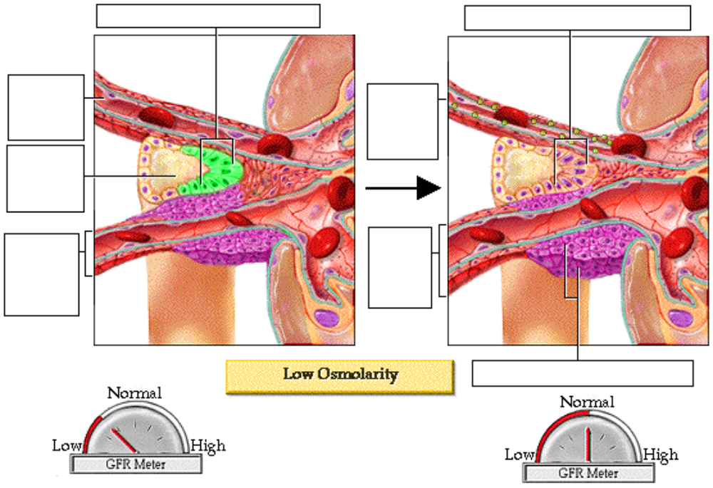

• Effect of Renin on the Regulation of the GFR. In the bloodstream, renin triggers a series of events that increase the level of the hormone angiotensin II. In the kidney, increased angiotensin II causes constriction of the efferent arteriole. This causes the blood flow out of the glomerulus to slow, thus increasing the glomerular hydrostatic pressure and restoring the glomerular filtration rate to normal. Angiotensin II also stimulates the release of the hormone aldosterone. The effects of aldosterone in the kidney will be discussed in the "Late Filtrate Processing" topic of this module.

Page 14. GFR Regulation Mechanisms: Sympathetic Nervous System Control
• Sympathetic nerve fibers innervate all blood vessels of the kidney as an extrinsic regulation mechanism. During normal daily activity they have minimal influence. However, during periods of extreme stress or blood loss, sympathetic stimulation overrides the autoregulatory mechanisms of the kidney.
• Increased sympathetic discharge causes intense constriction of all renal blood vessels. Two important results occur:
1) The activity of the kidney is temporarily lessened or suspended in favor of shunting the blood to other vital organs
2) The lower GFR reduces fluid loss, thus maintaining a higher blood volume and blood pressure for other vital functions. As you can see, renal function has almost stopped.
• Reduction in filtration cannot go on indefinitely, as waste products and metabolic imbalances increase in the blood. Autoregulation mechanisms are now ineffective in preventing acute renal failure.
• When fluid is given intravenously, the blood volume increases. With increasing blood volume, notice the gradual rise in blood pressure, reduction in sympathetic discharge, and restoration of renal functioning.

Page 15. Summary
• Glomerular filtrate is formed by filtration of water and small solutes through the filtration membrane.
• Net filtration pressure is the glomerular hydrostatic pressure minus the opposing forces of capsular hydrostatic pressure and glomerular osmotic pressure.
• Blood pressure and flow in the nephron is monitored and controlled by renal autoregulation mechanisms in order to maintain a relatively steady glomerular filtration rate.
• During periods of severe blood loss, the sympathetic nervous system overrides the renal autoregulatory mechanisms to shunt the blood to other critical areas.

** Now is a good time to go to quiz question 4:
• Click the Quiz button on the left side of the screen.
• Click on the scrolling page list at the top of the screen and choose "4. Autoregulation".

Notes on Quiz Questions:
Quiz Question #1: Filtration Membrane
• This question asks you to identify the layers of the filtration membrane.

Quiz Question #2: Filtrate Contents
• This question asks you to identify the components of filtrate

Quiz Question #3: Filtration Pressures
• This question asks you to identify the types of pressures affecting GFR and predict some of the factors influencing these pressures.

Quiz Question #4: Autoregulation
• This question asks you to predict if the efferent and afferent arteriole will vasoconstrict or vasodilate based on blood pressure. You may want to fill out this chart as you work through this question:
 | Condition A | Condition B | Condition C | Condition D
Blood Pressure

Efferent Arteriole

Afferent Arteriole

Study Questions on Glomerular Filtration:
1. (Page 1,3.) What are the three processes in the formation of urine?

2. (Page 3.) Briefly describe the movement of fluid during filtration. What part of the nephron and what capillaries are involved?

3. (Page 3.) Briefly describe the movement that occurs during reabsorption. What part of the nephron and what capillaries are involved?

4. (Page 3.) Briefly describe the movement that occurs during secretion. What part of the nephron and what capillaries are involved?

5. (Page 3.) In this diagram, identify which arrows correspond to the process of filtration, reabsorption, and secretion. | 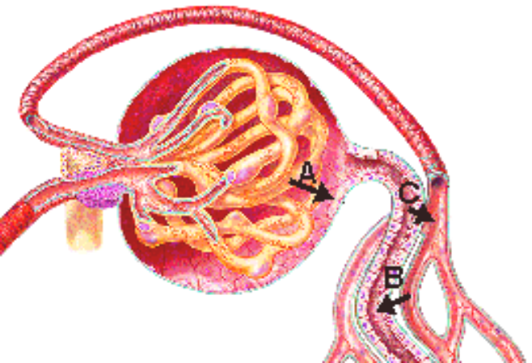
6. (Page 4.) What is the filtration force in the glomerulus?

7. (Page 5.) List the three layers of the filtration membrane.

8. (Page 5.) What is the main factor that determines what passes through the filtration membrane?

9. (Page 5.) Blood can be divided into particles, based on size: blood cells, protein, and small molecules and ions. Which of these can freely pass through the filtration membrane?

10. (Page 5.) What process drives filtration?

11. (Page 5.) If the filtration membrane is damaged and protein is lost in the urine, what effect would the loss of the following plasma proteins have on the body?
a. albumin b. blood clotting proteins c. globulins and complement

12. (Page 6.) What is the fluid called that collects in the capsular space?

13. (Page 6.) What are the four main categories of components of the glomerular filtrate?

14. (Page 6.) Give two examples of organic molecules that are filtered at the glomerulus.

15. (Page 6.) Give three examples of nitrogenous wastes that are filtered at the glomerulus.

16. (Page 6.) Give three examples of ions that are filtered at the glomerulus.

17. (Page 6.) The concentration of substances within the glomerular filtrate are similar to the concentration of substances in the ____.

18. (Page 8.) What are three forces affecting filtration at the glomerulus. In which direction (towards the blood or towards the filtrate) does each of the forces push fluid?

19. (Page 8.) Why is the blood pressure in the glomerulus so high?

20. (Page 8.) Why is there more osmotic pressure in the glomerular capillaries than in the filtrate?

21. (Page 8.) Calculate the net filtration pressure at the glomerulus when the hydrostatic pressure is 60 mm Hg, the back pressure is 15 mm Hg, and the osmotic pressure is 28 mm Hg.

22. (Page 10.) What is the term used for the total amount of filtrate formed by all the renal corpuscles in both kidneys per minute?

23. (Page 10.) What happens to most of the approximately 180 liters of fluid filtered at the glomerulus each day?

24. (Page 10.) What increases or decreases the GFR?

25. (Page 11.) When blood pressure fluctuates during normal daily activities, how does the kidney maintain a relatively constant glomerular filtration rate?

26. (Page 11.) What happens to the diameter of the afferent arteriole during mild exercise? What happens to the GFR?

27. (Page 11.) What happens to the diameter of the afferent arteriole during relaxation? What happens to the GFR?

28. (Page 12, 13, 14) What are the two autoregulatory mechanisms that influence the glomerular filtration rate?

29. (Page 12.) According to the myogenic mechanism for regulation of the glomerular filtration rate, what happens to the afferent arteriole and blood flow to the glomerulus when the wall of afferent arteriole is stretched due to a high blood pressure?

30. (Page 12.) According to the myogenic mechanism for regulation of the glomerular filtration rate, what happens to the afferent arteriole and blood flow to the glomerulus when the wall of afferent arteriole experiences a low blood pressure?

31. (Page 13.) What three factors trigger the tubuloglomerular mechanism for regulation of the glomerular filtration rate?

32. (Page 13.) What does a high concentration of sodium chloride in the terminal portion of the ascending loop of Henle indicate?

33. (Page 13.) What does a low concentration of sodium chloride in the terminal portion of the ascending loop of Henle indicate?

34. (Page 13.) When there is a high glomerular filtration rate, the tubuloglomerular mechanism acts to decrease the GFR. Circle the appropriate highlighted words in the first flowchart on page 13 to explain how this works.

35. (Page 13.) When there is a low glomerular filtration rate, the tubuloglomerular mechanism acts to increase the GFR. Circle the appropriate highlighted words in the second flowchart on page 13 to explain how this works.

36. (Page 13.) What cells produce and secrete renin?

37. (Page 13.) When is renin released?

38. (Page 13.) What is the effect of renin?

39. (Page 13.) What is the effect of constriction of the efferent arteriole?

40. (Page 14.) When does the sympathetic nervous system override the autoregulatory mechanisms of the kidney?

41. (Page 14.) What is the effect of the sympathetic nervous system on the kidney?

