Early Filtrate Processing
Graphics are used with permission of:
Pearson Education Inc., publishing as Benjamin Cummings (http://www.aw-bc.com)

Page 1. Introduction
• Once the filtrate is formed, the early tubular segments of the nephron reabsorb solutes and water back into the blood to restore its volume and composition.
• They also remove some solutes from the blood and secrete them into the filtrate to fine tune the blood’s composition.

Page 2. Goals
• To examine the passive and active processes of reabsorption and secretion
• To understand how filtrate processing differs in early sections of the tubule.
• To understand the role of the countercurrent multiplier in forming the medullary osmotic gradient

Page 3. Reabsorption: Reclaiming Valued Substances
• The relationship of glomerular filtration and tubular reabsorption is something like a parent who cleans a child's room by arbitrarily throwing much of the room's contents into the trash box. That's analogous to glomerular filtration. But as soon as the parent is gone, the child quickly reclaims his favorite things from the box. This rescue of ‘valued substances’ is like the process of tubular reabsorption of solutes back into the blood. All objects remaining in the trash box will be discarded as waste.

Page 4. Reabsorption Pathways
• To be reabsorbed into the blood, substances in the filtrate must cross the barrier formed by the tubular cells.
• There are two reabsorption pathways:
1. the transcellular pathway
2. the paracellular pathway
• Most solutes that are reabsorbed use the transcellular pathway. They diffuse or are actively transported through the luminal and basolateral membranes of the tubular cells into the interstitial space and then into the peritubular capillaries.
• The second pathway is the paracellular one through the tight junctions into the lateral intercellular space. Certain tight junctions are not as tight as the name implies and will allow this pathway, while others will not.
• Although most substances use the transcellular pathway, water and certain ions use both paths, especially in the proximal convoluted tubule. Both pathways lead into the interstitial space, then through the endothelium of the peritubular capillaries into the blood.
• Label this diagram and using arrows indicate both the transcellular and paracellular pathways:
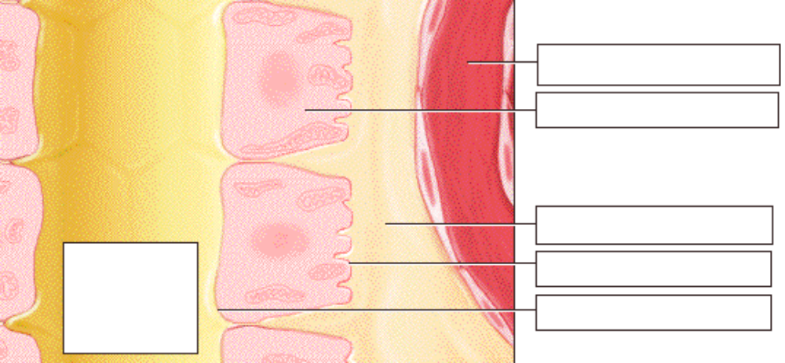

Page 5. Reabsorption Overview: Diffusion of Water
• The force driving the formation of the filtrate is blood pressure within the glomerulus.
• What drives reabsorption, which reclaims the valued substances?
• How water to diffuses from the lumen through the tight junctions of these generic tubular cells into the interstitial space:
1. Water will move from its higher concentration in the tubule through the tight junctions to its lower concentration in the interstitium.
2. Water will also move through the plasma membranes of the cells that are permeable to water.
** Notice that they use a darker color to indicate a higher osmolarity.
• On this diagram, indicate:
1. Where the water concentration is highest and lowest.
2. Where the osmolarity is higher and lower. 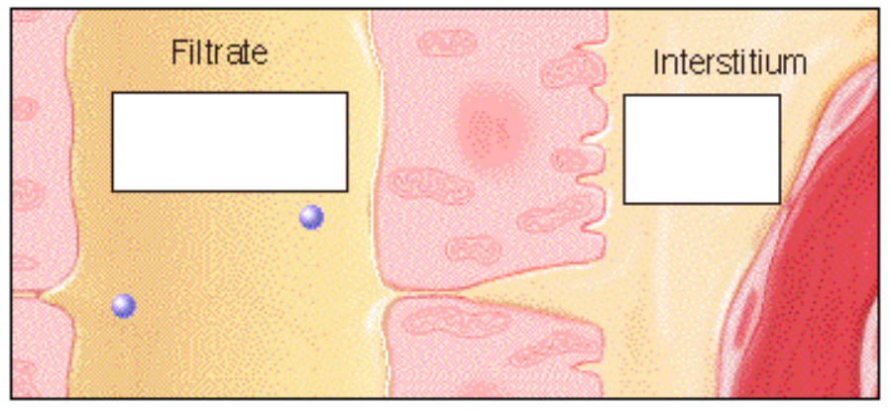

Page 6. Reabsorption Overview: Interstitial Osmolarity
• How can we increase the osmolarity of the interstitium?
• Transporting sodium into the interstitium will raise its osmolarity. Water will then diffuse from the tubule through the tight junctions and permeable plasma membranes to the interstitium, equilibrating the two osmolarities.

Page 7. Reabsorption Overview: Membrane Activity
• How will the reduction in the intracellular sodium ion concentration resulting from the basolateral transport affect the activity at the luminal membrane?
• The transport of sodium ions through the basolateral membrane will cause more ions to be reabsorbed through the luminal membrane.

Page 8. Reabsorption Overview: Summary
• The transport of sodium ions has two important direct results:
1) The interstitial osmolarity increases, causing water to diffuse out of the tubular lumen
2) the lowered intracellular concentration causes additional sodium ions to be reabsorbed through the luminal membrane.
• This provides more sodium ions to be actively transported and enables the cycle to repeat.
• In addition sodium ion transport enables the reabsorption of most substances in the nephron.

Page 9. PCT Basolateral Membrane: Active Transport
• The renal tubules are composed of specialized cells in each region that accomplish a different stage of filtrate processing.
• The proximal convoluted tubule is where major reabsorption of valued substances occurs. We'll look first at the activities occurring at the basolateral membrane of the tubular cells.
• The reabsorption of many substances from the glomerular filtrate in the PCT depends directly or indirectly on the active reabsorption of the sodium ion.
• The cellular structure responsible for this process is the sodium/potassium ATPase ion pump located in the basolateral membrane.
• Using energy from ATP, the ion pump carries out primary active transport of sodium ions out of the cell and potassium ions into the cell.
• As it yields its energy, ATP is converted to ADP and an inorganic phosphate ion, or Pi.
• The sodium-potassium pump is found in the basolateral membrane of many regions of the nephron.

• As you watch the animation of the sodium potassium pump, describe what is happening between each picture in the diagram below:
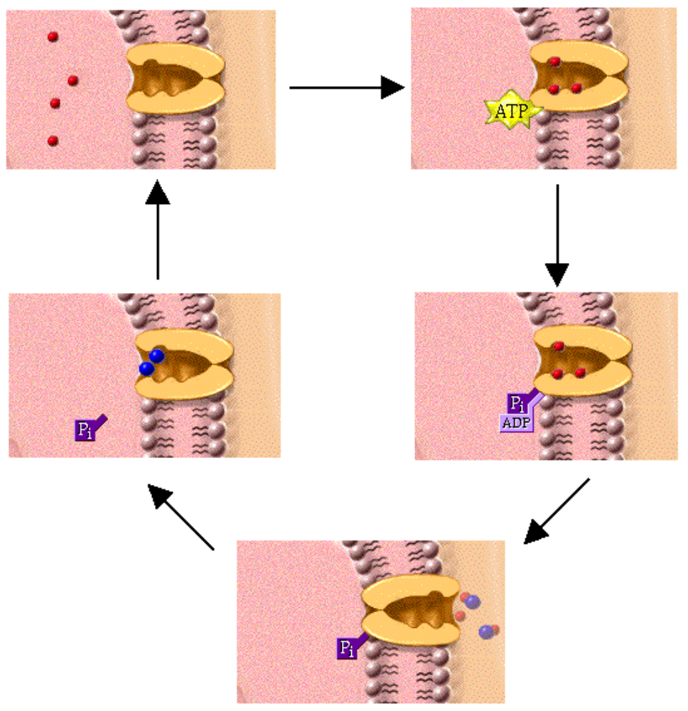
• Watch what happens to the fluid in the interstitial space as a result of the ion pump's activity. Notice that the interstitial fluid is becoming more concentrated, as indicated by the darker color. The net effect of the ion pump’s activity is to decrease the sodium ion concentration inside the cell and increase its concentration outside the cell, thereby increasing the interstitial osmolarity.
• This increased osmolarity around the PCT soon draws water from the tubule, decreasing the interstitial osmolarity again, and together the water and solutes diffuse passively into the peritubular capillaries and are carried away.

Page 10. PCT Basolateral Membrane: Diffusion
• There are two additional transmembrane proteins in the basolateral membrane:
1. a potassium ion channel
2. a glucose carrier molecule
• The glucose carrier molecule binds only to glucose, and transports it across the basolateral membrane by a passive mechanism called facilitated diffusion. Glucose can move either into or out of the cell, depending on its concentration. Since in the situation shown here, its concentration is highest in the cell, glucose moves out of the cell into the interstitium.
• The potassium ion channel lets most of the potassium ions diffuse from the tubular cells back into the interstitium. It prevents the sodium-potassium ATPase ion pump from causing potassium ion depletion in the blood or excess accumulation in the cells.
• In addition to the molecules you see here, many other substances also cross the basolateral membrane by similar mechanisms.
• Label the parts of this diagram:
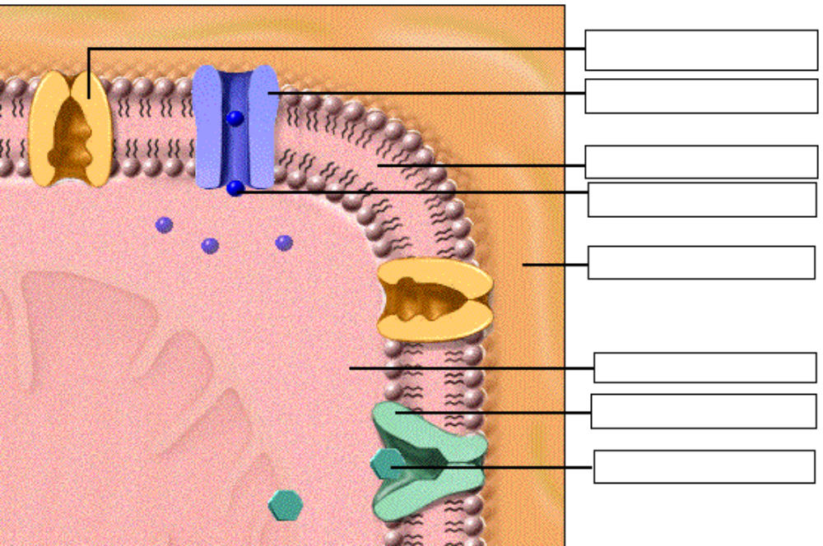

Page 11. PCT Luminal Membrane Activity
• The luminal membrane of the proximal convoluted tubule contains many transport proteins.
• Here you see three sodium-hydrogen countertransport carrier molecule, and two sodium/glucose cotransport carrier molecules.
• The activity of all these carrier molecules depends on sodium-potassium ATPase ion pump activity in the basolateral membrane.

• Sodium Channels. The sodium ion concentration of the cytosol has been lowered by the activity of the sodium/potassium pumps in the basolateral membrane. As a result, additional sodium ions move from the high extracellular concentration in the filtrate through the luminal membrane to the low intracellular concentration in the cytosol. They are transported by simple diffusion through sodium channels, and they then move to the basolateral membrane and are pumped into the interstitium as you have seen.
• Sodium-Hydrogen Countertransport Molecule. The countertransport (or antiport) carrier molecule carries a sodium ion into the cell, and in exchange secretes a hydrogen ion into the filtrate. Here in the PCT, this activity is dependent on the movement of a sodium ion down its concentration gradient from high extracellular to low intracellular concentrations. This is an example of secondary active transport driven by the primary active transport of the basolateral membrane. The hydrogen ion being secreted here is generated in the cell for acid/base balancing purposes.
• Sodium-Glucose Cotransport Carrier Molecule. The cotransport (or symport) carrier molecules carry both sodium and glucose into the cell. The reabsorption of glucose depends on the movement of a sodium ion down its concentration gradient from high extracellular to low intracellular concentrations. This is an example of secondary active transport. Glucose now moves down its concentration gradient to the basolateral membrane, where it is transported into the interstitium by facilitated diffusion as seen previously.
• Label this diagram and indicate the direction of movement of glucose, sodium, and hydrogen ion:
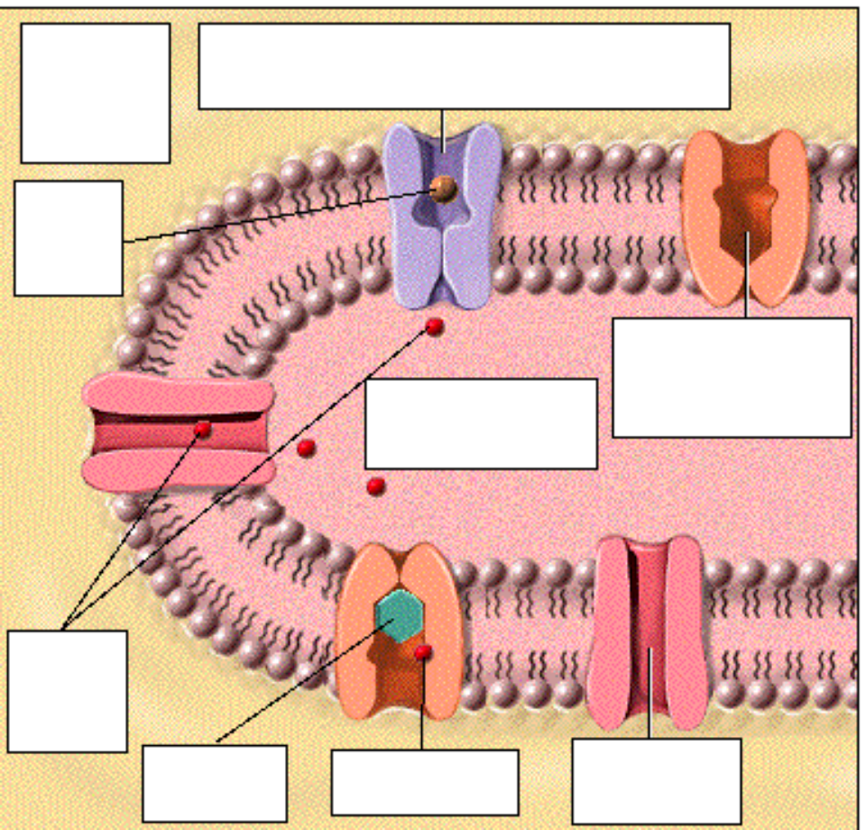
• This animation shows only a few of the molecules that cross the luminal membrane of the PCT. Although not shown here, water and many other solutes diffuse or are actively transported through the luminal membrane for reabsorption back into the blood.
• Transport Maximum, or Tm. For most actively reabsorbed solutes, the amount reabsorbed in the PCT is limited only by the number of available transport carriers for that specific substance. This limit is called the transport maximum, or Tm. If the amount of a specific solute in the filtrate exceeds the transport maximum, the excess solute continues to pass unreabsorbed through the tubules and is excreted in the urine.

Page 12. The Effect of Hyperglycemia
• Glucose is vital to the body’s normal functioning. However, in hyperglycemia, a condition that accompanies the disease diabetes mellitus, excess glucose accumulates in the blood.
• If the number of cotransport molecules is not sufficient to handle an abnormally high concentration of glucose in the filtrate, the transport maximum is exceeded and the ‘extra’ glucose will be excreted in the urine.

Page 13. Glucose Reabsorption Analogy
• The concept of transport maximum is much like this factory analogy. A fixed number of workers is matched to the maximum number of sacks of sugar they can remove from a moving conveyor belt. Under normal conditions all sugar is removed, because the number of workers and their rate of work is adequate to remove all of the sacks from the belt.
• If the number of sacks moving down the belt is increased, the workers cannot handle the extra load while working at their normal rate. They will remove only their “normal” amount, and the excess sugar will end up as waste.
• In the condition of hyperglycemia resulting from diabetes mellitus, excess sugar in the filtrate exceeds the transporting capacity of the available carriers in the cells of the proximal convoluted tubule. Therefore, some of the sugar is not reabsorbed and so is excreted in the urine.

Page 14. PCT Paracellular Pathway
• The second reabsorption route, the paracellular pathway, uses the small space between cells as a passageway.
• The tight junctions of the proximal convoluted tubule are not as tight as their name implies. The increased osmolarity of the fluid in the lateral intercellular spaces, resulting from sodium-potassium ATPase ion pump activity, causes water to diffuse from the tubular lumen through the paracellular pathway.
• As this water moves, sodium, chloride, and potassium ions may also follow passively in a process called solvent drag. A large percentage of potassium and chloride ions are reabsorbed in this manner.
• Notice that the flow of water into the lateral intercellular space reduces the osmolarity of the interstitial fluid, so that it equilibrates with the osmolarity of the filtrate.

Page 15. Summary of Reabsorption in the PCT
• To summarize the activities of the proximal convoluted tubule:
• Sodium/potassium ATPase ion pumps in the basolateral membrane drive the reabsorption of water and solutes by increasing the sodium ion concentration of the interstitium.
• Hydrogen ions are secreted into the filtrate to provide an acid/base balance.
• Abundant channels and transport molecules in the luminal membrane provide passage for solutes to move down their concentration gradients between the filtrate and the cytosol of the cell.
• Water and solutes move by bulk flow from the interstitium into peritubular capillaries to complete their reabsorption process.
• As a result, valued substances have been reclaimed. Approximately 65% of the filtrate is reabsorbed into the peritubular capillaries from the PCT. Included in this reabsorbed volume is virtually 100% of the filtered glucose, amino acids, and any proteins that may have escaped from the glomerulus.

Page 16. Reabsorption in Thin Descending Loop of Henle
• As the tubule transitions from the proximal convoluted tubule to the thin, descending loop of Henle, it straightens and dips into the medulla, and its epithelium changes from cuboidal to flattened squamous cells.
• As in the PCT, the cells here are permeable to water, allowing diffusion in response to osmotic gradients. The increasingly high osmolarity of the medullary interstitium provides a strong osmotic gradient that pulls water out of the filtrate.
• Sodium ions, chloride ions, and most solutes cease to be reabsorbed in this region, because the flattened cells lack transport proteins. As a result of these conditions, a great deal of water leaves the filtrate, while solutes are retained. This causes the filtrate to become increasingly more concentrated as it passes down the tube.

Page 17. Luminal Membrane Reabsorption in Ascending Loop of Henle
• Label this diagram. Draw arrows to show direction of ion movement:
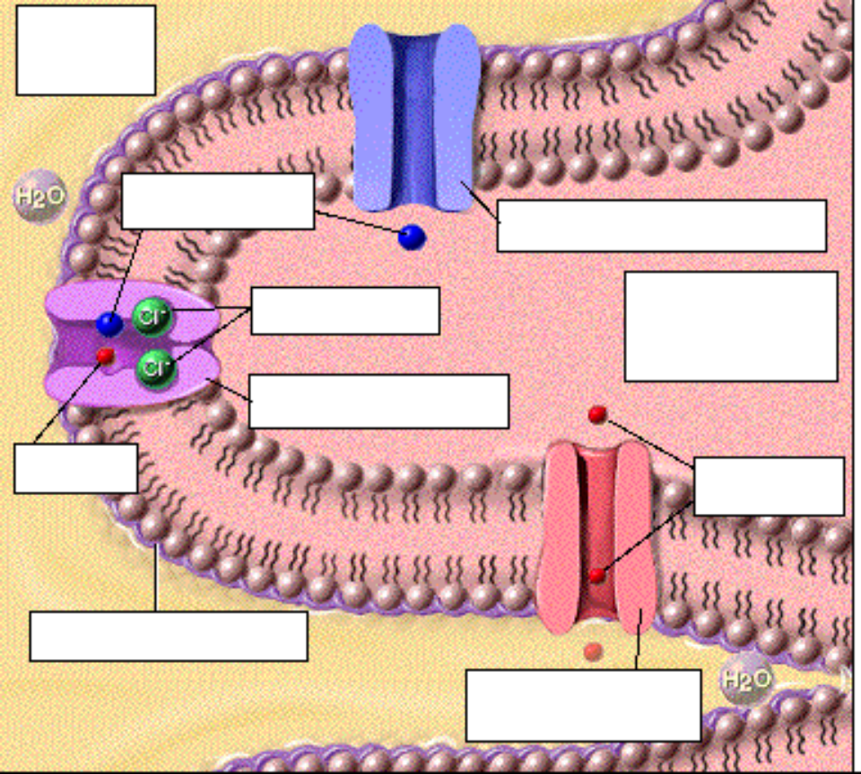
• As the loop of Henle ascends toward the cortex, the thin squamous cells transition to simple cuboidal cells of the thick ascending limb.
• Water permeability of these cells is greatly restricted by tight junctions and by a glycoprotein layer that covers the luminal membrane.
• Looking at the luminal membrane of these cells, we see that they lack a brush border, in contrast to the cells of the proximal convoluted tubule. However, they do have a limited number of short microvilli containing many ion channels and secondary active transport molecules.
• Notice that this secondary active transport molecule is not the same carrier as the sodium/glucose cotransporter in the PCT. Instead, this carrier molecule cotransports a potassium ion and two chloride ions. However, just as with the sodium/glucose cotransporter, it is the sodium ion moving down its concentration gradient that drives this activity. The import of potassium does not increase the cell's potassium concentration, because these ions diffuse back into the filtrate through the potassium ion channels in the luminal and basolateral membranes. As we shall see on the next page, the imported chloride ions follow the sodium ions through the cytosol to the basolateral membrane.

Page 18. Basolateral Membrane Reabsorption in the Ascending Loop of Henle
• The cells in the basolateral membrane possess the same sodium-potassium ATPase ion pumps and potassium channels as do the cells of the proximal convoluted tubule. These pumps generate a sodium ion concentration gradient that drives the reabsorption of other substances through the luminal membrane.
• Notice also the chloride channel, which allows chloride ions entering from the luminal membrane to follow sodium ions out of the cell.
• The increasing osmolarity of the interstitial fluid is the result of sodium, chloride, and potassium ions being reabsorbed from the filtrate and transported into the interstitial space. The restricted diffusion of water out of the filtrate, prevents equilibration of the filtrate and interstitial fluid.
• The cells of the ascending limb of the loop of Henle are able to maintain an osmotic difference between these two fluids of approximately 200 milliosmoles.

Page 19. Summary of Ascending Limb of the Loop of Henle Activity
• Label the processes (A-C) in this diagram. Also show the milliosmoles at each place in the ascending loop of Henle:
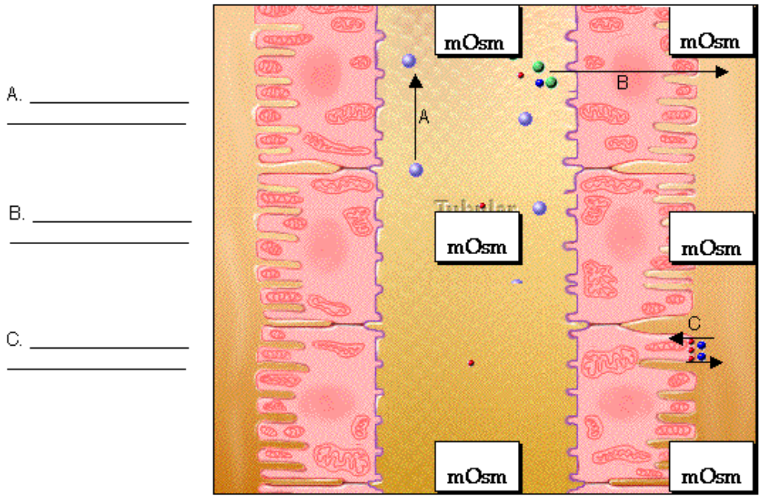

• In summary, as a result of solutes being removed from the filtrate and water being retained, there are two very important effects:
1) The filtrate becomes increasingly dilute as it moves up the tubule.
2) The osmolarity of the interstitium is 200 milliosmoles greater than the osmolarity of the filtrate at any given level of the tubule.
• Notice particularly that this has also formed an osmolarity gradient from the bottom of the interstitium to the top. In this medullary osmotic gradient, the osmolarity of the deeper region is greater than that of the region close to the cortex.

Page 20. The Loop of Henle: A Countercurrent Multiplier
** There are many pauses on this page. Make sure you don't click the Next button until all the animations are finished.
• To demonstrate the current theory of how the loop of Henle forms the medullary osmotic gradient, here's a simplified view of the cortex and medulla.
• This theory is called the countercurrent theory because of the opposing flow of filtrate within the two limbs of the loop.
• The complex interplay of the ascending and descending limbs forms and maintains an interstitial osmolarity with a gradient from approximately 1200 milliosmoles near the bottom of the loop to the normal 300 milliosmoles near the cortex. The gradient formed by this activity is essential for the concentration of urine.
• Label this diagram:
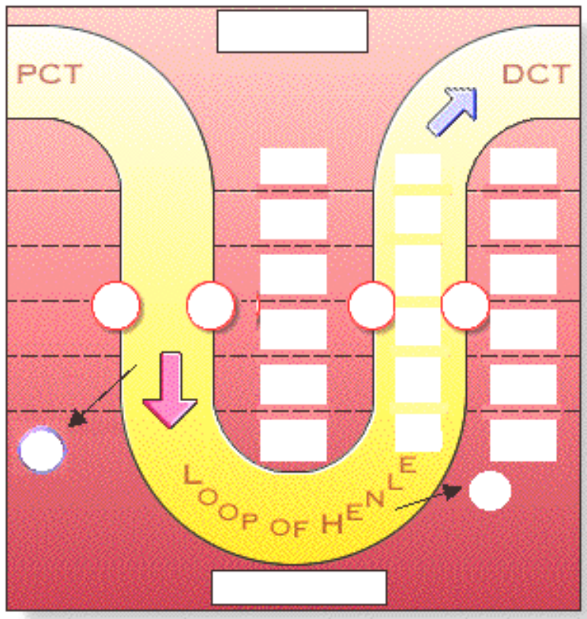
• Ascending Limb.
• To demonstrate how the gradient is formed, we will look first at the role of the ascending limb of the loop and then at that of the descending limb, because the ascending limb creates the conditions necessary for the descending limb to function.
• The ascending limb of the loop actively transports sodium chloride into the interstitium, increasing its concentration, while restricting the diffusion of water.
• The interstitium surrounding the tubule becomes more concentrated, while the fluid inside becomes more dilute.
• As the fluid moves up the loop there is progressively less solute to pump out, so the highest concentrations of solutes are near the bottom of the loop.
• Descending Limb.
• The role of the descending limb in this process is to provide a continuous, concentrated supply of sodium chloride to the ascending limb.
• The filtrate concentrates as it moves down the descending limb, because water diffuses into the higher osmolarity interstitium created by the ascending limb.
• The solutes remaining in the tube reach a concentration approximately four times greater than normal body fluid. The effect is much like what happens in the Great Salt Lake when water evaporates and salt is left behind; the fluid that is left is very salty.
• This salty filtrate provides a ready supply of sodium chloride for the ascending limb to maintain the osmotic gradient.
• Combined Activities.
• The way the two limbs cooperate to multiply the solute concentration from the normal 300 milliosmoles of the cortex to a level four times higher in the medulla is called the countercurrent multiplier mechanism.
• This mechanism has also diluted the luminal fluid in the ascending limb to an osmolarity of approximately 100 milliosmoles; as a result, water is retained, while solutes are removed. This graphic now shows the 200 milliosmole difference between filtrate and interstitium developed by the cells of the thick ascending limb.

Page 21. The Vasa Recta: A Countercurrent Exchanger
• How are the solutes in the medullary interstitium kept from being carried away by the blood? The cells of the medulla require nutrients to function properly; however, blood in a normal capillary flowing through the medulla would also reabsorb and remove massive amounts of solutes from the medullary interstitium. This would quickly weaken the osmotic gradient. To avoid this problem, the capillaries of the vasa recta form ‘hair pin’ loops enabling them to function as countercurrent exchangers.
• Blood in the vasa recta loops delivers nutrients such as glucose and oxygen to the cells of the region.
• At the same time, the loops function as countercurrent exchangers of sodium chloride and water.
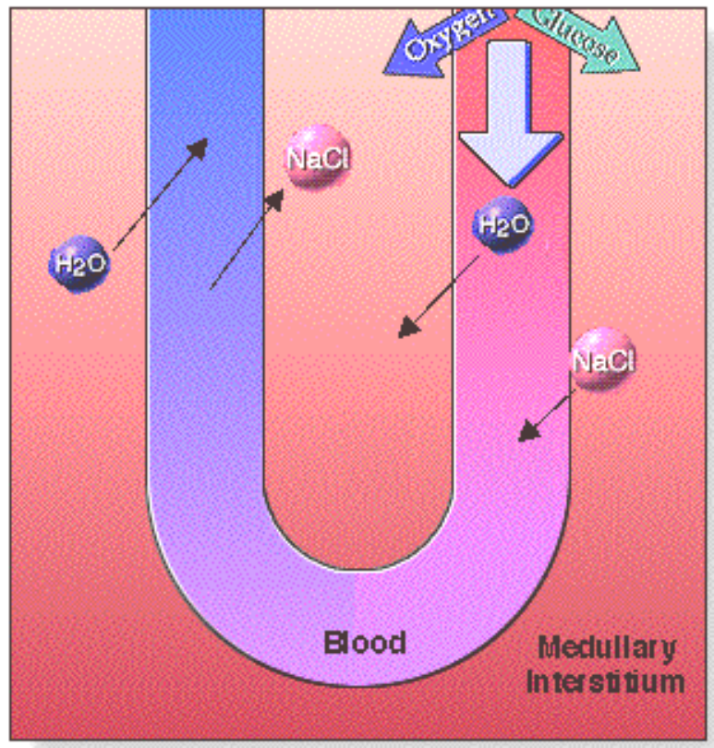
• The exchange mechanism works as follows:
1. Blood moving down the descending portion of the vasa recta loop passes through areas of increasing osmolarity.
2. Responding to osmotic pressure, water diffuses out of the blood into the interstitium.
3. At the same time, sodium and chloride ions diffuses into the blood as a result of its higher concentration in the interstitium.
4. If this blood now left the medulla, the sodium and chloride ions would be removed and lost to the osmotic gradient. However, the capillary actually reverses direction, so the conditions also reverse.
5. The viscous blood moves up the ascending portion of the vasa recta through areas of decreasing osmolarity. The blood regains the water by osmosis and loses most of the solutes back into the interstitium.
• The net result is that the blood has brought nutrients to the cells of the medulla without carrying away extensive amounts of solute, which would weaken the osmotic gradient.

Page 22. Summary
• 65% of the filtrate is reabsorbed in the proximal convoluted tubule through active and passive transport processes.
• The filtrate is concentrated in the descending loop of Henle; water is lost while solutes are retained.
• The filtrate is diluted in the ascending loop of Henle; solutes are lost while water is retained.
• The asymmetrical pattern of water and sodium chloride reabsorption in the ascending and descending loop of Henle creates an osmotic gradient within the medullary region.
• The vasa recta circulate blood through the medulla to provide nutrients without removing solutes and weakening the osmotic gradient.

** Now is a good time to go to quiz questions 1-11:
• Click the Quiz button on the left side of the screen.
• Work through quiz questions 1-11. Fill in the charts below as you answer the questions.

Notes on Quiz Questions:
Quiz Question #1: Tubular Permeability Characteristics
• This question asks you to rate the permeability of the PCT, descending loop of Henle, and ascending loop of Henle to water, ions, and glucose. Fill out this chart as you do this question:
 | Permeability to Water | Permeability to Na+ and Cl- Ions | Permeability  to Glucose
Proximal Convoluted Tubule
Descending Loop  of Henle |  |  | _____________
Ascending Loop  of Henle |  |  | _____________

Quiz Question #2: Descending and Ascending Loop of Henle
• This question asks you to choose what will happen to water , ions, and filtrate in the ascending and descending limb of the loop of Henle. Fill out this chart as you do this question:
 | Descending Loop of Henle | Ascending Loop of Henle
Sodium & Chloride Ions
Water
Filtrate

Quiz Question #3: Membrane Transport Trivia
• This question asks you to classify various membrane transporters. Fill in this diagram as you do the question:
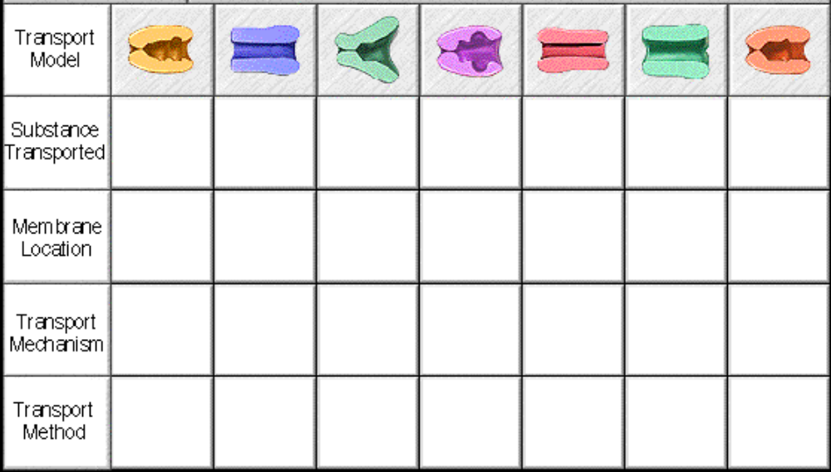

Quiz Question #4: Effects of Furosemide
• This question asks you to predict what will happen if a drug is given that will block ion reabsorption in the ascending limb of the loop of Henle.

Quiz Question #5: Increase/Decrease Furosemide
• This question asks you to predict the effect of the drug on the body.

Quiz Question #6: Glucose and Sodium Reabsorption in the PCT
• This question asks you to predict what will happen if there is an increase or decrease in sodium/potassium pumps.

Quiz Question #7: Water Reabsorption in the PCT
• This question asks you to predict what will happen if there is an increase in sodium/potassium pumps.

Quiz Question #8: Permeability of Loop of Henle
• This question asks you to rate the impermeability of the ascending and descending loop of Henle to water, sodium ions and chloride ions.

Quiz Question #9: Vasa Recta 1
• This question asks you to determine why there is a movement of water out of the blood and a gain of sodium and chloride ions in the blood as the blood descending in the vasa recta.
** This animation is best viewed in slow motion. You may want to click on the "Settings" button at the bottom of the screen and adjust the animation speed.

Quiz Question #10: Vasa Recta 2
• This question asks you to predict why blood moves sluggishly in the vasa recta.

Quiz Question #11: Vasa Recta 3
• This question asks you to determine why there is a movement of sodium and chloride ions out of the blood and a gain of water in the blood as the blood ascends in the vasa recta.

Study Questions on Early Filtrate Processing:
1. (Page 1.) What two renal processes are accomplished by the renal tubules? Briefly review each process.

2. (Page 3.) Which is a more selective process: glomerular filtration or reabsorption? Discuss.

3. (Page 4.) What are the two pathways for reabsorption?

4. (Page 3.) Which arrows below correspond to the transcellular pathway for reabsorption? Which correspond to the paracellular pathway of reabsorption?
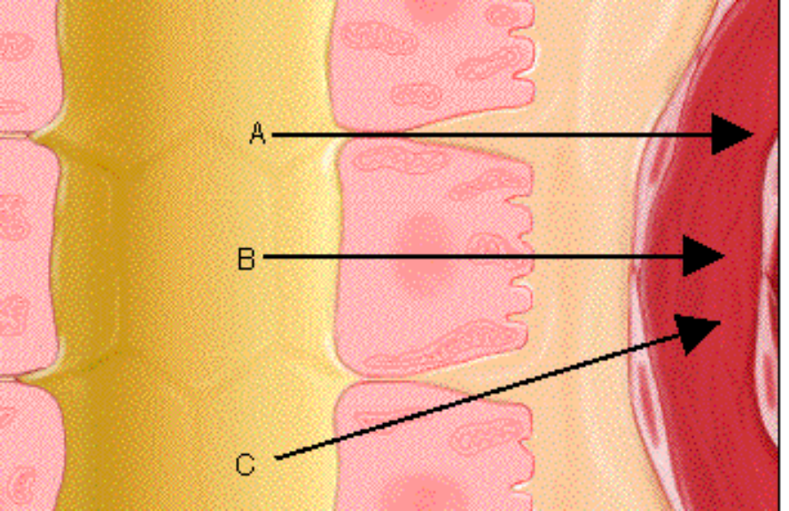

5. (Page 4.) Trace the movement of a substance via the transcellular pathway.

6. (Page 4.) Trace the movement of a substance via the paracellular pathway.

7. (Page 4.) Do most solutes use the transcellular or paracellular pathways?

8. (Page 4.) What substances use the paracellular pathway?

9. (Page 5). What is the driving force for glomerular filtration?

10. (Page 5.) What is the difference between a solution that has a high osmolarity and a solution that has a low osmolarity?

11. (Page 5.) Water tends to move from areas of (select all that apply):
a. lower water concentration to areas of higher water concentration
b. higher water concentration to areas of lower water concentration
c. areas of higher osmolarity to areas of lower osmolarity
d. areas of lower osmolarity to areas of higher osmolarity

12. (Page 5.) What is the driving force for the reabsorption of water?

13. (Page 5.) If water is to be reabsorbed from the filtrate to the interstitium, which would have to have the higher osmolarity, the filtrate or the interstitium?

14. (Page 5.) What are the two ways that water can diffuse from the filtrate to the interstitium? Classify the two ways using the diagram below:
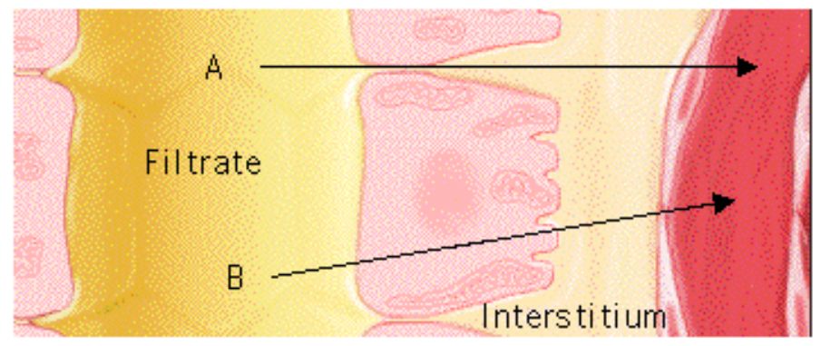

15. (Page 6.) How can the osmolarity of the interstitium be increased?

16. (Page 7,8.) When sodium ions are transported from the inside of the tubular cells into the interstitium, what happens to the osmolarity of the interstitium? What is the result of changes to the osmolarity of the interstitium?

17. (Page 7,8.) When sodium ions are transported from the inside of the tubular cells into the interstitium, what happens to the movement of ions into the cell? Why does this occur?

18. (Page 9.) Where is the sodium-potassium pump located on tubule cells?

19. (Page 9.) The diagrams to the right represent the function of the sodium potassium pump. Put the diagrams in order, beginning with the binding of sodium to the pump.  20. (Page 9.) Place the following events of the sodium-potassium pump's action in order:  _____ ADP is released and the pump opens to the outside releasing sodium. Two potassiums bind.  _____ ATP is hydrolyzed into ADP and Pi which remains attached to the inner surface of the pump.  _____ Inside the cell, three sodium's bind to the pump.  _____ ATP binds to the inner surface of the pump.  _____ Pi is released from the pump and the pump opens to the inside of the cell, releasing the potassium.  21. (Page 9.) Why is it said that ion pump carries out primary active transport of sodium ions. | 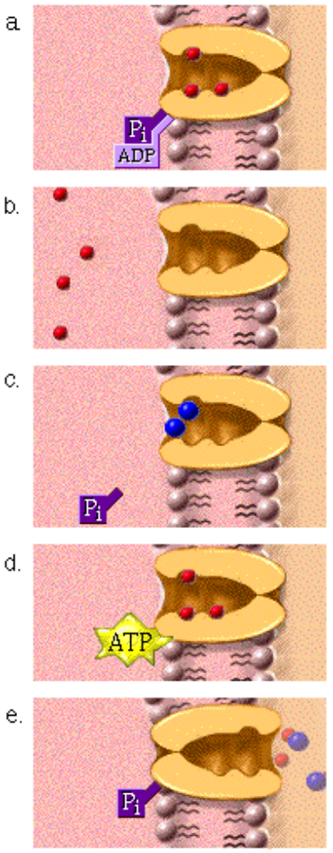

22. (Page 10.) Name three transmembrane proteins found in the basolateral membrane of the PCT.

23. (Page 10.) Explain how the glucose carrier in the basolateral membrane of the PCT works.

24. (Page 10.) What is the purpose of the potassium ion channel in the basolateral membrane of the PCT?

25. (Page 10.) Label the parts of the diagram on p. 10.

26. (Page 11.) Label the diagram on p. 11.

27. (Page 11.) List the names of three transport proteins found on the luminal surface of the cells in the PCT.

28. (Page 11.) a. What is the function of the Sodium-hydrogen Countertransport Molecule on the luminal membrane of the PCT? What does it transport and in what direction? b. Why is its activity dependent on the sodium potassium pump in the basolateral membrane? c. Why is this called countertransport? d. Why is this called secondary active transport?

29. (Page 11.) a. What is the function of the Sodium Channel on the luminal membrane of the PCT? What does it transport and in what direction? b. Why is its activity dependent on the sodium potassium pump in the basolateral membrane?
30. (Page 11.) What is the function of the Sodium-Glucose Cotransport Carrier Molecule on the luminal membrane of the PCT? What does it transport and in what direction? b. Why is its activity dependent on the sodium potassium pump in the basolateral membrane? c. Why is this called cotransport? d. Why is this called secondary active transport?

31. (Page 11.) Define "the transport maximum".

32. (Page 11.) If the volume of a specific solute in the filtrate exceeds the transport maximum, what happens to the excess solute?

33. (Page 12.) Why do diabetics end up with glucose in their urine?

34. (Page 14.) What causes water to diffuse via the paracellular pathway?

35. (Page 14. ) Explain solvent drag.

36. (Page 15.) Approximately what percentage of filtrate is reabsorbed in the PCT?

37. (Page 15.) What molecules are usually totally reabsorbed in the PCT?

38. (Page 16.) What is reabsorbed in the thin ascending loop of Henle? What is the driving force for that reabsorption?

39. (Page 16.) Why are sodium and chloride ions not reabsorbed in the thin descending loop of Henle?

40. (Page 16.) What happens to the concentration of the filtrate as it moves down the thin descending loop of Henle?

41. (Page 17.) Label the diagram on p. 17.

42. (Page 17.) What is reabsorbed in the thick ascending loop of Henle and early DCT?

43. (Page 18.) The cells of the ascending limb of the loop of Henle are able to maintain an osmotic difference between these two fluids of approximately 200 milliosmoles. What is this due to?

44. (Page 19.) Label the processes in the diagram on p. 19.

45. (Page 19.) Explain the osmolarity of the interstitium in the medulla.

46. (Page 19. Which of these statements applies to the descending loop of Henle and which applies to the ascending loop of Henle?
a. The fluid inside the tubule becomes more dilute.
b. The filtrate concentrates as it moves, because water diffuses into the higher osmolarity interstitium.

47. (Page 20.) Where in the loop of Henle is the filtrate the most concentrated?

48. (Page 20.) The countercurrent theory is called that because of the opposing flow of filtrate within the two limbs of the loop. What flows out of the tubule in the descending loop and what flows out in the ascending loop?

49. (Page 20.) What is the purpose of the countercurrent mechanism in the loop of Henle?

50. (Page 21.) The vasa recta forms hairpin loops. a. In the descending portion of the vasa recta loop which direction do water and ions move? b. In the ascending portion of the vasa recta loop which direction do water and ions move? c. What is the net result of these movements?

51. (Overview.) Fill out this chart with "permeable" or "impermeable".
 | Permeability to Water | Permeability to Na+ and Cl- Ions | Permeability  to Glucose
Proximal Convoluted Tubule
Descending Loop  of Henle |  |  | _____________
Ascending Loop  of Henle |  |  | _____________

52. (Overview.) Fill out this chart:
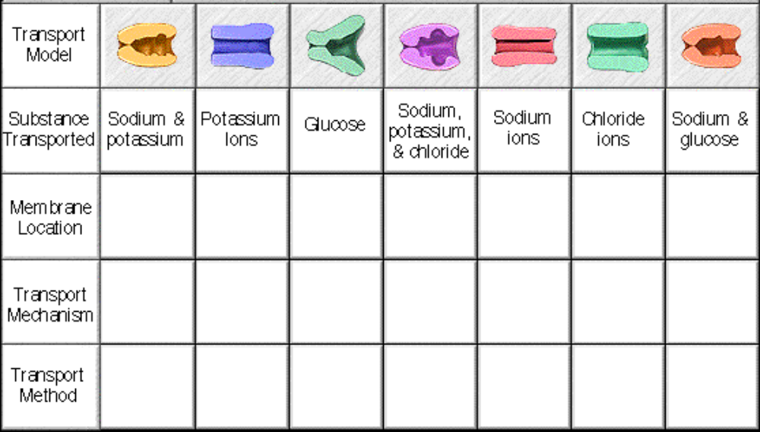

53. (Overview.) Fill out this chart with "concentrates", "dilutes", "moves in", or "moves out".
 | Descending Loop of Henle | Ascending Loop of Henle
Sodium & Chloride Ions
Water
Filtrate

