Late Filtrate Processing
Graphics are used with permission of:
Pearson Education Inc., publishing as Benjamin Cummings (http://www.aw-bc.com)

Page 1. Introduction
• The final processing of filtrate in the late distal convoluted tubule and collecting ducts comes under direct physiological control.
• In this region, membrane permeabilities and cellular activities are altered in response to the body's need to retain or excrete specific substances.

Page 2. Goals
• To understand the role of the hormone aldosterone in the reabsorption of sodium and secretion of potassium.
• To examine the role of the antidiuretic hormone in the concentration of urine.
• To understand the role of the medullary osmotic gradient in the concentration of urine.

Page 3. Late Filtrate Processing: Analogy
• The bulk of reabsorption occurs in the early tubular segments. In these regions the rates of both reabsorption and secretion are relatively constant, because the membrane permeabilities are relatively fixed.
• In the later tubular segments you are about to tour, the membrane permeabilities change in response to changing physiological conditions and hormone levels. This variability provides a mechanism for precisely regulating the final balance of fluid and solutes returned to the blood.
• An analogy for this two-stage process would be to use a steady but unregulated flow to fill a container to almost the level needed--that’s early filtrate processing. Then use a precisely regulated flow of water to top off to the exact level--that’s late filtrate processing. Bulk filling is analogous to the reabsorption of water and solutes occurring in the early tubular segments. Fine-tuning is analogous to late filtrate processing.

Page 4. Filtrate Processing in the CCD: Hydrogen Ion Secretion
• The epithelium of the collecting ducts consists of two cell types. Each of these cells plays a different role in the final processing of filtrate.
1. Intercalated cells
The intercalated cells help to balance the blood pH by secreting hydrogen ions into the filtrate through ATPase pumps in the luminal membrane.
2. Principal cells
The principal cells perform hormonally regulated water and sodium reabsorption and potassium secretion.
• Label this diagram of the two cell types in the late distal convoluted tubule and the collecting ducts:
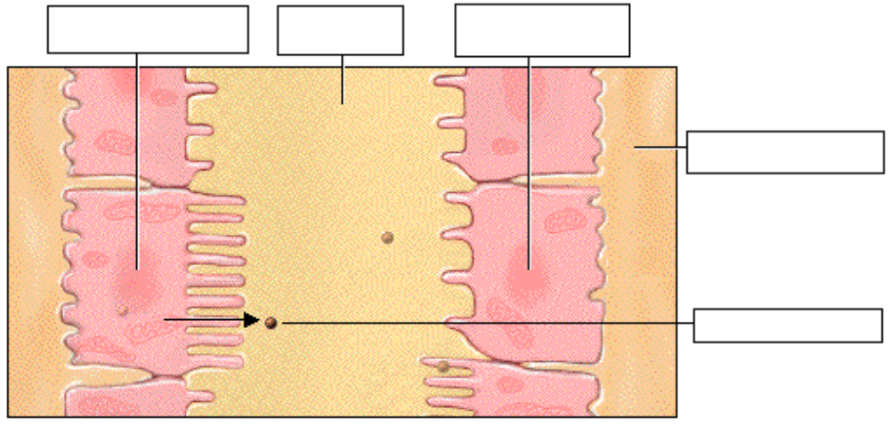

Page 5. Filtrate Processing in the CCD: Role of Aldosterone
• The permeability of the principal cells are permeable to sodium ions and water is controlled by two hormones: aldosterone from the adrenal gland and antidiuretic hormone, or ADH, from the posterior pituitary gland.
• Let’s first look at the role of aldosterone, which precisely regulates the final amount of sodium reabsorbed. When levels of sodium and potassium ions in the blood are balanced, aldosterone levels remain low. As a result, there are few sodium-potassium ATPase ion pumps in the basolateral membrane and few sodium and potassium channels in the luminal membrane. Therefore, sodium ion reabsorption and potassium ion secretion are both low.
• Label this diagram to show what happens when levels of sodium and potassium ions in the blood are balanced and aldosterone levels remain low:
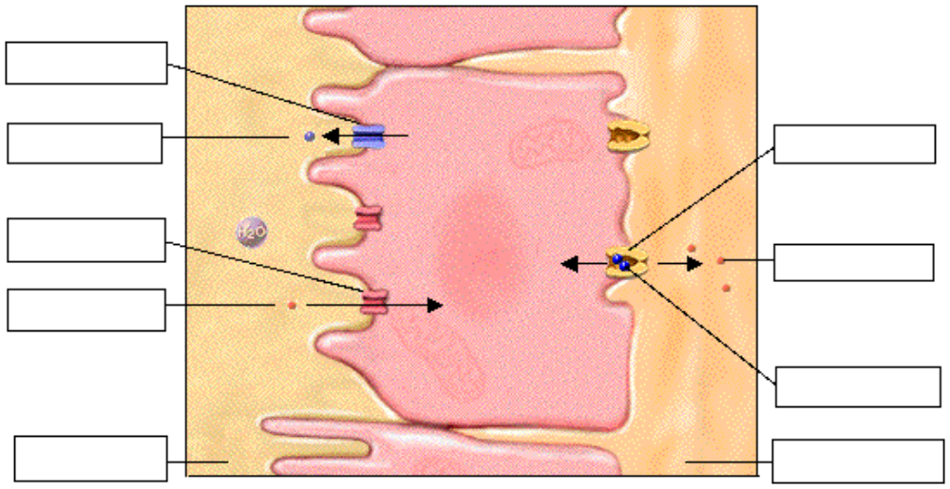
• However, a decrease in the level of sodium ions or an increase in potassium ions in the blood will trigger the release of aldosterone.
• Label this diagram to show what happens when aldosterone levels are high:
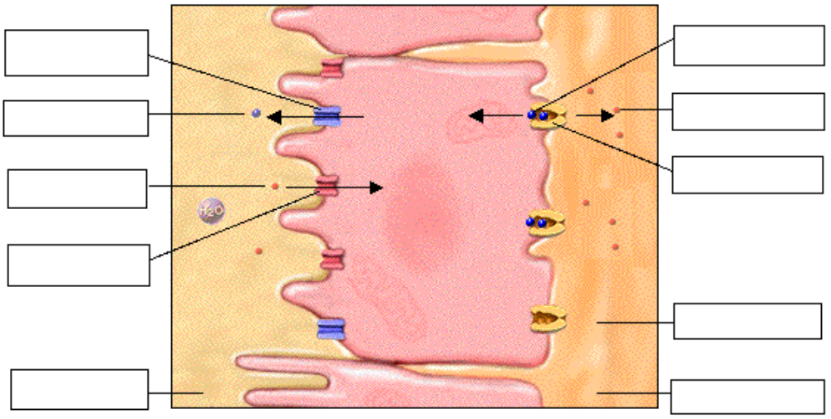
• In response to increased aldosterone, both sodium ion reabsorption and potassium ion secretion increase.
• This occurs because the principal cells increase the number and activity of sodium/potassium pumps in the basolateral membrane. The number of sodium and potassium channels in the luminal membrane is also increased.
• Notice the absence of potassium channels in the basolateral membrane. Potassium ions enter the cell through the basolateral membrane, but instead of diffusing back into the interstitium, they diffuse to the luminal membrane and are secreted into the filtrate.
• The effects of aldosterone are not confined to the collecting duct. It has similar effects on cells of the distal convoluted tubule.
• You should also notice the resulting increase in interstitial osmolarity. Water is not following the solute, because the luminal membrane of the collecting duct is relatively impermeable to water unless it is stimulated by ADH.

Page 6. Filtrate Processing in the CCD: Role of Antidiuretic Hormone
• Aldosterone and antidiuretic hormone act independently to regulate salt and water, but can also work together.
• The cell you see here has been stimulated as yet only by aldosterone, so it is still impermeable to water.
• When stimulated by ADH, principal cells quickly insert luminal water channels, increasing their water permeability.
• Notice that the interstitial osmolarity decreases. When water molecules can diffuse through a membrane, osmolarities on each side of the membrane equilibrate.
• Label this diagram to show what happens when both aldosterone and ADH levels are high:
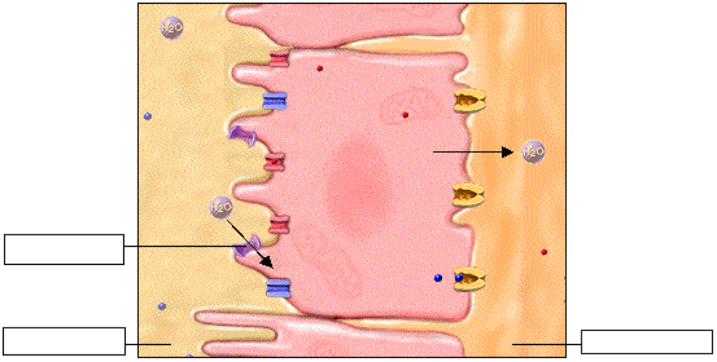

Page 7. Response to Dehydration and Overhydration
• Now let’s look at two common conditions to demonstrate how ADH functions in our everyday lives.
• Dehydration:
• In dehydration, which could be caused by hot weather, perspiration causes the body to lose both water and sodium.
• In response, ADH is released; it stimulates the kidney to conserve body fluid by increasing reabsorption of water from the filtrate.
• Therefore, the volume of filtrate entering the medullary collecting duct is reduced, so urine volume decreases.
• Overhydration:
• Overhydration, which could be caused by drinking several cans of soda or other beverages, triggers a decrease in ADH.
• As a result, membrane permeability for water and sodium ions decreases, reabsorption slows dramatically, and the volume of filtrate entering the medullary collecting duct increases above the normal level, causing urine volume to increase.
• High urine volumes also occur when substances containing diuretic chemicals are consumed.
• Circle the appropriate words below for each picture:

Dehydration or Overhydration Dehydration or Overhydration

High ADH or Low ADH High ADH or Low ADH

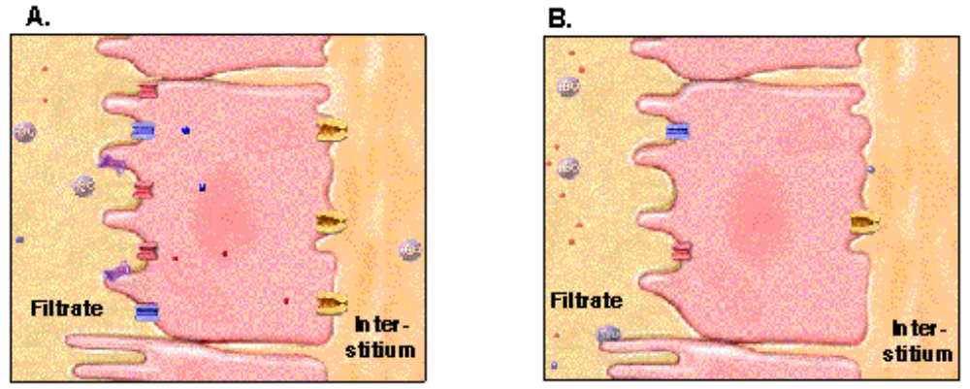
• If you increase plasma volume by drinking fluids, you effectively dilute the sodium content of the extracellular fluids including blood plasma, thus turning down the stimulus for ADH release. If those drinks are caffeinated like coffee or alcoholic like beer, the fluid output may be higher than anticipated because those substances have a diuretic effect. A diuretic is a chemical that increases urine output. For example caffeine promotes vasodilation thus increasing the GFR and alcohol has an effect on release of ADH.

Page 8. Medullary Osmotic Gradient: Review
• We are now ready for the final concentration of the filtrate as it enters the medullary collecting duct.
• Recall from the Early Filtrate Processing topic that the asymmetrical pattern of reabsorption in the ascending and descending loop of Henle created an osmotic gradient in the renal medulla.
• Here again is the schematic medullary gradient. The dark color in the deeper regions of the gradient represents a high solute concentration that gradually changes to the lighter, low solute concentration near the cortex. The solutes forming the gradient are sodium and chloride ions and other substances including urea. We now add osmolarity indicators in milliosmole units and a schematic diagram of the tubules and collecting ducts.
• Label this diagram:
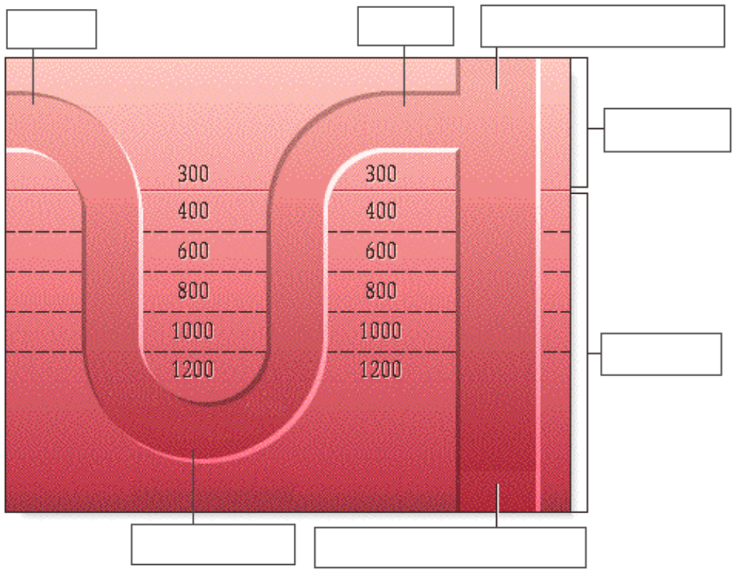

Page 9. Progressive Change in Filtrate Osmolarity
• Using this schematic diagram, let’s review how filtrate concentration in the tubules is related to interstitial osmolarity. Watch the changes in the concentration and volume of the filtrate as it passes through the differing osmotic environments of the cortex and medulla.
• Fill out this chart as you proceed:

 | Proximal Convoluted Tubule | Descending Loop  of Henle | Ascending Loop  of Henle | Late Distal Convoluted Tubule and Cortical Collecting Duct
Osmolarity of Filtrate
Osmolarity if Interstitium
Permeability to Water
Permeability to Solutes
Filtrate Volume

• Proximal Convoluted Tubule:
• Since the cells of the PCT are highly permeable to both solutes and water, the relative osmolarity of the filtrate remains equal to the 300 milliosmole solute concentration of the interstitium.
• The cells' high permeability also accounts for a 65% reduction in filtrate volume.
• Descending Loop of Henle:
• Watch the simulated drop of filtrate as it moves down the tube to the bottom of the loop. Notice that the osmolarity of the filtrate increases and the volume decreases. Recall that the cells of this region are permeable to water but not to solute.
• As the filtrate moves down the tube through regions of higher osmolarity, water diffuses out into the interstitium, reducing the filtrate volume by an additional 15%. The solutes remain behind in the tubule and become more concentrated as the filtrate approaches the bottom of the loop.
• Ascending Loop of Henle:
• The cells of the thick segment of the ascending loop of Henle are permeable to solute but not to water, making them function essentially opposite to the cells of the thin segment of the descending loop.
• As the concentrated filtrate flows up the ascending loop, the cells actively transport solutes into the interstitium, causing the osmolarity of the filtrate to fall to less than 300 milliosmoles.
• Because water remains in the tubule, the filtrate volume remains unchanged.
• The opposing flow and opposite activities of the descending and ascending segments of the loop of Henle is called the countercurrent multiplier mechanism.
• Cortical Collecting Duct
• The osmolarity of the filtrate entering the late DCT and cortical collecting duct can be as low as 100 milliosmoles.
• Recall that in the cells of this region, the reabsorption of sodium ions and water is regulated by the hormones aldosterone and antidiuretic hormone respectively.
• In normal hydration conditions, low levels of both hormones promote the reabsorption of sodium ions and water from the filtrate. This maintains the low osmolarity of the filtrate, while reducing its volume by an additional 15%.

Page 10. Urine Concentration: Medullary Collecting Duct
• The last step in the formation of urine occurs as the filtrate passes down the medullary collecting duct.
• Of the 125 milliliters per minute of filtrate that entered the proximal convoluted tubule from the glomerular capsule, 95% has been reabsorbed back into the blood.
• Only about 6 milliliters per minute, or 5%, remains to enter the medullary collecting duct.
• Antidiuretic hormone regulates the final amount of water reabsorbed in the collecting duct, and thus determines the final concentration of urine.

Page 11. Conditions Affecting Final Urine Volume
• The osmotic gradient constructed by the countercurrent multiplier mechanism concentrates the urine by drawing water from the filtrate as it travels through the medullary collecting duct.
• The degree of concentration is regulated by antidiuretic hormone, which controls the water permeability of the duct. ADH levels vary in response to various conditions, including the individual's hydration status.
• Fill in this table as you go through the rest of this page:
 | Normal Hydration | Dehydration | Overhydration
ADH Secretion

Presence of Water Channels in Medullary Collecting Duct
Water Permeability

Urea Permeability

Interstitial Medullary Osmolarity
Osmolarity of Urine

• Normal Hydration
• With normal hydration and levels of ADH, water channels are present in the luminal membranes of these cells, resulting in moderate water permeability.
• ADH also facilitates the diffusion of urea out of the medullary collecting duct into the interstitium.
• Although it is considered a nitrogenous waste product, urea is responsible for up to 40% of the medullary interstitial osmolarity. From the interstitium, urea passively re-enters the filtrate in the loop of Henle and re-circulates back to the collecting ducts. It may then again diffuse into the interstitium or pass into the renal pelvis as a component of urine.
• Notice that, as it descends, the filtrate drop shrinks in volume and darkens slightly as water is lost and solutes are concentrated.
• The filtrate does not equilibrate with the osmolarity of all medullary regions and is therefore not as concentrated as possible.
• Normal urine has an osmolarity of about 600 milliosmoles or twice normal body osmolarity.

• Dehydration
• With dehydration, a high level of ADH creates two important changes:
1. It causes additional luminal water channels to be added to the duct, which increases its permeability to water.
2. It increases the permeability of the duct to urea, which in turn increases the interstitial osmolarity. This increased osmolarity draws additional water from the filtrate.
• Therefore, as the filtrate passes through the lumen of the duct, it equilibrates with each regional increase in osmolarity.
• Notice the decrease in size and darkening color of the filtrate drop as it descends through the duct.
• In severe dehydration conditions, the low volume of urine excreted may be concentrated to about 1400 milliosmoles, or more than four times the osmolarity of normal body fluids.
• Overhydration
• With overhydration, ADH levels are very low or absent, and the duct cells remain relatively impermeable to water and urea.
• The reduction in urea permeability decreases the medullary interstitial osmotic gradient, reducing the water-drawing power of the interstitium.
• As the filtrate passes through the lumen of the medullary collecting duct, it does not equilibrate with any regional change in osmolarity and therefore remains unmodified.
• Notice that the filtrate drop remains the same size and color as it descends through the duct.
• The final urine, which is dilute and high in volume, may have an osmolarity as low as 100 milliosmoles.
• Circle the proper state that corresponds to the following diagrams:
dehydrated dehydrated dehydrated
normal hydration normal hydration normal hydration
overhydration overhydration overhydration
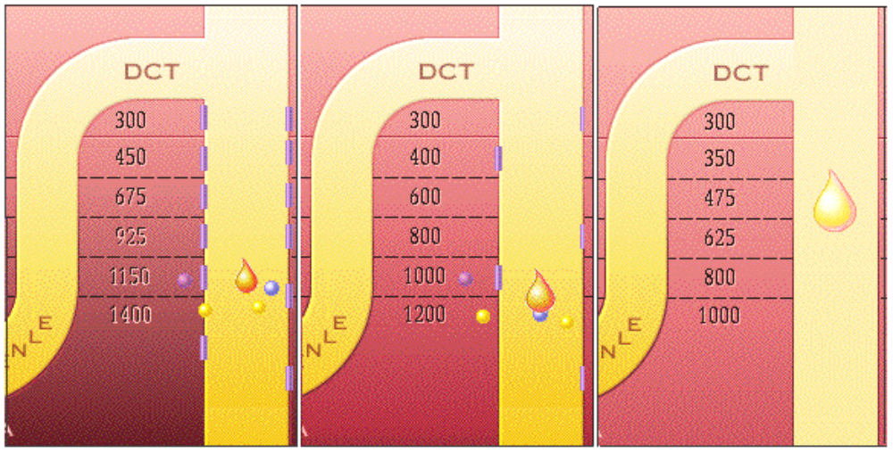• List two differences between the diagrams above:

1. ______________________________________________

2. ______________________________________________

Page 12. Final Urine Volume
• Fill in the chart as you proceed:
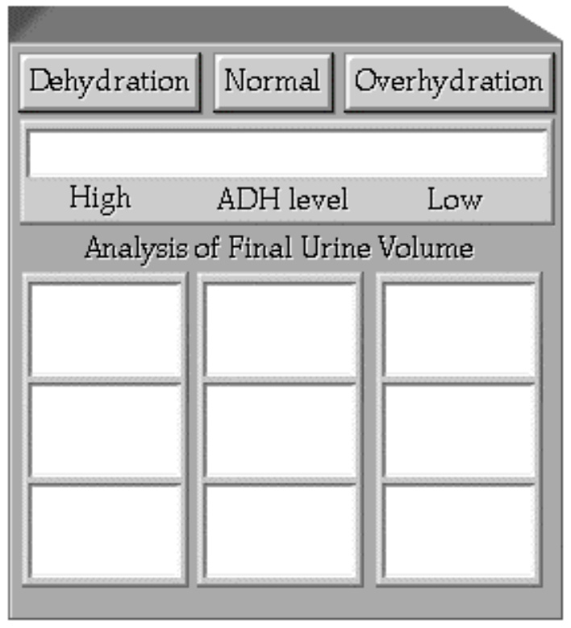
• Let’s look at the final volume of urine produced per minute and per day for each of the levels of hydration you have just seen.
• Recall that 95% of the water has been reabsorbed from the 125 milliliters per minute of glomerular filtrate produced by the kidney before the filtrate enters the medullary collecting duct.
• Record your data on the chart on the next page.
• With high levels of antidiuretic hormone, the approximate final urine volume is 0.2% percent of the filtrate. This is equal to one fourth of a milliliter per minute or 400 milliliters per day. Two conditions in which this might occur would be severe dehydration or blood loss.
• With normal levels of antidiuretic hormone, about 99% of the filtrate is reabsorbed into the blood. This leaves about 0.9% or 1.1 milliliters per minute of concentrated urine to continue the passage into the renal pelvis and urinary bladder. This equals about one and one half liters per day.
• With low levels of antidiuretic hormone, the approximate final urine volume is 12.5% of the filtrate. This is equal to 16 milliliters per minute or 22.5 liters per day. This situation might be caused by either temporary or chronic conditions. High volumes of dilute urine are temporarily produced after a person drinks either a large volume of fluid or fluids that contain diuretic drugs
such as caffeine or alcohol. In a chronic condition called diabetes insipidus, urinary volume may reach extremely high levels, because either antidiuretic hormone is not released by the posterior pituitary or the tubular cells do not bind and respond to this hormone.

Page 13. Summary
• Late filtrate processing includes both reabsorption and secretion.
• Late filtrate processing of sodium, potassium, water, and urea is under direct control of aldosterone and antidiuretic hormone.
• The medullary osmotic gradient and ADH both contribute to final urine concentration.
• In normal conditions, about 99% of the glomerular filtrate is reabsorbed during its passage through the tubules and ducts.

** Now is a good time to go to quiz questions 1-5:
• Click the Quiz button on the left side of the screen..
• Work through quiz questions 1-5.

Notes on Quiz Questions:
Quiz Question #1: Tubular Region Activities
• This question asks you to give the region(s) of the tubule where filtrate become more concentrated.

Quiz Question #2: Tubular Region Activities
• This question asks you to give the region(s) of the tubule where filtrate become more dilute.

Quiz Question #3: Tubular Region Activities
• This question asks you to give the region(s) of the tubule where the volume of filtrate changes.

Quiz Question #4: Dehydration Chain Reaction
• This question asks you to list the proper sequence of events that occurs when dehydration increases or decreases.

Quiz Question #5: Urine Samples
• This question asks you to predict the condition of the patient based on the analysis of the urine sample.

Study Questions on Late Filtrate Processing:
1. (Page 3.) Does most reabsorption occur in the early tubular segments or later tubular segments?

2. (Page 3.) Why does most reabsorption occur in the early tubular segments as opposed to the later tubular segments?

3. (Page 3.) Does fine-tuning of the filtrate occur to a greater extent in the early tubular segments or later tubular segments?

4. (Page 4.) What are the names of the two types of epithelium found in the collecting ducts?

5. (Page 4.) What is the function of the intercalated cells in the collecting ducts?

6. (Page 4.) What is the function of the principal cells in the collecting ducts?

7. (Page 4.) Label the diagram on page 4.

8. (Page 5.) What two hormones control the permeability of principal cells? Where are each of these hormones secreted from?

9. (Page 5.) Label the first diagram on page five that shows what happens when levels of sodium and potassium ions in the blood are balanced and aldosterone levels remain low.

10. (Page 5.) What triggers the release of aldosterone?

11. (Page 5.) What happens to sodium ions and potassium ions in the collecting ducts when there is an increase in aldosterone?

12. (Page 5.) Label the second diagram on page five that shows what happens when aldosterone levels are high.

13. (Page 5.) What happens to membrane transport proteins in the principal cells of the collecting ducts when aldosterone levels are high?

14. (Page 5.) Why does the potassium get secreted, as opposed to being reabsorbed when aldosterone is present in the collecting duct?

15. (Page 5.) Why does the osmolarity of the interstitium increase in the presence of aldosterone and in the absence of ADH?

16. (Page 6.) What is the effect of ADH on principal cells of the collecting ducts?

17. (Page 6.) Label the diagram on p. 6.

18. (Page 6.) What is the effect of ADH on interstitial osmolarity?

19. (Page 7.) What is lost by the body during dehydration due to perspiration?

20. (Page 7.) What hormone is released during dehydration due to perspiration? What is its effect?

21. (Page 7.) What happens to urine volume as a result of ADH during dehydration?

22. (Page 7.) What happens to the secretion of ADH during overhydration?

23. (Page 7.) What happens to urine volume in overhydration when ADH levels are low?

24. (Page 7.) Which of the following corresponds to the appearance of the collecting duct when an individual is overhydrated? Which corresponds to dehydration? Explain.

25. (Page 7.) What is a diuretic?

26. (Page 7.) When there is an increase in dehydration, are the following increased or decreased?
a. Body water _______.
b. Blood osmolarity _______.
c. ADH release from the pituitary _______.
d. Water permeability of the collecting ducts _______.
e. Water reabsorption _______.
f. Urine concentration _______.
g. Urine volume _______.

27. (Page 8.) Label the diagram corresponding to page 8 of the medullary osmotic gradient.

28. (Page 8.) Explain the medullary osmotic gradient.

29. (Page 9.) Fill out the table on page 9.

30. (Page 9.) Under conditions of normal hydration is the filtrate osmolarity in the CCD low or high? Why?

31. (Page 10). Under normal hydration, what percentage volume of fluid is reabsorbed in the following areas of the nephron: a. PCT b. descending Loop of Henle c. ascending Loop of Henle d. cortical collecting duct e. Under normal hydration, what percentage volume of fluid enters the medullary collecting duct?

32. (Page 10). What hormone regulates the final amount of water reabsorbed in the medullary collecting duct?

33. (Page 11.) Fill in the table on p. 11.

34. (Page 11.) Given the interstitial osmolarity diagrams on page 11, chose which corresponds to dehydration, normal hydration, and overhydration.

35. (Page 11.) Given the interstitial osmolarity diagrams on page 11, list two differences between the diagrams.

36. (Page 11.) In the medullary collecting duct, ADH influences the reabsorption of both water and ____.

37. (Page 11.) As urea leaves the medullary collecting duct and travels into the interstitium, what happens to the osmolarity of the interstitium?

38. (Page 11.) What happens to the urea that enters the interstitium?

39. (Page 12.) Place the following figures into the proper column below:
0.2 % of filtrate, 0.9% of filtrate, 12.5% of filtrate
1.25 mL/min, 1.10 mL/min, 16.0 mL/min
0.4 liters/day, 1.5 liters/day, 11.5 liters/day
little or no ADH, moderate ADH, high ADH
 | Normal Hydration | Dehydrated | Overhydrated
% of filtrate which
becomes urine
milliliters of urine formed per minute
liters of urine formed per day
ADH secreted

40. (Page 12.) In normal conditions what percentage of the glomerular filtrate is reabsorbed during its passage through the tubules and ducts?

41. (Summary) In which two regions of the tubule does the filtrate become more concentrated?

42. (Summary) In which region of the tubule does the filtrate become more dilute?

43. (Summary) In which region of the tubule does the volume of filtrate change?

44. (Summary) When there is a high level of potassium in the blood, do the following increase or decrease?
a. adrenal release of aldosterone ________.
b. sodium/potassium active transport ________.
c. potassium secretion ________.
d. sodium excretion ________.
e. interstitial osmolarity ________.
f. water reabsorption ________.
g. urine volume ________.

