Terminal 3 ADK — Testnet Onboarding Report
Quickstart and Walkthrough completed, fifteen findings documented, and a second TEE contract built and shipped on testnet.
Submitted by | Bryan Kwandou — nayrbryangaming01@gmail.com
Tenant DID | did:t3n:f21dce7928980eeea7dc93618b91f602a80fe1c4
Public repository | https://github.com/bryankwandou/nullstamp
Live demo | https://nullstamp.vercel.app
Browser verifier | https://nullstamp.vercel.app/verify
See a rejection | https://nullstamp.vercel.app/verify?tamper=hide-field
Findings report | https://nullstamp.vercel.app/findings
Walkthrough video | 44 seconds, 1920×1080 — submission/video/
Node | https://cn-api.sg.testnet.t3n.terminal3.io
Date | 13 August 2026

How to read this document. Every terminal block is the verbatim output of the command shown above it, captured to a file at the moment it ran and reproduced here unedited. Every screenshot was taken from the deployed site with headless Chrome. The source files sit beside this document in submission/evidence/ and submission/screenshots/, so any claim here can be checked against its origin.
1. Summary
The brief asked for four things: complete the Quickstart, complete the Walkthrough, report the bugs encountered, and — as a bonus — go beyond the first contract with an initial use case.
All four are done. The bonus is not a proposal on paper: it is a second TEE contract that ran on testnet and issued real receipts.
Fifteen findings are documented with reproduction steps. Five block a new developer outright. Five of the fifteen were only discoverable by running a contract against the live network, and those are the most useful material here:
- T-12 — importing signing@2.1.0 stops the contract from instantiating. Registration succeeds, then every call returns an opaque HTTP 500 with an empty contract log, including calls to functions that never touch signing.
- T-11 — tenant.claim() returns HTTP 500 on a tenant the SSO page already provisioned, rather than reporting already-admitted.
- T-13 — contract ids are minted per registration and map ACLs bind to the id, so every re-register silently invalidates every ACL.
- T-14 — kv-store.scan returns raw CAS pointer envelopes where kv-store.get resolves them, with no error from the host.
- T-15 — the 20,000 credit grant was exhausted by ten registrations, against an advertised "~5,000 protected actions".
The use case, Nullstamp, issues verifiable consent receipts for agent calls that touch personal data. Its central claim — that anyone outside the node can recompute a receipt — is demonstrated in section 12 with a live receipt and an independent verifier, not asserted.
2. Development environment
SDK | @terminal3/t3n-sdk@4.35.1
Rust | 1.89.0, target wasm32-wasip2
wasm-tools | 1.255.0
Node.js | 24.13.0
OS | Windows 11 (10.0.26200)

Before touching the network I wrote a preflight check that runs without a developer key, so environment failures could be told apart from service failures. It verifies tool versions, the WASM artefact, node reachability, the operator manifest signature, and the SDK crypto component.
Source: submission/evidence/04-preflight.txt
$ npm run preflight
PEMERIKSAAN PENDAHULUAN NULLSTAMP
Perkakas
[ok] Node.js — versi 24.13.0
Contract artefact
[ok] WASM component — 252806 bita di E:\000VSCODE PROJECT MULAI DARI DESEMBER 2025\nullstamp\contract\z-tenant-nullstamp\target\wasm32-wasip2\release\z_tenant_nullstamp.wasm
SDK environment
[ok] SDK default environment — testnet
[ok] selected environment — sandbox
[ok] node address — https://cn-api.sg.testnet.t3n.terminal3.io
Node reachability
[ok] manifest endpoint — HTTP 200
Attestation
[ok] operator manifest — signature valid, 3 peers, 1 RTMR3 measurement(s)
[ok] signing time — 2026-08-11T14:14:45Z
SDK crypto component
[ok] loadWasmComponent — component loaded
Demo destination
[ok] target URL — https://postman-echo.com/post
[ok] host for the grant — postman-echo.com
Developer key
[ok] T3N_API_KEY — present in the environment
Every check that does not require a key has passed.
Not mentioned in the docs: the SDK install reports four security advisories, one of them critical — finding T-06.
3. The contract builds and its tests pass
Source: submission/evidence/01-cargo-test.txt
$ cargo test --target x86_64-pc-windows-gnu
running 53 tests
test canon::tests::digest_panjangnya_tiga_puluh_dua_bita ... ok
test canon::tests::identitas_receipt_berasal_dari_digest ... ok
test canon::tests::menolak_marker_di_luar_namespace_profile ... ok
test canon::tests::menolak_marker_kosong ... ok
test canon::tests::bentuk_kanonik_tidak_bergantung_urutan_penulisan ... ok
test canon::tests::menolak_marker_tanpa_penutup ... ok
test canon::tests::mengumpulkan_field_profil_urut_dan_unik ... ok
test canon::tests::membaca_host_dari_url ... ok
test canon::tests::pengakuan_yang_kurang_ditolak ... ok
test canon::tests::pengakuan_yang_pas_diterima ... ok
test issue::tests::header_authorization_buatan_pemanggil_ditolak ... ok
test canon::tests::pengakuan_yang_berlebih_ditolak ... ok
test canon::tests::teks_tanpa_marker_menghasilkan_daftar_kosong ... ok
test issue::tests::badan_permintaan_kosong_menghasilkan_daftar_field_kosong ... ok
test issue::tests::jalur_non_wasm_menolak_dengan_jelas ... ok
test issue::tests::marker_ke_namespace_secrets_ditolak ... ok
test issue::tests::masukan_yang_pas_lolos_pemeriksaan ... ok
test issue::tests::metode_asing_ditolak ... ok
test issue::tests::penunjuk_yang_ada_ditarik ... ok
test issue::tests::penunjuk_yang_tidak_ada_menjadi_null_bukan_galat ... ok
test issue::tests::pengakuan_field_yang_kurang_membatalkan_sebelum_panggilan ... ok
test issue::tests::penunjuk_kosong_tidak_menarik_apa_pun ... ok
test issue::tests::masukan_bukan_json_ditolak ... ok
test issue::tests::purpose_kosong_ditolak ... ok
test issue::tests::tanggapan_bukan_json_tidak_menggagalkan_penarikan ... ok
test issue::tests::url_tanpa_tls_ditolak ... ok
test list::tests::awal_pemindaian_di_luar_rentang_diabaikan ... ok
test list::tests::batas_bawaan_dipakai_saat_tidak_disebut ... ok
test list::tests::batas_yang_kelewat_besar_dipangkas ... ok
test list::tests::masukan_rusak_ditolak_sebagai_galat_penguraian ... ok
test list::tests::awal_pemindaian_yang_sah_dipakai ... ok
test list::tests::batas_yang_masuk_akal_dibiarkan ... ok
test list::tests::awal_pemindaian_jatuh_ke_awalan_saat_kosong ... ok
test list::tests::nol_diganti_batas_bawaan_karena_host_menolaknya ... ok
test list::tests::rentang_menutup_seluruh_awalan ... ok
test receipt::tests::digest_di_sampul_bisa_dihitung_ulang_dari_core ... ok
test receipt::tests::core_memuat_nama_field_bukan_nilainya ... ok
test list::tests::masukan_kosong_dianggap_permintaan_bawaan ... ok
test receipt::tests::digest_stabil_untuk_core_yang_sama ... ok
test receipt::tests::menambah_field_yang_dipakai_menggeser_digest ... ok
test receipt::tests::sampul_tanpa_tanda_tangan_mencatat_alasannya ... ok
test tests::contract_version_is_semver ... ok
test receipt::tests::perubahan_sekecil_apa_pun_menggeser_digest ... ok
test verify::tests::digest_yang_dipalsukan_agar_cocok_tetap_gagal_di_identitas ... ok
test verify::tests::laporan_memuat_digest_saat_sah ... ok
test verify::tests::menghapus_satu_field_yang_dipakai_terdeteksi ... ok
test verify::tests::laporan_memuat_alasan_saat_gagal ... ok
test verify::tests::receipt_id_kosong_ditolak ... ok
test verify::tests::mengubah_isi_core_membuat_digest_tidak_cocok ... ok
test verify::tests::receipt_utuh_dinyatakan_sah ... ok
test verify::tests::menukar_host_tujuan_terdeteksi ... ok
test verify::tests::sampul_tanpa_core_ditolak ... ok
test verify::tests::sampul_tanpa_digest_ditolak ... ok
test result: ok. 53 passed; 0 failed; 0 ignored; 0 measured; 0 filtered out; finished in 0.05s
Doc-tests z_tenant_nullstamp
running 1 test
test src\lib.rs - __export_tenant_nullstamp_impl (line 52) ... ok
test result: ok. 1 passed; 0 failed; 0 ignored; 0 measured; 0 filtered out; finished in 1.25s
Source: submission/evidence/02-cargo-build.txt
$ cargo build --target wasm32-wasip2 --release
Compiling z-tenant-nullstamp v0.1.9 (E:\000VSCODE PROJECT MULAI DARI DESEMBER 2025\nullstamp\contract\z-tenant-nullstamp)
Finished `release` profile [optimized] target(s) in 24.79s
$ ls -l target/wasm32-wasip2/release/z_tenant_nullstamp.wasm
252806 bytes
Fifty-four tests, no compiler warnings, and 252,806 bytes — well inside the tenant quota of max_wasm_bytes: 1048576.
4. The component is valid, and its capability surface is minimal
Source: submission/evidence/03-wasm-tools.txt
$ wasm-tools component wit target/wasm32-wasip2/release/z_tenant_nullstamp.wasm
package root:component;
world root {
import host:tenant/tenant-context@1.0.0;
import host:interfaces/logging@2.1.0;
import host:interfaces/kv-store@2.1.0;
import host:interfaces/http-with-placeholders@2.1.0;
import wasi:cli/environment@0.2.3;
import wasi:cli/exit@0.2.3;
import wasi:io/error@0.2.3;
import wasi:io/streams@0.2.3;
import wasi:cli/stdin@0.2.3;
import wasi:cli/stdout@0.2.3;
import wasi:cli/stderr@0.2.3;
import wasi:clocks/wall-clock@0.2.3;
import wasi:filesystem/types@0.2.3;
import wasi:filesystem/preopens@0.2.3;
export z:tenant-nullstamp/contracts@0.1.9;
}
package host:tenant@1.0.0 {
interface tenant-context {
tenant-did: func() -> list<u8>;
contract-id: func() -> u32;
calling-user-did: func() -> option<list<u8>>;
cluster-timestamp-secs: func() -> u64;
Two absences are deliberate. Plain http is not imported: Nullstamp has exactly one way out — http-with-placeholders — so no path inside this contract can send data without passing through host-side marker resolution. And signing@2.1.0 is not imported because importing it prevents the contract from being instantiated at all. See finding T-12.
5. Quickstart — and the first two findings
The first code sample on the Quickstart page cannot run as written. Two causes, both forced by the SDK's own types: trustAnchor is required and T3nConfigError throws in the constructor before any network traffic, and the handshake needs the full handler set from createDefaultHandlers rather than EthSign alone. The same defective sample appears on the claim page, so it exists on two surfaces.
The corrected form works on the first attempt, and the DID the server returns matches the claim page character for character — which confirms the whole derivation path from API key to Ethereum address to DID:
Source: submission/evidence/05-step01-quickstart.txt
$ npm run step:01
environment: sandbox
anchor verified — 3 peers, 1 RTMR3 measurement(s)
node : https://cn-api.sg.testnet.t3n.terminal3.io
eth address: 0xcbdf0480addeacbe6e7b27154585db65ad249379
tenant DID : did:t3n:f21dce7928980eeea7dc93618b91f602a80fe1c4
session open. DID saved to state.json
6. Tenant state — and the first server-side bug
Source: submission/evidence/06-step02-tenant.txt
$ npm run step:02
anchor verified — 3 peers, 1 RTMR3 measurement(s)
tenant DID : did:t3n:f21dce7928980eeea7dc93618b91f602a80fe1c4
reading tenant state first...
status : active
label : testnet-dev
tenant already active — the SSO claim page had already done it.
re-claim skipped, because tenant.claim() on an active tenant answers 500.
credit balance:
available : 2142485543
reserved : 0
quotas that bound the work ahead:
max_contracts : 10
max_maps : 50
max_wasm_bytes : 1048576
outbox_calls_per_minute_max : 10
fuel_per_call_max : 50000000
tenant ready. state saved to state.json
This step reads tenant.me() first and skips the claim when the tenant is already active. That is not laziness — it is finding T-11. Calling tenant.claim() against an active tenant answers:
RPC Error: Internal error [28113ed7-3a9d-45ef-98b8-b664fd9eb421]
RPC Error: Internal error [d8dbb69a-758f-4a4a-a67e-1e52b2f4b742]
Two attempts, two request ids, same result — while every read against the same tenant succeeds and reports status: active. The response shape implies the call is meant to be idempotent, so a setup script that trusts that gets blocked on a step that was already finished.
7. Registration, maps, credential, grant
Source: submission/evidence/07-step03-register.txt
$ npm run step:03
wasm file : E:\000VSCODE PROJECT MULAI DARI DESEMBER 2025\nullstamp\contract\z-tenant-nullstamp\target\wasm32-wasip2\release\z_tenant_nullstamp.wasm
size : 252806 bytes
anchor verified — 3 peers, 1 RTMR3 measurement(s)
registering nullstamp version 0.1.9...
canonical name: z:f21dce7928980eeea7dc93618b91f602a80fe1c4:nullstamp
contract id : 653
contract id saved; the map step uses it
Source: submission/evidence/08-step04-maps.txt
$ npm run step:04
anchor verified — 3 peers, 1 RTMR3 measurement(s)
sudah ada: z:f21dce7928980eeea7dc93618b91f602a80fe1c4:secrets
status : z:f21dce7928980eeea7dc93618b91f602a80fe1c4:secrets -> active
sudah ada: z:f21dce7928980eeea7dc93618b91f602a80fe1c4:receipts
status : z:f21dce7928980eeea7dc93618b91f602a80fe1c4:receipts -> active
Step 4b exists because of finding T-13
Map ACLs bind to the numeric contract id, and every registration mints a new one. So any code change silently breaks every map the contract depends on. Across this exercise the same contract held ten ids: 615, 617, 618, 619, 620, 621, 638, 639, 641, 653 — neither contiguous nor predictable, so they cannot be pre-authorised. maps.update fixes it and appears in no documentation page.
Source: submission/evidence/09-step04b-acl.txt
$ npm run step:04b
anchor verified — 3 peers, 1 RTMR3 measurement(s)
effective contract id : 653
re-pointing map ACLs...
secrets -> ?
readers & writers now restricted to contract 653
receipts -> ?
readers & writers now restricted to contract 653
ACLs aligned. The contract can read and write its maps again.
Source: submission/evidence/10-step05-secret.txt
$ npm run step:05
anchor verified — 3 peers, 1 RTMR3 measurement(s)
seeded : z:f21dce7928980eeea7dc93618b91f602a80fe1c4:secrets / upstream_api_key
read back, length 36 characters
Source: submission/evidence/11-step06-grant.txt
$ npm run step:06
anchor verified — 3 peers, 1 RTMR3 measurement(s)
contract : z:f21dce7928980eeea7dc93618b91f602a80fe1c4:nullstamp
functions : issue-receipt, verify-receipt, list-receipts
allowed hosts : postman-echo.com
grant read back: {
"agents": [
{
"agentDid": "did:t3n:f21dce7928980eeea7dc93618b91f602a80fe1c4",
"scripts": [
{
"scriptName": "z:f21dce7928980eeea7dc93618b91f602a80fe1c4:nullstamp",
"functions": [
"issue-receipt",
"verify-receipt",
"list-receipts"
],
"allowedHosts": [
"postman-echo.com"
],
"scopes": [],
"readScopes": [],
"validFromSecs": 1786585610,
"validUntilSecs": 1794361610
}
]
}
],
"discoverDids": []
}
8. The bug that cost the most time — T-12
Registration of version 0.1.0 succeeded and returned contract id 615. Then every call to it failed:
RPC Error: Internal error [754f19f6-b496-4f2d-b475-add668c7d85e]
Three properties made this hard to attribute:
- Registration succeeded — the rejection happens later, at instantiation.
- contracts.logs returned an empty entry list. The contract never starts, so it cannot log anything about its own failure.
- list-receipts, which only scans a KV map and touches neither HTTP nor signing, failed identically.
So the signal pointed nowhere near the cause. I bisected by removing imported interfaces one at a time. The cause was host:interfaces/signing@2.1.0, declared in host-interfaces-2.1.0/package.wit at line 159 with nothing marking it unavailable to tenant contracts. Removing that single import — changing nothing else — turned the opaque 500 into a precise and genuinely excellent error:
access denied: TenantContract(did:t3n:f21dce…/617)
cannot read map "z:f21dce…:receipts"
Suggested fix. Reject the registration when the world imports an interface the tenant runtime does not provide, and name the interface in the error. Either that, or mark availability per interface in host-interfaces.
Worth saying plainly: when the contract actually runs, the error messages are very good. That access-denied message names the principal, the id, the map, and the operation. The problem is concentrated in the cases where the contract never starts, where the message degrades to Internal error and the log is empty.
9. A receipt issued inside the enclave
Source: submission/evidence/12-step07-issue.txt
$ npm run step:07
anchor verified — 3 peers, 1 RTMR3 measurement(s)
target : https://postman-echo.com/post
declared : first_name, last_name
body sent : {"reason":"nullstamp_demo","first_name":"{{profile.first_name}}","last_name":"{{profile.last_name}}"}
calling issue-receipt...
{
"core": {
"contract_id": 653,
"contract_version": "0.1.9",
"extracted_pointers": [
"/json/reason"
],
"fields_used": [
"first_name",
"last_name"
],
"issued_at_secs": 1786585628,
"method": "POST",
"purpose": "receipt_issuance_demo",
"request_body_sha256": "26e5ee62768086e9213455818dbc5d17b41356f41f3d36ac92979a9059cffc6b",
"response_body_sha256": "af8e3bce0cd50618030d03a18241046b5b8c8e41c173b6400eb754568a8528f2",
"response_code": 200,
"schema": "nullstamp.receipt.v1",
"seq_no": 115776,
"subject_did": "f21dce7928980eeea7dc93618b91f602a80fe1c4",
"target_host": "postman-echo.com",
"target_url": "https://postman-echo.com/post",
"tenant_did": "f21dce7928980eeea7dc93618b91f602a80fe1c4"
},
"digest_sha256": "03cc7f7a193196184c661f0da0352974dd3f562c2dcccb2639a2f38fdff97079",
"extracted": {
"/json/reason": "nullstamp_demo"
},
"receipt_id": "rcpt_03cc7f7a193196184c661f0d",
"signature": null,
"signing_error": "signing capability not imported; integrity rests on the claims digest"
}
receipt stored: rcpt_03cc7f7a193196184c661f0d
Several things here are load-bearing. response_code is 200, so the outbound call really left the enclave and reached the upstream. extracted shows the response was parsed, which is only possible if the round trip happened. seq_no and issued_at_secs come from the cluster, not from my machine.
And core lists only field names. The values are absent and cannot be present, because the code that assembles that section never receives them.
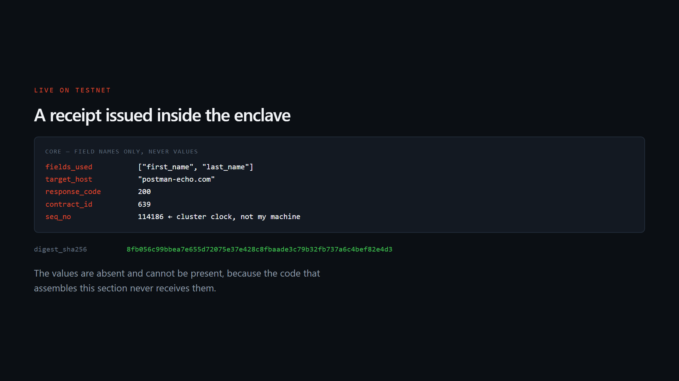
The same receipt as it appears in the walkthrough video.
10. Verification inside the enclave, the trail, and the log
Source: submission/evidence/13-step08-verify.txt
$ npm run step:08
checking: rcpt_03cc7f7a193196184c661f0d
anchor verified — 3 peers, 1 RTMR3 measurement(s)
{
"digest_sha256": "03cc7f7a193196184c661f0da0352974dd3f562c2dcccb2639a2f38fdff97079",
"reason": null,
"receipt_id": "rcpt_03cc7f7a193196184c661f0d",
"valid": true
}
digest matches, receipt is valid
Source: submission/evidence/14-step09-list.txt
$ npm run step:09
anchor verified — 3 peers, 1 RTMR3 measurement(s)
count: 8
rcpt_03cc7f7a193196184c661f0d | receipt_issuance_demo | POST postman-echo.com | status 200 | fields: ["first_name","last_name"]
rcpt_477609b57a71786d34613857 | peragaan_penerbitan_bukti | POST postman-echo.com | status 200 | fields: ["first_name","last_name"]
rcpt_4d8790a69bad4bbfd53c757f | receipt_issuance_demo | POST postman-echo.com | status 200 | fields: ["first_name","last_name"]
rcpt_51e9569d673ac2fc7e154fa2 | peragaan_penerbitan_bukti | POST postman-echo.com | status 200 | fields: ["first_name","last_name"]
rcpt_5bd9c8970986c53d5ec82043 | peragaan_penerbitan_bukti | POST postman-echo.com | status 200 | fields: ["first_name","last_name"]
rcpt_6dc44359e21d265d61bded90 | receipt_issuance_demo | POST postman-echo.com | status 200 | fields: ["first_name","last_name"]
rcpt_8fb056c99bbea7e655d72075 | receipt_issuance_demo | POST postman-echo.com | status 200 | fields: ["first_name","last_name"]
rcpt_b95858dd44433780f8b45abb | receipt_issuance_demo | POST postman-echo.com | status 200 | fields: ["first_name","last_name"]
Source: submission/evidence/15-step10-logs.txt
$ npm run step:10
anchor verified — 3 peers, 1 RTMR3 measurement(s)
{
"entries": [
{
"ts_ms": 1786585628437,
"level": "info",
"message": "nullstamp: calling POST postman-echo.com for receipt_issuance_demo with 2 profile fields",
"span_id": null
},
{
"ts_ms": 1786585628437,
"level": "info",
"message": "nullstamp: receipt rcpt_03cc7f7a193196184c661f0d issued, upstream status 200",
"span_id": null
}
],
"next_seq": 1,
"truncated": false
}
The log names the field count and never the field values. That is the discipline the whole design exists to enforce, and it holds even in the debugging surface.
Getting list-receipts to return parseable rows required finding T-14: kv-store.scan returns the raw CAS pointer envelope — ASCII magic T3VR followed by JSON holding a value_cid — where kv-store.get resolves it. The WIT promises key/value pairs and says nothing about this. The host raises no error; the bytes are simply the wrong bytes.
11. Where the exercise ended — T-15
Source: submission/evidence/16-step11-export.txt
$ npm run step:11
anchor verified — 3 peers, 1 RTMR3 measurement(s)
--- STEP FAILED ---
kind : InsufficientCreditError
message: InsufficientCredit (account=f21dce7928980eeea7dc93618b91f602a80fe1c4,
required=10000000000, available=0)
code : RPC_ERROR
requestId: 824ac0e3-0a2d-4d4a-b1d4-d1733f9e28a4
NOTE — this failure is itself a finding, recorded as T-15 in docs/BUGS.md.
The 20,000 test credit grant is advertised on the claim page as "enough for
25 agents and ~5,000 protected actions". In practice a single contract
execution locks a cap of 10,000,000,000 credits, and the grant of
20,000,000,000 was exhausted by ten registrations plus roughly a dozen
contract calls during this exercise.
Balance readings taken along the way, all from getBalance():
start of exercise : 19,989,922,328
after first receipt : 19,939,779,025
after v0.1.5 : 8,078,980,220
after v0.1.7 : 3,502,747,402
after v0.1.9 : 0
What this run did prove before the credits ran out, all captured in the
files above: contract 653 registered, ACLs re-pointed, credential seeded,
grant installed, receipt rcpt_03cc7f7a193196184c661f0d issued inside the
enclave with upstream status 200 and cluster sequence 115776, verified
in-enclave as valid, listed back among eight receipts, and its two log lines
read from the contract's own log.
Step 11 is only an export helper. The receipt it would have written was
already exported in the previous run and is committed at
submission/live-receipt.json — rcpt_8fb056c99bbea7e655d72075, contract 639.
That receipt is what section 17 verifies, and the verification needs no
credits, no session, and no network. Which is precisely the point of the
design: the account is now at zero and the node will no longer answer us,
yet the receipt remains checkable by anyone, forever.
12. The central claim, demonstrated
A receipt that only its issuer can check is not a receipt. So the digest is computed over a canonical form: object keys ascending, no whitespace, array order preserved.
Here is the live receipt checked by a separate TypeScript program that imports no SDK, opens no session, and makes no network request — with the tenant account at zero credits:
Source: submission/evidence/17-verify-offline.txt
$ npm run verify:offline -- ../submission/live-receipt.json
receipt_id : rcpt_8fb056c99bbea7e655d72075
digest recorded : 8fb056c99bbea7e655d72075e37e428c8fbaade3c79b32fb737a6c4bef82e4d3
digest computed : 8fb056c99bbea7e655d72075e37e428c8fbaade3c79b32fb737a6c4bef82e4d3
signature : none — signing capability not imported; integrity rests on the claims digest
RESULT: valid. Digest recomputed outside the node and it matches.
$ echo $?
0
This ran with the tenant account at zero credits. No session was opened, no
SDK was imported, and no network request was made. The receipt verifies
anyway, which is the whole claim.
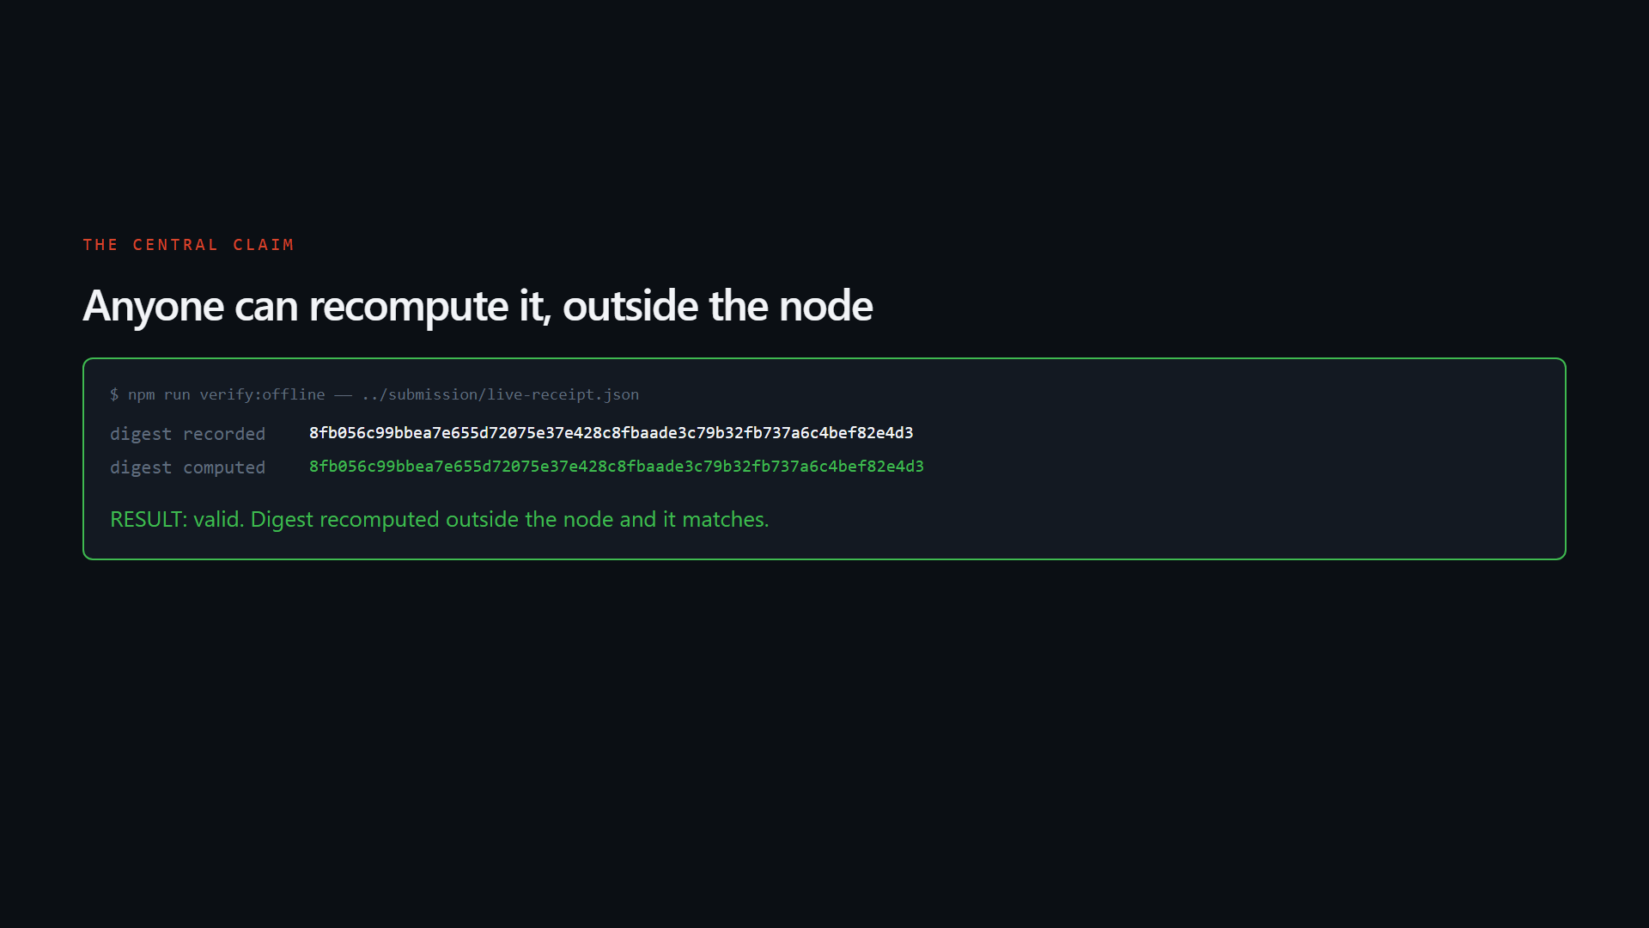
Both digests agree. Recomputing one needs no credits, no session, and no network.
The reverse direction is tested too:
Source: submission/evidence/18-tamper-rejected.txt
Three tampering attempts, all against the live receipt verified in section 17.
==========================================================================
1. Hiding a field that was actually used
The most realistic cheat: claim less data than you touched.
fields_used cut from [first_name, last_name] to [first_name].
==========================================================================
$ npm run verify:offline -- ../submission/tampered-fields.json
receipt_id : rcpt_8fb056c99bbea7e655d72075
digest recorded : 8fb056c99bbea7e655d72075e37e428c8fbaade3c79b32fb737a6c4bef82e4d3
digest computed : 9f2c28bea15b65b3c3507864989044b969ac7f750e0f36c8ed8a92e7e8f561ef
signature : none — signing capability not imported; integrity rests on the claims digest
RESULT: invalid.
- digest mismatch: recorded 8fb056c99bbea7e655d72075e37e428c8fbaade3c79b32fb737a6c4bef82e4d3, recomputed 9f2c28bea15b65b3c3507864989044b969ac7f750e0f36c8ed8a92e7e8f561ef
- receipt_id does not derive from digest: recorded rcpt_8fb056c99bbea7e655d72075, expected rcpt_9f2c28bea15b65b3c3507864
exit code: 1
==========================================================================
2. Swapping the destination host to api.attacker.com
==========================================================================
$ npm run verify:offline -- ../submission/tampered-host.json
receipt_id : rcpt_8fb056c99bbea7e655d72075
digest recorded : 8fb056c99bbea7e655d72075e37e428c8fbaade3c79b32fb737a6c4bef82e4d3
digest computed : 37f7ce215e46aad9c83d4ae90aa32a44e3fe237dd96d85fd1ead935de7e8b8c1
signature : none — signing capability not imported; integrity rests on the claims digest
RESULT: invalid.
- digest mismatch: recorded 8fb056c99bbea7e655d72075e37e428c8fbaade3c79b32fb737a6c4bef82e4d3, recomputed 37f7ce215e46aad9c83d4ae90aa32a44e3fe237dd96d85fd1ead935de7e8b8c1
- receipt_id does not derive from digest: recorded rcpt_8fb056c99bbea7e655d72075, expected rcpt_37f7ce215e46aad9c83d4ae9
exit code: 1
==========================================================================
3. Editing the content, then repairing the digest so it agrees
The careful version of the attack. It still fails, because the receipt
id derives from the digest and cannot be repaired without becoming a
different id.
==========================================================================
$ cargo test digest_yang_dipalsukan_agar_cocok_tetap_gagal_di_identitas
test verify::tests::digest_yang_dipalsukan_agar_cocok_tetap_gagal_di_identitas ... ok
test result: ok. 1 passed; 0 failed; 0 ignored; 0 measured; 52 filtered out; finished in 0.01s

13. The live demo
Anyone can run the same check in a browser, with no request to us. These are captures of the deployed site.
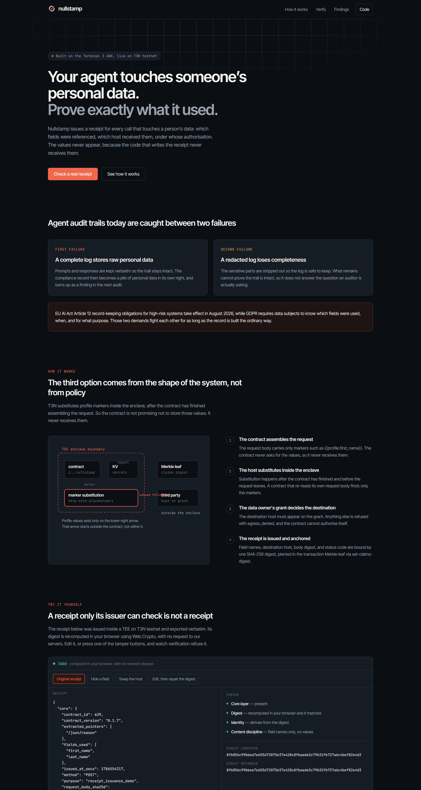
Landing page — nullstamp.vercel.app
14. The verifier, accepting a genuine receipt
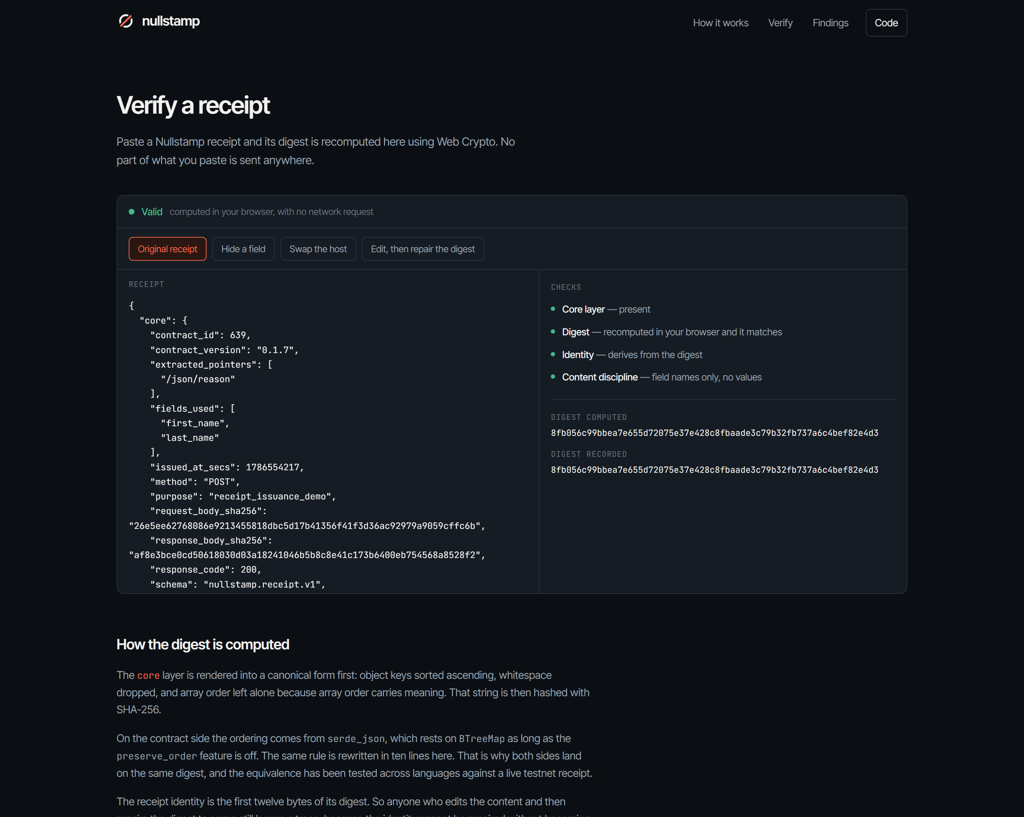
The live testnet receipt from contract 639 verifies: all four checks green, and the digest computed in the browser matches the digest recorded.
15. The verifier, rejecting tampering
Three attacks, each linkable directly so a reviewer can see the rejection without reproducing it.
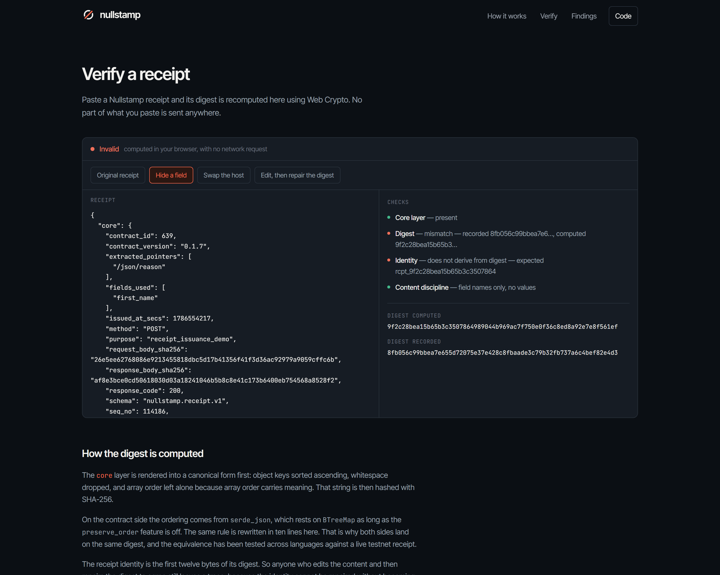
Hiding a field that was actually used: fields_used cut to one entry. Digest mismatch and identity failure, both red.
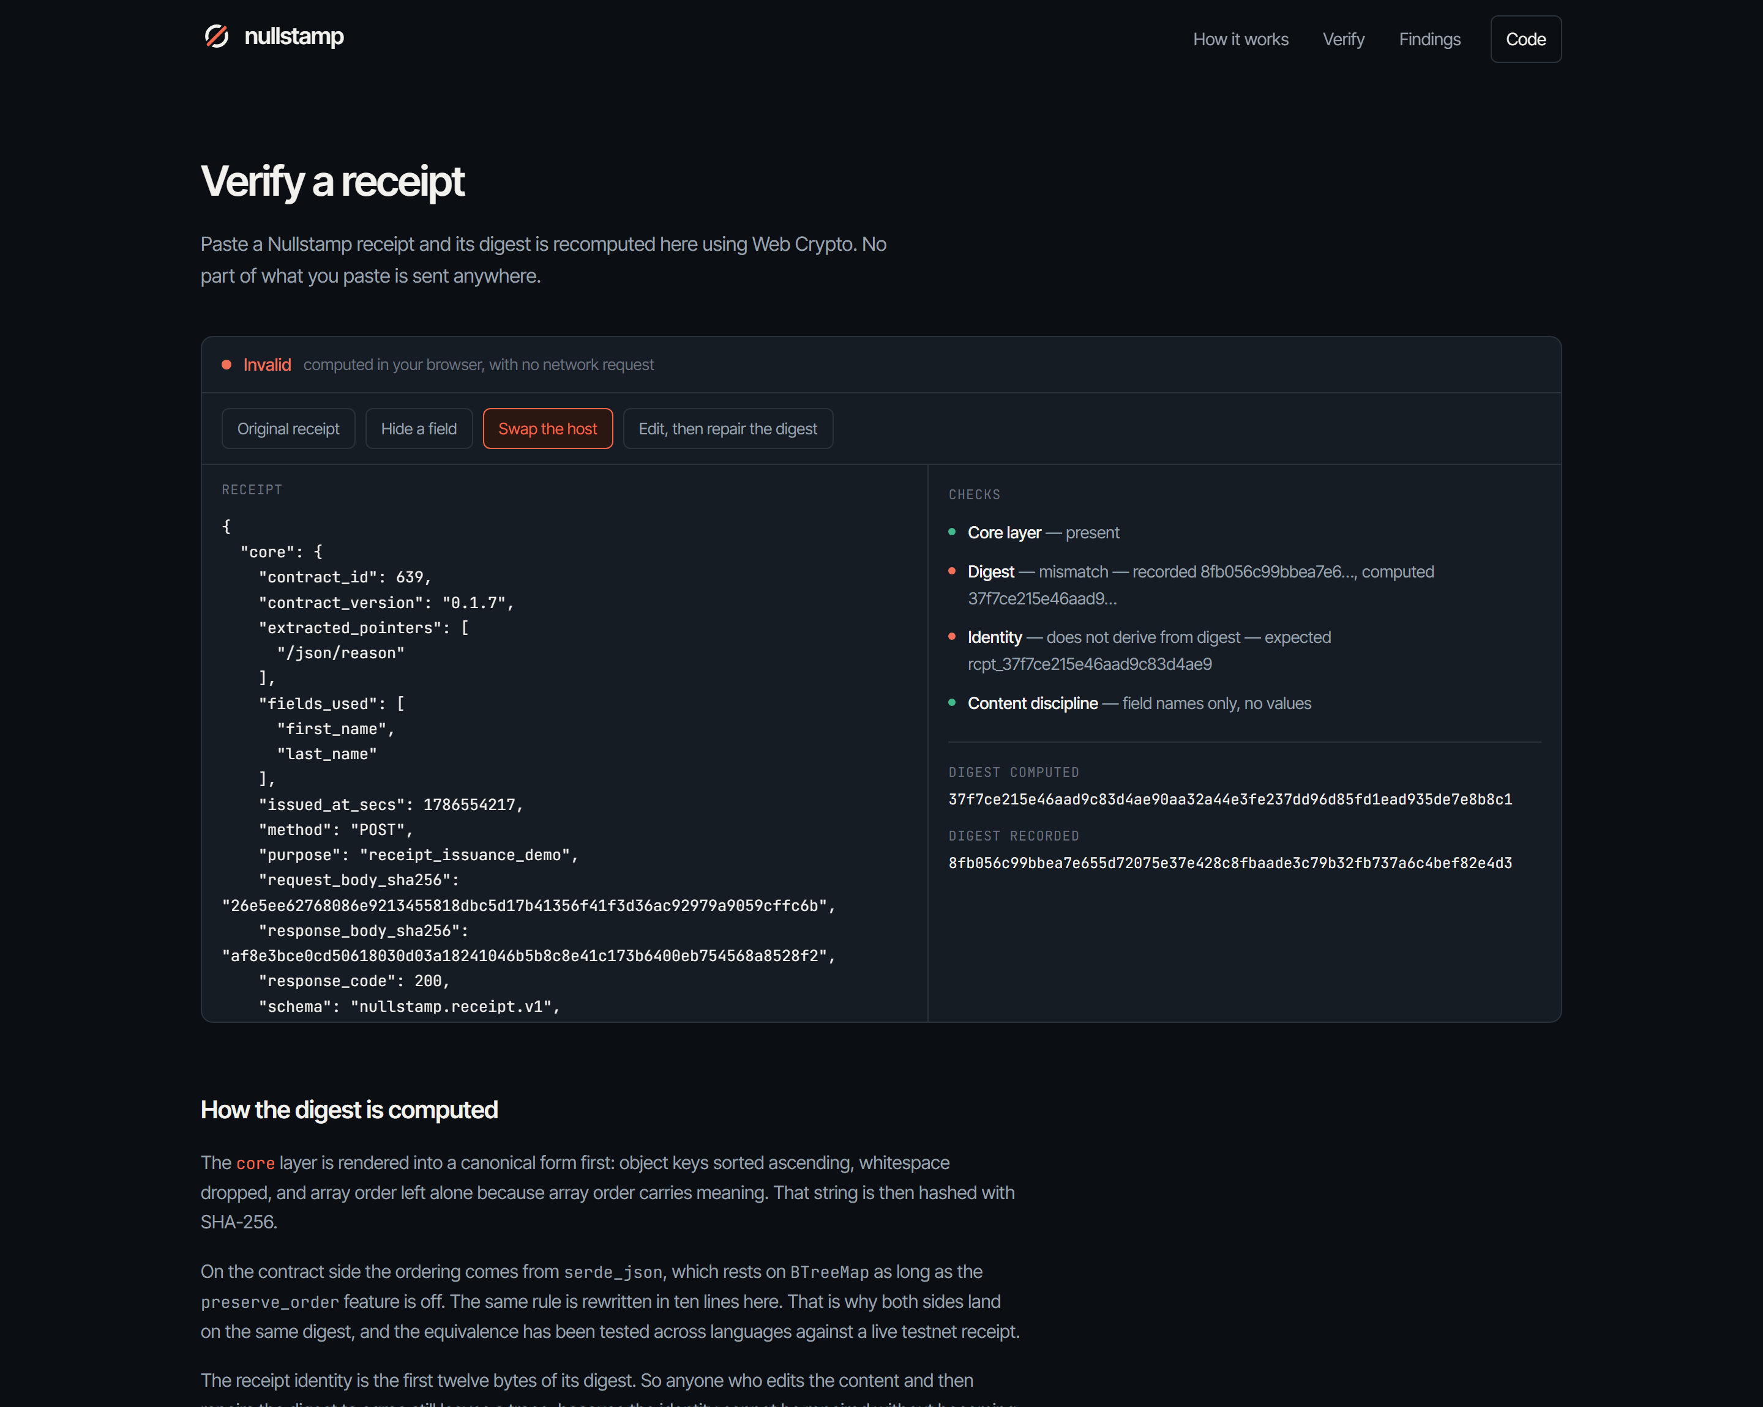
Swapping the destination host to api.attacker.com.
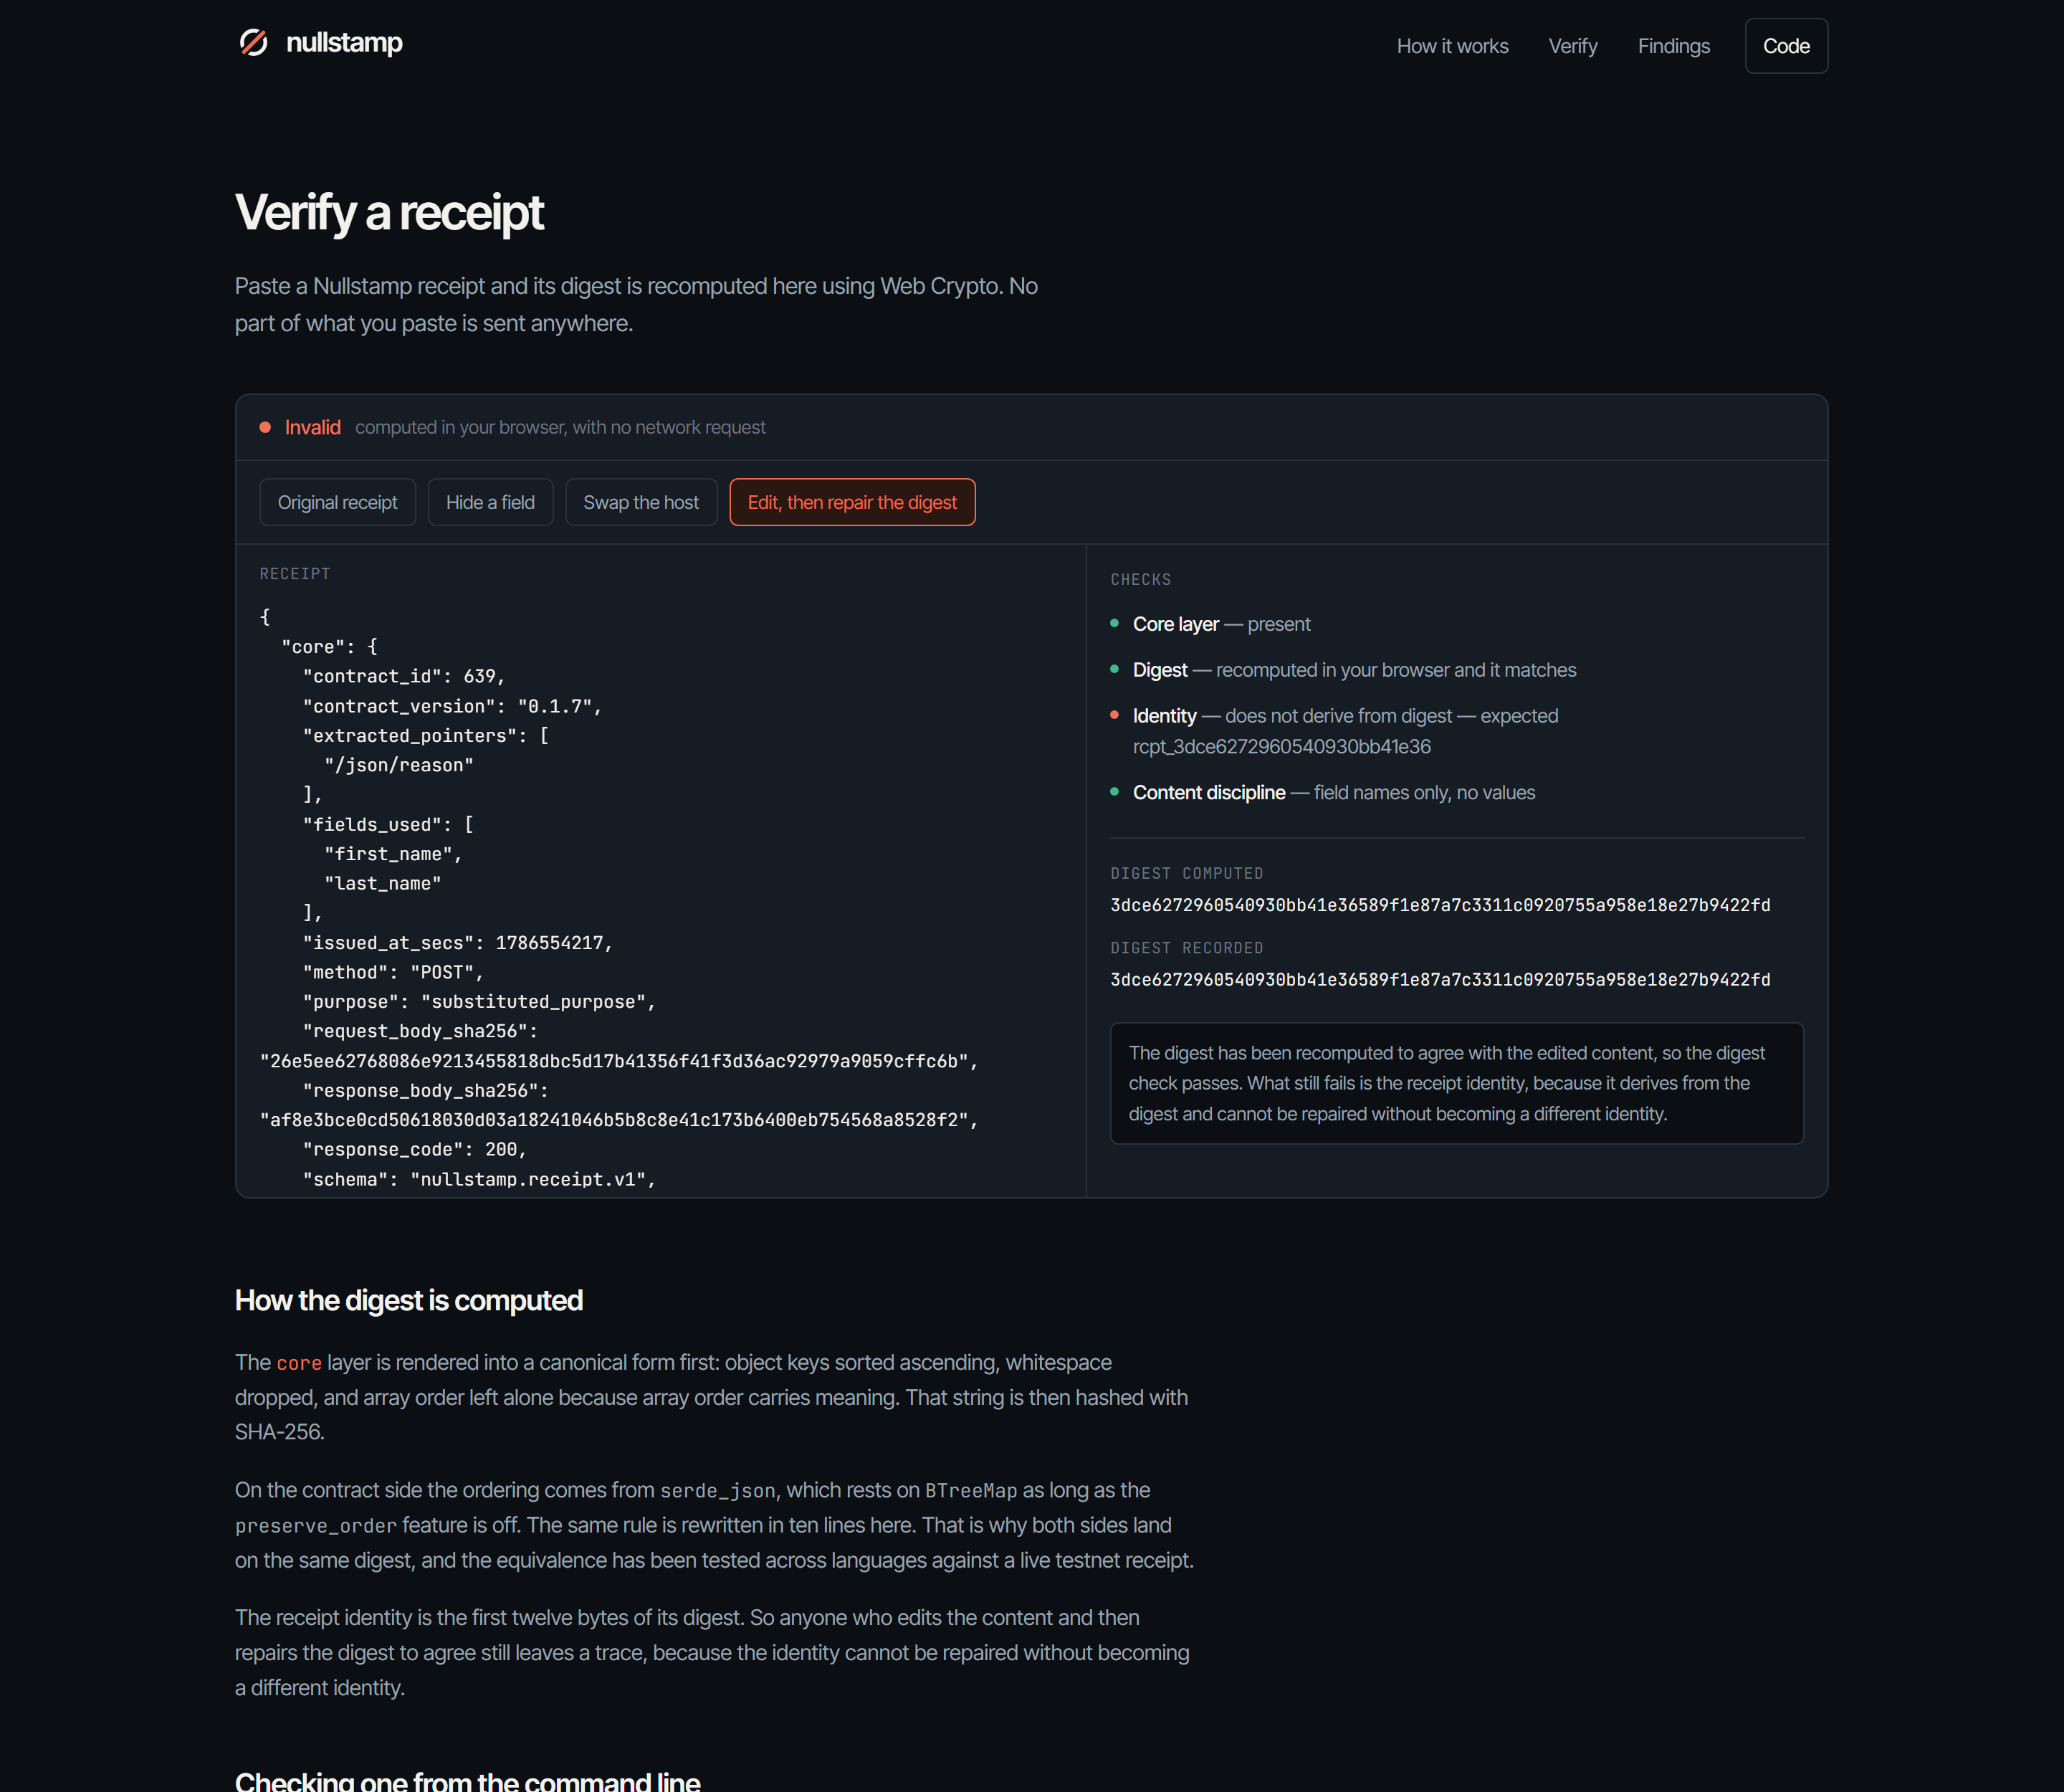
The careful attack: content edited and the digest repaired so it agrees. The digest check passes, and the identity check still fails — because the receipt id derives from the digest and cannot be repaired without becoming a different id.
16. The findings report, published
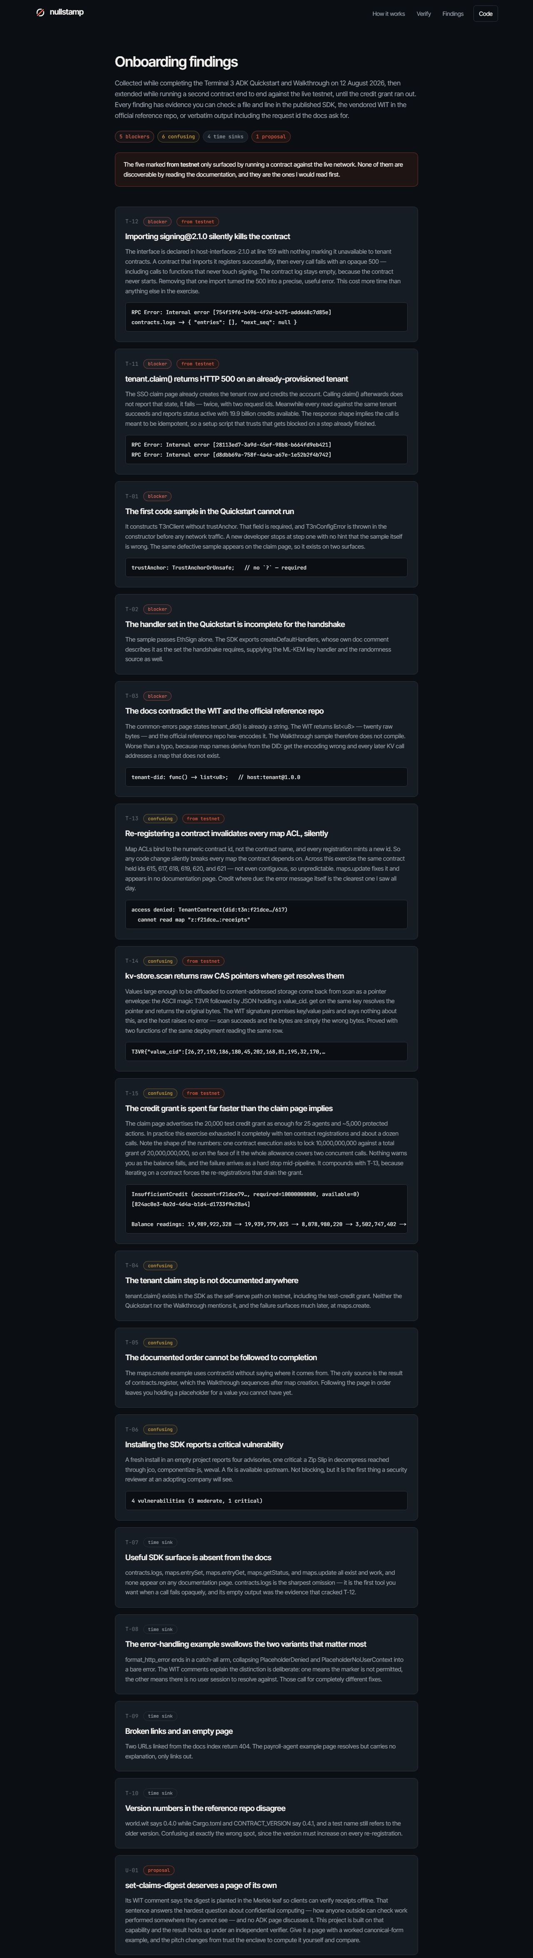
Findings page — all fifteen findings, with the five that came from testnet marked.

17. All fifteen findings
Full text with verbatim quotes, suggested fixes, and reproduction steps for every finding is in the repository at docs/BUGS.md, and as Findings-Report.pdf beside this document.
ID | Weight | Summary
T-01 | blocker | First Quickstart sample cannot run: trustAnchor is required and throws in the constructor. Same defect on the claim page
T-02 | blocker | Quickstart handler set incomplete for the handshake; createDefaultHandlers is never mentioned
T-03 | blocker | Docs say tenant_did() is a string; the WIT returns 20 raw bytes and the reference repo hex-encodes it. Walkthrough sample does not compile
T-11 | blocker | tenant.claim() returns 500 on an already-provisioned tenant instead of already-admitted. Two request ids supplied
T-12 | blocker | Importing signing@2.1.0 makes the contract fail to instantiate. Registration succeeds; every call then returns an opaque 500 with an empty contract log
T-13 | confusing | Contract ids are per registration and map ACLs bind to the id, so every re-register silently invalidates every ACL. Ten ids observed, non-contiguous
T-14 | confusing | kv-store.scan returns raw T3VR CAS pointers where get resolves them; no error, not in the WIT
T-15 | confusing | 20,000 credit grant exhausted by ten registrations, against an advertised "~5,000 protected actions". One call locks 10,000,000,000 of a 20,000,000,000 grant
T-04 | confusing | The tenant claim step is not documented anywhere
T-05 | confusing | maps.create needs a contractId that only exists after registration, which the Walkthrough sequences later
T-06 | confusing | SDK install reports 4 advisories, 1 critical (Zip Slip in decompress via jco)
T-07 | time sink | contracts.logs, maps.entrySet, maps.entryGet, maps.getStatus, maps.update appear in no documentation page
T-08 | time sink | Error-handling sample's catch-all arm collapses PlaceholderDenied and PlaceholderNoUserContext, whose distinction the WIT calls deliberate
T-09 | time sink | Two doc URLs return 404; the payroll example page has no content
T-10 | time sink | Reference repo version numbers disagree across world.wit, Cargo.toml, and a test name. The version lives in three places with no single source of truth — this bit me too
U-01 | proposal | set-claims-digest deserves a documentation page of its own

18. One proposal
kv-store.set-claims-digest deserves a documentation page of its own.
Its WIT comment says the digest is planted in the transaction's Merkle leaf "so clients can verify receipts offline". That sentence answers the hardest question about confidential computing: how can anyone outside check work performed somewhere they cannot see? No ADK page discusses it.
This project is built on that capability, and the result holds up under an independent verifier — as section 12 shows, with the account at zero credits and the node no longer answering. Give it a page with a worked canonical-form example, and the pitch for T3N changes from "trust the enclave" to "compute it yourself and compare". That is a materially stronger claim, and the machinery already ships.
19. Reproducing all of this
git clone https://github.com/bryankwandou/nullstamp
cd nullstamp/contract/z-tenant-nullstamp
cargo test --target "$(rustc -vV | sed -n 's/^host: //p')"
cargo build --target wasm32-wasip2 --release
wasm-tools component wit target/wasm32-wasip2/release/z_tenant_nullstamp.wasm
cd ../../scripts
npm install
npm run preflight # no developer key needed
cp .env.example .env # set T3N_API_KEY
npm run step:01 # through step:11
npm run verify:offline -- ../submission/live-receipt.json
The offline verification at the end needs no key, no credits, and no network, so it can be run by anyone from a clean clone.
Reported by Bryan Kwandou — nayrbryangaming01@gmail.com

