CE2107 Lab2 Assignment Sheet (to be submitted to NTULearn before next lab)

Name: Bryan Lu We Zhern Lab Group: SE4 Date: 23/09/2022

1. Section 6.2. Give a short 2-3 lines description on concept behind the reflectance reading process. Why does the black surface result in slower voltage decay?

The reflectance of the surface will affect the amount of current passing through the transistor, which will in turn affect the decay rate of the capacitor voltage. By measuring the voltage after a set time, we can determine whether the surface is a black or not.

Black surface reflects less IR, which will decrease the amount of current passing through the transistor, which leads to a slower decay rate of the capacitor voltage.

1. Section 6.2. Which parameter do you need to tweak in the Reflectance_Read() if the reflectance sensor reading is not accurate? Hint: check the 8 steps for Reflectance reading.

The delay time of Reflectance_Read().

1. Section 6.2. Write down the procedure to initialise P7.4 to be an input pin without internal pull-up resistor

P7->SEL0 &= ~0x10;

P7->SEL1 &= ~0x10;

P7->DIR &= ~0x10;

P7->REN &= ~0x10;

1. Section 6.3. Where are the sources of the offset error between actual distance and the estimated distance return by the function Reflectance_Position()?

Sources of offset error includes noise in measurement data, and height difference between the sensors and the surface.

1. Section 7.2.  Figure 7. The robot state toggled between LEFT and CENTER state repeatedly when it is detected that the robot is off to the left of the line (input: ‘01’). Under such condition, do you expect the robot to move toward the right in the zig-zag pattern or do you expect it to move in the smooth curve. Assume we shorten the time in each state from 500msec to 5 msec.

Smooth curve, as it will adjust its moving pattern fast enough that it will appear to be moving very smoothly.

1. Section 7.3. Fix the bug in the 11-state FSM design.  
   A picture containing table

   Description automatically generated

Fixed Version

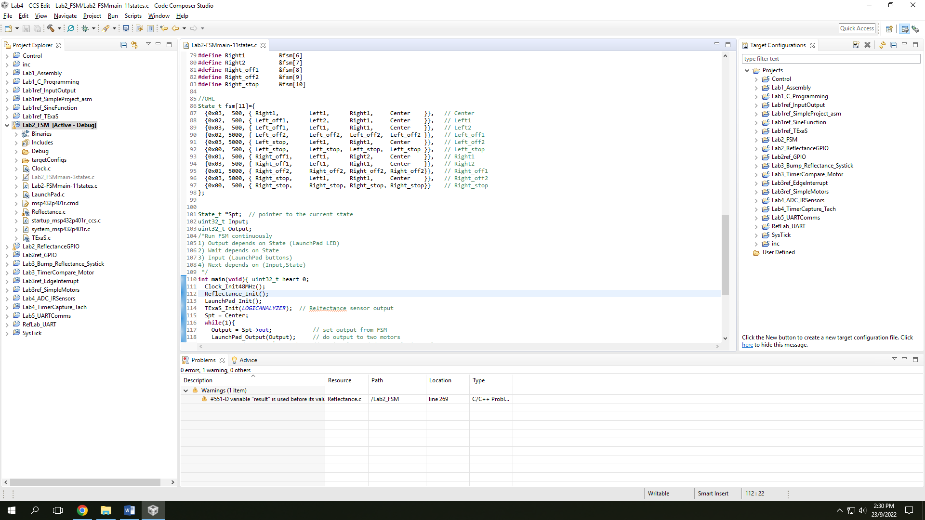

1. Section 7.3. What is the purpose of toggling LED within the main routine or ISR?

To let the user knows that the main routine is running, and the length of the program cycle.

1. Section 7.4. What hardware and software modifications are required in order for the robot to move within a lane, i.e. between two black lines, instead of following a line? Detail algorithm not required. Just one bullet point each for hardware and software.

Hardware:

Extra sensors for wider coverage.

Software:

To follow between two black lines, we check for the two ends of the sensor input for the two black lines instead of the center bits for following a line.