CE2107 Lab4 Assignment Sheet (to be submitted to NTULearn before next lab)

Name: Bryan Lu We Zhern Lab Group: SE4 Date: 28/10/2022

1. Section 6.1. What is the issue when an obstacle is placed too close to the IR sensor? What can you do to prevent such ambiguity?

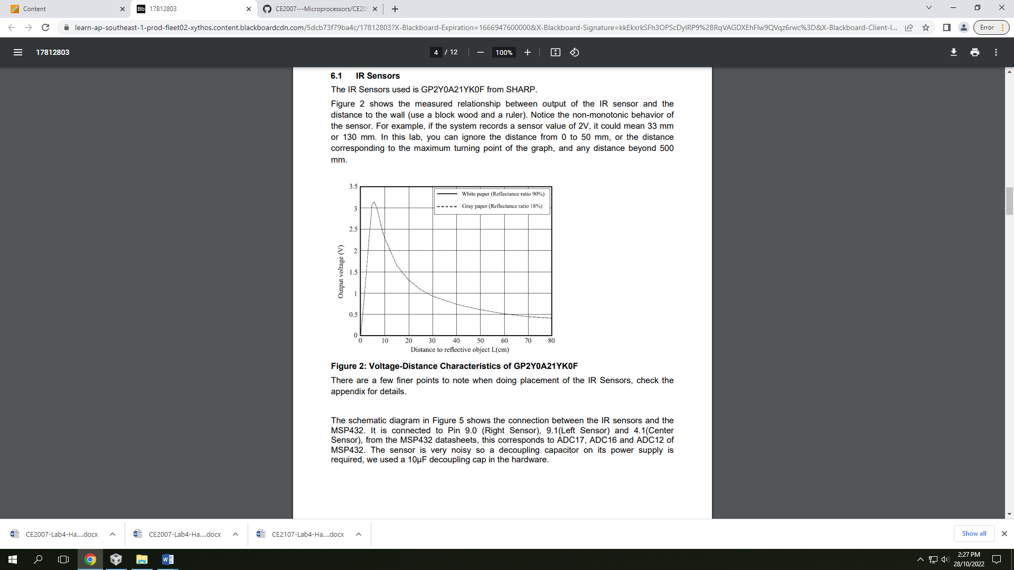

Measurements of IR sensors are not accurate at close distances as the IR sensors’ reading are not monotonic. From the curve above, it shows that the reading of the IR sensors decrease as the distance increase only after a certain threshold, but if the distance is too short, the reading would increase as the distance increase, which yields an unwanted result. This might cause the application to mistake an object to be far away when in reality it is just very close to the sensors.

To prevent such ambiguity, we can place the sensors on our robot such that the distance between the sensors and the edge of the robot is larger than or equal to the threshold distance, so all readings of objects away from the robot would be on the right side of the curve after the threshold.

1. 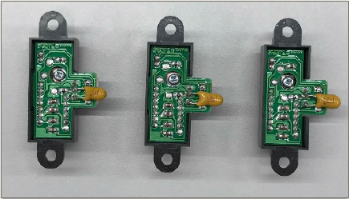Section 6.1. What is the purpose of the 10uF decoupling capacitor?

It helps reduce the noise of the sensors’ readings so that it can give a more stable value.

1. Section 6.2. Which port pins is ADC Ch12, 16 and 17 inputs mapped to? What is the PSELx settings required to configure the pins to ADC function?

ADC Channel 17 is mapped to Port 9, pin 0 (P9.0)

ADC Channel 12 is mapped to Port 4, pin 1 (P4.1)

ADC Channel 16 is mapped to Port 9, pin 1 (P9.1)

The SEL bits for the corresponding pins on Port 9 and 4 needs to be set to 11 are as following:

P9->SEL1 |= 0x03;

P9->SEL0 |= 0x03;

P4->SEL1 |= 0x02;

P4->SEL0 |= 0x02;

1. Section 6.2. With respect to the ADC on MSP432, what are the two stages involved in every Analog to Digital Conversion of an Analog signal?

MSP432 uses 14-bit SAR analog to digital converter. The whole ADC process consists of two parts, the ADC first sample the input signal voltage (Sample-and-Hold), the detected voltage level is then passed into the SAR ADC for digitization (Conversion).

1. Section 6.3. What does the function LPF_Calc() does? What are the initial values of the buffer associated with LPF_Calc()? Why do we need this function?

The function implements an average algorithm over past reading values to compute the 14 bit ADC value output. When a new data is read by the sensors, a new average will be calculated with the oldest value removed.

The initial values of the buffer are all the initial reading of the sensor after it warmed up.

This function will ensure that our final reading would be more stable by “filtering” our sudden high frequency noise.

1. Section 6.3. Describe the algorithm you used to estimate the actual distance based on the IR Sensor value.

Step 1: Collect the data of sensor raw reading versus the actual distance of the object

Step 2: From the data collected, plot a curve that best fits the data acquired.

Step 3: Implement the algorithm for the conversion functions, if the output is inaccurate, we can try repeating step 1 and 2 to obtain a more accurate outcome.

1. Section 7.2. Which timer capture input (Timer and Channel number) does P10.4 and P10.5 correspond to?

P10.4 and P10.5 correspond to Timer A3 Channel 0 and 1 respectively.

1. Section 7.2. Which edge (falling, rising, both) is the timer input capture configured to trigger on? What happens when a capture event occurs?

Rising edge.

The timer value would be “captured” into the corresponding CCR register (CCR0 and CCR1) via IQR Handlers.

1. Section 7.2. Why is the calculated value of pulse duration, derived from the timer capture values, not a constant value but seemed to keep changing?

The tachometers, which are used to calculate the value of pulse duration, uses light rays to calculate rotation. However, in a real-life scenario, these light rays would not be of perfect condition and would suffer from fluctuations at the receiving end of the tachometer. Consequently, the square pulses created may not be at constant intervals with one another. Hence, the calculated value of pulse duration is not a constant value, but a changing one.