Exercise 1: The Smart Phone Rivalry

1. Translate the natural language statements above describing the dealing within the Smart Phone industry in to First Order Logic (FOL).

**Statement:** sumsum, a competitor of appy

**FOL:** competitor_of(sumsum,appy).

**Statement:** sumsum developed some nice smart phone technology called galacticas3

**FOL:** developed_by(galactica_s3, sumsum).

**Statement:** stevey is boss of appy

**FOL:** boss_of(stevey, appy).

**Statement:** stevey stole galactica_s3 from sumsum

**FOL:** steal(stevey, galactica-s3, sumsum).

**Statement:** Unethical for boss to steal business from rival companies

**FOL:** ∀Boss, ∀Company, ∀OtherCompany, ∀Business((boss_of(Boss, Company) ∧ steal(Boss, Business, OtherCompany) ∧ rival(Company, OtherCompany) ∧ business(Business)) → unethical(Boss))

**Statement:** A competitor is a rival

**FOL:** , ∀X, ∀Y(company(X) ∧ company(Y) ∧ competitor_of(X,Y)) → rival(X,Y)

**Statement:** Smart phone technology is a business

**FOL:** ∀X(smart_phone_tech(X)) → business(X)

1. Write these FOL statements as Prolog clauses.

/* Declare companies */

company(sumsum).

company(appy).

/* sumsum is a competitor of appy */

competitor_of(sumsum,appy).

competitor_of(X,Y):-

    competitor_of(Y,X).

/* galactica_s3 is a smart phone technology */

smart_phone_tech(galactica_s3).

/* galactica_s3 is developed by sumsum */

developed_by(galactica_s3, sumsum).

/* stevey is boss of appy */

boss_of(stevey, appy).

/* stevey stole galactica_s3 from sumsum */

steal(stevey, galactica_s3, sumsum).

/* Boss is unethical if they steal business from other company who is a rival*/

unethical(Boss):-

    boss_of(Boss, Company),

    steal(Boss, Business, OtherCompany),

    rival(Company, OtherCompany),

    business(Business).

rival(X,Y):-

    company(X),

    company(Y),

    competitor_of(X,Y).

/* smart phone technology is a business */

business(X):-

    smart_phone_tech(X).

1. Using Prolog, prove that Stevey is unethical. Show a trace of your proof. (

Exercise 2: The Royal Family

1. A screenshot of a computer code

   AI-generated content may be incorrect.Define their relations and rules in a Prolog rule base. Hence, define the old Royal succession rule. Using this old succession rule determine the line of succession based on the information given. Do a trace to show your results.

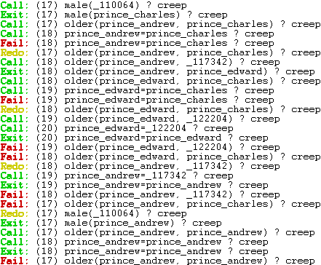

1. Recently, the Royal succession rule has been modified. The throne is now passed down according to the order of birth irrespective of gender. Modify your rules and Prolog knowledge base to handle the new succession rule. Explain the necessary changes to the knowledge needed to represent the new information. Use this new succession rule to determine the new line of succession based on the same knowledge given. Show your results using a trace.

