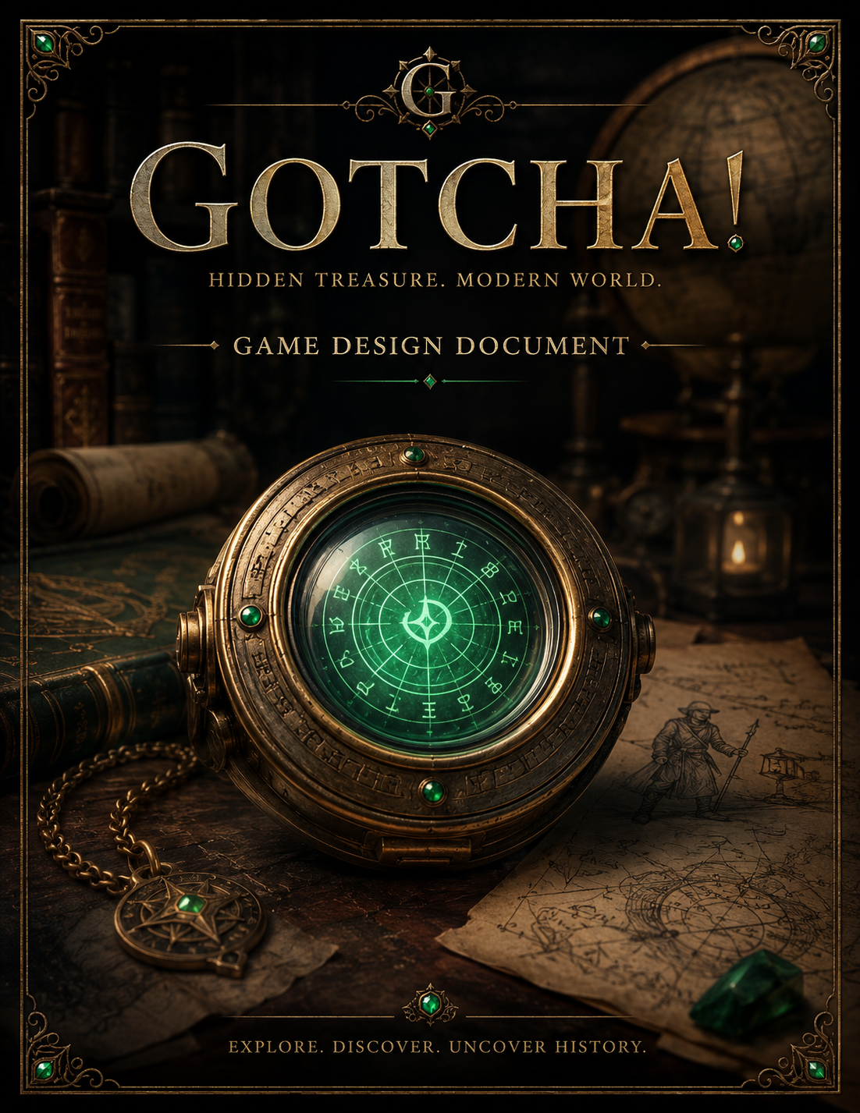

GOTCHA!
Game Design Document
Version: 0.1 (Living Document)
Project Codename: Gotcha!
Genre: Real-World Treasure Hunting Adventure
Platform: Mobile First (PWA → Native iOS / Android)

Contents
Chapter 1 – Executive Summary & Vision 2
Chapter 2 - Story & World 8
Chapter 3 – Characters 15
Chapter 4 – The Player Experience 23
Chapter 5 – The First Expedition (Tutorial) 33
Chapter 6 – The Lens & Resonance System 41
Chapter 7 – Progression & Economy 51
Chapter 8 – UI / UX Design 60
Chapter 9 – Game Systems Architecture 71
Chapter 10 – Gotcha! Operations 81
Chapter 11 – Development Roadmap 89
Chapter 12 – Long-Term Vision 99

Chapter 1 – Executive Summary & Vision
What is Gotcha!?
Gotcha! is a real-world treasure hunting adventure that transforms ordinary places into archaeological expeditions.
Players become modern treasure hunters, wielding an ancient artifact known as the Goetchae Lens to uncover long-forgotten treasure hidden throughout the modern world.
Rather than searching for treasure buried beneath the earth, hunters discover that ancient resonance signatures have survived through time and can only be revealed by aligning the Lens with modern objects that unknowingly share those same patterns.
Every hunt contributes to a larger mystery surrounding the legendary Lost Vault, while every discovery strengthens both the hunter and the global community of explorers.
The game is designed to make players see everyday shopping as an adventure rather than an errand.

The Vision
Our Mission
Create the world's first treasure hunting game where players genuinely feel like explorers rather than consumers.
The game should make players:
- look forward to opening the app every morning
- feel excited walking into a store
- smile when a treasure is revealed
- build a long-term relationship with the Goetchae Lens
- contribute to a community expedition larger than themselves
If successful, players should eventually associate grocery stores, hardware stores, and retail locations with exploration rather than shopping.

The North Star
Every feature in Gotcha! should strengthen one fantasy:
"I am carrying an ancient relic that reveals hidden treasure concealed within the modern world."
If a feature weakens that fantasy, it should be redesigned or removed.

Design Philosophy
The Real World Is The Game Board
The world already contains enough interesting places.
Rather than creating a fictional map, Gotcha! overlays an ancient world onto the modern one.
Players don't travel to stores.
They travel to resonance anomalies.
The existence of a store is simply how the modern world intersects with ancient history.

Discovery Before Reward
Rewards should always feel earned.
The player should never tap a button and receive treasure.
Treasure is uncovered through exploration, deduction, travel, and discovery.

One Iconic Artifact
The Goetchae Lens is the centerpiece of the entire experience.
It is:
- the logo
- the app icon
- the primary interface
- the cipher
- the resonance detector
- the treasure revealer
- the player's identity
Everything meaningful in the game happens through the Lens.

Simplicity Through Ritual
The daily gameplay loop should become familiar without becoming boring.
Every expedition follows the same rhythm:
- Choose a resonance anomaly.
- Travel.
- Awaken the Lens.
- Solve the glyph cipher.
- Reveal the Resonance Pattern.
- Consult the Curator's Archive.
- Find the modern vessel.
- Match the resonance.
- Recover the treasure.
The familiarity of this ritual should become comforting rather than repetitive.

Progress You Can Feel
Players should not simply gain levels.
They should become increasingly attuned to the Lens.
As Personal Resonance grows:
- the Lens awakens faster
- more glyphs resonate automatically
- visual effects become richer
- treasure reveals become more dramatic
- seasonal event odds improve
Progress should be experienced, not merely displayed.

Community Over Competition
Players are not competing to finish first.
They are uncovering history together.
Every treasure recovered weakens an ancient resonance anomaly.
Every hunter contributes to Community Resonance.
When enough resonance has been recovered, new discoveries become possible for everyone.

The Curator Is Knowledge
The Curator is not the hero.
He is the bridge.
He spent decades researching ancient civilizations and constructing the Goetchae Archive.
His work allows hunters to translate ancient resonance into modern product matches.
Without him, the Lens reveals patterns.
With him, those patterns become discoveries.

The Core Player Fantasy
The player should never feel like they are:
- scanning barcodes
- checking into stores
- completing shopping tasks
Instead they should feel like they are:
- investigating ancient resonance
- decoding forgotten glyphs
- consulting centuries of research
- recovering hidden treasure
- rebuilding history

Success Criteria
Gotcha! succeeds when players naturally say:
"I wonder where today's resonance anomalies are."
instead of:
"I wonder what today's tasks are."
The game should create anticipation rather than obligation.
Players should return because they are curious about what they will discover next, not because they fear missing a streak.

Executive Summary Non-Negotiables
The Goetchae Lens is the iconic centerpiece of the franchise.
The player is always a treasure hunter, never a shopper.
The Curator provides knowledge, not solutions.
The Archive is a bridge between ancient resonance and the modern world.
Every mechanic must strengthen the fantasy of exploration.
Treasure is discovered, never simply awarded.
Travel should feel like embarking on an expedition.
Simplicity is more valuable than feature count.

Chapter 2 - Story & World
Design Principle
The world of Gotcha! should feel ancient, mysterious, and believable.
The story exists to support gameplay, not interrupt it. Every discovery should answer one question while creating another. Players should feel as though they are uncovering history rather than reading it.
The greatest mysteries should remain unsolved until they are earned.

The World
Long before the modern world existed, an ancient civilization created a method of preserving something more valuable than gold.
Rather than recording locations with maps or language, they discovered that every object possessed a unique resonance. These resonance signatures became a universal method of identifying and cataloging treasure.
Using a remarkable brass instrument known today as the Goetchae Lens, they could tune into those signatures and reveal hidden treasures invisible to ordinary eyes.
Over centuries, civilizations disappeared.
Empires fell.
Languages were forgotten.
The Lens survived.
The treasure did not disappear.
Only humanity's ability to find it.

The Lost Vault
Legends tell of a magnificent Vault containing the greatest collection of ancient treasure ever assembled.
Rather than being destroyed or stolen, the Vault was intentionally hidden.
Its location has remained unknown for centuries.
Before the Vault was concealed, thousands of individual treasure remnants were scattered throughout the world.
Each remnant carries its own unique resonance signature.
Together, they form breadcrumbs leading toward the Lost Vault.
Every treasure discovered by the player represents another recovered piece of history.

The House of Goetchae
The first reference to the House of Goetchae is discovered inside an ancient locked journal.
At the beginning of the game, neither the player nor the Curator understands its significance.
Only later is it revealed that the Curator's family unknowingly descended from the House of Goetchae.
For generations, one simple brass key engraved with the letter G was passed from parent to child.
Its purpose had long been forgotten.
Only after the Curator unlocks the ancient journal does its meaning become clear.
The Goetchae family were never the owners of the treasure.
They were its keepers.
Over hundreds of years, the pronunciation of "Goetchae" gradually evolved into what is now spoken as "Gotcha."
The title of the game is therefore both a celebration of discovery and a subtle connection to the ancient family whose responsibility was to protect history itself.

The Curator
The Curator spent decades exploring forgotten civilizations around the world.
During an expedition near the Great Barrier Reef, he discovered an ornate brass Lens enclosed in coral with an ancient scroll explaining only one thing:
The Lens could be awakened.
Driven by curiosity, he traveled to a historic coastal library hoping to identify the strange artifact.
Hidden behind an old atlas he discovered a locked leather-bound journal bearing the same emblem as the Lens.
Without understanding why, he used the brass key he had worn around his neck since childhood.
It fit perfectly.
Inside he discovered:
- references to the House of Goetchae
- the earliest pages of an unfinished Archive
- evidence that resonance signatures could still be detected today
For the first time, the Curator realized his family's heirloom had never been ornamental.
It had been waiting.

The Goetchae Lens
The Goetchae Lens is the only known artifact capable of interpreting ancient resonance.
It is not magical in the traditional sense.
It is an ancient instrument built around principles that modern science cannot yet explain.
The Lens performs four essential functions.
Detects resonance anomalies.
Decodes ancient glyphs into Resonance Patterns.
Confirms resonance alignment with modern vessels.
Reveals hidden treasure.
As the player's Personal Resonance grows, the Lens becomes increasingly attuned to its owner.
The artifact itself visibly evolves through use.

Resonance
Resonance is the invisible connection between ancient treasure and the modern world.
Every treasure fragment emits a unique resonance signature.
The Lens detects these signals.
When resonance grows strong enough, it forms visible glyphs.
When the glyphs are correctly aligned, twelve glowing resonance lines appear inside the Lens.
Together they form an Ancient Resonance Pattern.
The Curator's Archive compares that pattern against modern product identifiers.
When a match is found, the modern object becomes the vessel through which the ancient treasure can be recovered.
The product does not contain the treasure.
It simply shares the resonance necessary for the Lens to reveal it.

The Curator's Archive
The Archive represents the Curator's life's work.
For decades he compared ancient resonance records with modern product identifiers.
Every successful hunt validates another piece of his research.
The Archive is not mysterious.
It is scholarly.
Its purpose is to translate forgotten history into modern understanding.
Without the Archive, the Lens reveals only resonance patterns.
With it, hunters know where to continue their search.

The Modern World
The world itself has become the game board.
Players never search for stores.
They search for resonance anomalies.
An ancient parchment map is projected over modern cartography.
Three significant resonance anomalies emerge each week.
Each anomaly represents an expedition.
When every treasure at that location has been recovered, the resonance weakens until the anomaly finally disappears from the map.
The world grows quieter.
Until new resonance emerges elsewhere.

Mysteries Reserved for Future Seasons
The opening chapters intentionally leave several questions unanswered.
Why was the Lost Vault hidden?
Who scattered the treasure?
Who built the Lens?
Why do resonance patterns correspond to modern products?
What lies inside the Lost Vault?
Why did the House of Goetchae become its guardians?
These questions should unfold naturally through seasonal storytelling rather than early exposition.

Story & World Non-Negotiables
- The player is uncovering history, not completing shopping tasks.
- The Curator guides but never overshadows the player.
- The Goetchae Lens is the centerpiece of both story and gameplay.
- Modern products are vessels, never the treasure itself.
- The Archive is scholarly rather than mystical.
- Every discovery should deepen the world's mystery.
- The real world is permanently transformed into an archaeological expedition.

Chapter 3 – Characters
Design Principle
Every character in Gotcha! exists to strengthen the player's feeling of being an explorer.
No character should ever overshadow the player.
The Curator opens doors.
The player walks through them.
The Lens makes discovery possible.
Every relationship in the game should reinforce curiosity, optimism, and wonder.

Character Philosophy
Gotcha! intentionally uses a very small cast of recurring characters.
This creates familiarity while allowing the world itself to become the primary source of mystery.
The emotional relationship is not between the player and dozens of NPCs.
It is between the player and three things:
- The Curator
- The Goetchae Lens
- The Lost World waiting to be rediscovered

The Curator
Role
- Mentor
- Historian
- Explorer
- Researcher
- Keeper of the Goetchae Archive

Character Summary
The Curator is an elderly explorer whose lifetime of research has led him to the greatest discovery of his career.
Inspired by legendary naturalists and explorers, he is calm, thoughtful, humble, and endlessly curious.
He does not seek treasure for wealth.
He seeks understanding.
His greatest adventure is no longer climbing mountains or diving shipwrecks.
It is helping the next generation finish what he started.

Visual Direction
Late seventies.
Weathered face.
Warm smile.
Kind eyes.
Trim white beard.
Explorer's field jacket.
Leather satchel filled with journals.
Old brass key engraved with the letter "G" hanging from a leather cord around his neck.
The key is never explained during the tutorial.

Personality
The Curator rarely speaks in long explanations.
Instead, he offers observations.
Questions.
Encouragement.
Wonder.
He celebrates discovery more than certainty.
Players should feel as though they are exploring alongside him rather than receiving instructions.

Dialogue Style
Examples:
"Curious..."
"The Lens has awakened."
"Remarkable."
"I've never seen resonance behave quite like this."
"Excellent work."
"Another piece of history returns."
"There was a time I would have followed that signal myself."
"Now... it's your turn."
His dialogue should always be concise.
Players should want to hear him speak because every sentence feels meaningful.

Backstory
Decades before the game begins, the Curator dedicated his life to studying forgotten civilizations.
During a dive near the Great Barrier Reef, he recovered an ornate brass Lens sealed inside a coral-covered container.
Attached to it was a weathered scroll describing only how to awaken the artifact.
Searching for answers led him to a historic coastal library.
Hidden behind an old atlas was a locked leather-bound journal bearing the same symbol as the Lens.
The brass key he had worn around his neck since childhood opened the lock perfectly.
Inside he discovered the earliest pages of the Goetchae Archive.
For the first time he realized his family's heirloom had never been decorative.
It had been waiting.

Narrative Purpose
The Curator is not the hero.
He is the bridge between the ancient world and the modern one.
Without him:
The Lens has no translation.
Without the player:
The Curator's research never comes alive.

The Player
Role
- Treasure Hunter
- Explorer
- Field Researcher

Character Summary
The player is never referred to as "the chosen one."
There is no prophecy.
No destiny.
The Curator chooses the player because they are willing to explore.
Everything the player becomes is earned through persistence rather than fate.

Player Fantasy
The player should feel:
"I carry an ancient relic."
"I uncover forgotten history."
"I recover hidden treasure."
"I help complete the Curator's life's work."
"I am becoming one of history's greatest treasure hunters."

Growth
Players do not become stronger because of levels.
They become more attuned to the Lens.
Higher Personal Resonance reflects a deeper connection with the artifact.
Mastery is shown through behavior rather than statistics.

The Goetchae Lens
Character Philosophy
Although it is an object, the Lens should feel like a character.
- It sleeps.
- It awakens.
- It listens.
- It resonates.
- It guides.
- It reveals.
Over months of play, the player should feel emotionally attached to the Lens.
It becomes their constant companion.

Personality Without Words
The Lens never speaks.
Its personality is communicated through:
- Light.
- Sound.
- Motion.
- Resonance.
- When dormant it is silent.
- When awakened it hums softly.
- When near treasure it becomes vibrant and energetic.
The player should gradually feel that the Lens has a life of its own.

The House of Goetchae
At the beginning of the game, the House of Goetchae exists only as a mysterious name discovered inside the ancient journal.
Neither the Curator nor the player understands its significance.
Future seasons gradually reveal:
- The origin of the Lens.
- The purpose of the Lost Vault.
- Why the Goetchae family became its keepers.
How the family name slowly evolved into the modern pronunciation:
"Gotcha."
This revelation should feel earned rather than explained.

Future Characters
Additional characters should only be introduced when they strengthen the player's adventure.
Potential examples include:
- Archivists assisting the Curator
- Rival treasure hunters
- Seasonal expedition leaders
- Historians
- Ancient figures revealed through recovered journals
New characters should always deepen the mystery rather than distract from it.

Character Relationships
The Curator provides knowledge.
The Lens provides discovery.
The Player provides action.
These three pillars form the emotional foundation of the entire game.

Character Non-Negotiables
- The player is always the hero.
- The Curator mentors but never overshadows.
- The Lens should feel alive without speaking.
- Wonder is more important than exposition.
- Every character should reinforce exploration.
- The relationship between the player and the Lens should deepen throughout the entire game.

Chapter 4 – The Player Experience
Design Principle
Gotcha! is designed around one simple fantasy:
- The player is a modern treasure hunter carrying an ancient artifact that reveals hidden treasure concealed throughout the modern world.
- Every interaction should reinforce that fantasy.
- The game should never feel like a shopping application, a coupon app, or a barcode scanner.
- The player should feel like they are embarking on a genuine expedition.

The Emotional Journey
Every expedition follows the same emotional progression.
Curiosity
Anticipation
Discovery
Achievement
Progress
Wonder
This emotional rhythm is more important than any individual mechanic.

The Expedition Loop
The gameplay loop intentionally mirrors a real archaeological expedition.
You don't immediately discover treasure.
You earn it.
Every hunt consists of six stages.

Stage One
A New Resonance Emerges
The player opens the game.
The Curator's Study slowly fades into view.
Morning light fills the room.
The Goetchae Lens rests quietly on its stone pedestal.
Its emeralds are dark.
The Curator smiles.
"Good morning."
"Three new resonance anomalies have appeared."
The ancient map unfolds across the table.
Three glowing resonance fields slowly pulse across the parchment.
The player has a choice.
Which expedition comes first?
The player never sees store names.
Only ancient resonance.

Stage Two
The Journey
The player selects a resonance anomaly.
The Lens projects its approximate location onto the ancient map.
The player presses:
Navigate
The game's role ends.
Apple Maps or Google Maps opens.
The player safely travels.
Travel is not considered gameplay.
It is part of the adventure.
Like driving to the trailhead before beginning a hike.

Stage Three
Entering the Resonance Field
Upon arriving near the destination, the player returns to Gotcha!
Nothing happens immediately.
The Lens remains quiet.
As the player approaches the resonance field...
One emerald flickers.
Then another.
A soft harmonic tone begins.
Ancient glyphs slowly materialize around the rotating cipher ring.
The Curator quietly observes.
"You're close."
"The Lens can finally hear it."
No maps.
No arrows.
No compass.
The player simply knows:
The expedition has begun.

Stage Four
Awakening the Lens
The Goetchae Lens now fills the screen.
The player rotates the perfectly circular cipher ring.
Ancient glyphs align.
Every successful alignment creates:
- a satisfying mechanical click
- a harmonic resonance tone
- one illuminated emerald
- one glowing resonance line within the glass
The player is not solving a barcode.
The player is tuning resonance.
When the final glyph aligns...
The Lens comes alive.
Twelve resonance lines stand perfectly within the glass.
Together they create an Ancient Resonance Pattern.
The Lens has awakened.
This ritual should become the defining interaction of Gotcha!, much like throwing a Poké Ball defines Pokémon.

Stage Five
The Archive
The awakened Lens projects the completed Resonance Pattern into the Curator's Archive.
The Archive immediately compares the pattern against decades of research.
The Curator smiles.
"Excellent."
"We've seen this resonance before."
The Archive displays:
- Product
- Brand
- Product image
No riddles.
No clues.
The puzzle has already been solved.
The Archive simply translates ancient knowledge into modern understanding.
The player has earned certainty.

Stage Six
Recovering the Treasure
The player searches the store.
Finds the product.
Raises the Lens.
The completed resonance pattern appears over the product barcode.
The player carefully aligns both patterns.
Perfect match.
Everything pauses.
The Lens hums.
The emeralds pulse together.
Golden particles begin swirling inside the glass.
The words appear.
RESONANCE LOCK
Silence.
Then...
The treasure erupts from the modern vessel.
Gold.
Gems.
Artifacts.
Ancient remnants.
The player instinctively smiles.
"Gotcha!"
The game never tells the player to say it.
The moment should naturally create that reaction.

After Every Discovery
The recovered treasure is added to the player's collection.
Personal Resonance increases.
The Lens glows slightly brighter.
The resonance anomaly weakens.
One breadcrumb leading toward the Lost Vault has been recovered.
The Curator quietly records another successful expedition inside the Archive.
History has been restored.

Completing a Resonance Anomaly
Each resonance anomaly contains multiple treasures.
Every recovered treasure weakens the anomaly.
The ancient map visibly changes.
The glow becomes smaller.
The signal grows quieter.
After the final treasure...
The resonance collapses.
The anomaly fades from the map.
The Curator closes his journal.
"That place has gone quiet."
The expedition is complete.
The player returns to the map.
Two resonance anomalies remain.
Which will they investigate next?

Personal Resonance
Personal Resonance represents the player's attunement to the Goetchae Lens.
It is not experience points.
It is not a level.
It is the relationship between hunter and artifact.
As Personal Resonance grows:
- More glyphs automatically resonate during the daily cipher.
- The Lens awakens more quickly.
- Treasure reveals become richer.
- Seasonal event odds improve.
- Visual and audio effects become more dramatic.
If the player becomes inactive, Personal Resonance slowly fades.
The relationship weakens.
Not permanently.
It can always be rebuilt through exploration.

Community Resonance
Every recovered treasure contributes to Community Resonance.
Community Resonance represents the world's collective progress toward uncovering the Lost Vault.
When Community Resonance reaches key thresholds:
- New expeditions appear.
- Seasonal discoveries unlock.
- Major treasure events begin.
- Community prize opportunities become available.
Unlike Personal Resonance, Community Resonance resets every season.
The world begins listening again.

The Daily Experience
Every session should feel familiar.
Not repetitive.
Players should wake up knowing exactly what to expect while remaining excited to discover what waits beyond the next resonance anomaly.
Morning.
Choose an expedition.
Travel.
Awaken the Lens.
Decode resonance.
Consult the Archive.
Find the modern vessel.
Recover hidden treasure.
Grow stronger.
Repeat.
This rhythm should become comforting through repetition rather than monotonous.

Player Experience Non-Negotiables
- The player is always a treasure hunter.
- The Lens is the centerpiece of every expedition.
- Travel is part of the adventure.
- The glyph cipher is the iconic interaction of the game.
- The Archive translates rather than puzzles.
- Treasure must always feel discovered rather than awarded.
- Every hunt should feel like uncovering another piece of a much larger mystery.
- Curiosity is always more valuable than complexity.

Chapter 5 – The First Expedition (Tutorial)
Design Principle
The tutorial should feel like the opening chapter of an adventure rather than a training exercise.
The player should never feel as though they are completing mandatory lessons.
Instead, they should feel as though they are joining the Curator on the greatest discovery of his life.
The tutorial should be playable in approximately five minutes while teaching every core mechanic naturally through story.

Tutorial Objectives
By the end of the tutorial the player should understand:
- Who the Curator is.
- What the Goetchae Lens is.
- What resonance is.
- How to solve the glyph cipher.
- How the Curator's Archive works.
- How to travel to a resonance anomaly.
- How to recover treasure.
- Why they should return tomorrow.
The player should not understand every mystery.
Questions are intentionally left unanswered.

Opening Cinematic
Black screen.
The sound of waves.
Rain.
Thunder.
A diver's flashlight slowly illuminates an ancient shipwreck beneath the Great Barrier Reef.
An elderly explorer carefully brushes coral away from an ornate brass object.
The Goetchae Lens.
Still perfectly preserved.
Attached is a bronze cylinder.
Inside rests a weathered scroll.
Only one sentence remains readable.
"Only the awakened Lens reveals what history has concealed."
Fade to black.

The Discovery
The player arrives inside the Curator's Study.
Books line every wall.
Ancient maps cover the tables.
Artifacts from decades of expeditions fill the room.
The Curator welcomes the player.
"I'm glad you came."
"I've spent my entire life searching for answers."
He briefly explains discovering the Lens and researching it at an old coastal library.
There he found a locked journal bearing the same symbol as the Lens.
The old brass key he had worn since childhood opened it perfectly.
Inside he found the first pages of what would become the Goetchae Archive.
He also discovered one remarkable truth.
Ancient treasure still resonates.

Receiving the Lens
The Curator carefully lifts the Goetchae Lens from its stone pedestal.
He studies it for a moment.
Then places it into the player's hands.
"It no longer belongs with me."
"It belongs in the field."
This should feel like the player has inherited an important responsibility rather than received equipment.

The Ancient Map
The Curator unfolds an old parchment map.
As the Lens approaches, the map slowly transforms.
Modern roads become visible beneath ancient cartography.
Three resonance anomalies appear.
Only one is active during the tutorial.
The Curator points toward it.
"Let's begin."
The player taps Navigate.
The device opens the phone's navigation application.

Arrival
The player arrives near the destination.
Nothing happens.
The Curator smiles.
"The signal is still weak."
As the player walks closer...
The emeralds begin glowing.
Ancient glyphs slowly appear around the Lens.
The Curator quietly says:
"Good..."
"The Lens can hear it."

The First Cipher
The Lens fills the screen.
The player rotates the outer ring.
Glyphs align.
One emerald illuminates.
One resonance line appears.
This repeats until all twelve resonance lines stand within the glass.
The player has just awakened the Lens.
Without realizing it...
They have learned the game's signature mechanic.

The Archive
The completed Resonance Pattern is automatically projected into the Curator's Archive.
The Curator studies it.
He smiles.
"We've catalogued this one."
The Archive reveals:
- Product
- Brand
- Product image
The Curator says:
"Now we find its modern vessel."

The First Treasure
The player locates the product.
Raises the Lens.
The resonance pattern appears over the barcode.
The player aligns both patterns.
Everything grows quiet.
The emeralds pulse.
A deep harmonic tone fills the room.
The words appear.
RESONANCE LOCK
Treasure erupts from the product.
Gold.
Gems.
Ancient artifact.
The player instinctively smiles.
The Curator quietly laughs.
"Congratulations..."
"You've just recovered your first piece of history."

Personal Resonance
As the treasure settles...
The Lens softly glows.
A thin ring surrounding the Lens fills slightly.
The Curator notices.
"Interesting..."
"The Lens is already responding to you."
Personal Resonance has begun.
No lengthy explanation is given.
Players simply understand that the relationship between themselves and the Lens has changed.

Returning Home
The player returns to the Curator's Study.
The recovered treasure is carefully placed inside the Archive display.
The resonance anomaly on the ancient map has become slightly dimmer.
The Curator closes his journal.
He looks toward the remaining resonance anomalies.
"There are many more waiting."
Fade out.

End of Tutorial
The full game begins.
The player now has access to:
- Three weekly resonance anomalies.
- The Goetchae Lens.
- The Curator's Archive.
- Personal Resonance.
- Treasure collection.
The player understands every core mechanic while still knowing almost nothing about the deeper mysteries.
That curiosity should drive continued play.

Mysteries Left Unanswered
The tutorial intentionally does not explain:
- The Lost Vault.
- The House of Goetchae.
- Why resonance exists.
- Why ancient patterns match modern products.
- Who built the Lens.
- The purpose of the brass key.
These questions become the foundation for future seasons.

Tutorial Non-Negotiables
- The tutorial must feel like the opening of an adventure.
- Story should teach mechanics naturally.
- The player should receive the Lens as a responsibility rather than a reward.
- The first treasure reveal must be memorable.
- The glyph cipher should become the iconic interaction of the game.
- Players should finish the tutorial excited to investigate the remaining resonance anomalies.
- The tutorial should create curiosity rather than complete understanding.

Chapter 6 – The Lens & Resonance System
Design Principle
The Goetchae Lens is not a tool.
It is the centerpiece of the Gotcha! universe.
Every meaningful interaction between the player and the ancient world occurs through the Lens.
The Lens should become as recognizable to Gotcha! as the Poké Ball is to Pokémon or the Hidden Blade is to Assassin's Creed.
Players should build an emotional relationship with the Lens over months and years.

Design Philosophy
The Lens should never feel like technology.
It should feel like an ancient scientific instrument built upon principles humanity no longer understands.
The player is not scanning barcodes.
They are tuning resonance.
The barcode is merely the modern vessel through which resonance is ultimately verified.

The Anatomy of the Goetchae Lens
The Lens consists of six primary components.
1. Brass Outer Ring
The perfectly circular outer ring rotates beneath the player's finger.
It contains the ancient glyph alphabet engraved around its circumference.
The ring provides satisfying tactile feedback through subtle clicks and haptic vibration.
This ring never changes throughout the lifetime of the game.
It is the player's constant companion.

2. Emerald Resonators
Twelve emeralds surround the Lens.
Each emerald represents one successfully tuned resonance frequency.
When dormant:
The emeralds remain dark.
As resonance is restored:
Each emerald slowly illuminates.
By the completion of the cipher:
All twelve emeralds glow brilliantly.
The player immediately understands progress without requiring progress bars.

3. The Crystal Lens
The center glass remains perfectly transparent while dormant.
As resonance increases:
Ancient light begins flowing beneath the surface.
The glass behaves almost like liquid.
The player should feel as though the Lens is awakening rather than turning on.

4. Resonance Lines
The Lens never reveals numbers.
Instead...
Every successful glyph alignment creates one glowing resonance line.
After all twelve glyphs resonate...
The completed pattern resembles a modern barcode.
This is known as an Ancient Resonance Pattern.
The player should never think:
"I solved a barcode."
They should think:
"I tuned the Lens."

5. The Handle
The handle exists primarily as a symbolic reminder that the Lens is a handheld artifact.
It should feel substantial.
Beautiful.
Timeless.
The handle should become part of the Gotcha! logo, with the Lens forming the "O."

6. Resonance Aura
As Personal Resonance increases, the Lens begins emitting richer visual effects.
Soft particles.
Light rays.
Subtle harmonic distortions.
The artifact should visually communicate its growing connection with the player.

The Daily Awakening
Every expedition begins with the same ritual.
The Lens rests silently.
The emeralds are dark.
The player enters a resonance field.
The Lens senses nearby resonance.
Ancient glyphs slowly materialize around the rotating ring.
The ritual begins.
This repetition should become comforting.
It is the heartbeat of Gotcha!

The Cipher
The glyph cipher is the signature interaction of the game.
Players rotate the outer ring.
When glyphs correctly align:
- a metallic click is heard
- one emerald illuminates
- one resonance line appears
- a harmonic tone plays
No timers exist.
No pressure exists.
The experience should feel calm.
Intentional.
Almost meditative.
When the final glyph aligns:
The Lens awakens.

Personal Resonance
Personal Resonance represents the relationship between the hunter and the Goetchae Lens.
It is not experience.
It is not a level.
It is attunement.
The Lens gradually learns its owner.
As Personal Resonance grows:
- Early Game
  - Every glyph must be solved manually.
- Mid Game
  - Some glyphs automatically resonate.
- Late Game
  - Most glyphs awaken immediately.
The player performs only the final alignments.
The ritual remains.
It simply becomes more elegant.
Personal Resonance slowly fades during long periods of inactivity.
The relationship weakens.
Never permanently.

Resonance Anomalies
Treasure emits resonance.
The Lens detects resonance.
Each week three significant resonance anomalies appear upon the ancient map.
These anomalies represent expedition sites.
The player chooses one.
The Lens projects its approximate location over modern cartography.
The game never refers to businesses or stores.
Only resonance.

Entering the Resonance Field
Travel itself is not gameplay.
The hunt begins only after entering the resonance field.
As the player approaches:
- The Lens begins reacting.
- One emerald flickers.
- Ancient glyphs appear.
The player immediately understands:
- The expedition has begun.
- No compass.
- No directional arrows.
The Lens simply responds because resonance has become strong enough to hear.

The Curator's Archive
Once awakened...
The Lens projects the completed Ancient Resonance Pattern directly into the Goetchae Archive.
The Archive represents decades of the Curator's research.
It compares the resonance pattern with known modern product identifiers.
The result is immediate.
The player receives:
- Product
- Brand
- Product image
The Archive is never cryptic.
The puzzle has already been solved.
The Archive is translation.
Not gameplay.

Resonance Lock
The player locates the product.
Raises the Lens.
The Ancient Resonance Pattern appears over the product barcode.
The player carefully aligns both patterns.
When perfectly matched:
- Everything pauses.
- The emeralds pulse.
- A deep harmonic resonance fills the Lens.
- The words appear.
- RESONANCE LOCK
The ancient and modern worlds have become synchronized.
Treasure can now be revealed.

Treasure Revelation
Treasure never appears because a barcode was scanned.
Treasure appears because resonance has been successfully synchronized.
The barcode merely provides the modern vessel.
The Lens performs the revelation.
This distinction should remain consistent throughout the entire game.

Growth of the Lens
The Lens should visually mature with the player.
Not by changing shape.
By changing behavior.
Higher resonance produces:
- Brighter emeralds.
- Richer harmonic sounds.
- More beautiful particles.
- Faster awakening.
- Greater confidence.
The player should feel they have formed a partnership with the artifact.

Audio Philosophy
The Lens communicates primarily through sound.
Every interaction should have a recognizable audio signature.
Brass rotation.
Mechanical clicks.
Emerald activation.
Resonance hum.
Final awakening.
Resonance Lock.
Treasure revelation.
A player should recognize the Lens without seeing the screen.

Haptic Philosophy
Haptics reinforce discovery.
Soft clicks while rotating.
Gentle pulses as emeralds illuminate.
A stronger vibration during Resonance Lock.
A satisfying final confirmation when treasure is revealed.
Haptics should never become distracting.
They should simply make the Lens feel physically present.

Future Expansion
Future seasons may introduce:
- New resonance behaviors.
- Rare harmonic events.
- Legendary resonance signatures.
- Ancient Lens upgrades that alter appearance cosmetically without changing gameplay.
The Lens itself should remain mechanically familiar throughout the life of the franchise.

Lens & Resonance System Non-Negotiables
- The Lens is the iconic symbol of Gotcha!
- The glyph cipher is the defining gameplay interaction.
- Players tune resonance rather than decode barcodes.
- The Archive translates rather than puzzles.
- Personal Resonance represents relationship rather than level.
- Modern products are vessels, not treasure.
- The Lens should feel alive without becoming magical in a fantasy sense.
- Every interaction should strengthen the player's emotional attachment to the Lens.

Chapter 7 – Progression & Economy
Design Principle
Progression should make players feel like increasingly capable treasure hunters.
The economy should support that fantasy rather than replace it.
Players should return because they enjoy uncovering treasure, not because they are chasing numbers.
Currencies exist to enrich exploration.
They should never become the primary objective.

The Three Layers of Progression
Gotcha! contains three independent progression systems.
Personal Progression
Represents the hunter's relationship with the Goetchae Lens.
Persistent.
Long-term.
Personal.

Expedition Progression
Represents completion of current resonance anomalies.
Weekly.
Temporary.
Adventure focused.

World Progression
Represents Community Resonance.
- Seasonal.
- Shared.
- Global.

These three systems create meaningful goals on three different time horizons.
- Daily.
- Weekly.
- Seasonally.

Personal Resonance
Personal Resonance is the player's most valuable asset.
It cannot be purchased.
It cannot be rushed.
It can only be earned through successful treasure recovery.
Personal Resonance represents trust between the hunter and the Lens.

Increasing Personal Resonance
Successful treasure recoveries increase Personal Resonance.
Larger discoveries provide slightly greater gains.
Consistency matters more than intensity.
The system rewards long-term dedication rather than binge play.

Resonance Decay
Personal Resonance slowly weakens during extended inactivity.
This is not intended as punishment.
Instead it represents the Lens becoming dormant without regular expeditions.
The player never loses permanent accomplishments.
Only attunement.
Regular exploration restores resonance naturally.

Resonance Milestones
Personal Resonance periodically unlocks noticeable improvements.
Examples include:
- Additional glyphs automatically resonate.
- Faster Lens awakening.
- Richer visual effects.
- More dramatic treasure reveals.
- Improved seasonal reward odds.
Every milestone should feel tangible.
The player should immediately notice the improvement.

Weekly Expedition Progression
Each week the ancient map reveals three resonance anomalies.
Each anomaly contains multiple treasure recoveries.
Every completed expedition slightly weakens its resonance.
Completing an anomaly awards:
- Significant treasure.
- Ancient Tablet Fragment.
- Increased Personal Resonance.
When every treasure has been recovered...
The anomaly disappears from the map.
The expedition has concluded.

Ancient Tablets
Tablet fragments represent major discoveries rather than routine rewards.
Players assemble fragments into complete stone tablets.
Completed tablets gradually reveal forgotten maps.
These maps ultimately reveal sections of the key leading toward the Lost Vault.
Tablet progression is intentionally slow.
Players should feel they are assembling history over months rather than days.

Community Resonance
Every successful treasure contributes to Community Resonance.
Community Resonance measures the world's collective progress.
Unlike Personal Resonance, Community Resonance resets every season.
This creates recurring excitement without removing long-term personal investment.

Community Events
When Community Resonance reaches predefined thresholds:
- New expeditions emerge.
- Seasonal discoveries unlock.
- Global celebrations begin.
- Premium prize opportunities become available.
The community should celebrate progress together.
Not compete against one another.

Treasure Economy
Treasure recovered from expeditions may include several reward categories.

Gold
Gold represents recovered historical wealth.
Gold is common.
Gold is used primarily for convenience purchases.
Examples:
- Cosmetic upgrades.
- Collection displays.
- Future customization features.
Gold should never allow players to bypass meaningful gameplay.

Gems
Gems represent exceptionally rare treasure.
They are significantly less common than gold.
Gems are primarily reserved for premium gameplay decisions.
Potential uses include:
- Purchasing additional expedition opportunities (future consideration).
- Cosmetic unlocks.
- Seasonal collectibles.
- Premium customization.
Gems should feel valuable.

Ancient Artifacts
Artifacts are collectible remnants recovered from expeditions.
Rather than functioning as equipment, artifacts primarily enrich the player's collection.
Examples:
- Ancient coins.
- Jewelry.
- Tools.
- Statues.
Ceremonial objects.
These items deepen the world and encourage long-term collecting.

Real-World Rewards
Occasionally the Lens reveals modern rewards.
Examples may include:
- Cash.
- Gift cards.
- Partner-sponsored prizes.
- Exclusive merchandise.
These rewards should always feel like extraordinary discoveries rather than routine payouts.
The excitement comes from uncertainty.
Not frequency.

Reward Philosophy
Most expeditions should provide modest but satisfying rewards.
Occasionally...
Something remarkable should happen.
Players should always believe:
"This could be the hunt."
That anticipation is more valuable than consistently large payouts.

Spending Philosophy
Players should rarely feel required to spend currency immediately.
Instead...
Currencies accumulate naturally over time.
Large purchases become meaningful milestones.
The economy should encourage anticipation rather than impulse spending.

Monetization Philosophy
The player should never feel forced to pay.
Premium purchases should enhance convenience or personalization.
They should never diminish the excitement of discovery.
Treasure should remain earned.
Not bought.

Long-Term Progression
Over years of play the player should experience:
- Greater Personal Resonance.
- A richer Curator's Study.
- Larger artifact collections.
- More completed Tablets.
- Additional story discoveries.
- Increasing prestige.
The player should feel that every expedition contributes to a lifelong adventure.

Progression & Economy Non-Negotiables
- Personal Resonance is the primary progression system.
- Personal Resonance cannot be purchased.
- Treasure should always feel earned.
- Gold and Gems support gameplay rather than replace it.
- Community Resonance creates cooperation rather than competition.
- Seasonal resets affect Community Resonance, never permanent player accomplishments.
- Every reward should reinforce the fantasy of recovering forgotten treasure.
- The economy should always remain secondary to exploration.

Chapter 8 – UI / UX Design
Design Principle
The user interface should disappear.
Players should feel like they are interacting with ancient artifacts rather than using software.
Every interface element should reinforce the fantasy that the modern world is being viewed through the Goetchae Lens.
The game should feel elegant, intentional, and uncluttered.
When in doubt, remove interface elements rather than add them.
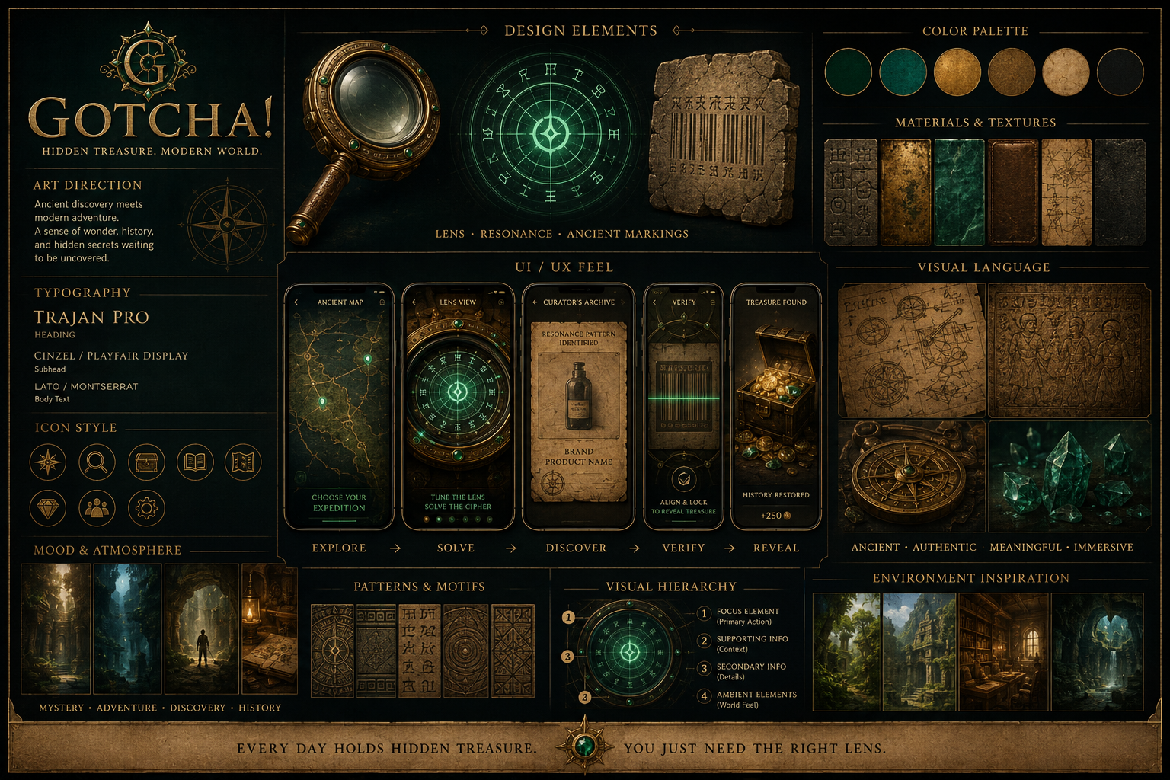

The Core Philosophy
The UI exists to support immersion.
Not information density.
The player should rarely see:
- Buttons
- Menus
- Pop-ups
- Toolbars
Instead they should see:
- Ancient artifacts
- Stone
- Brass
- Glass
- Parchment
- Light
- Resonance
Modern technology should quietly disappear beneath the experience.

The Four Environments
The entire game is built around four primary environments.
Every screen belongs to one of them.

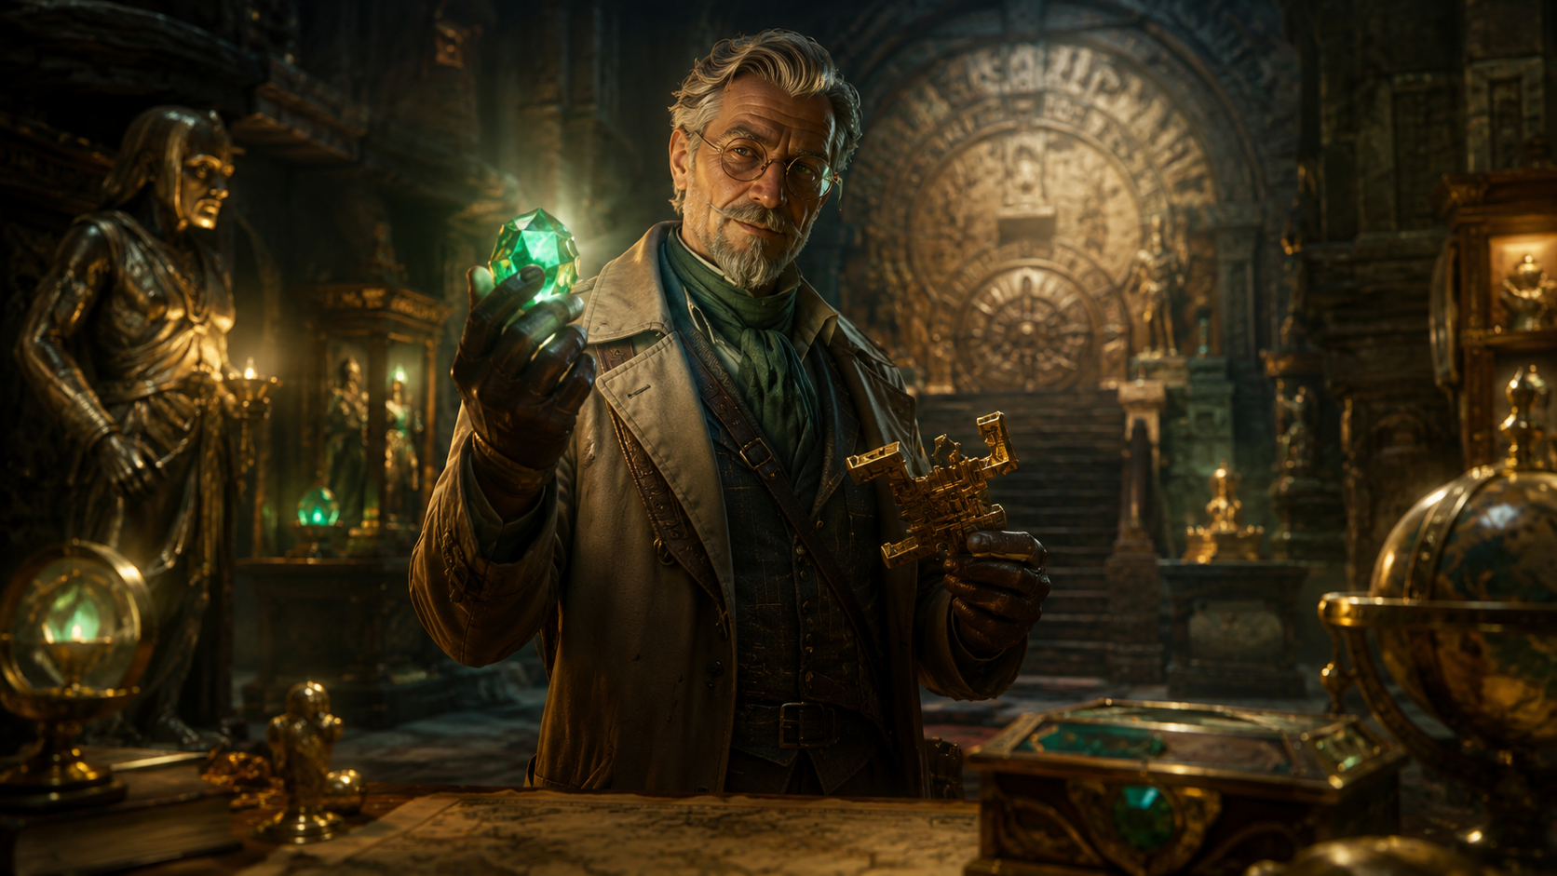
1. The Curator's Study
Purpose:
- Home
- This is the player's headquarters.
- The Study is alive.
- Books.
- Maps.
- Artifacts.
- Journals.
- Tablet displays.
- The Lens resting on its pedestal.
- Nothing feels static.
As the player progresses:
- More shelves fill.
- More maps appear.
- More artifacts are displayed.
- The Study itself becomes a visual representation of player progress.
- The player should enjoy simply spending time here.

2. The Ancient Map
Purpose:
Choosing Expeditions
The map combines:
- Ancient parchment
- Modern satellite roads
- Topographic drawings
- Resonance anomalies
- The player never sees:
- Store names.
- Pins.
- Shopping centers.
Instead...
- Three glowing resonance anomalies appear.
- Each anomaly pulses gently.
- Selecting one expands it slightly.
A simple button appears:
- Navigate
- Tapping Navigate opens the phone's navigation application.
The game never pretends to replace navigation.

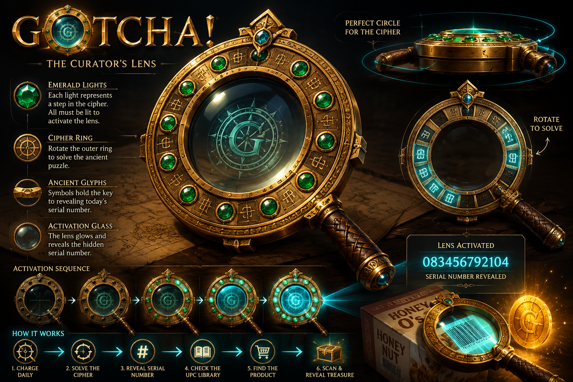
3. The Goetchae Lens
Purpose:
Primary Gameplay
The Lens occupies nearly the entire display.
The player should never feel like they are looking at a UI.
They are looking through an ancient instrument.
The Lens becomes:
- The scanner.
- The puzzle.
- The reveal.
The identity of the game.
Everything important happens here.

4. The Archive
Purpose:
Translation
The Archive should feel scholarly.
Not technological.
Leather journals.
Handwritten notes.
Museum sketches.
Pressed documents.
Historical drawings.
The Archive instantly translates the Ancient Resonance Pattern into:
- Product
- Brand
- Product image
- Nothing else.
- Its purpose is clarity.
- Not mystery.

Minimal Interface Philosophy
Players should spend their attention on discovery.
Not menus.
Only essential interface elements remain visible.
Examples:
- Personal Resonance
- Current Expedition
- Settings
Everything else appears only when needed.

Color Philosophy
Primary Materials
Aged brass
Dark stone
Old parchment
Deep emerald
Warm candlelight
Dark walnut
These colors communicate age.
Not fantasy.
The game should feel grounded.

Resonance Colors
Resonance itself is the only vibrant element.
Dormant
Dark emerald
Weak
Soft green
Active
Bright emerald
Resonance Lock
Gold
Treasure Reveal
Warm gold and white
The player's eyes should naturally follow resonance.

Typography
Typography should resemble museum exhibit labels.
Elegant.
Readable.
Never decorative enough to reduce clarity.
Titles may use a subtle historical serif.
Body text should remain modern and highly legible.
The game should feel timeless rather than medieval.

Motion Philosophy
Nothing moves without purpose.
Animations should feel physical.
Heavy.
Intentional.
Examples:
- The Lens rotates with slight momentum.
- Emeralds illuminate gradually.
- Parchment gently unfolds.
- Books close naturally.
- Tablet fragments slide into place with weight.
- Nothing should snap instantly.
- The world has mass.

Audio and Visual Synchronization
Every important animation should have matching audio.
Rotation
Soft brass friction.
Glyph alignment
Mechanical click.
Emerald activation
Crystal tone.
Cipher completion
Harmonic chord.
Treasure Reveal
Deep resonance followed by cascading coins and subtle echoes.
The player should feel every discovery.

Haptic Design
The phone should become an extension of the Lens.
Soft vibration
Glyph alignment.
Gentle pulse
Emerald activation.
Strong confirmation
Resonance Lock.
Warm rolling vibration
Treasure eruption.
Haptics should never become repetitive.
They reinforce physicality.

Navigation Philosophy
Players should never become lost inside menus.
Every screen should be reachable within two interactions.
Primary destinations:
- Study
- Map
- Lens
- Collection
- Settings
Nothing else belongs in permanent navigation.

Notification Philosophy
Notifications should sound like invitations.
Not reminders.
Examples:
"A new resonance anomaly has emerged."
"The world is beginning to resonate."
"The Lens has fully recharged."
Avoid:
"Daily reward available."
"Come back now."
"Claim your bonus."
Everything should reinforce exploration.

Accessibility
The experience should remain immersive for everyone.
Support includes:
- Color-blind safe resonance indicators.
- Optional subtitles.
- Scalable text.
- Adjustable haptics.
- Reduced motion mode.
- Audio cues paired with visual feedback.
- One-handed operation where possible.
The experience should never rely on a single sensory input.

Performance Philosophy
The UI should always feel effortless.
Fast loading.
Responsive interactions.
Immediate feedback.
The player should never wait on the interface.
The technology should disappear.

Future Expansion
The interface should be designed to grow gracefully.
Future additions should appear naturally within the existing environments rather than introducing entirely new screens.
For example:
- Seasonal expeditions appear as new journals.
- New collections appear as additional display cabinets.
- Historical discoveries appear as expanding shelves.
The Curator's Study should evolve instead of becoming cluttered.

UI / UX Non-Negotiables
- The interface should feel like interacting with artifacts rather than software.
- The Lens is the primary interface of the game.
- The Curator's Study is the emotional home of the player.
- The Ancient Map reveals resonance anomalies, never businesses.
- The Archive is scholarly rather than technological.
- Modern UI conventions should disappear wherever possible.
- Every animation should feel physical.
- Resonance is the primary visual language.
- Simplicity is always preferred over feature density.
- Every screen should reinforce the fantasy of exploration.

Chapter 9 – Game Systems Architecture
Design Principle
Every system in Gotcha! exists to support a single fantasy:
- The player is carrying an ancient relic that guides them toward hidden treasure concealed within the modern world.
- Technical systems should remain invisible.
- The player should experience only exploration, discovery, and progression.
Whenever possible, multiple gameplay mechanics should be unified into a single coherent system rather than introduced as separate features.

System Overview
Gotcha! is composed of several interconnected systems.
Each system has a single responsibility.
Together they create one seamless expedition.

- Curator
- Goetchae Archive
- Ancient Resonance Pattern
- Goetchae Lens
- Glyph Cipher Puzzle
- Resonance Anomaly
- Ancient Map
- GPS Navigation
- Real World
- Modern Product
- Barcode Match
- Treasure Revelation
- Personal Resonance
- Community Resonance

No system exists independently.
Every action naturally leads to the next.

Core Gameplay Systems
Ancient Map
Purpose:
Reveal weekly resonance anomalies.
Responsibilities:
- Display approximately three active resonance anomalies.
- Overlay ancient cartography onto modern mapping.
- Never reveal business names.
- Launch native phone navigation.
Inputs
Weekly anomaly database.
GPS location.
Outputs
Selected expedition.

GPS Navigation
Purpose:
Safely transport the player.
Responsibilities:
- Use Apple Maps or Google Maps.
- No gameplay occurs while driving.
The application resumes once the player reaches the resonance field.

Resonance Field
Purpose:
Determine when the hunt begins.
Responsibilities:
- Detect when the player has entered the destination area.
- Unlock the Lens.
- Reveal the glyph cipher.
- No indoor positioning required.
- No aisle-level tracking required.
The resonance field simply determines whether the expedition has begun.

Goetchae Lens
Purpose:
Primary gameplay interface.
Responsibilities:
- Display the glyph cipher.
- Awaken through resonance.
- Reveal Ancient Resonance Patterns.
- Verify Resonance Lock.
- Reveal treasure.
- Track Personal Resonance.
The Lens is both the primary gameplay mechanic and the primary user interface.

Glyph Cipher
Purpose:
Create meaningful player interaction before every hunt.
Responsibilities:
- Generate one unique glyph arrangement.
- Allow the player to tune resonance.
- Produce twelve resonance lines.
- The puzzle should require approximately thirty seconds for a new player.
Experienced players naturally complete it faster through Personal Resonance.

Goetchae Archive
Purpose:
Translate ancient resonance into modern information.
Responsibilities:
- Receive completed Resonance Pattern.
- Compare against modern product database.
Return:
- Product
- Brand
- Product image
The Archive never generates clues.
Translation is immediate.

Product Verification
Purpose:
Confirm the hunter located the correct modern vessel.
Responsibilities:
- Read UPC barcode.
- Compare against Archive result.
- Initiate Resonance Lock.
- Reveal treasure.
Barcode verification becomes the true proof that the expedition succeeded.

Treasure Engine
Purpose:
Generate expedition rewards.
Responsibilities:
- Determine:
  - Treasure contents.
  - Gold.
  - Gems.
  - Artifacts.
  - Tablet fragments.
  - Prize probability.
  - Treasure quality.
Treasure should always appear consistent with progression rules.

Personal Resonance Engine
Purpose:
Track player attunement.
Responsibilities:
- Increase through treasure recovery.
- Decay through inactivity.
- Unlock gameplay improvements.
- Influence seasonal reward probability.
Personal Resonance should never be purchasable.

Community Resonance Engine
Purpose:
Measure worldwide expedition progress.
Responsibilities:
- Aggregate Personal Resonance activity.
- Unlock seasonal events.
- Trigger world milestones.
- Reset every season.
Community Resonance should encourage cooperation.
Never competition.

Data Flow
Every expedition follows the same system flow.

- Weekly Anomaly
- Player Selects Expedition
- GPS Navigation
- Player Enters Resonance Field
- Glyph Cipher Unlocks
- Ancient Resonance Pattern
- Archive Translation
- Modern Product
- Barcode Verification
- Resonance Lock
- Treasure Reveal
- Personal Resonance
- Community Resonance
- Progress Saved

Every gameplay session follows this exact architecture.

State Management
Each expedition has a simple lifecycle.
- Hidden
- Available
- Selected
- Navigating
- In Resonance Field
- Cipher Active
- Archive Translation
- Searching
- Verified
- Treasure Revealed
- Expedition Updated
- Completed

This predictable state machine simplifies both design and engineering.

Data Model
Player
Stores:
- Personal Resonance
- Collections
- Progress
- Season history
- Statistics

Expedition
Stores:
- Location
- Remaining treasures
- Difficulty tier
- Rewards
- Expiration

Treasure
Stores:
- Reward contents
- Story progression
- Probability values
- Artifact metadata

Archive Entry
Stores:
- Ancient Resonance Pattern
- UPC
- Brand
- Product
- Image
- Verification status

Community
Stores:
- Current season
- Community Resonance
- Unlocked milestones
- Global statistics

Scalability
The architecture should support expansion without redesign.
Future additions may include:
- Additional regions.
- Additional retailers.
- Seasonal expeditions.
- Historical storylines.
- Live world events.
- New collectible artifact sets.
None of these additions should require redesigning the core expedition loop.

Security Philosophy
Game integrity is more important than complexity.
Primary validation points include:
- GPS confirmation within the resonance field.
- Correct UPC verification.
- Server-authoritative treasure generation.
- Secure reward distribution.
The barcode becomes the definitive proof that a treasure has been recovered.

Engineering Philosophy
The player should never notice the technology.
Maps.
Databases.
Cloud infrastructure.
Networking.
Probability calculations.
Analytics.
All exist only to support the illusion of carrying an ancient artifact.
Technology should disappear behind the fantasy.

Game Systems Architecture Non-Negotiables
- Every system exists to strengthen the treasure-hunting fantasy.
- The Lens remains the centerpiece of gameplay.
- The Archive is translation, not gameplay.
- Barcode verification is the definitive confirmation of discovery.
- Indoor positioning is intentionally avoided.
- Native navigation handles travel.
- Systems should remain modular and independently expandable.
- Simplicity is preferred over technical sophistication whenever the player experience remains unchanged.

Chapter 10 – Gotcha! Operations
Design Principle
Gotcha! is a living world, not a procedurally generated game.
Every expedition is intentionally crafted to deliver a rewarding, reliable, and immersive experience. Behind every weekly hunt is a coordinated effort between brands, retailers, content creators, and the Gotcha! Operations team.
Players should feel like the world is naturally evolving.
Operations exists to make that illusion possible.

The Mission
The Operations team is responsible for bringing the world of Gotcha! to life.
Rather than developing software, Operations develops adventures.
Their responsibilities include:
- Partner onboarding
- Hunt planning
- Product verification
- Treasure balancing
- Quality assurance
- Seasonal content
- Live event coordination
- Community health
- Player support

The Weekly Expedition Pipeline
Every expedition follows the same production process.
Phase 1
Campaign Planning
Approximately eight weeks before launch, campaigns begin.
Operations coordinates with participating retailers and brands to determine:
- participating stores
- participating products
- campaign objectives
- prize sponsorship
- seasonal themes
The objective is to create engaging treasure hunts while supporting partner goals without compromising the player experience.

Phase 2
Hunt Design
Once products are finalized, Hunt Designers create the weekly expeditions.
Each hunt defines:
- resonance anomaly
- participating store
- five treasure products (MVP)
- resonance patterns
- treasure rewards
- artifact drops
- story flavor
- event modifiers
For the MVP, every player receives the same three weekly anomalies.
Future versions will dynamically assign personalized hunts.

Phase 3
Archive Integration
Each selected product becomes part of the Curator’s Archive.
Every entry contains:
- Brand
- Product
- UPC
- Product image
- Resonance Pattern
- Difficulty
- Reward table
- Campaign
- Season
- Store availability
The Archive is the bridge between ancient resonance and modern products.

Phase 4
Validation
Before a hunt can launch, every expedition undergoes quality assurance.
Validation includes:
- UPC verification
- barcode scan testing
- product image verification
- store confirmation
- reward balancing
- progression review
- narrative review
No hunt launches without successfully completing validation.

Phase 5
Launch
Every Sunday at midnight:
- Previous anomalies disappear.
- Community Resonance resets (if seasonal).
- Three new anomalies emerge.
- New treasures become available.
- New story content unlocks.
Players experience a seamless transition into a new week of exploration.

Product Selection Philosophy
Products selected for Gotcha! should be dependable.
Preferred products:
- widely stocked
- stable UPCs
- consistent packaging
- predictable shelf locations
- available throughout the campaign region
Products that frequently change packaging or inventory should be avoided whenever possible.
The player should never lose immersion because of unreliable inventory.

UPC Governance
The barcode is the definitive proof that a treasure has been recovered.
To ensure reliable gameplay, participating partners agree to communicate:
- UPC changes
- packaging redesigns
- discontinued products
- regional UPC differences
- temporary product substitutions
- before scheduled campaigns begin
The Operations team maintains the Archive to reflect these changes.

Hunt Scheduling
The Operations calendar should always remain ahead of players.
Target schedule:
- 8 weeks planned
- 6 weeks designed
- 4 weeks validated
- 2 weeks finalized
- 1 week locked
- Launch
Maintaining this pipeline ensures that new expeditions are always ready before previous hunts conclude.

Hunt Availability
MVP
Every player receives identical weekly expeditions.
Three resonance anomalies appear each week.
Each anomaly contains five treasures.
Every anomaly begins Sunday at 12:00 AM.
Every anomaly ends the following Sunday at 11:59 PM.
This approach minimizes operational complexity while validating the core gameplay loop.

Full Launch
Future operations support:
- personalized expeditions
- regional hunts
- sponsor-exclusive campaigns
- dynamic anomaly generation
- seasonal world events
- limited-time discoveries
Operations evolves from managing a single world into orchestrating millions of unique adventures.

Live Operations
Although expeditions are planned in advance, the world must remain responsive.
Operations continuously monitors:
- hunt completion rates
- scan success
- reported inventory issues
- fraud
- server health
- player feedback
When necessary, Operations may replace products, rebalance rewards, or issue Archive updates to preserve gameplay quality.
The player should experience these adjustments as natural changes in the living world rather than maintenance.

Future Operations Team
As Gotcha! grows, dedicated roles may include:
- Director of Live Operations
- Brand Partnership Managers
- Retail Partnership Managers
- Hunt Designers
- Content Curators
- Archive Specialists
- Product Verification Specialists
- Live Event Coordinators
- Community Managers
- Player Support
Every member of the Operations team contributes to the same objective:
Creating unforgettable treasure hunts.

Operations Non-Negotiables
- Every expedition is intentionally designed.
- Player immersion always outweighs operational convenience.
- Products must be reliable before becoming treasure vessels.
- Hunts are validated before launch.
- The Curator’s Archive is the authoritative source of truth.
- The world should always feel alive.
- New adventures should always be waiting.

Chapter 11 – Development Roadmap
Design Principle
Development should proceed by validating the core player experience one layer at a time.
Every milestone should answer a specific design question before additional complexity is introduced.
The objective is not to build the largest game possible.
The objective is to build the smallest version that fully delivers the fantasy of becoming a modern treasure hunter.
Features should only be added when they strengthen the core expedition loop.

The North Star
Every phase of development should answer one question:
"Does this make the player feel more like a treasure hunter?"
If the answer is no, the feature should be redesigned, postponed, or removed.
The expedition loop must remain the center of the experience.

Phase 1 – Proof of Fun
Goal
Validate that the core expedition loop is genuinely enjoyable.
This phase focuses entirely on gameplay.
No economy.
No multiplayer.
No live events.
No monetization.
The objective is to determine whether the combination of:
- Travel
- Cipher
- Product discovery
- Treasure reveal
creates a satisfying experience.

Features
Curator introduction.
Single resonance anomaly.
Ancient map.
Navigate button.
GPS destination check.
Goetchae Lens.
Glyph cipher.
Curator's Archive.
Static UPC database.
Barcode verification.
Treasure reveal.
Basic Personal Resonance.
Simple treasure inventory.

Success Criteria
Players enjoy solving the Lens.
Players understand the story.
Players smile during treasure revelation.
Players willingly complete multiple hunts.
Players ask:
"Can I do another?"

Phase 2 – Core Progression
Goal
Determine whether long-term progression motivates continued play.

Features
Multiple weekly resonance anomalies.
Personal Resonance progression.
Automatic glyph resonance.
Treasure collection.
Ancient Tablets.
Collection display.
Expanded Curator's Study.
Basic player statistics.
Improved treasure animations.

Success Criteria
Players return repeatedly.
Players notice progression.
The Lens feels increasingly personal.
Players begin forming habits around weekly expeditions.

Phase 3 – Community Systems
Goal
Create anticipation beyond individual play.

Features
Community Resonance.
Seasonal progression.
Global milestones.
World events.
Community statistics.
Season reset.
Major expedition unlocks.

Success Criteria
Players care about community progress.
Community events generate excitement.
Players discuss upcoming milestones.
Players feel part of something larger.

Phase 4 – Live Operations
Goal
Transform Gotcha! into a continuously evolving platform.

Features
Seasonal expeditions.
Story chapters.
Limited-time artifact collections.
Holiday events.
Regional expeditions.
Brand partnerships.
New treasure sets.
Rotating themes.

Success Criteria
Players remain engaged across multiple seasons.
Story continues evolving.
Returning players always discover something new.

Phase 5 – Platform Expansion
Goal
Expand beyond the initial market while preserving the core experience.

Potential Features
Native mobile applications.
International expansion.
Additional languages.
Expanded retailer network.
Premium collectibles.
Special events.
Large-scale community expeditions.
Future wearable integrations.

Technical Milestones
Prototype
Single-player web application.
Static product database.
Manual expedition generation.
Basic authentication.
Simple treasure reveal.

Alpha
Multiple expeditions.
Cloud database.
Player accounts.
Persistent Personal Resonance.
Expanded Archive.
Basic analytics.

Beta
Live weekly anomaly generation.
Community Resonance.
Season support.
Reward balancing.
Performance optimization.
Security improvements.

Launch
Scalable infrastructure.
Brand-ready reporting.
Stable economy.
Live operations tools.
Customer support systems.
Analytics dashboard.

Content Milestones
The story should grow alongside development.
Prototype
One expedition.
One Curator introduction.
One completed treasure recovery.

Alpha
Expanded dialogue.
Additional artifact types.
Curator's Study progression.
Ancient Tablet system.

Beta
Season One narrative.
Goetchae family mystery.
Expanded Archive.
Lost Vault references.

Live
Ongoing seasonal storytelling.
Historical discoveries.
Additional explorers.
Community events.
New artifact collections.

Metrics for Success
Development should be guided by player behavior rather than assumptions.
Examples include:
- Tutorial completion rate.
- Average cipher completion time.
- Average expedition completion rate.
- Treasure recovery rate.
- Weekly returning players.
- Personal Resonance retention.
- Average number of completed expeditions.
- Community event participation.
These metrics should improve player experience rather than encourage addictive design.

Features Explicitly Deferred
The following ideas are intentionally postponed until the core gameplay has been validated.
Indoor positioning.
Augmented Reality.
Player trading.
Guilds.
PvP.
Crafting.
Artifact upgrades.
Random home scanning.
Complex inventory systems.
Paid progression shortcuts.
None of these systems should be implemented until the expedition loop has proven itself.

Guiding Development Philosophy
Every new feature should answer three questions.
Does it strengthen the treasure-hunting fantasy?
Does it improve the expedition loop?
Would players still enjoy the game without it?
If any answer is no, the feature should be reconsidered.
The greatest strength of Gotcha! will come from discipline rather than feature count.

Development Roadmap Non-Negotiables
- Validate gameplay before expanding scope.
- Story and mechanics should evolve together.
- The Lens remains the centerpiece of every milestone.
- Personal Resonance always outweighs currency progression.
- Community systems enhance rather than replace solo play.
- Every release should make the world feel larger without making the game more complicated.
- Simplicity is a competitive advantage.
- Preserve wonder above all else.

Chapter 12 – Long-Term Vision
Design Principle
Gotcha! is not intended to be a seasonal mobile game.
It is intended to become a living world that continues evolving for years.
The long-term vision is not measured by features.
It is measured by whether players still feel the same sense of wonder years after their first expedition.
Every addition to the game should make the world feel larger without making it more complicated.

The Vision
Gotcha! exists to transform the ordinary into the extraordinary.
The modern world is already filled with places people visit every day.
Grocery stores.
Home improvement stores.
Pharmacies.
Sporting goods stores.
Department stores.
Most people walk through these places without noticing anything remarkable.
Gotcha! changes that.
Players begin seeing every store as a potential archaeological site.
Every aisle becomes unexplored territory.
Every product becomes a possible vessel hiding a forgotten piece of history.
The goal is not to gamify shopping.
The goal is to make players rediscover the excitement of exploration.

A Living Adventure
Unlike traditional games with a beginning and an end, Gotcha! should feel like an expedition that never truly finishes.
The world constantly changes.
New resonance anomalies emerge.
New artifacts are discovered.
New chapters of history are uncovered.
The player should never feel they have completed the world.
Only that they have helped understand it.

The Curator's Legacy
The Curator is not searching for treasure.
He is preserving history.
His life's work is not measured by gold recovered.
It is measured by knowledge restored.
Over time, the player's relationship with the Curator should evolve from student to trusted colleague.
Eventually...
The player becomes part of the Curator's legacy.
Future hunters may one day learn from discoveries that today's players helped uncover.

The Goetchae Archive
The Archive should become one of the defining features of the franchise.
Every expedition adds another verified piece of history.
Every season expands humanity's understanding of resonance.
Years after launch, the Archive should feel like a genuine museum collection assembled by millions of discoveries.
The player should feel proud knowing they helped build it.

The Lens
The Goetchae Lens should become one of the most recognizable objects in gaming.
Players should immediately recognize:
- Its silhouette.
- Its emeralds.
- Its harmonic sounds.
- Its resonance lines.
- Its rotating brass ring.
The Lens should become synonymous with discovery.

The Community
The Gotcha! community is not a collection of competitors.
It is a global expedition.
Every hunter contributes to something larger than themselves.
When Community Resonance reaches important milestones, players should celebrate together.
The greatest discoveries should feel like achievements shared across the entire world.

The Story
The story should never become static.
Every season should answer one important mystery while introducing another.
Examples include:
- The origin of the Lens.
- The builders of the Lost Vault.
- The history of the House of Goetchae.
- The purpose of resonance.
- The civilizations that came before.
The player should always believe there is another discovery waiting beyond the horizon.

Brand Partnerships
Brands are not advertisements.
Within the world of Gotcha!, they become modern custodians of forgotten resonance.
The player never feels like they are interacting with a sponsor.
Instead, they are recovering history through modern vessels.
Successful partnerships should strengthen immersion rather than interrupt it.
Every participating brand should make the world feel richer.
Never more commercial.

The Real World
The greatest achievement of Gotcha! would be changing how players see the world around them.
A grocery store should no longer feel routine.
A hardware store should no longer feel ordinary.
Players should occasionally think:
"I wonder if there's resonance here."
That moment represents the success of the entire franchise.
The game has escaped the phone.
It has changed perception.

A Multi-Generational World
Gotcha! should be designed so that new players can begin at any time without feeling left behind.
Veteran players should have prestige through experience and Personal Resonance.
New players should always feel capable of beginning their own adventure immediately.
The world welcomes everyone.

Beyond Mobile
The long-term vision is not limited to one platform.
Potential future experiences may include:
- Native mobile applications.
- Tablet experiences.
- Web experiences.
- Wearable integrations.
- Educational museum collaborations.
- National treasure events.
- Historic landmark expeditions.
- Augmented reality experiences.
- Board games.
- Books.
- Animation.
- Collectible replicas of the Goetchae Lens.
The franchise should expand naturally while remaining true to its core identity.

The Legacy of Gotcha!
The ultimate goal is not simply to entertain.
It is to inspire curiosity.
Curiosity about history.
Curiosity about exploration.
Curiosity about the ordinary objects surrounding us every day.
If players begin looking at the world differently because of Gotcha!, then the game has succeeded.
Long after players forget individual treasures, they should remember one feeling.
Wonder.

Final Design Philosophy
Whenever a future decision becomes difficult, ask one question.
Does this make the player feel more like a treasure hunter?
If the answer is yes, it belongs.
If the answer is no, it should be reconsidered.
That single principle should guide the future of Gotcha! more than any individual mechanic.

Long-Term Vision Non-Negotiables
- Wonder always comes before reward.
- The Lens remains the heart of the franchise.
- The Curator remains the keeper of knowledge.
- The player remains the hero.
- Exploration always outweighs efficiency.
- The real world remains the game board.
- Story and gameplay evolve together.
- Community should inspire cooperation rather than competition.
- Simplicity is a long-term competitive advantage.
- Every new feature must strengthen the fantasy of modern treasure hunting.

Closing Statement
Gotcha! is not a game about products.
It is not a game about barcodes.
It is not a game about shopping.
It is a game about rediscovering wonder.
The world has always been filled with hidden treasure.
Players simply needed the right Lens to see it.

July 2026 MVP Alignment Update
Purpose: This section captures the current canonical MVP direction and should be treated as the working design baseline for chapter-by-chapter review. Earlier clue, guess, and spendable-currency ideas are not deleted; they move to future variant status until they are intentionally reintroduced.
Core MVP loop: resonance anomaly -> sequential cipher -> Archive identification -> physical product search -> Lens barcode scan -> treasure collected -> Personal Resonance increases -> next cipher unlocks.
Weekly scope: each HuntWeek contains 3 resonance anomalies, one per participating national-chain location category. Each anomaly contains 5 sequential ProductTargets, for 15 product targets per week.
Design guardrail: the Lens is not a general utility tool. It exists for cipher alignment, product scan confirmation, and treasure reveal. Personal Resonance may make ciphers easier, but the Lens should not become a broad hint machine.
Economy guardrail: Gotcha Gold remains a collectible treasure type for now, not a spendable economy. Progression should be driven by Personal Resonance, artifacts, completed anomalies, and community events.

Chapter 1 - Executive Summary & Vision
- Define the MVP around one crisp promise: follow resonance to real places, solve the cipher, identify the product through the Archive, scan the correct barcode, and recover treasure.
- The MVP should prove the core behavior loop and player fantasy before adding paid boosts, inventory crafting, advanced AR, or complex prize economies.
- Success measure: players understand what to do without a clue system and feel that the product scan is the payoff to a puzzle, not a detached barcode task.
Evaluation question: Does the opening vision explain Gotcha! as a resonance treasure hunt clearly enough that a new player can repeat the loop back in one sentence?

Chapter 2 - Story & World
- Resonance is the central fiction: ancient treasures leave signals that appear as anomalies in modern retail locations.
- The Archive is scholarly and factual. Once a cipher is solved, it reveals the exact product identity, brand, image, and approved UPC family; it does not drip-feed riddles or extra clues in the MVP.
- The world should feel mysterious but rule-bound: cipher first, Archive second, real-world product discovery third.
Evaluation question: Which parts of the lore help the player act, and which parts are flavor that can be saved for later?

Chapter 3 - Characters
- The player role is Seeker, not generic treasure hunter. A Seeker studies resonance, solves glyph ciphers, consults the Archive, and confirms discoveries through the Lens.
- The Curator should speak only at critical moments: first onboarding, first anomaly unlock, first completed store, first tablet fragment, community event activation, and major prize moments.
- Avoid constant character chatter during the store loop so the player feels capable and the fiction does not slow down the hunt.
Evaluation question: Where should the Curator intervene so it feels meaningful rather than noisy?

Chapter 4 - The Player Experience
- A weekly hunt includes 3 store anomalies with 5 treasures each. Inside a location, ProductTargets unlock sequentially.
- Per-product flow: solve cipher -> reference Archive -> find product -> scan barcode -> receive treasure -> Personal Resonance increases -> next cipher unlocks.
- Wrong scans should provide soft, non-punitive feedback and let the player keep searching immediately.
Evaluation question: Does the player always know the next action without needing traditional clues?

Chapter 5 - The First Expedition / Tutorial
- The tutorial should teach one complete miniature loop: anomaly found, cipher solved, Archive reveals a product, Lens scan confirms it, treasure reveal follows.
- Do not introduce guesses, clue purchases, Gold spending, or inventory crafting in the first expedition.
- The first successful scan should establish the emotional rhythm: puzzle solved, product found, Lens confirms, treasure appears, resonance increases.
Evaluation question: What is the shortest playable first expedition that teaches the entire game without explaining the entire world?

Chapter 6 - The Lens & Resonance System
- The Lens has three MVP powers: align/solve ciphers, scan/confirm products, and reveal recovered treasure.
- Personal Resonance is the main player progression stat. As it increases, it may reduce cipher friction by revealing a few glyphs, narrowing Archive uncertainty, or improving alignment feedback.
- The Lens should not be used as a store navigation detector, warm/cold radar, paid hint engine, or unrelated utility in the MVP.
Evaluation question: How can Lens upgrades make ciphers feel smoother without replacing the player solving the puzzle?

Chapter 7 - Progression & Economy
- Progression is primarily Personal Resonance, completed anomalies, recovered treasures, and stone tablet map fragments.
- Gotcha Gold remains collectible-only until there is a narrative breakthrough that makes it feel native to the world.
- Completing a location should award meaningful artifact progress. The current preferred direction is stone tablet map pieces that contribute to a larger community event.
Evaluation question: Should artifacts be awarded per completed store, per full HuntWeek, or through a slower seasonal cadence?

Chapter 8 - UI / UX Design
- The UI should support the new order: Map anomaly -> location detail -> cipher screen -> Archive reveal -> Lens scan -> treasure reveal -> next target.
- The Archive screen must feel like a confident identification result, not a clue list.
- The Lens scanner should remain a dramatic moment after the cipher is solved, not an always-available generic scanner in the final MVP flow.
Evaluation question: Which screens need to be collapsed, moved into popups, or split so the no-scroll 1080 x 1920 target remains clean?

Chapter 9 - Game Systems Architecture
- Core data model should represent HuntWeek -> Anomaly -> ordered ProductTargets -> Cipher -> ArchiveEntry -> UPC family -> Reward/Treasure.
- Server-authoritative state should eventually validate target unlock order, solved ciphers, barcode scans, treasure grants, Personal Resonance, and artifact progress.
- Wrong scans should be logged for analytics and product confusion insights but should not punish the player.
Evaluation question: What data must be server-authoritative before beta, and what can remain local/prototype-only?

Chapter 10 - Gotcha! Operations
- Operationally, each weekly set requires 3 participating locations and 15 product targets with validated UPCs, product images, Archive entries, and cipher content.
- Retail value comes from dwell time, store visits, product discovery, and check-in/anomaly activation data rather than encouraging rushed scanning.
- Any sweepstakes, prize, or grand event mechanic needs legal review before real-value rewards are awarded.
Evaluation question: What is the minimum weekly content production workflow that one operator can maintain reliably?

Chapter 11 - Development Roadmap
- Near-term build priority: implement the revised no-clue product flow in the app, including sequential ciphers, Archive reveal, Lens scanner gate, and treasure reveal.
- Next priority: define the artifact cadence and stone tablet map progression so completed stores feel significant without ending the larger mystery too quickly.
- Defer: spendable Gold, crafting, paid boosts, advanced image recognition, AR, and complex leaderboard prize brackets until the core loop is strong.
Evaluation question: Which single vertical slice should be beta-ready first: one store with five targets, or a lighter three-store weekly structure?

Chapter 12 - Long-Term Vision
- Community Resonance should culminate in large shared events tied to the stone tablet map and a grand prize opportunity.
- Personal Resonance can weight eligibility or odds for major events, but the rules must remain transparent, fair, and legally reviewed.
- The long-term fantasy is a living retail treasure network where individual Seekers recover fragments and the community unlocks larger mysteries together.
Evaluation question: What does the first community-scale event look like in a way that feels epic but remains operationally and legally manageable?

Open Design Decisions To Resolve Next
- Artifact cadence: one stone tablet fragment per completed store, one per completed week, or a hybrid where store completion earns sub-fragments and weekly completion forms a major fragment.
- Personal Resonance math: how much resonance each treasure grants and how it affects cipher difficulty without turning into a pay-to-solve or auto-play system.
- Archive reveal format: what exact product data appears after cipher completion, and how much certainty is appropriate for beta.
- Community event rules: how Personal Resonance influences event eligibility or probabilities while keeping the experience fair and legally defensible.
- Beta content workflow: who creates ciphers, validates UPC families, uploads Archive entries, and schedules weekly anomalies.
Recommended next review sequence: start with Chapter 1 to lock the promise and MVP boundaries, then Chapter 4 for the moment-to-moment loop, then Chapter 6 for the Lens rules. Those three chapters define the spine; the remaining chapters should follow from them.

