Bryan Huang
Engineering Portfolio

About
I design and make structurally-efficient balsa wood bridges. I delve into my design process of deck arch truss balsa wood bridges, explaining design choices and ways I optimized them. A big reason why I make is competition. I fell in love with the bridge competition after competing because I felt there really was no limit to what we could produce. The constraints and pressure from the brilliant minds in the competition drove me to create a better, more unique design.
Skills: SOLIDWORKS (structural simulation, structural members feature) · AutoCAD (technical drawing, dimensioning) · simulation debugging & validation · iterative design optimization · technical documentation · cross-functional team leadership
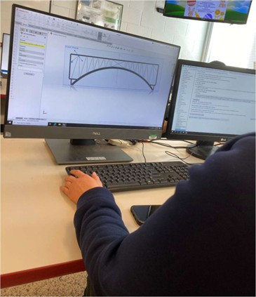
Modeling structural members and running load simulations in SOLIDWORKS.

Featured Project: Deck Arch Truss Bridge Design (2023–2025)
Role: I led the team's engineering direction, but the bridge itself was my individual design. I created the full CAD model, performed all structural simulations, drafted the technical drawings, and iterated through all design revisions myself. For the physical build, I completed roughly half of the cutting and about 80% of the gluing and assembly work, and reviewed and finalized all documentation.
Context: I competed in the Delaware Bridge Design Competition each year from 2023–2025 in a team with two other students. The objective of the competition is to design and construct the most structurally efficient balsa wood deck arch truss bridge.

Iteration 1 (2023): Baseline Design
My first time trying the structural members feature in SOLIDWORKS, in preparation for our actual design - this can be considered my very first attempt at the bridge design. We researched different types of trusses and chose a configuration of X and Howe trusses to distribute as much weight outwards as possible.
After months of research and design, we moved to construct the physical model. It took roughly 30–40 combined hours of work to assemble the pieces, as it required us to precisely cut the wood to a fitting measurement and then glue them together. At first, our finished design was actually too small to fit on the tester as our calculations were off - fortunately, I was able to simply glue a piece of wood on each end and it fit nicely. When we competed this year, our team won first place in the state for the 9–10th grade bracket!
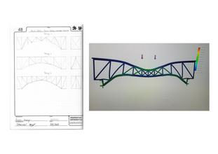  Design sketches translated into a SOLIDWORKS structural model. | 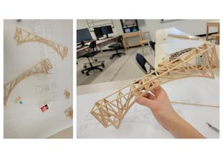  Hand-cutting and assembling balsa wood components for the 2023 build.

Iteration 2 (2024): A Failed Hypothesis, and How I learned
When I competed in 2024, I wanted to put in even more effort and try a more unique design, as I felt mine from last year was very simple. As I researched, I grew interested in a paper about an auxiliary arch system that seemed very promising - that was the inspiration for the design I created this year. Since I opted to add in an auxiliary arch (after weighing pros and cons), the construction process took much longer, as we effectively had to make close to double the cuts for the trusses on each side of the arch. We used pins to align and hold down components as we constructed the bridge. It took a few weeks for my group to finish cutting, gluing, and assembling the bridge, but we were able to finish successfully.
The completed bridge was about 50% heavier than the design from last year. It did not perform up to expectations and had a lower strength-to-weight ratio than my previous design. We did not place in the 2024 competition.
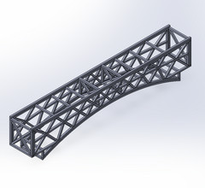
The completed 2024 auxiliary-arch design, modeled in SOLIDWORKS.

Iteration 3 (2025): More Testing
Since my design attempt in 2024 did not work as expected, I decided to revisit my original design from 2023 and revise it by strengthening weak points from that time. I wanted to put in even more effort than the last two years and research more so that I could finally design a better bridge than before. The design vastly changed over the months I worked on it. I later changed the way I simulated the models after I realized there were so many inconsistencies with the simulations in SOLIDWORKS - force configs (where they were applied varied on each different model due to how I set up the members), fixtures (where it would be fixed to), and not taking laminations into consideration. After playing with SOLIDWORKS for a while, I opted to use the setting “treat all solid bodies as solid,” and this fixed most of the issues.
I took the deformation ratio from my 2023 bridge and compared it to the actual testing results from the competition and got a variance scale of around 2.52. Then I did the same with testing my bridge from 2024 and got a variance scale of around 3.02, which is quite close to the other one. Using these numbers, I chose to trust the SOLIDWORKS simulation. I modeled 8 design iterations and ran many more simulations, tweaking based on numbers I pulled from these simulations.
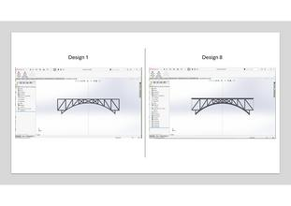  The design vastly changed over the months I worked on it. | 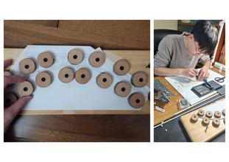  I decided to make the arch a single strong piece rather than gluing together small pieces of wood that would be much weaker.
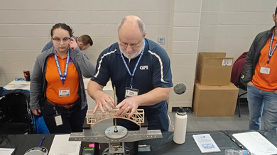
Load testing the final 2025 design at competition.

Reflection
The 2025 bridge is the most meaningful to me. In 2023 our team won without having any prior experience. We tried even harder the next year, but did worse. 2025 was the year I tried my hardest, researching and testing even more. We lost again, but it was the year I learned the most about bridge design. When I competed, I constantly asked myself how I could optimize my bridge even more. I was always left wondering how I could have done it better.

