WYLLO PLAYER
Module System & Provider Website Integration Guide
How modules connect Wyllo to anime and manga sources
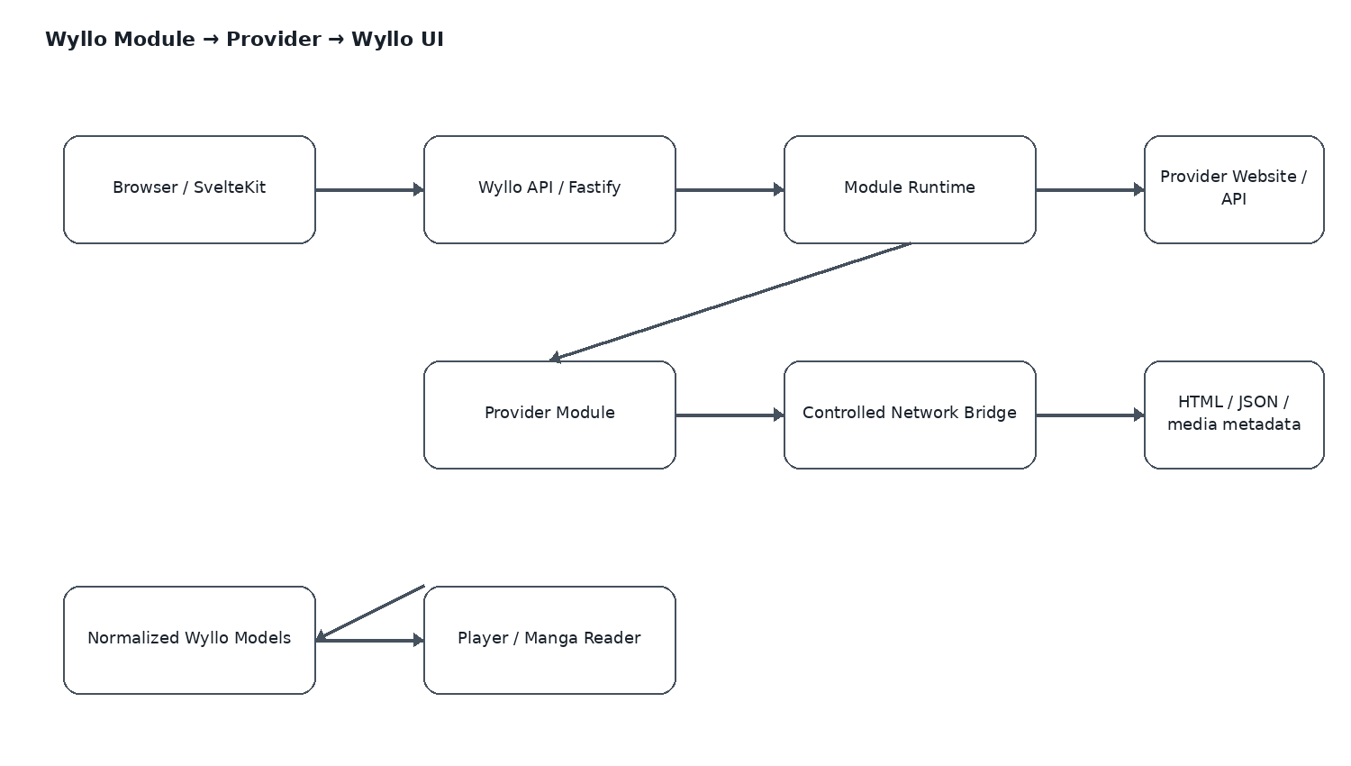
Website-first • SvelteKit • TypeScript • Fastify • PostgreSQL • Redis

1. Purpose
This companion guide explains exactly what happens between a Wyllo user clicking Search/Play/Read and an external provider returning information. The central idea is simple: Wyllo owns the product experience; modules own provider integration.
- Understand what a Wyllo module is.
- Understand where the provider website/API URL comes from.
- See how the module calls the provider and parses its response.
- See how provider-specific data becomes a stable Wyllo model.
- See the complete anime and manga request flows.
- Understand the module registry and runtime.
- Understand security, caching, failures, and future scaling.

2. The Core Mental Model
Browser
↓
Wyllo API
↓
Module Runtime
↓
Provider Module
↓
Authorized provider website / API
↓
HTML / JSON / permitted media metadata
↓
Module parses + maps the response
↓
Wyllo-normalized model
↓
Wyllo API
↓
Browser
The main application should not contain every provider's selectors, URL patterns, or parsing rules. Those provider-specific details belong inside the corresponding module.

3. What Is a Module?
A module is a versioned adapter package. It contains metadata plus runtime code that implements a known Wyllo contract.
Part | Purpose
Manifest | Identifies the module, content type, version, capabilities, source information, and runtime limits.
Entry script | Implements operations such as search, details, episodes, streams, chapters, or pages.
Provider configuration | Identifies the authorized website/API or source family the module is built for.
Runtime permissions | Controls network and other capabilities available to the module.
Tests/fixtures | Allow deterministic tests without repeatedly calling the live provider.

4. Where Does the Website Come From?
The module runtime does not magically discover a website. A developer creates a module for a known, authorized source. The source URL or API endpoint is part of the module configuration, while the module code contains the logic for using it.
{
"id": "example-anime-v1",
"name": "Example Anime",
"contentType": "video",
"contractVersion": 1,
"moduleVersion": "1.0.0",
"runtime": {
"entry": "index.js",
"mode": "sandbox"
},
"source": {
"baseUrl": "https://example.com"
},
"capabilities": [
"search",
"details",
"episodes",
"stream"
]
}
So there are two separate pieces of knowledge: the manifest says which source the module is designed for, and the entry script says how to communicate with that source.

5. Three Things That Must Not Be Confused
Component | Question | Example
Module Registry | Which adapters are available? | example-anime-v1, example-manga-v1
Module | How do I communicate with this provider? | search, parse details, find chapters
Provider | Where does source data live? | https://example.com
Wyllo API | How does the frontend access normalized data? | GET /api/v1/anime/:id
Wyllo UI | How does the user interact? | Search, Player, Manga Reader

6. Complete Module Lifecycle
1. Discover: Wyllo sees installed/available modules through its registry.
2. Validate: The runtime validates the manifest, version, capabilities, and configured limits.
3. Load: The module entry script is loaded in the controlled runtime.
4. Invoke: A Wyllo API operation invokes a known module handler.
5. Request: The module uses a controlled HTTP/browser bridge to contact its provider.
6. Parse: Provider-specific HTML/JSON is converted into Wyllo's common model.
7. Validate: The runtime/API validates the module's returned object.
8. Cache: Safe metadata/results may be cached.
9. Return: The normalized result is returned to the frontend.

7. Anime Flow
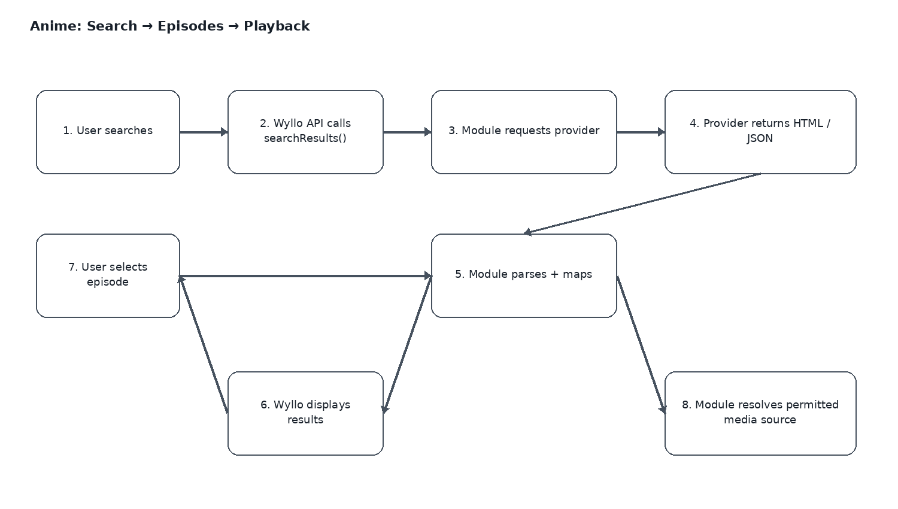

7.1 Search
globalThis.searchResults = async function(query) {
const response = await fetchv2(
`https://example.com/search?q=${encodeURIComponent(query)}`
);
return parseSearchResults(response);
};
The module knows how the provider represents search results and maps them to Wyllo's AnimeSearchResult[] model.

7.2 Details
globalThis.extractDetails = async function(id) {
const response = await fetchv2(
`https://example.com/anime/${id}`
);
return parseAnimeDetails(response);
};

7.3 Episodes
globalThis.extractEpisodes = async function(id) {
const response = await fetchv2(
`https://example.com/anime/${id}`
);
return parseEpisodes(response);
};

7.4 Playback source
globalThis.extractStreamUrl = async function(episodeId, language) {
const response = await fetchv2(
`https://example.com/episode/${episodeId}`
);
return parseAuthorizedVideoSources(response, language);
};
The player should ultimately receive an authorized direct media source such as HLS or MP4, not simply an HTML page.

8. Manga Flow
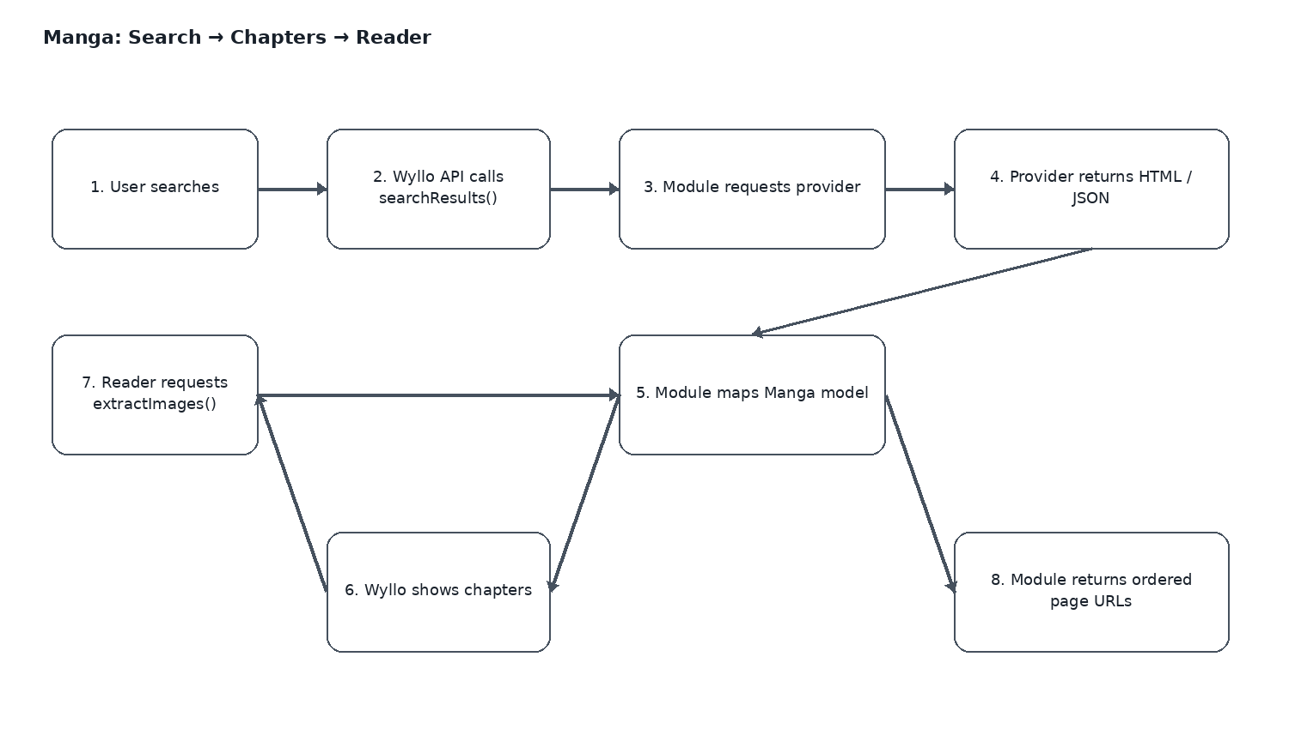
Manga follows the same adapter pattern, but the final content is ordered chapter/page information.
globalThis.searchResults = async function(query, page = 1) {
const response = await fetchv2(
`https://example.com/search?q=${encodeURIComponent(query)}&page=${page}`
);
return parseMangaResults(response);
};
globalThis.extractDetails = async function(id) {
const response = await fetchv2(`https://example.com/manga/${id}`);
return parseMangaDetails(response);
};
globalThis.extractChapters = async function(id) {
const response = await fetchv2(`https://example.com/manga/${id}`);
return parseChapters(response);
};
globalThis.extractImages = async function(chapterId) {
const response = await fetchv2(`https://example.com/chapter/${chapterId}`);
return parsePages(response);
};

9. Provider Data → Wyllo Data
A provider may return a provider-specific shape:
{
"name": "Some Anime",
"episode_number": "12",
"href": "/watch?id=8392",
"poster": "//cdn.example.com/a.jpg"
}
The module translates it into a stable Wyllo shape:
{
"id": "8392",
"title": "Some Anime",
"episodeNumber": 12,
"posterUrl": "https://cdn.example.com/a.jpg"
}
This translation layer is the reason the SvelteKit frontend can remain provider-agnostic.

10. Wyllo Contracts

Anime
interface WylloAnimeModule {
searchResults(query: string): Promise<AnimeSearchResult[]>;
extractDetails(id: string): Promise<AnimeDetails>;
extractEpisodes(id: string): Promise<Episode[]>;
extractStreamUrl(
episodeId: string,
language?: "sub" | "dub"
): Promise<VideoSource[]>;
}

Manga
interface WylloMangaModule {
searchResults(query: string, page?: number): Promise<MangaSearchResult[]>;
extractDetails(id: string): Promise<MangaDetails>;
extractChapters(id: string): Promise<Chapter[]>;
extractImages(chapterId: string): Promise<Page[]>;
}

11. Module Registry
The registry is a catalogue of adapters. It is not the provider content itself.
{
"id": "example-anime-v1",
"name": "Example Anime",
"contentType": "video",
"version": "1.0.0",
"packageUrl": "https://modules.wyllo.example/example-anime-v1.zip",
"sha256": "...",
"minWylloVersion": "0.1.0"
}
For the MVP, modules can simply live inside the Wyllo repository. A public registry, checksums, and signatures can be introduced later.

12. Recommended Repository Structure
wyllo-player/
├── apps/
│ ├── web/ # SvelteKit
│ └── api/ # Fastify
├── packages/
│ ├── module-sdk/ # contracts + types
│ ├── module-runtime/ # loader + isolation + bridges
│ ├── anime-core/ # normalized anime models
│ ├── manga-core/ # normalized manga models
│ ├── player-core/ # source selection
│ └── reader-core/ # manga reader logic
└── modules/
├── anime/
│ ├── provider-a/
│ └── provider-b/
└── manga/
├── provider-a/
└── provider-b/

13. What the Runtime Controls
Capability | Wyllo policy
Network | Controlled HTTP/browser bridges only.
Timeout | Terminate long-running module operations.
Response size | Limit downloaded bytes.
Concurrency | Limit simultaneous requests per module.
Filesystem | No direct filesystem access.
Environment | No access to Wyllo secrets/environment variables.
Shell/process | No arbitrary process or shell access.
Database | No direct database access.
Browser automation | Only through a controlled bridge when required.
Credentials | Never expose user passwords or Wyllo secrets to arbitrary modules.
Security note: Node's vm module by itself should not be considered a strong sandbox for untrusted third-party code. For externally supplied modules, a separate worker/service/container with explicit permissions is safer.

14. fetchv2-style and pagev2-style Bridges
The current public Synthetiq module documentation demonstrates a useful split between a direct HTTP bridge and a browser-like bridge. Wyllo can adopt the same architectural idea while defining its own contract.
Bridge | Typical use | Wyllo recommendation
fetchv2-style | JSON APIs, HTML pages, simple HTTP requests | Default path.
pagev2-style | Pages requiring client-side JavaScript/browser behavior | Use only when necessary.

15. Source Resolver
Module
↓
Raw video sources
↓
Source Resolver
├── validate
├── language preference
├── subtitle availability
├── quality preference
├── health/fallback
└── ranking
↓
Wyllo Video Player
This keeps provider-specific extraction separate from playback policy.

16. Caching and Provider Load
- Cache search results briefly.
- Cache metadata and chapter lists longer.
- Do not treat expiring media URLs as permanent.
- Use Redis for short-lived provider/API cache data.
- Use PostgreSQL for Wyllo-owned application data.
- Respect provider rate limits and avoid duplicate requests.

17. Error Handling
Failure | Expected behavior
Module timeout | Controlled error + module health event.
Provider 404 | Return not-found instead of crashing.
Provider 429 | Back off and respect rate limits.
Malformed response | Module parsing error; mark source unhealthy.
Invalid module output | Runtime rejects it before it reaches the UI.
One source unavailable | Try another available module/source where appropriate.
Expired media URL | Resolve the source again.

18. What Happens When the User Clicks Play?
User clicks Episode 12
↓
GET /api/v1/episodes/8392/sources
↓
Fastify asks Module Runtime
↓
extractStreamUrl("8392", "sub")
↓
Module contacts authorized provider
↓
Module extracts permitted media sources
↓
Runtime validates VideoSource[]
↓
Source Resolver ranks/falls back
↓
Fastify returns source(s)
↓
Svelte video player starts playback
The browser does not need to know the provider's internal page structure.

19. What Happens When the User Opens a Manga Chapter?
User opens Chapter 120
↓
GET /api/v1/chapters/120/pages
↓
Module Runtime
↓
extractImages("120")
↓
Module contacts authorized provider
↓
Module extracts ordered page URLs
↓
Runtime validates Page[]
↓
Svelte manga reader renders pages

20. Adding a New Authorized Provider
- Create modules/anime/provider-a/ or modules/manga/provider-a/.
- Create manifest.json and index.js.
- Configure the authorized provider base URL/API endpoints.
- Implement search.
- Implement details.
- Implement episodes or chapters.
- Implement permitted stream/page resolution.
- Add fixtures and integration tests.
- Register and health-check the module.
- Use it through the existing Wyllo API without changing the frontend.

21. Legal and Security Boundary
The module system is an integration architecture, not a mechanism for bypassing access controls. Wyllo should only integrate sources and content that the project is authorized to access, index, display, or stream.
- Prefer public APIs or authorized/public content.
- Do not bypass DRM.
- Do not bypass authentication or paywalls.
- Do not defeat anti-bot or other access-control mechanisms.
- Never expose user credentials, private cookies, or Wyllo secrets to modules.
- Keep module permissions narrow and auditable.

22. Recommended Wyllo Implementation Order
- Define Module Contract v1.
- Implement @wyllo/module-sdk.
- Implement manifest validation.
- Implement a trusted development runtime.
- Implement controlled fetchv2-style HTTP access.
- Build one authorized example anime module using fixtures.
- Build one authorized example manga module using fixtures.
- Connect modules to Fastify endpoints.
- Add Redis caching and module health.
- Build SvelteKit search/details/player/reader flows.
- Add stronger isolation before accepting externally supplied modules.
- Later add signed module packages and a public registry.

23. Final Mental Model
WYLLO
│
stable contracts
│
Module Runtime
│
┌────────┴────────┐
│ │
Anime Module Manga Module
│ │
▼ ▼
Authorized source Authorized source
│ │
▼ ▼
HTML / JSON HTML / JSON
│ │
▼ ▼
parse/map parse/map
│ │
└────────┬────────┘
▼
Wyllo models
│
▼
Web UI / Player / Reader
In one sentence: the module is the translation layer between an external source and Wyllo's stable internal contracts.

24. Reference Material
The design is informed by the public Synthetiq module concepts discussed for Wyllo. Wyllo should implement its own contracts and runtime rather than becoming dependent on Synthetiq.
- Synthetiq Module Guide — https://synthetiq.uk/modules/
- Synthetiq Modules — https://github.com/kas021/Synthetiq-Modules
- Synthetiq Manga Sources — https://github.com/Synthetiq-HQ/synthetiq-manga-sources
- Synthetiq Manga Format — https://raw.githubusercontent.com/Synthetiq-HQ/synthetiq-manga-sources/main/docs/FORMAT.md

