WYLLO PLAYER
Web Application — Product & Technical Blueprint
Anime streaming + manga reading in one responsive website
Version 1.0 • Web-first architecture
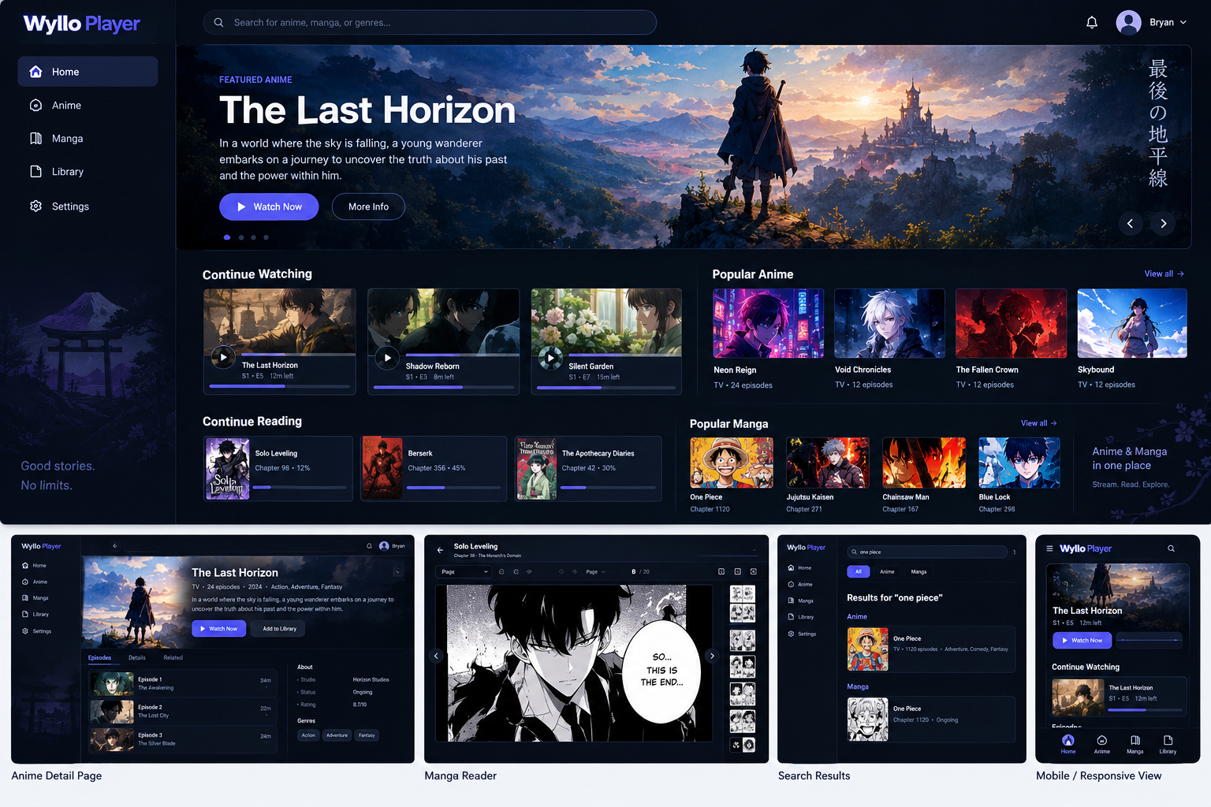
Concept UI direction for Wyllo Player

1. What We Are Building
Wyllo Player is a browser-based entertainment platform focused on two experiences: watching anime and reading manga. The first release is intentionally a website only. There is no native Android app, iOS app, desktop client, or TV application in the initial scope.
The product should feel like a modern streaming service: fast search, attractive artwork, a personal library, continue-watching/reading, detailed content pages, a full video player, and a dedicated manga reader.
The provider layer should be modular. The Wyllo UI and database should work with normalized Anime and Manga models rather than being tightly coupled to one content source.

1.1 Product principles
- Web-first: everything required for the first product works in a modern browser.
- Responsive: desktop, tablet and mobile browser layouts are part of the same website.
- Fast: cache metadata and avoid unnecessary provider requests.
- Modular: content adapters can be changed without rewriting the UI.
- Simple: start with a modular monolith instead of premature microservices.
- Private by design: collect only data that the product genuinely needs.
- Provider-neutral: use authorized sources and do not hard-code the product around one provider.

2. What the Reference Architecture Tells Us
The current public Synthetiq ecosystem is useful as an architectural reference, but Wyllo should not copy it blindly. Its public Player repository describes a media player, while a separate module catalogue contains signed/versioned content modules. The module catalogue also exposes both video and manga/image-oriented modules. This supports the idea of keeping the application shell separate from provider-specific content adapters.
For Wyllo, the same principle becomes a web architecture: the browser talks to Wyllo's API, the API talks to normalized content services, and provider adapters live behind explicit contracts.

3. Recommended Technology Stack
Layer | Technology | Purpose | Why
Website | SvelteKit + TypeScript | All user-facing pages | Fast, component-based and excellent for a responsive media UI.
Styling | Tailwind CSS | Design system / responsive layout | Rapid iteration while keeping spacing and responsive rules consistent.
UI icons | Lucide | Navigation/player/reader icons | Consistent icon set without creating dozens of custom assets.
API | Node.js + Fastify + TypeScript | Business logic and provider orchestration | Lightweight and strong for network-heavy workloads.
Validation | Zod | Validate API/module/provider data | Prevents malformed external data from reaching the UI.
ORM | Drizzle ORM | Database access | Type-safe SQL-oriented approach and good fit for TypeScript.
Database | PostgreSQL | Users, metadata, library and progress | Reliable relational foundation.
Cache | Redis | Caching, rate limiting and short-lived state | Keeps provider calls and API load under control.
Video | HTML5 video + HLS | Anime playback | Browser-oriented playback model; HLS can provide adaptive streams where supported.
Manga | Custom Svelte reader | Pages, zoom, navigation and progress | Full control over the reading experience.
Testing | Vitest + Playwright | Unit/API/E2E tests | Covers both logic and real browser behavior.
DevOps | Docker + GitHub/GitLab CI | Repeatable development/deployment | Simple and portable.

3.1 Why TypeScript?
TypeScript is the best default for Wyllo because the same language can be used for the website, API contracts, module SDK, validation schemas, tests and tooling. This reduces context switching and makes shared models such as Anime, Episode, Manga and Chapter easier to maintain.
You already have Java/Spring experience, so Java remains a viable alternative. However, for a web-first product whose difficult part is provider integration and a rich browser UI, a TypeScript-first stack will let you move faster.

4. Complete Wyllo Architecture
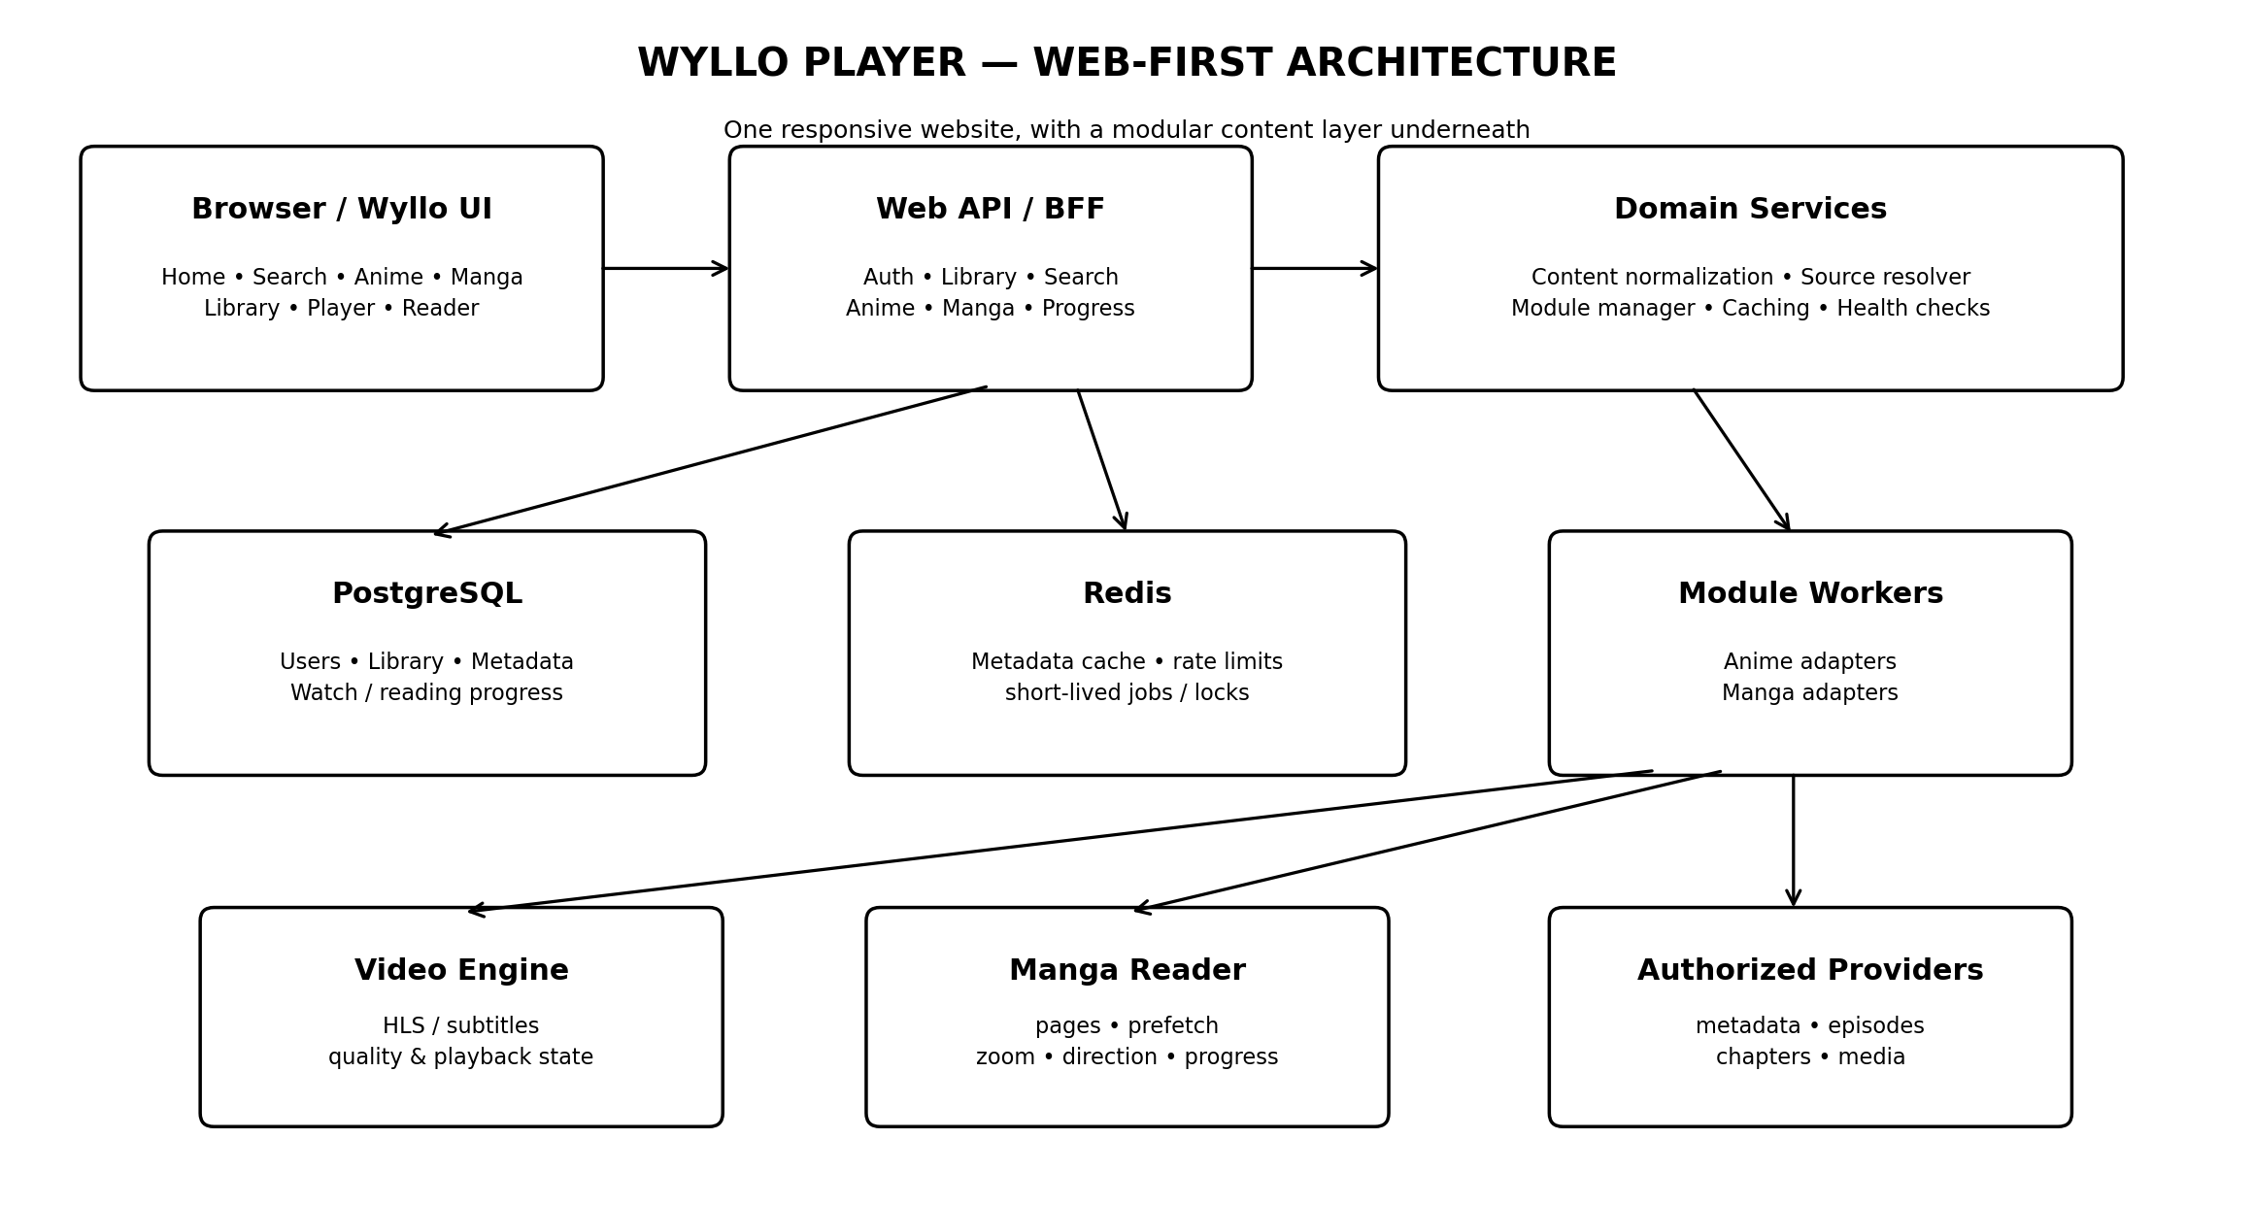
The key rule is that the browser never needs to understand how a provider works. It only receives normalized Wyllo data.
Browser
↓ HTTPS
SvelteKit website
↓
Wyllo API / BFF
↓
Domain services
├── Anime service
├── Manga service
├── Library service
├── Progress service
├── Search service
└── Module manager
↓
Provider modules / workers
↓
Authorized content sources

5. Repository Structure
wyllo-player/
├── apps/
│ ├── web/ # SvelteKit website
│ └── api/ # Fastify API
│
├── packages/
│ ├── domain/ # Shared domain types
│ ├── contracts/ # API + module contracts
│ ├── validation/ # Zod schemas
│ ├── database/ # Drizzle schema/migrations
│ ├── ui/ # Shared UI components
│ └── config/ # Shared configuration
│
├── modules/
│ ├── anime/
│ │ └── provider-example/
│ └── manga/
│ └── provider-example/
│
├── tests/
│ ├── integration/
│ └── e2e/
│
├── infra/
│ ├── docker/
│ └── compose/
│
└── docs/
Use a pnpm workspace. Keep everything in one repository initially. The provider modules can become separately versioned later if that becomes necessary.

6. Functional Requirements

6.1 Home page
- Featured anime hero/banner.
- Continue Watching row.
- Continue Reading row.
- Popular Anime.
- Popular Manga.
- Recently updated content.
- Quick access to Anime, Manga and Library.
- Global search.

6.2 Anime
- Search anime.
- Filter results.
- View anime details.
- View seasons/episodes.
- Select available language/subtitle options.
- Select a working source when multiple sources are available.
- Play video.
- Seek, pause, resume and change quality where available.
- Save watch progress.
- Automatically continue to the next episode where possible.

6.3 Manga
- Search manga.
- View manga details.
- View chapter list.
- Open a chapter.
- Read page images in a dedicated reader.
- Support single-page and continuous vertical modes.
- Support right-to-left and left-to-right reading.
- Zoom / fit width / fit height.
- Remember chapter and page progress.
- Preload nearby pages for smooth reading.

6.4 Library
- Add/remove anime and manga.
- Favorites.
- Continue Watching.
- Continue Reading.
- Progress indicators.
- Sort/filter library.

7. Website Information Architecture
/
├── Home
├── search
│ └── ?q=...
├── anime
│ └── [animeId]
├── watch
│ └── [episodeId]
├── manga
│ └── [mangaId]
├── read
│ └── [chapterId]
├── library
└── settings

7.1 Navigation
Desktop:
Wyllo Player logo
Home
Anime
Manga
Library
Settings
Search ------------------------- Profile
Mobile browser:
Wyllo Player Search
content
Home Anime Manga Library
Do not build separate mobile pages. Use responsive breakpoints and a shared component system.

8. Visual Design Direction
The supplied concept uses a dark cinematic interface. This is a design direction, not a final implementation. The final UI should be based on reusable tokens rather than one-off page styling.
- Dark background with high-contrast text.
- Purple/blue accent for primary actions.
- Large artwork for hero content.
- Rounded content cards with restrained borders.
- Clear progress bars on watched/read items.
- Minimal navigation chrome around the actual content.
- Strong typography hierarchy.
- Responsive card grids that collapse naturally on smaller screens.
Concept mockup:

9. Database Design
users
user_settings
anime
anime_titles
anime_genres
anime_genre_links
episodes
episode_sources
anime_provider_refs
manga
manga_titles
manga_genres
manga_genre_links
chapters
chapter_pages
manga_provider_refs
library_items
watch_progress
reading_progress
modules
module_versions
module_health
search_history
favorites

9.1 Important design rule
Never make a provider ID your primary application ID. Wyllo should own its IDs and store provider references separately. This allows one title to be linked to several providers and allows a provider to disappear without destroying the user's library.

10. API Design
GET /api/v1/search?q=one-piece&type=anime
GET /api/v1/search?q=one-piece&type=manga
GET /api/v1/anime/:id
GET /api/v1/anime/:id/episodes
GET /api/v1/episodes/:id/sources
GET /api/v1/manga/:id
GET /api/v1/manga/:id/chapters
GET /api/v1/chapters/:id/pages
GET /api/v1/library
POST /api/v1/library
DELETE /api/v1/library/:id
GET /api/v1/progress
PUT /api/v1/progress/watch
PUT /api/v1/progress/read

11. Provider Module System
A provider module converts a provider's API/HTML/network responses into Wyllo's normalized models. The UI must not know provider-specific selectors, URLs or response structures.
interface AnimeModule {
id: string;
version: string;
search(query: string): Promise<Anime[]>;
getDetails(id: string): Promise<AnimeDetails>;
getEpisodes(id: string): Promise<Episode[]>;
getSources(episodeId: string): Promise<VideoSource[]>;
}
interface MangaModule {
id: string;
version: string;
search(query: string): Promise<Manga[]>;
getDetails(id: string): Promise<MangaDetails>;
getChapters(id: string): Promise<Chapter[]>;
getPages(chapterId: string): Promise<Page[]>;
}

11.1 Module execution
- Wyllo discovers an installed module.
- Wyllo validates module version and compatibility.
- The module runs through a controlled interface.
- The module returns normalized data.
- Wyllo caches suitable metadata.
- The UI consumes only Wyllo's normalized API.
For the first version, keep modules as trusted code maintained by the project. If third-party modules are introduced later, isolate them in worker processes and restrict their permissions.

12. Anime Playback Flow
User searches
↓
Wyllo Search Service
↓
Run provider adapters
↓
Normalize + deduplicate
↓
Anime Details
↓
Episode list
↓
Source Resolver
↓
Source validation / health check
↓
Browser video player
↓
Save progress

12.1 Source resolver
The source resolver should rank available sources using configurable factors such as language, subtitle availability, resolution, recent health and response time. Source URLs may be short-lived, so do not treat them as permanent database records.

13. Manga Reader Architecture
Manga details
↓
Chapter list
↓
Chapter manifest
↓
Page loader
↓
Prefetch queue
↓
Reader
├── page mode
├── continuous mode
├── RTL
├── LTR
├── zoom
└── fit width
↓
Reading progress

13.1 Reader performance
- Do not load every page of a long chapter simultaneously.
- Load the current page plus a small window of nearby pages.
- Lazy-load images below the viewport.
- Use object URLs or browser caching carefully.
- Persist progress after meaningful page changes rather than every scroll event.
- Keep the reader independent from the manga detail page.

14. Page-by-Page Implementation Plan

Step 1 — Project foundation
Create pnpm workspace, SvelteKit app, Fastify API, PostgreSQL and Redis. Add linting, formatting, TypeScript strict mode and CI.

Step 2 — Design system
Build Button, Input, Card, Modal, Tabs, Badge, ProgressBar, Skeleton, Avatar and navigation components.

Step 3 — Authentication
Implement registration/login or an external identity provider. Add protected API routes.

Step 4 — Database
Create migrations for users, anime, manga, library and progress.

Step 5 — Search
Create unified search endpoint and UI. Start with one provider and normalized models.

Step 6 — Anime details
Build anime detail page, episodes and metadata.

Step 7 — Video player
Build watch route, playback controls and progress persistence.

Step 8 — Library
Add favorites and Continue Watching.

Step 9 — Manga details
Build manga detail page and chapters.

Step 10 — Reader
Implement page loading, reader controls and progress.

Step 11 — Module manager
Extract provider logic behind stable module interfaces.

Step 12 — Reliability
Add caching, retries, timeouts, provider health checks and observability.

Step 13 — Polish
Responsive layouts, loading states, error states, accessibility, keyboard shortcuts and performance optimization.

Step 14 — Production
Containerize, deploy API/database/cache, configure domain, HTTPS, backups and monitoring.

15. Testing Strategy
Level | Tool | Examples
Unit | Vitest | Source ranking, normalization, progress calculations
API integration | Vitest + test DB | Search, library, progress, provider adapters
Browser E2E | Playwright | Search → details → watch; Search → manga → read
Visual/manual | Browser device emulation | Desktop/tablet/mobile responsive layouts
Load | k6 later | Search/API concurrency and cache behavior

16. Security and Privacy
- Never expose database credentials to the browser.
- Validate every provider response before it enters the application model.
- Use timeouts and rate limits for external requests.
- Use secure cookies or properly scoped tokens for authentication.
- Sanitize metadata rendered in the UI.
- Keep provider credentials, if any, server-side.
- Treat module signatures as authenticity/integrity checks, not as a substitute for sandboxing.
- Log module failures without storing unnecessary personal data.
- Back up user/library/progress data.
- Do not bypass DRM, paywalls, authentication barriers or other access controls.

17. Content and Legal Boundary
Wyllo is an application architecture, not a license to redistribute copyrighted media. Only integrate sources and content that you are legally authorized to access, index, stream, or display in the jurisdictions where Wyllo operates. The provider module architecture should be usable with licensed providers, user-owned media, public-domain material, or other authorized sources.

18. The Actual MVP I Recommend
Do not attempt to build every feature at once. The first functional Wyllo release should contain:
- Home page.
- Global search.
- Anime details.
- Episode list.
- One authorized anime provider module.
- Video playback.
- Watch progress.
- Manga search.
- Manga details.
- Chapter list.
- Basic manga reader.
- Reading progress.
- Library/favorites.
- Responsive desktop/tablet/mobile browser layouts.

18.1 What is NOT in MVP
- Native mobile apps.
- Desktop applications.
- TV applications.
- Third-party module marketplace.
- AI recommendations.
- Social features.
- Complex microservice infrastructure.
- Offline downloads unless there is a clear legal/product requirement.

19. After MVP
MVP
↓
More authorized providers
↓
Better source fallback
↓
Better search + metadata
↓
Recommendations
↓
Notifications / release tracking
↓
Optional PWA enhancements
↓
Native clients only if users actually need them

20. Definition of Done
Wyllo MVP is ready when a new user can:
- Open the website without installing anything.
- Search for an anime.
- Open its details page.
- Select an episode.
- Play an authorized stream.
- Leave and return later with playback progress restored.
- Search for a manga.
- Open its chapters.
- Read a chapter smoothly.
- Return later and continue from the previous page.
- Add both anime and manga to a personal library.
- Use the website comfortably on desktop and mobile browser widths.

21. Recommended Build Order for Us
If we implement this together, I recommend working vertically rather than creating the entire backend first. Each milestone should produce something visible in the browser.
- Milestone 1: Wyllo shell — navigation, theme, responsive layout and home screen.
- Milestone 2: Search UI + API + normalized Anime model.
- Milestone 3: Anime detail + episode pages.
- Milestone 4: Video player + watch progress.
- Milestone 5: Manga model + search/details.
- Milestone 6: Manga reader + page progress.
- Milestone 7: Unified library.
- Milestone 8: Provider/module abstraction.
- Milestone 9: Caching, health checks and production hardening.

22. Final Architecture Decision
Wyllo Player should begin as one responsive website backed by one modular TypeScript API. SvelteKit owns the experience, Fastify owns the application API, PostgreSQL owns durable state, Redis handles short-lived caching and coordination, and provider modules translate external sources into Wyllo's normalized Anime and Manga models.
The most important engineering goal is to make the provider layer replaceable. If that boundary is correct, the rest of Wyllo — the home page, library, video player, manga reader and user experience — can evolve without being rewritten every time a content source changes.

Appendix — Reference Sources
The architecture was informed by the currently public Synthetiq repositories:
• Synthetiq Player — github.com/Synthetiq-HQ/synthetiq-player
• Synthetiq Modules — github.com/kas021/Synthetiq-Modules
• Synthetiq Manga Sources — github.com/Synthetiq-HQ/synthetiq-manga-sources

