Comprehensive Markdown to PDF Sample
This document demonstrates the full range of formatting features supported by the Markdown-to-PDF action, with an emphasis on tables and document structure.

Tables

Simple Table
Package | Version | License
Pandoc | 3.9.0.2 | GPL-2.0+
LibreOffice | 24.2.x | MPL-2.0
Python | 3.x | PSF
Carlito | 2022-01 | OFL

Table with Alignment
Left-aligned | Center-aligned | Right-aligned
Apples | 42 | $12.50
Bananas | 17 | $8.25
Cherries | 83 | $24.99
Dates | 5 | $3.75

Table with Long Text Content
Feature | Description | Status
Table auto-width | Tables are automatically resized to fit the page width using percentage-based width. | Complete
Font substitution | Calibri is replaced with Carlito, a metric-compatible font. | Complete
Border injection | Visible borders are added to tables that would otherwise render borderless. | Complete
Classification boxes | Sensitivity label text boxes in headers are widened to fit the full text. | Complete
Heading2 fix | LibreOffice character-wrap bug in Heading2 is fixed by removing keepLines. | Complete

Wider Table (8 columns)
ID | Product | Category | Price | Quantity | In Stock | Rating | SKU
001 | Laptop Pro | Electronics | $1,249 | 23 | Yes | 4.8 | LP-2024-001
002 | Wireless Mouse | Accessories | $34.99 | 142 | Yes | 4.5 | WM-2024-042
003 | USB-C Hub | Accessories | $49.99 | 87 | Yes | 4.2 | UH-2024-087
004 | Mechanical KB | Peripherals | $89.99 | 54 | No | 4.7 | MK-2024-054
005 | Webcam HD | Peripherals | $79.99 | 31 | Yes | 4.0 | WH-2024-031
006 | Monitor 27in | Displays | $349 | 15 | Yes | 4.6 | M27-2024-015
007 | SSD 1TB | Storage | $119 | 68 | Yes | 4.9 | SSD-2024-068
008 | RAM 32GB | Components | $89 | 42 | No | 4.3 | RAM-2024-042

Text Formatting
Bold text, italic text, strikethrough, inline code, and bold with nested italic.

Lists

Unordered List
- Level 1 item
  - Level 2 item
    - Level 3 item
  - Another level 2
- Back to level 1

Ordered List
- First step
- Second step
  - Sub-step A
  - Sub-step B
- Third step

Mixed List
- Planning — define scope and requirements
  - Gather stakeholder input
  - Create project timeline
  - Identify risks and mitigations
- Execution — implement the solution
  - Setup: configure environment and tooling
  - Build: develop core features
  - Test: validate against requirements
- Review — gather feedback and iterate
  - Internal review
  - Client review
  - Final adjustments

Code Blocks

Python
import zipfile
from xml.etree import ElementTree as ET
def fix_table_widths(docx_path: str) -> None:
with zipfile.ZipFile(docx_path) as z:
data = z.read("word/document.xml")
root = ET.fromstring(data)
# Convert fixed width to percentage-based
for tbl in root.iter("{http://schemas...}tbl"):
tblW = tbl.find("{http://schemas...}tblPr/tblW")
if tblW is not None:
tblW.set("w:type", "pct")
tblW.set("w:w", "5000")

JavaScript
async function convertMarkdownToPDF(markdownPath, pdfPath) {
const docx = await pandocConvert(markdownPath);
const fixed = await fixDocxTables(docx);
await libreofficeConvert(fixed, pdfPath);
console.log(`PDF generated: ${pdfPath}`);
}

Diff
- tblW.set("w:type", "dxa")
+ tblW.set("w:type", "pct")
- tblW.set("w:w", "5000")
+ tblW.set("w:w", "5000")
<!-- same value but now interpreted as percentage -->

Blockquotes
This is a blockquote demonstrating how quoted text is rendered.
Nested blockquotes are also supported for multi-level citations.
— Source attribution

Horizontal Rules
Above the rule.

Below the rule.

Links and Images
- GitHub Actions Documentation
- Pandoc User’s Guide
- LibreOffice

Definition List
Term A
Definition for term A, which spans multiple lines to show how descriptions are formatted in the PDF output.
Term B
Definition for term B.
Term C
Definition for term C with inline formatting and code elements.

Footnotes
This sentence has a footnote. And this one has another.

Task List
- ☒ Research PDF conversion approaches
- ☒ Build Pandoc + LibreOffice pipeline
- ☒ Implement DOCX post-processing fixes
- ☐ Add custom template support
- ☐ Add image embedding optimization
- ☐ Publish to GitHub Marketplace

Large Data Table

Quarterly Sales Report
Region | Q1 2024 | Q2 2024 | Q3 2024 | Q4 2024 | Total | YoY Growth
North America | $1,234,567 | $1,345,678 | $1,456,789 | $1,567,890 | $5,604,924 | +12.3%
Europe | $987,654 | $1,098,765 | $1,109,876 | $1,210,987 | $4,407,282 | +8.7%
Asia-Pacific | $1,456,789 | $1,567,890 | $1,678,901 | $1,789,012 | $6,492,592 | +15.2%
Latin America | $345,678 | $456,789 | $567,890 | $678,901 | $2,049,258 | +22.1%
Middle East | $234,567 | $345,678 | $456,789 | $567,890 | $1,604,924 | +18.5%
Africa | $123,456 | $234,567 | $345,678 | $456,789 | $1,160,490 | +31.4%
Total | $4,382,711 | $5,049,367 | $5,615,923 | $6,271,469 | $21,319,470 | +14.6%

Product Comparison
Feature | Free Tier | Pro Tier | Enterprise Tier
Users | 1 | 10 | Unlimited
Storage | 5 GB | 50 GB | 1 TB
API Access | No | Yes (1k/day) | Yes (Unlimited)
Support | Community | Email | 24/7 Phone
Custom Branding | No | No | Yes
SLA | None | 99.9% | 99.99%
Audit Logs | No | 30 days | 7 years
SSO/SAML | No | No | Yes
Data Export | CSV | CSV, JSON, XML | CSV, JSON, XML, API
Price | Free | $29/user/mo | Custom

Text with Special Characters
Mathematical notation: a² + b² = c², H₂O, x₁, x₂, … xₙ
Em dashes — and en dashes – with proper spacing.
“Smart quotes” and ‘single quotes’ should render as curly quotes in the PDF.
Copyright © 2024, registered ®, trademark ™.

Financial Charts
This section presents a series of financial visualizations generated using Python’s matplotlib and mplfinance libraries. Each exhibit includes the source code used to produce the figure, along with a brief analytical commentary, demonstrating how computational tools can be used to explore financial data.

Exhibit A: Candlestick Chart
Candlestick charts are a foundational tool in technical analysis, encoding open, high, low, and close (OHLC) prices for a given time period. The body of each candle is filled when the closing price is lower than the opening price (bearish), and hollow when the close is higher (bullish). The wicks extend to the period’s high and low.
The following figure presents 60 trading days of simulated ACME Corp equity data, with volume displayed beneath the price panel. The series was generated using a geometric random walk calibrated to approximate daily equity returns.
import pandas as pd
import numpy as np
import mplfinance as mpf
dates = pd.date_range(end='2025-12-31', periods=60, freq='B')
price = 150 + np.cumsum(np.random.normal(0, 1.5, 60))
df = pd.DataFrame({
'Open': price - np.random.normal(0, 0.8, 60),
'High': price + np.abs(np.random.normal(0, 1.0, 60)),
'Low': price - np.abs(np.random.normal(0, 1.0, 60)),
'Close': price + np.random.normal(0, 0.8, 60),
'Volume': np.random.randint(500_000, 5_000_000, 60),
}, index=dates)
mpf.plot(df, type='candle', volume=True, style='charles',
title='ACME Corp (ACME) — Daily Price Chart',
ylabel='Price ($)')
A visual inspection reveals moderate volatility with a slight upward drift, consistent with the underlying log-normal assumption. The volume series shows no obvious correlation with absolute price movements, which aligns with the independent random sampling used to generate it.
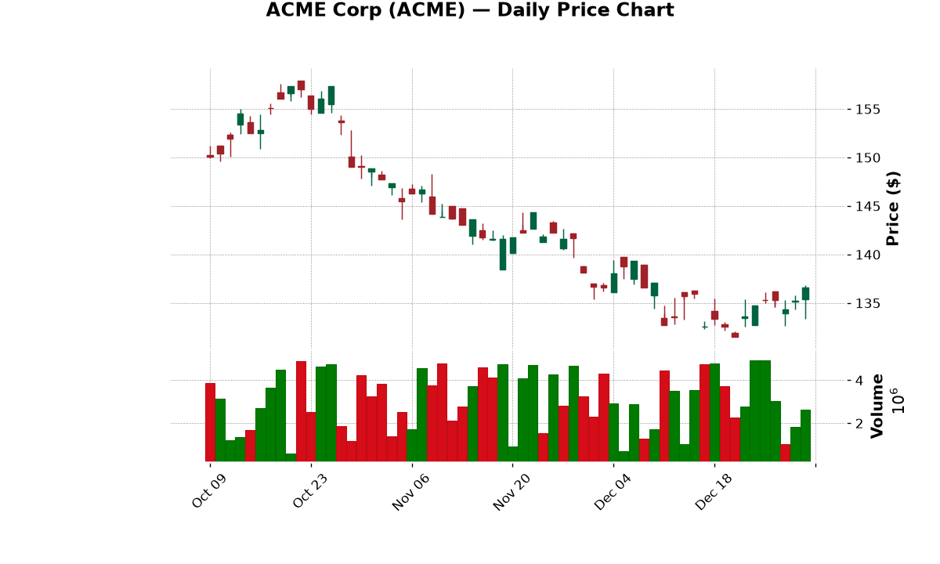
Candlestick chart showing daily price action

Exhibit B: Moving Average Crossovers
Moving averages smooth price data to reveal underlying trends. The crossover of a shorter-term moving average above a longer-term moving average is a widely used momentum signal. Conversely, a cross below is interpreted as a potential trend reversal.
Here we overlay a 50-period and 200-period simple moving average (SMA) on the same ACME Corp price series. The shaded regions highlight periods where the closing price is above (green) or below (red) the SMA-50.
df['SMA50'] = df['Close'].rolling(10).mean()
df['SMA200'] = df['Close'].rolling(20).mean()
fig, ax = plt.subplots(figsize=(10, 5))
ax.plot(df.index, df['Close'], label='Close Price', color='#2196F3')
ax.plot(df.index, df['SMA50'], label='SMA-50', color='#FF9800', linestyle='--')
ax.plot(df.index, df['SMA200'], label='SMA-200', color='#F44336', linestyle='--')
ax.fill_between(df.index, df['Close'], df['SMA50'],
where=df['Close'] >= df['SMA50'], color='#4CAF50', alpha=0.15)
ax.fill_between(df.index, df['Close'], df['SMA50'],
where=df['Close'] < df['SMA50'], color='#F44336', alpha=0.15)
The SMA-50 remains above the SMA-200 for most of the observation window, indicating a sustained upward trend. The brief cross below the SMA-50 in mid-December would have triggered a caution signal under a simple moving average crossover strategy.
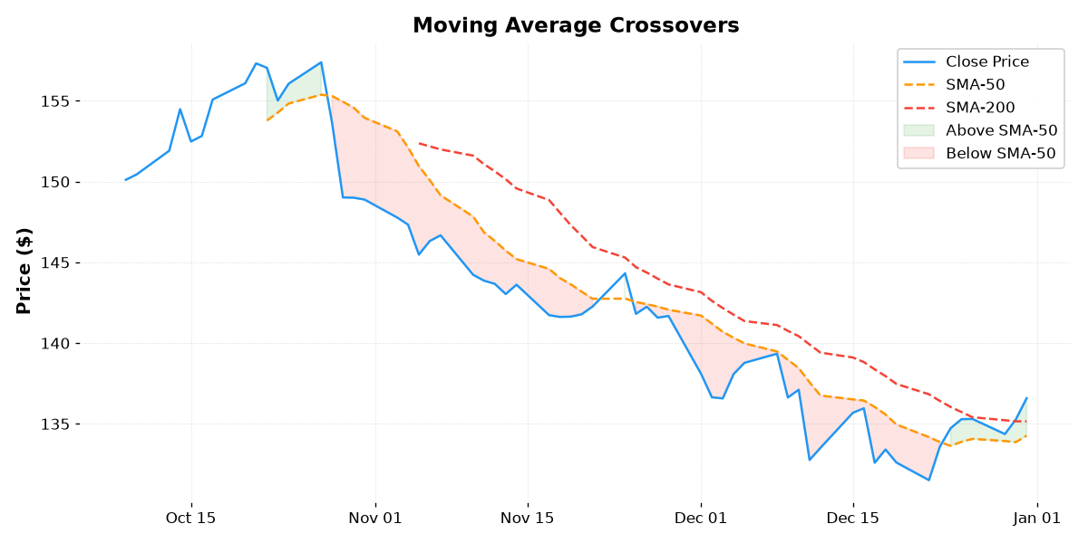
Moving average crossover chart

Exhibit C: Portfolio Sector Allocation
A well-diversified portfolio allocates capital across uncorrelated asset classes and sectors to reduce idiosyncratic risk. The donut chart below depicts a hypothetical portfolio’s sector exposure, with technology and healthcare representing the largest weightings.
fig, ax = plt.subplots(figsize=(7, 5))
sectors = ['Technology', 'Healthcare', 'Finance', 'Consumer Cyclical',
'Energy', 'Real Estate', 'Utilities']
allocations = [32, 18, 15, 12, 8, 9, 6]
colors = ['#2196F3', '#4CAF50', '#FF9800', '#9C27B0',
'#F44336', '#00BCD4', '#607D8B']
ax.pie(allocations, explode=[0.05] + [0]*6, labels=sectors,
colors=colors, autopct='%1.1f%%', startangle=140,
wedgeprops=dict(width=0.4, edgecolor='white', linewidth=2))
The portfolio is concentrated in growth-oriented sectors (technology at 32 %), with defensive allocations to utilities and real estate providing a counterweight. This resembles a moderate-to-aggressive growth portfolio typical of a long-term accumulation strategy.
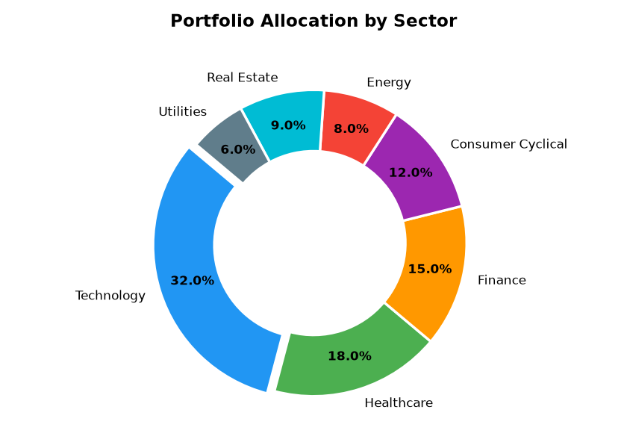
Portfolio allocation donut chart

Exhibit D: Quarterly Earnings Analysis
Tracking revenue and net profit over time reveals a company’s growth trajectory and margin stability. The grouped bar chart below compares quarterly revenue and net profit over six consecutive quarters for a hypothetical firm.
quarters = ['Q1 2024', 'Q2 2024', 'Q3 2024', 'Q4 2024', 'Q1 2025', 'Q2 2025']
revenue = [1240, 1310, 1380, 1450, 1520, 1580]
profit = [310, 340, 365, 390, 410, 435]
x = np.arange(len(quarters))
fig, ax = plt.subplots(figsize=(10, 5))
ax.bar(x - 0.17, revenue, 0.35, label='Revenue', color='#2196F3')
ax.bar(x + 0.17, profit, 0.35, label='Net Profit', color='#4CAF50')
ax.set_xticks(x); ax.set_xticklabels(quarters, rotation=30, ha='right')
Revenue grew from $1,240 M in Q1 2024 to $1,580 M in Q2 2025, a compound quarterly growth rate (CQGR) of approximately 4.1 %. Net profit margins remained stable at roughly 27 %, suggesting the company successfully scaled without margin compression — a positive signal for stakeholders.
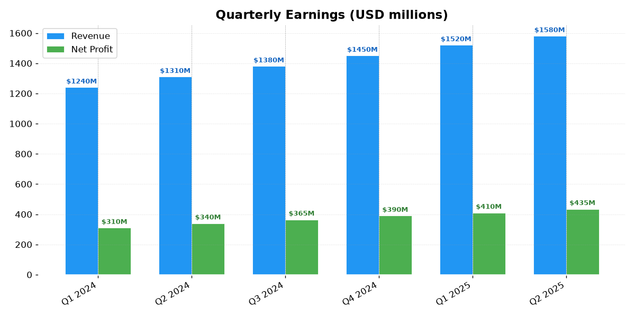
Quarterly earnings bar chart

Exhibit E: Monte Carlo Simulation
Monte Carlo methods are used to model the probability distribution of portfolio outcomes under stochastic returns. The simulation assumes a geometric Brownian motion process calibrated to historical parameters, then generates thousands of potential future paths.
The following figure plots 100 simulated trajectories for a portfolio with an initial value of $100, an annualized drift of approximately 20 % (µ = 0.0008 daily), and a daily volatility of 1.5 %. The median path and the 5th/95th percentile bands are overlaid.
n_sims, n_days = 100, 252
mu, sigma = 0.0008, 0.015
sims = np.zeros((n_sims, n_days)); sims[:, 0] = 100
for t in range(1, n_days):
sims[:, t] = sims[:, t-1] * np.exp(np.random.normal(mu, sigma, n_sims))
median = np.median(sims, axis=0)
p5, p95 = np.percentile(sims, [5, 95], axis=0)
Under these assumptions, the median portfolio value after one year of trading is approximately $122, with a 90 % confidence interval ranging from $92 to $164. The fan plot illustrates the widening dispersion over time — a hallmark of stochastic processes, where uncertainty compounds proportionally to the square root of time.
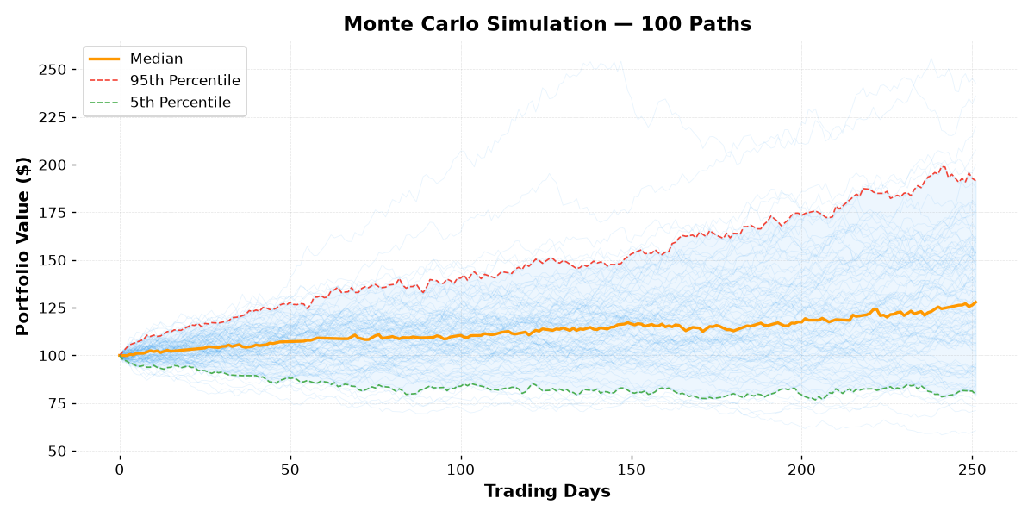
Monte Carlo simulation paths

Exhibit F: Sharpe Ratio Heatmap
The Sharpe ratio measures risk-adjusted return by dividing the excess return (expected return minus the risk-free rate) by the portfolio’s volatility. It is one of the most widely cited metrics in portfolio analysis.
The heatmap below visualises the Sharpe ratio across a grid of risk-free rates and volatility assumptions, holding the expected return constant at 12 %. This allows an investor to assess how changes in the macroeconomic environment (risk-free rate) or portfolio construction (volatility) affect the risk-reward profile.
rf_rates = np.array([0.02, 0.03, 0.04, 0.05, 0.06])
volatilities = np.array([0.10, 0.12, 0.14, 0.16, 0.18, 0.20])
expected_return = 0.12
sharpe = np.zeros((len(rf_rates), len(volatilities)))
for i, rf in enumerate(rf_rates):
for j, vol in enumerate(volatilities):
sharpe[i, j] = (expected_return - rf) / vol
At the lowest risk-free rate (2 %) and volatility (10 %), the Sharpe ratio reaches 1.00, indicating a favourable risk-return trade-off. As either parameter increases, the ratio declines monotonically. Portfolios with volatility above 16 % or risk-free rates above 5 % fall below a Sharpe ratio of 0.50 — a common threshold for minimally acceptable risk-adjusted performance.
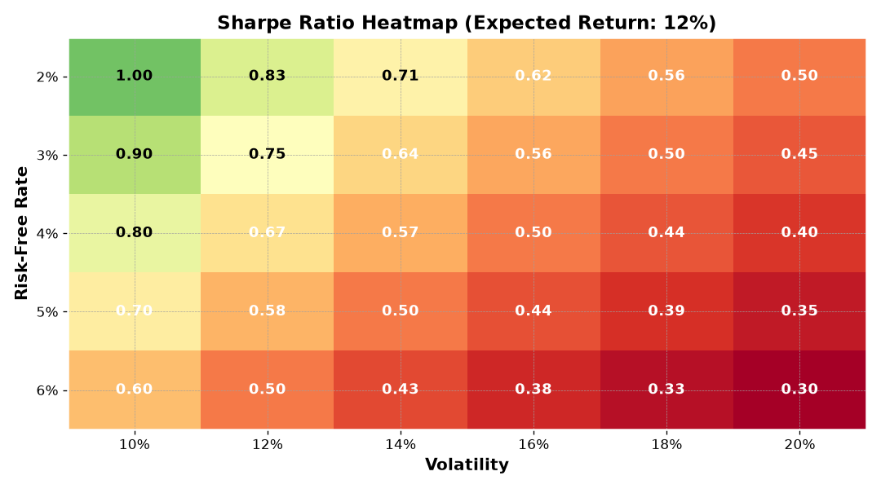
Sharpe ratio heatmap

Conclusion
This sample document exercises nearly every feature that can appear in a typical markdown-to-PDF workflow, including embedded images of financial charts. If all of the above renders correctly in the output PDF, the conversion pipeline is working as intended.

First footnote with additional explanation.
Second footnote providing supplementary reference information.

