Markdown-to-PDF
A GitHub Action that converts Markdown documents to polished PDFs using Pandoc and LibreOffice. Designed for teams that need publication-ready output from plain-text sources.
$$σ=\sqrt{\frac{1}{N}\sum_{i=1}^{N}{{\left(x_{i}−μ\right)}^{2}}} μ=\frac{1}{N}\sum_{i=1}^{N}{x_{i}}$$
Quarterly Revenue by Region
Region | Q1 | Q2 | Q3 | Q4 | Total
NA | $1.23M | $1.35M | $1.46M | $1.57M | $5.60M
EU | $0.99M | $1.10M | $1.11M | $1.21M | $4.41M
APAC | $1.46M | $1.57M | $1.68M | $1.79M | $6.49M
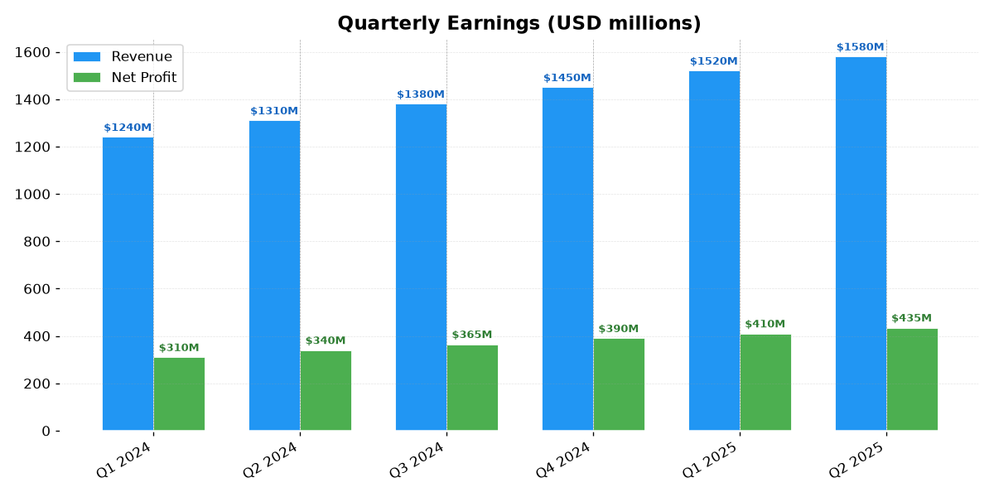
Quarterly earnings
Features: table auto-width, font substitution (Calibri → Carlito), code block styling, section page breaks, embedded images, and classification box support.

