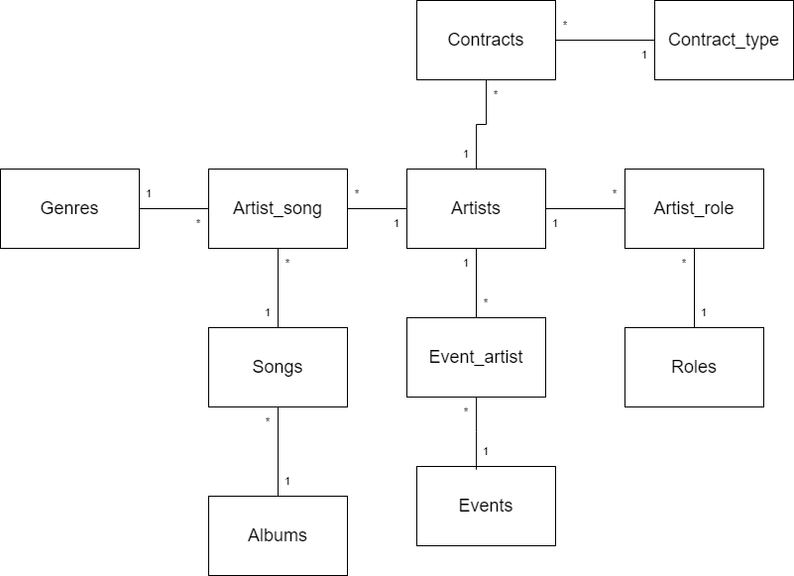
Fig (2.0.2) ERD with dummy tables

Data Dictionary

Entity Name: Albums
Primary Key: AlbumID
Foreign Key:
Attribute Name | Data type | Length | Constraint | Domain Constraint | Remark
AlbumID | Varchar | 10 | PK | Like (‘Alb-%’) | Unique identifier of each album
AlbumTitle | Varchar | 50 | - | - | Name of the album
ReleaseDate | Date | - | - | Valid Date | Release Date of the album
If the album is deleted, delete all its songs. Update all related records if the album ID changes.
If the genre is deleted, set GenreID to NULL. Update all related records if the genre ID changes

Entity Name: Songs
Primary Key: SongID
Foreign Key : AlbumID, GenreID
Attribute Name | Data type | Length | Constraint | Domain Constraint | Remark
SongID | Varchar | 10 | PK | Like (‘Sng-%’) | Unique identifier of each song
SongTitle | Varchar | 50 | - | - | Name of the song
Duration | Time | - | - | Valid Time | Duration of the song
Language | Varchar | 50 | - | - | Language of the song
ReleaseYear | INT | 4 | - | Year > 1900 | Year of the song released
AlbumID | Varchar | 10 | FK | Like (‘Alb-%’) | Album the song belongs to
GenreID | Varchar | 10 | FK | Like (‘G-%’) | Genre Of the Song

Entity Name: Genres
Primary Key: GenreID
Foreign Key :
Attribute Name | Data type | Length | Constraint | Domain Constraint | Remark
GenreID | Varchar | 10 | PK | Like (‘G-%’) | Unique identifier of each genre
Name | Varchar | 50 | - | - | Name of the genre
Description | Text | - | - | - | Optional Description of the genre

Entity Name: Artists
Primary Key: ArtisID
Foreign Key:
Attribute Name | Data type | Length | Constraint | Domain Constraint | Remark
ArtistID | Varchar | 10 | PK, FK | Like (‘Art-%’) | Unique identifier of each artist
ArtistName | Varchar | 50 | - | - | Name of the artist
StageName | Varchar | 50 | - | - | Artist’s Stage Name
BirthDate | Date | - | - | Valid Date | Artist’s Birth Date
Nationality | Varchar | 50 | - | - | Artist’s Nationality

Entity Name: Artist_song
Primary Key: ArtistID+SongID
Foreign Key : ArtistID, SongID
Attribute Name | Data type | Length | Constraint | Domain Constraint | Remark
ArtistID | Varchar | 10 | PK | Like (‘Art-%’) | Unique identifier of each artist
SongID | Varchar | 10 | PK, FK | Like (‘Sng-%’) | Unique identifier of each song
RoyalityPercentage | Decimal | 5,2 | - | - | Percentage of royalties earned.
Delete the record if the artist is deleted. Update all related records if the artist ID changes
Delete the record if the song is deleted. Update all related records if the song ID changes
Entity Name: Roles
Primary Key: RoleID
Foreign Key:
Attribute Name | Data type | Length | Constraint | Domain Constraint | Remark
RoleID | Varchar | 10 | PK | Like (‘R-%’) | Unique identifier of each role
RoleName | Varchar | 50 | - | - | Name of the role
Description | Text | - | - | - | Optional Description of the role

Entity Name: Artist_role
Primary Key: ArtistID+RoleID
Foreign Key: ArtistID,RoleID
Attribute Name | Data type | Length | Constriant | Domain Constraint | Remark
ArtistID | Varchar | 10 | PK | Like (‘Art-%’) | Unique identifier of each artist
RoleID | Varchar | 10 | PK | Like (‘R-%’) | Unique identifier of each role

Entity Name: Contract_type
Primary Key: ContractTypeID
Foreign Key:
Attribute Name | Data type | Length | Constriant | Domain Constraint | Remark
ContractTypeID | Varchar | 10 | PK | Like (‘Ct-%’) | Unique identifier of each contract type
Term | Varchar | 50 | - | - | Term of the contract type

Entity Name: Contracts
Primary Key: ContractID
Foreign Key: ArtistID , ContractTypeID
Attribute Name | Data type | Length | Constriant | Domain Constraint | Remark
ContractID | Varchar | 10 | PK | Like (‘Con-%’) | Unique identifier of contract
ArtistID | Varchar | 10 | FK | Like (‘Art-%’) | Unique identifier of each artist
ContractTypeID | Varchar | 10 | FK | Like (‘Art-%’) | Unique identifier of each contract type
StartDate | Date | - | - | - | StartDate of the Contract
Duration | Varchar | 20 | - | - | Duration of the contract
PaymentAmount | Decimal | 10,2 | - | - | Total payment under the contract
Prevent deletion of an artist if they are under contract. Update all related records if the artist ID changes.
Set ContractTypeID to NULL if the contract type is deleted. Update all related records if the contract type ID changes.
Entity Name: Events
Primary Key: EventID
Foreign Key:
Attribute Name | Data type | Length | Constriant | Domain Constraint | Remark
EventID | Varchar | 10 | PK | Like (‘E-%’) | Unique identifier of event
EventName | Varchar | 50 | - | - | Name of the event
Date | Date | - | - | - | Date of the event
Location | Varchar | 50 | - | - | Location of the event
Entry Fee | Decimal | 8,2 |  | - | Entry fee of the ticket

Entity Name: Event_artist
Primary Key: EventID, ArtistID
Foreign Key:
Attribute Name | Data type | Length | Constriant | Domain Constraint | Remark
EventID | Varchar | 10 | PK, FK | Like (‘E-%’) | Unique identifier of event
ArtistID | Varchar | 10 | PK, FK | Like (‘Art-%’) | Unique identifier of each artist
Date | Date | - | - | - | Date of the event
PerfromanceDuration | Time | - | - | - | Performance duration of the artist
Stage Role | Varchar | 50 | - | - | Stage Role of the artist
If the event is deleted, all associated records in this table are also deleted. Updates EventID in this table if it changes in the parent table.
If the artist is deleted, their associated event records are also deleted. Updates ArtistID in this table if it changes in the parent table.

