# Methods

Agro-ecological classes

Purpose

To provide instructions for generating one or more agroecological class raster layers from USDA Cropland Data Layer (https://www.nass.usda.gov/Research\_and\_Science/Cropland/metadata/meta.php)

Requirements:

* ArcGIS 10.4 with Spatial Analyst
* Python libraries compatible with ArcGIS 10.4 ArcPy package
  + Python 2.7.10, 32-bit
  + Numpy 1.9.2
  + Pandas 0.15.2

Assets:

* Git repository: <https://github.com/bryanrcarlson/AgroecosystemClasses>

Instructions:

1. Procure raw data
   1. Download data from CropScape data portal (<https://nassgeodata.gmu.edu/CropScape/>)
      1. Select tool to Import Area of Interest. Use the shapefile in the file Received\FromHarsimranKaur\region\_boundary.zip
      2. Select tool to Download Defined Area of Interest Data. Specify projection as UTM Zone 11.
      3. Choose year and download
2. Prepare data for analysis using ArcMap
   1. Ensure that pixels represent 30 m2 (~~pre-2010 are set to 56 m2~~ now 2007 and prior are 56 m2, later years or 30x30); if not, use the Resample tool:  
        
      X = 30, Y = 30, Resampling Technique = NEAREST, Environment >> Processing Extent >> ~~Use original~~ Use “Default”  
        
        
        
        
      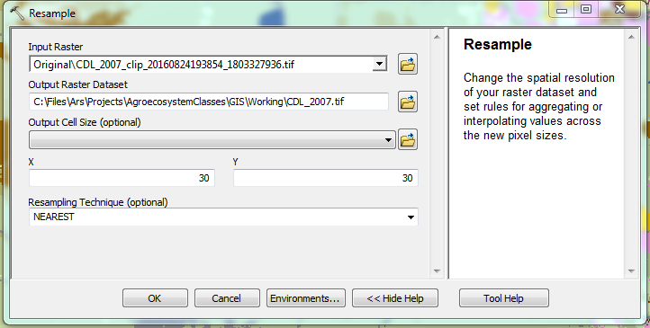
   2. Rebuild the attribute table in order to get count and remove null values. Also remove background (value == 0) values.  
        
      Use Raster Calculator: **Con(“{path to CDL}”>0, “{path CDL}”)**

**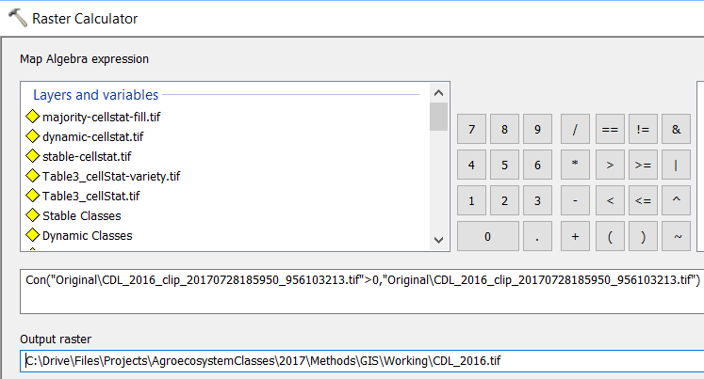**Right click on the created layer > Properties > Symbology > select Unique Values

1. Create irrigation layer
   1. Create a layer with only “Irrigated” crops
      1. Review “"\{year}\Methods\Python\ScriptRasterCalculator\RasterValueCategories.csv” to associate attribute table Value to categories. ~~To do this, view the metadata associated with the most recent data. You can copy the table into Excel and use the fixed width option in Text to Columns tool.~~ To do this, view National worksheet from CropScape\_YYYY\_Stats.xlsx from <https://www.nass.usda.gov/Research_and_Science/Cropland/sarsfaqs2.php#Section3_21.0>, and compare – check if any new pixel values were added.
         1. ~~The items in the table were derived from an aggregate of all of the years of data after rebuilding the raster attribute table in the previous step. So RasterValueCategories.csv include all values from 2007 to year of last updated (2015 as of writing).~~ Make sure to include any missing values in newly generated attribute table to RasterValueCategories.csv
      2. Review/edit Python script "\{year}\Methods\Python\ScriptRasterCalculator\scriptCreateArgumentsForRasterCalculatorManual.py"
         1. Add years to the array "~~outFilesHistoricYears~~" “historicYears” until includes all to current year (~~but not~~ including current) (NOTE brc 20180307 – I’m not sure what this means now. Current year that the data are processed which would be 2018, for example, since 2017 is released feb 2018, or current year of available data; e.g. 2017?)
         2. Update as needed variables listed under "Parameters"
         3. Likely will need to update "**layerCurrentYear**"
      3. Run Python script "scriptCreateArgumentsForRasterCalculatorManual.py"
         1. This will overwrite any existing files, so consider making a backup. This script will generate "RasterCalculatorArgs.txt" with the arguments to extract categories. The script will also generate "RasterCalculatorHistoric{year}.txt" which includes Raster Calculator argument to extract agricultural pixels needed to determine "Irrigated" lands
      4. In ArcMap, run the Raster Calculator tool and copy/paste the generated argument for Irrigation located in the RasterCalculatorArgs.txt file. Name the output layer as “CDL\_{current year}\_Irrigated.tif”. The example below shows running the tool for Range pixels, but Irrigation is similar:  
           
         IPUOA!PUOD 
         国 国 団 ロ 国 国 曰 
         国 曰 国 ロ 「 〔 鬥 一 」 
         ロ 
         LIO w 」 0 」 u - 2 」 OW 」 0 」 5u8- 5UIUÆM pue 」 0 」 」 2 も 
         お pa ~ 豈 」 」 当 す 102 」 ロ リ pa ~ 豈 」 」 一 昱 〈 〉 
         お pa 帑 5u 」 当 ロ 02 」 ロ リ pa ~ 豈 」 」 一 昱 〈 〉 
         お pa 帑 5u 」 当 02 」 ロ リ pa ~ 豈 」 」 一 昱 〈 〉 
         お pa 帑 旦 」 」 当 1102 」 ロ リ pa 帑 5u 」 一 昱 〈 〉 
         お - pa 帑 旦 」 」 当 日 」 ロ ソ pa 帑 旦 」 」 一 昱 〈 〉 
         お - pa 帑 旦 」 」 ー 当 」 ロ ソ pa 帑 旦 」 」 一 昱 〈 〉 
         u 。 ま 2 」 dxa 2 」 qa6 イ dew 
         包 」 ~ 昼 コ 0 ・ 
   2. Create new layer of combined Irrigated pixels for all historic years and current year.
      1. If needed, create Irrigated layer for all historic years or, if available, use previously created combined Irrigation layer (should be named “CDL\_2007-{latest year}\_Irrigated.tif”)
         1. Generate previous year irrigation layer by changing “layerCurrentYear” parameter in scriptCreateArgumentsForRasterCalculatorManual.py, running it, then copy/pasting the Irrigation command for Raster Calculator in RasterCalculatorArgs.txt. Or copy/paste the command in a text editor and do a replace all for the year.
      2. Combine as needed all historic and current Irrigated layers using the Mosaic to New Raster tool in ArcMap. Use parameters as specified in the below image (it may be important to have more recent years at the top of the Input Raster list).  
           
         Mosaic To New Raster 
         Inpu t Rasters 
         COL 
         COL 
         COL 
         COL 
         COL 
         COL 
         COL 
         COL 
         COL 
         2015_Irrigated bf 
         _lrrigated bf 
         2014 
         2013_Irrigated bf 
         2012_Irrigated bf 
         _lrrigated bf 
         2011 
         2010 _lrrigated bf 
         _lrrigated bf 
         2009 
         _lrrigated bf 
         2008 
         Irrigated bf 
         2007 
         Output Location 
         C : Files\Ar spr ojects\Agr oeco systemCIasses\GIS IW orkng 
         Raster Dataset Name with Extension 
         Spa bal Reference for Raster (optional) 
         WGS 1984 UTM Zone IIN 
         Pixel Type (optonan 
         8 UNSIGNED 
         Cellsize (opbonan 
         Number of Bands 
         Mosaic Operator (optional) 
         MO saic Colormap Mode (optional) 
   3. Determine irrigated pixels based on rainfall and cropping history
      1. Use Raster Calculator to create a layer with Agricultural and Ag-Irrigated values for the current year. Also create layers for all historic if they are not already available.  
         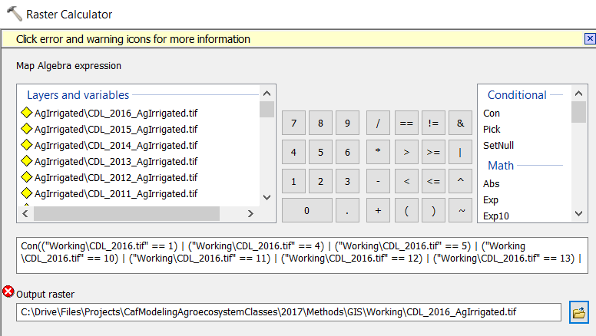
         1. Output each layer as “CDL\_{year}\_AgIrrigated.tif”
         2. Use Raster Calculator argument found in “{year}\Methods\Python\ScriptRasterCalculator\RasterCalculatorHistoric{year}.txt”
      2. Use “prism\_utm800” layer (800 m x 800 m cell size)
      3. A pixel is assumed to be irrigated if majority (>= 70%) of historic years are cropped in a location with less than 311 mm of annual rainfall
      4. View/edit Python script "scriptCreateArgumentsForRasterCalculatorManual.py" if have not done so in previous steps
         1. Update layerNamePrecipitationData, layerNameAgIrrigatedBaseName, layerNameAgIrrigatedSuffix, historicYears, pricipitationCutOff
            1. proportionCroppedCutoff determines proportion of years pixel is cropped in area with less rainfall as specified by **pricipitationCutoff**. Depending on number of total years, this proportion may change (it was 6/9 when we had 9 years).
      5. Run Python script "scriptCreateArgumentsForRasterCalculatorManual.py" if have not done so in previous step
      6. Open Raster Calculator
         1. Set cell output to 30
         2. In the Raster Calculator tool >> Environments… >> Raster Analysis >> Cell Size: As Specified Below, 30  
              
            Environment Settings 
            Geodata base Adva nced 
            Fields 
            Random Numbers 
            Ca rtog ra phy 
            Coverage 
            Raster Analysis 
            Cell Size 
            As Specified Belon 
            Raster Storage 
            Geostatistical Analysis 
      7. Copy/paste generated code from "RasterCalculatorAlgorithmicIrr.txt" to Raster Calculator and create new layer named "CDL\_{year}\_AlgorithmicIrrigation.tif"  
           
         IPUOA!PUOD 
         pa 帑 旦 」 」 1 3 + 」 4 - pa 帑 旦 」 」 1 当 ロ 」 ロ ソ pa 帑 旦 」 」 1 3 + 」 4 - pa 帑 旦 」 」 1 当 す 1 」 ロ ソ 
         国 国 団 ロ 国 国 曰 
         暑 国 三 国 ロ 「 〔 鬥 一 
         u042E 」 0 」 u 一 2 」 」 0 」 5u0 凵 - 」 」 0 」 」 2 】 て -0 
         ロ 
         レ ) 【 」 ロ ソ pa 帑 旦 」 」 一 昱 〈 〉 
         一 【 」 ロ ソ pa 帑 旦 」 」 一 昱 ◇ 
         」 ロ ソ pa 帑 旦 」 」 一 昱 ◇ 
         〕 【 」 ロ ソ pa 帑 」 一 昱 ◇ 
         一 【 」 ロ ソ pa 帑 旦 」 」 一 昱 ◇ 
         I 」 ロ ソ pa 帑 旦 」 」 一 昱 ◇ 
         u 。 ま 2 」 dxa 2 」 qa6 イ dew 
         包 」 ~ 昼 コ 0 ・ 
   4. Aggregate irrigation layers “CDL\_{year}\_AlgorithmicIrrigated.tif” and “CDL\_{year}-{year}\_Irrigated.tif”
      1. Use Mosaic To New Raster tool to combine Irrigated and AlgorithmicIrrigated layers, name new layer as “CDL\_{year}\_Irrigated\_AlgorithmicIrrigated.tif"  
           
         Mosaic To New Raster 
         Inpu t Rasters 
         CDL_2015 Algorithmiclrrigated bf 
         Output Location 
         C : File s\Ar spr ojects\Agr oeco systemCIasses\GIS IW orkng 
         Raster Dataset Name with Extension 
         Spa bal Reference for Raster (opbonal) 
         WGS 1984 UTM Zone IIN 
         Pixel Type (optional) 
         8 UNSIGNED 
         Cellsize (opbonan 
         Number of Bands 
         Mosaic Operator (optional) 
         MO saic Colormap Mode (optional) 
   5. Generate AEC layers for each year and generate aggregate AEC with dynamic and stable pixels specified.
      1. Edit scriptGenerateAec.py and edit parameter values as needed
         1. Path variables likely need to be updated, “years” array will need to be updated to current year
         2. If RasterValueCategories.csv was updated in step 3.1.1, update all getXXX functions in the “RasterCalculatorArgs.txt” with the new script as generated by scriptCreateArgumentsForRasterCalculatorForAecScript.py (you may need to run this – it will overwrite file created by scriptCreateArgumentsForRasterCalculatorManual.py. I need to update these scripts to function together better)
         3. Run script (see below for basic program flow)

## Basic program flow of scriptGenerateAec.py

* For each year
  + Create agroecosystem layer
    - Set base Cropland Data Layer
    - Set irrigation layer
    - Create Anderson classification layers using map algebra (http://landcover.usgs.gov/pdf/anderson.pdf)
      * Create Orchard layer
      * Create Forest layer
      * Create Wetland layer
      * Create Water layer
      * Create Urban layer
      * Create Barren layer
      * Create Range layer
      * Create Ag layer
    - Create Ag layer with Irrigation pixels removed using Raster Calculator
    - Create Dryland layer using Extract By Mask tool
      * ExtractByMask(rasterCdl, rasterAgNoIrrigated)
    - Create Dryland Fallow layer using Raster Calculator
    - Generate focal statistics using Focal Statistics tool
      * FocalStatistics(rasterDrylandFallow, NbrRectangle(400,400,"CELL"),"MEAN","DATA")
    - Use focal statistics to create annual, transition, grain-fallow layers
      * rasterAnnual = Con((rasterFocalStatistic <= 0.1)&(rasterAgNoIrrigated==1),11)
      * rasterTransition = Con((rasterFocalStatistic > 0.1)&(rasterFocalStatistic<=0.4)&(rasterAgNoIrrigated==1),12)
      * rasterGrainFallow = Con((rasterFocalStatistic > 0.4)&(rasterAgNoIrrigated==1),13)
    - Combine all layers using Mosaic To New Raster tool to create final aec layer
      * arcpy.MosaicToNewRaster\_management([rasterIrrMaster,rasterAnnual,rasterTransition,rasterGrainFallow,rasterOrchard,rasterForest,rasterWetland,rasterWater,rasterUrban,rasterBarren,rasterRange],resultDirName,"anthrome"+str(currYear)+"n.tif",coordinateSystem,"8\_BIT\_UNSIGNED",30,1,"FIRST","FIRST")
    - Save intermediate layers if specified, otherwise delete
* Create "anthrome" map with dynamic and stable AECs
  + Find and set all paths to aec layers
  + Create majority raster using Cell Statistics
    - arcpy.gp.CellStatistics\_sa(anthromes, majorityRasterTempPath,"MAJORITY", "DATA")
  + Fill NoData values of majority raster with value of current year
    - Con(IsNull(majorityRasterTempPath), anthromePathCurrYearPath, majorityRasterTempPath)
  + Create variety raster using Cell Statistics
    - arcpy.gp.CellStatistics\_sa(anthromes, os.path.join(outputDirWorking, "varietyRaster.tif"),"VARIETY", "DATA")
  + Set cutoff value for dynamic and unstable
  + Determine stable, dynamic, unstable values using Raster Calculator
    - stableRaster = Con(varietyPath, majorityPath, "", "Value = 1")
    - dynamicRaster = Con(varietyPath, Raster(majorityPath) + 100, "", "Value > 1 AND Value < " + str(dynamicUnstableCuttoff))
    - unstableRaster = Con(varietyPath, Raster(majorityPath) + 200, "", "Value >= " + str(dynamicUnstableCuttoff))
  + Combine layers using Mosaic To New Raster tool
    - arcpy.MosaicToNewRaster\_management([stableRaster, dynamicRaster, unstableRaster],outputDirPathResult,"anthrome.tif",arcpy.SpatialReference("WGS 1984 UTM Zone 11N"),"8\_BIT\_UNSIGNED",30,1,"FIRST","FIRST")
  + Save intermediate layers if specified, otherwise delete