## Edit Box Slither

### String

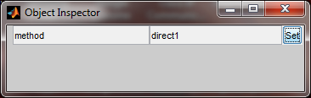

The string will be attempt to convert to numeric (using str2num) . If the cell is empty it will assume it’s a string. The value then will be written to the object class.