Reliabilty

clear classes
cd('C:\SourceSafe\Stocks & Shares\Programs\Reliabilty\')
obj = Reliabilty;
warning off
DATASET = obj.OverallReport(today-3);
disp(' ')
disp(DATASET) ;

Analysis on mulitiple times a day updates is not supported
Analysis on mulitiple times a day updates is not supported

ProgramName ResultName NumberOfDaysSinceLastUpdate
'QuoteAbstractionLayer' 'BB_Investment_Status' 22
'QuoteAbstractionLayer' 'DL_InvestedSymbolForecasts' 22
'QuoteAbstractionLayer' 'FT_BestInvestment' 22
'QuoteAbstractionLayer' 'FT_BestInvestment_Invested' 22
'DigitalLook' 'Forecasts' 7
'QuoteAbstractionLayer' 'TradeStrategyRev1' 5
'QuoteAbstractionLayer' 'Stox5_Star' 4
'BritishBulls' 'ALL_STATUS' 1
'BritishBulls' 'BUY_IF' 1
'BritishBulls' 'SELL_IF' 1
'BritishBulls' 'SystemConfirmed' 1
'FinicialTimes' 'BrokerUpdates' 1
'FinicialTimes' 'Buy_IF' 1
'FinicialTimes' 'Performance' 1
'FinicialTimes' 'Sync' 1
'Stox' 'Best_Investments' 1
'Yahoo' 'BB_BuyIF_Spread' 1
'Yahoo' 'BB_Spread' 1
'Yahoo' 'MasterSyncDayEnd' 1
'Yahoo' 'SellConfirmation' 1
'Yahoo' 'Winners' 1
'BritishBulls' 'CurrentEvent' 0
'WhatBrokersSay' 'InvestedSymbols' 0
'WhatBrokersSay' 'WatchList' 0
'Yahoo' 'Confirmation' 0
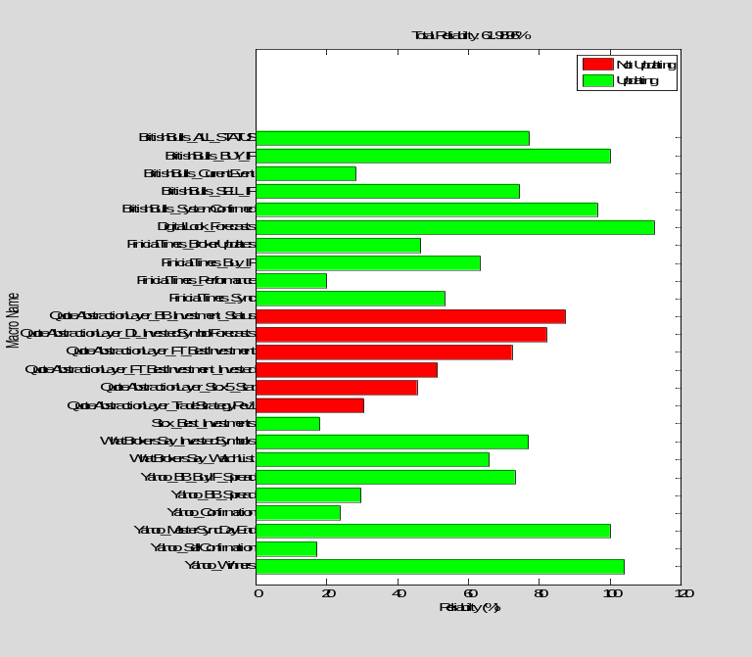

D = obj.WeekReportAll;
x = size(D,1);
Header = ['Task Mon Tues Wed Thurs Fri'];
disp(Header)

for i = 1:x
string = [D{i,1},' ',D{i,2},' ',D{i,3},' ',D{i,4},' ',D{i,5},' ',D{i,6}];
disp(string)
end

??? No appropriate method, property, or field WeekReportAll for class FinicialTimes.

British Bulls Review

Macro Name | Results Folder Name | FTP server folder | .Bat Name | Task Name
BestInvestments | SystemConfirmed | SystemBuyConfirmed | BestInvestments | BB - Best Investments
BUYIF_Investments | BUY_IF (Log here)  ALL_STATUS | britishbulls/BuyIf_Tommorrow/Stage1/ | BuyIf_Investments | BB - BuyIf
HistoricalAnalysis | HistoricalAnalysis | N/A
Invested | InvestedSymbols | N/A
InvestedStatus | INVESTED_STATUS | N/A | InvestedStatus | BB - Invested Status
SELLIF_Investments | SELL_IF | britishbulls/SELL_IF/
Sync.txt | CurrentEvent | britishbulls/HistoricalData/ | Sync.bat | BB - Sync

Fincincal Times Review

Macro Name | Results Folder Name | FTP server folder | .Bat Name | Task Name
BrokerUpdates | BrokerUpdates | /ft/ | BrokerUpdates | FT Broker Updates
Sync |  |  |  | FT Sync
BestInvestments | Best_Investments | /ft/
Invested | Invested | N/A | Invested | FT Invested
BUY_IF | Buy_IF |  | BUY_IF

Speed of task

BB – BuyIf

Last Updated: 8th Dec

BB Current Event

BB – Historical Analysis

When it should be executed:

Actions:

1. Add start/end time generically in the RunMacro command.

Table - LINKS
Program Name | Result Folder Name | MacroName
British Bulls | ALL_STATUS | BUYIF_Investments

Check

Summary page on the task manager

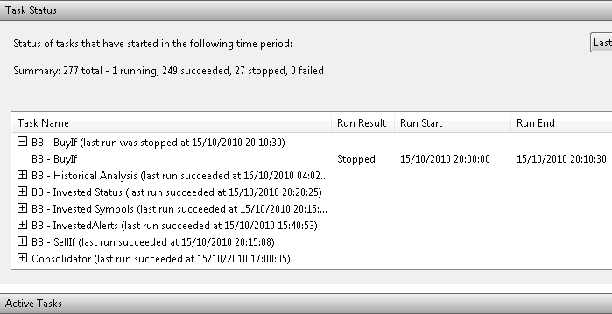

Taskmgr – check for multiple sessions.
This works in the command prompt but does not work for here?

DATASET = obj.ReadTaskList();

Image Name PID Session Name Session# Mem Usage
========================= ======== ================ =========== ============
System Idle Process 0 Services 0 24 K
System 4 Services 0 125,492 K
smss.exe 480 Services 0 360 K
csrss.exe 560 Services 0 1,864 K
wininit.exe 608 Services 0 344 K
csrss.exe 620 Console 1 1,676 K
avgchsvx.exe 628 Services 0 1,296 K
avgrsx.exe 636 Services 0 796 K
avgcsrvx.exe 696 Services 0 1,672 K
services.exe 732 Services 0 3,016 K
lsass.exe 844 Services 0 2,816 K
lsm.exe 852 Services 0 2,364 K
winlogon.exe 1036 Console 1 1,788 K
svchost.exe 1168 Services 0 3,540 K
svchost.exe 1228 Services 0 4,496 K
svchost.exe 1368 Services 0 6,160 K
svchost.exe 1392 Services 0 72,380 K
svchost.exe 1404 Services 0 17,688 K
audiodg.exe 1516 Services 0 8,292 K
svchost.exe 1540 Services 0 948 K
SLsvc.exe 1560 Services 0 980 K
svchost.exe 1596 Services 0 8,460 K
svchost.exe 1736 Services 0 10,176 K
wlanext.exe 1884 Services 0 2,108 K
spoolsv.exe 2000 Services 0 3,116 K
svchost.exe 236 Services 0 9,864 K
avgwdsvc.exe 2064 Services 0 1,560 K
svchost.exe 2096 Services 0 368 K
IAANTmon.exe 2172 Services 0 1,220 K
svchost.exe 2376 Services 0 1,432 K
RalinkRegistryWriter.exe 2396 Services 0 272 K
sprtsvc.exe 2424 Services 0 392 K
svchost.exe 2444 Services 0 1,284 K
tgsrvc.exe 2472 Services 0 452 K
TVECapSvc.exe 3012 Services 0 1,124 K
svchost.exe 3036 Services 0 1,716 K
winvnc4.exe 3060 Services 0 1,068 K
X10nets.exe 3156 Services 0 1,772 K
WUDFHost.exe 3308 Services 0 1,392 K
TVESched.exe 3388 Services 0 984 K
csrss.exe 4076 RDP-Tcp#0 2 4,388 K
winlogon.exe 2132 RDP-Tcp#0 2 1,684 K
taskeng.exe 3128 RDP-Tcp#0 2 4,076 K
dwm.exe 2640 RDP-Tcp#0 2 3,380 K
explorer.exe 1828 RDP-Tcp#0 2 31,620 K
IAAnotif.exe 3692 RDP-Tcp#0 2 1,376 K
IntelHCTAgent.exe 3636 RDP-Tcp#0 2 3,036 K
CCU_TrayIcon.exe 472 RDP-Tcp#0 2 1,392 K
RtHDVCpl.exe 2596 RDP-Tcp#0 2 2,464 K
TVEService.exe 4020 RDP-Tcp#0 2 3,148 K
brs.exe 2736 RDP-Tcp#0 2 1,124 K
PDVDServ.exe 2920 RDP-Tcp#0 2 1,904 K
sprtcmd.exe 2328 RDP-Tcp#0 2 628 K
avgtray.exe 3608 RDP-Tcp#0 2 6,316 K
ehtray.exe 2756 RDP-Tcp#0 2 2,952 K
RaUI.exe 4068 RDP-Tcp#0 2 2,776 K
ehmsas.exe 4184 RDP-Tcp#0 2 560 K
ehsched.exe 4240 Services 0 3,020 K
wmpnscfg.exe 4360 RDP-Tcp#0 2 2,244 K
unsecapp.exe 4432 RDP-Tcp#0 2 1,600 K
WmiPrvSE.exe 4536 Services 0 2,884 K
CCU_Engine.exe 5176 RDP-Tcp#0 2 912 K
AlertService.exe 5280 Services 0 856 K
ehrecvr.exe 5424 Services 0 13,524 K
taskeng.exe 5548 Services 0 2,292 K
SearchIndexer.exe 8264 Services 0 18,372 K
mDNSResponder.exe 16796 Services 0 1,288 K
AppleMobileDeviceService. 8544 Services 0 580 K
iPodService.exe 9372 Services 0 1,664 K
taskeng.exe 11616 Console 1 3,580 K
explorer.exe 13092 Console 1 26,284 K
dwm.exe 6316 Console 1 60,032 K
IAAnotif.exe 10408 Console 1 1,380 K
RtHDVCpl.exe 7748 Console 1 1,864 K
TVEService.exe 6244 Console 1 3,248 K
brs.exe 14572 Console 1 1,164 K
PDVDServ.exe 15516 Console 1 1,916 K
sprtcmd.exe 16736 Console 1 604 K
rundll32.exe 10364 Console 1 1,260 K
avgtray.exe 9564 Console 1 4,404 K
iTunesHelper.exe 14012 Console 1 1,916 K
sidebar.exe 10376 Console 1 15,008 K
ehtray.exe 15372 Console 1 2,488 K
RaUI.exe 9792 Console 1 1,868 K
wmpnscfg.exe 13880 Console 1 2,808 K
ehmsas.exe 11948 Console 1 1,168 K
unsecapp.exe 15724 Console 1 1,468 K
CCU_Engine.exe 9668 Console 1 1,452 K
rundll32.exe 6624 Console 1 3,552 K
taskeng.exe 92976 RDP-Tcp#0 2 1,224 K
TunerFreeMCEService.exe 20932 Services 0 3,828 K
avgnsx.exe 92652 Services 0 828 K
wmpnetwk.exe 54276 Services 0 17,468 K
cmd.exe 67512 RDP-Tcp#0 2 1,520 K
MATLAB.exe 43592 RDP-Tcp#0 2 114,860 K
ehrec.exe 49832 Services 0 24,436 K
ehvid.exe 17576 Services 0 9,028 K
taskmgr.exe 109596 RDP-Tcp#0 2 6,760 K
ehshell.exe 76212 Console 1 118,628 K
ehexthost.exe 24528 Console 1 15,000 K
wmplayer.exe 33668 Console 1 21,452 K
WINWORD.EXE 36184 RDP-Tcp#0 2 37,884 K
MATLAB.exe 63572 RDP-Tcp#0 2 194,024 K
cmd.exe 26048 RDP-Tcp#0 2 2,188 K
tasklist.exe 99428 RDP-Tcp#0 2 4,924 K
WmiPrvSE.exe 69496 Services 0 6,188 K
??? Index exceeds matrix dimensions.

Error in ==> Reliabilty>Reliabilty.TaskListFile2DataSet at 42
ImageName = Strings(3:end,1:26);

Error in ==> Reliabilty>Reliabilty.ReadTaskList at 32
DATASET = obj.TaskListFile2DataSet(filename);

clear classes
obj = DigitalLook('RunOnInt',false);
DATASET = obj.CompareFolders('DigitalLook','Forecasts')

DATASET =
DateStr DatesNum DATASET URL xls
[1x11 char] 7.3445e+005 'true' 'true' 'true'
[1x11 char] 7.3446e+005 'true' 'true' 'true'

clear classes
obj = DigitalLook('RunOnInt',false);
DATASET = obj.CompareFolders('FT_BrokersView','Performance')

Warning: Objects of 'FT_BrokersView' class exist. Cannot clear this class or any of its
super-classes.
Warning: Objects of specgraph.barseries class exist - not clearing this class
or any of its super-classes
Warning: Objects of specgraph.baseline class exist - not clearing this class
or any of its super-classes
Warning: Objects of graph2d.series class exist - not clearing this class
or any of its super-classes
Warning: Objects of graphics.datacursorbehavior class exist - not clearing this class
or any of its super-classes
Warning: Objects of graphics.panbehavior class exist - not clearing this class
or any of its super-classes
Warning: Objects of graphics.zoombehavior class exist - not clearing this class
or any of its super-classes
Warning: Objects of graphics.rotate3dbehavior class exist - not clearing this class
or any of its super-classes
Warning: Objects of graphics.ploteditbehavior class exist - not clearing this class
or any of its super-classes
Warning: Objects of scribe.legend class exist - not clearing this class
or any of its super-classes
Warning: Objects of scribe.legendinfo class exist - not clearing this class
or any of its super-classes
Warning: Objects of scribe.legendinfochild class exist - not clearing this class
or any of its super-classes
DATASET =
DateStr DatesNum DataSet URL xls
[1x11 char] 7.3416e+005 'true' 'false' 'true'
[1x11 char] 7.3419e+005 'true' 'false' 'true'
[1x11 char] 7.3426e+005 'true' 'false' 'true'
[1x11 char] 7.3426e+005 'true' 'false' 'true'
[1x11 char] 7.3429e+005 'true' 'false' 'true'
[1x11 char] 7.3429e+005 'true' 'false' 'true'
[1x11 char] 7.3445e+005 'true' 'false' 'false'
[1x11 char] 7.3445e+005 'true' 'true' 'true'
[1x11 char] 7.3445e+005 'true' 'true' 'true'
[1x11 char] 7.3445e+005 'false' 'true' 'false'
[1x11 char] 7.3445e+005 'false' 'true' 'false'
[1x11 char] 7.3445e+005 'false' 'true' 'false'
[1x11 char] 7.3445e+005 'false' 'true' 'false'
[1x11 char] 7.3445e+005 'false' 'true' 'false'

