**CS 276 Final Exam Spring 2020 NAME: Blake Bryant**

1. Run the following sql scripts from the Moodle shell:
   1. Enrollment table: **enrollment.sql**
      1. Student_id
      2. Course_number
      3. Term_code
      4. Grade
   2. Student table: **student.sql**
      1. Student_id
      2. Student_first_name
      3. Student_last_name
   3. Credit table: **credit.sql**
      1. Course_number
      2. Number_of_credits
2. Create the following modules. They do not need to be placed within a package.
   1. Write a function called NUM_CREDITS that given a term and a student_id returns the number of credits that student took that term. Test this function by calling it will a student_id of 'L22222222' and a term code of 201940 and displaying the number of credits. Paste below screen shots of your code and the results of your test.

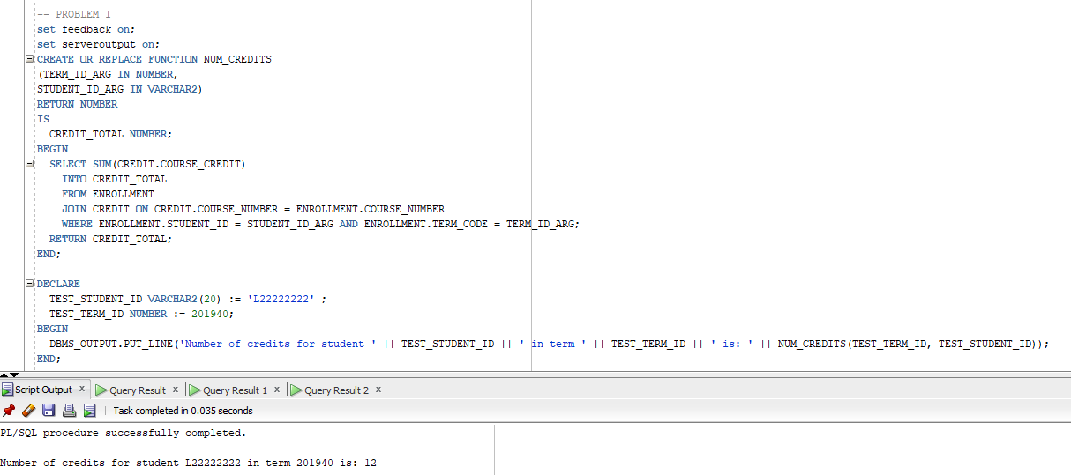

* 1. Write a procedure called CALC_TUITION that given term code passed as a parameter does the following. 201940
     1. This procedure should output the term code
     2. Then for each student, this procedure should output the student’s id, first name, last name and total tuition cost for that student for the term. The student’s tuition cost will be the number of credits taken that term times $130 per credit. Your procedure must call NUM_CREDITS function to get the number of credits taken that term by that student.
     3. Finally the procedure should output the sum of all tuition costs for all students for that term.
     4. Test the procedure by passing a term code of 201940.
     5. Paste below screen shots of your code and the results of your test.

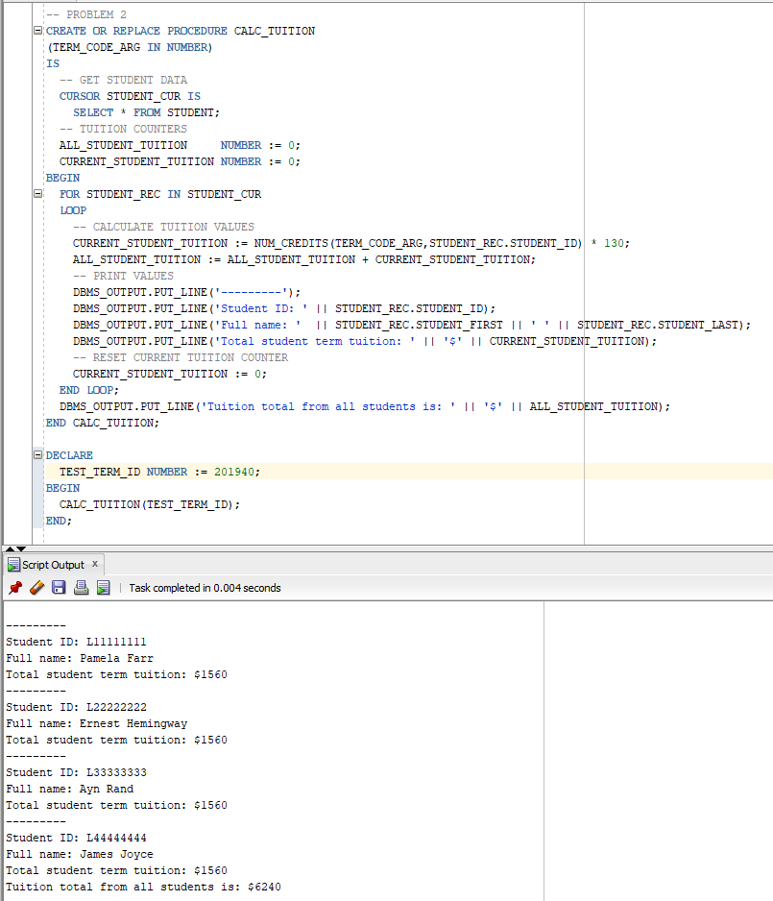

* 1. Write an AFTER UPDATE trigger that outputs the student_id, first name, last name, previous grade and new grade when an UPDATE statement altering a grade in the enrollment table is executed. Test your trigger by updating the CS120 grade for student_id 'L11111111' to an 'A'. Paste below screen shots of your code and the results of your test.

