**CS 276 – Lab 1 Spring 2020 NAME: _____________________________**

1. Write an anonymous block that will define and assign values to three scalar variables called TEST_DATE, TEST_NAME and TEST_NUMBER in the declaration section. Make sure to declare the correct datatypes, and to set serveroutput on. In the execution section, use DBMS_OUTPUT.PUT_LINE to print out the following

“Test Date: “ TEST_DATE

“Test Number: “ TEST_NUMBER

“Test Time: “ TEST_TIME

Include either block or line comments in your script.

Paste your code and a screen print of the results here…

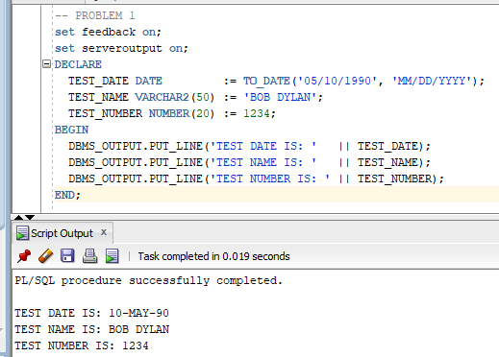

1. Why will Oracle throw an error with the following identifiers? (Each is different)
2. House Number

**Answer:** Variables cannot have spaces in them like other programming languages.

1. 1815_Coburg_Rd

**Answer:** Variables in PL/SQL cannot start with numbers.

1. Student-Name

**Answer:** Variable identifiers, also, cannot have hyphens; they can have underscores, though.

1. Write a SELECT statement to output the current date to DUAL.

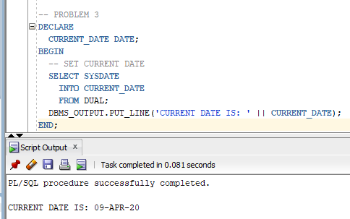

1. Enter and execute the following anonymous block. Note the use of the current_block variable in both the outer and inner blocks of nested code. If you don’t understand why the specific output is being produced, read about PL/SQL variable scope in your textbook. Screen-print the output that the following anonymous block produces here to show you’ve done this exercise.

DECLARE

current_block varchar2(10) := 'OUTER';

outer_block varchar2(10) := 'OUTER';

BEGIN

dbms_output.put_line ('[current_block]['||current_block||']');

DECLARE

current_block varchar2(10) := 'INNER';

BEGIN

dbms_output.put_line('[current_block]['||current_block||']');

dbms_output.put_line('[outer_block]['||outer_block||']');

END;

dbms_output.put_line ('[current_block]['||current_block||']');

END;

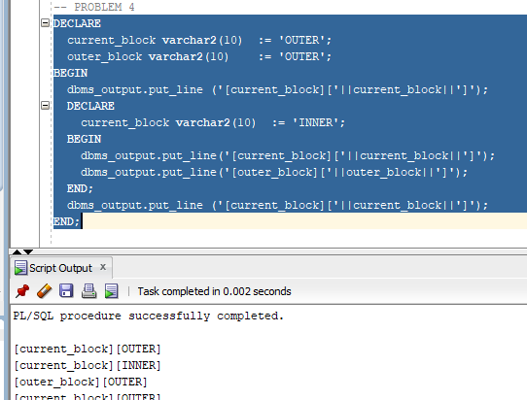

1. Using the slides as examples, write an anonymous block that declares two variables that represent the length and width of a rectangle. It should then find the area of the rectangle by multiplying the two variables. Output the length, width and area.

Paste your code and a screen print of the results here…

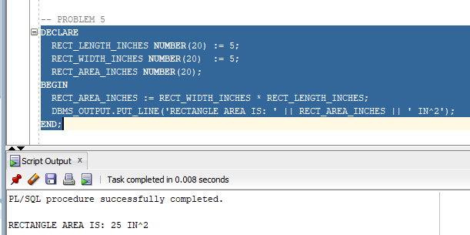

1. Write a CREATE TABLE statement to create a table with a few columns. You can use whatever table and variable names you want. Write one or more INSERT statements that puts data into your table. Now write an anonymous block that uses the SELECT INTO statement to get date out of the table and place that data into variables. Use dbms_output and the SUBSTR function to output part of one of the variables.

Paste your code and a screen print of the results here…

